Title: Component Creation from VHDL Code MaxPlusII Tool Tip

Problem: You would like to create a component out of your VHDL code that will be placed onto your schematic or GDF file.

Solution:

We would like to create a graphical component out of the Mux41 VHDL code that was used in an earlier lab (i.e. mux41.vhd) and use it graphically in another design. This code is shown below:

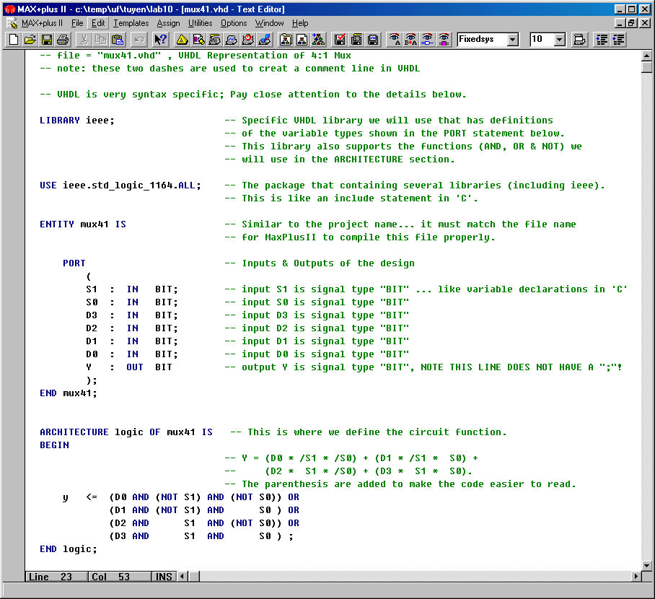

The steps to create a graphical component for this code are:

1. Assume that two files, Labx.gdf and mux41.vhd, are in the same directory. In MaxPlus2, open mux41.vhd, set your project to this file, and compile it.

2. After compilation, a symbol file, mux41.sym, has been created in that same directory.

3. Open your schematic (Labx.gdf) in the same directory as the symbol file and set your project to this file. This is the file in which you want to place your newly created VHDL component symbol. Now right click the mouse to enter a symbol and select your symbol you just created from the VHDL code.

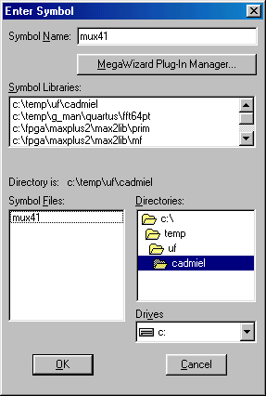

4. You should see the symbol that you have created from your VHDL file now on your schematic. It is illustrated on the next page.

Special Note: It is best not to name the VHDL component and GDF file the same name… use different names for each.

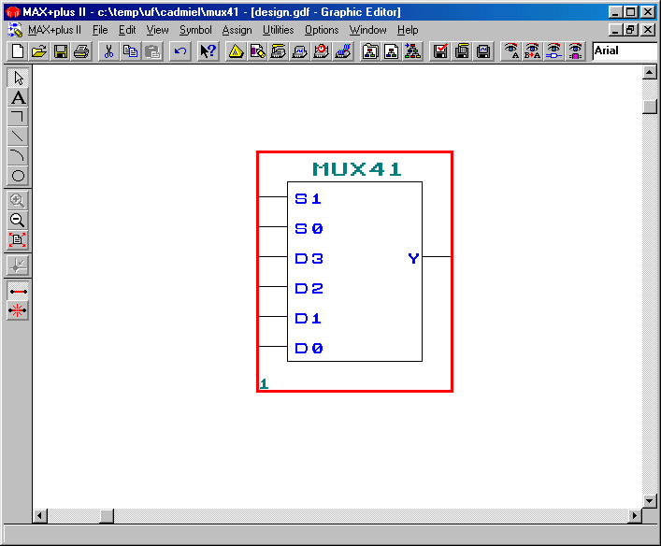

5. You can now add wires & I/O to the input and output ports of the component as you would any other component grabbed out of Altera’s libraries.

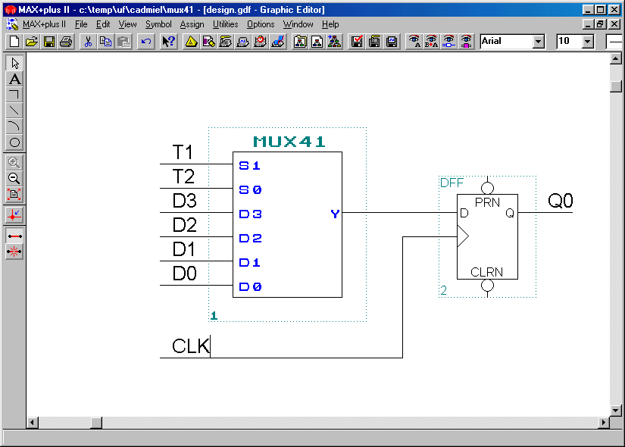

Example application:

The logic equations of the controller of an ASM can be easily specified using VHDL (much easier than graphically entering the gates). More importantly, they can be easily changed during the debugging phase without having to redraw and connect the gates every time. Using the graphical symbol, the equations can then be integrated with the rest of the ASM.

