Bump:

The bump sensors consist of 1 micro switches mounted at the rear of the platform. It is used when the robot is backing up after finding a full can or after releasing an empty can. If the bumper is getting activated an obstacle have been hit and the robot will go full speed forward and do a turn. If the rear bumper was pressed, the analog input read 45-55. The reason for only having one bumper switch in the back and none on the sides is that the robot will never get bumped on the sides.

Designed Sensor:
Figure 2 below shows the designed sensor. The designed sensor is composed of two sensors. When a can, either full or empty hits the first sensor, the circuit is energized and Stoker will know that a can is present. If the spring is compressed so the second sensor will energize the circuit, Stoker knows that a full can is present and continues it search. If the circuit is not energized, Stoker will pick up the empty can.
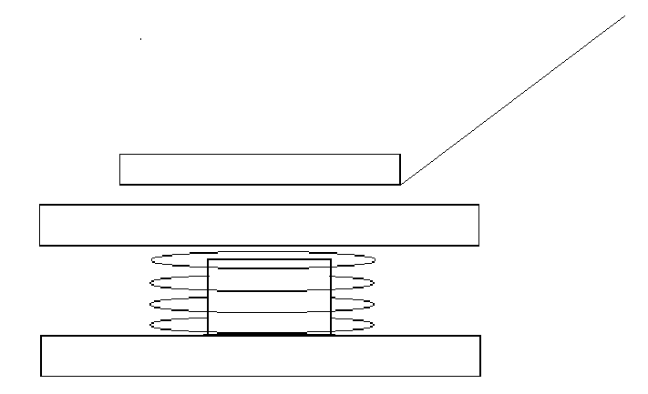
Figure 2
All parts were purchased at Lowe’s or found at home
- 2 Copper plates (1/2 inch)
- Wires (8 inch each)
- Metal plate (1/4 inch)
- Plastic strip (2 inches)
- Metal tip (1/8 inch)
Total cost for the completed sensor was approximately $1.
Figure 3, shows the sensor attached to Stoker and all the possible ways the can approach the designed sensor.

