Final Report
Spy Robot

Student Name: Yu-Ju Lin
TA : Scott Nortman
Rand Chandler
Instructor: A. A Arroyo
Table of Contents
Abstacrt 2
- Executive Summary 2
- Introduction 3
- Platform Design 3
- Actuator Design 6
- Sensors Design 6
- Behaviors 5
- Experimental Layout and Results
- Conclusion 5
- Documentation
- Appendices

Abstract
Explorer robot is a robot can be used to explore limited space and transmit live video through wireless RF channel to remote workstation, the goal of spy robot is to search interesting stuff from where people are not able to reach.
Explorer can avoid collision through its advanced sensor system. It can reach specific location thorugh its wheel encoder and return to its home.

Executive Summary
The SPY robot includes 1 wireless RF channel video camera, 4 IR emitters and detectos, 2 shaft encoders and 1 photocell. While in task execution, robot will transmit video through RF channel to remote site to show the live image that robot sees at that time. When an obstacle is detected by robot, it will try to avoid it by change its direction.
In the beginning, user must enter location to robot. The location is presented by coordinate like (x,y) in feet. The real world coordinate is then transferred to internal coordinate in X direction and Y direction. Initially, robot thinks its current location as (0,0), when left wheel rotates, shaft encoder will begin to count. Each time robot makes a turn, internal coordinate will rotate too. When internal location has reached, robot think itself has reached its destination in real world then it will begin returning to base.
In the road to detination, when an obstacle is detected, robot will try to avoid collision by changing direction. It will first backward then turn 90 degree clockwise then continue its journey.
When destination is reached, it will turn its head to Y minus direction then flash its LED.
Since LED detector sense range is about half feet, so the grid size should be larger than 1 feet. And SPY robot is not designed for solving maze, it will not appropriate to put it into a very complex environment and wish it will find the route from base to destionation, this will not work. And because of the error of shaft encoder, it is not appropriate for robot to travle very long range and wish it will return to base, the longer travel range, to larger error will make by robot thus it probably not able to return to base.

Introduction

Sometimes we drop small things like diamond rings, pens or valuable stuff under hidden places like under bed, under table or places that we can not reach. If we can have some mechanism that can show us where’s the lost stuff would helps a lot. That’s why I proposed this SPY robot that can explore certain places that human couldn’t reach.

SPY is a robot that is very tiny (about 5 in cube) and capable of navigating some specific places. It will explore toward pointed direction, avoid obstacles and transmit images that it “sees”. When the specified location is reached, it will return to its home. While it is exploring, it will transmit live video through its wireless (RF) video camera to home base. If the place that user assigned is in low light condition, robot will turn on its light in order to capture images. When robot found some obstacles on the path, it will turn to other direction to avoid collision and continue its work. When robot reach destination, it will show user that the task has been done by turn its head toward home direction and then blinking its LED.

The organization of this paper is as following: Section III introduce robot platform, section IV talks about actuation that will be used in this project and section V is about sensor designs and section VI is about behavior for this robot. Section VII is experinment and results. Section VIII is conclusion. The last section is appendix.

- Platform design
Since SPY is designed for exploring limited places like very narrow places or height limited places. It is will be more appropriate to make it as small as possible. I did not choose it to as small as 1-inch cube size because it will increase design difficulty and because this is a prototype, the size of some parts probably not small enough, so the whole platform size is around 5-inch cube.
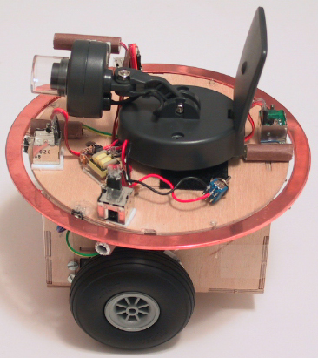
Figure 1 SPY platform design.
There are three wheels, two of them is driven by two servos. Wheel encoders is attached to two front wheels to record how many steps has been explored at each wheel at a given time. In this way, the robot can trace back to its home using these recorded data. Shaft encoder is attached at left and right side of robot against the black and white stripe wheel.
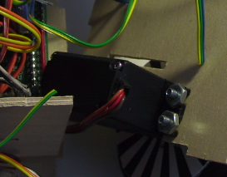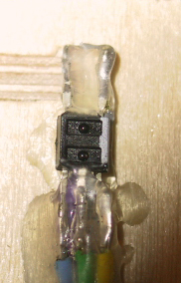
Figure 2. Wheel design(left) and shaft encoder(right)
The power is composed of 6 NiCd batteries to supply enough driven strength. Power pack is located at the rear side of robot. Since wireless video camera consumes lots of power for wireless communication, it would drain out lots of power from robot. To avoid burn out TJPro board, I designed another power line dedicated for video camera. And since video need 12V, I also design a 4.5V to 12V regulator for video camera power supply.
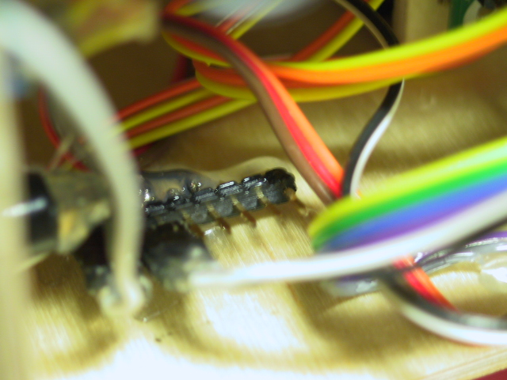
Figure 3. (Left)Power pack location (Right) Another power line dedicate for video camera
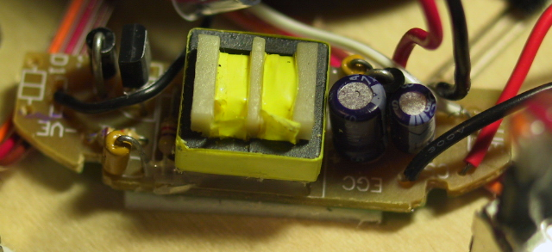
Figure 4. Video camera power regulator
Camera is located at top of robot. To avoid collision, 4 IR sensors are equipped. IR sensors sense that if any obstacle is approaching ( or robot is approaching any obstacle). IR sensors are located at front left, front right, rear left and rear right of robot. Because IR detector is very sensitive and bumper is made of metal, I use alumni to shield IR emitter such that it will be affected by bumper and the IR detector will not so sensitive to the environment. Since camera can not show image when the light is dim, I use one photocell to detect light condition, it is located beside the camera.
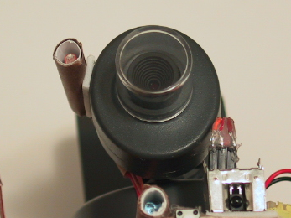
Figure5. Camera and light sensors. Below the camera are IR emitter and IR detector

Sometimes, IR sensos do not work so well, bumpers are needed to prevent collision. Since bumper should be firm enough to make bumper sensor work properly, I use copper bumper.
Metal bumper
Figure 6. Bumper design

- Actuator Design

The actuation that will be used in this project are tow hacked servos. Hacked servo is connected with driven wheel, it can forward and backward according to code used. Two wheels are being used as driven wheel.

- Sensors Design

Sensors that will be used in this project are: 4 IR sensors, two wheel encoders, 4 micro-switches, one photoresistor and one sonar.

IR sensors are used for sense possible obstacles. Wheel encoders are used to record how many “steps” has passed in a given time at each wheel. And micro-switches are used for bumper. Photoresistor is used for sense environment light condition, if it is in low light condition, robot will turn on its own light to help camera capture images.

Shaft encoder components
The components in my wheel encoder are:
- Shaft encoder
- 32 segments striped wheel
- Interface circuit
- Software driver

Shaft Encoder
Shaft encoder is a sensor that measures the position or rotation rate of a shaft. From signal point of view, we can tell shaft encoder as: absolute encoders and incremental encoders. Absolute encoders deliver a code that corresponds to a particular orientation of the shaft while incremental encoders produce a pulse train. The pulse is generated when output voltage of shaft encoder changes from high to low(or vice versa), so the faster the shaft turns the faster the pulse generated.

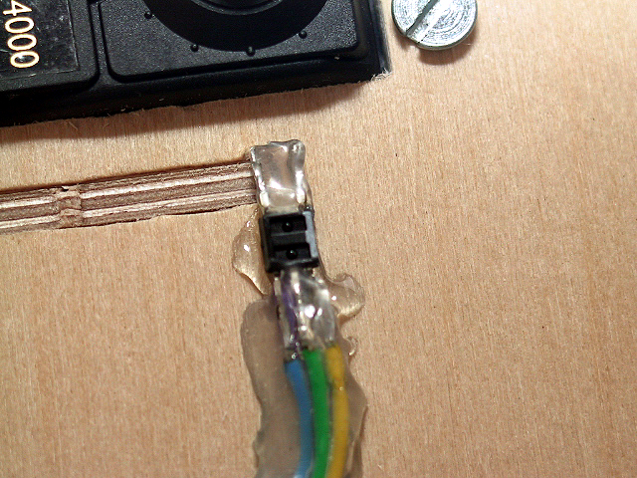
From implementation point of view, we can tell shaft encoder as:photointerrupter and photoreflector. Photointerrupter includes an inferared LED emitter and a photodetector and a slotted disk. When disk spins, the light is interrupted by the moving slots thus photodetector detects the changes of the light and generate pulse at its output. If we use microprocessor the count the pulses generated by photodetector, we can know how far the wheels has rotated. The photoreflector is different, it uses the reflection of the light to detect the movement of the wheel. Inferared LED emitter emits light to striped wheel. Since light will not reflect if it meets black stripes, phototransistor then detects the changes of the light and sends out singals according to the reflection.

The encoders that I use in SPY robot is Hamamatsu P5587 photoreflector. The photoreflector is packaged with an infrared LED and a phototransistor in a very compact unit. The device is attached on the body of the robot and the distance between device and striped wheel is about 0.5cm.

Striped Wheel
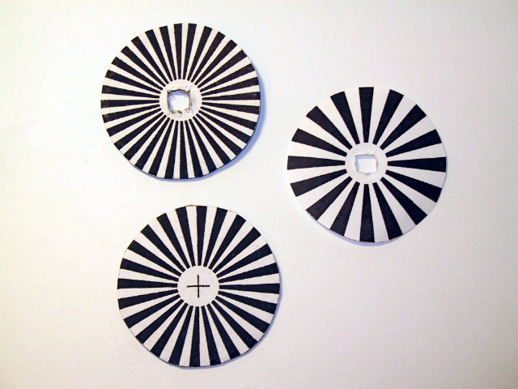
The width of the stripes is an important issue in designing shaft encoder. I tried 32 segments, 48 segments and 64 segments striped wheel, only 32 segments striped wheel works correctly Although more stripes give greater resolution to the output measurements, but the stripes cannot be narrower than the field of view of the photoreflector. That’s the reason why it does not work well in 48 segments and 64 segments.

Because the near-infrared energy emitted by the LED can penerate thin, white paper, so I put thick hard paper behind printed striped wheel this will make sure the light will reflect if it meets white stripes.

Interface circuit
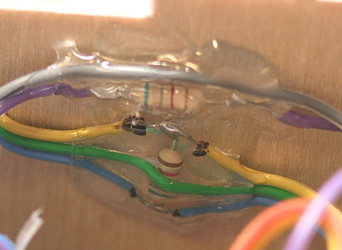
Since Hamamatsu P5587s photoreflectors have circuitry integrated in the package to amplify and condition the output of the phototransistor, the only interface components required for connecting to the TJPro board are two resistors: 680Ω and 6.8KΩ resistor. 680Ω resistor is connected to the input of the LED to limit the current through LED. 6.8KΩ resistor is connected to the output of the phototransistor to pull up phototransistor's open-collector output.

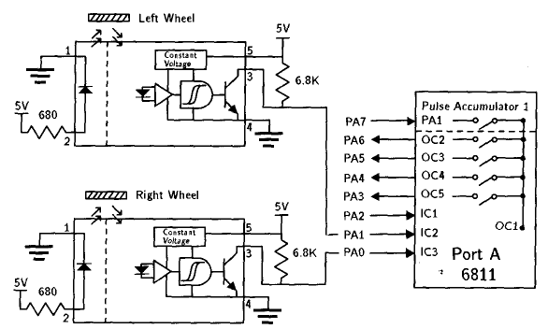

The power for Hamamatsu P5587s photoreflector is coming from analog port on TJPro board. Analog port provides regulated 5V and ground connection thus meets our need.
5
4
3
1
2

The wires connecting TJPro board and photoreflector are: Grey for pin 1, Purple for pin 2, Blue for pin 3, Green for Pin 4, Yellow for pin 5. The pin assignment for Hamamatsu P5587s photoreflector is as below: Pin 1 is connected to LED ground. Pin 2 provides LED power. Pin 3 is for signal. Pin 4 is ground and Pin 5 is power.

MC68HC11’s port A has 8 pins, they have various input capture and output compare registers associated with them, which are able either to mark the time that events happen on those pins or to initiate events at preprogrammed times.

In the original design of interface circuits, the left wheel shaft encoder is connected to MC68HC11’s PA7. A pulse accumulator function is associated with PA7 making it easy to count the pulses produced by the shaft encoder in software, but PA7 pin is used for motor control, I choose PA1 and PA0 for right and left wheel shaft encoder. I only use pin 1 of PA1 and PA0 on TJPro board, pin2 and pin 3 which are for power and ground connection is not used since they are not regulated.

Software Driver
To drive wheel encoder, we need some surgery to interrupt handler. MC68HC11 port A pin PA0, PA1 and PA2 are associated with input capture registers. To count encoder clicks, we must use interrupt handlers. Since right wheel encoder is connected to PA1, IC2 register is for right wheel encoder. Same as left wheel encoder, which is connected to PA0, thus IC3 register is for left wheel encoder.

There are four actions can be assigned to input capture registers. They are: capture disable, capture on rising edge and capture on any edges. We must use TCTL2 register to set the desired response for any successful input-event detection. Since four different responses can be assigned for one input capture, it is obvious that we need 2 bits to represent all possible value. In TCTL2 register, EDG3A and EDG3B is for setting IC3 response action, EDG2A and EDG2B is for setting IC2 response action. The address for TCTL2 is $1021, in ICC11, TCTL2 is a legitimate variable, we don’t need to do anything before using this variable.

EDG3A | EDG3B | EDG2A | EDG2B | Configuration
0 | 0 | 0 | 0 | Capture Disable
0 | 1 | 0 | 1 | Capture on Rising Edge
1 | 0 | 1 | 0 | Capture on Falling Edge
1 | 1 | 1 | 1 | Capture on Any Edge

We will trigger on risign edges, so four bits must be written to the TCTL2 register to configure it for risigng edge-triggered interrupts. In order not to disturb other setting, I store 0101 to the least significant 4 bits and leave other four bits not changed.
TCTL2
$1021 | 0 | 0 | EDG1B | EDG1A | EDG2B | EDG2A | EDG3B | EDG3A
 | x | x | x | x | 0 | 1 | 0 | 1

Each time an interrupt happened according to the event we assigned, an interrupt flag will be set indicates that an interrupt event happened. The flag of input capture register is contained by TFLG1 register. TFLG1 register is at address $1023, and we can use TFLG1 variable name in ICC11 directly without pre-define. When input capture event happened, associated flag bit ICxF will be set, hardware will automatically initiate an interrupt. Code in the interrupt service routine thus must clear the ICxF flag; otherwise, when an attempt is made to return from the interrupt, the hardware will think the ICx interrupt is pending and immediately service it again. Suppose IC3 interrupt happened, after service, we must write a 1 to the bit in the TFLG1 register that corresponds to that interrupt’s flag as below.
TFLG1
$1023 | OC1F | OC2F | OC3F | OC4F | OC5F | IC1F | IC2F | IC3F
 | x | x | x | x | x | x | X | 1

It is obvious that after IC2 service, we must clear IC2F flag. After above discussion, the interrupt handler routine, which automatically runs whenever a rising edge is detected, must do the following tasks: increment a counter, clear the interrupt flag and return from the interrupt.
Now we need to configure interrupt vector such that when IC event happened, hardware will jump to our service routine instead of default interrupt service. The TMSK1 register contins the bits that must be set to enable interrupts associated with events on any input capture pin. TMSk1 is at address $1022 and the bits associate to input capture 3 and input capture 2 are IC3I and IC2I.
Strat Interrupt handler
Increase counter
Clear Flag
Return from Interrupt

TMSK1
$1022 | OC1I | OC2I | OC3I | OC4I | OC5I | IC1I | IC2I | IC3I
 | x | x | x | x | x | x | 1 | 1

Before we set IC2I and IC3I bits, interrupt handler will not handle inputer capture 2 and input capture 3 events. Now we should redirect interrupt vector to our routine. The vector address for IC3 interrupt is $FFEA, and IC2 interrupt is $FFEC. The two byte address stored at this location is the address at which the user’s interrupt handler code muse begin. In ICC11, to modify interrupt handler, we must modify vectors.c file. The interrupt handler routine for IC2 and IC3 now are changed to my_TIC3_isr and my_TIC2_isr routine. The whole flow is presented in following page.
Initial interrupt start
Turn off interrupt
Set TCTL2 register
Set TMSK1
Store my_TIC3_handler address into $FFEA
Store my_TIC2_handler address into $FFEC
Turn on interrupt

Source code for software driver is attached at the end of report.
- Behavior

User first assign one position to robot like x=???, y=??? then robot will go to that position. On the path to destination, if robot meet obstacle, it will turn around and continue its path. While it is walking, it will record steps that it used in past few seconds to record path. Once destination is reached, robot will return to its home according to the data it recorded.

In the beginning, the coordinate that robot standing now is position (0,0). To go to destination, robot will try to increase Y direction first. If it met obstacle, it will turn 90 degree and try to increase X direction. If positive Y and X direction has obstacle, it will go to negative Y direction until X direction is free of obstacle then go X direction. If Y or X direction is meet, robot will go other direction until destination is meet.

Since this robot is not for maze explorer, I will not program it as those mice that run in maze. But reasonable obstacle avoidance will be programmed.

- Experimental Layout and Results
Wheel Encoder
Wheel encoder can be used to measure the distance from last measured position to current position. To measure this simply reset counter for each wheel in the beginning of measure, then at the destination ,see how many clicks happened so far then we know the distance. To measure velocity of robot, we need constantly check clicks of each wheel. This can be done by checking clicks every second(or reasonable time), then we know the velocity of robot.
The most challenge application of wheel encoder is to synchronize two wheels such that robot walks as straight as possible. This includes measure wheel clicks and adjust motor power level. Since motor device is not uniform and the zero point of each servo is different and the adjustment for different servo is different too. Thus it is almost not possilbe for two servos with identical properties. The challenge now becomes how could we use software to adjust two servo such that two servo will have similar performance.
Using wheel encoder and make two servos runs at the same rate is feasible. Before robot begins, robot itself will run a self-calibrate to sync two servo. Once it got reasonable clicks sync, it will start perform its task. In the beginning of calibrate routine, it will assign full power level for each motor. Then run and wait 9000 e-clocks. Since processing interrupt takes time, after 9000 e-clock, we wait another 500 e-clock to let interrupt handler finish its work. Then we compare clicks from two wheels. The adjustment for each motor is according to the click counts. If right wheel count is more than left wheel count then right motor power is adjusted according to following equation:
$$\text{Right_motor_power}=\frac{\text{Right_motor_power}×\text{Left_clicks}}{\text{Right_clicks}}$$
The same is done when left wheel count is more than right wheel count accroding to following equation:
$$\text{Left_motor_power}=\frac{\text{Left_motor_power}×R\text{ight}\text{_clicks}}{\text{Right_clicks}}$$
But after some tries, both left motor power and right motor power will decrease, we don’t want this situation happened, so I made re-adjustment if motor power becomes too low. If right motor power level is lower than 100 and after adjustment left motor power will not exceed 100, then we do following adjustment:
${\text{Right}}_{{\text{motor}}_{\text{power}}}=\text{100}$ ${\text{Left}}_{{\text{motor}}_{\text{power}}}=\frac{({\text{left}}_{{\text{motor}}_{\text{power}}}×\text{100})}{{\text{right}}_{{\text{motor}}_{\text{power}}}}$
Same is done when left motor power is lower than 100:
${\text{Left}}_{{\text{motor}}_{\text{power}}}=\text{100}$ ${\text{Right}}_{{\text{motor}}_{\text{power}}}=\frac{({\text{Right}}_{{\text{motor}}_{\text{power}}}×\text{100})}{{\text{Left}}_{{\text{motor}}_{\text{power}}}}$
Because moto performance will decrease when battery power level decrease, this increases the difficulties of syncing both motors. So when two motors are at the same clicks, program will try same power level and see if the result clicks are the same. If they are the same, then calibrate routine ends and begins to execute regular task, otherwise it will calibrate again.
I do 20 times of experinments and found right motor power is about twice powerful than left motor power. Actually after calibrate, the average power level for left motor is always 100, and power level for right motor is about 74. The average calibrate time in each experinment is about 7*9500=66500 e-clocks.
The experinment chart and result is included at the end of report.
Range measure
From the experinment I did, the range and the click counts is about:
1 feet = 26 clicks
Rotation measure
For roatate 90 degree, the click count should be 6 clicks.
IR detection measure
For correctly detect obstacle, IR detector should continuous detect bounced IR. In the experinment, if obstacle is in half feet range, IR detector will have a reading about 100. I use this as threash hold to tell that an obstacle is detected.
IR coverage
In the IR coverage experinment, I use hand to detect the exact IR coverage. The measured IR coverage is about 45 degree.
45 degree

- Conclusion
The SPY robot exactly executed the assigned task if the path to the destination is not complex and obstacles are apart in 1 feet range. If obstacles are too colse to each other, the robot will be fooled. It would be difficult to tell all the obstacles in the journey to destination since we have to sense environemt each time we move a step.
Since the limited memory of TJPro, we can not remember all the events happed in the journey and thus it is not practical to ask robot to solve whether destination is reachable or not. That means that if destination is not reachable, robot will not know and will try to find a path to the destination till it run out all the power.
The other drawback of SPY robot is because of the inaccuracy of wheel encoder, it is not practicle to ask robot to travle a very long journey. The longer the robot travel, the more error the robot will make.
But this drawback can be solved by using more accurate encoder like more stripes or use GPS to locate current position then adjust internal data. But this will result in large platform and consume more power and complexity.
IX. Appendix

