



Jonathan Gamoneda
EEL 5666 – Intelligent Machines Design Lab
Fall 2001
December 4, 2001

Table of Contents

TABLE OF CONTENTS…………………………………………………………2

ABSTRACT……………………………………………………………………….3

EXECUTIVE SUMMARY……………………………………………………….4

INTRODUCTION………………………………………………………………..5

INTEGRATED SYSTEM………………………………………………………..5

MOBILE PLATFORM…………………………………………………………..6

ACTUATION ……………………………………………………………………7

SENSORS…………………………………………………………………………8

BEHAVIORS ……………………………………………………………………15

EXPERIMENTAL LAYOUT and RESULTS…………………………………16

CONCLUSION …………………………………………………………………..17

DOCUMENTATION…………………………………………………………….19

APPENDIX……………………………………………………………………….20

PICTURES………………………………………………………………………..28

ABSTRACT

The purpose of the lil golfing buddy©™ is to construct an intelligent mobile robot to place a golf ball on a tee. The robot will go around a small area of artificial grass looking for a tee on the ground. The robot will also be able to avoid larger obstacles. After it has found the tee it will approach it and then position the robot so an arm can be deployed to place the ball on the tee. Then the robot will back up and wait for the sound of a golf ball being hit. After it hears the sound it will try to place another ball on the tee.
EXECUTIVE SUMMARY
The lil Golfing buddy was to design to help any golfer practice on artificial grass at any driving range across the United States of America. The lil Golfing Buddy was aimed at helping the golfers focus on driving the golf ball with out having to worrying about bending down and keep putting another golf ball on the tee.
The lil Golfing Buddy was built to work in a small area about 6 feet by 6 feet. With in a minute the lil Golfing buddy will locate the tee and then attempt to place a golf on top of the tee. The Golfing Buddy will then back up and wait to hear the sound of a golf ball being hit. (Please reload the Golfing Buddy manually before hitting the teed ball) Upon hearing the sound it will repeat the process.
The lil Golfing Buddy is powered with eight 1.2V NICD batteries and motion is obtained with two partially modified servos and a caster wheel in the rear to maintain balance. The lil Golfing Buddy is controlled with an 68HC11 based board, the Mekatronix MRC11, and the MRSX01, its accompanying expansion board.
The lil Golfing Buddy uses 5 different sensors to complete its task. The IR Sharp Range IR’s are used to located the tee. The Sharp Can IR detectors will be used for obstacle avoidance. The cds cells will be used in conjunction with the laser beams to make a break beam sensor. The break beam sensor will be placed in an X-Y coordinate system to find the exact location of the tee. I simple sound circuit using a LM386 Op-amp is used to detect when the golf ball is being hit. A thermo resistor is used to determine the temperature and if the golfer needs to take a break.
INTRODUCTION

Have you even been in this scenario? You have not golfed in a while and want to get some practice. You head on over to the local driving range for some swings and of course to see if you can hit the golf ball ranger, which is collecting the balls. At the driving range you earnestly purchase the Jumbo bucket of golf balls not thinking of how out of shape you are or how awful your driving is. By the time you are half way through with the jumbo bucket of golf balls you are tired of constantly re-teeing your golf ball. This is where the lil Golfing Buddy©™ can be used. While you are busy watching your balls hooking or slicing, the lil Golfing buddy©™ will be placing another golf ball on your tee.

INTEGRATED SYSTEMS
The micro controller of the lil Golfing Buddy©™ is a Motorola 68HC11 based board from Mekatronix, part number MRC11. Also used on the lil Golfing Buddy is the MSRX01 a sensory board from Mekatronix’s that connects to the MRC11 board. The MSRX01 or expansion board will be used to gather information from the sensory devices (IR, sound, light beam, and bump) as well as control 4 servos and various LEDs.
There will be at least 2 light beam sensors (placed in an x-y coordinate system) used to find the location of the tee. The system will consist of cds cells to determine if either beam has been broken. I am going to use 2 different laser-pointing pens for the light beams. They will be turn on prior to starting the robot using a DPDT switch.
A picture of the MRC11 and MSRX01 boards can bee seen in Figure 1.
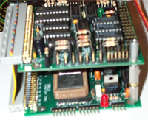
Figure 1 The MSRX01 board is on top. The MRC11 board is on the bottom. The chip in the brown socket is the 68HC11.

MOBILE PLATFORM
The mobile platform of the lil golfing buddy©™ is shown in Figure 2. The platform is about 12 inches long. The platform was designed in AutoCAD and cut out of ‘1/8’ inch plywood. The latest version of the design can be seen in Figure 1. The teeth shape parts that are visible in the design where going to be used to extend and retract the arm bucket assembly, but do to time that part of the project was omitted. Most of the weight, i.e. controller board, sensory board, and the batteries, will be placed towards the rear so when the robot is in normal operation it will not tip forward.
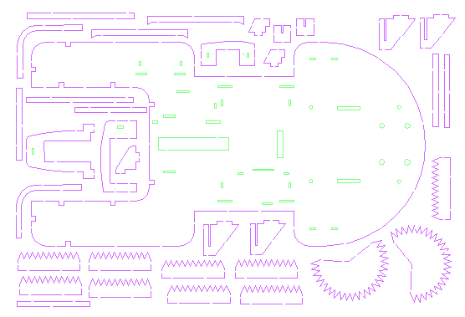
Figure 2 The shell of the mobile platform for the lil golfing buddy

ACTUATION
The body of the robot will be moved by using two diamond servos (bought from mekatronix see documentation) mounted on the platform in Figure 2. The two servos were partially modified to allow them to turn a complete 360 degrees. The two drive servos had a rated torque of 43oz/in. A caster wheel is going to be in placed in the rear of the robot to complete the suspension and balance out the design.
Programming the robot to move was a snap after I made some simple functions in C. I made a function forward() that allowed the robot to move forward. Please view Appendix for the other functions that were used to move and control the lil Golfing Buddy’s Systems.
The golf ball bucket and arm will be moved by a hitec servo (s-303 from servo city see documentation). The rated torque on this servo is 49oz/in. A sketch of how the servo will work to place the ball on the tee is shown in Figure 3. The arm of the assembly will be place in a fixed distanced into the open area of the front of the robot. The location will be the exact spot of where the X-axis laser beak and the Y-axis laser beam cross, where the tee would be. Then servo wheel will slowly turn, thus lowering the bucket and gently placing the ball on the tee.
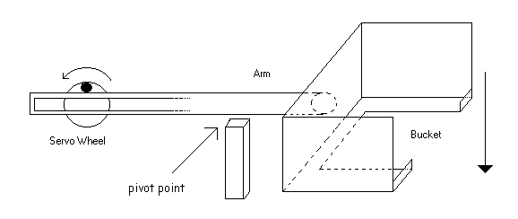
Figure 3 The arm and bucket apparatus of the lil golfing buddy©™.
A final servo was used to place the Y-axis’s cds cell into position when ready. This was a small mini servo, a hitec HS-55 Feather Servo from servo city. The rated torque on the servo is 18.05oz in.
I used the two servo ports on the sensory expansion board to control the 4 servos. This was accomplished by using a simple 2 input AND gate chip and Pins 2 and 3 of PortD as shown in Figure 3.1. Servo1 and servo2 pins come from the Sensory expansion board, and the others are self-explanatory.
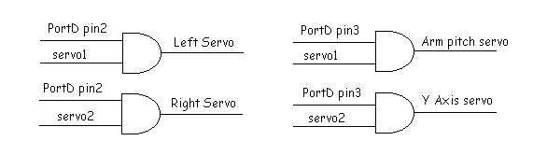
Figure 3.1 The mux circuit of servos

Sensors
The robot is equipped to handle at least 5 different kinds of sensors to complete its goal. They are the following: Inferred detectors (and emitters), bump sensors, Light beam sensors (cds cells), a temperature sensor (High Precision Temperature-to-Voltage Converter), and a sound sensor. Please note that not all the sensors were used for the final robot.
Two different kinds of IR sensors will be used on the lil Golfing buddy. The IR detectors will be used to avoid obstacles and to detect the tee. The tee will be detected by using the Sharp Range IR detectors and emitters, part number GP2D12. I will have one of each underneath each side of the robot near the front tips of the robot. The robot will scan just above the floor in a cross-eyed configuration. Figure 4 is a collection of values from a test conducted with the Sharp Range IR. The values where obtained by placing a white piece of paper at varying distances from the IR device. At each distance 10 readings where recorded. Both IR devices give about the same values for the same distances. Figure 5 is a graph of Volts vs. Distance.
Figure 5 The graph of the IR values
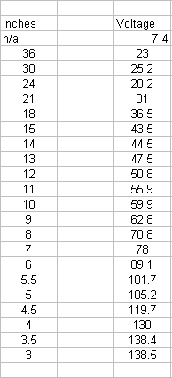
Any objects in front of 3 inches give a poor reading to the device. This is probably due to the fact that it uses triangulation of the IR beam in order to determine the distance. When the object is too close to the device, it does not work properly.
The Sharp Range IR is ideal for located the tee. The sensors have a narrow range of vision, the object must be in front of it in order to get a proper reading. In placing a tee size object in front of the IR device, a reading of 60 was obtained at 10 in.
Figure 4 The values obtained from the Sharp Range IR’s. NOTE: That the voltage values are given in hex format with 255 = 5V.

That is about the same reading as with the white piece of paper, which was 59.9. A moving tee sized object test was also conducted (at about the speed that the robot will drive around and look for the tee) over the area the IR detector vision. It was able to distinguish the tee, the following readings are: 11, 8 , 10 ,18 ,45 ,58 ,4 ,4 10, 13.
Two more IR detectors will be used to avoid obstacles. While the more accurate sharp Rangers scan the floor, the older sharp cans, part number GP1U5, will be used to collision avoidance. The sharp can’s will be placed on the topside of the front tips of the robot to determine if the robot is going towards a tee or a larger object. And as a bonus, the Sharp Range IR’s and the sharp cans run on different frequencies, so each set of IR detectors should not interfere with the other.
Bump sensors will be used if the IR system fails to detect a larger object or if the robot has ran into the tee. Bump sensors will also be used to start the robot. There will be a three bump sensors that will be located in the middle of the robots cavity, one on each tip and then one in the back. Figure 6 shows how they will be placed on the robot. Figure 7 shows how the circuit is to be constructed.
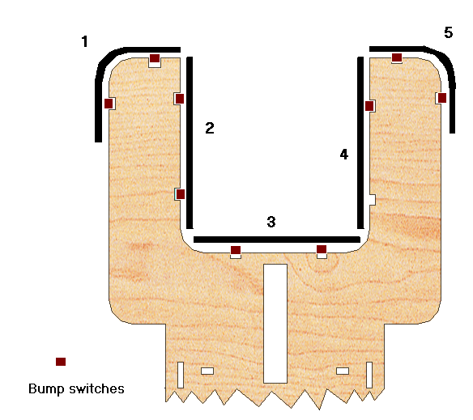
Figure 6 This pictures shows how the bump system will look on the lil Golfing buddy
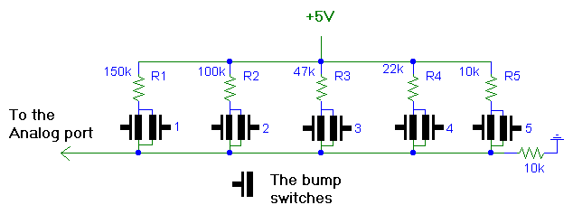
Figure 7 Shows how the bump switches will be measured. Each Group 1 through 5 will have 2 bump switches in parallel as shown. If any of the two switches in the group get pushed, it will be as the whole bumper is affected and the robot will act accordingly.

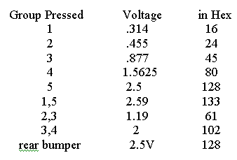
Table 1.1

The Table 1.1 is all the expected combinations that the bump switches may be pressed during normal operation. R1 is actually 149.3kΩ, R2 is 98.3kΩ, R3 is 47.2kΩ, R4 is 21.8kΩ and R5 is 9.9kΩ. The common resistor is 10kΩ. The values in the table reflect the actual resistor values.
The back bumper is a simple voltage divider circuit. It is the last resistor R5 and the 10k resistor that is tied to ground in Figure 7 with two bump switches in parallel. When none of the switches are press, the voltage read 0V, when it is pressed it read 2.5V or 128_{hex}.
The light beam sensors will be made from 2 laser pointing pens, 2 cds cells, and 2 resistors that help make up a voltage divider circuit with the cds cells. This is new and unique because no one has used two laser break beams as an x-y coordinate system. The break beam sensor will be constructed by aiming the laser into the cds cell. This will allow the robot to determine the exact location of the tee. Figure 8 shows how the Laser pens and the cds cells will be placed on the robot.

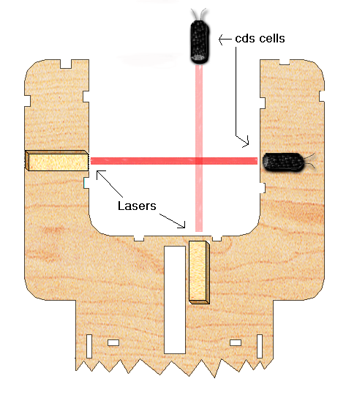

Figure 8 shows the orientation of how the two laser beams will be setup.

When the laser beam is hitting the cds cell the voltage is at 250_{hex}. Even with the beam about ¼ block, the voltage is still 250_{hex}. When about half of the beam is blocked it gives a reading of about 239-245_{hex} Volts. When the beam is ¾ blocked the Voltage is below 10_{hex}. When both of the cds cells read less than 15_{hex} volts, then the robot is in the correct position and the golf ball is ready to be placed on the tee.
The sound sensor will be used to determine when I golf was hit from the tee. After the robot has recognized this event, it will attempt to place another ball on the tee. The circuit that I have constructed to determine sound is in Figure 9. Table 2 shows values from this circuit
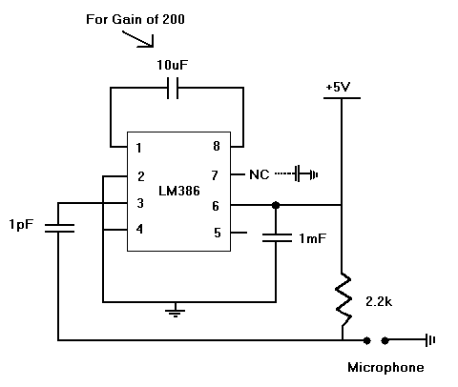
Figure 9 The circuit that is used to detect when the golf ball is being hit.

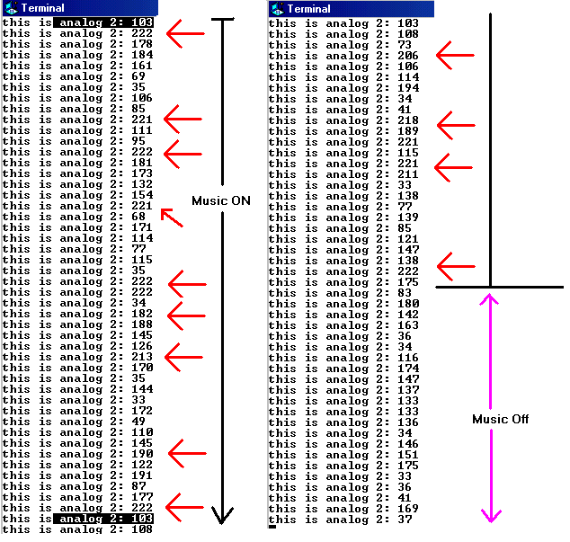
Table 2 The Data values obtained using the circuit in sound detecting circuit in Figure 6.

The red arrows in Table 2 point out the Maximum voltage that the sound detecting circuit produces while an Offspring song was being played fairly loud. When the music is off, the voltage stays around 130-175_{hex} with ambiance noise. Sometimes the voltage goes down to about 30-45_{hex}. When music is being played, or a loud clap ( like a golf ball being hit), the max goes above 190_{hex}, and in most cases easily above 200_{hex}. The microphone will go in the front of the robot and it will indicate that a sound was detected when the voltage goes above 195_{hex}.

Another sensor that I am trying to incorporate into the robot is a temperature sensor, if time permits. This sensor will be used to monitor the heat from the servos and the outside temperature. When it is plugged in room temperature, the reading was about 41_{hex} or 8V, which is about 30°C. And when I blow hot air towards the sensor it reads a Max of 46_{hex}, which is about 38°C. Figure 10 is a graph of the temperature sensor.
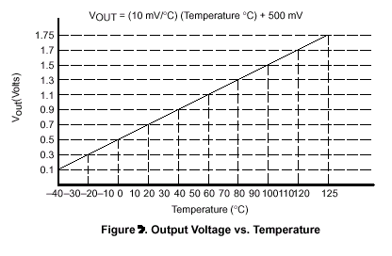
Figure 10

BEHAVIORS
The most common behavior for the robot will be it ability to avoid obstacles that are larger than it. The other common behavior that it will perform is when it bumps into an object, it reverses, turns to the right about 30 degrees and then continues going straight.
The specialized behavior of the robot will be it ability to find a tee, get close to it and then place the robot in a precise location so that the arm can be lowered to place a golf ball atop of the tee. The robot will then back up about 1 foot from the tee. The robot will then listen for a sound. Before hitting the golf ball the user should place another golf ball in the bucket again. After hearing what it thinks is a golf ball being hit, the lil golfing buddy will drive back to the tee to repeat the operation.

EXPERIMENTAL LAYOUT and RESULT
The robot took about 3 months to complete. The code to operate call still be tweak and improved but the lil Golfing Buddy can avoid obstacles, find a tee, and place a golf ball on top of the tee.
The lil Golfing Buddy is designed to work in a relative small area with boarders (for now). In a space about 6 feet by 6 feet and one tee, with walls about half of his height.
The first behavior that was implemented and works with out any problems is obstacle avoidance. Using the sharp cans and IR emitting diodes, the lil Golfing Buddy easily avoids obstacles bigger than a tee and taller than him. I do have video of this, please see Appendix for more information.
The next thing to be programmed into the obstacle avoidance was the tee finding behavior. After many version of this code I was finally happy with what is in the Appendix. I can almost guarantee that the lil Golfing buddy can find the tee within one minute of the start of the search.
The last part that was programmed was the Y-axis and pitch control. When the X-axis’s laser beam was broken, the robot would then move the Y-axis’s cds cell down to create the Y-axis break beam. When that was broken too, the robot would then lift it back to up to prepare for the lowing of the golf ball. The golf ball is then lowered and the robot backs up.
This was all accomplished and can be seen on video that I have saved, see documentation .

CONCULSION
My goal at the start of this project was to create a autonomous intelligent robot that could place a golf ball on top a tee and I have successfully accomplish it. I have successfully record on video my robot performing obstacle avoidance and tee finding as well as a video of placing a golf ball on a tee. When you put the two programs together it is a little buggy and doesn’t work all the time but it does work. I did not have enough time to implement the sound part of the design, but that circuit was test and is shown working in the sensory part of the report.
I am really happy that the lil Golfing Buddy can find the tee under a minute almost every time. The tee finding code and the obstacle avoidance code works great and beyond my expectations.
Some things that I would do differently if I was able to start the project over again. I would use real motors to drive the robot, not the partially modified servos. It was to hard to make the robot go in a straight path, and it would be easier to control the lil Golfing Buddy if stepper motors were used instead.
The other major thing I would do is construct a automatic ball re-loader that would reload the lil Golfing Buddy automatically. The re-loader would either be on the lil Golfing Buddy itself or a docking station that the lil Golfing Buddy would go in to in order to get another ball.
And lastly I would build the lil Golfing buddy to stay within a boundary. Instead of using walls to keep the lil Golfing Buddy in a small area, I would make a boundary from a wire so that the lil Golfing Buddy would search in a small area enclosed by the wire.
Many things were learned while building this robot. It takes a lot of hard work and details to build something like the lil Golfing buddy. This robot made me use things that I have learned in my first 3 years of college. I really enjoyed this experience and hope to apply things that I have learned to other classes and my future jobs.

DOCUMENTATION

Thanks to
IMDL class: Instruction from Dr. Arroyo, Aamir Qaiyumi, Scott Nortman, and Dr. Schwartz.

Keith L. Doty. MRC11 Assembly Manual; Mekatronix 1999.

Keith L. Doty. MRSX01 Assembly Manual; Mekatronix 1999.

Keith L. Doty. Talrik Assembly Manual; Mekatronix 1999.

Visit www.mekatronix.com to get the latest version of the Assembly Manuals.

Servo City, www.servocity.com.

www.onsemi.com for free samples, the 2 input AND chip.

Special Thanks to David Offner for his tools, supplies, and help. Also to my parents for funding this adventure.

For the latest information please email me at Homerj31@aol.com or JonathanGamoneda@aol.com . You can also visit the lil Golfing Buddy website at http://members.aol.com/homerj31/lgb/home.html

Appendix
The working code used for the lil Golfing Buddy
/************************************************************************
* Title all_FIN
* Programmer Jonathan Gamoneda
* Date November, 2001
* Version all_FIN
*
* Description
The below comments were made during the various improvements and changes that
I have made throught out the live of the program.Grammer or spelling was not
a concern. I left them in here to show the reader the evolution of the
lil golfing buddy code.

Versoin all_2
Going to try and implement the whole code NOW.

In this program, this is my first attempt at getting all of the systems
on the lil golfing buddy working together. The Arm and Yaxis code and
definations are coming from servot8. All the nessacary things, like defines
functinos etc are in this version. in All_2 is where i am going to start change
the code.

This is just alpha8_1d or as the file name is alpha8d1 but with a new name
The level of finding the tee is high and it will ATleast run into the tee
within about 45 seconds. Please see the video of best, best2, best3

for alpha8_1d
Change the order when looking for the tee. CHeck to see if the tee was closer first
then checked to see if it is far away

for alpha8_1c:
And i am porting that if the tee is closer to robot, that the robot will turn less

Going to try and fix MISTAKEN identities of the tee which causes it
to go left alot of the time. I am just moving which TeeIR is checked first

This is different than is is supposed to be from the baises of versoin 8_1
Please see the lab notebook for more information.
The change is going to be made on how the robot reads and interupts the
avoidance information. Put the lSharpIR into the else of the RsharpIR.
The code work fine, it just turns to the left to much....going to try and fix it with
alpha9_1b

IMPORTANT NOTE: Make sure that the IR tee are point in the right direction
MAKE sure they are not point down to much to hit the ground and make sure
they are not point up and missing the tee.
IMPORTANT NOTE: IMPORTANT NOTE: IMPORTANT NOTE: IMPORTANT NOTE:----above.

With the first test of alpha8_1 just going back inforth an NOT finding the tee,
going to try some changes in this version

This is alpha8_1 the second try of avoidance and tee finding.

* In this program, the first of the ALPHA versions, this is my second attemp to
put together tee finding and obstacle avoidance. Since this is the first version
8 i wil start with 8_1

* After some testing of the turning of the robot, on November 25,2001 the wait
times to get the robot to turn exactly towards the tee is around 170ms this
maybe change if the robot is ofer turning. On the next version which i will
start calling alpha8, i wil actually program some tee find and obstacle avoidance

* Please see page 13-14 of the lab notebook. After testing the turning of the robot
with the front of the IR sensors it seems it only needs to turn about 140ms
for either a right turn or a left turn. So in this version I change the methods
Rightturn(0) and LeftTurn(0) that they turn for abotu 140ms

* IN version 71, gone are the menus and all methods.
This version is just going to be used to find the tee and then drive towards it
from the preivous versions, all the methods assume to be working
and the that robot goes "straight"
I did change the turning wait times for the 90 degree turn

* In 6 version 6 i am just trying to get the robot to go straigh as best as it can

* IN 5_2 getting the turning dircetion correct
* in the 5_1 versoin, the turning functions where turning to much
but that is due to the fact that i speed up the pulse withds, i am going
to put the old numbers back to see if it makes a difference

* I have tried for many hours to get the tee finding code to work
* But since i have gotten mild success on it, I decided to start the code from
* sratch. IN this version of taljay, it is a 3 part program. The first part test
* just the sensors. The seconde part test the various servos by allowing the user
* to change the pulsewitdh's. The third program will test the new functions that are
* are made to the program.
* old from versoin beta_4
* IN this versions of taljay there is just one method for analog port and
* cds(),,,they both now take an argument that is an integer. In this program
* I hope to get I nice obsitcal avoidance code working with with this program
************************************************************************/

//Includes

#include <tkbase.h>
//#include <stdio.h>
// End of includes

//Constant variables for obstacle avoidance and methods
#define startAvoid 44
#define IR_LimitRight 111
#define IR_LimitLeft 115

#define CDS1_SEL 0x0a
#define CDS2_SEL 0x0b
#define CDS3_SEL 0x0c
#define CDS4_SEL 0x0d
#define CDS5_SEL 0x0e
#define CDS6_SEL 0x0f

#define IRDT7_SEL 0x12
#define IRDT8_SEL 0x13
#define IRDT9_SEL 0x14
#define IRDT10_SEL 0x15
#define IRDT11_SEL 0x16
#define IRDT12_SEL 0x17
#define IRDT13_SEL 0x08
#define IRDT14_SEL 0x09

//DELETE *.* THESE LATER
//#define Charge_Volts_SEL 0x10 /*Not an MRSX01 connector*/
//#define Battery_Volts_SEL 0x11 /*Not an MRSX01 connector*/

//*************** PROTOTYPES **********************
unsigned int analogPort(int);
unsigned int cds(int);
void init_everything(void);
void ImyServos(void);

//these following methods are for driving, using simple methods
void forward(void);
void back(void);
void stop(void);
void RightTurn(int);
void LeftTurn(int);
void Right(void); //used for the RightTurn Function ONLY
void Left(void); //use for the LeftTurn Function ONLY
void slowRight(void);
void slowLeft(void);
//END of PROTOTYPES

//**************** IR and Stages Constants ******************
/*IR emitter output port driver, the output latch at address 0xffb9 */
#define IRE_OUT *(unsigned char *)(0xffb9)
#define DDRDport *(unsigned char *)(0x1009)
#define portD *(unsigned char *)(0x1008)

#define bit23 0x0C //for DDRD register
#define bit2 0x04 //for motor servos
#define bit3 0x08 //for the positional servos

/*Constant for driving all the 40KHz modulated IR emitters on when loaded into IRE_OUT */
#define IRE_ALL_ON 0x0f
#define STAGE1_ON 0x2f
#define STAGE2_ON 0x4f
#define STAGE12_ON 0xCf
#define STAGE3_ON 0x8f
#define STAGE123_ON 0xEF

/*Constant for turning all the 40KHz modulated IR emitters off when loaded into IRE_OUT */
#define IRE_ALL_OFF 0x00
#define STAGE1_OFF 0x20
#define STAGE2_OFF 0x40

#define yFirst 0x09F6 // 2520 this is guess as to where the Yaxis' cds cell should go.
#define yMax 0x09BA //2490 THIS IS THE ABSOULTE MAX the servo can spin to
#define yMin 0x0A3C //2620 the servo should never be near this pulse width
//the yAtRest is going to be change to 3500 from 3350
#define yAtRest 0x0DAC //3350 this is where the servo is place when looking for the tee.
#define resetArm 0x0AF0 //0x0BB8 //3000
#define finalPitch 0x1068 //0x1004
#define smallStep 0x0A //these last to where changed from varibles to
#define step 0x64 //defined
// End of Constants

// Globals Varibles
unsigned int crap, fBumper, lSharpCan, rSharpCan, RteeIR, LteeIR, Xaxis, Yaxis;
unsigned int extraIR, extraIR1, extraIR2, extraIR3;
int i;

/*$$$$$$$$$$$$$$$$$$$$$$$$$$$$$$$$$$$$$$$$$$$$$$$$$$$$$$$$$$$$$$$$$$$$$$$$$
$$$$$$$$$$$$$$ This is the MAIN of the program. $$$$$$$$$$$$$$$
$$$$$$$$$$$$$$$$$$$$$$$$$$$$$$$$$$$$$$$$$$$$$$$$$$$$$$$$$$$$$$$$$$$$$$$$$*/
void main(void)
{
int i, j;

//initilize everything
init_everything();
//set the positional servos up to get ready to work
ImyServos();

/*DO NOT start until the inner Horizontal bumper is pressed*/
while(front_bumper() != startAvoid);

IRE_OUT = STAGE1_ON; /* Turns on all the 40KHz modulated IR emitters */

//Get the sensor values
rSharpCan = analogPort(2);
lSharpCan = analogPort(4);
RteeIR = analogPort(12);
LteeIR = analogPort(14);
fBumper = front_bumper();
Xaxis = cds(5);

while(RteeIR < 55 && LteeIR < 50 )
{
/*If there is no tee, just go foward*/
AGAIN: forward();
rSharpCan = analogPort(2);
lSharpCan = analogPort(4);
/*check to see if an obstacle is in the way*/
if(lSharpCan > IR_LimitLeft || rSharpCan > IR_LimitRight)
{ //if so then there is something in the way
stop();
wait(300); //wait a lil bit before do something
/*Now check to see if it was the right or left sharp can*/
if(lSharpCan > IR_LimitLeft)
{
RightTurn(3);
RightTurn(2); //this equals about 180 degrees of a turn
}
else
{
if(rSharpCan > IR_LimitRight)
{ //then turn to the left
LeftTurn(3);
LeftTurn(2);
// LeftTurn(0); //then total turn is about 180 give or take 20 degrees
}
else
forward();
}
}
else
forward();

IRE_OUT = STAGE1_ON; //make sure that STAGE1 LED is on
/*Now refresh the values of the teeIR's so the robot continues looking
for the lil tee*/
RteeIR = analogPort(12);
LteeIR = analogPort(14);
}

/*Now if the robot has found the tee, or it thinks that it has found the tee
Then it starts to exacute this part of the program. First it checks to see
if the Right teeIR caused the break of the while loop, then the Left tee IR*/

IRE_OUT = STAGE2_ON; //TURN on stage2 LED
stop();
RteeIR = analogPort(12);
LteeIR = analogPort(14);

if(LteeIR > 78)//81 used to be 96
{
wait(200);
Right();
wait(80);
stop();
wait(200);
forward();
}
else
if(LteeIR >= 44 && LteeIR <= 79)//78 used to be 95
{
wait(200);
RightTurn(0);
wait(200);
forward();
}
else
{
if(LteeIR > 78)//81 used to be 96
{
wait(200);
Right();
wait(80);
stop();
wait(200);
forward();
}
else
if(RteeIR >= 55 && RteeIR <= 79)//used to be 95
{ //then turn to the left
wait(200);
LeftTurn(0);
wait(200);
forward();
}
else
{
wait(1);
goto AGAIN;
}
}

/*Now that the robot has hopefully turned the right way watch the
port that the break beam is on to detect when the robot has located
it, but also keep looking for bigger walls*/
while(cds(5) > 200)
{
rSharpCan = analogPort(2);
lSharpCan = analogPort(4);
/*check to see if an obstacle is in the way*/
if(lSharpCan > IR_LimitLeft || rSharpCan > IR_LimitRight)
{
goto AGAIN;
}
}

/*Now if is gets here, then that means that the tee should have broken the
Axis Break beam and that the is ready for the next stages of the project
To located the exact location of the tee and to place the golfball on the tee*/
stop();
IRE_OUT = STAGE12_ON; //TURN on stage12 LED
wait(1000);

portD = bit3;
//now slowly turn the servo closer to the AT rest point
for(i=yAtRest; i > yFirst; i -=smallStep)
{
servo(0, i);
wait(25);
}
stop();
wait(200);

portD = bit2; //turn on the motor servos

//this is new and not tested before using the EXTRA IR
extraIR1 = analogPort(3);
extraIR2 = analogPort(3);
extraIR = (extraIR2 + extraIR1)/2;
//if extraIR is great than 77 then the tee is on the right side of the Yaxis and
//the robot should turn to the right
crap = 0;
if(extraIR > 108)
{
if(cds(4) > 180)
{
while(cds(4) > 180 && crap != 3)
{ crap +=1;
RightTurn(5);
}
}
}
else
{
if(extraIR < 108)
{
if(cds(4) > 180)
{
while(cds(4) > 180 && crap !=3)
{ crap +=1;
LeftTurn(5);
}
}
}
}

wait(1000);
//I HOPE THE ABOVE CODE WORKS

if(cds(5) < 200 && cds(4) < 180)
{
IRE_OUT = IRE_ALL_OFF;
}
else
IRE_OUT = STAGE123_ON;
ImyServos();//to make sure if the ball does not get on the Tee, it won't break my yaxis
wait(1000);
stop();

portD = bit3; //make sure Arm sevor is selected

//this slowly lowers the arm to place the golfball on the tee
for(j=resetArm; j < finalPitch; j +=step)
{
servo(1, j);
wait(300);
}
stop();
wait(300);

portD = bit2; //select the motor servos.

back();
wait(1000);

ImyServos();

//this is where the sound detecting code will go.

}//End of Main ******************************/

/************************************************************************
*************************************************************************
************ THE START OF MY METHODS *************************
*************************************************************************
************************************************************************/

/* The analogport() is a methods that the end user can call from the
main program that will allow the end user to obtained the analog
value from any Analog port on the MSRX11 board It takes the
place of read_IR. You can pass numbers from 1-14 in it*/
unsigned int analogPort(int get)
{ if(get<=6) //NOTE: this method does not check for bad inputs
{
return analog(get + 1);
}
if(get==7){mux_sensor(IRDT7_SEL); return analog(0);}
if(get==8){mux_sensor(IRDT8_SEL); return analog(0);}
if(get==9){mux_sensor(IRDT9_SEL); return analog(0);}
if(get==10){mux_sensor(IRDT10_SEL); return analog(0);}
if(get==11){mux_sensor(IRDT11_SEL); return analog(0);}
if(get==12){mux_sensor(IRDT12_SEL); return analog(0);}
if(get==13){mux_sensor(IRDT13_SEL); return analog(0);}
if(get==14){mux_sensor(IRDT14_SEL); return analog(0);}
else
return 0;
}

//This mehtod takes an integer from 1 to 6 to select the correct
//port of the cds to be read, and then returns the analog value of
//the voltage divider circuit of a cds and 1 resistor (either 1k or 10k)
unsigned int cds(int num)
{ if(num==1){mux_sensor(CDS1_SEL); return analog(0);}
if(num==2){mux_sensor(CDS2_SEL); return analog(0);}
if(num==3){mux_sensor(CDS3_SEL); return analog(0);}
if(num==4){mux_sensor(CDS4_SEL); return analog(0);}
if(num==5){mux_sensor(CDS5_SEL); return analog(0);}
if(num==6){mux_sensor(CDS6_SEL); return analog(0);}
else
return 0;
}//end of cds method

/*Use this function to turn right. It takes an arugment that is an int
If degree = 0 , tfor tee turn
If degree = 1 , then the turn is about 20-30
If degree = 2 , then the turn is about 45
If degree = 3 , then the turn is about 90*/
void RightTurn(int degree)
{ //for a 10-20 degree turn
if(degree == 0)
{
Right();
wait(145);//this number used to be 170
stop();
wait(1);
}
//for a 20-30 degree turn
if(degree == 1)
{
Right();
wait(185);
stop();
wait(1);
}
//for a 45degree turn
if(degree == 2)
{
Right();
wait(370);
stop();
wait(1);
}
//for a 90 degree turn
if(degree == 3)
{
Right();
wait(720);
stop();
wait(1);
}
//for a 180 degree turn
if(degree == 4)
{
Right();
wait(1460);
stop();
wait(1);
}
if(degree == 5)
{
Right();
wait(80);
stop();
wait(1000);
}
}

/*Use this function to turn Left. It takes an arugment that is an int
If degree = 0 , for Tee turn
If degree = 1 , then the turn is about 20-30
If degree = 2 , then the turn is about 45
If degree = 3 , then the turn is about 90*/
void LeftTurn(int degree)
{ //for a 10-20 degree turn
if(degree == 0)
{
Left();
wait(145); //this number used to be 170
stop();
wait(1);
}
//for a 20-30 degree turn
if(degree == 1)
{
Left();
wait(185);
stop();
wait(1);
}
//for a 45degree turn
if(degree == 2)
{
Left();
wait(370);
stop();
wait(1);
}
//for a 90 degree turn
if(degree == 3)
{
Left();
wait(690);
stop();
wait(1);
}
//for a 180 degree turn
if(degree == 4)
{
Left();
wait(1460);
stop();
wait(1);
}
if(degree == 5)
{
Left();
wait(80);
stop();
wait(1000);
}
}

//this is the right turn function that makes the robot motors go
// in opposite directions turning the robot to the left
void Left(void)
{
servo(0, 4430); //left motor
servo(1, 4430); //right motor
}

//This function makes the motors turn oppsite directions making the
//robot turn to the right
void Right(void)
{
servo(0, 1530); //left motor
servo(1, 1530); //right motor
}
//Use this function to make the robot go forward
void forward(void)
{
servo(0, 2400); //left motor,,,used to be 1650
servo(1, 4900); //right motor
}

//Use this function to make the robot go back
void back(void)
{
servo(0, 1200); //left motor
servo(1, 4800); //right motor
}

//When this function is called, the both servos on the lil golfing
//buddy will stop
void stop(void)
{
servo(0, 0); //left motor
servo(1, 0); //right motor
}

//This fucntiong initinlizes everything. Please see contents of the function
void init_everything()
{
//initilize everything
init_analog();
init_motortk();
init_clocktk();
init_serial();
init_servos();
IRE_OUT = STAGE1_OFF;
}
void ImyServos(void)
{
DDRDport = bit23;
portD = bit3;
//for yaxis use left servo control
servo(0, yAtRest);//yAtRest
//for arm pitch use right servo control
servo(1, resetArm);//resetArm
wait(1000);
stop(); //just added in all_2
portD = bit2;
}
//these last to functions are used to located the EXACT locations of the TEE
void slowLeft(void)
{
servo(0, 3100); //left motor
servo(1, 3100); //right motor
}
//This function makes the motors turn oppsite directions making the
//robot turn to the right
void slowRight(void)
{
servo(0, 2850); //left motor
servo(1, 2850); //right motor
}

Picture of the lil Golfing Buddy

