Navi-GATOR

IMDL Design Robot

Fall 2003

EEL5666

Name: Mohsan Habibi

Date: 12/11/03
Table of Contents
Abstract 3
Executive Summary 3
Introduction 3
Integrated System 3
Mobile Platform 4
Actuation 4
Sensors 5
Behaviors 5
Experimental Layout and Results 8
Conclusion 9
Documentation 9
Appendices 9

Abstract

The goal of this robot was to navigate using a ground-positioning system, similar to the Global Positioning System that is widely used today. This positioning system consists of three external sonar transmitters (analogous to satellites), and one onboard receiver which receives these pulses sent by the transmitters. The robot would use this information as it traversd the room detecting objects. Every time an object is detected, the robot would save the coordinate that was calculated using the positioning system. The user would then later be able to extract coordinates of detected objects from memory.

Executive Summary

Navi-GATOR is controlled by an Atmel™ ATMega16 microcontroller, which contains 16 kilobytes of FLASH memory, as well as four PWM channels, eight ADCs, and four input/output ports. The system also contains the Maxim™ MAX266 to notch-filter 40 kHz signals coming from the receiver, in addition to optocouplers, LCD interface, bump switches, an ultrasonic transducer, IR-ranging headers, H-bridge motor driver, RS-232, and a comparator. The aim of the robot was to use this system to traverse a room, while calculating coordinates of detected objects. The entire robot was done on a PCB which was then mounted on the platform.

Introduction

The aim of this robot is to provide navigation and mapping features that will provide information about the locations of obstacles and objects in the room. The robot will either randomly or systematically navigate a room, recording features such as exact location of objects (based on a coordinate system to be defined later). The actuators for the motors and all sensors will be controlled and monitored by a self-made board housing the ATMega16 microcontroller. Aside from the usual bump and proximity (IR) sensors, the robot will utilize sonar mapping techniques based on the “triangulative positioning” principal that the ever-so-popular Global Positioning System (GPS) is based on. Hopefully, this will enable the robot to take nearly exact coordinate measures of the path it traveled, and the obstacles detected to provide much better mapping data. This paper will discuss the sensors in detail, the integration of these sensors, the platform, actuation, and the exact code used to implement this robot.

Integrated System

The following sensors were be used in this project:

- Sharp™ GP2D12 IR Proximity sensors
- Bump Switches
- Sonar Transmitters/Receivers

The front-mounted IR-sensor serves an important part in obstacle and wall recognition, since this data about nearby objects will be saved in internal memory. The robot’s current coordinate will be calculated using the sonar transmitter and receivers—which will employ the “triangulization principal.” From the current coordinate of the robot, and the distance the IR sensor detects the objects, the robot will then be able to calculate the coordinate of the obstacle and store this datum in memory. After surveying the entire room, the robot will have information about many of the objects in the room, including their size and position.

All components were put on a Protel-designed PCB. Thus the robot just consisted of one board—minimizing wires. This schematic of this board gives a more informative description of how these components were connected. The schematic is located in the Appendix.

Mobile Platform

The platform is circular in shape (to follow convention), with two actuated motors controlling the two wheels. The platform will also have a caster for second-axis support. I found an already manufactured robot chasis manufactured by Pololu™ that had this basic shape for an economical price. In order to use time efficiently, I chose to order this chasis. The following figure shows what the platform looks like:

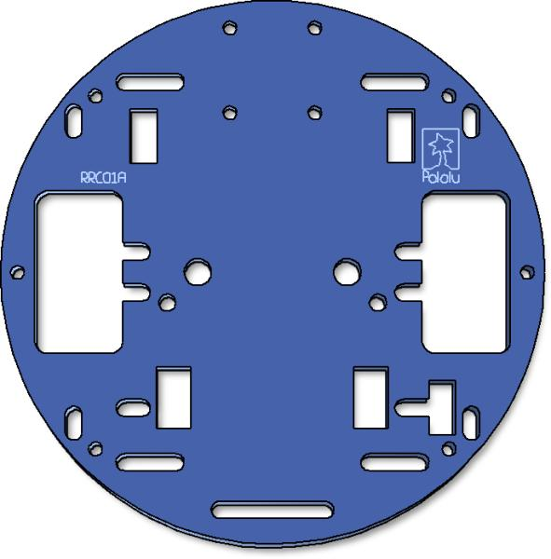

Fortunately, the company also sells the gearboxes with the correct sized tires to fit this chasis perfectly, saving additional time. These tires and gearboxes were mounted, as well as a ball-caster.

Actuation

Robot movement is done by a twin-motor gearbox, which consists of two separate drivetrains for each motor, thus each motor is independent allowing the robot to turn in place, etc. The motors are rated for 3 VDC, but can typically be operated at up to 6 VDC.

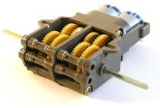
To control the motors, a Texas Instruments™ SN754410NE dual H-bridge was used, opto-iso-connected to timer 0’s PWM port, timer 2’s PWM port, and two general purpose I/O pins (for direction selection).

Sensors

The following sensors were be used:

Sensor | Company/Model | Location | Purpose
IR Proximity | Sharp GP2D12 | Front | Obstacle/Wall Detection
Bump Switches | Various | Surrounding | Avoid damaging collision
Sonar TX/RX | Generic | 3 Locations | Positioning

IR Proximity

The Sharp GP2D12 was the sensor was choice because of its cost and performance. It is connected to one of the ADC pins to monitor distances of objects ahead. The code that interfaces this in the Appendix. These served the purpose quite well, and were able to detect objects easily from about a few feet away.

Bump Switches

The bump switches serve as an added obstacle detection, if the IR proximity sensor fails to detect some objects. There are four mini lever-type switches that were found at a surplus store, each connected (using pull-up resistors) to two of the port pins on the microcontroller. When either of these pins goes low, an interrupt is triggered to respond in an appropriate manner (in this case, move backwards and turn left) for now.

Ultrasonic Sonar

The following diagram shows the location of the sonar sensors, and grid-mapping technique:

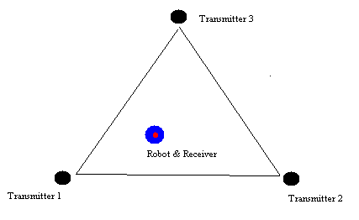
The transmitters are arbitrarily placed in a equilateral triangle, with side length of 10 feet (for now). The robot will determine the distance away from each transmitter to calculate its current coordinate. Pulses by each transmitter will triggered at fixed intervals of 0.5s, with a period of 4s, as shown below. However, 4 seconds was not practical for updating coordinate, so instead, this was changed to 2 seconds.

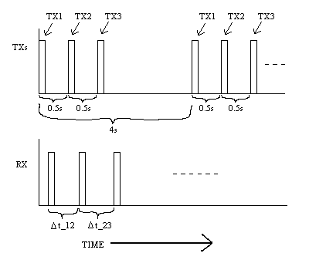
The receiver (robot) determines the time difference between each of the pulses to compute coordinate. The exact equations can be found in the Appendix.

The transmitters are generic (non-brand Taiwan manufactured) ultrasonic transducers with a frequency of 40kHz and a bandwidth of 1kHz. The pulse generation of these transducers are done by an Atmel™ AT90S2313—where a PWM port was used for 40 kHz signal generation. A tri-state driver/buffer was used to control when each transducer would receiver the 40 kHz pulse. This timing was done by the AT90S2313, and pulsed quite precisely. The driver was connected to the common ground, and powered by a 9V battery. The AT90S2313 was powered via a simple 5V regulator connected to the 9V battery. The code for the transmitting sonar pulse generation is located in the Appedix.

The hardware schematic for interfacing the receiving sonar was borrowed from the MIL/IMDL website, and worked very well. The schematic is shown below:

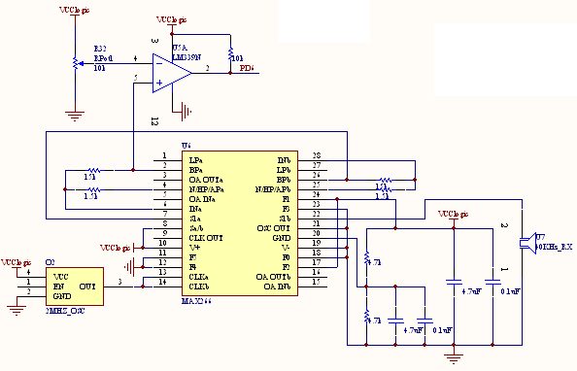
The output of this system is pin 2 of the LM339N comparator. This signal was fed directly to the input capture pin of the microcontroller.

Behaviors

The robot should behave like the following:

- Move straight for a random amount of time or until an obstacle/object is detected. While doing this, the robot is calculating position via sonar, and displaying it’s coordinate to the user.
- After a certain interval if no object is detected, turn a random direction, and go back to the previous step until an object is detected.
- When an object is found, save the robot’s current coordinate in a specified memory location for obstacles, and move appropriately to avoid this obstacle.

The code for this is located in within the main code in the Appendix.

Experimental Layout and Results

The main experimentation and measurements that are needed in this robot are the range and directivity between the transmitting sonars and the receivers. In preliminary tests, the transmitters had a directivity of approximately 45 degrees and a range of about 10 feet, taking into consideration the receiver. The receiver consists of the MAX266 set to bandpass filter 40 kHz, with the output of that connected to a comparator to create a logic level detectable by the input capture unit on the microcontroller. The following were taken from the transducers datasheets.

Receiving Unit
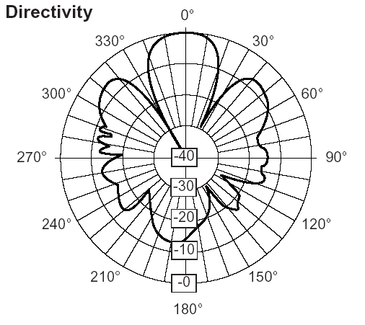

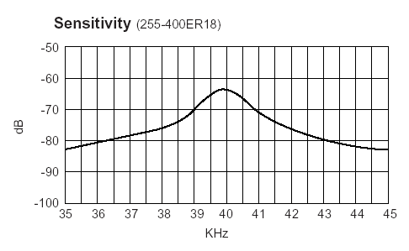
Transmitting Unit

Directivity
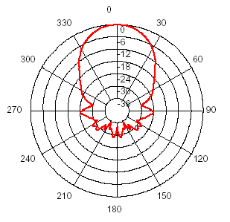

Sensitivity
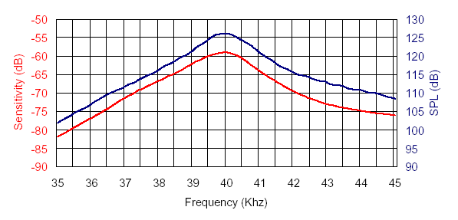

Conclusion

During demoing the robot was not able to determine coordinate information precisely and not as reliably as expected. However, it was later determined that the position and direction of the transducers matter a lot. After putting the transmitting transducers a few feet above the surface of the robot, the system performed much better. Aside from this, the robot was able to store coordinates of detected objects in its internal memory for extraction by the user later on.

Documentation

Parts

Digikey: http://www.digikey.com
Acroname: http://www.acroname.com
Pololu: http://www.pololu.com

Information

MIL website: http://mil.ufl.edu,
(Sonar Receiving circuit: http://www.mil.ufl.edu/imdl/handouts/msonar.pdf )

Appendices

Schematic for Navi-Gator’s PCB

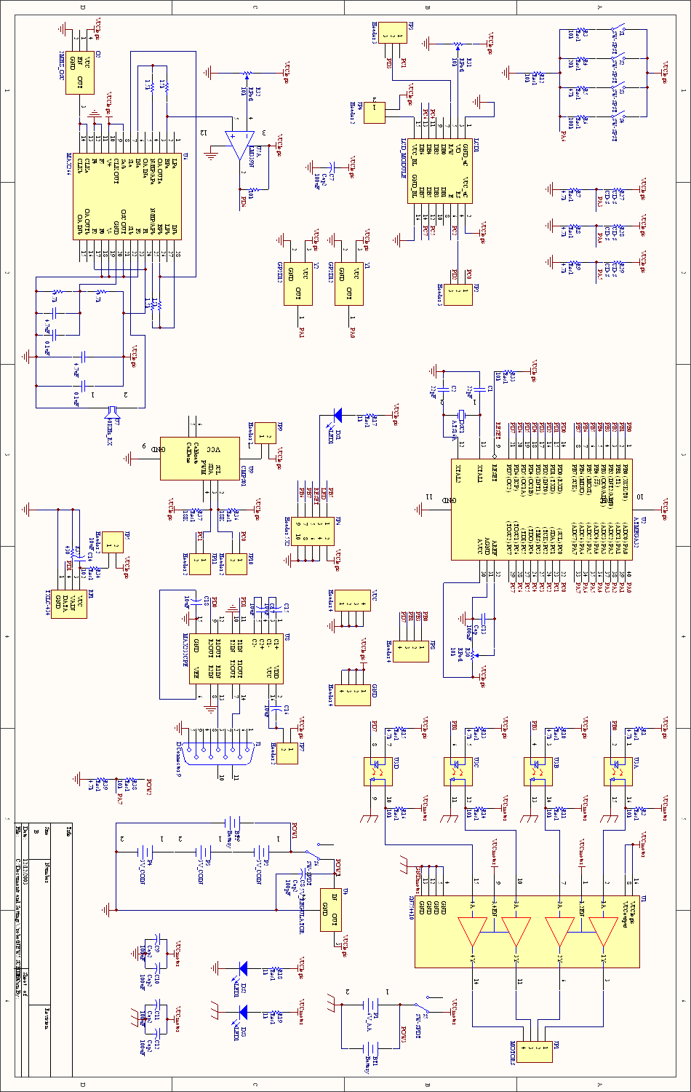
PCB Layout of Robot (everything inclusive)

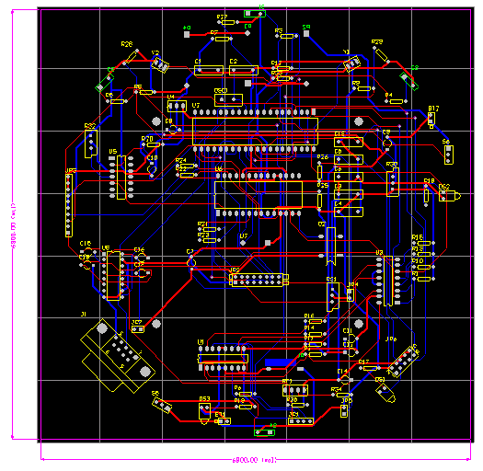
Mathcad Script for Determination and Testing of Positioning Formulas

The following shows formulas for calculation, and tests a data point to see if it comes up with the correct coordinate. The interactive script was tested for several points, and it came out exactly—this just shows one test point being tested.

f / s at 25 degrees Celsius

What the robot knows
1. Coordinates of ALL 3 transmitters
2. The delay between each transmitters pulse sent
3. Time differences between each of the detected pulses

Calculation of Position
1. Calculate differential distances
2. Calculate Position

Mathcad Formulas Optimized for Better Precision Using ‘long’ Rather than Floating Point (implemented in robot)

Code for Transmitting Pulse generation (external to robot on AT90S2313)

#include <90s2313.h>
#include <delay.h>

// Timer 1 output compare interrupt service routine
interrupt [TIM1_COMP] void timer1_comp_isr(void)
{
OCR1=OCR1+50;
// Place your code here

}

// Declare your global variables here

void trans123() // Pulsing routin
{
while (1)
{
#asm("sbi 0x18, 0x00") // PORTB0=1
delay_ms(100); // Pulse positive width=100 ms
#asm("cbi 0x18, 0x00") // PORTB0=0

delay_ms(400); // Pulse period = 100 + 400 = 500

#asm("sbi 0x18, 0x01") // PORTB1=1
delay_ms(100); // Pulse positive width=100 ms
#asm("cbi 0x18, 0x01") // PORTB1=0

delay_ms(400); // Pulse period = 100 + 400 = 500

#asm("sbi 0x18, 0x02") // PORTB2=1
delay_ms(100); // Pulse positive width=100 ms
#asm("cbi 0x18, 0x02") // PORTB2=0

delay_ms(900); // Pulse period = 100 + 400 = 500
}
}

void trans111() // Debugging, testing routines
{
while (1)
{
#asm("sbi 0x18, 0x01") // PORTB1=1
delay_ms(100); // Pulse positive width=100 ms
#asm("cbi 0x18, 0x01") // PORTB1=0

delay_ms(400); // Pulse period = 100 + 400 = 500

#asm("sbi 0x18, 0x01") // PORTB1=1
delay_ms(100); // Pulse positive width=100 ms
#asm("cbi 0x18, 0x01") // PORTB1=0

delay_ms(400); // Pulse period = 100 + 400 = 500

#asm("sbi 0x18, 0x01") // PORTB1=1
delay_ms(100); // Pulse positive width=100 ms
#asm("cbi 0x18, 0x01") // PORTB1=0

delay_ms(900); // Pulse period = 100 + 400 = 500
}
}

void trans1() // Debugging, testing routines
{
while (1)
{
#asm("sbi 0x18, 0x01") // PORTB1=1
delay_ms(100); // Pulse positive width=100 ms
#asm("cbi 0x18, 0x01") // PORTB1=0

delay_ms(400); // Pulse period = 100 + 400 = 500
}
}

void main(void)
{
// Declare your local variables here

// Input/Output Ports initialization
// Port B initialization
// Func0=Out Func1=Out Func2=Out Func3=Out Func4=In Func5=In Func6=In Func7=In
// State0=0 State1=0 State2=0 State3=0 State4=T State5=T State6=T State7=T
PORTB=0x00;
DDRB=0x0F;

// Port D initialization
// Func0=In Func1=In Func2=In Func3=In Func4=In Func5=In Func6=In
// State0=T State1=T State2=T State3=T State4=T State5=T State6=T
PORTD=0x00;
DDRD=0x00;

// Timer/Counter 0 initialization
// Clock source: System Clock
// Clock value: Timer 0 Stopped
TCCR0=0x00;
TCNT0=0x00;

// Timer/Counter 1 initialization
// Clock source: System Clock
// Clock value: 4000.000 kHz
// Mode: Normal top=FFFFh
// OC1 output: Toggle
// Noise Canceler: Off
// Input Capture on Falling Edge
TCCR1A=0x40;
TCCR1B=0x09;
TCNT1H=0x00;
TCNT1L=0x00;
OCR1H=0x00;
OCR1L=49;

// External Interrupt(s) initialization
// INT0: Off
// INT1: Off
GIMSK=0x00;
MCUCR=0x00;

// Timer(s)/Counter(s) Interrupt(s) initialization
TIMSK=0x00;

// Analog Comparator initialization
// Analog Comparator: Off
// Analog Comparator Input Capture by Timer/Counter 1: Off
// Analog Comparator Output: Off
ACSR=0x80;

// Global enable interrupts
#asm("sei")

while (1)
{
trans123(); // Start pulsing
};
}

Code for robot’s behaviors

#include <mega16.h>

// Alphanumeric LCD Module functions
#asm
.equ __lcd_port=0x15
#endasm
#include <lcd.h>
#include <delay.h>
#include <stdlib.h>
#include <math.h>

#define ADC_VREF_TYPE 0x00
// Read the AD conversion result
unsigned int read_adc(unsigned char adc_input)
{
ADMUX=adc_input|ADC_VREF_TYPE;
// Start the AD conversion
ADCSRA|=0x40;
// Wait for the AD conversion to complete
while ((ADCSRA & 0x10)==0);
ADCSRA|=0x10;
return ADCW;
}

const unsigned int normalspeed=50;
const unsigned int irnear=300;
const unsigned int turntime=2000;
const unsigned int reversetime=2000;
const signed long tx_delay=31297, clock_speed=62500, sound_speed=11400;

unsigned char ovcounter; // counter for timer overflow
unsigned long sens1, sens2, cycles_12, cycles_23; // sens1=time when TX1 pulsed, and sens2=TX2, cycles12,23 are pulse differences
signed long xpos, ypos, tempv1, tempv2, b2,b3,c2,c3; // Coordinate and temporary variables
unsigned long pulse_clocks;
signed long bbv, ccv; // temp vars
char mystr[12];
char transn; // Can be 1, 2, 3.. Indicates transducer it is currently looking for.
unsigned int vals12[40]; // Array for storage of detected objects, x
unsigned int vals23[40]; // y coord Array
char i12; // Iterator for arrays

signed long bb(signed long cycles12) // Temporary variable/function for positioning calculation
{
return (( cycles12 - tx_delay )*sound_speed/clock_speed );
}

signed long cc(signed long cycles12, signed long cycles23) // Temporary variable/function for positioning calculation
{
return (cycles23 + cycles12 - 2*tx_delay)*sound_speed/clock_speed;
}

signed int ipow(signed int base, unsigned int exp) // Outputs base^exp
{
if (exp==1) return base;
if (exp==0) return 1;
return (base*ipow(base,exp-1));
}

signed long lpow(signed long base, unsigned int exp) // Outputs base^exp
{
if (exp==1) return base;
if (exp==0) return 1;
return (base*lpow(base,exp-1));
}

signed long temp1(signed long b, signed long c) // Temporary variable/function for positioning calculation
{
return (signed long)lsqrt((unsigned long) ((-1*(b-100)*(b+100)*(b-c+100)*(b-c-100)/1000000)*(c-100)*(c+100)) );
}

signed long temp2(signed long b, signed long c) // Temporary variable/function for positioning calculation
{
return ( 2*(b2-b*c+c2-7500)/5 );
}

signed long xcoord(signed long b, signed long c) //Calculates coordinate
{
return ( ( (1732*tempv1*c + 2*b3*c2 - 3*b2*c2 + b*c3)/1000 + 20*b2 - 30*b*c + 25*c2 - 150000 )/tempv2 );
}

/*
signed long xcoord(signed long b, signed c)
{
return ( ( 1732*tempv1*c + 2*b3*c2 - 3*b2*c2 + b*c3 + 20000*b2 - 30000*b*c + 25000*c2 - 150000000 )/(1000*tempv2) );
}
*/

signed long ycoord(signed long b, signed long c) // Y coordinate
{
return ( ( 20*tempv1*b - 10*tempv1*c - 865000 + 173*b2 - 173*b*c + (173*b*c3 - 173*b2*c2 + 865000*c2)/10000 ) / (10*tempv2) );
}

void initcal() // Sets up temporary variables for calculation
{
bbv=bb(cycles_12);
ccv=cc(cycles_12,cycles_23);

b2=lpow(bbv,2);
b3=lpow(bbv,3);
c2=lpow(ccv,2);
c3=lpow(ccv,3);

tempv1=temp1(bbv,ccv);
tempv2=temp2(bbv,ccv);
}

void display(char flash *str)
{
lcd_clear();
lcd_putsf(str);
delay_ms(20);
}

void displayxy(unsigned char x, unsigned char y, char flash *str)
{
lcd_gotoxy(x,y);
lcd_putsf(str);
delay_ms(20);
}

void displayxys(unsigned char x, unsigned char y, char *str)
{
lcd_gotoxy(x,y);
lcd_puts(str);
delay_ms(20);
}

void displays(char *str)
{
lcd_clear();
lcd_puts(str);
delay_ms(20);
}

void calcoord() // Main function which calls other functions to calc coord.
{
initcal();
xpos=xcoord(bbv,ccv);

ltoa(xpos,mystr);
displayxys(0,0,mystr);

ypos=ycoord(bbv,ccv);

ltoa(ypos,mystr);
displayxys(0,1,mystr);

//ypos
}

// Timer 1 overflow interrupt service routine
interrupt [TIM1_OVF] void timer1_ovf_isr(void)
{
ovcounter++;
}

// Timer 1 input capture interrupt service routine
interrupt [TIM1_CAPT] void timer1_capt_isr(void) // ISR for detecting pulses from TX.
{ #asm("cli")
sens2=(unsigned long)ICR1L + (unsigned long)ICR1H * 0x100;
pulse_clocks=(unsigned long)sens2 - (unsigned long)sens1 + ((unsigned long)ovcounter) * 0x10000;
if ((pulse_clocks > 22000)) //Used to be 5500
{ // Valid Pulse

if (pulse_clocks > 100000) // used to be 25000
{
displayxy(7,1,"L");
}
else
{
displayxy(7,1," ");

if (pulse_clocks > 40000) //This block determines which transducer to look for next. //Used to be 10k
{
transn=2; // Found trans 1, now next time look for 2

}
else
{

if (transn==2) // Found trans 2, save difference
{
cycles_12=pulse_clocks;
transn=3;
// ltoa(cycles_12,mystr);
// displayxys(0,0,mystr);

}
else
{
if (transn==3) // Found trans 3, save difference and display coordinate
{
cycles_23=pulse_clocks;
transn=1;
// ltoa(cycles_23,mystr);
// displayxys(0,1,mystr);
calcoord();

}
}
}
}

sens1=sens2;
ovcounter=0;

delay_ms(150);
}
#asm("sei")
}

unsigned int randdir() // Random direction generator
{
return (((rand()%10)/5));
}

//Direction 0 is forward, 1 is backwards.. Input speed from 0-255
void leftmotor(unsigned int direction, unsigned int speed)
{
speed=speed+speed/4;

if (direction==0)
{
PORTB=PORTB | 0x01; //Turn PB0 on (specifies polarity of motor...
speed=255-speed; // Adjust for reverse speed (polarity reversal of PB0)
}
else
PORTB=PORTB & 0x02; //Turn PB0 off (and leave PB1 alone);

OCR0=speed;
}

void rightmotor(unsigned int direction, unsigned int speed)
{
speed=speed;

if (direction==1)
{
PORTB=PORTB | 0x02; //Turn PB1 on (specifies polarity of motor...
speed=255-speed; // Adjust for reverse speed (polarity reversal of PB1)
}
else
PORTB=PORTB & 0x01; //Turn PB1 off (and leave PB0 alone);

OCR2=speed;
}

unsigned int rightIR() // Outputs reading of right IR
{
return read_adc(0);
}

unsigned int leftIR()
{
return read_adc(1);
}

// The following functions do the specified task for a length of t milliseconds

void stopt(unsigned int t)
{
rightmotor(0,0);
leftmotor(0,0);
delay_ms(t);
}

void turnleftt(unsigned int t)
{
rightmotor(0,normalspeed/2);
leftmotor(1,normalspeed/2);
delay_ms(t);
stopt(5);
}

void turnrightt(unsigned int t)
{
rightmotor(1,normalspeed/2);
leftmotor(0,normalspeed/2);
delay_ms(t);
stopt(5);
}

void forwardt(unsigned int t)
{
rightmotor(0,normalspeed);
leftmotor(0,normalspeed);
delay_ms(t);
stopt(5);
}

void reverset(unsigned int t)
{
rightmotor(1,normalspeed);
leftmotor(1,normalspeed);
delay_ms(t);
stopt(5);
}

// These do the specified movements continuously until stop() is issued

void stop()
{
rightmotor(0,0);
leftmotor(0,0);
}

void turnleft()
{
rightmotor(0,normalspeed/2);
leftmotor(1,normalspeed/2);
}

void turnright()
{
rightmotor(1,normalspeed/2);
leftmotor(0,normalspeed/2);
}

void forward()
{
rightmotor(0,normalspeed);
leftmotor(0,normalspeed);
}

void reverse()
{
rightmotor(1,normalspeed);
leftmotor(1,normalspeed);
}

unsigned int rnear()
{
if (rightIR()>irnear)
return 1;
else
return 0;
}

unsigned int lnear()
{
if (leftIR()>irnear)
return 1;
else
return 0;
}

void avoid() // Main obstacle avoidance/detection function
{
displayxy(7,0,"F");
forward();

while((rnear()==0) && (lnear()==0))
{
delay_ms(100); //Arbit. 100ms delay
};

displayxy(7,0,"O");

i12=i12%10;
vals12[i12]=cycles_12;
vals23[i12++]=cycles_23;

delay_ms(100);
reverset(reversetime/2); //reverse for 1s if both indicate an object

delay_ms(1000);

delay_ms(3000);

reverset(reversetime/2);

if (rnear()==1 && lnear()==1)
{
if (randdir()==0)
{
turnrightt(turntime);
}
else
{
turnleftt(turntime);
}
}
else
if (rnear()==1)
{
// displayxy(5,0,"OBJ");
turnleftt(turntime);
}
else
{
// displayxy(5,0,"OBJ");
turnrightt(turntime);
}

}

// Declare your global variables here

void main(void)
{
// Declare your local variables here

// Input/Output Ports initialization
// Port A initialization
// Func0=In Func1=In Func2=In Func3=In Func4=In Func5=In Func6=In Func7=In
// State0=T State1=T State2=T State3=T State4=T State5=T State6=T State7=T
PORTA=0x00;
DDRA=0x00;

// Port B initialization
// Func0=Out Func1=Out Func2=In Func3=Out Func4=In Func5=In Func6=In Func7=In
// State0=0 State1=0 State2=T State3=0 State4=T State5=T State6=T State7=T
PORTB=0x00;
DDRB=0x0B;

// Port C initialization
// Func0=In Func1=In Func2=In Func3=In Func4=In Func5=In Func6=In Func7=In
// State0=T State1=T State2=T State3=T State4=T State5=T State6=T State7=T
PORTC=0x00;
DDRC=0x00;

// Port D initialization
// Func0=In Func1=In Func2=In Func3=In Func4=In Func5=In Func6=In Func7=Out
// State0=T State1=T State2=T State3=T State4=T State5=T State6=T State7=0
PORTD=0x00;
DDRD=0x80;

// Timer/Counter 0 initialization
// Clock source: System Clock
// Clock value: 15.625 kHz
// Mode: Fast PWM top=FFh
// OC0 output: Non-Inverted PWM
TCCR0=0x6D;
TCNT0=0x00;
OCR0=0x00;

// Timer/Counter 1 initialization
// Clock source: System Clock
// Clock value: 16000.000 kHz
// Mode: Normal top=FFFFh
// OC1A output: Discon.
// OC1B output: Discon.
// Noise Canceler: On
// Input Capture on Rising Edge
TCCR1A=0x00;
TCCR1B=0xC4; //bit 7 is noise cancellor bit (on=enable)
//bit 2..0: 101: prescal=1024, 001: prescal=1 (page 111), 100=256
TCNT1H=0x00;
TCNT1L=0x00;
OCR1AH=0x00;
OCR1AL=0x00;
OCR1BH=0x00;
OCR1BL=0x00;

// Timer/Counter 2 initialization
// Clock source: System Clock
// Clock value: 15.625 kHz
// Mode: Fast PWM top=FFh
// OC2 output: Non-Inverted PWM
TCCR2=0x6F;
ASSR=0x00;
TCNT2=0x00;
OCR2=0x00;

// External Interrupt(s) initialization
// INT0: Off
// INT1: Off
// INT2: Off
GICR=0x00;
MCUCR=0x00;
MCUCSR=0x00;

// Timer(s)/Counter(s) Interrupt(s) initialization
TIMSK=0x24;

// Analog Comparator initialization
// Analog Comparator: Off
// Analog Comparator Input Capture by Timer/Counter 1: Off
// Analog Comparator Output: Off
ACSR=0x80;
SFIOR=0x00;

// ADC initialization
// ADC Clock frequency: 8000.000 kHz
// ADC Voltage Reference: AREF pin
// ADC High Speed Mode: Off
// ADC Auto Trigger Source: None
ADMUX=ADC_VREF_TYPE;
ADCSRA=0x81;
SFIOR=0x00;

// LCD module initialization
lcd_init(8);

srand(19);

//stopt(4000); //Pause for 4 seconds for user to get away

display("GO!");
delay_ms(2000);

transn=1; // Set guess to transmitter 1

i12=0;

#asm("sei") // Setup all interrupts

while (1)
{
avoid(); // Run obstacle avoidance, rest is done by interrupts

};
}

