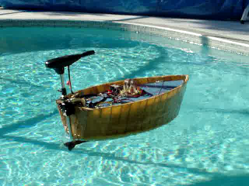

‘Fishin’-μChips’ Design Report

Andrew P. Lilly

Intelligent Machine Design Lab

EEL 5666

NSF - REU

Dr. A. Antonio Arroyo

Summer & Fall 2003

Machine Intelligence Lab

University of Florida

Gainesville, FL U.S.A.

12/09/03

Table of Contents

Title Page…………………………………………………………………. 1

Table of Contents………………………………………………………… 2

Abstract……………………………………………………………………. 3

Executive Summary………………………………………………........... 4

Introduction……………………………………………………………….. 5

Integrated System………………………………………………………... 5

Micro-Controller System………………………………………………… 6

Power System……………………………………………………………. 7

Platform…………………………………………………………………… 8

Actuation………………………………………………………….………. 9

Sensors……………….…………………………………………….......... 10

Behaviors…………………………………………………………............ 12

Testing…………………………………………………………………….. 12

Conclusion………………………………………………………………… 13

Documentation…………………………………………………………… 14

Appendices……………………………………………………………….. 15

Abstract

Fishin’-μChips is a partially autonomous boat robot that operates in salt and fresh water environments. The device propels itself across the water surface using a battery operated trolling motor and steers by rotating the trolling motor using a ¼ scale airplane servo. The robot has two modes of operation: radio-controlled mode and autonomous mode. When operating in radio-controlled mode, the robot acts as a radio controlled boat. When operating in full-autonomous mode, the boat meanders randomly across the water, while detecting and avoiding obstacles via sonar range finders. In its final implementation, this robot is intended to catch small fish and return them to a pre-defined location. The following paper discusses the specifics of this aquatic autonomous robot:

Executive Summary

Fishin’-μChips is a 4 feet long, 2 feet wide, 1.5 feet high, partially autonomous boat robot that operates in salt and fresh water environments. Its scale and design make it suited for lake and coastal water operation. The device consists of a displacement type, non-planing, fiberglass-over-foam hull, an electric trolling motor, a steering servo, two batteries, a motor driver, a sensor array, a communication system, and a micro-controller. Fishin’ Chips has two modes of operation: radio control mode and full-autonomous mode. When operating in radio-control mode, the robot acts as a radio-controlled boat. When operating in full-autonomous mode, the boat meanders randomly across the water, while detecting and avoiding obstacles via sonar range finders.

Introduction

Having been frustrated by the task of having to catch small bait fish, I decided to build an autonomous robot to catch small fish for me. In May of 2003, I began work on the design of the robot that was to become Fishin’ μChips. Details of this work are included in this report.

Integrated System

Fishin’ μChips can be best described as a series of sub-systems whose union determines the overall characteristics and behavior of the robot. These sub-systems are as follows: the micro-controller system, the power system, the platform, the drive system, the sensor array, the location system, the base station/user interface system, and the fish catching and storage system. In the current design realization, the location system is only partially implemented and the fish catching and storage system has been omitted.

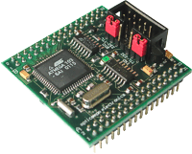
Micro-Controller System

The fish-gator is controlled by the letATwork II evaluation board, which utilizes an Atmel ATMega128 microcontroller. The controller was selected for its extensive register assets, its analog to digital interface potential, it ease of programming, and for the experience of learning to program a non-Motorola μcontroller. The code for the letATwork II board was developed in WinAVR using Programmers Notepad and Pony Prog 2000, licensed under the GNU open source license agreement.

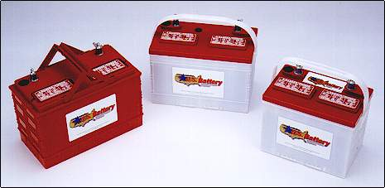

Power System

The power system is composed two batteries. The system provides on board power to the micro-controller system, the drive system, the sensor array, the communication/location system, the fish catching system, and the fish storage system. The power supply can power the system for 12 hours, and recharge fully within 12 hours, enabling ½ duty cycle continuous operation.

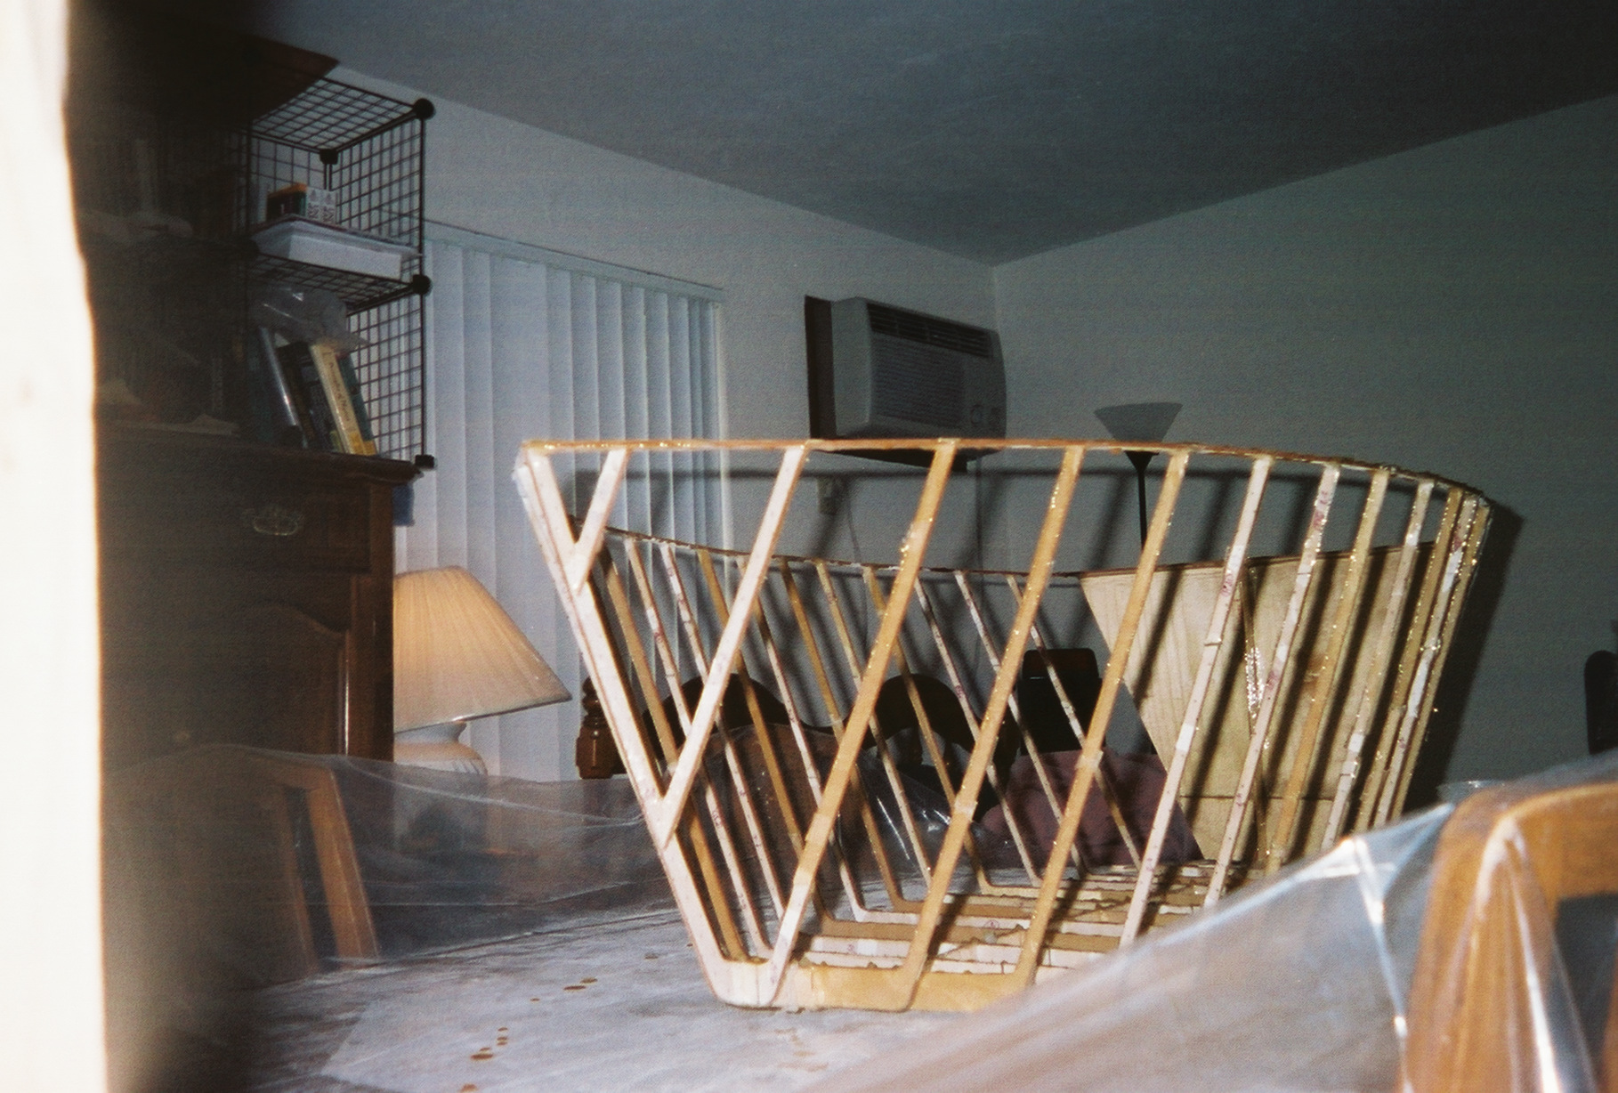
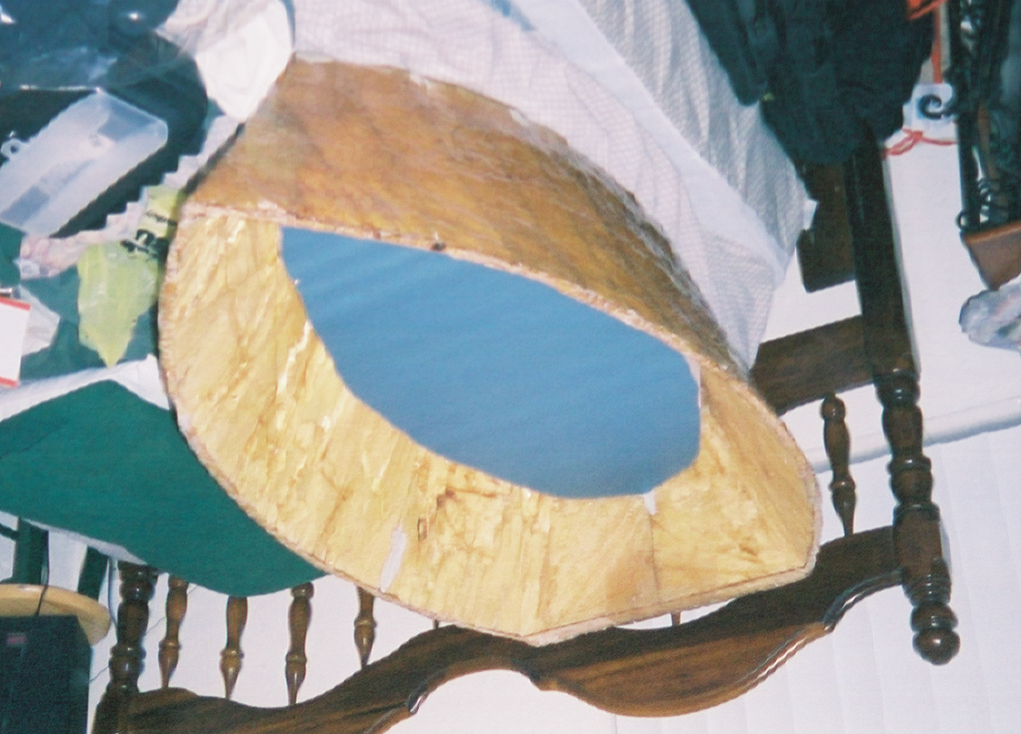
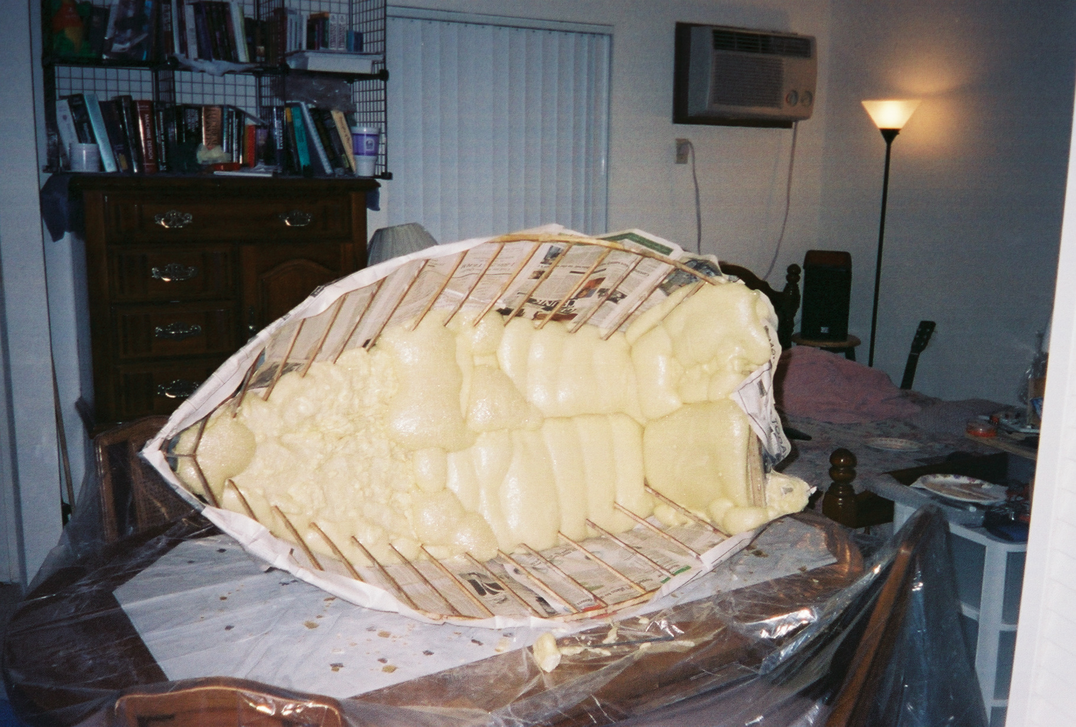
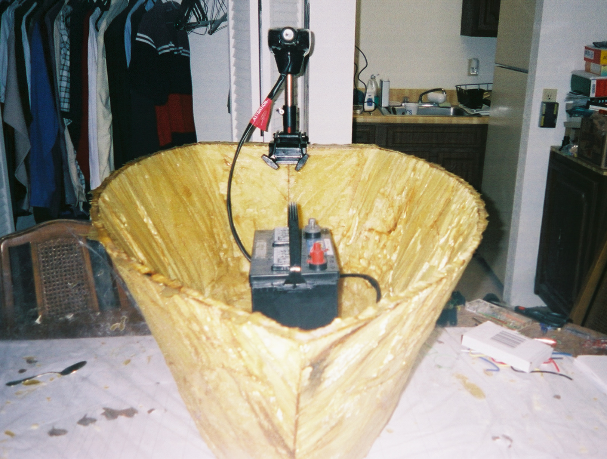

Platform

The platform maintains the integrity of the robot in either fresh or salt water environments. It provides adequate and relatively stable buoyancy. The prototype of the platform is of similar shape to a 2-person fishing boat and is constructed using foam, thin plywood, and fiberglass. Design and prototype of the platform was performed primarily within AutoCAD.

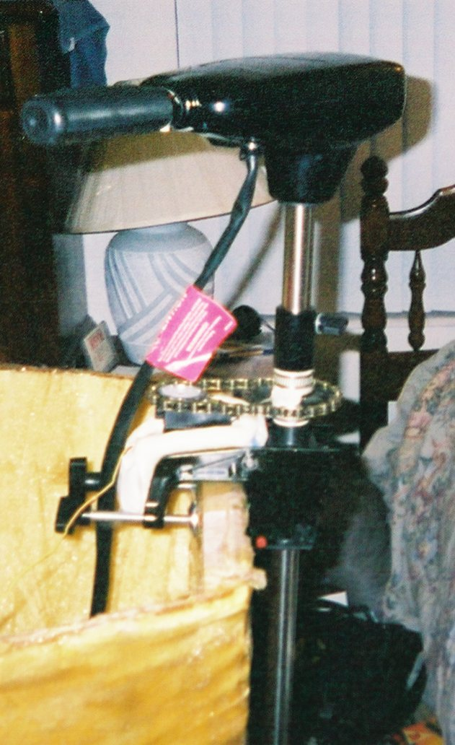

Actuation

The drive system effectively transports the robot from one desired location to another. It is able to both propel and steer the platform while avoiding interference with most water-dwelling plant and animal life. Further, it adequately responds to commands from the micro-controller. Basic specifications are: a reversible motor and servo-to-chain driven vectored thrust rudder system. For the motor drive system, I chose a 35-pound-thrust trolling motor from Motor Guide™. For the servo, I chose a ¼ -scale-aircraft type, 6 volt, PWM controlled, RC servo. The chain assembly comprises a bicycle chain and two bicycle sprocket gears from a local bike shop, as shown in the above figure. This chain provides a 2:1 gearing ratio from the servo to the rotational axis of the motor, at a cost of reducing the effective rotational travel of the motor by ½. With the gearing of the servo, twice the torque generated by the servo itself is delivered to the axis of the motor to cause it to turn. The price paid, though, is that as the servo swings its full movement of 180º, ±90º from center, the motor only swings 90º, or ±45º from center. This ‘restricted’ motor rotation, however, does not adversely affect the maneuverability of the robot.
Sensors

The sensor array is here defined as: all the devices that provide inputs to the micro-controller that are then used to determine outputs from the microcontroller to the rest of the fish-gator device. Surface Object avoidance sensors will include 3-6 sonar range finders along with a host of bump sensors along the edges of the fiberglass hull. Bottom Object avoidance will consist of at least one immersible sonar depth finder
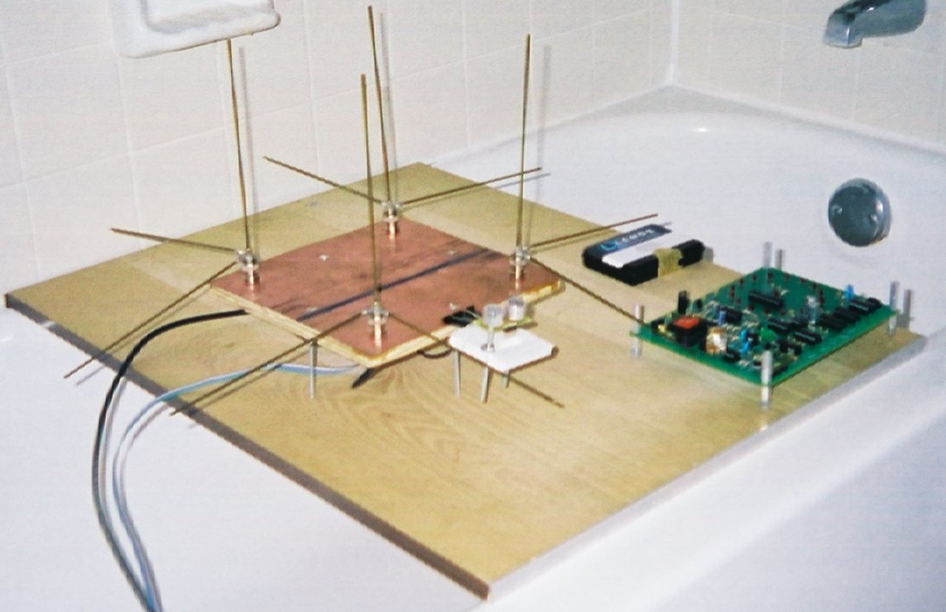

Communication/Location Sensor Sub-System

The location system of the fish-gator device is to interface with the base station system via the communication system to provide the micro-controller its location with respect to the base station. This location information would then be used to allow the fish-gator to both depart and return to the base station at the discretion of the micro-controller program or the user, via the communication system. For Fishin’ Chips, the location sensor system uses a pseudo-Doppler radio direction finding array as shown above.
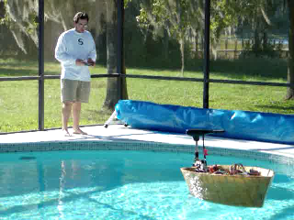

Base Station/User Interface Sensor Sub-System

The base station system provides a radio signal to the fish-gator communication/location system, allowing it to establish its location with respect to the base station. The user interface system allows the user of the device with a means of high-level control of the device and a way of locating the device if it becomes lost or incapacitated.

Behaviors

As described in the background, I want to implement three primary behaviors: motion with obstacle avoidance, fish catching, and fish storage. The motion behavior was described in the drive system. The other two behaviors are described below.

Fish Catching Behavioral Sub-System

The fish catching system is as of yet not implemented, but will be used to efficiently find and catch bait fish and deliver them to the fish storage system. Potential design solutions for the catching system include a hook and line system or a trap system. Catch detection or trap detection might be achieved by sonar proximity sensors, bump sensors, or resistive strain sensors. Additional desired goals of the catching system would be its reusability without re-baiting and its ability to resolve catching a fish that is too large for the system to process.

Fish Storage Behavioral Sub-System

The fish storage system, also not yet implemented, is to securely maintain live fish once they are caught. The device should allow the fish catching system to easily and safely remove caught fish from the catching device

Testing

Although full implementation of this device is not complete, the design of the device is modular with iterative debugging periods such that working revisions of the device are presented as it progresses through the implementation cycle. The series of pictures included in this report correspond to pool tests of Fishin’ μChips conducted over the Summer 2003 and Fall 2003 semesters.

Conclusion

This was a very ambitious system for a summer research project. Approximately seven months into the design life-cycle, I am now coming to grips with the challenges that I will face as I further develop the prototype to include more interesting behaviors. In early summer 2003, I deemed the potential and practicality for the implementation of this device to warrant further investigation and consequent prototype. To this end, I dedicated the entire summer, and a significant part of the fall 2003 semester to develop the system as far as basic seaworthiness, radio-control, and simple obstacle avoidance. Reliability problems do exist which I attribute to my use of pin-board components, and I hope to quickly resolve these problems by constructing printed circuit boards before further work is undertaken.

It is a somewhat hilarious proposition to state: “Hello everyone, this is my boat. It doesn’t sink. It moves around and doesn’t hit anything… usually, and aside from that it doesn’t do much else.” But that is, essentially where I am at right now in the development of Fishin’-μChips. The next stage of implementation, slated for summer 2004, will be to further improve obstacle avoidance by connecting a few more sonar range finders, a digital compass, and possibly an underwater sonar sensor. With these components, the boat will have better means of obtaining accurate ‘situational awareness’ within its environment. Also included in the next stage of implementation will be the final implementation of the special sensor, the Doppler Radio Direction Finder. Debugging of the second revision of this sensor had to be put on hold at the end of this semester in an attempt to complete other subsystems for demo. Additionally, I want to develop a cart of some sort to ease the difficulty of transporting the bulk of the boat from location to location.

As the implied purpose of the research experience was to develop non-trivial applications of intelligent automated control, this device clearly satisfied the bounds of acceptability for MIL NSF REU and was thus prototyped during the summer and fall of 2003 by Andrew Lilly.

Documentation

Parts List
Fiberglass Hull Materials:
Two Part Marine Fiberglassing Foam
Polyester Hand-Lay-up Resin
Chopped Strand Matt and Woven Roving Fiberglass
T-Tech Plywood Framing

LetATWork II Microcontroller

(3) SRF08 Devantech Sonar Range Finders

Hobbico Command, CS-72, ¼ Scale BB Servo

Motor Guide 35 lb_{f} electric trolling motor

US Battery 120 AH Deep Cycle 12V Lead Acid Marine Battery

Panasonic 7AH 12V Rechargeable Sealed Lead Acid Battery

2*16 Monochrome LCD Display

“Radio Direction Finding Simplified” (book) based ‘Roanoke Doppler’:
‘Ed Greany’ Doppler Circuit Board Radio Direction Finder

Bicycle Sprockets of gear tooth ratio 2:1 and Bicycle Chain

General Purpose Epoxy

‘Lemos International’ TXM and SILRX FM transmitter and receiver pair
Appendices

PDF Datasheets (in electronic format)

Atmega128complete.pdf
Complete guide to the Atmega 128 microprocessor

Atmega128summary.pdf
Summary overview of the Atmega 128 microprocessor

HD44780u.pdf
Datasheet for Hitachi 44780 type LCD displays

Txm.pdf
Datasheet for the Radiometrix 433F FM radio transmitter

Silrx.pdf
Datasheet for the Radiometrix 433F FM radio receiver

