PUFF: The Autonomous Agent
For EEL 5666
Intelligent Machine Design Lab

Steve McKinnon
Instructor: Keith L. Doty
TA: Scott Jantz
FALL 97
Table of Contents

Abstract…………………………………………………………………………. 3
Executive Summary…………………………………………………………….. 4
Introduction……………………………………………………………………… 5
Integrated System………………………………………………………………. 6
Mobile Platform………………………………………………………………… 7
Actuation………………………………………………………………………… 8
Sensors………………………………………………………………………….. 8
IR……………………………………………………………………… 8
Bump………………………………………………………………….. 9
Ultrasonic……………………………………………………………… 9
CDS Photo Resistor…………………………………………………… 13
Behaviors……………………………………………………………………….. 13
Collision Avoidance………………………………………………….. 13
Bump Detection………………………………………………………. 14
Hiding/Searching……………………………………………………… 15
Predator/Prey Detection………………………………………………. 15
Conclusion……………………………………………………………………… 16
Appendix……………………………………………………………………….. 17
Source Code………………………………………………………….. 17
Abstract

This document is a basic summary of a project completed for EEL 5666: Intelligent Machine Design Lab (IMDL). The project required for this course was the design, testing, and implementation of an autonomous agent. This agent must utilize four basic sensors to perform a variety of behaviors. These requirements are left simple and vague, to promote creativity and allow undergraduates like myself to participate in this unique class.
Executive Summary
For the completion of this project an autonomous agent must be designed and implemented. The agent must have four sensors, and one of these sensors must be of the student’s design. Also, the agent must perform at least four different functions.
The project discussed in this document contains one basic robot platform with basic sensor suite. Using this sensor suite the robot will be able to “sense” its environment. However, two algorithms will be used to simulate two different agents. One agent will be a predator who will seek out a prey. On the other hand, there will be a prey who will avoid the predator agent. After both algorithms have been designed and implemented, they will hopefully interact with each other in a similar relationship found in nature.
Introduction
This document contains the information obtained through the design and implementation of the autonomous agent to be developed for IMDL. The scope of this paper is confined to the basic robot platform and the algorithms to be used. The paper discusses the integrated system and the individual sensors used to perceive the agent’s environment. This document also discusses the variety of behaviors that were performed with the basic sensor suite. Finally, the paper closes with a summary of work accomplished and discusses the limitations of the work performed. Future work on this project is also mentioned in the conclusion.
Integrated System
The goal of this project was to design an autonomous agent with a variety of functions and behaviors. Specifically, this agent could simulate predator and prey behaviors depending on the arbitrator process imbed in the machine’s code. Mekatronix’s Talrik Junior was the platform for this robot’s design. A M68HC11 microprocessor is the heart of the TJ. The TJ is also has two types of sensors, and the modified design in this project adds two additional sensors. Using all of these sensors, the microprocessor is able to sense some characteristics about its environment and behavior accordingly. The figure below shows the sensors as inputs to the microprocessor which uses this to perform the associated behaviors.
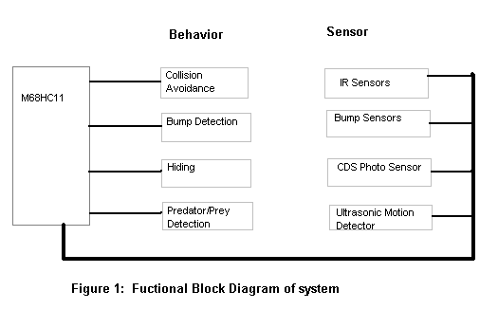

Mobile Platform
The platform used is Mekatronix Talrik Jr shown below in Figure 2. This robot has a very compact design making it agile and very maneuverable. In fact, the wheels are placed in a manner allowing the agent to spin on its center. The TJ has a single chip computer board (Novasoft MSCC11), and a battery supply located beneath its topside. For this project the TJ platform was modified with two additional sensors. The modified TJ platform is shown in Figure 3 below.
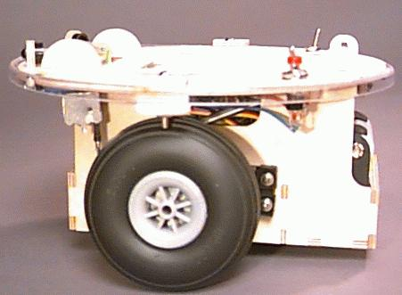 Figure 2b

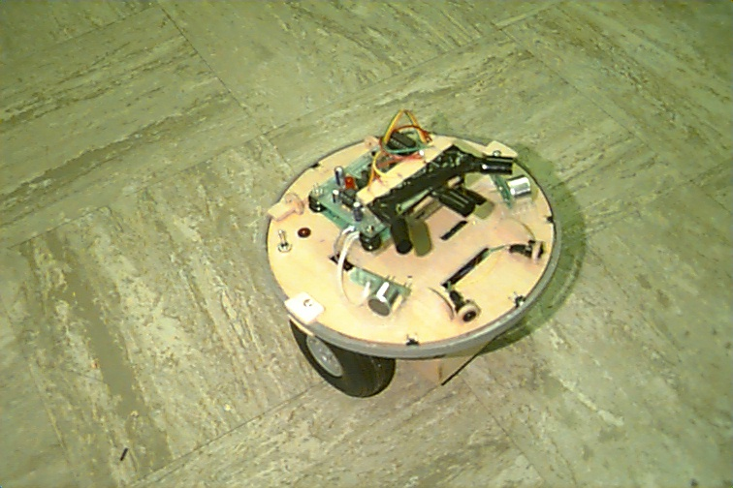
Figure 3: Modified TJ Platform

Actuation
The robot is driven by two independent servo motors. These servos act essentially as DC motors with feedback circuitry. A 50Hz signal is used to drive the servos in a given direction. Depending on the duty cycle of this signal the servos will drive the wheels at a given speed. The servos are the only type of actuation in the system. The software for the motor drivers can be found in the TJ application package from Novasoft.

Sensors
IR Emitters and Detectors:
The TJ also detect infared light, or IR. Two infared IR emitters are used to project 40kHz IR light. Moreover, there are two IR detectors which can detect this projected light. There are one of these detectors mounted on the right side of the robot and another sensor mounted on the left side. In this arrangement, the TJ can detect which direction the light is coming from. Furthermore, the IR detectors (Sharp GP1U58) are modified to give an analog voltage corresponding to the amount of IR received. The nominal value for these IR detectors is 88 (decimal) on the A/D port and the saturation value is about 130. The left sensor and right sensors are connected to the A/D converter on pins PE6 and PE7 respectively. Software to modulated the IR emitters correctly can be found in the TJ applications package from Novasoft.
Using the analog output from the IR detectors the direction and intensity of incoming light can be measured. If the TJ approaches an object at close range the IR from the emitters is reflected off the object and back to the IR detectors. As a result, an object can be detected and avoided through arbitration of the motors. One of the major drawback to this sensor is its occasional problems sensing its environment. For example, if the object is of the dark in color less light will be reflected. It is almost impossible to determine range without complex algorithms. Moreover, the TJ has problems detecting some shapes such as skinny or round due to lack of reflected light. It is important to leave the TJ in a non-complex environment for reliable interaction.

Bump Detectors:
The bump detectors are the simplest sensor located on the TJ. There are three forward facing bump switches and one on the rear. Each sensor is simple a switch that is either closed or open. The forward looking bump switches are all interconnected with a pull down resistor and then connect to the PC5 of the microprocessor. Therefore, if the switch becomes closed at any time the signal becomes high on the input pin.
A bumper is placed around the outside of the TJ over these bumper switches, so that collisions can be detected from other areas besides the switches themselves. It is important to have a properly placed bumper, so that if a collision does occur the bumper returns to its original position after the TJ has separated itself from the object. This sensor has the most priority over the other sensors in this project. If I collision is detected by the switches the TJ immediately backs up before returning to its original function.

Ultrasonic Motion Detector:
This sensor is a modified version of a electronics kit provided from Jameco Electronics. The part number for this motion detector kit is 125090 and can be purchased by calling the vendor at 1-800-831-4242. The kit itself contains a matched pair of ceramic transducers which convert movement to electrical energy and vice versa. Through some modification, the basic functionality inherent to these transducers will be used in a way for one robot to detect the direction and range of another robot. Furthermore, this will allow them the robots to interact in a specific algorithm chosen.

JAMECO'S ULTRASONIC MOVEMENT DETECTOR:
The kit provided by Jameco provides two ultrasonic transducers advertised to detect motion from 4-7m away. A crystal provides an operation frequency of 40kHz to the two transducers. The kit also provides a variety of additional characteristics. First, an LED provides visual evidence that movement has been sensed. Second, there is a PCB-mounted switch which can be used to switch between an automatic reset about 0.3 seconds after the detector has been triggered or to stay latched on. Finally, the unit provides pads which allow for additional circuits such as buzzers or lights.
The transmitter circuit consists of a crystal-locked cmos gate oscillator feeding a 40kHz square wave to a cmos driver. This in turn drives the transmitter in anti-phase to get the maximum output. The transmitter circuit is shown below in Figure 4.

The receiver circuit (Figure 5) takes the electrical output of the transducer and amplifies the signal over a transistor and operational amplifier. Then, the output is converted to DC in a peak detector and taken to the non-inverting input of another operation amplifier. The feedback circuit of this operation amplifier can be adjusted by a potentiometer. This second op amp quickly adjusts to a steady high output if there is no change in the incoming signal.
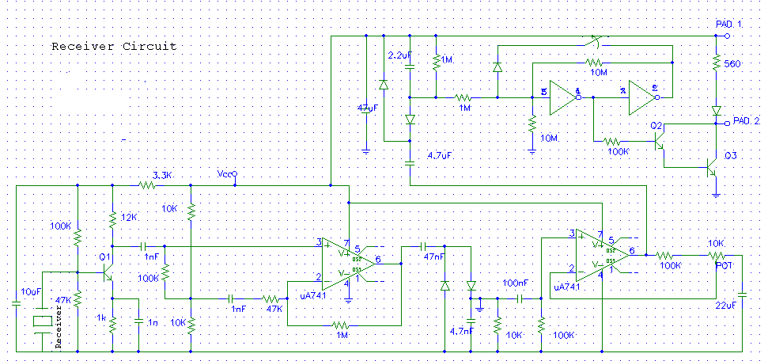
Figure 5: Receiver Circuit
Sound waves reflected by objects arrive at the receiver in different phases. Moreover, if the sound waves are in phase they create a larger signal whereas if the sound waves return out of phase they cancel each other out. Due to this characteristic if an object moves towards or away from the receiver it cause the receiver signal to alternate cycles from high to low. This is the change that triggers the device. They steady high output of the second op amp is pulled down causing the cmos gates to switch.

KIT MODIFICATION AND INDENTED ALGORITHM:
The transmitter and receiver circuits will be separated for use with the autonomous agents. Since, circuitry is common to both the transmitter and receiver some hardware modifications will be made. The predator robot will carry two receiver circuits and will listen for the prey. The receiver pair will be located on different sides of the robot, so that the direction of the signal can be quickly perceived by the agent. The algorithm to sense direction is similar to the IR obstacle avoidance, except that the robot's arbitrator will turn the motors in the direction of the strongest signal, rather than avoiding this. The predator will "listen" for the signal that the prey will transmit.

PERFORMANCE AND OBSERVATION OF SENSOR CHARACTERISTICS:
An experiment was used to determine some of the characteristics of this ultrasonic motion detector. The Jameco kit provides a LED which lights up every time the device is triggered by movement, and provided an easy method of testing the limitations of the sensor.
IR sensors have a limitation when searching for a reflected signal. For example, a stronger IR signal can be measured off a light surface than a dark surface. However, these ultrasonic transducers do not have this same limitation. Sound waves are not effected by the color of a reflecting surface. However, they are effected by the shape. A concave object will provide a stronger reflected signal than a flat object. Moreover, a flat object will reflect a stronger signal than a convex object.
The receiver circuit's sensitivity can be adjusted by the potentiometer. Varying the sensitivity of the device, a flat and concave object were used to determine the greatest distance that could be detected. The following data was obtained,
RESISTANCE(OHMS) DISTANCE OF DISTANCE OF
FLAT OBJECT(FT) OF CONCAVE OBJECT(FT)
----------------------------------------------------------
100 4 6
2.5K 4.5 6.5
5K 5 7.25
7.5K 6 8
10K 7 9.5

This data shows one of the limitations of the sensor. For if used for collision avoidance, a robot would not easily detect some objects due to shape. Moreover, if this sensor was used to range object error should be expected. The receiver circuit is very sensitive, and would result in greater range errors with greater distances.
This motion detector sensor is the most elaborate sensor found in this project. Modifications must be made from the current design however. Through implementation of this sensor with the robot a problem has been observed. The A/D converter samples at a given rate which is much slower than oscillating signal given from the receiver circuitry. The output waveform would probably be readily usable if a low pass filter was used on the current output waveform. Despite this problem, the TJ can detect motion consistently. Range and directions problems will hopefully be rendered at a later date.
CDS Photo Resistor:
The CDS photo resistor sensor is very simple. The sensor itself is a simple voltage divider as shown in Figure 6. The value of the resistor can be adjusted to give a variety of sensitivities to different types of light. For example, a 1k and 100k resistor force the circuit to be sensitive to bright and dark light respectively.
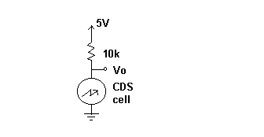 The voltage over the CDS cell is taken to the A/D converter on the microprocessor. There are three of these sensors placed on the robot, and they all vary in their direction.

Behaviors
Collision Avoidance:
Collision Avoidance is accomplished with the IR system. The IR detectors are connected to the analog port of the microprocessor. When a tolerance is exceeded on one of the detectors the system’s arbitrator “senses” an object and sends the proper speed and direction outputs to the motors. For example, if the left IR detector give a value above a certain tolerance the arbitrator tells the robot to turn right, or away from the object.
One of the biggest problems with this behavior is called the “Braitenburg Trap.” This situation occurs when both the right and left detectors sense a value above threshold. The system’s arbitrator wants to go both direction, so when implemented the robot just seems to shake back and forth. To solve this problem the arbitrator looks to see when this situation happens and then tells the motors to back up for a set amount of time (see source code in ARBIT_SR).

Bump Detection:
This behavior depends on the bump switches located around the outside of the TJ. If they are triggered the arbitrator simply backs up for a set amount of time. In fact, this behavior has the highest priority in the system.
Hiding/Searching:
This behavior can either be seen as hiding or searching depending on if the algorithm being used is that of the prey or predator respectively. In either case, the system uses the CDS cells to search for the darkest part of the room. Once all three CDS sensors register a dark reading, then the robot knows it has reached its destination. In the prey’s case, it now hides until a predator robot comes. In contrast, when the predator robot reaches its destination it will poke around searching for the prey who should have left by then.
Predator/Prey Detection:
The ultrasonic motion receivers are used for this behavior. The prey uses this sensor when it is hiding. Once it detects a prey in its vicinity it begins to run away. Similarly, the predator uses this sensor to detect the prey. However, with a better output signal from the motion detector the predator should be able to chase the prey with this same signal.
Similar to the IR system, there are two receivers placed on opposite sides of the robot. This should give the arbitrator some sense of direction. However, due to the fact the receiver circuit is too sensitive or the A/D converter does not sample fast enough this sensor can only be used to detect motion.
Conclusion
The goals of this project have been achieved for the most part. The final robot platform has a great sensor suite which has many possible functions. However, the M68HC11E2 only has 2K EEPROM and 256 bytes of RAM, so the memory capacity is limited. With a bigger memory, the entire sensor suite could be utilized to perform elaborate and more “intelligent” behaviors. Moreover, modification still needs to be done on the ultrasonic sensor. This sensor has some advantages over using IR for collision avoidance or object chasing. If the output of this sensor was passed through a low pass filter the signal may actually be used for a more useful function. Eventually, both the prey and predator algorithms will be completed, and both designs will be implemented together to hopefully simulate some behaviors found in nature.
Appendix
Source code in assembly:
*Steve McKinnon
*IMDL
*12/1/97
*shell v1.4 collison avoidance WITH BUMP DETECTION (FINAL)
********************************************************************
EEPROM EQU $B600
RAM EQU $0000
RAMEND EQU $01FF
REGS EQU $1000
OPTION EQU $1039
ADCTL EQU $1030
ADR1 EQU $1031
ADR2 EQU $1032
ADR3 EQU $1033
ADR4 EQU $1034
TMSK1 EQU $1022
TMSK2 EQU $1024
TFLG2 EQU $1025
PACTL EQU $1026
PORTC EQU $1003
* Constants
NSAMP EQU 100
BIT0 EQU %00000001
BIT1 EQU %00000010
BIT6 EQU %01000000 ;LEFT SENSOR
BIT7 EQU %10000000 ;RIGHT SENSOR
INV6 EQU %10111111
STSIZE EQU 20

****** DATA ********
ORG $00
PID RMB 1 ;PROCESS ID
SP1 RMB 2 ;STACK POINTER FOR IR READ
SP2 RMB 2 ;STACK POINTER FOR SONIC READ
SP3 RMB 2 ;STACK POINTER FOR PHOTO READ
SP4 RMB 2 ;STACK POINTER FOR ARBITRATOR
SP5 RMB 2 ;STACK POINTER FOR MOTOR ROUTINE
STACK1 RMB STSIZE
STACK2 RMB STSIZE
STACK3 RMB STSIZE
STACK4 RMB STSIZE
STACK5 RMB STSIZE
BUMP RMB 1
IR_LEFT RMB 1
IR_RIGHT RMB 1
SONAR_LEFT RMB 1
SONAR_RIGHT RMB 1
CDS_LEFT RMB 1
CDS_CENTER RMB 1
CDS_RIGHT RMB 1
MOTOR_LEFT RMB 2
MOTOR_RIGHT RMB 2
ACTUAL_LEFT RMB 2
ACTUAL_RIGHT RMB 2
_SERVOS_BUSY:
RMB 2
_SIGNAL_STATE:
RMB 2
_CURRENT_WIDTH:
RMB 2
_WIDTH:
RMB 4
_current_mode
rmb 1
****** INTERRUPT VECTORS *******
ORG $FFFE
FDB MAIN
ORG $FFE4
fdb _IRREAD
ORG $FFE6
FDB _SERVO_HAND
ORG $FFF0
FDB RTI_ISR
**********************************************************************8
ORG $F800
MAIN LDX #REGS
*Turn on A/D System
LDAA #%10000000 ; Bit 7 (ADPU) of OPTION
STAA OPTION-REGS,X
* Wait 100 ms for Pump Charge to Stabilize
LDAA #40 ; 2 E cycles
WAIT1 DECA ; 2 E cycles
BNE WAIT1 ; 3 E cycles
*
BCLR PACTL,X BIT1 ;SET INTERRUPT RATE FOR 8.19MSEC...
BSET PACTL,X BIT0
BSET TMSK2,X BIT6 ;ENABLE RTI INTERRUPT
*
LDX #STACK1+STSIZE-1 ;INITIALIZE STACK POINTERS FOR PROCESSES
STX SP1
LDX #STACK2+STSIZE-1
STX SP2
LDX #STACK3+STSIZE-1
STX SP3
LDX #STACK4+STSIZE-1
STX SP4
LDX #STACK5+STSIZE-1
STX SP5
* ;INITIALIZE ALL STACKS
LDS SP5 ;ASSUME PREVIOUS PID WAS 5
LDX #MOTOR_SR
PSHX
LDY #0
PSHY ;IY
PSHY ;IX
PSHY ;A AND B
LDAA #BIT6 ;CCR WITH X=1 AND I=0
PSHA ;CCR
STS SP5
*
LDS SP4 ;ASSUME PREVIOUS PID WAS 4
LDX #ARBIT_SR
PSHX
LDY #0
PSHY ;IY
PSHY ;IX
PSHY ;A AND B
LDAA #BIT6 ;CCR WITH X=1 AND I=0
PSHA ;CCR
STS SP4
*
LDS SP3 ;ASSUME PREVIOUS PID WAS 3
LDX #PHOTO_SR
PSHX
LDY #0
PSHY ;IY
PSHY ;IX
PSHY ;A AND B
LDAA #BIT6 ;CCR WITH X=1 AND I=0
PSHA ;CCR
STS SP3
*
LDS SP2 ;ASSUME PREVIOUS PID WAS 2
LDX #SONIC_SR
PSHX
LDY #0
PSHY ;IY
PSHY ;IX
PSHY ;A AND B
LDAA #BIT6 ;CCR WITH X=1 AND I=0
PSHA ;CCR
STS SP2
*
LDAA #1
STAA PID
LDS SP1 ;INITIALIZE CURRENT PROCESS AS 1
*
LDY #3000
STY ACTUAL_LEFT ;INITALIZE CURRENT MOTOR WIDTH
STY ACTUAL_RIGHT
JSR _INIT_SERVOS ;INTIALIZE SERVOS
JSR _INIT_IR ;INTIALIZE IR EMITTERS
JSR _IR_ON ;TURN ON IR
CLI ;TURN ON INTERRUPTS
JMP IR_SR ;GO TO PROCESS 1
****************************************
************************************
RTI_ISR LDX #REGS
BRCLR TFLG2,X BIT6 ENDRTI ;IGNORE ILLEGAL INTERRUPT
BCLR TFLG2,X INV6 ;CLEAR FLAG
LDAA PID ;FIND CURRENT PID
CMPA #1
BEQ SAVEP1
CMPA #2
BEQ SAVEP2
CMPA #3
BEQ SAVEP3
CMPA #4
BEQ SAVEP4
CMPA #5
BEQ SAVEP5
BRA ENDRTI ;IGNORE ILLEGAL PID
SAVEP1 STS SP1 ;SET NEXT PROCESS
LDAA #2
STAA PID
LDS SP2
BRA ENDRTI
SAVEP2 STS SP2
LDAA #3
STAA PID
LDS SP3
BRA ENDRTI
SAVEP3 STS SP3
LDAA #4
STAA PID
LDS SP4
BRA ENDRTI
SAVEP4 STS SP4
LDAA #5
STAA PID
LDS SP5
BRA ENDRTI
SAVEP5 STS SP5
LDAA #1
STAA PID
LDS SP1
BRA ENDRTI
ENDRTI RTI
************************************
****************************************
IR_SR BRA IR_SR
LDX #REGS
LOOP1 LDAA #%00010110 ;SAMPL
STAA ADCTL-REGS,X
LDAA #6 ; 2 E cycles
WAITR DECA ; 2 E cycles
BNE WAITR ; 3 E cycles
LDAA ADR3
STAA IR_LEFT
LDAA #%00010111 ;SAMPR
STAA ADCTL-REGS,X
LDAA #6 ; 2 E cycles
WAITL DECA ; 2 E cycles
BNE WAITL ; 3 E cycles
LDAA ADR4
STAA IR_RIGHT
BRA LOOP1
****************************************
SONIC_SR LDX #REGS
LOOP2 SEI
LDAA #%00010001 ;SAMPL
STAA ADCTL-REGS,X
LDAA #6 ; 2 E cycles
WAITR DECA ; 2 E cycles
BNE WAITR ; 3 E cycles
LDAA ADR1
STAA SONAR_LEFT
LDAA #%00010101 ;SAMPR
STAA ADCTL-REGS,X
LDAA #6 ; 2 E cycles
WAITL DECA ; 2 E cycles
BNE WAITL ; 3 E cycles
LDAA ADR2
STAA SONAR_RIGHT
CLI
BRA LOOP2
***************************************
PHOTO_SR LDX #REGS
LOOP3 BRA LOOP3
***************************************
ARBIT_SR LDX #REGS
JSR LOOP4
BRA ARBIT_SR
LOOP4 LDAA PORTC
ANDA #%00100000 ;CHECK PC5
BNE GOBACK ;BUMP DETECTION IF NOT ZERO
LDAA CDS_RIGHT
CMPA #253
BLT STOPQU ;IF CDSRIGHT DARK CHECK LEFT
BRA SKIP ;ELSE SKIP
STOPQU LDAA CDS_LEFT
CMPA #253
BLT MSTSTOP ;IF CDSLEFT DARK TOO THEN STOP
BRA SKIP ;ELSE SKIP
MSTSTOP JSR STOP
RTS
SKIP LDAA IR_LEFT ;COLLISION AVOIDANCE
LDAB IR_RIGHT
CMPB #98
BLT RLOW
CMPA #98
BLT GOLEFT
LDAA IR_LEFT
LDAB IR_RIGHT
CMPB #250
BGT RHIGH
CMPA #250
BGT GOLEFT
*
LDAA IR_LEFT
CMPA IR_RIGHT
BLT GOLEFT
BRA GORIGHT
*
RHIGH CMPA #250
BGT GOBACK
BRA GORIGHT
*
RLOW CMPA #98
BLT FORWARD
BRA GORIGHT
GOBACK LDY #3500
STY MOTOR_LEFT
LDY #2400
STY MOTOR_RIGHT
JSR DELAY
RTS
GOLEFT LDY #3500 ;WORKS
STY MOTOR_LEFT
LDY #3500
STY MOTOR_RIGHT
RTS
LILLEFT LDAA CDS_LEFT
SUBA CDS_RIGHT
CMPA #150
* BPL STR
LDY #3000 ;WORKS
STY MOTOR_LEFT
LDY #3500
STY MOTOR_RIGHT
RTS
GORIGHT LDY #2300
STY MOTOR_LEFT
LDY #2400
STY MOTOR_RIGHT
RTS
LILRIGHT LDAA CDS_RIGHT
SUBA CDS_LEFT
CMPA #100
* BLT STR
LDY #2300
STY MOTOR_LEFT
LDY #3000
STY MOTOR_RIGHT
RTS
FORWARD LDAA CDS_CENTER ;NO COLLSION, SO FIND DARKNESS
CMPA #250
BLT STR ;GOSTRAIGHT IF DARK AHEAD
LDAA CDS_LEFT
SUBA CDS_RIGHT
BLT LILRIGHT ;LEAN RIGHT
BRA LILLEFT ;LEAN LEFT
STR LDY #2300 ;STRAIGHT MOTOR VALUES
STY MOTOR_LEFT
LDY #3500
STY MOTOR_RIGHT
RTS
STOP LDY #3000 ;STOP ROUTINE
STY MOTOR_LEFT
STY MOTOR_RIGHT
WAIT4 LDAA SONAR_LEFT ;WAIT FOR PREDATOR
CMPA #180
BHI DONE4 ;DETECT WITH LEFT...RUN!
LDAA SONAR_RIGHT
CMPA #180
BHI DONE4 ;DETECT WITH RIGHT...RUN!
BRA WAIT4
DONE4 LDY #3500 ;BACK UP OUT OF HIDING AND GO...
STY MOTOR_LEFT
LDY #2800
STY MOTOR_RIGHT
JSR DELAY ;WAIT TO FINISH BACKING UP...
RTS
***************************************
MOTOR_SR
LDD ACTUAL_LEFT
CPD MOTOR_LEFT
BLT INCL
BEQ FIXLEFT
LDD ACTUAL_LEFT
SUBD #50
STD ACTUAL_LEFT
BRA FIXLEFT
INCL LDD ACTUAL_LEFT
ADDD #50
STD ACTUAL_LEFT
FIXLEFT LDD #0
LDX ACTUAL_LEFT
PSHX
JSR _SERVO ;LEFT
PULX
*
LDD ACTUAL_RIGHT
CPD MOTOR_RIGHT
BLT INCR
BEQ FIXR ;DO NOTHING
LDD ACTUAL_RIGHT
SUBD #50
STD ACTUAL_RIGHT
BRA FIXR
INCR LDD ACTUAL_RIGHT
ADDD #50
STD ACTUAL_RIGHT
FIXR LDD #1
LDX ACTUAL_RIGHT
PSHX
JSR _SERVO ;RIGHT
PULX
BRA MOTOR_SR
***************************************
DELAY LDX #5 ;APPROX = 2 SEC
OUTER LDY #10000 ;4 CYCLES
INNER CMPA $00 ;3
DEY ;4
BNE INNER ;3
DEX ;3
BNE OUTER ;3
RTS
***************************************Source Code for IR modulation and to drive the servos can be found in the TJ applications software from Novasoft.

