Gyroscopically Stabilized and Controlled Single-Wheeled Autonomous Vehicle

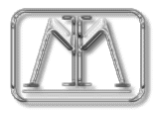
2000 Florida Conference on Recent Advancements in Robotics
February 14, 2000

Robert D. Cavin Machine Intelligence Laboratory University of Florida
Nechyba, Michael Electrical and Computer Engineering Dept. Gainesville, FL
Arroyo, A. Antonio
Schwartz, Eric M.

Abstract: The objective of this experimentation is the creation of a prototype single-wheeled autonomous vehicle capable of righting itself from any position, spinning about its own axis, moving both forward and backward, and avoiding obstacles in its path. This design has the benefit of a narrow profile, excellent maneuverability, and good terrain handling capabilities. However, the static instability of the platform requires dynamic balancing. Both balance and turning ability will be provided by use of an internal gyroscope. Forward and reverse mobility will be accomplished by applying a torque to a mass hanging from the free-spinning central shaft of the outside shell, forming the single “wheel” of the design.
The platform will gain feedback from the environment using a tilt sensor and electronic compass for balance and heading, a shaft encoder on the main drive motor for speed, and sonar for object avoidance. The completed prototype will use the information provided by these sensors to follow a specified path while maintaining balance and avoiding obstacles. While the intelligent behaviors of the prototype will be limited, the design will be implemented to allow easy code change and sensor addition to accommodate future robotic applications.

Introduction
In current robotic applications, advances in artificial intelligence and system control are met or exceeded by innovations in platform design. Two-legged walkers, hoppers, bug-inspired crawlers, and others are hot topics of research – all to increase mobility and flexibility of the platform to allow the advances in artificial intelligence to be applied to more environments. In this vein, this project will follow the work of Carnegie Mellon University in the development of a single-wheeled vehicle capable of a tighter turning radius, higher speed, greater fall recovery ability, and greater terrain handling than many wheeled and legged platforms.
This paper will follow the conception, development, integration, and testing of the MIL Gyrobot. The basics of the integrated system will be presented, followed by detailed information on the mechanical design, actuation, sensors, and behaviors of the device. The paper will close with experimental results and conclusions on the successes and shortfalls of the design, followed by the references used in the design. As this project is primarily a mechanical investigation, heavy emphasis will be placed on design of the prototype while results will be limited to qualitative analyses of prototype performance.

Integrated System
The objective of this experimentation is the creation of an autonomous single-wheel system that can right itself on its edge, maintain its balance, turn about its own axis, and move both forward and backward while avoiding obstacles. As this design is a prototype, intelligent behaviors will be limited to following a specified path while performing the above functions.
Control of the single wheel is accomplished using an internal gyroscope with constrained axes of rotation. Balance and turning will be achieved using the effect of gyroscopic precession induced by applied torque. For forward and reverse motion, the gyroscope is used as a hanging mass to which torque is applied, resulting in rotation of the outer shell.
Sensors for the device will include a tilt sensor and electronic compass for balance and direction feedback, a shaft encoder for position and speed control information, and sonar transducers for object avoidance. As the design progresses, other sensors will be added to improve utility for specified applications.
Intelligent control will be provided using the 68HC11 micro-controller on the Motorola EVBU board. The processor will be responsible for dynamically balancing the device on its contact edge through independent servo control of two axes of the gyroscope gimbals. The controller also controls speed and object avoidance. Future additions to the platform, such as vision – a system capable of being totally enclosed in a clear housing, would require separate processors that would interface with the 68HC11.

Mechanical Design
The MIL Gyrobot is designed to, from all outside appearances, defy the laws of physics. Similar to balancing a pencil on its point, the Gyrobot design rides on a single point of contact to the ground and maintains balance. As mentioned, the unit should be able to rotate about this point of contact with no transnational motion. The finished implementation should also be able to right itself when fallen. To perform these complex tasks, an internal gyroscope will be constrained to the outside wheel of the bot in a manner such that the forces generated by gyroscopic precession will provide proportional torque for balance and turning. This design, based on Carnegie Mellon University’s Gyrover project (seen below), is a highly unstable but very maneuverable platform capable of operation in almost any environment.
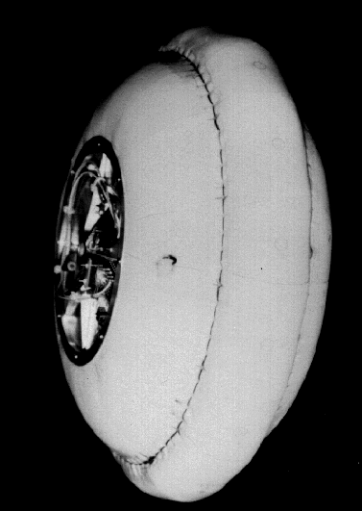
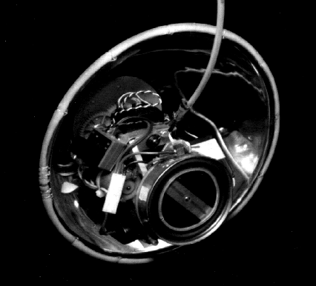

CMU GyroverI CMU GyroverII

The work of Carnegie Mellon was followed closely in the original design specifications of this project. A large (5” diameter or larger) gyro disk would be spun at several thousand rpm and hung from the central shaft of the unit on roller bearing cradles. A motor attached to the heavy gyro assembly would be geared to the outside shell to provide forward and reverse movement by application of torque to the hanging mass of the gyroscope and gimbals system. The CMU Gyrover used a disk so large that the central shaft of the outside wheel could not be connected to both sides of the wheel - the disk interfered with the direct path of the shaft. The initial design for this project instead involved a shaft connected at both sides to the outside shell and a gyroscope offset from the central axis to allow clearance of the disk and shaft. Also, the methods of constraint of the gyroscope itself differed, as CMU’s brute force approach required motors and connectors outside a suitable price range.
The first step in the construction of the MIL Gyrobot was the design and implementation of the gyroscope itself. As this was the most critical, and possibly most expensive, component of the system, all other aspects of the design were to be built around the gyro. In attempts to procure a gyro from a research institution or manufacturer, it was found that there was no suitable solution available in a price range acceptable to the project. In fact, very few gyroscopes of significant size were found. The second path taken was a scavenger hunt for a disk of acceptable size and mass that could be spun at high speed with an external motor to create the gyroscopic effect. Again, this search resulted in failure. Thus alternative methods were investigated.
After attempts to requisition an acceptable gyroscope failed, it was decided to create a gyroscopic disk, shaft, bearing, and gimbals assembly with materials available to the Machine Intelligence Lab. This option required a reevaluation of the size of the gyroscopic disk to be used in the design. As machining of the components was left to the project designer (myself, who had in fact never machined anything), quality of the finished product was known to be in question. The dangers of spinning an approximately 5lb poorly balanced gyroscope to several thousand rpm made this option infeasible. Instead, the design was modified so that a smaller disk could be used to provide necessary forces. This will be discussed below in the explanation of the construction of the outside wheel of the system.
The disk and shaft were machined in the Aerospace Machine Shop at the University of Florida. The finished disk has an outside diameter of 3.5” and a thickness of 1” at the perimeter of the circle. A 0.75” diameter 0.25” long shank extends from each side of the disk with 3 holes separated 120° to accommodate 0.25” #6 set-screws. Within a ring 0.75 inches from the outside edge of the disk to the edge of the shank, 0.3” of both sides of the disk are removed to reduce the weight of the disk. As the moment of inertia generated by the disk is largely based on the radial center of mass distance from the center, the weight near the center provides little benefit for generating force. However, removing this material reduces the mass of the entire system, requiring less generated force to balance and turn the platform.

A 0.25” diameter 3” shaft was then machined from a steel rod. A 0.25” hole was drilled in the center of the disk and the two pieces machined further for the best fit possible. Though a lot of care was taken in this procedure, the limited equipment available and the lack of machining experience led to approximately 1 mil (1/1000th of an inch) of play between the shaft and the disk. Though not desired, the ability to adjust the orientation of the gyro on the shaft by control of the three set-screws on either side of the disk allowed for vibration reduction. Bearings for the shaft and disk assembly were purchased from a local remote-control hobby store. The 0.25” inside diameter, 0.375” outside diameter steel needle bearings were those used in the axles of R/C cars, and thus rated for speeds up to 10,000 rpm. The ends of the shaft were further machined to allow the bearings a snug but non-binding fit.
The gimbal mechanism was then designed to allow 360° rotation of the gyroscope about 2 axes, as well as allowing for a motor attachment to power the disk itself. Discarding the rectangular hanger devised in early concept drawings, the components were rounded to reduce stress at any particular point in the piece. Using AutoCAD, a 0.25” oval ring with 2” x 4” radii with a 1.5” x 2” square platform on both sides was drafted. The platforms were added to provide a disk drive-motor attachment mechanism that was built into the gimbals itself. Two more copies of this design were made without the platforms. Additional 2” long pieces that followed the contour of this oval at the apex of the smaller radius were generated. For the outer half of the gimbals, a 0.5” thick semi-circle with a 4.5” radius was drawn. Again, two identical copies of this design were made. Each of the above mentioned pieces was split into two identical halves at 22.5° from horizontal to allow the creation of two pieces that would be joined together during the final construction of the gyroscope system.
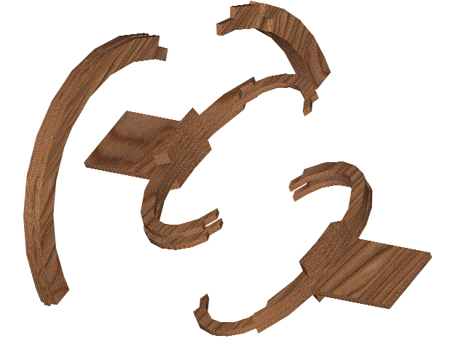
Gimbals Mechanism (Split to allow assembly)

The AutoCAD drawings were offset 0.032” on each side. The designs were then imported into QuickCAM for Windows and then cut from 1/8” plywood using a T-Tech machine with a wood bit. The identical pieces were bonded together with epoxy to form 3/8” plywood structures capable of bearing the weight and forces induced by the gyroscope. The bearings were bonded into the inner oval to accept the machined ends of the gyro shaft. The gyro disk was attached to the shaft, the shaft inserted into the bearings of each half of the inner oval, and the inner oval halves joined to create the inner assembly of the gimbals.
To constrain the rotation of the inner oval to a single axis, 3/16” brass dowels were inserted into the oval along an axis perpendicular to the rotation of the gyroscope wheel. At the bottom of the outside semi-circular component of the gimbals, 5/16” outside diameter, 3/16” inside diameter aluminum tubing was inserted perpendicular to the plane of the unit to accept the shafts of the inner oval. When oiled, this system provides a simple, low-friction solution to constrain the rotation of the inner ring of the gimbals.
At this point, the system design was reevaluated based on the difficulty of effectively constraining the gimbals when attached to a rotating shaft. Again breaking from the concept design, the inner shaft was tied directly to the gyroscope and internal equipment. Instead of rotating with the outside wheel, one end of the shaft was allowed to rotate freely from the shell using the previously mentioned shaft and tubing technique while the shaft of a DC motor was used as the opposing end coupling. This allowed torque to be applied to the inside mass without the need for a gearing system to the outside shell. Also, the constraint of the gimbals to the total system was greatly simplified. The central shaft designed to accommodate an available Maxon DC motor that provided acceptable torque, speed, and axial loading ability. The resulting design was 1” x 1” square and of appropriate length to span the width of the outside shell. This shaft was again realized using the T-Tech machine.
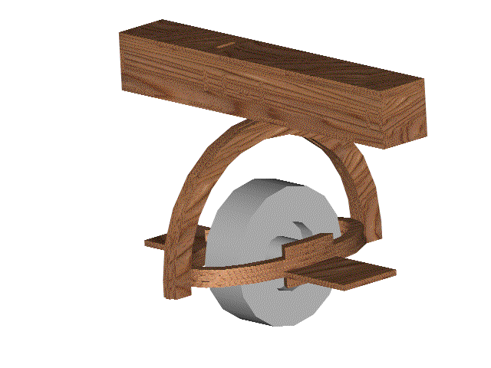

Completed Gyro, Gimbals, and center shaft

To mount the gyroscope gimbals mechanism to the now non-rotating central shaft, the previous method of using a brass shaft with an aluminum outside collar was employed. However, since the outer ring mounted to the shaft at only a single point (instead of two opposing points as in the inner oval to the outer semi-circle), the joint proved too poor to effectively constrain the rotation about a single axis. Instead, a second 1/8” plywood plate was added in the middle of the central shaft on a plane parallel to the bottom of the shaft. Two bearings with an inside diameter of 3/16” and an outside diameter of 3/8” were purchased from the R/C hobby store. These bearings were mounted in the bottom of the shaft and in the added plate along the center vertical axis of the design. The brass shaft, with an outside diameter of 3/16”, was passed through both bearings to produce two tight single-axis constraints 0.5” apart. This joint allowed the gyro and gimbals to spin freely about an axis perpendicular to the central shaft with little play along other axes.
The second mechanical obstacle in the creation of the MIL Gyrobot was the design and implementation of the outer shell. As the Gyrobot was designed to move both forward and backward by rotation of the outside shell, a tire shape proved to be the obvious solution. The dimensions of this shape had been largely predetermined by using AutoCAD simulations to find the smallest shell capable of enclosing the gyroscope and necessary electronics. As a larger radius tire would require greater forces to balance due to mechanical leverage considerations, it was decided that the smallest design would prove the best. The size determined in these simulations, and in fact the size of the final implemented model, was a wheel diameter of 14” and a width of 9”, with an appropriate curvature to allow for free movement of the gimbals 360° about each non-constrained axis.
The first design strategy was to purchase clear Lexan or Plexiglas salad bowls of the appropriate diameter joined together open-face to open-face, creating a quasi-spherical shape with a thin point of contact to the ground when stood on edge. A bike tire was also considered for used around the rim of the bowls to create a more traditional single-point-of-contact riding surface. However, it was soon discovered that no market products were readily available that would satisfy the previously determined dimensions. Instead, a bowl structure was designed in AutoCAD with a 3” diameter central hub, 8 0.5” thick radial ribs, and an 0.75” thick outside ring with an outside diameter of 14”. The curvature of the ribs was simply a well-fitting curve joining the central hub to the outside ring. Two copies of this design were produced from 1/8” birch plywood using the T-Tech machine. Two separate bowls were assembled and attachment holes made along the outer rings to allow the two units to be bolted together, forming the outside tire shell.
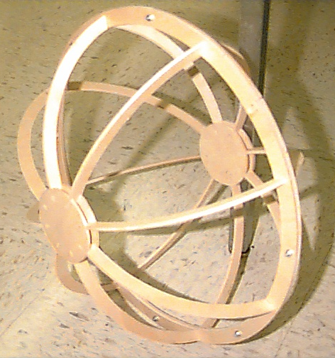

Initial Shell Design

Upon initial testing, however, it was determined that the force generated by the gyroscope would be insufficient to balance this design. As the “tire” balanced on the thin ¼” edge formed by merging the two bowls, the system would be very unstable with a tilt greater than a few degrees. The forces required for recovery are equal to the torque produced by the distance of the center of mass from the point of contact on an axis parallel to the ground. Because the design was constructed with only 8 ribs, the point of contact was often not in line with a rib, and as such the Gyrobot would contact the ground at the same point during a fall until two ribs touched. At this point, the shell would tend to rest in the “cradle” between the two nearest ribs. Righting the unit from this position would require a rolling motion to rock the shell so that the outside rim is in contact with the ground. More importantly, a lifting force would be required to overcome the step faced when the convex curvature of the outside rim contacts the floor while the ribs are no longer supporting the design.
To bypass this mechanical dilemma, a new outer-shell was designed. Based on input from Borja Carballo and Olivier Bourg, members of the UF Machine Intelligence Lab, this new shell was designed such that, when viewing a cross-section of the robot, the point of contact to the ground was a circle. The radius of this circle was such that its center point was above the center of mass of the unit. During a fall, the center of mass would be displaced in a way that tended to push the system upright, requiring less force from the gyro for balance.

Center of Mass
---
|
|
5”
|
|

Riding Surface

Riding Surface Ribs

As the electronic controlling hardware had not yet been determined, the center of mass of the original wheel structure, center shaft, and the gyro gimbals and disk was found. The center of mass of the entire system was estimated to be approximately 5" directly above the point of contact to the floor. (The accuracy of this number was not critical, as weight could be added to the final design to fine-tune the C.G. of the device.) To accommodate this specification, a new shell design was drafted in AutoCAD with the same diameter and width as the previous shell (14" diameter - 9" width). The riding surface was implemented as a circle with a radius of 5" set 2" below the center of the “wheel” in a cross-sectional view. This circle was then joined smoothly to interface with the same center hub design used in the original shell, as well as an additional hub on the inside of the ribs for extra support and easier mounting. To increase strength and reduce the effects of “rib saddling” mentioned earlier, sixteen ribs were used in this design instead of the original eight.
To provide a smooth riding surface, the shell was designed with a 75%/25% split, as opposed to the two identical halves used in the original. Four concentric circular ribs were designed - a 14" outside-diameter circle for the center of the unit, two circles with the radius of a rib 2"along the curvature of the rib from the center, and a smaller circle to form the structure of the smaller half of the design. The outside diameter of ribs 2" in either direction from the center and all circular ribs except for the smallest was reduced 3/32" to accommodate a covering on the riding surface. All pieces were milled and assembled. A 3/32" thick balsa sheeting was then applied to the indention of the shell along the riding surface. The balsa was cut in 4" by 4" squares, soaked in water, and then bent by hand and glued with Zap CA to form the curvature and support needed in areas between the ribs.
Each of the above components was assembled to yield the final mechanical structure. This design included a gyroscopic disk and gimbals assembly hanging inside of the tire-like outside shell from a shaft through the axis of this shell. Properly controlled, this system, would provide a platform capable of meeting the design specifications.

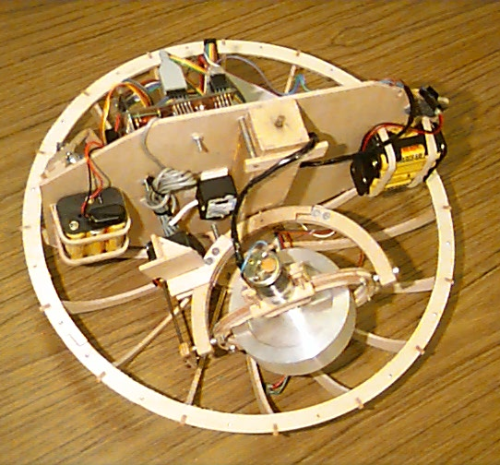
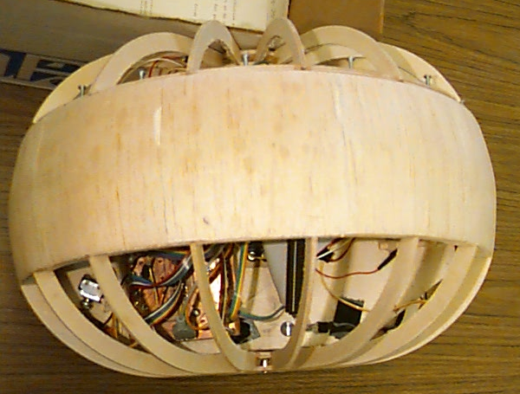

Final Outer Shell Design Complete Gyro Assembly

Actuation
Because this platform is statically unstable, actuation requires both movement and balance controls. However, this instability allows for excellent maneuverability, as the device is able to rotate about its central axis, move forward and backward at greater than, and can right itself from any position.
Control is made more difficult by the fact that all actuation must be accomplished inside the external shell. To dynamically maintain balance and to achieve turning capability, gyroscopic precession was used. Precession can best be explained as follows: when a torque is applied about the Y axis to a mass spinning about the X axis, a reaction torque is created in the Z axis about the center of rotation of the mass. This effect can be seen by spinning a bicycle wheel and hanging one end from a string. The torque applied by gravity causes the wheel to rotate around the string.
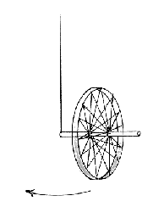

Gyroscopic Precession Example

For use in this platform, assume that the Z-axis is perpendicular to the ground plane and that the X-axis is parallel to the ground plane and passes through one point on the front and one point on the back of the outside shell. Also assume the intersection of these axes is at the center of rotation of the gyro. In this scenario, application of torque about the Z-axis will apply balancing force and torque about the X-axis will provided turning capability.
Forward and reverse motion of the platform is accomplished by applying torque to the mass of the gyro and batteries hanging from the central shaft. Because the hanging mass always tries to achieve equilibrium by hanging directly below the central shaft, the outside shell rotates rather than the inside mass, resulting in movement of the entire device.

Translational Movement
Sensors
The sensor suite for this platform includes indicators for balance, speed, object avoidance, and heading. Other application specific sensors may be added in the future to increase the capabilities of this design.
Balance is achieved by feedback from a tilt sensor constrained to the central shaft. This sensor works in conjunction with a gimbaled electronic compass to control the torque applied to the gyroscope in both active axes.
A shaft encoder on the main drive motor indicates speed. Since the shaft is constrained to the outside shell and the motor is constrained to the independently rotating inside shaft, any relative motion will be indicated by the shaft encoder. Thus, unless the outside shell slips about the point of contact with the ground plane or the inside shaft and mass moves significantly from a vertical orientation, the speed of the device may be calculated by simple equations involving the radius of the shell and the relative rate of rotation.
As this device will be primarily for outside use, sonar was chosen to implement object avoidance. The sonar transducers used will be those available from Mekatroniks. As the electronics for the device are enclosed within the outside shell, the prototype will only read the sonar when there are no ribs of the shell near the path of the sound.

Behaviors
The behaviors of this autonomous agent will be largely application specific. At present, the purpose of this project is the development of a single-wheeled platform suitable for future investigations. As such, behaviors of this prototype will remain simple.
The primary behavior of this device is to maintain balance at all times. This is achieved through applied torque to the internal gyro with feedback from the tilt sensor. To avoid changing its current direction while balancing, the robot’s secondary behavior is to maintain heading, accomplished through use of the internal electronic compass and torque applied to the gyro on a perpendicular axis to that used for balancing.
The single movement behavior of the prototype will be object avoidance. While moving forward, the device will use sonar to try and turn around obstacles. If trapped, the unit will turn in place and find a possible direction to proceed in. Due to the complexities of balancing the platform, bump sensors are not needed since if a wall is hit, the unit will tip over and will be unable to right itself in the space available (too close to a wall or object). Thus the object avoidance scheme of the design must be robust enough to keep the unit away from nearby objects.

Experimental Layout and Results
For initial testing of the design, the microcontroller was given control of the balancing and turning servos. The controlling software also accepted input from a two-channel radio receiver to control turning and forward and backward motion. As this project is still in its early stages, the only autonomous feature tested was balance.
Due to the weight of the unit and the limited speed of the controlling electronics the prototype could not maintain balance without user help. As such, subsequent tests were limited to investigations with the unit in a constrained environment. Under these conditions, the completed prototype exhibited basic characteristics of the design specification. Torque could be generated to balance and turn the design as per the original hypothesis. Force could be applied to move the entire unit forward and backward, but due to the unexpected weight of the electronics the center of gravity was moved too high for the torque to be properly transferred to generate translational motion.

Conclusion
The prototype met many of the design characteristics, but due to the weight of the complete unit was unable to perform as specified. To be functional, the design would require a larger gyroscope mass that could be controlled more rapidly. As cost was a limiting factor in this design, a more heavily funded research into the area of gyroscipically controlled vehicles could easily remedy many of the debilitating issues encountered. Because of the obvious benefits of a functional platform of this design, future experimentation following the basic construction defined in this report is will be continued and is encouraged for other experimenters.

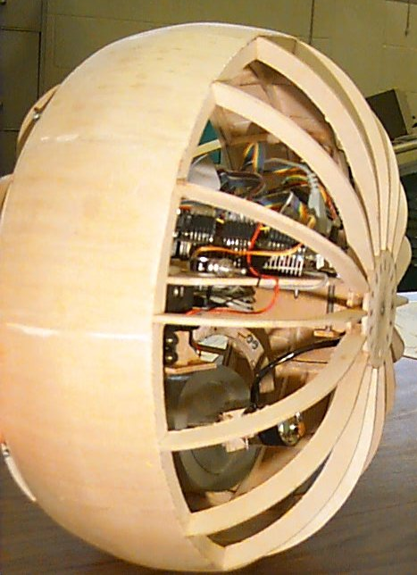

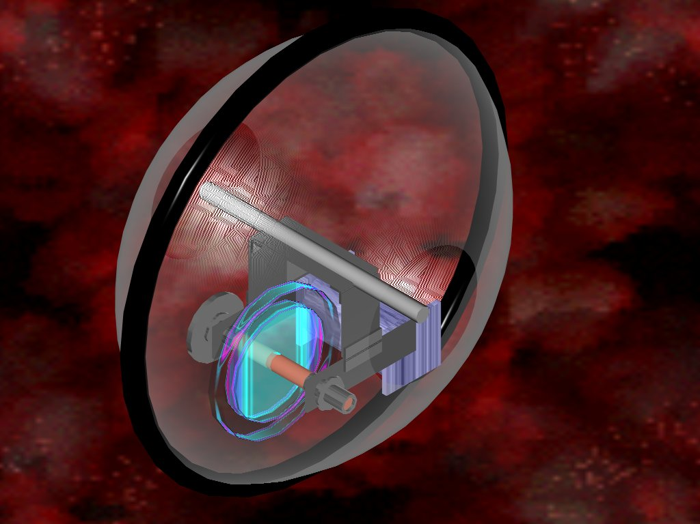

Concept Design Completed Prototype

Documentation
Xu, Yangsheng and Brown, Ben;
A Single-Wheel, Gyroscopically stabilized Robot (GYROVER);
http://www.cs.cmu.edu/afs/cs/project/space/www/gyrover/gyrover.html

Jones, Joseph, Seiger, Bruce and Flynn, Anita;

Mobile Robots: Inspiration to Implementation Second Edition
A K Peters, Natick, Massachusetts

