Opening Mechanism
The first step was to design the mechanism and define what kind of motion could be used. In order to do so, two software were used:
- Fourbar (Figure 9).
- Working Model (Figure 10).
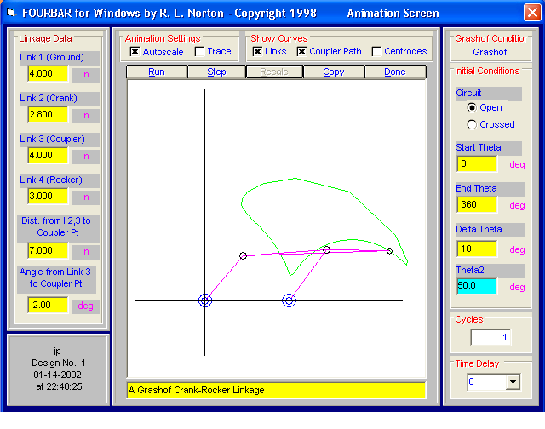
Figure 9, Fourbar.
Fourbar allowed to enter the length of the different links and to get a coupler curve (the green curve in Figure 9). Than by modifying in real time those dimensions it was possible to get a range of curve and pick which one would provide the proper motion.
Those linkages were than drawn in Working Model, where the actual physical motion could be simulated.
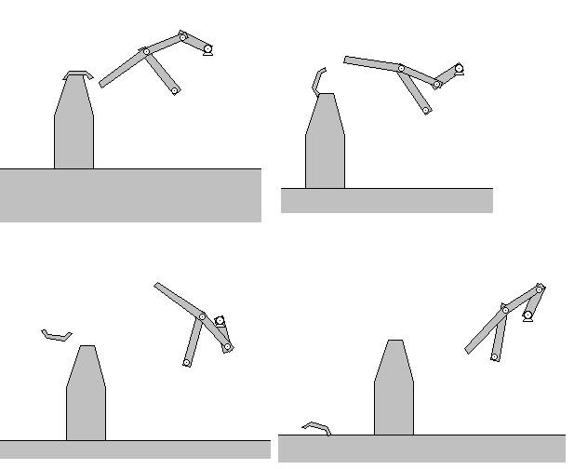
Figure 10, Working Model.
From those simulations it was decided that a four bar mechanism would be the best mechanism to use. Some forces lost due to friction could be compensated by mechanical advantages. With this in mind, a hand drawing was made using the desired position of the mechanism, namely the starting line and ending line of the opening device, see Figure 11. These two positions were obtained from opening a beer manually and mimicking this operation.
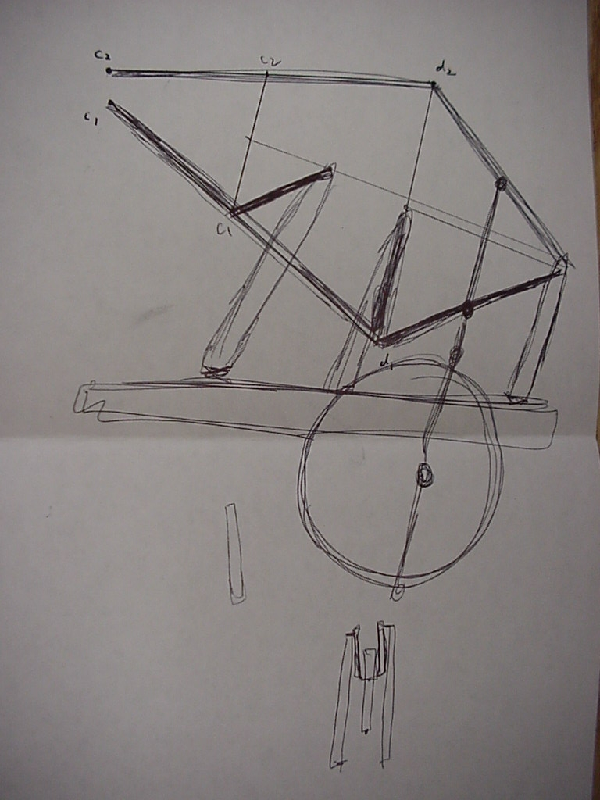
Figure 11, First Mechanism.
From this drawing realized to scale, a cad drawing was derived in order to cut the necessary parts required to build a prototype, see Figure 12.
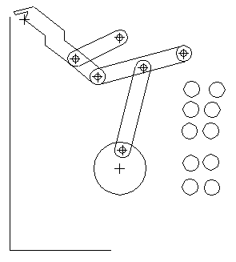
Figure 12, CAD Drawing.
Using these parts a prototype was created. This prototype was a fourbar mechanism. It was composed of two rockers (2 and 3), and a coupler (1), the four linkages were numbered (ground was considered has one linkage), see Figure 13.
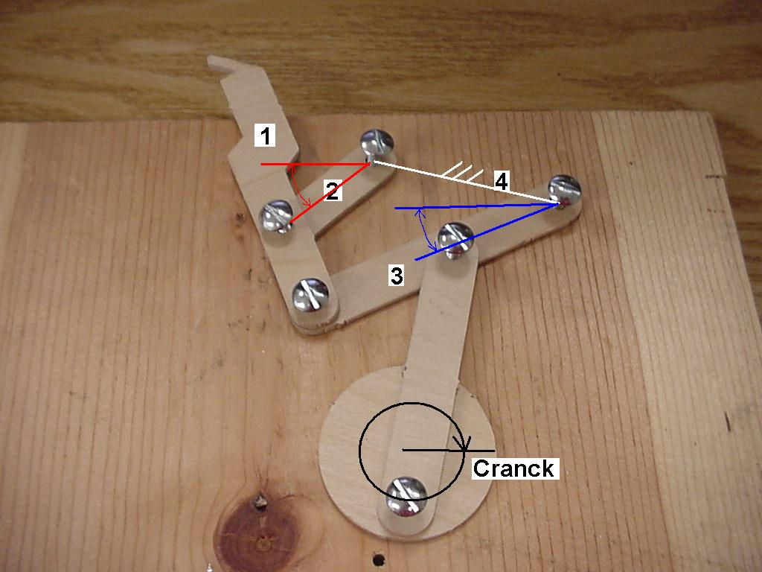
Figure 13, Prototype.
Taking into account the results of the prototype a to-scale hand drawing was derived and the layout of the different linkage was drawn, see Figure 14.
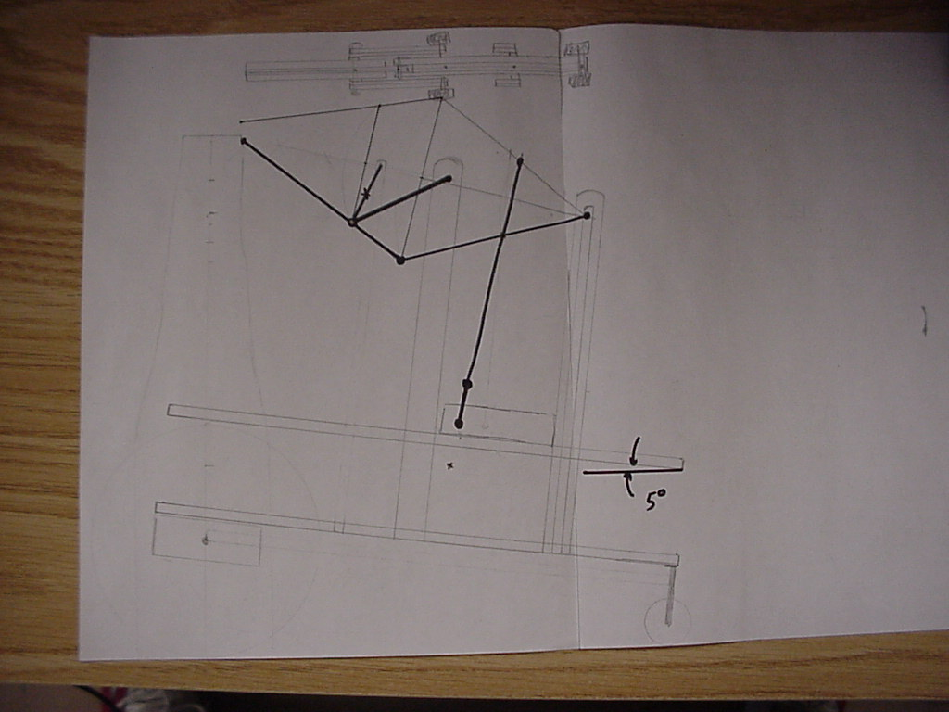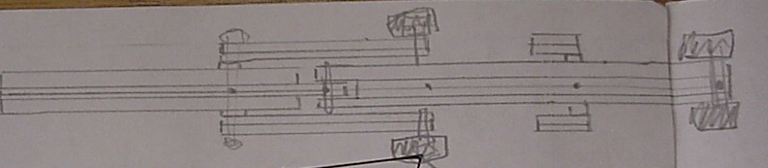
Figure 14, To Scale Drawing and Layout of the Mechanism.
An AutoCAD drawings was than derived in order to prototype and build the mechanism, see Figure 15.
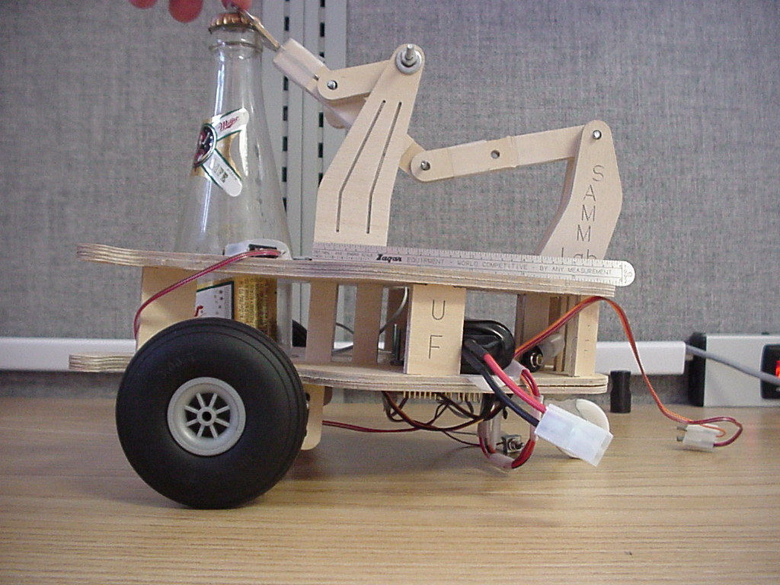
Figure 15, Mechanism on the Platform.
Some testing was done in order to determine if the mechanism would work, but a toggle point was present in the design rendering it unusable. In this case the toggle point would either bring the mechanism to collapse and/or required an added force to open the beer.
The next step was to determine the required force in order to open the beer. A force gage was used in order to do so, see Figure 16.
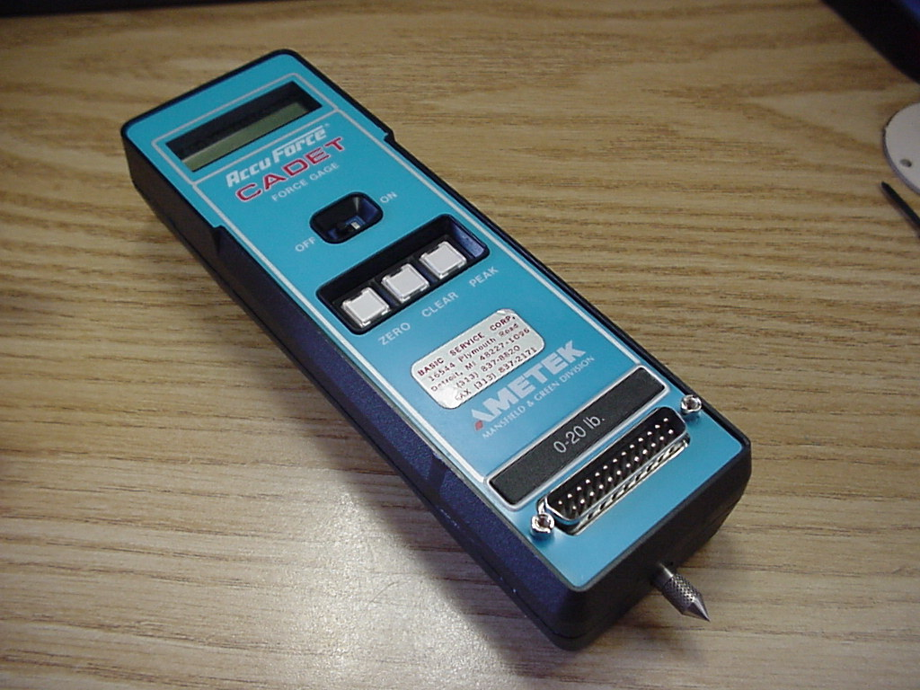
Figure 16, Force Gage.
A beer was open and a force of about six pound at a two inches distance was found giving a torque of 12lbs in. The servo-motors were also tested experimentally to get their forces; the results were in agreement with rated force provided by the manufacturer of the motors, see Figure 17.
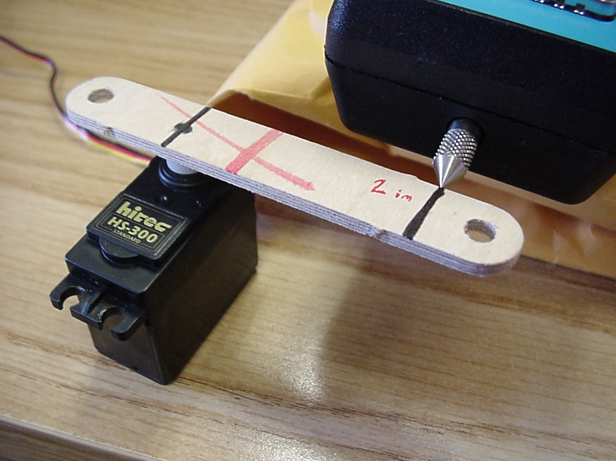
Figure 17, Experimental Setup.
A force of 1.47lbs at 2 in was found giving a torque of 2.94lbs in. At this point it was obvious that one motor would not be enough to open the beer. It was decided to use two motors in parallel and an arm of 4in. This increased the torque to 11.76 lbs in (almost the required torque to open the beer). The following mechanism was obtained, see Figure 18.
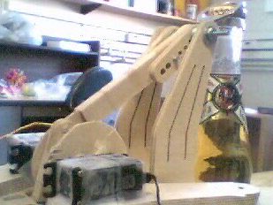
Figure 18, Mechanism With Small Servo.
The testing was done using two small servos 42oz/in. This showed that the servo were not powerful enough. It was decided to buy two 75oz/in motor. The torque would be enough to open the beer.
In order to get a working mechanism, AutoCAD was used, instead of the hand derivation, to derive the links, joints and length for the mechanism this added more precision. From those drawing the parts were cut and mechanism tested.
Range of motion of the mechanism was shown in Figure 19. Also shown were the starting position (white) and opening position (blue).
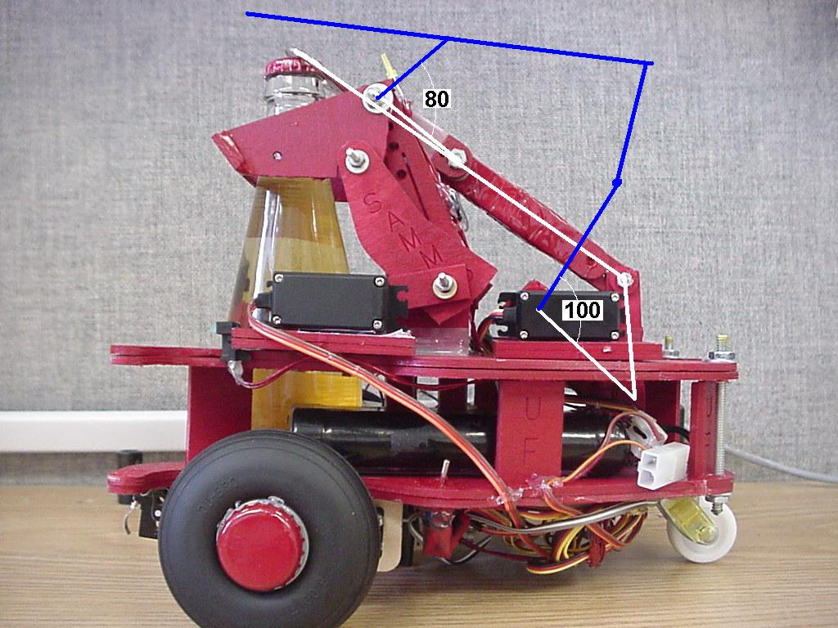
Figure 19, Angle and Position.
The final mechanism 3D Drawing, was shown in Figure 20.
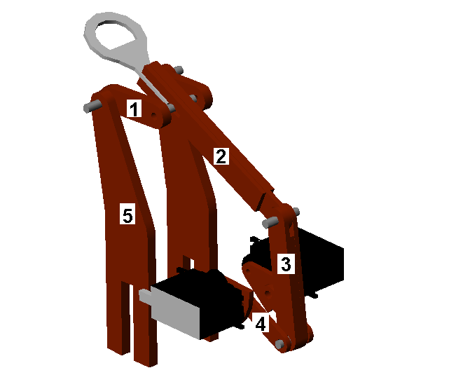
Figure 20, Final Mechanism.

