University of Florida
Department of Electrical and Computer Engineering
EEL5666
Intelligent Machines Design Laboratory

Sensor Design
for robot MMH

Name: Lee Cofer
Date: 4/23/02
TAs: Aamir Qaiyumi
Uriel Rodrigiez
Instructor: A.A. Arroyo

Sensor Design
MMH’s goal is to simulate mine hunting by finding and marking magnets that are on the floor. The special sensory suite that allows MMH to do this is a combination of Hall Effect sensors to locate the magnets and a mechanical design that drops a single BB on or near the magnet. MMH has an array of seven Hall Effect sensors positioned in a line on the bottom front of the platform as seen in Fig.1. When any of the seven sensors detects a magnet underneath it, MMH will stop and drop a BB on the magnet. The BB dropper, as seen in Fig.2, consists of a funnel shaped tube that is positioned at an angle so that gravity pulls the BBs to the front of the tube. A door controlled by a servo is located at the front of the tube keeping the BBs from falling out until one needs to be dropped.
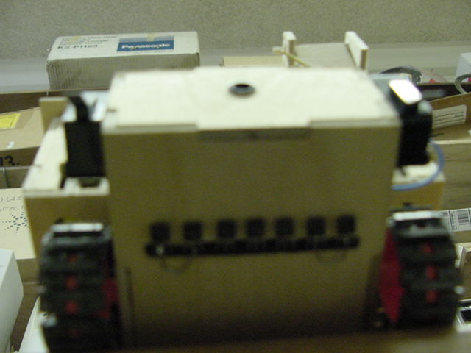

Fig. 1 Hall Effect Sensors

Fig. 2 BB Dropping Mechanism

Problems Encountered
The only problem encountered was finding an angle to place the funnel. The angle has to be large enough so that the BBs roll to the front of the funnel, but small enough so that they do not bunch up and get stuck in the front of the funnel. A good angle to use was found to be between 20 to 30 degrees.

Pros and Cons
The good thing about the design is that the BBs are round and are less likely to get stuck in the funnel. The bad part design is that since the BBs are round they tend to roll away from the location of the magnet when they hit the floor. Also, the bad property of the Hall Effect sensors is that they can only sense a magnet at very close distances. The largest distance that a magnet can be detected by the Hall Effect sensors is ½” and that is with a very strong magnet.

Future Suggestions
None

Component Information

Hall Effect Sensors
Digi-key Part #: DN6848
Cost: $1.04
701 Brooks Avenue South
P.O. Box 677
Thief River Falls, MN 56701-0677
1-800-344-4539
www.digikey.com

Standard Servo
Tower Hobbies Part #: LXH288
Cost: $11.99
PO Box 9078
Champaign, IL 61826-9078
800-637-7303
www.towerhobbies.com

The BB dropper mechanism cannot be bought, but can be built with the design in Fig.3 below.

Fig. 3 BB Dropper Mechanism schematic

Test Code

/************************************************************************
* Title minedet3.c *
* Programmer Lee Cofer *
* Date 4/7/2002 *
* Version 3 *
* *
* Description *
* This program tests the Hall Effect sensors and the BB Dropper *
* *
************************************************************************/
/*************************** Includes ********************************/
#include <tkbase.h>
#include <servotk.h>
#include <hc11.h>
#include <mil.h>
#include <vectors.h>
/************************ End of Includes ****************************/

/*************************** Constants ********************************/
#define SERVO1 0
#define HALL1 analog(6)
#define HALL2 analog(7)
#define HALL3 IRDT[8]
#define HALL4 IRDT[9]
#define HALL5 IRDT[10]
#define HALL6 IRDT[11]
#define HALL7 IRDT[12]

/************************ End of Constants ****************************/
/*************************** Prototypes *********************************/
void mineDetect(void);
/************************ End of Prototypes *****************************/
/***************************** Globals **********************************/
int open=2800, close=2200, BBtime = 150;
int hall1, hall2, hall3, hall4, hall5, hall6, hall7;
/************************** End of Globals ******************************/

void main(void)
/****************************** Main ***********************************/
{

init_analog();
init_clocktk();
init_serial();
init_servos();
printf("Begin \n");

while(1)
{
mineDetect();
}
}
/**************************** End of Main ******************************/

void mineDetect()
{/************************************************************************
* Function: Will detect magnets and drop a BB on it *
* time *
* Returns: None *
* *
* Inputs *
* Parameters: None *
* Globals: None *
* Registers: None *
* Outputs *
* Parameters: None *
* Globals: None *
* Registers: None *
* Functions called: None *
* Notes: *
************************************************************************/

read_IR();
hall1=HALL1;
hall2=HALL2;
hall3=HALL3;
hall4=HALL4;
hall5=HALL5;
hall6=HALL6;
hall7=HALL7;

if(hall1 < 10 || hall2 < 10 || hall3 < 10 || hall4 < 10
|| hall5 < 10 || hall6 < 10 || hall7 < 10)
{ printf("Detected \n");
servo(SERVO1,open);
wait(BBtime);
servo(SERVO1,close);
wait(1000);
}
}

