Hacked LiteOn Analog IR Sensors

I purchased several LiteOn digital IR receivers modulated for 56.5kHz and set out to hack them to be analog. After several hours and a lot of probing, I found the hack. It is pictured in Figure 1.

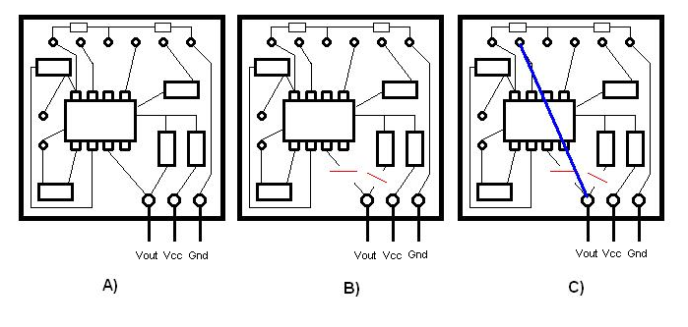

Figure 1

The first step is to open the can to get access to the electronics inside. When the can is open, the electronics board inside should look like Figure 1A. There is on main black chip with eight pins, several surface mount resistors, the bottom of solders for components on the other side of the board, and traces connecting them. The next step is to cut the two traces that connect to the output pin. This is shown in Figure 1B. The final step is to solder a jumper (i.e. a piece of wire wrap wire) between the output pin and the bottom of a solder, as shown in Figure 1C.

It was found that the voltage on the out put pin varied from 1.575V when there was no IR to 2.530V when the IR LED was less than one inch from receiver.

