Motor Driver Board

The motors are driven by two National Semiconductor LMD18200T H-bridges located on a motor driver board originally designed for the OO-PIC, but still works for this application. The schematic for the relevant parts of the board can be found in Figure 5.

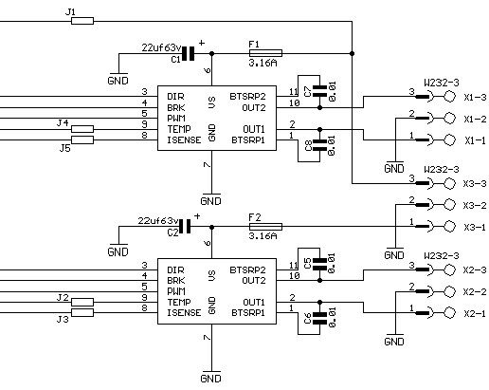

Figure 5

The H-bridges can deliver up to 3 amps of continuous current and 6 amps peak current. There are also two 3-amp fuses located on the board to ensure that the chips are not blown. Each chip uses three control signals to control the motor: a) a PWM signal to control speed b) a direction signal to indicate forward or backward and c) a brake signal.

The chips were sampled from National Semiconductor (www.national.com) because they cost $17 each. The bare board was purchased from Acroname (www.acroname.com). The rest of the components, listed on Magnevation’s website (www.magnevation.com) were purchased from Jameco.

