University of Florida
Department of Electrical and Computer Engineering
EEL 5666
Intelligent Machines Design Laboratory
Kyle Hagin
TA: William Dubel
Steven Pickles

Instructor: A. A Arroyo

“Betsy 2000”
Final Written Report

Summary

The project started with an autonomous airplane, crashed and became a hovercraft, and then had to be changed at the last minute to a totally different robot. The robots I made never were fully functional. I have been able to get every sensor to work and interface with the microprocessor and lcd and produce some actuation.

The new robot

The new robot consists of a hexapod walker frame with 10 servos for the legs. The outer four legs each have two servos. These servos lift each leg and move it over. The inner two legs only move up and down. The robots original task was going to be to find a color marker and go to it and check a pot with soil in it to tell whether it has water or not. It uses the cmu cam to find the colored object. Then it will line it self up with the object and use the sonar to judge how far away it is. This will line it up so that the arm with soil probe extends into the pot. There is an accelerometer that keeps the probe vertically aligned with the ground so that the probe goes directly into the soil. Originally I was going to try and hook up the radio modem and send a message to another microcontroller to actuate servos and turn on a small hose for the plants without water.

Actuation

There are 14 servos all together. There are the ten previously mentioned for the legs. Then there are two for the pan and tilt servos and two for the arm mechanism.

Sensors not on the other robots

On this robot there are two sensors not included on the other robots. These sensors include the soil detector and the CMUcam. The soil detector is basically a voltage divider hooked up to the analog pins of the microprocessor. When the probe is inserted there is either infinite resistance which means dry or there is a finite resistance which means there is water in the soil. The cmu cam is basically to track the color flag to tell the bot where to go.

Autonomous Airplane

Design an aircraft that will be able to self stabilize using angular rate measurement coupled with accelerometer measurements. The aircraft will use global positioning data that it receives through serial communication to modify its course. The present design will be limited in distance because of the current fuel capacity.

Purpose

The purpose of this particular design is to develop the necessary hardware and software for an aircraft to be able to self stabilize and self navigate to a predetermined GPS coordinate. This design will be carried out with the intention of being able to take out the hardware and software and easily integrate it into another aircraft.
The design will be useful in making small aircraft autonomous to perform tasks such as:
-Aerial photography
-Antennae for point-to-point radio communication
-Eventually lead to autonomous cargo planes
There can be many uses for a self-stabilized and self navigated aircraft system.

Integrated System

Angular Rate Sensor (Analog)

Accelerometer Sensor(Analog)

Main Processor
Servos on Ailerons, Rudder, elevator(PWM)

Manual Communcation
Standard RC Radio

Serial GPS Communication

Note: This is only a tentative Design. Certain Design Parameters may be changed.

Get Sensor Data

Desired Angle?
yes

No, Move Servo For Correction

Basic Self Stabilization Algorithm For Each Axis of Movement

Get GPS Coordinates and Determine Heading

On Course

yes

No, Determine Necessary Maneuver to Regain Proper Heading

Basic Self Navigation Algorithm

Function

The aircraft can be broken into subsystems to easier explain the overall function.
The subsystems are:
Airframe consisting of
-Engine
-Control surfaces (ailerons, elevator, rudder)
-Servos
Hardware and Control Systems
-Main microprocessor
-Angular rate sensors
-Accelerometer sensor
-GPS serial module

Airframe

The airframe is a scaled version of the Piper Cub aircraft. This plane is a high wing aircraft with stable flight characteristics. This plane was chosen because of its high stability and its low speed. The plane has a seven-foot wingspan and is four feet in length.
The engine is on the small end of the engines it can handle because of the desire for slow speeds. It is a .46 cubic inch Glow fuel powered engine. Glow fuel is basically a mix of Methanol, castor oil, and nitro-methane. The engine will control the altitude of the aircraft and not necessarily the speed.
There are three different control surfaces. Each of these control surfaces can control the rotation about each of the three axis of movement. These control surfaces will be controlled via servos.
The first control surfaces are the ailerons, located about half way down the wings. These will move in opposite directions to create more drag one side of the aircraft and more lift on the other side causing a banking maneuver. The ailerons control the rotation about the axis that extends the length of the aircraft.
The next control surface is the rudder. The rudder is located in the rear of the aircraft and acts a lot like the rudder on a boat. When the rudder is moved one direction it will cause a rotation about the axis that extends vertically through the center of the aircraft.
The elevator is the last control surface. It is located at the rear of the aircraft and is perpendicular to the rudder and parallel with the wings. The elevator will control the rotation about the axis that extends through the wings. When the elevator is moved up or down it will cause the aircraft to point up or down. This control surface actually also controls the speed of the aircraft.

Hardware and Control Systems

The main processor is the ATMEGA 128 chip on the new Mekatronix board. This board was chose because of its large rang of capabilities. The board has 16 servo channels with power and ground for a standard servo connection. There are 23 10 bit analog channels. The chip has 128k byte of memory available for programming. The board also has two UARTS for serial connections and a two/three wire serial connection as well.
Another board that is being considered as a back up is a board from SparkFun with a PIC18F452 processor on it. The processor has 2 pwm channels with input capture and output compare. It has an eight-channel ten-bit analog to digital converter. There is 32k of program space. The board has a connection for a RS232 db-9 serial cable. It can be programmed via ICSP.

Angular Rate Sensors

The angular rate sensors will measure the rate of rotation around each of the aforementioned axis of the aircraft. The angular rate sensor in this design is the ADXRS300 made by Analog Devices. It outputs an analog signal that changes proportionally to the angular rate about the axis perpendicular to the top of the chip. It will out put a value of 2.5V when there is no rotation. The voltage will change as the rotation is increased or decreased.

Accelerometer Sensors

The accelerometer is the ADXL203 also from Analog Devices. This particular accelerometer outputs two analog signals one for the x and y axis. It measures the acceleration due to gravity on the x and y axis parallel with the top of the chip. When the top of the chip is perpendicular to the force of gravity the output on both analog channels is 2.5V. As the chip is rotated on either of the axis the voltage will increase or decrease depending on the direction of rotation. The difference between the accelerometer and the angular rate sensor is that the angular rate sensor will go back to 2.5V after it has been rotated and will not tell you which way is up. The accelerometer will put out a voltage proportion to its acceleration due to gravity as long as it remains in that position.

GPS

The global position system module is a Rikaline 6010 that outputs a serial signal in NMEA standard format. This format provides the GPS coordinates, velocity, and altitude up to sixty thousand feet. This is going to be the backbone of the navigation system.

Function Summary

The plane will use the control surfaces to change its orientation in space on each of the three axis of movement. There will be three angular rate sensors coupled with three accelerometer sensors that will give the microprocessor the data to determine the planes orientation in space. The microprocessor will then use that data to determine any corrections needed to maintain or perform the desired flight maneuver. The GPS will give the necessary telemetry data to determine the desired flight path.
The aircraft will be able to accept commands for a destination GPS coordinate. Then use the orientation data to maintain a track toward the destination. The current design is not going to be able to take off and land autonomously.

Hover Craft

Angular Rate Sensors
The angular rate sensors will measure the rate of rotation around the vertical axis that passes through the middle of the hovercraft. The angular rate sensor in this design is the ADXRS300 made by Analog Devices. It outputs an analog signal that changes proportionally to the angular rate about the axis perpendicular to the top of the chip. It will out put a value of 2.5V when there is no rotation. The voltage will change as the rotation is increased or decreased.
When the hovercraft is hovering there is no force of friction to hold it in place. So it is basically free floating on a cushion of air. There is a force called gyroscopic precession that is acting on the hovercraft caused by the rotation of the lift motor. The motor acts like a physical gyroscope and is mounted to the hovercraft. Since it is mounted to the hovercraft the total angular momentum of the system is conserved causing the gyroscopic precession to be applied to the entire craft. This causes the hovercraft to spin in place.
The angular rate sensor will measure the spin caused by gyroscopic precession. This measurement will be used to tell which motors to increase the throttle for hovering in place. There is a basic algorithm for the software in fig 1. The craft will just lower lift motor power to remain in a non-moving state by using the force of friction on the ground.

Testing
A simple program that takes the analog value and puts out to the LCD can be used to test the sensor.
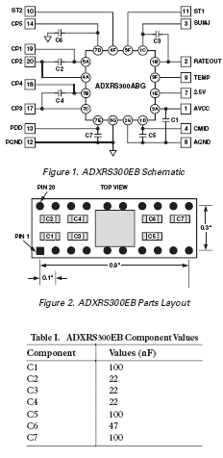
Here is the Circuit for the Angular Rate Sensor. This comes straight from the data sheet.
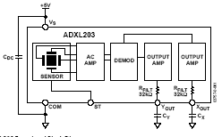
Here is the circuit for the Acclerometer. This Comes straight from the data Sheet.

Accelerometer Sensors
The accelerometer is the ADXL203 also from Analog Devices. This particular accelerometer outputs two analog signals one for the x and y axis. It measures the acceleration due to gravity on the x and y axis parallel with the top of the chip. When the top of the chip is perpendicular to the force of gravity the output on both analog channels is 2.5V. As the chip is rotated on either of the axis the voltage will increase or decrease depending on the direction of rotation.
The difference between the accelerometer and the angular rate sensor is that the angular rate sensor will go back to 2.5V after it has been rotated and will not tell you which way is up. The accelerometer will put out a voltage proportion to its acceleration due to gravity as long as it remains in that position. Also, the accelerometers are not very accurate in yaw measurements.
This sensor was very useful for the previous autonomous plane project because it could be used to measure very important tilt information for the aircraft. Now the roll an pitch axis are very stable due to the gyroscope nature of the motor. It is like a spinning top where it will remain stable and will resist rotational forces perpendicular to the axis that is spinning.
So, now this sensor will be used to tell the craft if it is upright in the event of a flip over or crash. The processor will immediately shut down the engines if the craft is flipped upside down or tilted more than 45 degrees.

Testing
To test the accelerometer the same program used to test the angular rate sensor can be used. This time the sensor was mounted to a protractor to be able to correspond values of the a/d to the actual angles. This data is seen below.
Angle | A/D
0 | 19584
20 | 20352
40 | 22912
60 | 26240
80 | 30720
90 | 32896
100 | 35200
120 | 39104
140 | 42368
160 | 44672
180 | 45440

These data values are consistent with what the data sheet says. As you can see in the graph there can be a linear approximation from 45 to 135. The data sheet says that at plus or minus 45 degrees there will be a linear relationship but below or above these values the slope is different.

Sonar
The sonar range finders used are made by a company called Devantech. The sensors are the SRF04. These sensors will allow a microprocessor to accurately measure distance. It uses a sonar ping to detect distances to objects by calculating the flight time of the ping and using the known speed of sound.
The processor will pulse a high signal on the input trigger line for approximately 10us. The SRF04 will then send out a 40khz-modulated signal via transducers as soon as the input trigger line goes low. Then the processor will wait for the echo line to go low once it goes low this is the time of the arriving echo. The two times subtracted will yield the approximate echo flight time. The distance can then be calculated using a simple equation:
Distance =(echo time) / (conversion factor)
The conversion factor for a unit of centimeters is 29us.
The hovercraft will use four of these sonar sensors mounted on rotating servos to detect objects. This will allow a full 360 degree perception of objects around the hover craft up to about 10ft. This information can then used to determine how to drive the motors to avoid the objects.

Testing
As mentioned before the signal must be timed and then the angle computed by the processor. The test is simple just put an object at known distance and record the value in centimeters output by the processor. These values can be tabulated and graphed to verify the linear relationship.

GPS
The global position system module is a Rikaline 6010 that outputs a serial signal in NMEA standard format. This format provides the GPS coordinates, velocity, and heading. This is going to be the backbone of the navigation system. The navigation system takes the Data and filters out the latitude, longitude, velocity, and heading. Then uses this data to guide the hovercraft to the pre programmed coordinates.
NMEA Format
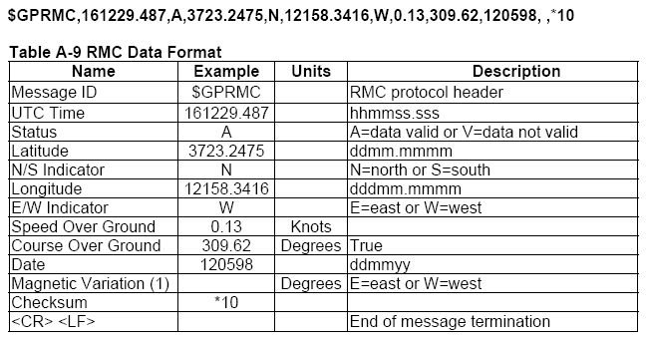
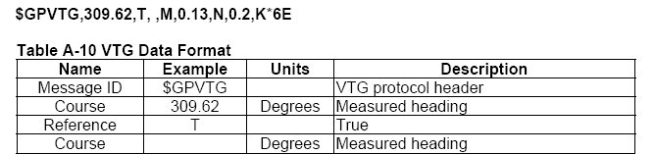
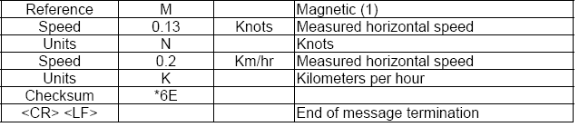
The basic software program will look for the headers (ie GPVTG) and then use the commas as delimiters to determine where the data needed is at. It is a little more complicated than that because there is a need for conversion from ASCII to usable data for the decimal numbers. A basic program that will just take what is coming in to the rx and displays it on the LCD is at the end of this report.

CONCLUSIONS
KEEP IT SIMPLE STUPID!!!! I tried to hard to do too much. I worked hard on this project and am coming up seriously short handed. I am probably going to fail out of engineering college because of the time I spent on this project. I feel like I learned an incredible amount doing this project but most employers don’t really care about what you know about. They just care what your GPA is.

