University of Florida
Department of Electrical and Computer Engineering
EEL 5666
Intelligent Machines Design Laboratory
Kyle Hagin
TA: William Dubel
Steven Pickles

Instructor: A. A Arroyo

“Autonomous Hover Craft Project”
AKA “Betsy 2000”
Sensor Report #1

Angular Rate Sensors
The angular rate sensors will measure the rate of rotation around the vertical axis that passes through the middle of the hovercraft. The angular rate sensor in this design is the ADXRS300 made by Analog Devices. It outputs an analog signal that changes proportionally to the angular rate about the axis perpendicular to the top of the chip. It will out put a value of 2.5V when there is no rotation. The voltage will change as the rotation is increased or decreased.
When the hovercraft is hovering there is no force of friction to hold it in place. So it is basically free floating on a cushion of air. There is a force called gyroscopic precession that is acting on the hovercraft caused by the rotation of the lift motor. The motor acts like a physical gyroscope and is mounted to the hovercraft. Since it is mounted to the hovercraft the total angular momentum of the system is conserved causing the gyroscopic precession to be applied to the entire craft. This causes the hovercraft to spin in place.
The angular rate sensor will measure the spin caused by gyroscopic precession. This measurement will be used to tell which motors to increase the throttle for hovering in place. There is a basic algorithm for the software in fig 1. The craft will just lower lift motor power to remain in a non-moving state by using the force of friction on the ground.

Testing
A simple program that takes the analog value and puts out to the LCD can be used to test the sensor.
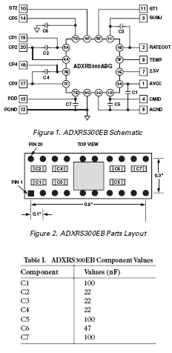
Here is the Circuit for the Angular Rate Sensor. This comes straight from the data sheet.
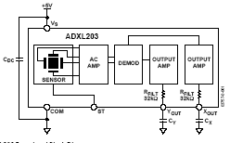
Here is the circuit for the Acclerometer. This Comes straight from the data Sheet.

Accelerometer Sensors
The accelerometer is the ADXL203 also from Analog Devices. This particular accelerometer outputs two analog signals one for the x and y axis. It measures the acceleration due to gravity on the x and y axis parallel with the top of the chip. When the top of the chip is perpendicular to the force of gravity the output on both analog channels is 2.5V. As the chip is rotated on either of the axis the voltage will increase or decrease depending on the direction of rotation.
The difference between the accelerometer and the angular rate sensor is that the angular rate sensor will go back to 2.5V after it has been rotated and will not tell you which way is up. The accelerometer will put out a voltage proportion to its acceleration due to gravity as long as it remains in that position. Also, the accelerometers are not very accurate in yaw measurements.
This sensor was very useful for the previous autonomous plane project because it could be used to measure very important tilt information for the aircraft. Now the roll an pitch axis are very stable due to the gyroscope nature of the motor. It is like a spinning top where it will remain stable and will resist rotational forces perpendicular to the axis that is spinning.
So, now this sensor will be used to tell the craft if it is upright in the event of a flip over or crash. The processor will immediately shut down the engines if the craft is flipped upside down or tilted more than 45 degrees.

Testing
To test the accelerometer the same program used to test the angular rate sensor can be used. This time the sensor was mounted to a protractor to be able to correspond values of the a/d to the actual angles. This data is seen below.
Angle | A/D
0 | 19584
20 | 20352
40 | 22912
60 | 26240
80 | 30720
90 | 32896
100 | 35200
120 | 39104
140 | 42368
160 | 44672
180 | 45440

These data values are consistent with what the data sheet says. As you can see in the graph there can be a linear approximation from 45 to 135. The data sheet says that at plus or minus 45 degrees there will be a linear relationship but below or above these values the slope is different.

Sonar
The sonar range finders used are made by a company called Devantech. The sensors are the SRF04. These sensors will allow a microprocessor to accurately measure distance. It uses a sonar ping to detect distances to objects by calculating the flight time of the ping and using the known speed of sound.
The processor will pulse a high signal on the input trigger line for approximately 10us. The SRF04 will then send out a 40khz-modulated signal via transducers as soon as the input trigger line goes low. Then the processor will wait for the echo line to go low once it goes low this is the time of the arriving echo. The two times subtracted will yield the approximate echo flight time. The distance can then be calculated using a simple equation:
Distance =(echo time) / (conversion factor)
The conversion factor for a unit of centimeters is 29us.
The hovercraft will use four of these sonar sensors mounted on rotating servos to detect objects. This will allow a full 360 degree perception of objects around the hover craft up to about 10ft. This information can then used to determine how to drive the motors to avoid the objects.

Testing
As mentioned before the signal must be timed and then the angle computed by the processor. The test is simple just put an object at known distance and record the value in centimeters output by the processor. These values can be tabulated and graphed to verify the linear relationship.

GPS
The global position system module is a Rikaline 6010 that outputs a serial signal in NMEA standard format. This format provides the GPS coordinates, velocity, and heading. This is going to be the backbone of the navigation system. The navigation system takes the Data and filters out the latitude, longitude, velocity, and heading. Then uses this data to guide the hovercraft to the pre programmed coordinates.
NMEA Format
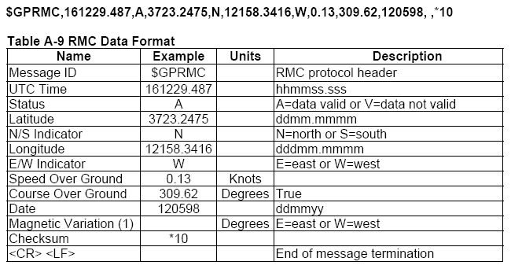
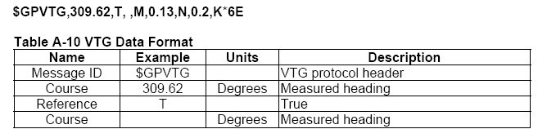
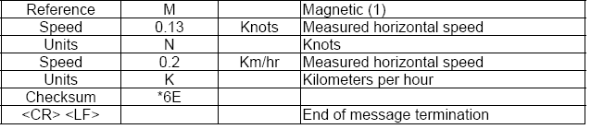
The basic software program will look for the headers (ie GPVTG) and then use the commas as delimiters to determine where the data needed is at. It is a little more complicated than that because there is a need for conversion from ASCII to usable data for the decimal numbers. A basic program that will just take what is coming in to the rx and displays it on the LCD is at the end of this report.

