University of Florida

Department of Electrical and Computer Engineering
EEL 5666 - Spring 2005
Intelligent Machines Design Laboratory

Instructor: A. Arroyo
TAs: William Dubel, Steven Pickles

FINAL REPORT

April 19, 2005

R. Michael Ihns

Table of Contents

I. Abstract 3
II. Introduction 3
III. Integrated System 3
IV. Mobile Platform 5
V. Actuation 6
VI. Sensors 6
- Ultrasound 6
- IR 7
- CDS Cell 7
- Solar Panel 7
- Microphone 7
- Accelerometer 8
- Wireless Video Camera 8
VII. Behaviors 8
VIII. Experimental Layout and Results 9
IX. Conclusion 9
X. Documentation 9
XI. Appendices 9

Abstract

The purpose of this paper is to describe the design, construction, and testing of a robot named ELSI (Electronic Light-Seeking Insect). This report will provide an overview of the components and methods used to allow the robot to fulfill its objectives. The platform, actuation, sensors and behaviors of the robot will be described.

Introduction

ELSI is a compact and efficient multi-legged walker. Her main goal is to survive without human interaction by replenishing her power source on her own and avoiding hazardous situations. She mimics the basic behaviors of a generic insect and can be treated as a pet. Her behaviors are those common to an insect and include obstacle avoidance, avoiding walking off edges, light-following and reacting to people and animals. She will also produce sounds and lights to express her state to her master.

Integrated System

Similar to an insect, ELSI walks on six legs. The leg movement is modeled after real insects and permits three legs to be on the ground at all times in a tripod arrangement. This tripod arrangement keeps ELSI stable over most kinds of terrain and makes it difficult for her to fall over. The walking pattern can be achieved using a variation on a widely known setup of three servos. The front and rear legs on each side of the walker are linked together and each controlled by one servo. The third servo tilts the center legs back and forth, which causes the robot to lean and lift or lower its other legs.
To make her self-sufficient, a solar panel is be used to recharge ELSI’s batteries. CDS cells are used to sense light intensity and direction, so that she can find the brightest light source to charge herself with. Muscle wire was considered for leg movement because of its muscle-like properties, but high current draw, low efficiency and difficulty of implementation made sub-micro servos a better choice.

Mobile Platform

To keep ELSI light and efficient, a very light yet strong platform is used. Carbon fiber is an ideal material in this regard and is used for to construct the body and legs. ELSI consists of platform three levels. The servos, battery, on-off switch, ultrasound module, and legs are all attached to the lower level.

The second level of the platform houses the custom PCB that was designed for this project. A solar panel, which ELSI uses to recharge herself, is mounted on the top level of the platform with Velcro and is removable. The LCD screen is also attached to the top level with Velcro, and can be removed when not needed to reduce weight and power consumption.

Printed Circuit Board

ELSI’s custom circuit board houses the microcontroller, power supplies, and sensor circuitry. The microcontroller board used was the Crumb8, which is based on the Atmel Atmega8 microcontroller. Figure 1 below is illustrates the general layout of the board. Two switching regulators are used – the LM2599T-5.0 (U1) and the LM2574HVN-5.0 (U2) – both made by National Semiconductor. Switching regulators were chosen for their high efficiency levels, which are in the range of 80% to 95%. The LM2599 is capable of continuously supplying 3 amps and is used to power the servos and most sensors. The ambient light level CDS cell, passive infrared sensor, and microcontroller are powered by the LM2574, which can supply up to 500mA.
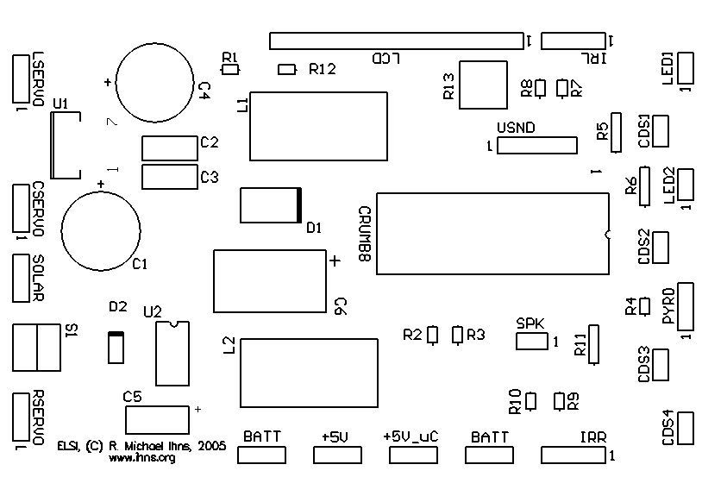
Figure 1 – ELSI’s custom PCB

Headers for every sensor are provided on the board. Headers are also provided for testing each voltage regulator (this came in very useful). The microcontroller is also interfaced with a piezoelectric speaker and an LED so that ELSI can provide visual and audio feedback. A power LED is also provided to indicate that the larger voltage regulator is on and the robot is in active mode. A small LED on the microcontroller let’s the user known whether the microcontroller is on.

Actuation

ELSI walks using a variation of a common method for six-legged robots which uses only three servos. Walking takes place in four stages, which are as follows:
- The center servo lifts the left side of the robot.
- The left servo moves the left front and back legs forward together. At the same time, the right servo moves the right front and back legs backward.
- The center servo lifts the right side of the robot.
- The left servo moves the left front and back legs backward, while the right servo moves the right front and back legs forward.

This scheme allows three legs to be on the ground at all times in a tripod arrangement, which provides optimal stability for the robot. Walking backwards and turning can also be similarly achieved in four stages.

ELSI uses three sub-micro servos manufactured by Naro for move her legs. Sub-micro servos made by Draganfly Innovations Inc. were originally used, but didn’t have enough torque to move the legs when the robot was at full weight. The Naro servos are the same size as the Draganfly servos but have very high torque for their size, generating around 27 oz-inch at 4.8V. The servos are controlled by the three PWM channels on the Atmega8.
Sensors

Ultrasound
ELSI uses a single Daventech SRF04 ranger for navigation and obstacle avoidance. This ultrasound module is compact, light, low current, and has a range from 3” to 10’.

IR
Two Fairchild QRB1134 infrared photoreflectors are used for edge detection. One sensor is attached to the foot of each front leg and is pointed towards the ground. These sensors have a short range and are ideal for detecting whether or not there is an edge present.

CDS Cells
Cadmium-sulfate (CDS) cells are used for light-following and measuring the ambient sunlight level. These cells act as resistors that increase in resistance in low light. Three CDS cells are used for light-following – one is pointed forward and one pointed to each side. The cells are mounted inside tubes to block out ambient light and are connected in series. The three cells will be connected together in series so that only two ADC inputs need to be used in order to determine the voltage across each cell, as shown in Figure 2 below.
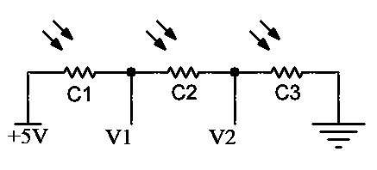
Figure 2 – Circuit diagram for light-direction-sensing with 3 CDS cells

Table 1 shows how the voltage drop across each cell is calculated from voltage measurements V1 and V2. Since the resistance across a CDS cell decreases as light intensity increases, the cell with the smallest voltage drop is seeing the most light and the cell with the largest voltage drop is seeing the least amount of light.

Cell | Voltage Drop
C1 | 5V – V1
C2 | V1 – V2
C3 | V2

Table 1 – Calculation of Voltage drop across each CDS cell

The fourth CDS cell is open and measures the ambient sunlight level. Measurements made from this cell are used to determine if the light level is strong enough to allow the solar panel to charge the batteries.

Passive Infrared Sensor

A passive infrared (PIR) sensor senses changes in the infrared radiation that is emitted by living creatures. This gives ELSI the ability to detect and react to the movement of people and animals. The PIR sensor used was removed from a motion sensor purchased at Lowe’s for $9. The model number printed on the sensor is KDS-4G1. No datasheet could be found, but the pin out was discovered through experimentation and is shown in Figure 3 below. It was determined from research on other PIR sensors that it should be connected to power through a resistor in roughly the 30 kilo-ohm to 3 mega-ohm range. It was also found that a 10uF capacitor should be used and that a resistor should be connected between the output and ground as well. To keep current draw low, ELSI uses a 1 mega-ohm resistor.
GND
OUT
VCC
Figure 3 – PIR Sensor Pin Out

The output of the sensor is around 1 volt. When motion is detected, the output either increases or decreases depending on the direction of the motion. The range of the output is affected by the intensity of the infrared heat detected.

Solar Panel and Charging Circuit
ELSI uses a solar panel to charge her batteries. Lithium-polymer batteries were used because they are compact, light-weight, and relatively easy to charge. ELSI uses a ThunderPower 7.4V (2-cell), 730mAh lithium-polymer battery that weighs only 31 grams. An 8.5V, 100mA solar cell array was originally used to charge the battery but did not provide enough voltage to charge the batteries, which had an unexpectedly high internal resistance of roughly 40 ohms. A much larger solar panel manufactured by PowerFilm, which outputs 19V and 120mA in full sunlight, was then used. This larger solar panel is made of a thin film and is much lighter than the original panel.

A diode is connected after the solar panel in order to prevent it from discharging the battery in low light. The solar panel constantly contributes some current to the circuit, making the robot very efficient. If the sunlight level is high enough to charge the batteries, ELSI can turn off the main voltage regulator and monitor the battery voltage through a voltage divider circuit which uses high-accuracy one mega-ohm resistors. Once the battery reaches full charge at 8.4V, ELSI will “wake up.”

Behaviors

ELSI mimics the basic behaviors of an insect. She is friendly and interacts with people but never has to be fed, making her an ideal pet.

Edge Detection
When first turned on, ELSI first calibrates her IR sensors used for edge-detection by leaning to each side recording the maximum and minimum values the sensors will output on that particular surface. As she walks, measurements are taken from the IR sensors whenever the feet are flat on the ground. If ELSI detects a value that is significantly larger than the calibrated value, she will assume she has found an edge. She will then extend her front leg forward and take another measurement to double check that there is in fact an edge. If she still sees an edge, she will back up, turn around, recalibrate the IR sensors and then continue with normal operation. If no edge is detected during the second measurement, she assumes that the surface has changed and recalibrates the IR sensors before continuing with normal operation. This method works very well for edge detection and this paper’s author has never seen it fail.

Obstacle Avoidance
When ELSI walks, she pivots around the center leg with each stride, which produces a slight “swaying” motion. This natural motion works perfectly as a scanning motion for the ultrasound module. The software takes readings from the ultrasound module at each peak in this pivoting motion, and keeps this information in short-term memory. ELSI then makes decisions on which way to turn when obstacles are encountered based on whether the closest object is located to the right or the left. This method works very well for obstacle avoidance and makes the robot look like it is making intelligent decisions about where to go. The method works very well for navigation through hallways and doorways.

Power Management
ELSI constantly monitors her battery voltage through a voltage divider circuit. When the battery level is high, she navigates using only feedback from the ultrasound module, making obstacle avoidance decisions as described above. When the battery voltage starts to drop, she will switch to light-seeking mode, where she will make decisions based on the direction with most light. This helps ELSI find a light source that is bright enough for her to charge her batteries with. At any point in time, if ELSI finds bright sunlight and the batteries are not fully charged, ELSI will stop and allow herself to charge. Finally, if the battery voltage falls below a critical level, ELSI will switch off her main voltage regulator and put the microcontroller in power-down mode to conserve power. She will periodically produce a “beep” through her piezoelectric speaker to warn her owner that she is in trouble. She will only wake up from this state if the battery voltage increases to a safe level.

Motion Detection
ELSI uses a passive infrared sensor to detect people and animals. During normal operation, ELSI will walk around and will check her PIR sensor every 2 minutes. If she detects no motion (i.e. no one is playing with her), she will go into sleep mode. In this mode, she monitors her PIR sensor and will only wakeup when she detects a person or animal interacting with her. This means that ELSI will not be active and make noise at night or when no one is home. This feature also makes her an ideal toy for a cat or dog (assuming the animal does not eat her).

Run Modes and Visual and Audio Feedback
A board-mounted button allows ELSI’s owner to change her run mode. ELSI’s run mode can be cycled through by pressing this button. The run modes can be changed between normal, light-seeking, obstacle avoidance, and sleep. ELSI lets her owner know which mode she is in by blinking an LED and beeping a different number of times for each mode. If an LCD is attached, she will display her current mode on the screen.

Experimental Layout and Results

The custom PCB did not function initially because of several design mistakes. These errors were fixed by soldering some jumper wires and cutting some traces so that eventually all of the sensors functioned correctly.

Fine-tuning ELSI’s walking and edge detection was very time consuming and required a lot of experimentation. The edge detection was tested in several different environments and in several different surfaces and always worked very well, rarely giving false readings and never walking off an edge.

Experiments were also conducted on the solar charging circuit. Table 2 shows the results of an experiment conducted with the first solar panel used. Table 3 shows the results with the Power Film solar panel.
Property Measured | Value
Initial Battery Voltage | 7.71V
Solar Panel Voltage | 8.08-8.30V
Short-Circuit Current | 90mA
Current Through Battery | 10mA
End Battery Voltage | 7.72V
Table 2 – 4.5 Hours of Full Sunlight with Edmund Scientifics 8.5V Panel

Property Measured | Value
Initial Battery Voltage | 7.57V
Solar Panel Voltage | 19V
Short-Circuit Current | 120mA
Current Through Battery | 120mA
End Battery Voltage | 7.63V
Table 3 – 2 Hours of Full Sunlight with Power Film 15V Panel

The tables above highlight the huge difference in performance between the two solar panels used. Second solar panel is much higher voltage and easily overcame the battery’s internal resistance, allowing it to charge at full current. Also note a much larger increase in battery voltage, even though the Power Film panel was only left in the sun for half as long.

The ultimate experiment, which would involve letting ELSI run free for several days to see how long she can survive, is yet to be conducted. In order for ELSI to succeed, the home she lives in must have windows that allow plenty of sunlight that ELSI has access to.

Conclusion

Although ELSI has not undergone any long term testing, there is strong evidence to suggest that she would be able to survive on her own, supplying herself with her own power, without the need human intervention. Besides her success as a hexapod walking robot and an electronic pet, ELSI has shown that a fully self-sufficient robot is clearly very real possibility.

Documentation
Component Sources Cost
Crumb8 Microcontroller Board chip45.com $24.00
Devantech SRF04 Ultrasonic Range Finder junun.org $32.00
Fairchild QRB1134 IR Photoreflectors junun.org $4.00
Carbon Fiber Sheets RobotMarketPlace.com $32.90
PowerFilm 15V 100mA Solar Panel sundancesolar.com $42.75
PCB Fabrication 4pcb.com $33.00
Naro Sub-Micro Servos (4, one spare) junun.org $64.00
Thunder Power 2-cell 7.4v 730mAh Lithium Batt rctoys.com $29.95
Pyroelectric (PIR) sensor Lowe’s $9.00
LCD Screen (already had it) Free
Piezoelectric Speaker (already had it) Free
Wires, tubing, screws, and other hardware Ace Hardware N/A
Board components, AVR programmer Digikey.com N/A
Misc. Lowe’s , Radio Shack N/A

Appendices
Custom PCB Schematic
(see following page)

