3/17/05
Eric Neihaus
TA: William Dubel
Steven Pickles

Instructor: A. A. Arroyo

University of Florida
Department of Electrical and Computer Engineering
EEL 5666C
Intelligent Machines Design Laboratory

Special Sensor Report
The golf ball colleting robot will detect the center (centroid) of a white golf ball on green, well-cut grass. The sensor works on a [RGB] = [Red Green Blue] color space. Each pixel has a corresponding [RGB] value. The sensor comes with a built in track color command (TC) that will detect the centroid of a user defined color in [RGB]. The user supplies upper and lower bounds for an acceptable value of color before the track color command is run. With the upper and lower bounds, the sensor knows what to look for.
Adjustments can be made for the size of the viewing screen with another built in function that uses a Cartesian coordinate system superimposed on the viewing screen of the camera. This value will be set so that the relative location of the centroid of the golf ball can be determined. Fuzzy logic will be used to define the PWM signal sent to each motor based on the region of the screen the centroid lays.

This report includes a trial run of the camera at 2:00 on Monday, March 14, 2005 at the university golf course driving range. The sensor had to contend with white sand poured over divot holes on the turf, so the difficulty was greater than needed. The grass was short, which worked to the advantage of the sensor, so the overall rating for difficulty of terrain was medium. The test went much better than expected. An IR lens filter is available for outside operation, but it will not be needed for my short range of detection (~20 feet). The camera will yield an even sharper image when the camera is still when resting on the frame of the robot. My hands are somewhat shaky, but it did not prove to be a problem for the camera.
Location dimensions are given for the location of the camera on the robot. Finally a demonstration for the camera operation when using the track color command is given via a screen shot of the graphical user interface (GUI) that came with the camera.

TC [ Rmin Rmax Gmin Gmax Bmin Bmax ] \r

According to the user manual, this command begins to Track a Color. It takes in the minimum and maximum RGB values and outputs a type T packet. The RGB values are defined by the user. A pure white object would have the value [RGB]=[240 240 240]. I tried various values of the lower and upper bounds. The following picture frame has a ±10 pixel for acceptable red, green, and blue color values:

Figure 1: Color Tracking with Upper and Lower Bounds of
[230 250 230 250 230 250]
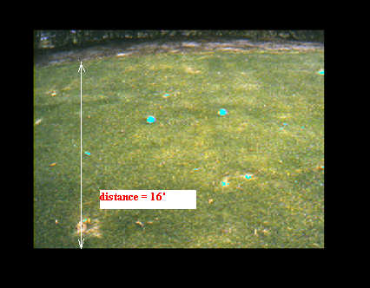

A type T packet, by default, returns the middle mass x and y coordinates, the bounding box, the number of pixels tracked, and a confidence value. The x and y coordinates are of primary interest since they will be used to direct the motors towards the golf balls.
The above image was generated by holding the camera at about 24’’ off the ground and pointing it towards the golf balls. The tilt angle was a little bit greater than will be used for the actual location of the camera when mounted on the robot frame. This angle is adjustable due to the mounting hinge that is part of the camera mount:

Figure 2: Camera Mount with Cabinet Hinge for Angle Adjustment
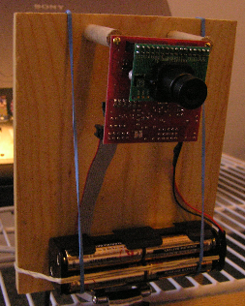

Figure 3: Horizontal Mounting Height for Camera
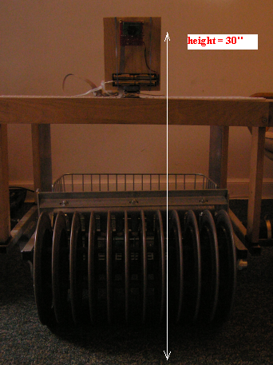

The height of the camera was determined by the trial photos taken when testing the sensor performance. About 24’’ was the height used when taking the photo shown in Figure 1. At this height, more than 16 feet of area was easily visible to the camera. With the added height of about 6 inches and the reduced tilt angle towards the ground, the camera will have an even larger field of vision. Again, the tilt angle of the camera lens with respect to vertical is an adjustable parameter, so the field of vision has a range. The following picture is the screen image the GUI gives when tracking a color:

Figure 4: Track Color Command
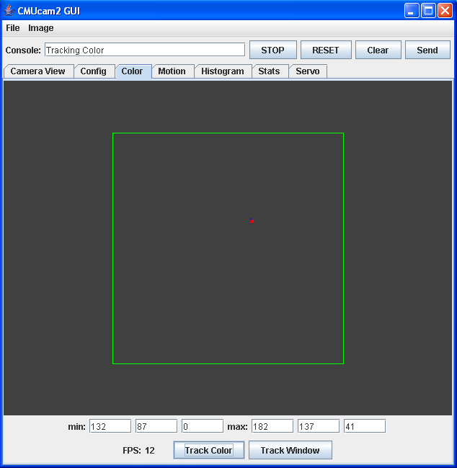

The red dot on the screen represents a golf ball on the turf.

VW [ x y x2 y2 ] \r

This command will set the Virtual Window size of the camera. It accepts the x and y Cartesian coordinates of the upper left corner (1,1) followed by the lower right of the window that will be set. The origin is located at the upper left of the field of view. VW can be called before an image processing command is made to constrain the field of view. Without arguments it returns to the default full widow size for the current combination of camera type, downsampling and resolution mode. Reducing the window size would speed up processing time when using the track color command, but time will not be an issue for this robot since it is not doing motion detection.

GT \r

This command will Get the current Track color values. Without the GUI, this command is a useful way to see what color values track window is using.

