University of Florida
Department of Electrical and Computer Engineering
EEL 5666
Intelligent Machine Design Laboratory

Sensor Report

3/17/05
Clifford Pannella

Sensor Suite:

“Dice” will be able to complete his duties by receiving information from a variety of sensors. These sensors will integrate and interact with the ATMEGA128 microcontroller to successfully play a game of craps: roll the dice, search for and find the dice, read the value rolled, calculate a win or a loss – all while avoiding obstacles.

The sensors that will be used in this process: bump sensors, infrared sensors, and photoreflectors. The infrared sensors and photoreflectors will be serving multiple purposes.

These sensors are individually explained in the subsequent pages.

Bump Sensors:

The bump sensors that will be used for this project are small chips with 4 pins. Approximately 6mm x 6mm in area, they are implemented by attaching a voltage to either of the pins on one side of the sensor, and measuring the voltage on the corresponding pin on the other side. The wiring inside represents a simple switch. When the button is pressed down, or “bumped”, the switch is closed and the opposite sides of the sensor are electrically connected, thus a voltage placed at say, the left side, can be read as an equal voltage on the right.

If the sensor is left “unbumped”, the switch is left open and no voltage will be produced at the output

“Dice” will use a set of 5 bump switches to successfully avoid obstacles – three placed in a semicircle at the front of the bot, and one placed at each of the back corners. The sensors will be wired to a digital port, and a voltage will be constantly provided, so that if any of the sensors are tripped the controller will be able to immediately identify it and execute a successful navigation of the obstacle.

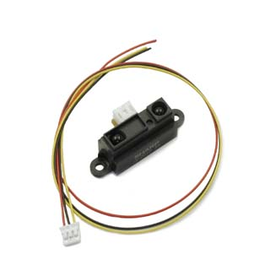
Infrared Sensors:

The infrared sensors used on “Dice” are Sharp GP2D120 Infrared Object Detectors. The GP2D120’s have identical electronics to the GP2D12’s, but have special lenses that give it a shorter detection range. This range is from about 4 cm to 30 cm.

There will be three IR sensors placed on “Dice”. Two will be mounted on the front on either side, about 3-4 centimeters above ground level. They will be slanted slightly inward so that their effective areas of sensoring are overlapping. If a die is in front of the bot, they will be able to sense it and the platform will do the necessary movements to line up the die and get it to the housing area. The third sensor will be placed on top of the platform and will be for object avoidance. The microcontroller will take the readings from all three sensors, and if the top sensor is transmitting a significantly lower analog voltage, it means that the object is a die. If all sensors are giving approximately the same output, then it is likely a wall and the servos will be put in reverse.

Experimentation/Results:

Sharp GP2D120 Infrared Object Detectors

Distance (cm) | Output Voltage (V) | Distance (cm) | Output Voltage (V)
0 | 1.23 | 32 | 0.34
2 | 2.35 | 34 | 0.29
4 | 2.98 | 36 | 0.26
6 | 2.65 | 38 | 0.23
8 | 1.97 | 40 | 0.21
10 | 1.20 | 42 | 0.17
12 | 0.97 | 44 | 0.15
14 | 0.91 | 46 | 0.14
16 | 0.81 | 48 | 0.12
18 | 0.68 | 50 | 0.09
20 | 0.60 | 52 | 0.08
22 | 0.56 | 54 | 0.06
24 | 0.48 | 56 | 0.05
26 | 0.42 | 58 | 0.04
28 | 0.41 | 60 | 0.03
30 | 0.37 | 65 | 0.03

OUTPUT
VOLTAGE
(V)

OBJECT DISTANCE (cm)

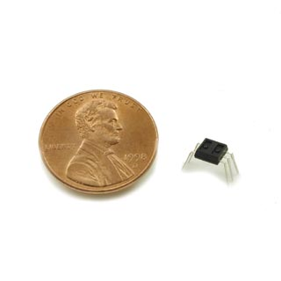
Special Sensor:

The special sensor of “Dice” is a combination of Hamamatsu photo IC digital output photoreflectors. These chips have a high-power infrared LED which interacts with a low voltage photo integrated circuit. The circuit consists of a high sensitivity photodiode, amplifier, Schmitt trigger circuit, and output phototransistor.

The output of the photoreflector is simple: if it finds a white reflective surface above it closer than about 6mm, it outputs 5V. Otherwise, it outputs 0V.

Here is a pinout for the P5587 photoreflector:
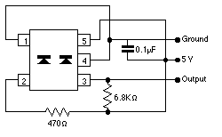

Pin 1: Cathode
Pin 2: Anode
Pin 3: Vout
Pin 4: Gnd
Pin 5: Vcc

The load resistance of 6.8KOhms is relative, and can be anywhere from about 2 to 10 KOhms. The resistance between the Anode and 5V should be under 1KOhm. The capacitance should be around 0.1uF.

Besides the special sensor, a series of photoreflectors will be placed underneath the robot to exhibit proper line-following techniques. There will be four of them in a diamond shape: the top and bottom chips (when looking at the bottom of the robot) will always stay on the line (black), while the two side photoreflectors will be on the transition of the line and the rest of the floor (white). If the controller gets a signal that one of the side reflectors is reading white while the other hovers over the line, it will compensate by sending new values to the servos to get back on track.

Experimentation/Results:

Hamamatsu P5587 Photoreflector:
Distance (mm) | Output Voltage (V) | Distance (mm) | Output Voltage (V)
0.0 | 4.88 | 4.5 | 5.02
0.5 | 5.02 | 5.0 | 5.02
1.0 | 5.02 | 5.5 | 5.02
1.5 | 5.02 | 6.0 | 2.11
2.0 | 5.02 | 6.5 | .42
2.5 | 5.02 | 7.0 | .07
3.0 | 5.02 | 7.5 | .04
3.5  (1,4) OR (1,2) | 5.02 | 8.0 | .03
4.0 | 5.02

OUTPUT
VOLTAGE
(V)

OBJECT DISTANCE (MM)

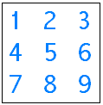
To correctly figure out how to implement my special sensor to be able to read the values of the dice, I first had to come up with an algorithm. I gave values to all possible positions of a black dot on a die:

I then looked at the value of “1”. Using a simple logic equation, a “1”, using the values of the above template, turns out to be:

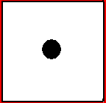

5 and not (1,2,3,4,6,7,8,9)

However, this can obviously be simplified. Using this type of equations for all values would be inefficient and overly-expensive, using nine photoreflectors for each die. In addition, the 2, 3, and 6 have two permutations for how they can lie. After all things were considered, here are the equations I came up with:

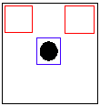
5 AND NOT (1,3)

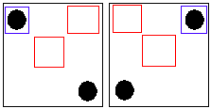
1 AND NOT (3,5)
OR
3 AND NOT (1,5)

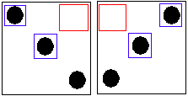
(1,5) AND NOT 3
OR
(3,5) AND NOT 1

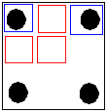
(1,3) AND NOT (2,4,5)

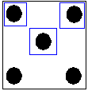
(1,3,5)

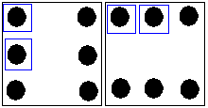

(1,4) OR (1,2)

Using these equations, it is easy to see that only five, not nine, photoreflectors are needed for each die, saving eight sensors total (at $2.20 a piece that’s almost a $20 savings). Here is a drawing on how the reflectors will be positioned on the chip, as well as where they will be when placed over the dice:
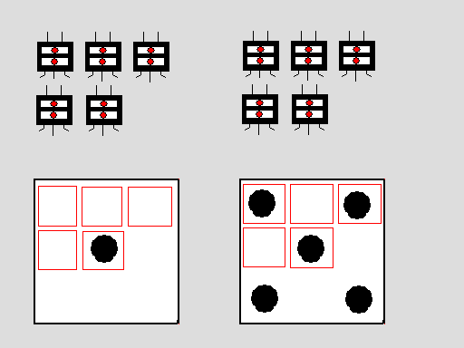

The only other issue is how to get the dice directly underneath the special sensors so that they can be properly read. This will be solved by having a sort of horizontal funnel underneath the robot so that when a die is found, the bot can just drive over it and it will be properly housed for reading. The sensors will be placed about 3-4 cm above the dice.

Sources for Parts:

Acroname –

Sharp GP2D120 Infrared Sensors
Quantity: 3
Price: $12.50

Hamamatsu P5587 Photoreflectors
Quantity: 14
Price: $2.20

In Lab –
Bump Sensors
Quantity: 5
Price: Free

