EEL 5666 IMDL

Spring 2005

Final Report

Instructor: Dr Arroyo, Dr Schwartz

Student: Justin Seabrook

Date: 04/19/05

Table of Content

Abstract...................................................................................................................... page 3

Executive Summary................................................................................................... page 4

Introduction................................................................................................................ page 5

Integrated System/ Actuation..................................................................................... page 5

Mobile Platform......................................................................................................... page 8

Sensors ..................................................................................................................... page 11

Behaviors ................................................................................................................. page 13

Conclusion ............................................................................................................... page 14

Abstract

In this report is the outline of the EEL5666 project. The project originally was to create a Platform Leveling Robot. That used two gyros and two accelerometers to keep the main chassis of the vehicle level over varying terrain. As difficulties and lack of electrical knowledge followed the final project was finally called Miracle. It is an obstacle avoidance robot using two bump switches and IR proximity detector to establish the presence of an object and adjust the servo motor accordingly to establish a new path. Other features are a LCD screen that is used for debugging purposes as well as a way to let the user know of progress.
Executive Summary

To start off the project an elaborate mechanical chassis was sketched using for independently controlled wheels at four corners of a platform. This platform was abandoned after some mechanical difficulties as well as the realization of the time necessary to learn the code necessary for the microcontroller. A RC tank with a built in gearbox was then purchased and stripped provide an area for a Plexiglas tray to attach components too. To increase the flexibility of this tray all components were placed using Velcro. The microprocessor chosen for this project was the MekVAR128 from Mechatronix. It is based on the Atmel128 and has a built in boot loader. Next a dual h-bridge was purchased to handle the DC motor control. This required a 5V power source so a 5V regulator was used in conjunction with a power strip made of jumpers for further expansion. Next a Hitachi LCD screen was acquired along with the necessary invert required to do the back lighting. Two bump switches were placed on the front for my first sensor. All items were constructed and powered and then programming was started. Being a mechanical engineer hindered this process drastically. Programmers Notepad with WinAVR was used for writing and compiling the code and HyperTerminal was used for downloading. After progress was made on the LCD the H-bridge was found to be faulty and forced another chassis change to a wood framed servo driven form. The Plexiglas tray with all components was moved whole to the new chassis and work on programming commenced again. Once the servos, bump switches, and LCD was operational an obstacle avoidance code was written. At this point the projects name became Miracle, because it was a Miracle it was working. The final undertaking was an IR detector that was implemented to aid in object detection.
Introduction

The original problem came from the leveling of mobile lift platforms in construction sites. As they move they sway and rock causing a unsafe condition for workers. If the tires were individually raised and lowered to keep the chassis level it would alleviate the problem. A servo operated model of the same problem combined with gyros and accelerometer would be an excellent test bed and was the original basis of the project, but was an to ambitious goal, but one that will be continued after this class. As the difficulties mounted the scope was narrowed and the following is the outline of that journey and the obstacle avoidance robot called Miracle that was the final result.

Integrated Systems/Actuation
The system consists of the following components:

- Microprocessor – The MekVAR128 from Meckatronix was used for the microcontroller. It is based on the Atmega Atmel128 set on an 8MHZ clock. It has a boot loader and other integrated addition like servo power rails and more. Programmers Notepad with WinAVR was used for writing and compiling the code and HyperTerminal was used for downloading.
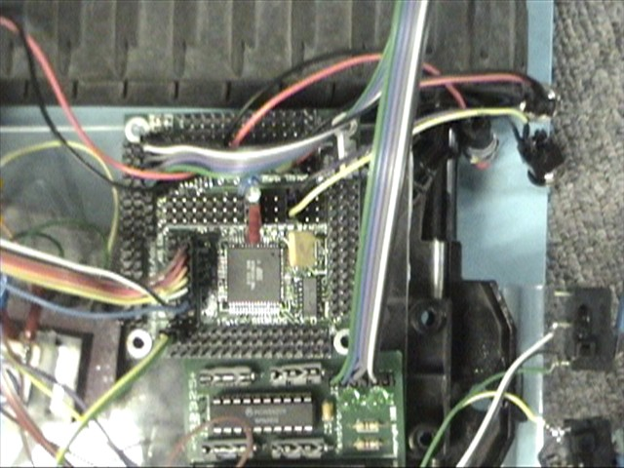
- LCD - A Hitachi LCD screen with a 2X20 character display was used. This display required a 50 character inverter to power the back lighting necessary to view the characters. It was setup for four bit mode in the code and worked well after mach initialization timing problems.
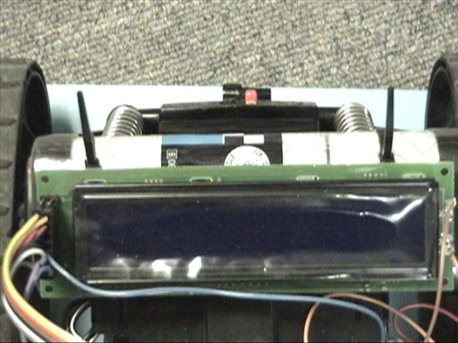
- Dual H-Bridge – This was purchased from Lynxmotion and assembled. This proved to be an effort in futility and was later discarded for servo motion. The H-bridge was very difficult to program as well as the DC motors wanted a high amperage draw because it was built for speed so it was proving rather difficult to get stable fluid motion.
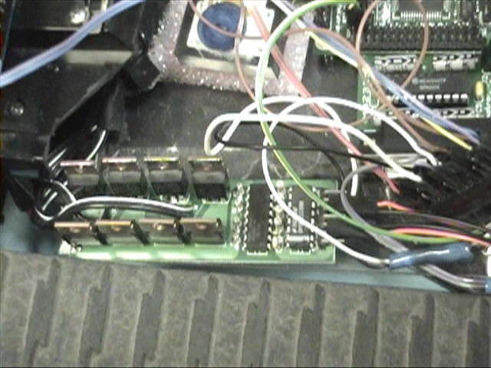
- Servos – This was opted for after the failure of the H-bridge integration. They required a PWM for controlling and were integrated much easier.
- Battery – A 7.2 Volt NiCad battery pack was recommended by Mekatronix and powered the board directly.
- Power Rail – A 5V power regulator was used to drop the voltage to a rail made of headers soldered together and the coated in Plasti-Dip for insulation.

Mobile Platform
The original platform was a RC tank that was dismantled and space cut out for the necessary components. This chassis was selected because of the single side drive supplied by one DC motor per side. This chassis also featured a built in selectable gearbox that would reduce the overall speed. The components were all affixed to a removable Plexiglas tray by Velcro to make for quick interchangeability if necessary. After the H-Bridge problems it proved to be a necessary and made the switch to the new chassis almost seamless. The new chassis is made of a wooden base that with servos attached to both side and a plastic slider attached to the rear. The Plexiglas tray was then attached to the top. 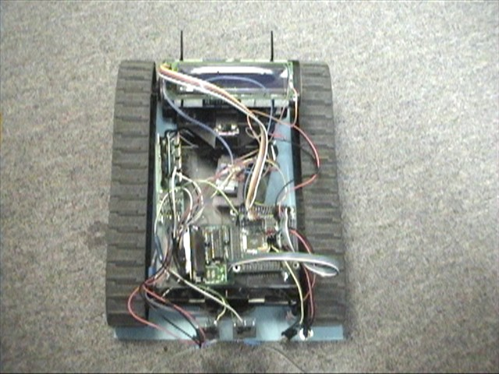
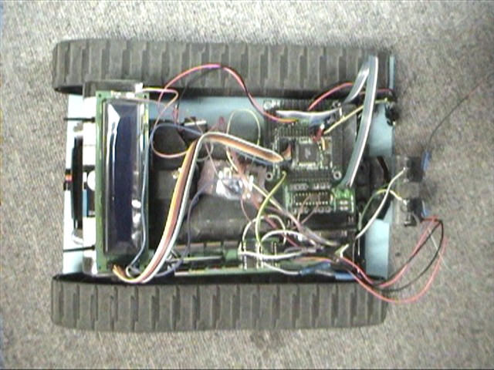
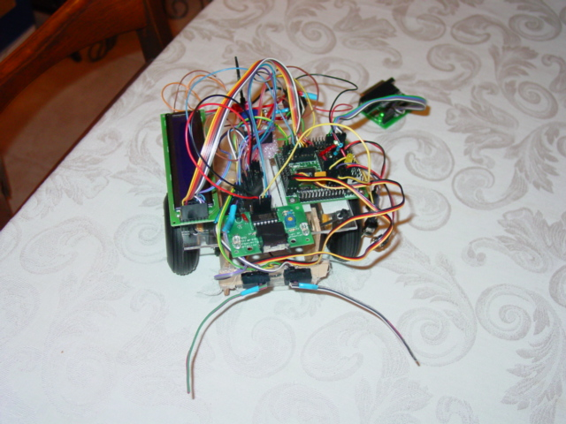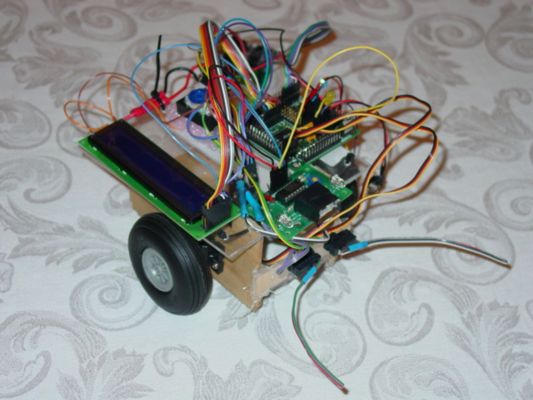

Sensors
- Bump Switches - There are two bump switches located on the front of the robot to sense contact with any object. They are oriented on the right and left of the front of the robot. This will allows me to obtain obstacle avoidance code that can make a logical distinction on the best way to proceed to overcome the object.
- IR Sight – This system was purchased from Lynxmotion and is used to detect objects in the path motion. This will aid as a early warning system to the bump switches. It was integrated into the obstacle avoidance code as well as the LCD display to give a hex value of the current output of the IR detector.
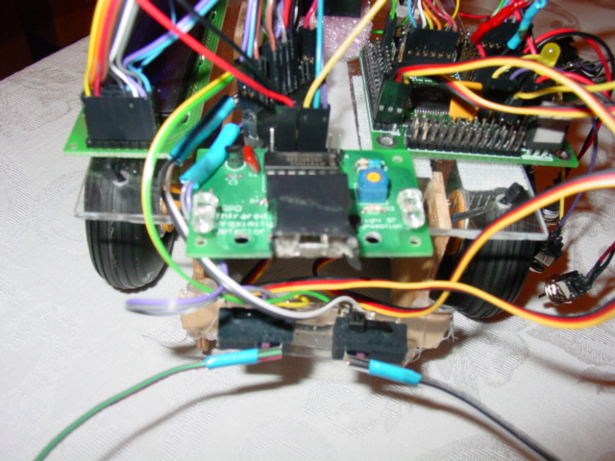
- Platform Leveling – Special Sensor Idea. A platform would be constructed in the middle of my current base. On this platform will be four servos positioned at each corner. These will be used to actuate each corner up and down to keep level. On this platform will be two gyros and two accelerometers oriented in the XY direction. XY will be defined as forward and back and side to side on the robot. The gyros selected are ADRXS300 from Analog Devices. The gyros will sense the tilt angle and respond accordingly. The accelerometer selected is a dual axis ADXL311 from Analog Devices. The accelerometers are used as a filter and backup system for the gyros. Gyros are not extremely fast with there reaction times to sudden launches, stops, vibration, or impacts. However accelerometers are very good in detecting the above conditions. So by using them in a algorithm comparing the two outputs a logical and effective outcome should be produced to actuate the servos and keep the platform level. Level will be gauged by two methods. First a bubble level will be affixed to the platform to give a accurate reading in relation to gravity, and a small object with a high moment of inertia will be used as a physical demonstration.

Behaviors
The robot has the following behavior:
- Initialization: The robot boots up and initialize the LCD and timers necessary for the different function. Next it displays “None” on the LCD screen to represent no bump switch has been pressed. On the next line of the LCD is the IR sensor hex display. The servos start forward motion at 10% output.
- Obstacle avoidance: The robot proceeds to wander around. If the object is tall enough to see an object with the IR detector it will change course to the right until it is no longer seen and then proceed. If the object is to short the IR will not see it and the bump switches will make contact on the right or the left and then backup and proceed to the right or the left away from the object and then move forward again. This will happen until theh object is overcome. As all this is going on there is constant information changes on the LCD to give a visual read out of the happenings with the robot.

Conclusion
Through all the struggles of this project this is a fully functioning obstacle avoiding robot with LCD readouts. By far the most difficult part of the project was the lack of electrical knowledge and the learning coding necessary to control the microprocessor. That combined with the common problems of integration, board failures, short circuits, ect made for a challenging though education experience. Overall I my goal for this class was to learn more about the application and inner workings of the electronics that are becoming more apart of the world around us. I believe I have successfully accomplished that goal. I plan to continue on this project and complete the platform leveling special sensor implementation that I originally planned using the base knowledge I gained from this semester project.

