DUSTY

The Intellivac

Aaron Tucker

Intelligent Machine Design Laboratory

Spring 2005
Table of Contents

Abstract 3

Executive Summary 4

Report on Dusty
Introduction 5
Integrated System 6
Mobile Platform 8
Actuation 10
Sensors 12
Behaviors 20

Conclusion 22

3. Abstract
Designed as an aid for individuals who are unable or unwilling to vacuum their homes, Dusty is a fully automatic vacuuming system. Able to avoid bumping into delicate furniture while getting close enough to clean around it, Dusty leaves no spot untouched. Equipped with an array of high-tech sensors, Dusty can sense furniture, walls, and even people walking nearby. Even dust bunnies along floorboards are no match for Dusty. His neck pans left and right to suck up all the nasties on your floor.

Operation is simple. Just turn him on and watch him go! Dusty begins by roaming freely around the room, getting a sense of his surroundings and the amount of dirt in the room. When he finds a particularly dirty area he stops and enters spot cleaning mode, meticulously vacuuming in that dirty area. Once satisfied with that area’s cleanliness, he moves on in search of more dirt.

Featuring rechargeable batteries and an easy-to-empty dust chamber (no bags to replace!) Dusty is the perfect replacement to a traditional vacuum cleaner.
4. Executive Summary

Designed as an aid for individuals who are unable or unwilling to vacuum their homes, Dusty is a fully automatic vacuuming system. Emerging products, such as the Roomba developed by iRobot, have only begun to explore the capabilities of automated vacuuming, and cost several hundred dollars. The goal of this project was to make a capable vacuum robot from an existing small vacuum cleaner.

Dusty is connected to a Dirt Devil Sweeper Vac sold for under $40 at grocery stores. Dusty’s electronic architecture is centered on the capable Atmel Atmega128 microcontroller.

Dusty’s main actuation is accomplished through a pair of 200 RPM, 12 V motors available from Jameco Electronics, and a general purpose servo that rotates the vacuums nozzle.

Dusty has been given two Sharp GP2D120 Infrared Sensors and two Devantech SRF04 Ultrasonic Range Finder units for obstacle avoidance.

Dusty has a special sensor that allows it to measure the density of small particulates using photoreflection. The Sharp GP2Y1010AU is mounted near the filter to provide a measure of the air entering the vacuum.

The robot is designed with different behaviors that it performs to achieve different goals.

In room cleaning mode, the robot moves primarily in straight lines or large arcs to cover a wide area. It switches to a back-and-forth pattern while in spot cleaning mode. This allows the user to set the robot near a particularly dirty area. The user can also choose automatic mode. In automatic mode the robot performs room cleaning until it detects high dust levels. The robot then switches to spot cleaning to concentrate vacuuming in that vicinity for some time. Finally the user can select wall following mode. In wall follow mode Dusty vacuums while following close to the wall.
5. Introduction

Vacuuming is a common chore that can be easily automated to help people who are unable or unwilling to vacuum for themselves. A vacuum robot is able to maintain a cleaner floor than a human because it is dedicated to that sole task, freeing up humans to work on my daunting tasks. Emerging products, such as the Roomba developed by iRobot, have only begun to explore the capabilities of automated vacuuming, and cost several hundred dollars. The goal of this project was to make a capable vacuum robot from an existing small vacuum cleaner.

A robot that performs household chores should be designed as a comprehensive replacement for more traditional methods. It must minimize its interference with its users’ daily lives.

As a beginner to robot design, and with limited mechanical training, I would like to focus on behavioral aspects of the robot. The robot is designed with different behaviors that it performs to achieve different goals.

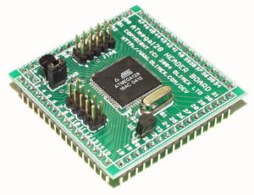
6. Integrated System

Dusty’s architecture is centered around the capable Atmel Atmega128 microcontroller. The microcontroller was purchased on a mini header board made by Olimex. This board is small compared to most boards, measuring just 47mm x 47mm. All the other electronics on the robot are interfaced to this controller.

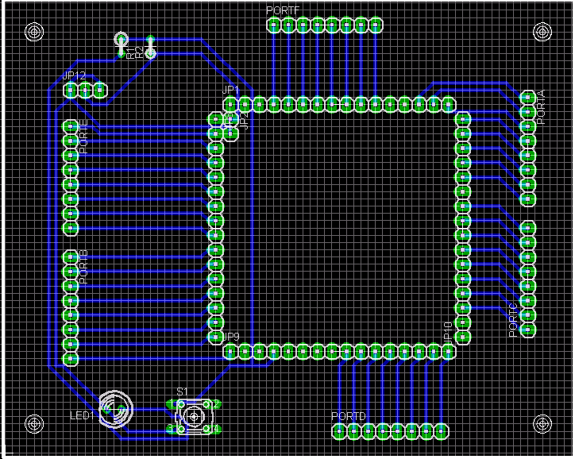
Because of the small size of this header board, a larger breakout board was made. This board made it easy to attach the Olimex header board to the rest of the robot. With this design the Olimex board is a very economical approach to the Atmega128.

Dusty is connected to a Dirt Devil Sweeper Vac sold for under $40 at grocery stores. The vacuum itself is connected to the microcontroller via a power relay. A DPDT relay was necessary to allow the vacuum charge circuitry to operate while to vacuum was powered off.

Dusty gathers information through various sensors placed strategically on the platform. Digital inputs, gathered from switches and sonars, are connected directly to I/O pins on the header board. Analog inputs, gathered from the edge sensor, IR sensors and dust sensor, are connected to A/D converter channels built into the Atmega128. Inputs are sampled at a regular interval, and the most recent values are stored in global access memory, for program control use.
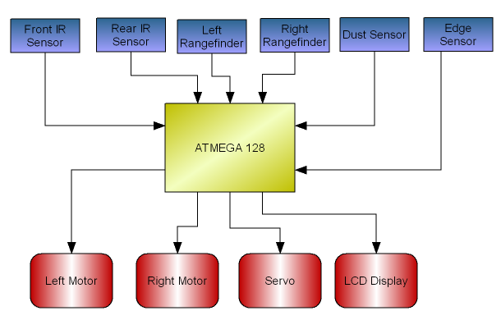
Information gathered from input devices is processed, and the robot takes action through its outputs: its two motors, its vacuum-head-mounted-servo, and its LCD screen. The motors and servos are interfaced using the Atmega128’s built-in PWM generator, and the LCD uses standard Hitachi interfacing.

7. Mobile Platform

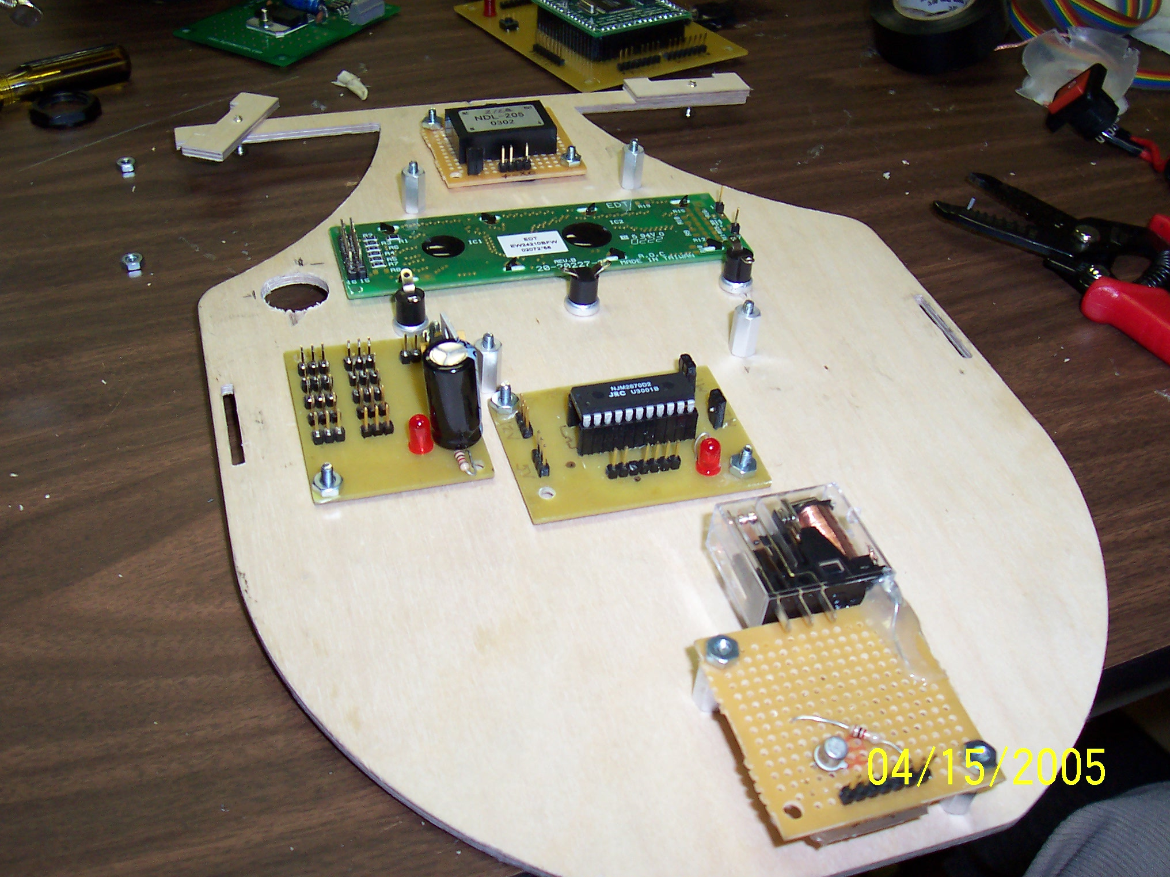
Since this robot is relatively heavy the robot runs on as few wheels as possible. This also allows for more torque on each wheel because the weight is less distributed. Turning radius is a relatively unimportant since vacuums primarily perform back and forth movements. Therefore two 2 inch “beetle” wheels are attached on Dusty’s sides. The wheels have foam tires and a plastic core. Dusty is built so that he rides as low to the ground as possible, so it can maximize the power of the vacuum suction. Miniature omnidirectional casters were added to the bottom of the platform, in the front and back, to maintain ground clearance. The casters proved to be an excellent choice.

Two identical thin layers of wood form the basic chassis. On layer is suspended above the other using tall motor mounts. This layout was designed with airflow in mind: a main concern was allowing ventilation of the vacuum fan which is blow out the sides of the existing vacuum packaging. Constraining the airflow reduces suction, and places a higher drain on the battery. In hindsight, it would have been preferable to enclose the robot. It would have provided much better aesthetics and would have actually allowed more space for electronic “cargo”.

Mounted facing forward are two sonar rangers that are angled about 30 degrees inward. The adjustable angle design was engineered by my colleague, Jose Garcia. This design proved to be an excellent choice.

The vacuum was completely disassembled for testing and interfacing. The handle of the vacuum was removed and some superfluous parts were eliminated. Two screw pegs were inserted into the front for servo mounting, as was suggested by my friend, Kevin Phillipson. A detachable servo head was bonded to the pivoting front head of the vacuum. The servo design provided excellent effect, moving the vacuum head effortlessly and dependably. Software limits were important to avoid overextending the physical tolerances of the vacuum head.

The platform has a fitted slot that houses the LCD handsomely. Above the screen are three push buttons for user input. Nearby there is also a prominent red power switch that controls the power supplies.

8. Actuation

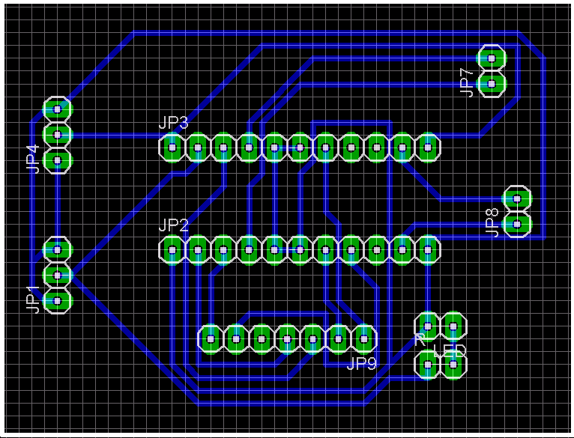
Dusty’s main actuation is accomplished through a pair of 200 RPM, 12 V motors available from Jameco Electronics. It should be noted that running from a 7.2V power supply these motors provided plenty of power for this application. The motors are driven by a NJM-2670 Dual H-Bridge that is available from Digikey or Mouser. This h-bridge is designed primarily for stepper motors, so its interfacing was a bit inefficient. Once these chips were interfaced correctly they were reliable.

The motors were tested to determine a typical stall current value. It was difficult to achieve 1A of stall current. Software controls were able to limit the typical changing-directions to current to as little as half of that value.

The motor software control is one of the best features of this robot. Drastic changes in motor speed or direction (forward vs. reverse) can cause hardware failure. Dusty uses an asymptotic smoothing formula to change speeds and directions.

Higher level functions request a motor setting by setting several “throttle” values. There are separate throttles for each wheel’s speed and direction. The motor software control compares the requested throttle values to the current motor speed and direction settings, and makes adjustments based on an asymptotic formula.

Motor_Speed = (K * Motor_Throttle+Motor_Speed) / (K + 1)

This formula can also be interpreted as a weighted average. The resolution of the smoothing refers to how many intermittent steps are taken from one value to the next, and is adjusted by the constant value K which allows easy adjusting. The speed of the smoothing is controlled by the interrupt service routine that callers the motor software control function. Dusty relies heavily on this software during spot cleaning mode. The wheels must constantly change direction, and the software successfully reduces motor impact.
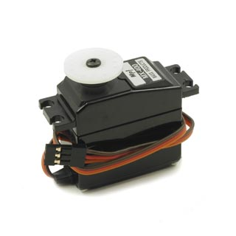
Dusty also has a general purpose servo attached to the vacuums nozzle. This rotates the nozzle when Dusty is turning so it does not get caught on obstacles. The nozzle is also able to rotate back and forth constantly to cover a slightly large vacuum area, however spot cleaning makes this feature redundant, and heavy servo usage places a heavy current toll on the power supply.

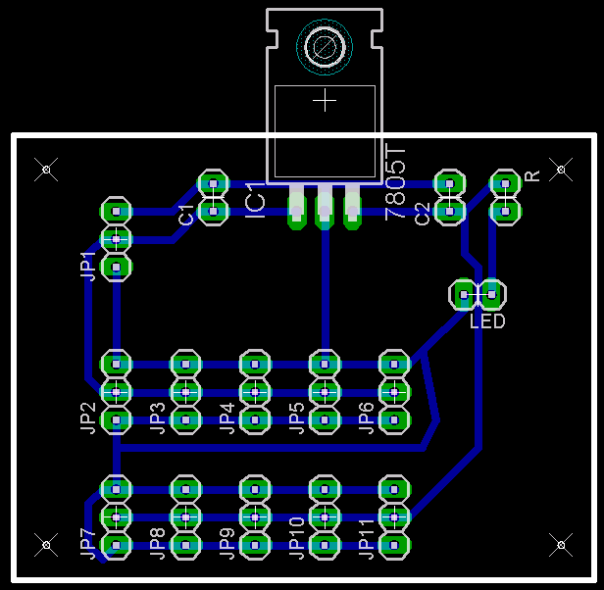
To keep the power supply to my other electronics as clean as possible, I used separate power supplies for the motors and servo. All the other electronics were connected to an identical power supply. These parallel supplies both ran off 7.2V rechargeable batteries.
9. Sensors

Dusty uses a variety of sensors which it uses to gather information about its environment. Since an overly shy robot will be constrained to repeatedly cleaning the same areas – those most wide open –the design of this robot calls for an aggressive interaction with the environment. Dusty must be able to get up close and personal to clean the objects around it – but without causing environmental or self-inflicted damage.

Dusty must know if it has bumped objects in its environment. Bump sensors placed strategically on the robot can sense any collisions so Dusty can react accordingly. Hopefully, Dusty won’t have too many collisions thanks to his forward looking sonar unit, which serves as a main set of eyes to detect upcoming obstacles. But it’s not always moving forward – in spot cleaning mode he has to look to his side. Mounted facing right Dusty has two infrared sensor to detect objects beside it (on the right). This sensor is also used by Dusty to find walls to follow. Additionally Dusty has a ground sensing CDS cell to ensure that if he encounters the edge of the world, he won’t fall off. Finally, Dusty has a dust sensor that measures the density of particulate matter.

Bump Sensors
Dusty’s bump sensors are constructed using small momentary push switches connected to pull-up resistors. The final placement is to be determined after further research into Dusty’s behaviors. It is expected that areas prone to collisions will be the extremities of the vacuum nozzle and the rear of the unit. Collision to the side of the unit are not expected based on the robot’s behavior, however this remains to be proven. Triggering of these sensors is a medium-priority event: sometimes a bump might be a good thing for Dusty. It may mean a wall is in front of him, and he loves following walls.

Dusty is designed to be an aggressive robot, and is not shy from tight places. The range-finding sensors (SONAR and IR units) are focused at unit level purposefully – the environment above the robot is of little importance. Dusty as a special bump sensor used to detect height. To ensure clearance under low structures, Dusty uses an antenna connected to a pair of bump sensors. Mounted near the front, the antenna allows Dusty to peak his nozzle under things without getting himself stuck. Triggering of the antenna sensor is a high-priority event because it threatens Dusty’s safety. If the antenna is pressed forward or backward, Dusty knows it must change direction.

Sonar
Dusty has two Devantech SRF04 Ultrasonic Range Finder units. The SRF04 is advertised to measure accurately from 3 cm to 3 meters, and may be purchased from Acroname.
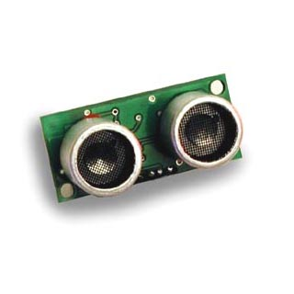
Operation of the SRF04 is based on sonic principles. After sending out an ultrasonic pulse, the unit outputs a pulse when a return echo is detected. Timing the delay between the sending of the pulse and the receiving of the echo allows distance to be measured to the nearest object large enough to produce an echo. According to the SRF04 documentation the pulse travels at a rate of .9 ft/msec.

The SRF04 is interfaced with the Atmega128 using a timer. Timing begins when the pulse is sent. The controller polls the output echo lead until a signal is detected, upon which the timer is stopped. The elapsed time is a direct measurement of the distance to the nearest measurable object. Although a 16-bit timer would allow Dusty to see farther, he is only concerned with his nearest surroundings, so an 8-bit timer can be used.

While converting this timer count value to common units of length measurement is useful to humans, it is meaningless to Dusty who is an expert at vacuuming but knows nothing of the metric system. Timer measurements (raw data) ranging from 0 (extremely close) to 255 (no object detected) are used by the robot for all its calculations. This is consistent with all other robot systems.

Initial testing of the sonar unit showed its output was reasonably steady for large, static objects. Variations occurred in output, and violent swings were observed from time to time. In dynamic, multi-object environments the sonar output quality was diminished. In these situations multiple echoes are detected. After the first sonar pulse, an echo is detected from the nearest object. The sonar pings again expecting another echo from this second ping. On the contrary, the echo it hears is from the first pulse, echoing from a distant feature. This situation is remedied by increasing the delay between subsequent sonar reads, allowing all the echoes to dissipate before restarting the process.

To test the sonar, a short program was written to take sonar readings in 250ms intervals, writing them to the LCD screen. A white card placed in front of the sonar was used to simulate an object. The distance from the card to the sonar was measured with a tape measure and compared to the output value. The results which can be seen in Appendix A suggest a strong linear trend (with approximate slope of 3/8) for distances over 3 ft, which is the maximum range Dusty needs.

Two levels of filtering have been developed to minimize the effects of outlier data. The first filter level is a low-pass filter which in effect takes an average of a specified number of n measurements. The measurements are stored in an array and then averaged, and the average is reported.

To concentrate on only the nearest objects, and remove outlying measurements, the second level of filtering compares each of the n individual measurements to the calculated average. If a measurement deviates from the average by more than a specified value it is identified as an outlier. Outliers are replaced with the average, effectively removing it from the data set. At the conclusion of the process a new average is calculated and reported. A large deviation tolerance has yielded acceptable results (difference < 50) while smaller tolerances have limited the resolution to unacceptable levels. Appendix B has an example of filtering in effect.

Dusty is designed to use the SRF04 as its primary method of sensing its environment due to its reliability in different environments. Its performance is not affected by outside noise or light levels. It is not sensitive to the color of objects or their luminosity. Testing with a variety of materials indicates low absorption by all common living-room materials.

Infrared Sensors
Dusty has been given two Sharp GP2D120 Infrared Sensors. One unit is placed on the servo on the front side of the robot. The second is placed under the upper level in line with its counterpart unit. This position is an auxiliary view for wall following and spot cleaning. Wall following is always performed with the wall on the right side of the robot. In spot cleaning mode the robot moves forward and backwards while inching rightward across a room, mimicking human vacuuming motions. The auxiliary view will be valuable for these behaviors.

The GP2D120 outputs a single analog signal with a range from 0 to 2.5V. The unit is operational once connected to a power supply. The D120 is unique for its special lenses which focus detection within a closer radius than other models. Dusty is only concerned with its immediate surroundings and therefore does not need a long vision range.

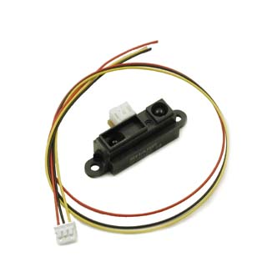
The output to the GP2D120 is connected to the analog-to-digital converter on Dusty’s controller. Measurements a reported on a scale from 0 to 255, however the range of actual values is 48 (no object detected) to 192 (extremely close). Like the Sonar unit, Dusty makes no attempt to convert these values to common length measurements. Instead reported values are compared to the range of values, in this case 48-192, to get a sense of how close an object is.

Testing showed output that was more stable, less vulnerable to fluctuation, than the sonar unit. On the downside, the IR unit is sensitive to color – darker objects absorb more light and are measured slightly farther than white objects. This effect is minimized at short distances, which is ideal since Dusty’s aggressive programming only takes his immediate surroundings into account.

To test the IR, a short program was written to take IR readings in 250ms intervals, writing them to the LCD screen. A black cloth placed in front of the IR was used to simulate an object. The color and texture of this material was expected to be the most absorbent type of environmental object Dusty might encounter. The distance from the shirt to the IR canon was measured with a tape measure and compared to the output value. The results which can be seen in Appendix A suggest useful output from 0 inches to 15 inches. In this region a linear trend can safely be approximated.

Two levels of filtering have been developed to minimize the effects of outlier data. The first filter level is a low-pass filter which in effect takes an average of a specified number of n measurements. The measurements are stored in an array and then averaged, and the average is reported.

To concentrate on only the nearest objects, and remove outlying measurements, the second level of filtering compares each of the n individual measurements to the calculated average. If a measurement deviates from the average by more than a specified value it is identified as an outlier. Outliers are replaced with the average, effectively removing it from the data set. At the conclusion of the process a new average is calculated and reported. A large deviation tolerance has yielded acceptable results (difference < 50) while smaller tolerances have limited the resolution to unacceptable levels. Appendix B has an example of filtering in effect.

Dust Sensor
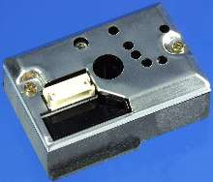
Dusty has a special sensor that allows it to measure the density of small particulates using photoreflection. The Sharp GP2Y1010AU is mounted near the filter to provide a measure of the air entering the vacuum. Originally intended for use in air filtration systems, this sensor has the ability to output variable analog values corresponding to varying dust density, and is able to distinguish smoke from dust.

The sensor is interfaced by using a pulse enable that is setup on one of the Atmega128’s PWM channels.
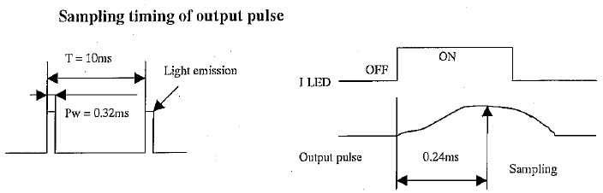
(from the GP2Y1010AU Datasheet)

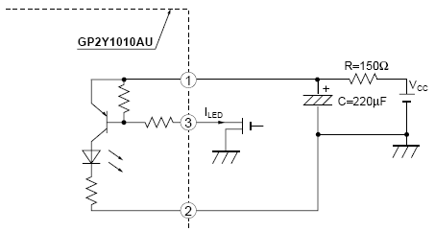
Using an output compare synchronized with the PWM signal, the output is sampled .24ms after the LED pulse.

There was some conflicting information in various datasheets for this product family as to the proper interface the input for these sensors. The following circuit was tested and worked well.

Typical output for non-dusty conditions was about 170mV in the dark and 240mV in a lit room. With dust the output was generally between 450 mV and 800 mV. Interfaced with the Analog to Digital Converter, this sensor provided a good measure of the air quality.

The major problem with this sensor was placement. The vacuum is small and has many moving parts that make it difficult to place this sensor. When the dust canister was clean the dust sensor worked well at detecting new dust. But once a sizeable amount of dust accumulates the dust sensor becomes useless as it is always outputting a high signal.

10. Behaviors

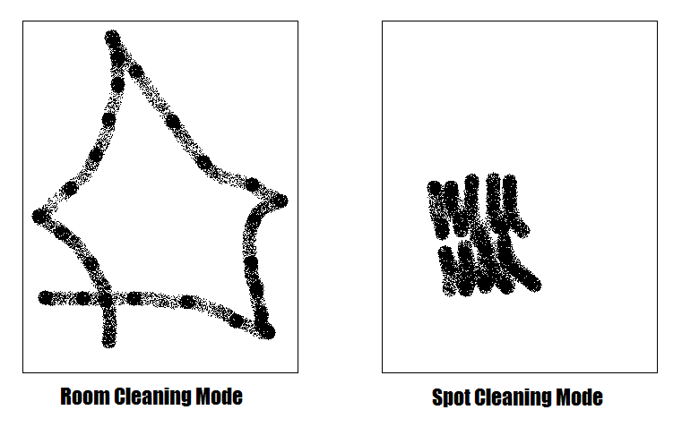
The robot’s most basic behavior is cleaning mode. The user can choose between two types of cleaning behaviors: room cleaning and spot cleaning. In room cleaning mode, the robot moves primarily in straight lines or large arcs to cover a wide area. It switches to a back-and-forth pattern while in spot cleaning mode. This allows the user to set the robot near a particularly dirty area.

The user can also choose automatic mode. In automatic mode the robot performs room cleaning until it detects high dust levels. The robot then switches to spot cleaning to concentrate vacuuming in that vicinity for some time.

Finally the user can select wall following mode. In wall follow mode Dusty sticks close to the wall until the wall disappears or his forward progress is blocked. This is accomplished by using the side-firing IR sensors. When the robot is started configuration measurements are taken – during this configuration the robot should be aligned next to a wall. Using this configuration as a baseline, the robot attempts to stay aligned with the wall while driving forward.

Dusty’s behaviors are modeled after a state machine. The robot is always is one of several specified states. Each state has a distinct behavioral pattern. Here is a summary of the algorithm:
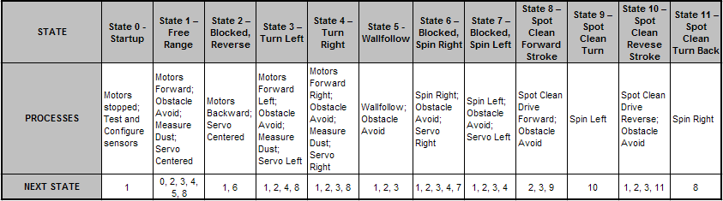

The full algorithm can be viewed in the source code.

12. Conclusion

In this section I will assume the first person to directly address some of the successes of the robot, as well as some of its failures. The robot was most successful as an instructional aid. I’ve learned more building this robot than I have in any other single class.

That said, a number of systems work extremely well on Dusty. Most of all, the motor control software does a great job doing what it was intended for. Driving is very smooth and changes in direction are not at all violent. As a result the entire motor system works dependably. Using the sensors the robot is good at obstacle avoiding. It was able to navigate well underneath my kitchen table, and it actually began spot cleaning and went around the legs.

Due to time constraints a number of good ideas had to be abandoned in the interest of finalizing the robot. The most intriguing idea that I abandoned was creating a charging home base for the robot. Only after building this robot do I realize how complicated creating a charging base is.

Some other future improvements would mainly center around the platform. This was one area in which I was under qualified and struggled to create something aesthetically pleasing. I would recommend closed encasings for most robots.

Finally, I’ve gained a much better understanding of how to plan for building these kinds of complex systems. It is very difficult to plan with very little experience. Now that I’ve become familiar with the basics of robotics I feel that I could make many more high quality robots.

Appendix A:
Experimental Results

Measured Distance | IR | Sonar
0 | 193 | 5
3 | 176 | 18
6 | 123 | 21
9 | 96 | 31
12 | 79 | 40
15 | 63 | 45
18 | 62 | 53
21 | 61 | 57
24 | 60 | 67
27 | 58 | 79
30 | 55 | 82
33 | 48 | 87
36 | 48 | 92
39 | 48 | 100

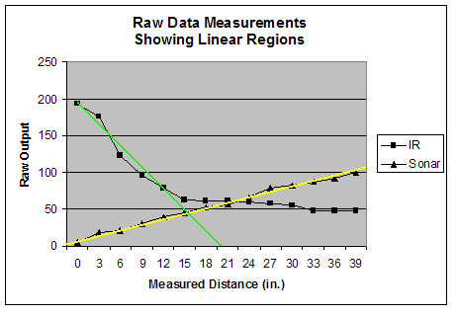
Appendix B:
Filtered Output Examples

Raw Data
46
108
130
108
130
46
108
46
108
130

Filtered Data
96
108
130
108
130
96
108
96
108
130

Extra Special Thanks To:

Kevin Phillipson, Brian, and Bobo at RASTA ROBOTICS

Rob Hamersma

Jose (Sonar Mounts)

Trevor and Albert (Motor Mount Layout and Motor Driver Schematic)

Sara Keen (Inverter Footprint)

Vivek Manoharan

And everyone else who helped me figure out what I’m doing!

