EEL5666 – Intelligent Machines Design Lab

Project Report

Instructor – Dr. Arroyo & Dr. Schwartz
TAs – Adam & Sara

04/25/2006

Sharan Asundi
Graduate Student
Department of Mechanical and Aerospace Engineering
University of Florida
Table of Contents

I. Abstract 3

II. Executive Summary 4

III. Introduction 5

IV. Integrated System 5

V. Mobile Platform 6

VI. Actuation 7

VII. Sensors 7

VIII. Conclusion 11
I. Abstract

Linux-based, Autonomous, Wireless-capable, Self-diagnosing Vehicle (LAWS-V) is a modified E-MAXX Model 3906 RC monster truck. LAWS-V is capable of navigating from point to point over a varied terrain (floor, carpet, hilly dirt, and grass) with obstacle avoidance. This report focuses on the construction and integration of hardware, software and the sensor suite in making the vehicle autonomous. LAWS-V is a PC104 based with a Debian 3.0 (Kernel 2.6.8) Linux operating system and a GCC compiler. 3 servos, onboard the vehicle, are controlled by a Mini SSC II servo controller and this servo controller is in turn commanded by a PC104 unit. An I/O board, PC104 compatible, is used to capture the sensor readings. The vehicle is mounted with IR sensors for obstacle avoidance, CdS photo resistors for object tracking, a PCMCIA adapter for wireless communication, a tracker sensor for line tracking and bump switches. The wheels are powered by a powerful DC motor and the resistance on the motor is varied using a servo. Ni-MH batteries of 8.3v supply energy to the DC motors and Li-Pol 11.1v batteries power the onboard processor, controller and sensors.

II. Executive Summary

At the beginning of this semester the concept of LAWS-V started becoming a reality. The focus of this project was to build an autonomous vehicle which would be capable of performing a given task in a group. AWESIMO which was already built by then was to be the role model for LAWS-V. Most of the funding for building this autonomous agent came from UCF. The RC Monster truck and the PC104 unit, which included the processor module, power module and the I/O module, were shipped from UCF. A PC104 wireless module previously used by AMAS researchers fit perfectly into this PC104 unit.

Once the different PC104 modules were all assembled together with appropriate power being supplied to each unit the next task was to load an Operating System on this processor. After a descent amount of consideration Debian Linux was chosen as the OS to be loaded on the PC104 unit. After several attempts Debian OS was loaded on the PC104 unit and the different ports were available for experimentation. A Mini SSC II servo controller, previously mounted on the vehicle platform, was connected to the PC104 unit and experiments to drive the servos went on for a while. Once the servos were being driven through the Mini SSC II servo controller the next task on hand was to make the vehicle autonomous by providing sensing capabilities. In doing so one of the more difficult tasks on hand was to drive a PC104 I/O module. The installation of the driver required the recompilation of the OS kernel and them integration of the driver with this kernel. After persistent effort and several tries the I/O module was made functional. Then the vehicle was mounted with IR sensors and photo resistors and initial testing for obstacle avoidance and light tracking was carried out. Subsequently both obstacle avoidance and object tracking were optimized and new sensors like the bump switches and line tracking sensors were implemented.
III. Introduction

Co-operative robots have been thought about for quite some time now. The idea behind building LAWS-V is based on co-operative autonomous agents capable of communicating between themselves to accomplish a particular task. One of the key features intercommunication and
References to the literature
Scope and objectives of project
A walk-through the paper

IV. Integrated System

LAWS-V is built on an E-MAXX Model 3906 RC monster truck platform. The RC receiver on the truck is replaced by a Mini SSC (serial servo controller) II. The Mini SSC II is an assembled and tested module that features a convenient phone-style jack for serial input, three-conductor servo connectors, power/sync LED to verify correct operation, and switchable range/resolution from 90° at 0.36° per unit or 180° at 0.72°/unit. A Mini SSC II allows you to control up to eight servos through a computer’s serial port using simple instructions at 2400 or 9600 bps. Following are some of the key significant features of the Mini SSC II…

- Power requirements (Mini SSC) - 7 to15 Vdc @ 10mA
- Power requirements (servo) - 4.8 to 6.0 Vdc (current varies)
- Serial input connector........header posts (both); 6p4c phone jack (II only)
- Serial input...............RS-232, 9600 or 2400 Baud
- Operating temperature.........0° to 50°C (32° to 122°F)
- Servo output connector ......3-pin header, 0.1"spacing: (PWM)(+V)(GND)

A PC104 unit mounted on the system commands the Mini SSC II serial servo controller. The PC104 unit is made up of 4 modules with the following features…

- MOPSlcd6 integrated CPU board
  - Intel Pentium with 266 MHz 32 KB Cache
  - Two Standard RS232C serial ports
  - 64 MB of SDRAM
  - ALI M1543C B1/M1531 PCI Chipset
  - 5V only Power Supply

- V104 Vehicle Power Supply
  - 25W output
  - 6V to 40VDC input range
  - Standard 5V and 12V, optional -5V and -12V

- Diamond-MM-16AT 16Bit Analog I/O Module
Analog Input
  - 16 single-ended / 8 differential inputs
  - 16-bit A/D resolution
  - 100KHz maximum aggregate A/D sampling rate
  - Programmable input ranges with maximum range of +/-10V
Analog Output
  - 4 optional analog outputs
  - Fixed and user-programmable output ranges
  - Simultaneous update
  - Autocalibrated outputs
Digital I/O
  - 8 dedicated digital outputs, TTL compatible
  - 8 dedicated digital inputs, TTL compatible

- Kontron PC/104-PCMCIA-1 Adapter Dual Slot PCMCIA Adapter

V. Mobile Platform

Anatomy of the E-Maxx

The mobile platform is based on the E-MAXX Model 3906 RC monster truck platform. The wheels are powered by 2 powerful DC motors. Two Ni-MH batteries provided with the monster truck supply energy to the motors. The suspensions in the chassis make the vehicle capable of navigating in several of the tough terrains. 3 servo motors mounted on the vehicle are capable of 3 functionalities – Steering, Shifting & speed control.

VI. Actuation

E-Maxx Wiring Diagram

The E-Maxx monster truck has 2 servos and an electronic speed control which again is a servo. The three servos are driven by the PC104 unit through the Mini SSC II. The electronic speed control servo is varies the resistance and thus the speed of the DC motors powering the wheels. The steering servo, as the name suggests is used for steering purpose. Finally the vehicle is capable of being driven in low and high gear and hence the shifting servo.

VII. Sensors

- IR Sensor Suite – 3 Sharp GP2D12 IR Sensor - 30" / Analog
This is an integrated sensor with IR emitter, detector, optics and timing logic. The GP2D12 outputs an analog voltage that varies as a function of the distance to an object obstructing its emitted infrared beam. The output signal is compatible with low-cost ADC circuits including those built into many robot controllers. The sensor can detect objects within a range of approximately 4" to 30".
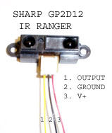

Sensor Operation
Inside the range finder, there is an infrared beam emitter and a “position sensing device,” or PSD. The PSD is a silicon device that works like a variable resistor whose resistance changes with the position at which the device is struck by light. When an object is placed in front of the sensor, it will reflect the emitted infrared beam back to the sensor. The angle of the returning beam will depend on how far away the object is. Returning beams with different incident angles will be focused by the receiver’s lens onto different parts of the PSD so that the resistance of the PSD varies with the distance from sensor to object. The sensor’s output voltage is based on this resistance.
Absolute Max Ratings
Parameter | Symbol | Rating | Unit
Supply Voltage | V_{CC} | -0.3 to +7 | V
Output Terminal Voltage | V_{O} | -0.3 to V_{CC}+0.3 | V
Operating Tempurature | T_{opr} | -10 to +60 | °C
Storage Tempurature | T_{stg} | -40 to +70 | °C
Operating Supply Voltage | V_{CC} | 4.5 to 5.5 | V

Output Values
The analog voltage vs. range is graphed below, left. Beam width vs. distance is graphed below, right. The beam width chart refers to the spread of the beam as “detection distance.” The beam is pretty narrow; even at its upper sensing limit of 80cm, it only spreads to 5cm wide.

Scope and Application
These are my obstacle avoidance sensors. I avoid obstacle if the voltage value on I/O pin is greater than 0.8v. I have 3 of them mounted on the front side – left, right and center.
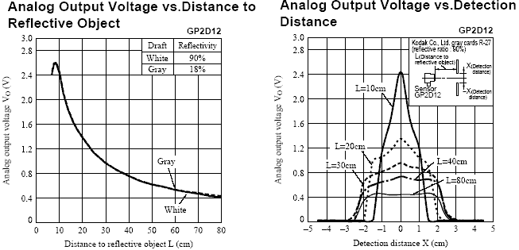
Distance can be approximated from the analog voltage by using the following power regression, where d is distance in cm and s is the sensor’s value from 0 to 255:
d(s) = 2141.72055 s^{-1.078867}
- Cisco Aironet 340 - Network Adapter

The Cisco Aironet 340 Series PC Card Client Adapter is a PCMCIA card radio module that provides transparent wireless data communications between fixed, portable, or mobile devices and other wireless devices or a wired network infrastructure. Host devices can be any device equipped with a PCMCIA card Type II or Type III slot.
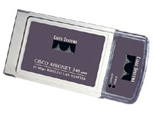
The PC card client adapter is fully compatible when used in a device supporting Plug-and-Play (PnP) technology. The PC card client adapter can also be built into peripheral devices such as printers to provide a transparent wireless connection to a wired network.

Scope and Application
To communicate remotely to my robot and as a medium for lcd feedback.
- Photoresistors

A photoresistor is an electronic component whose resistance decreases with increasing incident light intensity. It can also be called a light-dependent resistor (LDR), or photoconductor.

A photoresistor is made of a high-resistance semiconductor. If light falling on the device is of high enough frequency, photons absorbed by the semiconductor give bound electrons enough energy to jump into the conduction band. The resulting free electron (and its hole partner) conduct electricity, thereby lowering resistance.

Cadmium sulfide cells
Cadmium sulfide or cadmium sulphide (CdS) cells rely on the material's ability to vary its resistance according to the amount of light striking the cell. The more light that strikes the cell, the lower the resistance. Although not accurate, even a simple CdS cell can have a wide range of resistance from about 600 ohms in bright light to one or two megohms in darkness. The cells are also capable of reacting to a broad range of frequencies, including infrared (IR), visible light, and ultraviolet (UV). They are often found on street lights as automatic on/off switches. They were once even used in heat-seeking missiles to sense for targets.

Scope and Application
I use these sensors to track objects (with lights).

- Bump Switches
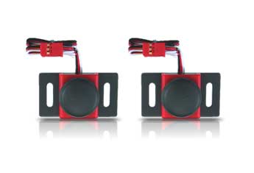
Vex Robotics – Bumper Switch Kit

Vex Robotics Bumper Switch Kit - Technical Info
Vex Robotics | Description
Switch Type | Momentary
Weight | 0.05 lbs. per switch
Wiring | Black - ground; Red – NC (no connect); White - control signal
- Line Tracking Sensor

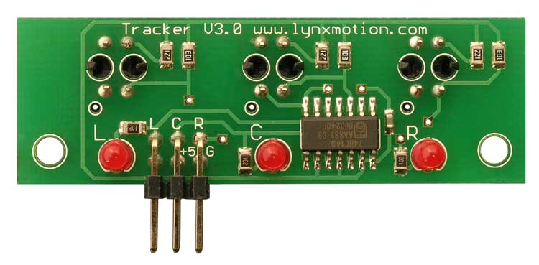
The Tracker is an Infrared reflective sensor trio that can be attached to the front of mobile wheeled robots.
The sensor delivers three digital signals to a microcontroller so the robot can reliably follow a black line on a white background, or vice versa.

VIII. Conclusion

Overall the experience of building a PC104 based autonomous agent has be just amazing. Thanks to Dr. Arroyo, Dr. Schwartz and the TAs Adam and Sara this class has been a rewarding experience. I hope to continue working on building the robot to make it more capable.

As a future scope I for see myself implementing and integrated health monitoring system in the next week and subsequently a precision navigation system and a cmu/web camera in the near future.

