EEL 5666

Intelligent Machine Design Laboratory

Spring 2006

Final Report

EARL
Electronic Autonomous Rappelling and Landing- Bot

Instructor: Dr. Arroyo

Etan Shaul

Table of Contents

Abstract...................................................................................3

Executive Summary................................................................4

Introduction.............................................................................4

Integrated System...................................................................5

Mobile Platform......................................................................5

Actuation.................................................................................6

Sensors....................................................................................7

Behaviors.................................................................................9

Experimental Layout...............................................................9

Conclusion...............................................................................10

Documentation........................................................................10

Appendices..............................................................................10

Abstract

Earl (Electronic Autonomous Rappelling and Landing – Bot) essentially manages to escape from the top of most tables. Earl, when placed on top of a table, finds an edge, hooks on to its lip and rappels off the opposite end of the table. It has a hinge like hook dangling off its front, which is lowered by a motor. Attached to the motor is a spool with wire that is fed through a custom designed tension sensor over a pulley and down onto the hook. Once the edge is found the robot positions itself parallel to it and lowers the hook. The robot then turns off the motor and backs up until sufficient tension is achieved. It will then back straight up with the correct cooperation between the wheels' servos and the motor releasing the line such that the line does not go limp. The opposite edge will be detected and the motor will lower itself to the ground and, of course, will report back the height of the table on its LCD display.

Executive Summary
Earl was ultimately created as a proof-of-concept demonstration. While many potential uses can be envisioned, its final utility will be left up to the user. The project was chosen due to the mix of disciplines involved. The project is heavily mechanical which proved challenging for a computer engineer with limited mechanical engineering experience. Earl also has many electrical components ranging from the power (batteries, voltage regulators etc) to the sensors. This robot allowed much diversity in terms of the work encountered. The major mechanical problem of the project was creating the actual lowering mechanism (attaching the spool to the motor, creating the pulley systems) and the tension sensor which was essential for the preservation of the servos. Attached to the high torque motor is a spool created by using two motor hubs facing each other. The line is wrapped around the spool then passed through the eye-hook of the tension sensor and then through a couple more hooks and finally through the main pulley. The idea with the routing of the line was to ensure that the force from the hook is, as much as possible, in the same direction as the motion of the tension sensor. As Earl backs up (after having hooked onto the table) the tension sensor is tripped letting the microprocessor now that the servos could potentially stall. At this point more line is released and the process is looped until the rear edge is found. Once this edge is found the robot backs up slightly while releasing line until it reaches the ground. The ground then trips the bump sensor which then reports back (on the LCD) the height of the table.

Introduction
Earl's uses could range from combat operations to surveying. The idea was chosen because I wanted to design a robot that didn't just stay flat on the ground. This together with the fact that I believed it can be done in a semester made it a great idea. The goal was to have the robot successfully rappel autonomously all the way to the ground when placed on a quadrilateral table top. Thus, the robot is capable of performing the following functions: finding (and not falling over) an edge of the table, positioning itself parallel to the edge, hooking on the edge's lip by backing up and maintaining tension, reversing to the opposite end of the table and rappelling to the floor and returning the height of the table.

Integrated System
The brain of the robot is the MAVRIC-IIB board with the Atmega128 microprocessor. This processor was chosen because of its abundant features such as 4k RAM, dual UART, 6 R/C servo headers, A/D ports and small design. It is one of the central points of the design since all the sensors, servos and motors run off of it. The code is written in C and compiled using the free gcc-avr compiler.

The microprocessor essentially collects data from all of the sensors, processes the data and then controls the servos and motor appropriately. A pulse width modulated signal is generated on the microprocessor and sent directly to the servos. For the motor, a motor driver board (courtesy of William Dubel) was cut out and the chips were received as free samples from TI. The PWM signal from the board is sent to the motor driver which then sends the processed signal to the motor.

Mobile Platform
Considerations in designing Earl's platform included modularity and durability. Perhaps most importantly, the platform had to be designed such that the robot could successfully lower itself off the edge of the table relatively smoothly without getting caught in anything or twisted to severely.

The platform was cut out using the T-Tech machine provided in lab using the wood provided. It is two-tiered with the lower tier housing most of the electronics and the upper tier housing the majority of the mechanical components. It was designed so that the wheels could be placed as low to the ground as possible so that as the robot is falling off the edge, as little of a drop as possible would take place. As the robot was being developed and lowering off the table was tested, several problems were encountered. First, the screws and connectors protruding off the bottom of the robot seemed to catch on the table as the robot was sliding off the edge. To fix this, two metal tracks were epoxied to the bottom. Also, the robot seemed to swing far to much after the final part of the bot left the table. Two long braces sticking off of the front were added in order to control the swinging.

Actuation
The robot propels itself across the table using two hacked servo powered wheels and a rear caster. The servos were purchased from lynxmotion.com. Wheels were taken from a toy car purchased at Wallmart and glued directly to the servos. A high torque planetary gear-head motor from lynxmotion.com is used to feed the line that supports the robot on its decent from the table.

The servos ended up doing their part, however, in the future I would recommend the strict use of dc motors for actuation. The movement provided by the servos appeared to be both inconsistent and cheap. Relative values of the left and right servos had to be continuously adjusted and the servos were greatly impacted by the weight of the platform. Motors would have provided much more solid and reliable actuation.

Sensors
The robot will uses several sensors in order to accomplish the task of rappelling off a table.

IR
In order to detect the edge of the table the robot is equipped with four Sharp GP2Y0A21YK infrared proximity sensor. These sensor are mounted downward facing on the far corners of the robot. They allow Earl to detect the edge (without falling off) and allow him to align himself parallel to the edge so that the hook can be lowered down to the table.

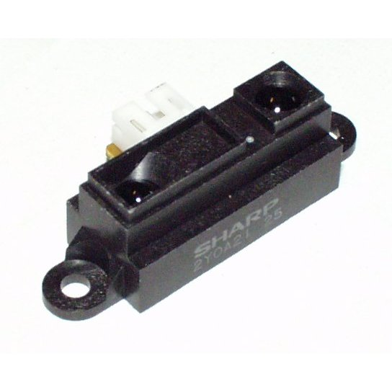

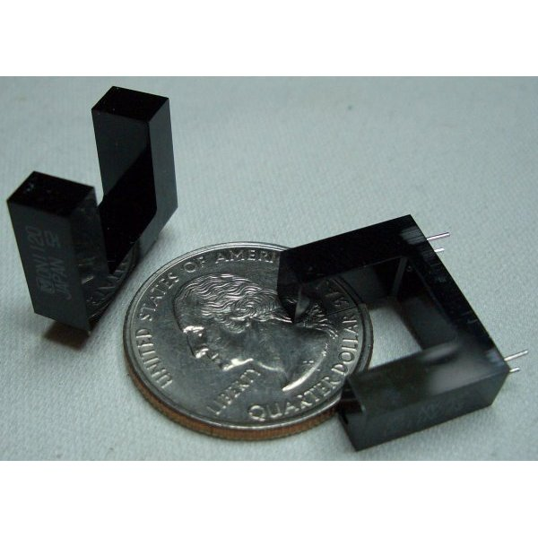
Tension Sensor

In order to ensure that the hook stays hooked onto the lip of the table, a custom tension sensor was built to tell the motor how fast to release line, as well as to tell the servos how fast to reverse. The sensor is essentially a spring loaded mechanism with an eye-hook on one end and a protrusion on the other. When the line (which is fed through the i-hook) is pulled, the protrusion on the other end will move. The amount it moves depends on the tension on the line. A photo-interrupter is placed at a predetermined position and is triggered when the protrusion passes through its uprights. Thus, feedback to the microcontroller can be sent about the tension in the line to ensure that it never goes limp causing the hook to fall off and the servos stall.

Motor Encoder

No motor encoder could be found that fit the motor that I purchased so I was forced to construct my own. A photo-interrupter was used to accomplish this. A nail was glued to stick out of the spool such that every time the motor rotated, the nail would interrupt the photo-interrupter. Thus, after the robot reaches the back of the table (and has already hooked onto the table), the controller starts counting the revolutions of the motor. Once the bump switch is triggered by the ground, the counting is finished. The height of the table can be found using simple calculations involving the circumference of the spool, the number of revolutions counted and an experimentally determined constant.

Bump

Finally, a rear facing bump switch was used. This switch is triggered when the ground is reached. After being triggered, the controller knows to stop counting motor revolutions and to begin determining the height of the table.

Behaviors
The robot starts out by having a human place it on top of a square table. The wheels' servos will then start spinning taking the robot in a certain direction. The robot will keep moving around until an edge is sensed by one of its two front IR sensors. Then based on the readings, it will reposition itself parallel to the edge (if its not already). The motor which controls the spool will release the line just enough so that the hook is directly in front of the lip of the table. The motor will then lock, and the robot will back up until the tension sensor is tripped. Then, the robot will back up while simultaneously the motor will release line. The exact ratio between the reverse speed and the rate of the line release was determined by trial and error. Using, the rear mounted IR sensor the robot will determine when the edge of the table is reached and start the motor encoding. The motor and the servos will then slow down and the robot will start rappelling off the table. The motor will release the line until the floor is detected (through a bump switch). Once the robot is sound on the ground, the height of the table will be reported on the screen.

Experimental Layout
The only constraints in experimentation are that the table must be quadrilateral and the table must have an inset lip. Earl is capable of hooking onto most square tables as the lip size usually ranges from around 1” to 3” which is around his capabilities.

Data from the IR sensor did not need to be collected and charted due to self calibration. Earl initially calibrates the IR sensors to the distance when he is flat on the table. If the value ever deviates slightly from this, the controller knows that an edge has been found.

Conclusion
Earl was a complete success. He accomplishes everything I had hoped and does so relatively smoothly. He can hook onto the table and lower himself to the ground completely autonomously and report back the height of the table. The height that he reports is, off course, subject to be off by +/- 2.5 which is the circumference of the spool.

If I were to redo the project, I would improve the design so that the robot falls off the edge more smoothly. Its descent is a little bit rough even though nothing breaks or rips. Occasionally, but not very often, I need to give Earl a little nudge off the table due to imperfect weight distribution. Other than this, the robot accomplishes everything I had in mind.

Documentation
Timer and PWM initialization code was borrowed from www.bdmicro.com.
Motor board design was borrowed from William Dubel.

Appendices
Source code available upon request.

