Final Report
Tom, The Predator Robot

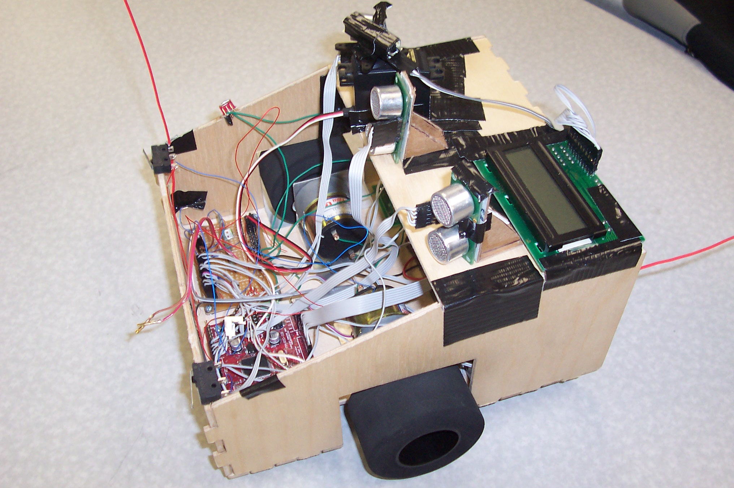

Joshua Hartman

Table of Contents

- Abstract.........................................................................................................................................2
- Introduction..................................................................................................................................3
- Integrated System........................................................................................................................3
- Mobile Platform...........................................................................................................................4
- Actuation.......................................................................................................................................4
- Sensors...........................................................................................................................................5
VII. Behaviors………………………………………………………………………..…….………..9
VIII. Conclusion…...………………………………………………………………..….……..……10
X. Appendices………………………………………...……………..……………….…………….11

Abstract

Tom and Jerry are two robots that like to play. Tom and Jerry mimic predator-prey behavior as Tom scans the room in search of Jerry, intelligently avoiding obstacles, in an attempt to catch Jerry.

Introduction

Tom is a simple robot intended to introduce myself to the field of robotics. Tom uses heuristics and random path finding in search of his prey, Jerry. In the spirit of robotics, I Tom sports advanced techniques like fuzzy logic for obstacle avoidance. With an infrared “eye”, Tom will intelligently turn toward an infrared signal he detects (Jerry's signature). A wireless communications link with Jerry allows the two robots to communicate the status of the chase. Helpful hints in this paper are in italics. For more information, please check jfilez.googlepages.com/robots, or email me at AtomicForce@gmail.com. I have a lot of information “in my head” and would be glad to assist in any project related to any of these components.

Integrated System
Tom’s system uses the following components:
- 1 MAVRIC II-B Development Board (www.bdmicro.com)
- 1 Hitachi HD44780 based LCD
- 3 Devantech SRF05 Sonars (www.acroname.com)
- 2 TPIC-0107B based motor controllers (www.digikey.com)
- 2 Gearhead Motors (www.lynxmotion.com)
- 1 Futaba S148 Servo (www.servocity.com)
- 1 Panasonic PNA4611M00XD-ND 36.7kHz Infrared Detector (www.digikey.com)
- 8 NiMH Batteries
- RF Communications Link (www.sparkfun.com)
- Bump Switches, Cables, resistors, switches, etc.

Mobile Platform
Tom is a “homely” shaped robot on two sumo wheels and a third caster wheel. Tom has a lower platform shaped like an H which supports the batteries, motor driver boards, motors, MAVRIC-IIB development board, and a simple prototyping board. Tom’s upper platform holds the LCD, servo, infrared detector, and the 3 sonar modules. The sonar modules are mounted vertically, glued to cardboard stands.

Actuation
Tom is powered via two GHM-02 gearhead motors from Lynxmotion. These motors feature a 30:1 gear ratio with a stall torque of 54.31 oz-in. Though these motors are only rated for 7.2V, I supply ~11V without incident. With my two 2.5” sumo tires, these motors can get the robot going at a pretty fast clip! I highly recommend the use of these motors, along with the motor driver board supplied for the class.

Sensors
Sonar
Tom gains sight through two SRF05 sonar detectors by Devantech. The SRF05 sonar system will raise a signal line after the transducer has pulsed and drop the signal line once the echo is detected, allowing for very accurate management. The SRF05 operates at 40kHz and has a maximum range of 4m and can detect objects as close as 3cm. I highly recommend these sonar.
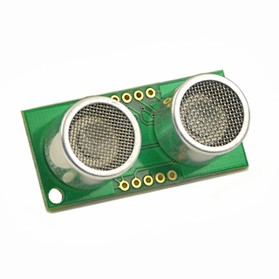
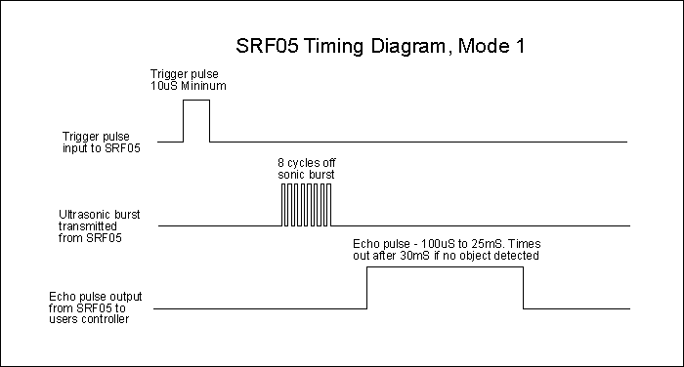
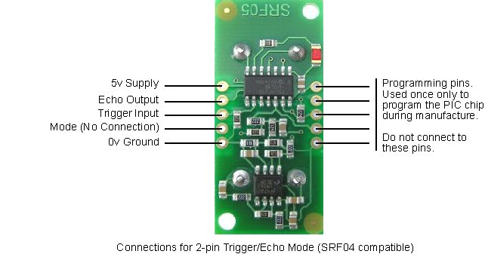
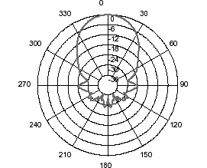
Figure 3, Devantech SRF05 Figure 4, SRF05 Beam Pattern
These are very easy to operate. Simply place a high signal on the trigger input pin for 10 us, then wait until there is a nonzero signal on the echo output line. The time this signal is on the line is linearly proportional to the distance the signal traveled before reaching the sonar. When using the sonar, please keep in mind that objects not perpendicular to the sonar will not reflect properly! Walls, for instance, are closer than they appear if you approach them obliquely!

Infrared
Tom has a Panasonic PNA4611M00XD-ND infrared detector centered around 36.7kHz. I highly recommend this detector if you want to pick up some kind of beacon. Sharp GP1UD based solutions are inferior because the detector will not work properly unless the transmitter is sending a varying signal. The transmitter simply establishes a Clear-on-compare signal set to toggle a pin every 200 clock cycles (about 36.8kHz) .The operation of this detector is very simple: Vout is 0 when infrared is detected, Vcc otherwise. You MUST read this voltage from the ADC due to impedance mismatches with the device!
The directivity is not tight enough to determine what direction the source is in. You must shield the detector for about an inch on either side to tighten the directivity. With this shielding, I was able to determine the direction of the beacon on top of Jerry within a few degrees of accuracy.

RF Communications
Tom and Jerry have bidirectional communications to moderate the predator prey behavior. We selected the “general purpose” 2400 baud RF links from www.sparkfun.com. I highly recommend you either do not use this module or you pay VERY careful attention to what I am about to say. Tom has an emitter broadcasting at 315Mhz and a receiver listening at 434Mhz. Jerry has a receiver at 315Mhz and an emitter at 315MHz. Now, the catch is that the 434MHz receiver can “hear” the 315MHz transmitter since the modules have a crummy bandpass filter. However, with both robots in a room, each manages to override the noise and the two have a successful link. Unfortunately, without a timesharing algorithm, they can’t get more than about 10 feet apart or they can’t “hear” the other.
Lock-on is a HUGE issue. The modules are connected to the microcontroller’s USART. The receivers are designed to lock-on to the baud rate of the transmitter, and will continue to increase the gain until they sense a signal to lock onto. This unfortunately means that the receivers will output noise when no communications are taking place! Therefore, you must constantly broadcast the lock-on code, 0xAA on the USART. This will transmit a continuous 01010101010101 pattern for the receiver to recognize.
Synchronization is another issue. Normal serial transmission have the line high when no transmission is occurring, and the drop of the start bit signals the beginning of the data frame. We have no luck with an RF link, so we must fix it by sending out a 0xFF before our data frame. This will pull the data pin high long enough for the RF receiver to synchronize with the start of the data frame!
Pulling this all together, whenever the transmitter’s buffer is filled, it sends out a 0xFF followed by the buffer, then clears the buffer. The receiver keeps track of the last 3 recorded signals. If the oldest was the lock_on code and the middle was not a lock-on code, we can be guaranteed that the next byte represents a valid data frame! Please see my code in the appendix for a better understanding.
Behaviors
Detecting Jerry
One of Tom's most important system is his swivel Infrared eye. The eye is mounted on a controllable server to scan from -45 degrees to 45 degrees continuously in search of Jerry. If it senses IR emissions, it will turn the robot in the direction of infrared.
Sneaking up on Jerry
If Jerry is in his grazing behavior, Tom will slow down his motor speeds in an attempt to sneak up on Jerry.
Catching Jerry
Jerry is a Jedi Knight! When Tom tries to catch Jerry, Jerry uses the mysterious and all-powerful force to hinder Tom’s turning.
Music Playing Mode
Everybody likes to hear classic rock tunes!
Obstacle Avoidance
Borrowing ideas from fuzzy logic, Tom classifies objects on the left, middle, and right as close, far, or in between so he can smoothly, swiftly, and nimbly avoid obstacles. His response is linearly related to the distance of the object detected – the closer the object, the stronger the turn.

Experimental Results
The following chart shows the correlation between distance and time between return pulses for the transducer. For distances beyond 15 inches, the sonar value divided by 55 gives an extremely good approximation of the distance. For closer distances, the linearity seems to break down. Adding 200 and dividing by 52 is a decent linear approximation of the distance.

Conclusion
In conclusion, Tom was a very fun and challenging robot to develop. While my project is simple, I had great difficulty getting the infrared detection and wireless communication working properly. I also underestimated the difficulties in getting robots to cooperate – putting their behaviors together to accomplish a game was a great challenge.
A few helpful hints for IMDLers or REU participants are to avoid wirewrap, build a compact design, and design your robots to be easily disassembled. Additionally, design your hardware and software in modular fashion – build and test a unit at a time, then test the connection of the two units. Finally, and most importantly, I strongly recommend the use of black duct tape in the construction of your robot. This material will hold it together and only strengthen over time. Kids, don’t leave home without it.
Appendices

Bump Switches
BumpSwitches.h

#include <avr/io.h>
#include <avr/interrupt.h>
#include "obstacles.h"

void init_bump_switches();

ISR(INT0_vect); //left bump switch
ISR(INT1_vect); //right bump switch
BumpSwitches.c
#include "BumpSwitches.h"

void init_bump_switches() {
EICRA=0b00001111;
EIMSK=0b00000011;
}
//left side
ISR(INT0_vect) {
stop(5);
backup(10);
stop(5);
turn_right(5);
stop(5);
}
ISR(INT1_vect) {
stop(5);
backup(10);
stop(5);
turn_left(5);
stop(5);
}

ADC Conversion
ADC.h

#include <avr/io.h>
#include <avr/interrupt.h>
#include <util/delay.h>
#include <stdio.h>
#include <stdlib.h>
#include <inttypes.h>
#include "LCD.h"
#include "obstacles.h"
#include "init.h"

#define FALSE 0
#define TRUE 1

int down;
unsigned int ADCbuffer[10];
unsigned int average;

void initADC();
int detect();
void camera_logic(int p);

ISR(ADC_vect);

ADC.c
#include "ADC.h"
#define cutoff 200

void initADC() {
DDRC=0xFF;
DDRB=0xFF;
PORTB=0;
ADMUX=0b01000000;
ADCSRA=0b11101111;
average=500;
}

ISR(ADC_vect) {
average=ADC;

int detect() {
if(average<cutoff) return 1;
return 0;
}

void camera_logic(int p) {
switch(p) {
case 0:
turn_left(3);
break;
case 1:
turn_left(1);
break;
case 2:
break;
case 3:
turn_right(1);
break;
case 4:
turn_right(3);
break;
case 5:
turn_right(1);
break;
case 6:
break;
case 7:
turn_left(1);
break;
case 8:
turn_left(3);
break;
}
}

LCD Display
LCD.h
#define E0 0x40
#define RS 0x10
#define LCD PORTC

char buffer[10];

extern void LCD_command(int db);
extern void LCD_clear(void);
extern void LCD_string(char db []);
extern void LCD_init(void);
extern void LCD_moveTo(int row, int col);
extern void LCD_data(char db);

#include <avr/io.h>
#include <avr/interrupt.h>
#include <stdio.h>
#include <inttypes.h>

LCD.c
#include "lcd.h"
int pos = 0;
int us50_sleep(int x) {

uint16_t i,j;
uint16_t delay=0;
for(i=0;i<x;i++)
for(j=0;j<1000;j++) delay++;

return delay;
}

void LCD_command(int db)
{
LCD = (db >> 4) | E0;
us50_sleep(1);
LCD = db >> 4;
us50_sleep(5);

LCD = (db & 0x0F) | E0;
us50_sleep(1);
LCD = db & 0x0F;
us50_sleep(100);
}
void LCD_clear()
{
//Clear Home
LCD_command(0x01);
pos = 0;
}

void LCD_init()
{
us50_sleep(300); //15
//initialize to 4 bit mode:
LCD_command(0x33);
us50_sleep(100);
LCD_command(0x32);

//2 lines 5x8 font
LCD_command(0x28);
//Display, no Curser, no Blink
LCD_command(0x0C);
// F curser and blink, E just curser

LCD_clear();
}

void LCD_string(char db [])
{
for (; *db!='\0';db++)
LCD_data(*db);
}

void LCD_moveTo(int row, int col)
{
pos = (row*20) + col;
if (pos<20)
LCD_command(0x80 | pos);
if (pos>=20 && pos<40)
LCD_command(0x80 | (pos%20 + 0x40));
if (pos>=40 && pos<60)
LCD_command(0x80 | (pos%40 + 0x14));
if (pos>60)
LCD_command(0x80 | (pos%60 + 0x54));
}

void LCD_data(char db)
{
// proper line wrap:
if (pos==20) LCD_command(0xC0);
if (pos==40) LCD_command(0x94);
if (pos==60) LCD_command(0xD4);
LCD = (db >> 4) | E0 | RS;
us50_sleep(1);
LCD = (db >> 4) | RS;
us50_sleep(1);
LCD = (db & 0x0F) | E0 | RS;
us50_sleep(1);
LCD = (db & 0x0F) | RS;

us50_sleep(1);
if (++pos==80)
pos = 0;
}
Music Routines
Music.h
#include <avr/io.h>
#include <avr/interrupt.h>
#include <util/delay.h>

#define speaker OCR3A

#define A3 33512
#define Bb3 31643
#define B3 30093
#define C4 28140
#define Db4 26617
#define D4 25078
#define Eb4 23709
#define E4 22342
#define F4 21126
#define Gb4 19927
#define G4 18808
#define Ab4 17766

#define A4 16756
#define Bb4 15821
#define B4 14925
#define C5 14097
#define Db5 13308
#define D5 12560
#define Eb5 11853
#define E5 11188
#define F5 10563
#define Gb5 9963
#define G5 9404
#define Ab5 8872

#define A5 8378
#define Bb5 7910
#define B5 7462
#define C6 7042
#define Db6 6648
#define D6 6275
#define Eb6 5922
#define E6 5590
#define F6 5278
#define Gb6 4982
#define G6 4702
#define Ab6 4439

#define tempo 300

double note_length;

void Music_init();

void qN(unsigned int note);
void hN(unsigned int note);
void wN(unsigned int note);
void eN(unsigned int note);
void first_jazz_eighth(unsigned int note);
void second_jazz_eighth(unsigned int note);
void jazz_qhN(unsigned int note);
void qhN(unsigned int note);

void play_go_gators();
void play_smoke_on_water();

void Mdelay(double length);

void qR();
void hR();
void wR();
void eR();

Music.c
#include "Music.h"

void Music_init() {
DDRE |= 0b00001000;
TCCR3A = (1<<COM3A0);
TCCR3B = (1<<WGM32) | (1<<CS30);

note_length=60.0/tempo;
}

void play_smoke_on_water() {
qN(D4);
qN(F4);
qhN(G4);

eN(D4);
eR();
eN(F4);
eR();
eN(Ab4);
hN(G4);

qN(D4);
qN(F4);
qhN(G4);
qN(F4);
hN(D4);
}

void play_go_gators() {
jazz_qhN(D5);
second_jazz_eighth(A4);
first_jazz_eighth(B4);
second_jazz_eighth(A4);
first_jazz_eighth(G4);
eR();
wR();

jazz_qhN(D5);
second_jazz_eighth(A4);
first_jazz_eighth(B4);
second_jazz_eighth(A4);
first_jazz_eighth(G4);
eR();
wR();

jazz_qhN(D5);
second_jazz_eighth(A4);
first_jazz_eighth(B4);
second_jazz_eighth(A4);
first_jazz_eighth(G4);
eR();
wR();

hR();
first_jazz_eighth(G4);
second_jazz_eighth(A4);
first_jazz_eighth(B4);
hN(C5);
}

void Mdelay(double length) {
unsigned i;
unsigned int l=length*10000;
for(i=0;i<l;i++) {
_delay_us(100);
}
}

void qhN(unsigned int note) {
//turn on speaker
DDRE|=0b00001000;
speaker=note;
//now do the proper delay
Mdelay(1.4*note_length);

//turn off speaker
DDRE&=0b11110111;
Mdelay(.1*note_length);
}

void jazz_qhN(unsigned int note) {
//turn on speaker
DDRE|=0b00001000;
speaker=note;
//now do the proper delay
Mdelay(1.45*note_length);

//turn off speaker
DDRE&=0b11110111;
Mdelay(.05*note_length);
}

void qN(unsigned int note) {
//turn on speaker
DDRE|=0b00001000;
speaker=note;
//now do the proper delay
Mdelay(.8*note_length);

//turn off speaker
DDRE&=0b11110111;
Mdelay(.2*note_length);
}

void hN(unsigned int note) {
//turn on speaker
DDRE|=0b00001000;
speaker=note;
//now do the proper delay
Mdelay(1.9*note_length);

//turn off speaker
DDRE&=0b11110111;
Mdelay(.1*note_length);
}

void wN(unsigned int note) {
//turn on speaker
DDRE|=0b00001000;
speaker=note;
//now do the proper delay
Mdelay(3.9*note_length);

//turn off speaker
DDRE&=0b11110111;
Mdelay(.1*note_length);
}

void eN(unsigned int note) {
//turn on speaker
DDRE|=0b00001000;
speaker=note;
//now do the proper delay
Mdelay(.45*note_length);

//turn off speaker
DDRE&=0b11110111;
Mdelay(.05*note_length);
}

void first_jazz_eighth(unsigned int note) {
//turn on speaker
DDRE|=0b00001000;
speaker=note;
//now do the proper delay
Mdelay(.55*note_length);

//turn off speaker
DDRE&=0b11110111;
Mdelay(.05*note_length);
}

void second_jazz_eighth(unsigned int note) {
//turn on speaker
DDRE|=0b00001000;
speaker=note;
//now do the proper delay
Mdelay(.35*note_length);

//turn off speaker
DDRE&=0b11110111;
Mdelay(.05*note_length);
}

void qR() {
Mdelay(note_length);
}
void eR() {
Mdelay(note_length/2);
}
void hR() {
Mdelay(note_length*2);
}
void wR() {
Mdelay(note_length*4);
}

Obstacle Avoidance
Obstacles.h
#include "Sonar.h"
#include "PWM.h"
#include <avr/io.h>

#define max(a,b) ( (a)>(b) ? (a) : (b) )

#define left_motor OCR1A
#define right_motor OCR1B

#define left_close 1200
#define left_far 1500
#define mid_close 500
#define mid_far 1500
#define right_close 1200
#define right_far 1500

uint8_t state;

void avoid();
void backup(int tenthseconds);
void turn_left(int tenthseconds);
void turn_right(int tenthseconds);
void turn_left_p(float percent);
void turn_right_p(float percent);
void stop(int tenthseconds);
void go_straight();

Obstacles.c
#include "obstacles.h"
#include "PWM.h"
#include "ADC.h"
#include "UART.h"

#define non_float_delay 10
#define float_delay 6

int last=0, current=0;
void avoid() {
current++;
float pC, pLC, pRC;
if(mid_sonar<mid_close || (left_sonar<left_close && right_sonar<right_close)) {

stop(5);
backup(20);
stop(5);
if(left_sonar<right_sonar) turn_right(5);
else turn_left(5);
stop(5);
}
else if(left_sonar<left_close) {

turn_right_p(1.0);
_delay_ms(non_float_delay);

}
else if(right_sonar<right_close) {

turn_left_p(1.0);
_delay_ms(non_float_delay);
}
else if(mid_sonar<mid_far) {
pC=((float)(mid_far-mid_sonar))/(mid_far-mid_close);
if(left_sonar<right_sonar) {
pLC=((float)(left_far-left_sonar))/(left_far-left_close);
turn_right_p( max(pLC,pC) );
}
else {
pRC=((float)(right_far-right_sonar))/(right_far-right_close);
turn_left_p(max(pRC,pC));
}
_delay_ms(float_delay);
}

else {
if(left_sonar<right_sonar) {
if(left_sonar<left_far) {
pLC=((float)(left_far-left_sonar))/(left_far-left_close);
turn_right_p( max(pLC,pC) );
}
else go_straight();
}
else {
if(right_sonar<right_far) {
pRC=((float)(right_far-right_sonar))/(right_far-right_close);
turn_left_p(max(pRC,pC));
}
else go_straight();
}
_delay_ms(float_delay);
}
// }

}

void backup(int tenthseconds) {
//reverse directions of left_motor and right_motor
PORTA=PORTA ^ 0b00000011;
left_motor=2*left_max/3;
right_motor=2*right_max/3;
int i;
for(i=0;i<10*tenthseconds;i++) _delay_ms(10);
//restore directions of left_motor and right_motor
PORTA=PORTA ^ 0b00000011;
}

void turn_right(int tenthseconds) {
if(jerrys_state==jerry_running && state==detect_jerry) {
left_motor=left_max>>1;
right_motor=0;
int i;
for(i=0;i<20*tenthseconds;i++) _delay_ms(10);
right_motor=right_max;
}
else {
left_motor=left_max;
right_motor=0;
int i;
for(i=0;i<10*tenthseconds;i++) _delay_ms(10);
right_motor=right_max;
}
}

void turn_left(int tenthseconds) {
if(jerrys_state==jerry_running && state==detect_jerry) {
left_motor=0;
right_motor=right_max>>1;
int i;
for(i=0;i<20*tenthseconds;i++) _delay_ms(10);
left_motor=left_max;
}
else {
left_motor=0;
right_motor=right_max;
int i;
for(i=0;i<10*tenthseconds;i++) _delay_ms(10);
left_motor=left_max;
}
}

void stop(int tenthseconds) {
int lT,rT;
lT=left_motor;
rT=right_motor;
left_motor=0;
right_motor=0;
int i;
for(i=0;i<10*tenthseconds;i++) _delay_ms(10);
left_motor=lT;
right_motor=rT;
}

void turn_left_p(float percent) {
if(jerrys_state==jerry_running && state==detect_jerry) {
right_motor=right_max >> 1;
left_motor=((int)((1-percent)*left_max))>>1;
}
else {
right_motor=right_max;
left_motor=(1-percent)*left_max;
}
}

void turn_right_p(float percent) {
if(jerrys_state==jerry_running && state==detect_jerry) {
left_motor=left_max>1;
right_motor=((int)((1-percent)*right_max))>>1;
}
else {
left_motor=left_max;
right_motor=(1-percent)*right_max;
}
}

void go_straight() {
left_motor=left_max;
right_motor=right_max;
}

PWM Initialization
PWM.h
#include <avr/io.h>

#define left_maxx 320
#define right_maxx 320
unsigned int left_max;
unsigned int right_max;

#define servo OCR1C
extern void PWM_init();

PWM.c
#include "PWM.h"

void PWM_init() {

TCCR1A=0b10101010;
TCCR1B=0b00000100;

// TCCR1A=0b10100011; //COM1A=10, COM1B=10, COM1C=00, WMG1:0=11
// TCCR1B=0b00000011; //WGM3:2=00, CS=011 (clk/64)
TCNT1=0;

left_max=left_maxx;
right_max=right_maxx;

OCR1A=left_max;
OCR1B=right_max;
}

Sonar Modules
Sonar.h
#include "LCD.h"
#include <avr/io.h>
#include <avr/interrupt.h>
#include <stdio.h>
#include <inttypes.h>
#include <util/delay.h>

#define sonar_out PORTA
#define sonar_in PINA
#define DDRSONAR DDRA

unsigned int left_sonar;
unsigned int right_sonar;
unsigned int mid_sonar;

extern void pulseLeftSonar();
extern void pulseRightSonar();
extern void pulseMidSonar();
Sonar.c
#include "Sonar.h"

unsigned int prev_right[2];
unsigned int prev_left[2];

void pulseRightSonar() {
// prev_right[3]=prev_right[2];
// prev_right[2]=prev_right[1];
prev_right[1]=prev_right[0];

sonar_out|=0b10000000;
_delay_us(10);
sonar_out&=0b01111111;

int temp=sonar_in & 0b01000000;
right_sonar=1;
while(temp==0) temp=sonar_in & 0b01000000;

while(temp!=0) {
right_sonar++;
temp=sonar_in & 0b01000000;
}

prev_right[0]=right_sonar;
//right_sonar=(prev_right[0]+prev_right[1]+prev_right[2]+prev_right[3])>>2;
right_sonar=(prev_right[0]+prev_right[1])>>1;
}

void pulseLeftSonar() {

//prev_left[3]=prev_left[2];
//prev_left[2]=prev_left[1];
prev_left[1]=prev_left[0];

sonar_out|=0b00100000;
_delay_us(10);
sonar_out&=0b11011111;

int temp=sonar_in & 0b00010000;
left_sonar=1;
while(temp==0) temp=sonar_in & 0b00010000;

while(temp!=0) {
left_sonar++;
temp=sonar_in & 0b00010000;
}

prev_left[0]=left_sonar;
//left_sonar=(prev_left[0]+prev_left[1]+prev_left[2]+prev_left[3])>>u2;
left_sonar=(prev_left[0]+prev_left[1])>>1;
}

void pulseMidSonar() {

sonar_out|=0b00001000;
_delay_us(10);
sonar_out&=0b11110111;

int temp=sonar_in & 0b00000100;
mid_sonar=1;
while(temp==0) temp=sonar_in & 0b00000100;

while(temp!=0) {
mid_sonar++;
temp=sonar_in & 0b00000100;
}

}

RF Trasmission
UART.h
#include <avr/io.h>
#include <inttypes.h>
#include <stdlib.h>
#include <stdio.h>
#include <util/delay.h>
#include <avr/interrupt.h>

#include "LCD.h"

#define lock_on 0b10101010

#define detect_jerry 0b01100110
#define end_of_game 0b10011001
#define searching 0b10100101

#define jerry_wandering 0x59
#define jerry_grazing 0b01100101
#define jerry_running 0b01101010
#define end_of_game_conf 0b10100110

uint8_t transmit;
uint8_t setup;
uint8_t jerrys_state;
uint8_t jerry_state_change;

uint8_t receive[3];

void initUART();
ISR(USART0_RX_vect);
ISR(USART0_UDRE_vect);

UART.c

#include "UART.h"

unsigned int cnt;

void initUART() {
DDRE=0b00000010;
transmit=lock_on;
setup=0;
UCSR0B=0b10111000; //Enable receiver & data register empty
//interrups and transmitter/receiver
UCSR0C=0b00000110;

UBRR0H = 0x01;
UBRR0L = 0x7F;
}

ISR(USART0_RX_vect) {
receive[2]=receive[1];
receive[1]=receive[0];
receive[0]=UDR0;

if(receive[1]!=lock_on && receive[2]==lock_on) {
//this is good data;
if(receive[0]!=jerrys_state) jerry_state_change=1;
jerrys_state=receive[0];
}
}

ISR(USART0_UDRE_vect) { //data register is empty, fill it will data
if(transmit!=lock_on) {
if(setup==0) {
UDR0=0xFF;
setup=1;
}
else {
UDR0=transmit;
setup=0;
transmit=lock_on;
}
}
else UDR0=lock_on;
}

Initialization Routine
init.c
#include "init.h"
#include "Sonar.h"
#include "LCD.h"
#include "Fuzzy.h"
#include "ADC.h"
#include "UART.h"
#include "pulseLED.h"
#include "BumpSwitches.h"
#include "Music.h"

void init() {

mid_sonar=5000;

DDRC=0xFF;
DDRB=0xFF;
//TCCR3A=0b10000010; //COM3A=10, COM3B=00, COM3C=00, WMG1:0=10
//TCCR3B=0b00000100; //WGM3:2=00, CS=100 (clk/256)

//DDRE=0b00001000;
//OCR3A=54;

//set up the angles{54 46 38 29 20} for the servo camera
angles[0]=54;
angles[1]=46;
angles[2]=38;
angles[3]=29;
angles[4]=20;
angles[5]=29;
angles[6]=38;
angles[7]=46;

DDRSONAR=0b10101011; //pin 7 = trigger input, pin 6 = echo output
//pin7=left trigger input, pin6=left echo output
//pin5=right trigger input, pin4=right echo output
LCD_init();
// init_bump_switches();
initADC();
initUART();

// pulseLED_init();

PORTA=0b00000001;

Music_init();
play_smoke_on_water();

PWM_init();

}

Main Routine
main3.c
#include <avr/io.h>
#include <avr/interrupt.h>
#include <stdio.h>
#include <stdlib.h>
#include <inttypes.h>

#include "LCD.h"
#include "Sonar.h"
#include "PWM.h"
#include "init.h"
#include "obstacles.h"
#include "ADC.h"
#include "UART.h"
#include "Music.h"

uint8_t temp;

int main() {
init();
sei();
unsigned int count=0, p=0, i=0;
unsigned int timer0=0;
state=searching;

while(1) {

pulseLeftSonar();
// pulseMidSonar();
pulseRightSonar();
avoid();

count++;

if( count%5==0 ) {
if(detect() ) {
state=detect_jerry;
camera_logic(p);
timer0=count;

if(p==1 || p==2 || p==3 || p==5 || p==6 || p==7) {
if(left_sonar<1000 || right_sonar<1000) {
LCD_clear();
left_motor=0;
right_motor=0;
LCD_string("Caught Jerry");
for(i=0;i<20;i++) {
transmit=end_of_game;
_delay_ms(10);
}
play_go_gators();
while (1){
transmit=end_of_game;
_delay_ms(10);
}
}
}

}

p=(p+1)%8;
servo=angles[p];
}

if(count-timer0 > 100) {
state=searching; //restore all motor function
left_max=left_maxx;
right_max=right_maxx;
}

if( count % 20 ==0 ) {
//send state;
transmit=state;
}

if(count % 300 == 0 && state==searching) {
// LCD_clear();
// LCD_string("Going random!");
//go in a random direction
turn_left(rand()>>10);
}

if(jerry_state_change) {
jerry_state_change=0;

if(jerrys_state==jerry_grazing) {
LCD_clear();
LCD_string("Jerry grazing");
}

if(jerrys_state==jerry_wandering) {
LCD_clear();
LCD_string("Jerry wandering");
}

if(jerrys_state==jerry_running) {
LCD_clear();
LCD_string(" Jerry running");
}

if(jerrys_state==jerry_wandering) {
state=searching;
left_max=left_maxx;
right_max=right_maxx;
}

if(jerrys_state==jerry_grazing && state==detect_jerry) {
left_max=180;
right_max=180;
}
else if(jerrys_state==jerry_running && state==detect_jerry) {
left_max=left_maxx;
right_max=right_maxx;
//slow down turning, turn back speed
}
}

_delay_ms(4);
}
}

