University of Florida
Department of Electrical and Computer Engineering
EEL 5666 Intelligent Machines Design Laboratory

Formal Robot Report

Introduction
The purpose of this project is to created several cooperative autonomous robots that simulate biological behavior. I will create one parent-type robot that is physically larger and has more sophisticated hardware and software. I will then create two child-type robots that are physically smaller than the parent and only have basic obstacle avoidance hardware and software. In addition, each robot will be able to talk (RF links) and see (IR Beacons of my own design). The robots should simulate biological behavior close to that of a family of ducks.

ROBI isn’t just about the novelty of a robot family or making robots act like cute ducks. I designed ROBI as a research platform based on the following observation:

" Human intelligence didn’t develop, nor did humans progress, until the invention of a common spoken language. As language has developed so has our universal intelligence. "

Being able to communicate and being aware of oneself and others is the only way that robots will ever be truly intelligent. Machines of all designs and abilities that can communicate and work together; that is why this isn’t just about ducks. This is a research platform to investigate how intelligence developes from communication and awareness.

Programming Model
Behaviors and integration are accomplished through two Finite State Machines. Both work together in a kind of unified state machine (simplifies the number of states to just a combination of states). One handles basic states such as Roaming, IR obstacle avoiding, and bump avoidance. The other handles behaviors such as following/find the parent, keeping track of the children, and monitoring for predators.
These FSM have a hierarchy of importance: meaning that a if sense() determines a bump switch is hit it, then the bump_obstacle state will always get picked over any other. Below is what the main function looks like. Very clean and simple. Each function in main is non-blocking so that pre-emptive multitasking is not needed. Special care must be taken to make each function non-blocking but as long as we can get through the while look in <300ms (reaction time) then all is good.
int main(void)
{
initialize();
timer_bdelay(100); //Wait for transients to die away

while (1)
{
sense(); //See obstacles
look(); //Look for other robots (if it is my turn)
talk(); //Talk if it is my turn
act();
}

return 1;
}

A simple sense routine looks like below. Look and talk would be similar outputting variables that allow act to calculate the new FSM states and act appropriately.

void sense()
{
if( bumpsw_isHit((NORTH | SOUTH | SOUTH_WEST | SOUTH_EAST)) )
mySense = FEEL_OBSTACLE;
else if( IRsw_seeObstacle() )
mySense = SEE_OBSTACLE;
else
mySense = NO_OBSTACLE;
}

Mobile Platform and Brain
Each robot uses a body similar to the TJ / RugWarrior platform but of my own simplified design. The body of the parent is7-1/2” in diameter while the children are 5” in diameter. This not only has the ascetics of an elders and adolescences but also allows the parent to physically carry more hardware.

The parent robot uses the Atmel ATMega128 based Mavric-IIB board. For the smaller size and simpler design, the children use a ATMega128 header board [See Appendix for a needed modification to the Olimex/Sparkfun header board].

Actuation
Each robot has two hacked servo motors and one omni-directional caster wheel (metal-ball caster kit). They are arranged in a triangular fashion for maximum stability and a good center of balance.

The servos are metal geared which allows for a higher torque and less risk of stripping the gears if the robot gets stuck. These servos are loud but a hard lesson was learned when quiet but plastic gear servos where ordered only to find out that they gears would strip in lesson than a few hours (HiTek HS-81 is not good for continuous rotation). The servos I do use are GWS Micro 2BBMG, they are good enough of the speed of the servo varies a lot with varying battery charge (so walking straight needs some form a linear control). They also draw quite a bit of current and are very electrically noisy. It is recommended to use these motors on a board who’s battery is at least 3V + Drop_Out_Voltage above what is regulated down to. This will prevent electrical noise to sensitive circuits like RF transceivers (a very hard and trying lesson learned). If done again I would never use a 7805 and absolutely not touch a 78L05. A favor is done by buying a regulator is some protections like load dump, and current sensing as well as a low DOV. I also suggest a battery pack of around 10v (8 batteries if you want to use elements like sound, speech recognition, or RF); again because of the motor’s noise.
Sensors
Bump
Each robot has 6-8 levered bump switches around the outer circle which are connected together via a small circular strip of wood. The levered bump switches are connected so that they can rotate which helps make the sensor more sensitive.
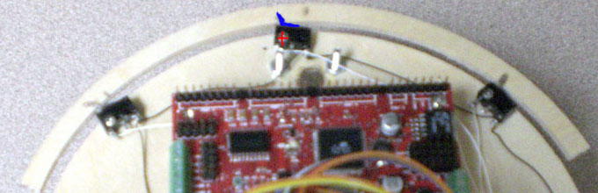

In the picture above the Red cross shows where a screw has been placed to secure the bump switch. It is not tight, however, which allows the switch to rotate on an axis making the sensor system much more sensitive. This also allows the connecting piece of wood to be inflexible. The lever of the bump switch is bent into a small cut out in the wood and then glued.

An important thing to note is that all the switches are oriented in the same direction. This configuration was experimentally found to be the best for a set of three sensors however many different configurations are possible each with its own pros and cons.

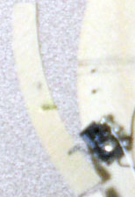 | The bump switch shown to the side is different than the three configuration show before.  The switch is fixed by way of a screw and nut. The switch can be rotated in or out by loosening the screw to let the level vary a certain distance away from the robot.  These wings are good for feeling out things on the sides of the robot such as walls or small obstacles it didn’t see.

Communication
In order to talk to each other, the robots are equipped with RF transceivers with a range of up to 500ft.
Sight

Building three robots means you need to be on a budget. $30 sonar sensors were out of the question, even $12 IR range finders weren’t cheap enough. I choose to go with the Sharp IS471F which is a cheap proximity sensor with a nominal range of about 2”.
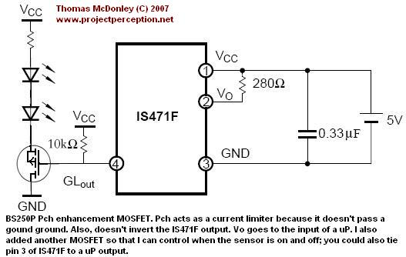 | Proper IR obstacle detection needs to be done well before you get that close to an obstacle. Therefore, I customized the sensor with a P-channel enhancement MOSFET to pulse the LED with large amounts of current. I also used the ground pin of the IS471F tied to my uP board to enable and disable the eyes.  The IS471F is great for this task
because it already uses a duty cycle of about 5% (ideal for pulsing diodes) and because it uses a comparator (and variations between each sensor) there is no cross talk. The sensor is phase and frequency sensitive and I had no trouble with interference between eyes or even robots. A p-channel MOSFET is used to limit current as it doesn’t pass a good ground but a 10 ohm resistor was also used. Each sensor should have 2 LEDs facing approximately 20º away from the sensor. Two sensors are placed on the front of the robot angled away from one another. Having two eyes is important as it allows for fluid steering instead of ‘scanning’.

Also an enhancement mode MOSFET is important because it allows the switch to open (be in saturation) with 5v(uP output) when Vcc could be as high as 12v. A PNP transistor can normally not provide this kind of biasing.

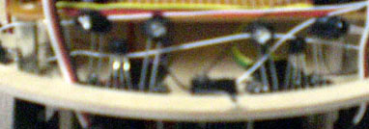

In order to be able to see each other, the robots will have a special IR Beacon of my own design with a controllable range of up to 12ft. Each robot will have IR receivers encircling the mobile platform. The robots take turns (using different periods of repetition to prevent interference) sending out a modulated IR signal. If this signal reaches a receiver than the two robots know their orientation to each other. By varying the strength of the IR signal the robots then know the relative distance.

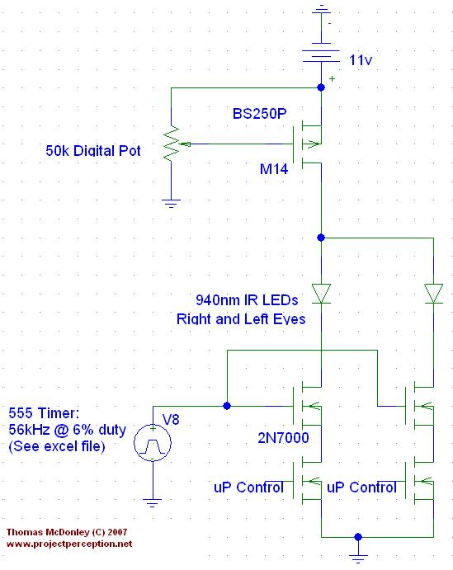 | The IR LEDs are pulsed with a current around 1A to ensure a maximum range of near 18ft. At the bottom of the schematic there is 4 n-channel MOSFETs. One is used to control the frequency and duty cycle and the other is used to control wheather or not the eye is on (by having independent control the motion of the robot can be more fluid and correct it’s path if the eyes see different things)  The potentiometer will control the gate voltage to a p-channel MOSFET. The gate is selected to have a wide saturation mode so that the current to the LEDs varies of a wide range of voltages. This also helps keep the readings linear.
The potentiometer is a digital pot so that it can be controlled with the microcontroller. Since the gate of a MOSFET doesn’t draw any current only one digital pot is needed to control the strength of all the beacons on the robot. There are many alternatives to using a digital pot but this gives the most control over LED intensity.

The receivers are simple Sharp gp1ue28 receivers. They are very sensitive so need to be shield both with a box to make them uni-directional and also with a separator between each to limit light leakage (see the figure below). Distance is measured by timing the first received pulse (weakest) to the last (strongest and guaranteed to be seen). This method was found to be almost linear and the readings are virtually the same on each of the 3 boards I made as well as with respect to position. The same parts should be used, shielding should be identical in nature and dimensions.

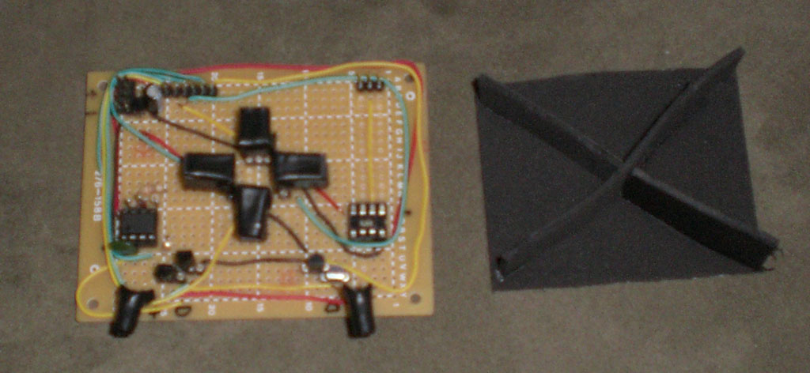

The robots will also be equipped with photo-transistors in order to help replicate animal behaviors/preferences.

Human Detector
Humans are detected thought the use of a motion sensor. A motion sensor is much cheaper than a pyro electric sensor. However, a motion sensor will need a bit of finessing to work as well as a pyro sensor would.
Behavioral Model
The behavior of the robots should be cooperative and biological in nature. Cooperative in that they must use sight and sound to interact with each other in a defined way with defined roles. Biological in that they will be limited in functionality to what is reasonable of an animal (namely a duck). For example, this means that sound travels only a certain distance and doesn’t need to have line of sight; however, sight must be sort range and should be limited to direct line of sight. The parent should also be able to care for its children is various ways such as: protection from predators, leadership, and nourishment.

The children should start off by following the parent. The parent should look for a safe area to let the children wander and play together. At this point, the parent should keep track of its children and guard them from predators. The children will be allowed to roam a certain radial distance away from the parent. The parent will consider any human within a certain radial distance as a predator. If the children are too far away or a predator is located then the parent should guide them appropriately. If time permits, the parent should recognize when too feed itself and the children and then lead them to the recharge station.

Goals
The project goals will be accomplished in the following order. However, to begin I will start off building the parent robot only. Once the parent robot has basic non-contact obstacle avoidance and a defined programming model then I will start to build the children as well.
The parent should:
1) Lead the children to a safe area
2) Signal children when it’s okay to wander
3) Scold children if they wander too far away
4) Protect children from any human presence
*5) Reform a line and lead children to food if anyone is hungry
The children should:
1) Follow each other or the parent
--In single file if time permits
2) Wander aimlessly (light and sound dependant)
3) Listen to parents scolding for getting too far away by re-uniting with
parent
4) Tell parent when they are hungry.
*5) Form some sort of interaction with other children. Self and sibling
aware; hopefully to form a sort of swam-style emergent behavior.
*6) Reform a line and follow parent to food if anyone is hungry.

( * ) Mark goals that are only if time permits.

Helpful Hints

The Atmel AtMega128 Boards
www.bdmicro.com has a great (and credit card sized) MavericIIB Atmega128 board that is excellently designed and built. It does have quite a few things you may never use though and is around $100. This board was designed to be used with batteries.
www.sparkfun.com has a header board that is 1/3 the price but I've found has a few draw backs and needs two modifications. The two draw backs are that the pins are not pulled out to port groupings like the Maveric board (but this isn't so much a problem because most the ports are in acesending/desending order). The biggest problem I've had with the board is the power regulator. It is a LM78l05 which only supplies 100mA, but the board can draw up to 400mA with everything on. It also has a drop out voltage of 2V (So a 7.2V supply is really cutting it close)! That coupled with the fact that the voltage monitor has a reset near 4.7V (from a regulated 5V), the board is very much prone to reset even when power spikes from the motors are carefully regulated. This board was therefore not designed to be used with batteries but this can all be fix easily.
However you can easily replace the Voltage Regulator with one of the following:
1)LT1129-5 @ 700mA with DOV of 0.4V
This chip has many protections so you don't really need a voltage monitor
2)TL750M05 @ 750mA with DOV of 0.6V
Same protections as the other but also Voltage Load Dump which is good to have with motors.
The Voltage monitor should be replaced with one that has a lower trip point more near 4V; or really just taken out if you get a good voltage regulator.

Programming
As for programming the boards their is a cheap serial programmer but it is not reliable and really isn't worth the money you are saving. There is a good JTAG and ICSP programmer from http://microcontrollershop.com/product_info.php?cPath=110_53&products_id=1106
AvrStudio is free and fully compatible with GCC and AVR Assembly. It is also compatible with the programmer I listed above. It is really very nice. One of the more impressive features is that you can address ports just like variables (although 16bit ports need special care).

Conclusions
The custom hardware was a lot of work to get working but I am pleased with the precision of the sight/distance sensor. I am also please of how well the modification of the proximity sensor works.

I would also strongly encourage the use of the Maveric IIB board. It is well designed and can hold up to the abuse of a beginning robot designer. The header-board must be modified as mentioned above.

In the future I would like to buy better servos that are less noisy and a bit more uniform from motor to motor. If money weren’t an option I would definitely go with a single geared motor that spins an axel each wheel is attached too (makes going straight trival). Steering can be accomplished with a servo that changes to angle of the drive system. Talk to a mechanical engineer about this; they know how to do it right.

Documentation
Intelligent Machine Lab @ UF
http://www.mil.ufl.edu/imdl/

Hacking a Servo by Kevin Ross
http://www.junun.org/MarkIII/Manual/kevin/servohack.html

IR Beacon
http://robotag.carleton.ca/resources/technical/ir_beacon.shtml

TJ Pro Maker
http://www.mekatronix.com/brief/robots.htm

