Obliterator

Final Report – IMDL Spring 2007
Jose Noriega

University of Florida
Department of Electrical and Computer Engineering
EEL 5666 – IMDL Spring 2007
Intelligent Machines Design Laboratory

Instructors: | TAs:
Dr. Arroyo | Adam Barnett
Dr. Schwartz | Julio Suarez

Table of Contents:

Title Page…………………………………………... 1
Table of Contents…………………………………... 2
Abstract…………………………………………….. 3
Executive Summary………………………………... 4
Introduction………………………………… ……... 5
Integrated System…………………………………... 6
Mobile Platform……………………………………. 7
Actuation…………………………………………….9
Sensors……………………………………………... 10
Behaviors…………………………………………... 13
Experimental Layout and Results………………….. 15
Conclusion…………………………………………. 17
Documentation……………………………………... 18
Appendix…………………………………………… 19

Abstract
The Obliterator is an autonomous sentry robot that combines obstacle avoidance with deadly accuracy in an auto-configuring package. The Obliterator patrols a given target area searching for heat sources while avoiding inanimate objects. Once a heat source is detected, the Obliterator will attempt to target the source. If the source has moved too quickly, the Obliterator will detect a false alarm and stand down. However, if the target is still within reach, the Obliterator will power up its laser cannon and shoot the target.
To deploy the system users simply power on the unit and leave the area within ten seconds. During these ten seconds the Obliterator is configuring its sonar, IR, and pyroelectric sensors to its immediate environment. Once the configuration process is complete, the Obliterator will be calibrated and all human presence detected will be dispatched for the next 1.5 hours.
The vehicle is equipped with a human detection sensor that identifies possible intruders in its general vicinity. The on board electronics are controlled by a Mavric IIB Atmel ATmega128 microcontroller board. The Obliterator utilizes sonar, IR, and motion detection sensors as its primary obstacle avoidance systems.

Executive Summary
This project report consolidates all systems information about the Obliterator autonomous robot created for the Intelligent Machines Design Laboratory (IMDL) class during the Spring 2007 semester. The professors in charge of IMDL are Dr. Arroyo and Dr. Schwartz. The semesters’ TAs were Adam Barnett and Julio Suarez.
The Obliterator is designed to be an indoor sentry platform. The purpose of the Obliterator is to substitute direct man-power in the battlefield. The Obliterator will patrol an area while using its sonar, IR, and bump sensors to perform obstacle avoidance. The pyroelectric PIR special sensors allow the Obliterator to identify heat sources in its direct vicinity.
Once the Obliterator begin patrolling the target zone, if contact is made with a moving heat source the machine targets the source. The targeting sequence consists of the Obliterator simulating motion by turning in place back and forth while facing the suspected target. If the machine detects a human presence, the Obliterator powers the ultra high-powered laser and shoots the intruder. If the target has moved too quickly for the Obliterator to complete its target sequence, the machine stands down.
The main processing power of the Obliterator is the Mavric IIb microcontroller board from BDmirco.com. This board uses an Atmel ATmega128 8-bit microcontroller programmable in C using the WinAVR GCC compiler and AVRStudio. All of the code for this project can be found in the appendix at the end of this report.

Introduction
The purpose of the Obliterator is to offer a cheap and viable substitute for man power on the battlefield. The ideal use of the Obliterator will come in urban conflict zones where insurgencies are constantly trying to recapture strategic command points. The military will clear entire neighborhoods only to find them repopulated with terrorist insurgents hours later. The Obliterator’s unique mission solves the need for a continued military presence in these areas. Once a building is cleared of enemy combatants, the Obliterator can be deployed in the building to ensure it is not reoccupied by the enemy.
The Obliterator is the latest technology in sentry bots available on the market, combining obstacle avoidance with deadly accuracy in an auto-configuring package. Upon startup the Obliterator will configure the sonar, IR, and pyroelectric sensors to its environment for ten seconds. All personnel need to vacate the premises during this start up time. Once deployed, the Obliterator will patrol its target area searching for heat signatures while avoiding obstacles. If a human is detected the Obliterator will attempt to target the intruder. If the target sequence is successful, the Obliterator powers up the laser cannon and dispatches the suspect. If the target is moving too quickly, the Obliterator will stand down and continue patrolling.

Integrated System
The Obliterator electronics are powered using the Mavric IIB development board. This board has an Atmega-128 microcontroller and a full set of peripherals and interfaces to connect to the variety of sensors on the robot. The following block diagram of the Obliterator’s subsystems illustrates the peripherals connected to the Mavric board:
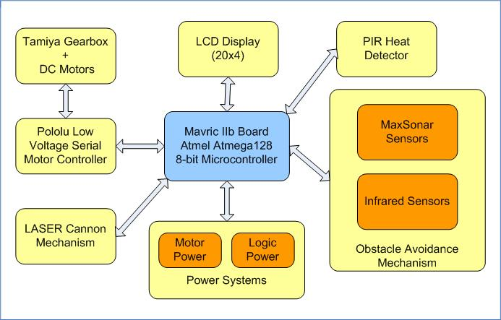
Figure 1: Obliterator Main Subsystems Block Diagram

The sensor systems used pin connections for VCC and GND from the Logic Power subsystem. The sensor outputs are fed into the PortF A/D channels to be sampled and filtered. The LCD display system is connected to PortA using the standard Hitachi HD44780U controller. The low voltage serial motor controller receives commands from the USART Tx pin on PortE. Finally, the LASER cannon mechanism is controlled by a custom-built circuit tied to PortB.

Mobile Platform
The Obliterator uses a steel frame consisting of Steel-Tec erector set parts. The customizability of the frame allows for flexibility when mounting all of the peripherals required for the Obliterator to perform its mission. The pre-drilled holes of the Steel-Tec parts allowed for easy layout when deciding where to mount the sensors, LCD, Mavric, gearbox, and protoboard onto the Obliterator. The robot moves using two DC motors and a Tamiya gearbox mechanism in the front. Towards the back of the platform are two ball casters that are dragged along as the robot moves. This makes turning in place easy and gives the Obliterator a sharp turn radius. The following image shows the final stage of the Obliterator’s mobile platform:
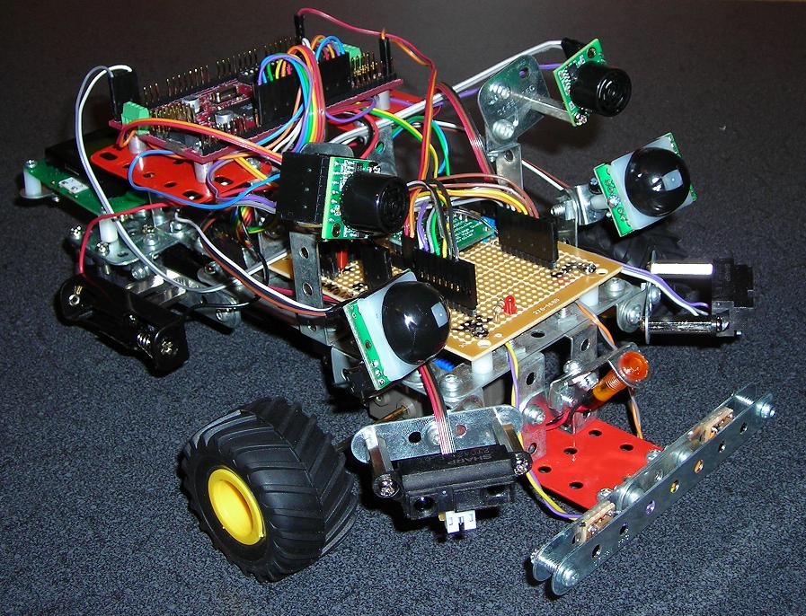
Figure 2: Final Obliterator Mobile Platform
The sonar sensors are mounted high and facing forward from the robot. This allows for detection of large objects directly ahead of the Obliterator. The IR sensors face left and right near the two wheels. This prevents obstacles from snagging on either of the wheels. The titanium reinforced bumper ensures anything that may be overlooked by the other sensors is detected by the bump switch mechanism. This ensures that small objects that are low and centered do not damage the robot. Finally, the PIR sensors are mounted facing up and towards the center to better detect humans present in the area.

Actuation
The motors are controlled by a serial low-voltage motor driver from pololu.com. The motor driver requires commands to control two 3volt DC motors that are attached to a Tamiya double gearbox. The motor commands have the following structure:
Figure 3: Motor Command Structure
while( !(UCSR0A & (1<<UDRE0)) ); //Wait for UART to clear
UDR0 = 0x80;//Start Byte
while( !(UCSR0A & (1<<UDRE0)) );
UDR0 = 0x00;//Device Type
while( !(UCSR0A & (1<<UDRE0)) );
UDR0 = 0x01;//Motor # and Direction
while( !(UCSR0A & (1<<UDRE0)) );
UDR0 = speed;//Motor Speed (0 to 127)
while( !(UCSR0A & (1<<UDRE0)) );
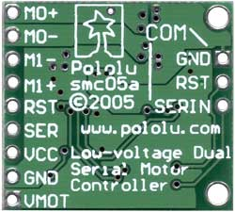
These commands are sent out the UART interface Tx bit to the Pololu serial motor controller pictured below. The controller requires a logic voltage, a motor voltage, a ground reference, and the serial interface to control the four output pins of the two motors. Motor0 is connected to the right motor and Motor1 is connected to the left motor. The three pins by labeled as “COM” are intended for RS-232 communications with a PC and are not connected.
Figure 4: Motor Controller

Sensors
The four main sensors on the Obliterator are sonar, IR, pyroelectric, and a bump switch. Using data from all of these systems, the machine avoids obstacles as it patrols the target zone.
Sharp GP2Y0 IR Sensor
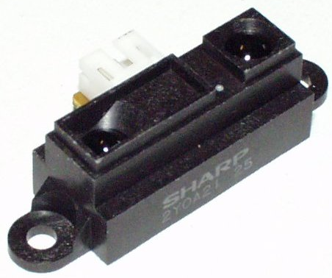
Figure 5: Sharp GP2Y0 IR Sensor
The Sharp IR sensor is an analog distance measuring device. The sensor has three pin connections, one for power, ground, and analog output. The analog pin is connected to the A/D port on the Mavric IIB board. This port can be read and depending on the voltage difference of the output ranging from 0v to 5v, the A/D converter gives a corresponding digital value between 0 and 255. The voltage versus distance graph shows the accuracy of the IR sensor. Anything closer than 5cm is not going to be detected and anything further than 30cm will not result in enough of a voltage change.

Max Sonar EZ-1 Range Sensor
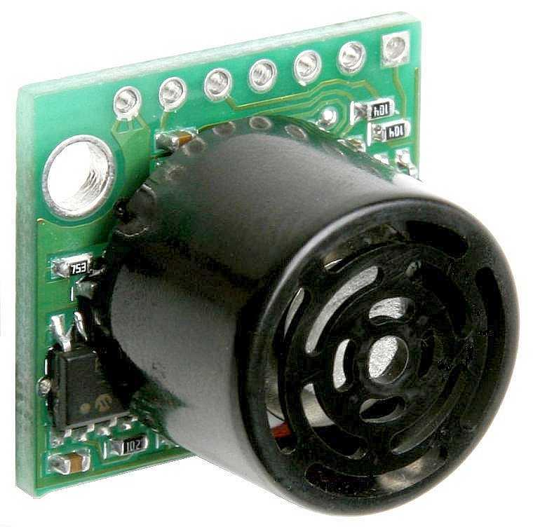
Figure 6: Sharp GP2Y0 IR Sensor
The Max Sonar sensor offers a variety of ways to interface a microcontroller with the sensor such as RS-232, pulse-timing, and analog. In order to maintain simplicity, I will use the analog system to interface the sonar sensor. By doing so, the sonar sensor will output a voltage between 0v and 5v that is proportional to how far an object is from the sensor. The scaling factor of the sensor is 10mV per inch distance from the object.
Bump Switch
I constructed titanium reinforced front bumper switch for the Obliterator to protect it from any small obstacles it may not detect using the other sensors. With the strategic placement of the IR low to the ground and the sonar high, the Obliterator usually detects all nearby obstacles prior to collision. However, in the event that a small obstacle is low enough to the ground and centered so as to miss all other sensors, the Obliterator’s bumper will trigger a behavior to get the robot unstuck.
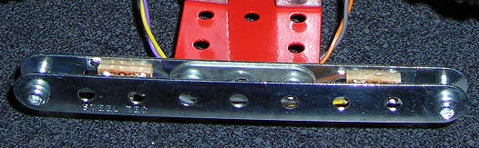
Figure 7: Titanium Reinforced Bumper Switch

Pyroelectric Infrared Special Sensor (PIR)
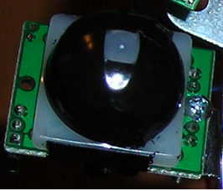
Figure 8: Parallax PIR Sensor
The Obliterator uses two pyroelectric sensors to identify human presence in its vicinity. The two sensors face towards the front center of the Obliterator to be able to target a heat source by using data from both sensors. These sensors are in fact digital sensors resulting in data that returns all or nothing heat detection. This leads to certain complications when trying to confirm that a target is still present in front of the PIR sensors. Since the PIR sensors are triggered by changes in heat if a target remains absolutely still in front of the robot when it is not moving, the pyroelectric sensors will not detect the heat source. Hence, the targeting sequence moves the robot back and forth in place to simulate motion. In doing so, the pyroelectric sensors can detect the heat source as if it were moving across their field of vision. Also, the Parallax sensors I purchased have a plastic cone covering the actual PIR sensor to filter the IR energy. However, the sensors were still too sensitive in the peripheral areas hence causing false positives along the side of the Obliterator. The solution I used was to cover the plastic sensors with black electrical tape and minimize the opening exposed to the environment. In doing so, the field of vision was greatly narrowed and the PIR sensors can better detect heat sources directly in front of the robot.

Behaviors
The Obliterator can operate in any of five behavior modes during the course of its mission. The first behavior mode is the “Collision Detect” mode. This mode is only triggered when the Obliterator bumps into an obstacle that it somehow missed using the other sensors. During this behavior, the Obliterator will back up from the obstacle, spin in place, and continue on with the behavior it was performing prior to the impact.
The second behavior is the “Initialization Mode” that the Obliterator undergoes upon start-up. When the Obliterator is first turned on it enters this mode and counts down for ten seconds. This initialization period serves to allow the sensors to power up and begin taking readings to eliminate transient noise and to allow the users who deployed the system to leave the premises with adequate time.
The third behavior is the “Target Acquisition” mode where the Obliterator moves around randomly avoiding obstacles searching for a heat source. In this mode the Obliterator can follow a variety of movements in a relatively random fashion depending on the environment. These movements include routines for turning left, turning right, spinning in place, and backing up. Using the sensors to detect obstacles, the Obliterator analyzes the data being collected and decides which of these movements to undertake as it is searching for a heat source to target.
The fourth behavior is the “Target Aiming” mode and it is triggered when a heat source is detected in front of the Obliterator. If a target is believed to have been acquired, the Obliterator enters a routine where it simulates motion to confirm the target is present. The Obliterator will turn slightly to the left and back to the right three times. This makes the target appear as in motion relative to the PIR sensors. If after the aiming sequence is complete the pyroelectric sensors do not confirm a target in front of the robot, the Obliterator will stand down and return to Target Acquisition mode. However, if after the targeting sequence is complete and the PIR sensors are still detecting a heat source, the Obliterator confirms the presence of a target and enters the final behavior.
The fifth and final behavior is called the “Obliterate” mode and it occurs after a successful targeting sequence is completed. Once the Obliterator has confirmed the target is directly ahead and it is a heat source, the Obliterator powers up the LASER cannon and fires at the target. This in turn completely obliterates the human and causes the Obliterator to turn around and continue searching for new targets in the Target Acquisition mode.
The code written to implement all of these behaviors is included in the appendix of this report. The behaviors are determined in the main body loop using sensor data and the Behavior_Arbitrate() method determines which behavior needs to be implemented at a given time.

Experimental Layout and Results
During the Target Acquisition mode the Obliterator sends the sensor data out to the LCD. This facilitates understanding what the machine is doing at any given time as well as provides a way to collect data results from environmental experiments. The following graphs illustrate the data values for the sonar and infrared sensors.
IR
Inches | Value
1 | 240
2 | 270
3 | 250
4 | 220
5 | 200
6 | 190
7 | 180

Figure 9: IR Sensor Data Graph
Sonar
Inches | Value
1 | 103
4 | 103
8 | 104
12 | 105
16 | 106
20 | 108
24 | 109

Figure 10: Sonar Sensor Data Graph
Using these data values I decided to establish cut off points to change behaviors based on how far away the robot was from an obstacle. For the IR data I chose to use a cut-off of 180 to ensure at least seven inches between one of the infrared sensors and the obstacle. As for the sonar data, I needed to detect large obstacles up ahead farther away to ensure that the PIR sensors would not see the approaching wall as a human in motion. Therefore I selected a sonar cut-off of 109 to maintain at least 2 feet away from the walls. Anything close would result in the PIR having a false positive and thinking the wall was a target in motion.

Conclusion
Using its array of sensors the Obliterator is able to complete its difficult mission. The sonar and infrared sensors provide the data to avoid obstacles while the pyroelectric sensors detect targets for the robot to obliterate. The only difficulty the Obliterator encounters is the possibility of false positive targets. The pyroelectric sensors are digital and do not discern between varying intensities of heat in motion. This results in the sensors sometimes being triggered by hot lamps or radiant light from the environment.
The next generation of Obliterator robots will use analog pyroelectric sensors. This will allow the machine to differentiate between varying degrees of heat and better select its targets. Also, more accurate targeting can be accomplished by combining analog PIR sensors to form a grid array. By having a grid of PIR sensors feeding data into the Obliterator’s behavior algorithm, more complex behaviors can be added and the robot can do things more accurately. A grid array of PIR sensors would allow the machine to turn towards the more intense heat direction and attempt to target the intruder. Also, the analog grid array would diminish the number of false positives by having it so all sensors have to detect a nearly identical heat intensity to declare the target as hostile.
Overall the Obliterator is successful in completing its mission of human detection and obliteration. This prototype vehicle represents the future of autonomous sentry bots for the purpose of securing a battlefield.

Documentation
Mavric IIb Datasheet – BDMicro.com
http://www.bdmicro.com/mavric-ib/mavric-ib.pdf

Atmel ATmega128 Datasheet – Atmel.com
http://www.atmel.com/dyn/resources/prod_documents/doc2467.pdf

Sharp GP2Y0 IR Datasheet – SparkFun.com
http://www.sparkfun.com/datasheets/Components/GP2Y0A21YK.pdf

MaxBotix EZ-1 Datasheet – MaxBotix.com
http://www.maxbotix.com/uploads/LV-MaxSonar-EZ1-Datasheet.pdf

Hitachi HD44780 LCD Datasheet – SparkFun.com
http://www.sparkfun.com/datasheets/LCD/GDM2004D.pdf

Pololu Serial Motor Controller Datasheet – Pololu.com
http://www.pololu.com/products/pololu/0120/smc05a_guide.pdf

PIR Pyroelectric Datasheet – Parallax.com
http://www.parallax.com/dl/docs/prod/audiovis/PIRSensor-V1.2.pdf

“IMDL Spring 2007 Lab Notebook” Jose Noriega – Schematics and diagrams

Appendix
Appendix A: Special Thanks
I would like to thank Drs. Schwartz and Arroyo for being understanding of the students needs as they progress through this difficult project. You were both right in saying that the sense of accomplishment at the end of the semester was worth the countless hours of headaches and frustration. Special thanks to Julio Suarez for his patience and skill in helping me throughout this project. Also to the select IMDLers who helped me by questioning and suggesting ways to improve my design.

Appendix B: Robot Code
The following 13 pages is the complete behavior code programmed in C using AVRStudio and the WinAVR GCC compiler. Programming was done using an ISP programmer and PonyProg 2000.

#include <avr/io.h>
#include <avr/interrupt.h>
#include <util/delay.h>
#include "lcd.h"
#include "FinalProject.h"
#include "MotorDriver.h"

//Globals
int LWheelDir; //1 = Forward 0 = Reverse
int RWheelDir; //1 = Forward 0 = Reverse
int LSpeed; //0 to 120 in increments of 30 (0,30,60,90,120)
int RSpeed; //0 to 120 in increments of 30 (0,30,60,90,120)

char name[21] = "Target Acquisition";

char LPI[6] = "LPI= "; //Text for Left Pyro
char RPI[6] = "RPI= "; //Text for Right Pyro
char LIR[6] = "LIR= "; //Text for Left IR
char RIR[6] = "RIR= "; //Text for Right IR
char LSO[6] = "LSO= "; //Text for Left Sonar
char RSO[6] = "RSO= "; //Text for Right Sonar

char LeftPyro[4]; //Sensor string output
char RightPyro[4]; //Sensor string output
char LeftIR[4]; //Sensor string output
char RightIR[4]; //Sensor string output
char LeftSonar[4]; //Sensor string output
char RightSonar[4]; //Sensor string output

int LeftPyroData; //Sensor data used for behavior
int RightPyroData; //Sensor data used for behavior
int LeftIRData; //Sensor data used for behavior
int RightIRData; //Sensor data used for behavior
int LeftSonarData; //Sensor data used for behavior
int RightSonarData; //Sensor data used for behavior

int BumpData; //Sensor data use for the bump switch

int LeftPyroArray[10] = {0,0,0,0,0,0,0,0,0,0}; //10 point averaging filter
int RightPyroArray[10] = {0,0,0,0,0,0,0,0,0,0}; //10 point averaging filter
int LeftSonarArray[10] = {0,0,0,0,0,0,0,0,0,0}; //10 point averaging filter
int RightSonarArray[10] = {0,0,0,0,0,0,0,0,0,0}; //10 point averaging filter

int Behavior0; //Variable used to determine behavior = All sensors clear
int Behavior1; //Variable used to determine behavior = Both sonar or both IR detect directly ahead
int Behavior2; //Variable used to determine behavior = Left sonar or IR detect => turn right
int Behavior3; //Variable used to determine behavior = Right sonar or IR detect => turn left
int Behavior4; //Variable used to determine behavior = Left and Right Pyro Sensors detect heat
int Behavior5; //Variable used to determine behavior

int ADdata; //Used to stablize UART data
int ADhigh; //Used to read UART data
int TempPyroLeft; //Used to calculate average pyro data
int TempPyroRight; //Used to calculate average pyro data
int TempSonarLeft; //Used to calculate average sonar data
int TempSonarRight; //Used to calculate average sonar data
int t; //Used for for-loops and delays
int q; //Used for for-loops and delays
int s; //Used for sensor arrays = Sonar
int p; //Used for sensor arrays = Pyro
int r; //Used for initial behavior delay
int z; //Used for pyro behavior loop
unsigned int tempC; //Used for bumper routine

int main(void)
{
DDRA = 0xFF; //PortA is all outputs. Used for the LCD.
DDRB = 0xFF; //PortB is all outputs. Used for the reset pin.
DDRF = 0x00; //PortF is all inputs. Used for the A/D converter.
PORTB = 0x00; //Initialize to 0
PORTF = 0x00; //Initialize to 0

s = 0; //Initialize sensor array variable
TempSonarLeft = 0; //Initialize sensor temp value
TempSonarRight = 0; //Initialize sensor temp value
LWheelDir = 1; //Initialize left direction variable
RWheelDir = 1; //Initialzie right direction variable
LSpeed = 0; //Initialize left speed variable
RSpeed = 0; //Initialize right speed variable

AD_Init(); //Turns on AD converter

USART_Init(); //Turns on UART
_delay_ms(15);

LCD_init(); //Turns on LCD

Oblit_Powerup(); //Runs the power up sequence

Motor_Init(); //Initializes motor driver

for(r=0; r<10; r++) //Sample enough sonar data to fill the 10 point averager
{
Sensor_Reading(0);
}

LCD_clear(); //Clears LCD
LCD_text_setup(); //Sets up text on LCD for sensors

while(1)
{
Sensor_Reading(1);

if(BumpData > 200 )
{
Bumper_routine();
}

if(LeftIRData <= 170 && RightIRData <= 170 && LeftSonarData >= 110 && RightSonarData >= 110)
{
Behavior0 = 1; //All sensors are clear
} //Move forward
else
{
Behavior0 = 0;
}

if(LeftSonarData < 110 && RightSonarData < 110 )
{
Behavior1 = 1; //Both sonar detect something up ahead
} //Turn around
else
{
Behavior1 = 0;
}

if(LeftIRData > 170 )
{
Behavior2 = 1; //Something on the left side of the robot
} //Turn right
else
{
Behavior2 = 0;
}

if(RightIRData > 170 )
{
Behavior3 = 1; //Something on the right side of the robot
} //Turn left
else
{
Behavior3 = 0;
}

if(LeftPyroData > 260 && RightPyroData > 260)
{
Behavior4 = 1; //Something hot up ahead
} //Target human
else
{
Behavior4 = 0;
}

Behavior_Arbitrate();
}

} //End of main

void Behavior_Arbitrate()
{
if(Behavior0 == 1 && Behavior1 == 0 && Behavior2 == 0 && Behavior3 == 0)
{ //If the path is clear, do this behavior
if(LWheelDir == 1 && RWheelDir == 1) //Move forward
{
if(LSpeed < 120 && RSpeed < 120)
{
LSpeed = LSpeed + 30;
RSpeed = RSpeed + 30;
Motor_forward(RSpeed, LSpeed);
delay150ms();
}
else
{
Motor_forward(120, 120);
delay150ms();
}
}
else
{
Motor_stop_left();
Motor_stop_right();
LWheelDir = 1;
RWheelDir = 1;
LSpeed = 0;
RSpeed = 0;
delay150ms();
}
}

if(Behavior0 == 0 && Behavior1 == 1 && Behavior4 == 0)
{ //Both sonars detect + no pyro detect
if(LWheelDir == 1 && RWheelDir == 0) //Spin around going right
{
if(LSpeed < 90 && RSpeed < 90)
{
LSpeed = LSpeed + 30;
RSpeed = RSpeed + 30;
LWheelDir = 1;
RWheelDir = 0;
Motor_spin_right(LSpeed, RSpeed);
delay150ms();
}
else
{
Motor_spin_right(90, 90);
delay150ms();
}

}
else
{
Motor_stop_left();
Motor_stop_right();
LWheelDir = 1;
RWheelDir = 0;
LSpeed = 0;
RSpeed = 0;
delay150ms();
}
}

if(Behavior2 == 1 && Behavior3 == 0 && Behavior1 == 0) //Something on the left side of the robot
{ //Turn right
if(LWheelDir == 1 && RWheelDir == 0)
{
if(LSpeed < 120)
{
LSpeed = LSpeed + 30;
RSpeed = 0;
LWheelDir = 1;
RWheelDir = 0;
Motor_turn_right(LSpeed);
delay150ms();
}
else
{
RSpeed = 0;
LWheelDir = 1;
RWheelDir = 0;
Motor_turn_right(120);
delay150ms();
}
}
else
{
if(LWheelDir == 0)
{
Motor_stop_left();
}
Motor_stop_right();
LWheelDir = 1;
RWheelDir = 0;
LSpeed = 0;
RSpeed = 0;
delay150ms();
}
}

if(Behavior3 == 1 && Behavior2 == 0 && Behavior1 == 0) //Something on the right side of the robot
{ //Turn left
if(LWheelDir == 0 && RWheelDir == 1)
{
if(RSpeed < 120)
{
LSpeed = 0;
RSpeed = RSpeed + 30;
LWheelDir = 0;
RWheelDir = 1;
Motor_turn_left(RSpeed);
delay150ms();
}
else
{
LSpeed = 0;
LWheelDir = 0;
RWheelDir = 1;
Motor_turn_left(120);
delay150ms();
}
}
else
{
if(RWheelDir == 0)
{
Motor_stop_right();
}
Motor_stop_left();
LWheelDir = 0;
RWheelDir = 1;
LSpeed = 0;
RSpeed = 0;
delay150ms();
}
}

if(Behavior2 == 1 && Behavior3 == 1 && Behavior1 ==0) //Both IR are triggered but no sonar
{
if(LWheelDir == 1 && RWheelDir == 0) //Spin around going right
{
if(LSpeed < 90 && RSpeed < 90)
{
LSpeed = LSpeed + 30;
RSpeed = RSpeed + 30;
LWheelDir = 1;
RWheelDir = 0;
Motor_spin_right(LSpeed, RSpeed);
delay150ms();
}
else
{
Motor_spin_right(90, 90);
delay150ms();
}

}
else
{
Motor_stop_left();
Motor_stop_right();
LWheelDir = 1;
RWheelDir = 0;
LSpeed = 0;
RSpeed = 0;
delay150ms();
}
}

if(Behavior4 == 1 )//&& Behavior1 == 1) //Both pyro detect
{
Motor_stop_left(); //Stop
Motor_stop_right();
LWheelDir = 1;
RWheelDir = 1;
LSpeed = 0;
RSpeed = 0;
delay150ms();

LCD_clear(); //Display we detected something
_delay_ms(1);
LCD_moveTo(1,3);
_delay_ms(1);
LCD_string("Motion");
_delay_ms(1);
LCD_moveTo(2,5);
_delay_ms(1);
LCD_string("Detected!!!!");

delay500ms(); //Wait period after obliteration

if(Behavior1 == 1)
{
Motor_spin_left(30,30);
delay100ms();
delay100ms();
Motor_stop_left();
Motor_stop_right();
}

for(r=0; r<3; r++)
{
Motor_spin_right(30,30);
Sensor_Reading(0);
delay500ms();
Motor_spin_right(60,60);
Sensor_Reading(0);
delay500ms();
Sensor_Reading(0);
delay500ms();
Sensor_Reading(0);
Motor_stop_left();
Motor_stop_right();

Sensor_Reading(0);
delay500ms();

Motor_spin_left(30,30);
Sensor_Reading(0);
delay500ms();
Motor_spin_left(60,60);
Sensor_Reading(0);
delay500ms();
Sensor_Reading(0);
delay500ms();
Sensor_Reading(0);
Motor_stop_left();
Motor_stop_right();
Sensor_Reading(0);
delay500ms();
}

if(LeftPyroData > 100 && RightPyroData > 100)
{
LCD_clear(); //Display we acquired something
_delay_ms(1);
LCD_moveTo(1,3);
_delay_ms(1);
LCD_string("Target Acquired");
_delay_ms(1);
LCD_moveTo(2,1);
_delay_ms(1);
LCD_string("Powering Cannon...");

delay500ms(); //Fire cannon code goes here!!!!!!
delay500ms();
delay500ms();
delay500ms();

//FIRE CANNON HERE

LCD_clear(); //Display we are firing
_delay_ms(1);
LCD_moveTo(1,3);
PORTB = 0x11; //Turn on cannon
_delay_ms(1);
LCD_string("OBLITERATED");
}
else
{
LCD_clear(); //Display it was a false alarm
_delay_ms(1);
LCD_moveTo(1,3);
_delay_ms(1);
LCD_string("False Alarm");
_delay_ms(1);
LCD_moveTo(2,5);
_delay_ms(1);
LCD_string("Standing Down");
Motor_stop_left();
Motor_stop_right();
delay500ms();
delay500ms();
delay500ms();
delay500ms();
}

//This code backs up and turns away from the target once destroyed
Motor_reverse(30,30);
delay150ms();
delay100ms();
Motor_reverse(60,60);
delay150ms();
delay100ms();
Motor_reverse(90,90);
delay150ms();
delay100ms();
Motor_reverse(90,90);
delay150ms();
delay500ms();
delay500ms();
delay500ms();
delay500ms();
PORTB = 0x01; //Turn off cannon

Motor_stop_left();
Motor_stop_right();
delay100ms();
delay100ms();

Motor_spin_left(30,30);
delay150ms();
delay100ms();
Motor_spin_left(60,60);
delay150ms();
delay100ms();
Motor_spin_left(90,90);
delay150ms();
delay100ms();
Motor_spin_left(90,90);
delay500ms();
delay500ms();
delay500ms();
delay500ms();
delay500ms();
delay500ms();

Motor_stop_left();
Motor_stop_right();
delay150ms();
/////////////////////////////////////////////////////////

LeftPyroData = 0; //This assures the same target is not targeted
RightPyroData = 0;
for(p=0; p<10; p++)
{
LeftPyroArray[p] = 0;
RightPyroArray[p] = 0;
}

LCD_clear(); //Return display to sensor output
_delay_ms(1);
LCD_moveTo(0,0);
_delay_ms(1);
LCD_text_setup();
}

}

void Sensor_Reading(int feedback) //Sensor Loop Used to read sensors and store global data.
{
//Bumper Switch data reading
ADMUX = 0b01100100;
_delay_ms(5);
ADhigh = ADCH;
ADdata = ADhigh;
BumpData = ADdata; //Stores bump data into global variable
_delay_ms(5);

//Left IR Sensor Code = Red Wire = PortF[3]
ADMUX = 0b01100011;
_delay_ms(5);
ADhigh = ADCH;
ADhigh = ADhigh + 100;
ADdata = ADhigh;
LeftIRData = ADdata; //Stores LeftIR data into global variable

//Right IR Sensor Code = Orange Wire = PortF[2]
ADMUX = 0b01100010;
_delay_ms(5);
ADhigh = ADCH;
ADhigh = ADhigh + 100;
ADdata = ADhigh;
RightIRData = ADdata; //Stores RightIR data into global variable

//Left Pyro Sensor Code = PortF[6]
ADMUX = 0b01100110;
_delay_ms(5);
ADhigh = ADCH;
ADhigh = ADhigh + 100;
LeftPyroArray[s] = ADhigh; //Stores LeftPyro data into global variable

//Right Pyro Sensor Code = PortF[5]
ADMUX = 0b01100101;
_delay_ms(5);
ADhigh = ADCH;
ADhigh = ADhigh + 100;
RightPyroArray[s] = ADhigh; //Stores RightPyro data into global variable

//Left Sonar Sensor Code = Purple Wire = PortF[1]
ADMUX = 0b01100001;
_delay_ms(5);
ADhigh = ADCH;
ADdata = ADhigh + 100;
LeftSonarArray[s] = ADdata; //Stores LeftSonar data into global LeftSonarArray

//Right Sonar Sensor Code = Blue Wire = PortF[0]
ADMUX = 0b01100000;
_delay_ms(5);
ADhigh = ADCH;
ADdata = ADhigh + 100;
RightSonarArray[s] = ADdata; //Stores RightSonar data into global RightSonarArray

//This will do all the feedback output in one IF statement:
if(feedback == 1) //If feedback was requested, print this to the screen
{
sprintf(LeftIR, "%d", LeftIRData);
_delay_ms(5);
LCD_moveTo(2,5);
_delay_ms(5);
LCD_string(LeftIR);
_delay_ms(5);

sprintf(RightIR, "%d", RightIRData);
_delay_ms(5);
LCD_moveTo(2,15);
_delay_ms(5);
LCD_string(RightIR);
_delay_ms(5);

sprintf(LeftPyro, "%d", LeftPyroData);
_delay_ms(5);
LCD_moveTo(1,5);
_delay_ms(5);
LCD_string(LeftPyro);
_delay_ms(5);

sprintf(RightPyro, "%d", RightPyroData);
_delay_ms(5);
LCD_moveTo(1,15);
_delay_ms(5);
LCD_string(RightPyro);
_delay_ms(5);

sprintf(LeftSonar, "%d", LeftSonarData);
_delay_ms(5);
LCD_moveTo(3,5);
_delay_ms(5);
LCD_string(LeftSonar);
_delay_ms(5);

sprintf(RightSonar, "%d", RightSonarData);
_delay_ms(5);
LCD_moveTo(3,15);
_delay_ms(5);
LCD_string(RightSonar);
_delay_ms(5);
}

s++;
if(s >= 10) //If s > array length, reset to 0
{
s=0;
}
q++;
if(q >= 5)
{
q=0;
}

TempPyroLeft = 0; //Reset temp variables to 0
TempPyroRight = 0;
TempSonarLeft = 0;
TempSonarRight = 0;

for(t=0; t<10; t++) //Add the array values into the temp variable
{
TempPyroLeft = TempPyroLeft + LeftPyroArray[t];
TempPyroRight = TempPyroRight + RightPyroArray[t];
TempSonarLeft = TempSonarLeft + LeftSonarArray[t];
TempSonarRight = TempSonarRight + RightSonarArray[t];
}

LeftPyroData = (TempPyroLeft / 10);
RightPyroData = (TempPyroRight / 10);
LeftSonarData = (TempSonarLeft / 10); //Average out the array data
RightSonarData = (TempSonarRight /10);
}

