Final

Report

University of florida
EEL 5666 - Intelligent Machine Design Lab
By
Siddharth Gaddam
UFID # 3733-8978

22nd April, 2007

Bluetooth Enable Autonomous Mobile Robot (BEAMR)

Table of Contents

1. Abstract 4
2. Executive Summary 5
3. Introduction 6
3.1 Scope 6
3.2 Sub Systems 6
3.3 Resources/Parts Used 6
3.4 Deliverables 7
4. Integrated System 8
5. Mobile Platform 9
6. Actuation 11
7. Sensors 12
7.1. Bump Switches 12
7.2. IR Proximity Sensors 13
7.3. Bluetooth Transceiver 13
7.4. Camera 17
8. Behaviors 19
8.1 Bump Sensors 19
8.2 IR Sensors 19
8.3 Bluetooth Transceiver 19
8.4 Camera 22
8.5 Low Voltage Dual Motor Serial Controller 24
8.6 LCD Module 25
9. Experimental Layout and Results 26
10. Conclusion 28
11. Documentation 30
12. Appendices 31
12.1 Appendix A – Pictures 31
12.2 Appendix B - Code 33

List of Figures

Figure 1 BEAMR System Level Block Diagram 8
Figure 2 The BEAMR Mobile Platform 10
Figure 3 Gearbox Assembly 11
Figure 4 IR Proximity Sensors and Front Bump Sensor 13
Figure 5 Blue Radios Bluetooth Transceiver 14
Figure 6 Bluetooth Standard (IEEE 802.15.1) Layers 15
Figure 7 FHSS graphically explained 16
Figure 8 C328 Camera Module 18
Figure 9 Setting up hyperterminal link using PuTTY 20
Figure 10 AT commands using Hyperterminal window 21
Figure 11 Camera System Block Diagram 22
Figure 12 C328 Commands List 23
Figure 13 Serial Command Sequence between Microcontroller and Camera 24
Figure 14 IR Sensor Length v/s Output Voltage graph 26
Figure 15 The Adjustable Voltage Regulator circuit 27
Figure 16 Snapshot of IR sensor values taken from cellphone 29
Figure 17 BEAMR Top View 31
Figure 18 BEAMR Back View 32

List of Tables

Table 1 Corresponding IR sensor analog and digital values at a given length 26

Abstract

With more and more people choosing to use wireless technology (GSM, CDMA, 802.11, Bluetooth, etc) for their daily communication needs, thus enabling them to be extremely mobile, more and more interesting and increasingly useful devices are flooding the market that make use of the above mentioned technologies. In order to have a closer understanding on the way these ubiquitous technologies work, I have decided to focus on one technology and incorporate it into the main design of the robot that I will be working on this semester. Hence, my proposal is to design a Bluetooth Enabled Autonomous Mobile Robot (BEAMR) that has navigational capabilities with the smarts to avoid collisions with obstacles in its path, thereby creating a mobile Bluetooth network.
Using a Bluetooth v2.0 transceiver, BEAMR will be able to communicate with any other Bluetooth enabled device in its range. BEAMR can be used to communicate with a nearby Bluetooth enabled cell phone in order to transmit photo/video images taken by an on-board camera.
With the help of low voltage motors, I wish to make the robot navigate through any path. Standard push button switches and IR proximity sensors will be used for implementing collision avoidance techniques.

Executive Summary

BEAMR, or the Bluetooth Enabled Autonomous Mobile Robot, is a sophisticated robot that takes pictures using its on-board camera and transmits the visual data to a nearby Bluetooth enabled device. BEAMR’s Bluetooth v2.0 transceiver is a power Class 1 radio with a 100m range. Using AT serial commands, a connection is established with a nearby Bluetooth device (cell phone, laptop, etc). The Atmel Mega128, which is the host microcontroller, interfaces with the camera serially using one of the UART ports. Upon power up, the microcontroller commands the camera to take a snapshot. The image data is then transmitted to the Mega128 from the camera. This data is then re-routed to the Bluetooth transceiver using the UART port. Once the data reaches the transceiver, the information is broadcasted across the Bluetooth network. As a connection with another Bluetooth device was already established at the start, the image data is received by the Bluetooth device. The image data, which is already in JPEG format, can be viewed using any picture viewing software installed on the device. At the same time, the Mega128 microcontroller navigates the robot by driving two low voltage motors. The microcontroller also reads two IR sensors using its ADC module and four push button switches, which aid in collision detection and avoidance.

Introduction

3.1 Scope

The scope of this project is to design a mobile robot that functions autonomously. Implementing the IEEE 802.15.1 wireless protocol (Bluetooth) is also included within the scope. Providing the robot with navigational capabilities and using the on-board sensors to prevent the robot from colliding with obstacles are part of the basic requirements. Interfacing the electric motor’s as well as the on-board camera with the Atmel Mega128 microcontroller unit is essential to the proper functioning of the robotic system.

3.2 Sub Systems

Dividing the entire system into function based individual modules makes it easier to manage the project. The overall BEAMR project consist of the following:
- Microcontroller Unit
- Bluetooth Transceiver
- On-Board Camera
- Actuation/Navigation
- IR Proximity & Push Button Sensors
- LCD Module
- Mobile Platform
- Power Source/Battery Unit

3.3 Resources/Parts Used

The following parts and resources will be used in order to help bring this project to a successful conclusion:
- Microcontroller Board: MAVRIC-IIB Development Board
- Microcontroller: Atmel Atmega128 MCU
- Memory: 128K Program Flash, 4K Static RAM, 4K EEPROM
- Bluetooth Transceiver: Bluetooth v2.0 DIP module by Blue Radios
- C328-7640 JPEG Compression VGA Camera Module
- Two 3V Mabuchi Low Voltage Motors
- Pololu’s Low Voltage Dual Motor Serial Controller
- Two Sharp GP2Y0A21YK/ GP2Y0D21YK IR Proximity Sensors
- Xiamen Ocular 2x16 LCD Module
- Tamiya Twin Motor Gearbox Assembly
- Two Circular Chassis, Two Rubber Tires, One Ball Caster
- SteelTec steel frames kit
- 3x2 and 1x1 AA battery pack for power source
- Two LM317T Adjustable Voltage Regulators
- AVR JTAG In-Circuit Emulator with USB Interface
- Programming Interface: AVR Studio with WinAVR C compiler

3.4 Deliverables

- BEAMR having the ability to navigate autonomously and also avoiding any obstacles in it’s path
- Using BEAMR to establish a Bluetooth connection with another Bluetooth enabled device
- Transfer visual data captured by the on-board camera on BEAMR to a cellular phone using the established Bluetooth network

Integrated System

The BEAMR integrated system is best described by the following illustration.

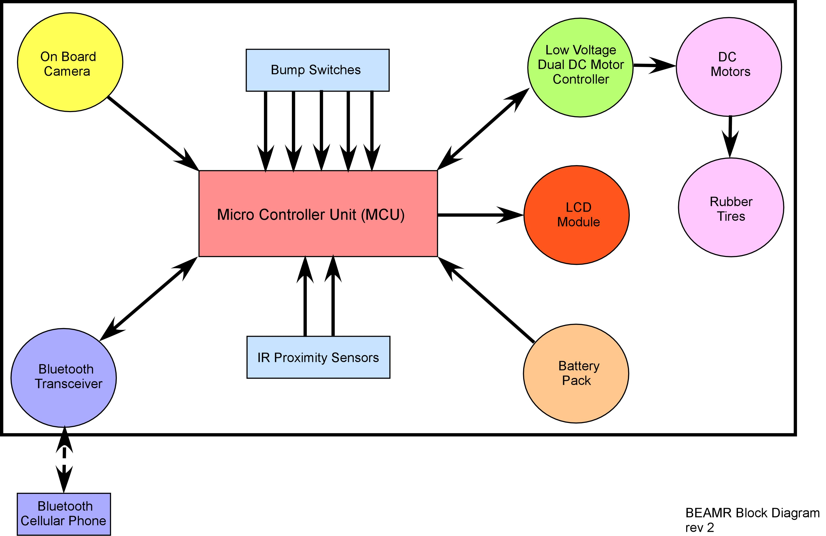
Figure 1 BEAMR System Level Block Diagram

The above diagram highlights all the interactions between the various sub-systems of BEAMR. The microcontroller manages the various interactions effectively using various methods such as polling and interrupt service routines. The interactions occur through various interfaces. Here is a list of the type of interface between the various sub-systems:
- MCU – Camera: UART
- MCU – Bluetooth Transceiver: UART
- MCU – Motor Controller: UART
- MCU – IR: ADC
- MCU – Bump: GPIO
- MCU – LCD: GPIO

Mobile Platform

In order to support all the on-board electronics, I have used two circular plastic chassis purchased from the Pololu website. The two chassis are bridged together using SteelTec’s steel frames. Additional steel frames are mounted onto this bride in order to mount additional electronics such as the Low Voltage Dual Motor Serial Controller, LCD Module, the Battery packs, the voltage regulator circuitry, the main power switch and the wiring boards.
The rear circular plate has the gearbox assembly, including the motors, latched on the underside of it. Two rubber tires are attached to the gearbox assembly. The Atmel Mega128 is screwed onto the rear plate using metal stand-offs. A single bump sensort brings up the rear of the BEAMR.
The underside of the front circular plate holds a ball caster. Whereas the Bluetooth transceiver is mounted using stand offs in the center of the plate, the two IR sensors are mounted on the front perimeter of the plate. A scaffolding is constructed between the IR sensors using the steel frames, in order to hold up the camera module. The camera module is held in place by two large screws and a steel joint. Three bump sensors, one in the front and one on each side are also part of the front platform.
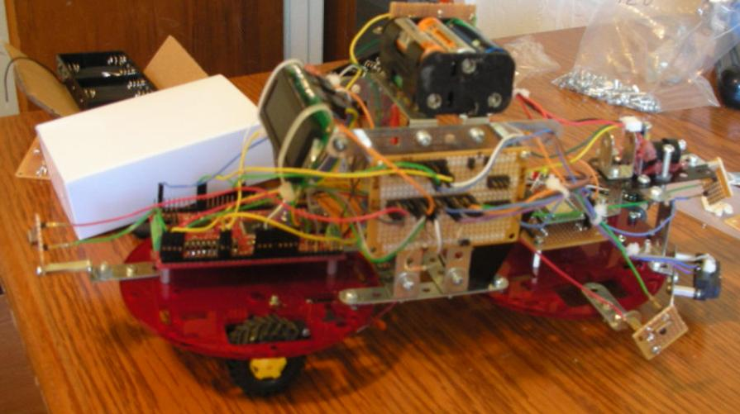
Figure 2 The BEAMR Mobile Platform

Actuation

For actuation, the BEAMR is using two 3V Mabuchi motors. These motors are encased in the gearbox assembly. The gearbox itself is assembled in a 203:1 low speed ratio. This configuration was chosen in order to improve the picture taking clarity. The two motors are driven Pololu’s Low Voltage Dual Motor Serial Controller (LVDMSC). The LVDSMC responds to serial commands from the microcontroller. The controller circuit itself is nothing but an H-bridge used to control the two motors and their direction. Pulse Width Modulation (PWM) logic is implemented on the controller to driver the motors at various user specified speeds. In order to improve the transmission and reduce the noise, 0.1uF caps are placed between the motor pins.
LVDSMC is driven using UART0. To configure the device, three bytes of data are sent through the transmitter after power up. To control the device, four bytes of data are sent specifying information such as the motor number, direction and speed.
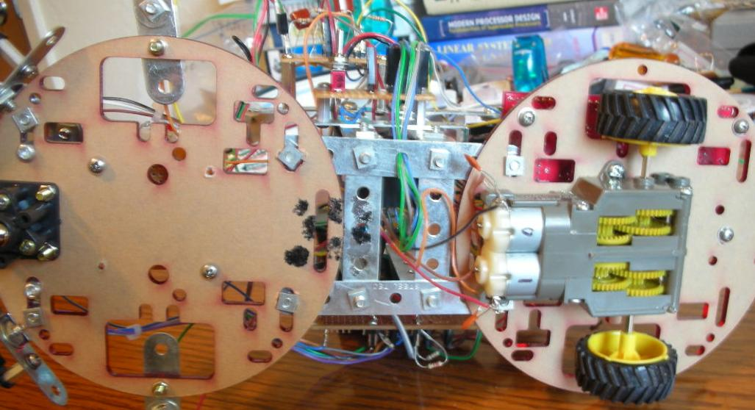
Figure 3 Gearbox Assembly

Sensors

The BEAMR’s primary function is to be mobile and capture pictures via an on board camera and use the Bluetooth protocol to transmit the visual data to a nearby device such as a cell phone or a Bluetooth enabled laptop.
In order to achieve the above stated functionality, BEAMR has to perform several tasks. These tasks are performed using various sensors/sensory devices. Below is the list of sensors that I am using along with a short statement on how it helps BEAMR.
- Bump Switches – Collision Detection
- IR Proximity Sensors – Collision Avoidance
- Bluetooth Transceiver – Making the BEAMR Bluetooth enabled
- Camera – Capturing visual data
The following report helps give a better and more detailed explanation on how each of the above sensory devices perform the necessary tasks to help BEAMR achieve it’s functionality.

Bump Switches

Bump switches or push button switches are used to simply detect an instance when BEAMR has collided with an obstacle. BEAMR has 4 bump switches strategically mounted around the perimeter of its chassis unit. The 4 push buttons are placed in such a way so that all collision angles are covered. Therefore, almost every time the BEAMR collides with an obstacle that offers substantial resistance, one of the switches gets pushed which in turn calls the microcontroller into action using the GPIO pins. When the microcontroller gets called, it knows which of the bump switches called the system. Based on the switch that has been bumped, the microcontroller guides BEAMR away from the obstacle. This way, the BEAMR will not move in the direction of the obstacle is thus saving the sub-systems from damage.

IR Proximity Sensors

The main function of the IR proximity sensors is to detect the distance of an object from the sensor using a infra red beam that it emits. I have mounted two Sharp GP2Y0A21YK proximity sensors at a 45 degree angle facing away from each other. This way, the two sensors can cover a wider range. The length or distance limit range for this Sharp sensor is 10cm to 80cm. This is an analog sensor. Hence, the analog output voltage of the sensor has to be converted to a digital signal using the A2D conversion module on the MAVRIC II board. The ADC sampling frequency is 115.2 KHz and the voltage reference is 5V with a 10-bit resolution.
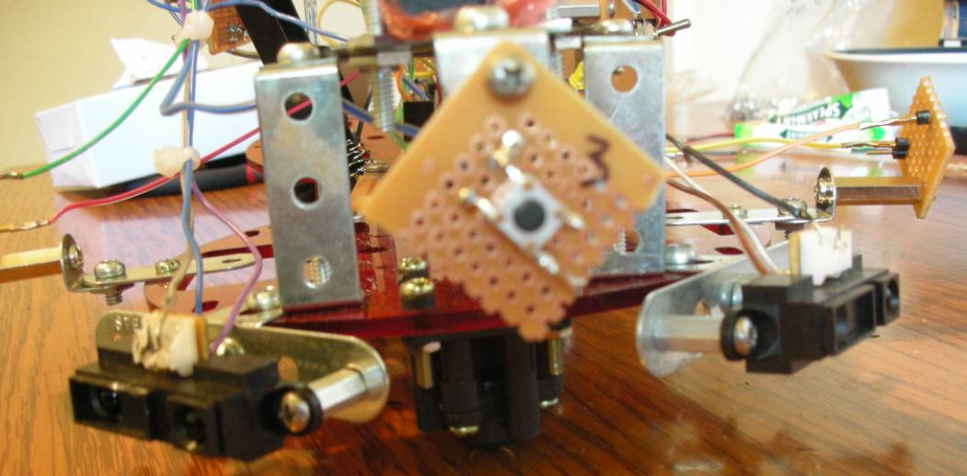
Figure 4 IR Proximity Sensors and Front Bump Sensor

Bluetooth Transceiver

I am using the Bluetooth BR-SC40N Class 1 module made by Blue Radios as my Bluetooth transceiver. This device interfaces serially with the microcontroller using an AT command set. The Hayes AT protocol is a modern communication protocol widely used in telephone modems. It has a defined command set that allows the microcontroller to send commands to the transceiver via the RS-232 port. It has a 100m range, powers up at 3.3V and draws typically 90mA.
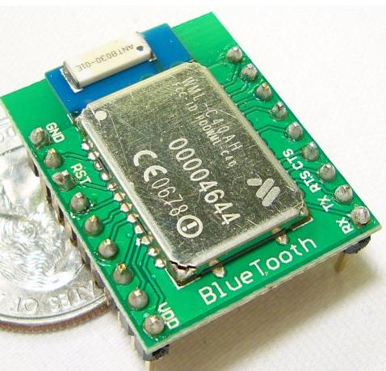
Figure 5 Blue Radios Bluetooth Transceiver
Bluetooth is wireless networking standard (IEEE 802.15.1) that works at the physical level in the form of a radio-frequency standard and it provides agreement at the protocol level, where devices have to agree on when bits are sent, how many will be sent at a time, and how the parties in a conversation can be sure that the message received is the same as the message sent. Bluetooth 2.0 can achieve data rates of 3 Mbps. However, as we are interfacing serially, our data rate will be limited by the baud rate of the serial connection.
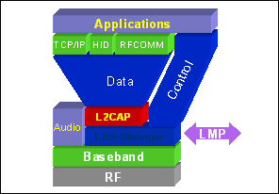
Figure 6 Bluetooth Standard (IEEE 802.15.1) Layers

Bluetooth networking transmits data via low-power radio waves. It communicates in the 2.402 GHz to 2.480 GHz frequency range. This frequency band has been set aside by international agreement for the use of industrial, scientific and medical devices (ISM).
The Baseband layer the timing, framing, packets and flow control on the link.
The Link Manager is responsible for managing connection states (authentication & encryption), enforcing fairness among slaves & power management.
The Logical Link Layer handles multiplexing, segmentation and reassembly of large packets and device discovery. For the Audio layer, the audio data is directly mapped to the baseband layer.
The Bluetooth protocol allows up to eight devices to connect simultaneously. To avoid interference between the devices, Bluetooth uses a technique called frequency hopping spread-spectrum (FHSS) that makes it rare for more than one device to be transmitting on the same frequency at the same time. In this technique, a device uses 79 individual, randomly chosen frequencies within a designated range (in the ISM band), changing from one to another on a regular basis. As the transmitters change frequencies so many times every second, more devices can make complete use of a pre defined limited slice of the radio spectrum. Since every Bluetooth transmitter uses spread-spectrum transmitting automatically, it’s unlikely that two transmitters will be on the same frequency at the same time.
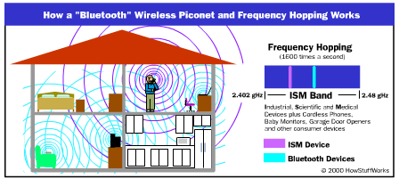
Figure 7 FHSS graphically explained

Each BT frame consists of a transmit packet and a receive packet. Each packet may have either 1, 3 or 5 slots of 625ùs. All units have a unique global ID(BD_Addr) address( 48 bits) using which devices establish connection and communicate with one another. The unit that initializes the connection is assigned as the master which controls the traffic of the connection. A master can simultaneously connect upto seven slaves. The master/slave roles can be swapped using the appropriate commands.
The very first command that the protocol executes is to identify the device it wants to connect to. It does this by looking for a unique device address that helps the transmitter identify the receiver. This way, even if there are several Bluetooth devices in an area, a unique connection can be established between any two or more without interfering with the others Bluetooth networks or piconets.
There are two kinds of links possible in a Bluetooth protocol. An Asynchronous Connectionless Link (ACL) is a packet switched link between a master and slave. It supports both isochronous and asynchronous data.
A Synchronous Connection Oriented (SCO) is a point to point full duplex link that is typically used for voice data. These packets do not use CRC and are not retransmitted. An ACL type link needs to be first established in order to set up SCO.
The Bluetooth protocol supports two Error Correction schemes: Forward error correction (1/3 and 2/3) and Automatic Repeat Request scheme.

Camera

The C328 JPEG compression module performs as a video camera or a JPEG compressed still camera. Users can send out a snapshot command from the host in order to capture a full resolution single-frame still picture. The picture is then compressed by the JPEG engine and transferred to the host. Here are some of its main features.
- Low-cost, & low-powered solution for high resolution image capture
- Built-in down-sampling, clamping and windowing circuits for VGA/ CIF/ SIF/QCIF /160x128/80x64 image resolutions
- RS-232: 115.2K bps for transferring JPEG still pictures or 160x128 preview @8bpp with 0.75~6 fps
- JPEG CODEC with variable quality settings for different resolutions
- Built-in color conversion circuits for 4 gray/16 gray/256 gray/12-bit RGB/16-bit RGB/ Pallet 256 RGB preview images
- Lens included on camera: F/No 2.0, f= 3.7mm, FOV = 66 deg diagonal, No IR cut filter
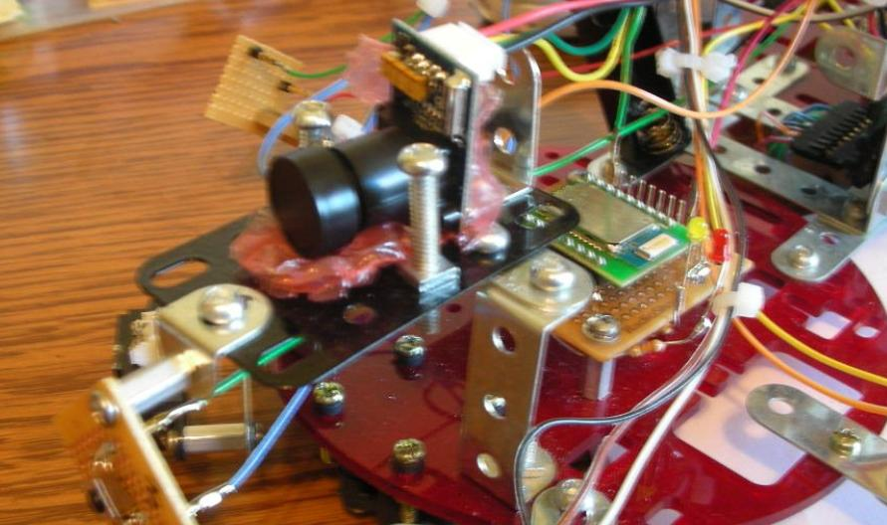
Figure 8 C328 Camera Module

Behaviors

8.1 Bump Sensors

The GPIO pins on PORTB are enabled as inputs. Their pull-up resistors are enabled too. In the infinite while loop in the main function, the microcontroller checks to see if any of the buttons have been pressed in each iteration. In the event of collision detection, the microcontroller checks to see which of the buttons has been pushed. Based on that, it calls the motor control functions to get away from the obstacle.

8.2 IR Sensors

The two IR sensors are read using the ADC channel. After initializing the ADC module, the ADC channels 0 and 1 are sampled at a frequency of 115.2 KHz. The ADC values are read from the ADC buffer. Several values can be read on a single channel and averaged out in order to give a truer picture of the value. But in our case, as we need it only for collision avoidance, once sample is enough.
In the infinite while loop in the main function, the IR values are read in each iteration. If the IR value shows that the sensor is less than 30 cm from any object, the motor control functions are called and collision avoidance action is taken.

8.3 Bluetooth Transceiver

The transceiver needs 3.3V to power up. Typically, it draws about 90mA in normal usage. In order to configure the Bluetooth transceiver, serial AT commands are used. The first step in this direction is to power up the transceiver using 3.3V. Then, a Bluetooth Dongle is attached to a PC. Using the dongle software on the PC, the on-board transceiver device is found and paired with the dongle. A hyperterminal window is then opened up using the default 9600/8/n/1 setting on the COM port where the connection was made. In my case, it is COM41 (This is assigned by Windows OS).
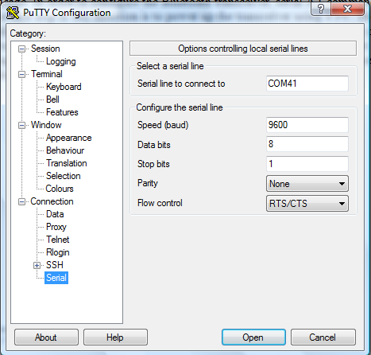
Figure 9 Setting up hyperterminal link using PuTTY

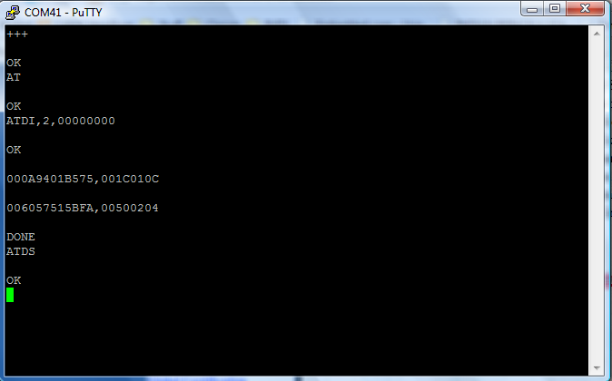
Figure 10 AT commands using Hyperterminal window

Once the connection is made and the two devices are talking to each other, the Bluetooth transceiver can be configured with the following settings:
- Putting device into commands mode: +++
- Master Mode: Format: ATDM, <BlueToothAddress>,UUID
  - Example: ATDM, 0012D205B8C0, UUID
  - The above command sets the transceiver as master and connects to a slave with the above mentioned BT address. (Point to Point Connection)
- Set Master Default BT Address: Format: ATSMA, <BlueToothAddress>,UUID
  - Example: ATSMA, 0012D205B8C0, UUID
  - The above command automatically sets the Master device (transceiver) to connect with the given BT Address slave device upon power up.
Once the connection is established, the UART port of the microcontroller is used to transmit the image data to the RX pin of the transceiver. Upon receiving this info, the transceiver sends the data to the connected slave Bluetooth device.

Camera

Figure 11 Camera System Block Diagram

The C328 needs 3.3V to power up. Typically, it draws about 60mA in normal usage. The C328 camera module responds to serial commands. Each command of the C328 is equal to 6 bytes. Here are the list of C328 commands and their serial values.
Figure 12 C328 Commands List

The camera has to be initialized and setup in the configuration that the user defines. I set the camera in the following configuration:
- Initial Cmd: Color Type = 07h = JPEG, JPEG Resolution = 01h = 80x64
- Get Picture Cmd: Picture Type = 01h = JPEG
- Snapshot Cmd: Snapshot Type = 00h = Compressed
- Package Size Cmd: Leave as it is for Default = 64 bytes
- Data Cmd: Data Type = 01h = Snapshot Picture
To connect to the camera, a SYNC command is sent 25-40 times until an ACK and SYNC command is received from the camera. Once they are received, the following serial command sequence is followed to successfully communicate with the camera.
Figure 13 Serial Command Sequence between Microcontroller and Camera

Low Voltage Dual Motor Serial Controller

Configuring and controlling the LVDMSC is pretty straightforward. After setting up UART0 in transmit mode at 9600/8/n/1 setting, a sequence of bytes have to be sent serially to the LVDSMC. To configure it in the two-motor mode, the following sequence of three bytes are sent:
0x80 – Start Byte
0x02 – Change Configuration
0x00 – Two Motors, Motors 0 & 1
After configuration, the device is powered off and on. After a delay of 100ms, the four control bytes can be sent:
0x80 – Start Byte
0x00 – Device Type
0x00 or 0x01 or 0x02 or 0x03 – Motors # & Direction
0x00 to 0x7F – Speed of Motor

I have defined several functions in my source code for different navigational purposes. Based on the sensor input, I call the appropriate navigational function.
After writing the code for this part, I decided to test it on the BEAMR. Upon running the code, I noticed that my code was able to move both the motors forward and both backward, but for some reason it couldn’t move one forward and the other backward at the same time. I lost sleep for two days trying to fix this seemingly simple error. In the end I concluded that my LVDSMC chip must be busted. But, when I tested the LVDSMC on a classmates design, it worked fine. After re-checking the code again, it dawned on me to check the wiring. As it turns out, the ‘-ve’ wires for the two motors were swapped. An embarrassing ordeal, but a huge lesson learnt. Always check wiring first.

LCD Module

The LCD module behavior functions have been provided by the IMDL class TA’s on the imdl.freeforums.org website. I have just copied and pasted their code into my project.

Experimental Layout and Results

- Below are the measurements taken after testing the IR sensor:-
L (cm) | Vout (V) | Dig V
0 | 0 | 0
5 | 3.3 | 676
10 | 2.25 | 461
15 | 1.5 | 307
20 | 1.25 | 256
25 | 1 | 205
30 | 0.9 | 184
35 | 0.8 | 164
40 | 0.75 | 154
45 | 0.65 | 133
50 | 0.6 | 123
55 | 0.55 | 113
60 | 0.5 | 102
65 | 0.475 | 97
70 | 0.45 | 92
75 | 0.425 | 87
80 | 0.4 | 82

Table 1 Corresponding IR sensor analog and digital values at a given length

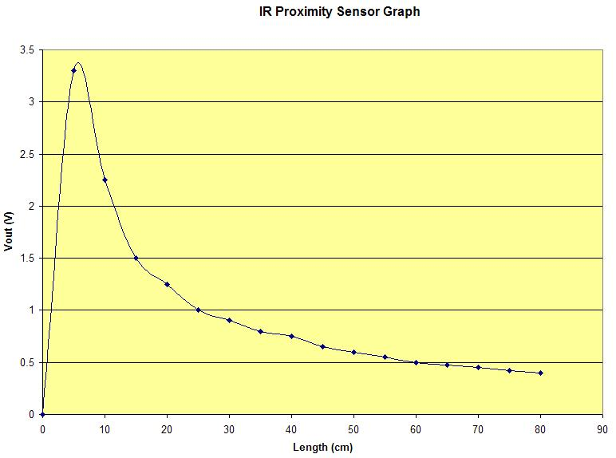

Figure 14 IR Sensor Length v/s Output Voltage graph

- Testing the Voltage Regulator (LM317T) before soldering it onto a prototype board:

Figure 15 The Adjustable Voltage Regulator circuit

I am using the above voltage regulator to get 3.3V from 5V. Before soldering the parts onto a board, I tested the circuit by hooking up all the parts on a bread board. My circuit set up is similar to what is shown in the figure above, except that I am using a 0.1uF cap tied between Vin and Gnd. R2 = 1800 ohms, R1 = 1500 ohms

Conclusion

In summary, BEAMR successfully navigates in a given flat area and also successfully implements collision detection and avoidance. I have been able to establish a Bluetooth connection between BEAMR and my Bluetooth enabled laptop as well as cell phone. But, unfortunately, I have not been able to successfully interface the microcontroller with the C328 camera. I have the necessary functions and behaviors in place, but for some reason, I am ending up with synchronization errors during the reception of the data packets. I got in touch with the manufacturer of the camera, and he is in the process of sending me some sample code. Also, I have gone through several online forums and have found that quite a few people were facing similar issues with this particular camera.
Hence, in order to prove that my Bluetooth connection works, I am sending the IR sensor values (IR0 and IR1) over the established BT connection between the transceiver and my cell phone. Upon code execution, I receive the IR sensor values on my Nokia 3650 as Bluetooth messages. The first line gives us the IR0 value where as the second line gives us IR1. Notice that when there is no obstacle in its line of vision, the IR values are around 190. When I put an obstacle in the path of IR0, this value went up to 307.
While taking up this project, I didn’t realize the complexity involved in setting up a simple point to point Bluetooth connection between two devices. Understanding the Bluetooth protocol and acquiring know-how of AT commands were important. After spending days together with the transceiver documentation, I was able to establish the connection pretty easily in the end.

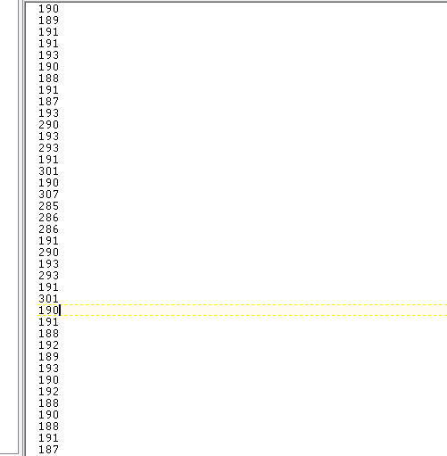
Figure 16 Snapshot of IR sensor values taken from cellphone

IMDL is definitely one of the most work intensive classes I have ever taken and also a lot of fun. Building a robot from scratch took quite a bit of creativity. It also forced me to think about the mechanical aspect of a design while designing an electronic part. The class was very informative regarding various machine intelligence concepts and I hope to expand my knowledge in this area in the future. My only grouch is with the IMDL Lab (BEN 340), which is quite pathetic in terms of basic components inventory. Other than that, this course was a huge learning experience. The professors and TA’s were very helpful, patient and supportive. Thanks a lot to all.

Documentation

MAVRICK-II Board:
http://www.bdmicro.com/mavric-iib/

Atmel Mega128:
http://www.atmel.com/dyn/products/product_card.asp?part_id=2018

Bluetooth Transceiver:
http://www.sparkfun.com/commerce/product_info.php?products_id=617

Camera:
http://www.electronics123.net/amazon/datasheet/C328-7640UM_V3.PDF

Motors and Motor Drivers:
http://www.pololu.com/products/pololu/0120/
http://www.pololu.com/products/tamiya/0061/

LCD Module:
http://www.sparkfun.com/commerce/product_info.php?products_id=709

Sharp IR Sensor:
http://www.sparkfun.com/commerce/product_info.php?products_id=242

Voltage Regulator:
http://www.national.com/pf/LM/LM317.html

Appendices

12.1 Appendix A – Pictures

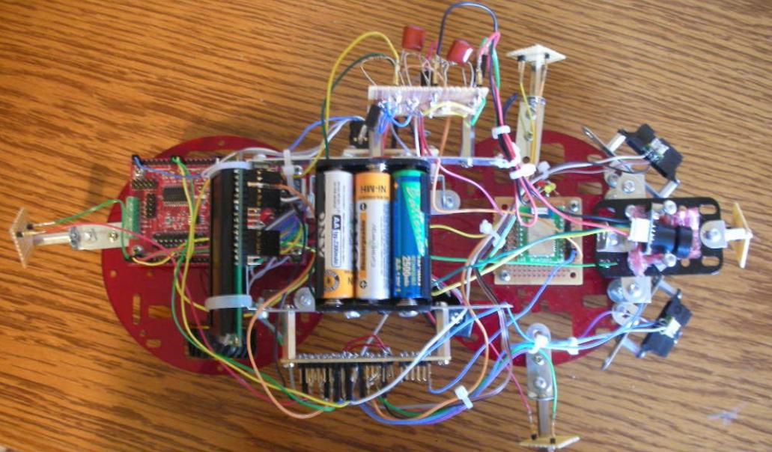
Figure 17 BEAMR Top View

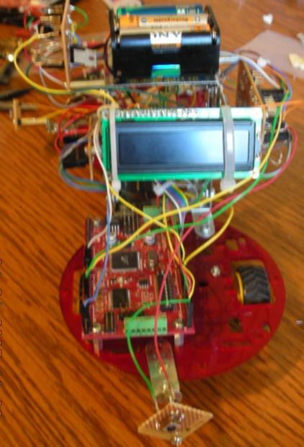
Figure 18 BEAMR Back View

12.2 Appendix B - Code

<globals.h>

extern void lcd_delay(); // short delay (50000 clocks)
extern void lcd_init(); // sets lcd in 4 bit mode, 2-line mode, with cursor on and set to blink
extern void lcd_cmd(); // use to send commands to lcd
extern void lcd_disp(); // use to display text on lcd
extern void lcd_clear(); // use to clear LCD and return cursor to home position
extern void lcd_row(int row); // use to put the LCD at the desired row
extern void lcd_string(char *a); //This function writes a string to the LCD.

extern void initUSART0();
extern void initLVDSMC();
extern void Motor_spin_left(int Rspeed, int LSpeed);
extern void Motor_spin_right(int Rspeed, int LSpeed);
extern void Motor_turn_left(int speed);
extern void Motor_turn_right(int speed);
extern void Motor_stop_left();
extern void Motor_stop_right();
extern void Motor_forward(int Rspeed, int Lspeed);
extern void Motor_reverse(int Rspeed, int Lspeed);

extern void initUSART1();
extern void initCAM();
extern void setupCAM();
extern void getImage();
extern void initUSART1_Flush(void);
extern void UART1_Tx(char data);
extern unsigned char UART1_Rx(void);

extern unsigned char image_64_80[12][64];

<main.c>

/*Bluetooth Enabled Autonomous Mobile Robot - BEAMR
Siddharth R Gaddam
IMDL - Spring 2007
University of Florida*/

#include <avr/io.h>
#include <avr/interrupt.h>
#include <avr/pgmspace.h>
//#include <avr/signal.h> -- File Obsolete. Using interrupt.h instead
#include <inttypes.h>
#include <stdlib.h>
#include <stdio.h>
#include <util/delay.h>
#include <math.h>

#include "adc.h"
#include "globals.h"

//#define BAUD 9600L /* use 9600 baud for UART0 connection */

/* baud rate register value for desired baud rate */
//#define BAUD_RR ((CPU_FREQ/(16L*BAUD) - 1))

#define CPU_FREQ 14745600L /* set to clock frequency in Hz */

#if CPU_FREQ == 16000000L
#define OCR_1MS 125
#elif CPU_FREQ == 14745600L
#define OCR_1MS 115
#endif

/*typedef struct c328_CMD_tag
{
unsigned int ID;
unsigned char Parameter1;
unsigned char Parameter2;
unsigned char Parameter3;
unsigned char Parameter4;
} c328_CMD;*/

volatile uint16_t ms_count;

/*
* ms_sleep() - delay for specified number of milliseconds
*/
void ms_sleep(uint16_t ms)
{
TCNT0 = 0;
ms_count = 0;
while (ms_count != ms)
;
}

/*
* millisecond counter interrupt vector
*/
SIGNAL(SIG_OUTPUT_COMPARE0)
{
ms_count++;
}

/*
* Initialize timer0 to use the main crystal clock and the output
* compare interrupt feature to generate an interrupt approximately
* once per millisecond to use as a general purpose time base.
*/
void init_timer0(void)
{
TCCR0 = 0;
TIFR |= _BV(OCIE0)|_BV(TOIE0);
TIMSK |= _BV(TOIE0)|_BV(OCIE0); /* enable output compare interrupt */
TCCR0 = _BV(WGM01)|_BV(CS02)|_BV(CS00); /* CTC, prescale = 128 */
TCNT0 = 0;
OCR0 = OCR_1MS; /* match in aprox 1 ms */
}

int main(void)
//void main(void)
{
uint16_t ir0;
uint16_t ir1;
//double volts0;
//double volts1;

DDRA = 0xFF; //PortA is all outputs. Used for the LVDMSC reset pin.
PORTA = 0x00;

DDRC = 0xFF; // Set all pins on portC to output for LCD (could also use DDRC = 0b11111111)
PORTC = 0x00;

DDRB = 0x00; //PortB is all inputs. Used for reading push button switches
PORTB = 0xFF; //Enable internal pull up resistors of port

init_timer0(); //Initializes Timer0

initUSART0(); //Initializes UART0 -- 9600/n/1 -- TX Only -- PORTE1
_delay_ms(15);
initLVDSMC(); //Initializes Motor Driver chip -- Motors 0 & 1
_delay_ms(15);

lcd_init(); // Set lcd in 4 bit mode, 2-line mode, with cursor on and set to blink

sei(); // enable interrupts

adc_init(); // initialize A/D Converter
ms_sleep(100); /* sleep for 0.1 second */

lcd_string("I am BEAMR"); // if your LCD is wired up correctly, you will see this text
// on it when you power up your Micro-controller board.

lcd_row(1);

lcd_string("SRG 2007");

initCAM();
setupCAM();
getImage();

while (1)
{

lcd_clear();
lcd_string("Reading IR's");
ms_sleep(100); /* sleep for 0.1 second */

ir0 = adc_readn(0, 1); /* sample channel 0 1 times, take average */
ms_sleep(5);
ir1 = adc_readn(1, 1); /* sample channel 1 1 times, take average */

//volts0 = ((double)ir0) * 5.0 / 1024.0; /* convert to Volts */
//volts1 = ((double)ir1) * 5.0 / 1024.0; /* convert to Volts */

lcd_row(1);

lcd_string("Moving Fwd");

Motor_forward(0x7F,0x7F);

if((ir0 > 307) && (ir0 < 614))
{
//Motor_reverse(0x7F,0x7F);

//ir0 = adc_readn(0, 1);
//_delay_ms(3500);
//if(ir0 < 307)
//{
Motor_spin_left(0x7F,0x7F);

lcd_clear();
lcd_string("Turning Left");

lcd_row(1);
lcd_string("Collision Avoided");

_delay_ms(2000);
Motor_forward(0x7F,0x7F);

}
//else
//Motor_forward(0x7F,0x7F);

if((ir1 > 307) && (ir1 < 614))
{
//Motor_reverse(0x7F,0x7F);

//ir1 = adc_readn(0, 1);
//_delay_ms(3500);
//if(ir1 < 307)
//{
Motor_spin_right(0x7F,0x7F);

lcd_clear();
lcd_string("Turning Right");

lcd_row(1);
lcd_string("Collision Avoided");

_delay_ms(2000);
Motor_forward(0x7F,0x7F);

}
//else
//Motor_forward(0x7F,0x7F);

//while(PORTG == 0x01) //Rear Button
if((PINB & 0x01) == 0)
{
Motor_forward(0x7F,0x7F);
lcd_clear();
lcd_string("Moving Fwd");

lcd_row(1);
lcd_string("Collision Detected");
}

//while(PORTG == 0x02) //Left Button
if((PINB & 0x02) == 0)
{
Motor_spin_left(0x7F,0x7F);
lcd_clear();
lcd_string("Turning Left");

lcd_row(1);
lcd_string("Collision Detected");
}

//while(PORTG == 0x04) //Right Button
if((PINB & 0x04) == 0)
{
Motor_spin_right(0x7F,0x7F);
lcd_clear();
lcd_string("Turning Right");

lcd_row(1);
lcd_string("Collision Detected");
}

//while(PORTG == 0x08) //Front Button
if((PINB & 0x08) == 0)
{
Motor_reverse(0x7F,0x7F);
lcd_clear();
lcd_string("Moving Bckwd");

lcd_row(1);
lcd_string("Collision Detected");
}

}

return 0;
}

<lcd.c>

/*

University of Florida

EEL 5666C Intelligent Machine Design Lab (IMDL)

LCD setup code by Adam Barnett (and one method written by Josh Hartman, noted below)

Implemented by: Siddharth R Gaddam

*/

#include <avr/io.h>
#include <avr/interrupt.h>
#include <avr/pgmspace.h>
//#include <avr/signal.h> -- File Obsolete. Using interrupt.h instead
#include <inttypes.h>
#include <stdlib.h>
#include <stdio.h>
#include <util/delay.h>

#include "adc.h"
#include "globals.h"

/* IMPORTANT!

Before using this code make sure your LCD is wired up the same way mine is, or change the code to
match the wiring of your own LCD. My LCD is connected to PortC of the At-Mega128 in the following manner:

PortC bit 7 : LCD data bit 7 (MSB)
PortC bit 6 : LCD data bit 6
PortC bit 5 : LCD data bit 5
PortC bit 4 : LCD data bit 4 (LSB)

PortC bit 3 : (not connected)
PortC bit 2 : LCD enable pin (clock)
PortC bit 1 : LCD R/W (read / write) signal
PortC bit 0 : LCD RS (register select) pin

Also remember you must connect a potentiometer (variable resistor) to the vcc, gnd, and contrast pins on the LCD.
The output of the pot (middle pin) should be connected to the contrast pin. The other two can be on either pin.

*/

void lcd_delay() // delay for 10000 clock cycles
{
long int ms_count = 0;
while (ms_count < 10000)
{
ms_count = ms_count + 1;
}
}

void lcd_cmd( unsigned int myData )
{

/* READ THIS!!!

The & and | functions are the BITWISE AND and BITWISE OR functions respectively. DO NOT
confuse these with the && and || functions (which are the LOGICAL AND and LOGICAL OR functions).

The logical functions will only return a single 1 or 0 value, thus they do not work in this scenario
since we need the 8-bit value passed to this function to be preserved as 8-bits
*/

unsigned int temp_data = 0;

temp_data = ( myData | 0b00000100 ); // these two lines leave the upper nibble as-is, and set
temp_data = ( temp_data & 0b11110100 ); // the appropriate control bits in the lower nibble
PORTC = temp_data;
lcd_delay();
PORTC = (temp_data & 0b11110000); // we have written upper nibble to the LCD

temp_data = ( myData << 4 ); // here, we reload myData into our temp. variable and shift the bits
// to the left 4 times. This puts the lower nibble into the upper 4 bits

temp_data = (temp_data & 0b11110100); // temp_data now contains the original
temp_data = (temp_data | 0b00000100); // lower nibble plus high clock signal

PORTC = temp_data; // write the data to PortC
lcd_delay();
PORTC = (temp_data & 0b11110000); // re-write the data to PortC with the clock signal low (thus creating the falling edge)
lcd_delay();

}

void lcd_disp(unsigned int disp)
{

/*

This function is identical to the lcd_cmd function with only one exception. This least significant bit of
PortC is forced high so the LCD interprets the values written to is as data instead of a command.

*/

unsigned int temp_data = 0;

temp_data = ( disp & 0b11110000 );
temp_data = ( temp_data | 0b00000101 );
PORTC = temp_data;
lcd_delay();
PORTC = (temp_data & 0b11110001);
lcd_delay(); // upper nibble

temp_data = (disp << 4 );
temp_data = ( temp_data & 0b11110000 );
temp_data = ( temp_data | 0b00000101 );
PORTC = temp_data;
lcd_delay();
PORTC = (temp_data & 0b11110001);
lcd_delay(); // lower nibble

}

void lcd_init()
{
lcd_cmd(0x33); // writing 0x33 followed by
lcd_cmd(0x32); // 0x32 puts the LCD in 4-bit mode

lcd_cmd(0x28); // writing 0x28 puts the LCD in 2-line mode

lcd_cmd(0x0F); // writing 0x0F turns the display on, curson on, and puts the cursor in blink mode

lcd_cmd(0x01); // writing 0x01 clears the LCD and sets the cursor to the home (top left) position

//LCD is on... ready to write

}

void lcd_string(char *a)
{

/*

This function writes a string to the LCD. LCDs can only print one character at a time so we need to
print each letter or number in the string one at a time. This is accomplished by creating a pointer to
the beginning of the string (which logically points to the first character). It is important to understand
that all strings in C end with the "null" character which is interpreted by the language as a 0. So to print
an entire string to the LCD we point to the beginning of the string, print the first letter, then we increment
the pointer (thus making it point to the second letter), print that letter, and keep incrementing until we reach
the "null" character". This can all be easily done by using a while loop that continuously prints a letter and
increments the pointer as long as a 0 is not what the pointer points to.

*/

while (*a != 0)
{
lcd_disp((unsigned int) *a); // display the character that our pointer (a) is pointing to
a++; // increment a
}
return;

}

void lcd_int(int value)
{

/*
This routine will take an integer and display it in the proper order on
your LCD. Thanks to Josh Hartman (IMDL Spring 2007) for writing this in lab
*/

int temp_val;
int x = 10000; // since integers only go up to 32768, we only need to worry about
// numbers containing at most a ten-thousands place

while (value / x == 0) // the purpose of this loop is to find out the largest position (in decimal)
{ // that our integer contains. As soon as we get a non-zero value, we know
x/=10; // how many positions there are int the int and x will be properly initialized to the largest
} // power of 10 that will return a non-zero value when our integer is divided by x.

while (value > 0) // this loop is where the printing to the LCD takes place. First, we divide
{ // our integer by x (properly initialized by the last loop) and store it in
temp_val = value / x; // a temporary variable so our original value is preserved. Next we subtract the
value -= temp_val * x; // temp. variable times x from our original value. This will "pull" off the most
lcd_disp(temp_val+ 0x30); // significant digit from our original integer but leave all the remaining digits alone.
// After this, we add a hex 30 to our temp. variable because ASCII values for integers
x /= 10; // 0 through 9 correspond to hex numbers 30 through 39. We then send this value to the
} // LCD (which understands ASCII). Finally, we divide x by 10 and repeat the process
// until we get a zero value (note: since our value is an integer, any decimal value
return; // less than 1 will be truncated to a 0)

}

void lcd_clear() // this function clears the LCD and sets the cursor to the home (upper left) position
{
lcd_cmd(0x01);

return;
}

void lcd_row(int row) // this function moves the cursor to the beginning of the specified row without changing
{ // any of the current text on the LCD.

switch(row)
{

case 0: lcd_cmd(0x02);
case 1: lcd_cmd(0xC0);

}

return;
}
//-------------------END OF LCD CODE-------------------------

<MotorDriver.C>

#include <avr/io.h>
#include <avr/interrupt.h>
#include <avr/pgmspace.h>
//#include <avr/signal.h> -- File Obsolete. Using interrupt.h instead
#include <inttypes.h>
#include <stdlib.h>
#include <stdio.h>
#include <util/delay.h>

#include "adc.h"
#include "globals.h"

//Function Definitions

void initUSART0()
{

UCSR0A = 0b00000000; //Doubling the asynchronous communication
//for baud rate error reduction

UCSR0B = 0b00001000; //Enabling the Transmitter
//8 data bits

UCSR0C = 0b00000110; //Selecting Asynchronous Operation, No Parity,
//one stop bit, and 8 data bits

UBRR0H = 0x00; //9600 baud for a 14.5746MHz clock
UBRR0L = 0x5F; //(191 Decimal)
}

void initLVDSMC()
{
PORTA = 0x01; //RST = 1
_delay_ms(5); //Wait

while ( !(UCSR0A & (1<<UDRE0)) ); //Start byte
UDR0 = 0x80;
while ( !(UCSR0A & (1<<UDRE0)) ); //Change configuration
UDR0 = 0x02;
while ( !(UCSR0A & (1<<UDRE0)) ); //2 Motors Motor0 and Motor1
UDR0 = 0x00;
while ( !(UCSR0A & (1<<UDRE0)) );

_delay_ms(5); //Wait
PORTA = 0x00; //RST = 0
_delay_ms(100); //Wait
PORTA = 0x01; //RST = 1
_delay_ms(5); //Wait
}

void Motor_spin_left(int Rspeed, int Lspeed)
{
while ( !(UCSR0A & (1<<UDRE0)) ); //Start byte
UDR0 = 0x80;
while ( !(UCSR0A & (1<<UDRE0)) ); //Device type
UDR0 = 0x00;
while ( !(UCSR0A & (1<<UDRE0)) ); //Motor # and Direction
UDR0 = 0x01; //Motor 0 = Right Motor
while ( !(UCSR0A & (1<<UDRE0)) ); //Motor Speed 0x00 to 0x7F (0 to 127)
UDR0 = Rspeed; //Move at speed
while ( !(UCSR0A & (1<<UDRE0)) );

while ( !(UCSR0A & (1<<UDRE0)) ); //Start byte
UDR0 = 0x80;
while ( !(UCSR0A & (1<<UDRE0)) ); //Device type
UDR0 = 0x00;
while ( !(UCSR0A & (1<<UDRE0)) ); //Motor # and Direction
UDR0 = 0x02; //Motor 1 = Left Motor
while ( !(UCSR0A & (1<<UDRE0)) ); //Motor Speed 0x00 to 0x7F (0 to 127)
UDR0 = Lspeed; //Move at speed
while ( !(UCSR0A & (1<<UDRE0)) );
}

void Motor_spin_right(int Rspeed, int Lspeed)
//void Motor_spin_right(char Rspeed, char Lspeed)
{
while ( !(UCSR0A & (1<<UDRE0)) ); //Start byte
UDR0 = 0x80;
while ( !(UCSR0A & (1<<UDRE0)) ); //Device type
UDR0 = 0x00;
while ( !(UCSR0A & (1<<UDRE0)) ); //Motor # and Direction
UDR0 = 0x00; //Motor 0 = Right Motor
while ( !(UCSR0A & (1<<UDRE0)) ); //Motor Speed 0x00 to 0x7F (0 to 127)
UDR0 = Rspeed; //Move at speed
while ( !(UCSR0A & (1<<UDRE0)) );

//_delay_ms(150);

while ( !(UCSR0A & (1<<UDRE0)) ); //Start byte
UDR0 = 0x80;
while ( !(UCSR0A & (1<<UDRE0)) ); //Device type
UDR0 = 0x00;
while ( !(UCSR0A & (1<<UDRE0)) ); //Motor # and Direction
UDR0 = 0x03; //Motor 1 = Left Motor
while ( !(UCSR0A & (1<<UDRE0)) ); //Motor Speed 0x00 to 0x7F (0 to 127)
UDR0 = Lspeed; //Move at speed
while ( !(UCSR0A & (1<<UDRE0)) );
}

void Motor_turn_left(int speed)
{
while ( !(UCSR0A & (1<<UDRE0)) ); //Start byte
UDR0 = 0x80;
while ( !(UCSR0A & (1<<UDRE0)) ); //Device type
UDR0 = 0x00;
while ( !(UCSR0A & (1<<UDRE0)) ); //Motor # and Direction
UDR0 = 0x01; //Motor 0 = Right Motor
while ( !(UCSR0A & (1<<UDRE0)) ); //Motor Speed 0x00 to 0x7F (0 to 127)
UDR0 = speed; //Move at speed
while ( !(UCSR0A & (1<<UDRE0)) );

while ( !(UCSR0A & (1<<UDRE0)) ); //Start byte
UDR0 = 0x80;
while ( !(UCSR0A & (1<<UDRE0)) ); //Device type
UDR0 = 0x00;
while ( !(UCSR0A & (1<<UDRE0)) ); //Motor # and Direction
UDR0 = 0x03; //Motor 1 = Left Motor
while ( !(UCSR0A & (1<<UDRE0)) ); //Motor Speed 0x00 to 0x7F (0 to 127)
UDR0 = 0x00; //Move at speed
while ( !(UCSR0A & (1<<UDRE0)) );
}

void Motor_turn_right(int speed)
{
while ( !(UCSR0A & (1<<UDRE0)) ); //Start byte
UDR0 = 0x80;
while ( !(UCSR0A & (1<<UDRE0)) ); //Device type
UDR0 = 0x00;
while ( !(UCSR0A & (1<<UDRE0)) ); //Motor # and Direction
UDR0 = 0x01; //Motor 0 = Right Motor
while ( !(UCSR0A & (1<<UDRE0)) ); //Motor Speed 0x00 to 0x7F (0 to 127)
UDR0 = 0x00; //Move at speed
while ( !(UCSR0A & (1<<UDRE0)) );

while ( !(UCSR0A & (1<<UDRE0)) ); //Start byte
UDR0 = 0x80;
while ( !(UCSR0A & (1<<UDRE0)) ); //Device type
UDR0 = 0x00;
while ( !(UCSR0A & (1<<UDRE0)) ); //Motor # and Direction
UDR0 = 0x03; //Motor 1 = Left Motor
while ( !(UCSR0A & (1<<UDRE0)) ); //Motor Speed 0x00 to 0x7F (0 to 127)
UDR0 = speed; //Move at speed
while ( !(UCSR0A & (1<<UDRE0)) );
}

void Motor_stop_left()
{
while ( !(UCSR0A & (1<<UDRE0)) ); //Start byte
UDR0 = 0x80;
while ( !(UCSR0A & (1<<UDRE0)) ); //Device type
UDR0 = 0x00;
while ( !(UCSR0A & (1<<UDRE0)) ); //Motor # and Direction
UDR0 = 0x03; //Motor 1 = Left Motor
while ( !(UCSR0A & (1<<UDRE0)) ); //Motor Speed 0x00 to 0x7F (0 to 127)
UDR0 = 0x00; //Stop
while ( !(UCSR0A & (1<<UDRE0)) );
}

void Motor_stop_right()
{
while ( !(UCSR0A & (1<<UDRE0)) ); //Start byte
UDR0 = 0x80;
while ( !(UCSR0A & (1<<UDRE0)) ); //Device type
UDR0 = 0x00;
while ( !(UCSR0A & (1<<UDRE0)) ); //Motor # and Direction
UDR0 = 0x01; //Motor 0 = Right Motor
while ( !(UCSR0A & (1<<UDRE0)) ); //Motor Speed 0x00 to 0x7F (0 to 127)
UDR0 = 0x00; //Stop
while ( !(UCSR0A & (1<<UDRE0)) );
}

void Motor_forward(int Rspeed, int Lspeed) //Sends robot forward at speed
{
while ( !(UCSR0A & (1<<UDRE0)) ); //Start byte
UDR0 = 0x80;
while ( !(UCSR0A & (1<<UDRE0)) ); //Device type
UDR0 = 0x00;
while ( !(UCSR0A & (1<<UDRE0)) ); //Motor # and Direction
UDR0 = 0x01; //Motor 0 = Right Motor
while ( !(UCSR0A & (1<<UDRE0)) ); //Motor Speed 0x00 to 0x7F (0 to 127)
UDR0 = Rspeed; //Move at speed
while ( !(UCSR0A & (1<<UDRE0)) );

while ( !(UCSR0A & (1<<UDRE0)) ); //Start byte
UDR0 = 0x80;
while ( !(UCSR0A & (1<<UDRE0)) ); //Device type
UDR0 = 0x00;
while ( !(UCSR0A & (1<<UDRE0)) ); //Motor # and Direction
UDR0 = 0x03; //Motor 1 = Left Motor
while ( !(UCSR0A & (1<<UDRE0)) ); //Motor Speed 0x00 to 0x7F (0 to 127)
UDR0 = Lspeed; //Move at speed
while ( !(UCSR0A & (1<<UDRE0)) );
}

void Motor_reverse(int Rspeed, int Lspeed) //Sends robot in reverse at speed
{
while ( !(UCSR0A & (1<<UDRE0)) ); //Start byte
UDR0 = 0x80;
while ( !(UCSR0A & (1<<UDRE0)) ); //Device type
UDR0 = 0x00;
while ( !(UCSR0A & (1<<UDRE0)) ); //Motor # and Direction
UDR0 = 0x00; //Motor 0 = Right Motor
while ( !(UCSR0A & (1<<UDRE0)) ); //Motor Speed 0x00 to 0x7F (0 to 127)
UDR0 = Rspeed; //Move at speed
//while ( !(UCSR0A & (1<<UDRE0)) );

while ( !(UCSR0A & (1<<UDRE0)) ); //Start byte
UDR0 = 0x80;
while ( !(UCSR0A & (1<<UDRE0)) ); //Device type
UDR0 = 0x00;
while ( !(UCSR0A & (1<<UDRE0)) ); //Motor # and Direction
UDR0 = 0x02; //Motor 1 = Left Motor
while ( !(UCSR0A & (1<<UDRE0)) ); //Motor Speed 0x00 to 0x7F (0 to 127)
UDR0 = Lspeed; //Move at speed
}
<cam.c>

#include <avr/io.h>
#include <avr/interrupt.h>
#include <avr/pgmspace.h>
//#include <avr/signal.h> -- File Obsolete. Using interrupt.h instead
#include <inttypes.h>
#include <stdlib.h>
#include <stdio.h>
#include <util/delay.h>
#include <math.h>

#include "adc.h"
#include "globals.h"

void initUSART1()
{

UCSR1A = 0b00000000; //Doubling the asynchronous communication
//for baud rate error reduction

UCSR1B = 0b00011000; //Enabling the Transmitter & Receiver
//8 data bits

UCSR1C = 0b00000110; //Selecting Asynchronous Operation, No Parity,
//one stop bit, and 8 data bits

UBRR1H = 0x00; //9600 baud for a 14.5746MHz clock
UBRR1L = 0x5F; //(191 Decimal)
}

void UART1_Tx(char data)
{
while ( !(UCSR1A & (1<<UDRE1)) ); //Checking for empty transmit buffer

UDR1 = data;
}

unsigned char UART1_Rx(void)
{

while(UCSR1A * (1<<RXC1)); //Checking for data in the receive buffer

return UDR1;
}

void initUSART1_Flush(void)
{

unsigned char dummy; //Declaring a dummy variable

while(UCSR1A & (1<<RXC1)) //Flushing out the reveive buffer by
dummy = UDR1; //assigning the buffer value to the dummy
}

void initCAM()
{
int i = 0;
//c328_CMD SendCmd, ReceivedCmd;
unsigned char byte1,byte2,byte3,byte4,byte5,byte6 = 0x00;

for(i=0; i<40; i++)
{
//Sending SYNC command
UART1_Tx(0xAA);
UART1_Tx(0x0D);
UART1_Tx(0x00);
UART1_Tx(0x00);
UART1_Tx(0x00);
UART1_Tx(0x00);

_delay_ms(50);

byte1 = UART1_Rx();
byte2 = UART1_Rx();
byte3 = UART1_Rx();
byte4 = UART1_Rx();
byte5 = UART1_Rx();
byte6 = UART1_Rx();

//Checking for ACK command for the Sync command
if( (byte1 == 0xAA) &&
(byte2 == 0x0E) &&
(byte3 == 0x0D) &&
((byte4 == 0x00) || (byte4 == 0x01) || (byte4 == 0x10) || (byte4 == 0x11)) &&
(byte5 == 0x00) &&
(byte6 == 0x00) )

break;
}

/*Checking for NACK command for the Sync command
if( (byte1 == 0xAA) &&
(byte2 == 0x0F) &&
(byte3 == 0x0D) &&
(byte4 == 0x00) &&
(byte5 == 0x00) &&
(byte6 == 0x00) )

break;*/

_delay_ms(15);

//Reading Receive Buffer for SYNC command
byte1 = UART1_Rx();
byte2 = UART1_Rx();
byte3 = UART1_Rx();
byte4 = UART1_Rx();
byte5 = UART1_Rx();
byte6 = UART1_Rx();

//Checking for SYNC Command
if( (byte1 == 0xAA) &&
(byte2 == 0x0D) &&
(byte3 == 0x00) &&
(byte4 == 0x00) &&
(byte5 == 0x00) &&
(byte6 == 0x00) )
{
//Sending ACK cmd upon receiving SYNC command
UART1_Tx(0xAA);
UART1_Tx(0x0E);
UART1_Tx(0x0D);
UART1_Tx(0x00);
UART1_Tx(0x00);
UART1_Tx(0x00);
}

}

void setupCAM()
{

unsigned char byte1,byte2,byte3,byte4,byte5,byte6 = 0x00;

//Sending Initial command
UART1_Tx(0xAA);
UART1_Tx(0x01);
UART1_Tx(0x00);
UART1_Tx(0x07); //JPEG
UART1_Tx(0x00);
UART1_Tx(0x01); //80x64 resolution

_delay_ms(50);

byte1 = UART1_Rx();
byte2 = UART1_Rx();
byte3 = UART1_Rx();
byte4 = UART1_Rx();
byte5 = UART1_Rx();
byte6 = UART1_Rx();

//Checking for ACK command for the Initial command
if( (byte1 == 0xAA) &&
(byte2 == 0x0E) &&
(byte3 == 0x01) &&
((byte4 == 0x00) || (byte4 == 0x01) || (byte4 == 0x10) || (byte4 == 0x11)) &&
(byte5 == 0x00) &&
(byte6 == 0x00) )
/*{
//Sending 'Set Packet Size' command
UART1_Tx(0xAA);
UART1_Tx(0x06);
UART1_Tx(0x08);
UART1_Tx(0x00);
UART1_Tx(0x02); //Package Size = 512
UART1_Tx(0x00);

_delay_ms(50);

byte1 = UART1_Rx();
byte2 = UART1_Rx();
byte3 = UART1_Rx();
byte4 = UART1_Rx();
byte5 = UART1_Rx();
byte6 = UART1_Rx();

//Checking for ACK command for the Set Packet Size command
if( (byte1 == 0xAA) &&
(byte2 == 0x0E) &&
(byte3 == 0x06) &&
((byte4 == 0x00) || (byte4 == 0x01) || (byte4 == 0x10) || (byte4 == 0x11)) &&
(byte5 == 0x00) &&
(byte6 == 0x00) )*/

{
//Sending 'Snapshot' command
UART1_Tx(0xAA);
UART1_Tx(0x05);
UART1_Tx(0x00); //Compressed Picture
UART1_Tx(0x00);
UART1_Tx(0x00);
UART1_Tx(0x00);

_delay_ms(50);

byte1 = UART1_Rx();
byte2 = UART1_Rx();
byte3 = UART1_Rx();
byte4 = UART1_Rx();
byte5 = UART1_Rx();
byte6 = UART1_Rx();

//Checking for ACK command for the Snapshot command
if( (byte1 == 0xAA) &&
(byte2 == 0x0E) &&
(byte3 == 0x05) &&
((byte4 == 0x00) || (byte4 == 0x01) || (byte4 == 0x10) || (byte4 == 0x11)) &&
(byte5 == 0x00) &&
(byte6 == 0x00) )
{

lcd_clear();
lcd_string("Cam Connected");
}
}

//}

}

void getImage()
{

unsigned char byte1,byte2,byte3,byte4,byte5,byte6 = 0x00;

unsigned char i,j;

unsigned int temp1;
unsigned int temp2;
double no_of_pkts;

unsigned int PID;
unsigned int PID_temp;
unsigned int Data_Size;
unsigned int Data_Size_temp;

//unsigned char image_64_80[12][64];

//Sending 'Get Picture' command
UART1_Tx(0xAA);
UART1_Tx(0x04);
UART1_Tx(0x01); //JPEG Snapshot Picture
UART1_Tx(0x00);
UART1_Tx(0x00);
UART1_Tx(0x00);

_delay_ms(50);

byte1 = UART1_Rx();
byte2 = UART1_Rx();
byte3 = UART1_Rx();
byte4 = UART1_Rx();
byte5 = UART1_Rx();
byte6 = UART1_Rx();

//Checking for ACK command for the Get Picture command
if( (byte1 == 0xAA) &&
(byte2 == 0x0E) &&
(byte3 == 0x04) &&
((byte4 == 0x00) || (byte4 == 0x01) || (byte4 == 0x10) || (byte4 == 0x11)) &&
(byte5 == 0x00) &&
(byte6 == 0x00) )
{
//_delay_ms(50);

byte1 = UART1_Rx();
byte2 = UART1_Rx();
byte3 = UART1_Rx();
byte4 = UART1_Rx();
byte5 = UART1_Rx();
byte6 = UART1_Rx();

////Checking for DATA command - 1st package, to get picture info
if( (byte1 == 0xAA) &&
(byte2 == 0x0A) &&
(byte3 == 0x01))

{
temp1 = byte5 << 8;
temp2 = temp1 | byte4;

no_of_pkts = ceil(temp2 / 58); //No. of Package = Image Size/(Package Size - 6)
//no_of_pkts = 12;

for(i=0; i <= no_of_pkts; i++)
{

//Send ACK with Package ID
UART1_Tx(0xAA);
UART1_Tx(0x0E);
UART1_Tx(0x00);
UART1_Tx(0x00);
UART1_Tx(i); //Package ID
UART1_Tx(0x00);

_delay_ms(50);

byte1 = UART1_Rx();
byte2 = UART1_Rx();
byte3 = UART1_Rx();
byte4 = UART1_Rx();

PID_temp = byte2 << 8;
PID = PID_temp | byte1;

Data_Size_temp = byte4 << 8;
Data_Size = Data_Size_temp | byte3;

if((i==PID) && (Data_Size <= 64))
{
for(j=0; j <= Data_Size; j++)
{
image_64_80[i][j] = UART1_Rx();

}

}

byte5 = UART1_Rx();
byte6 = UART1_Rx();
}

//Send ACK with Package ID
UART1_Tx(0xAA);
UART1_Tx(0x0E);
UART1_Tx(0x00);
UART1_Tx(0x00);
UART1_Tx(0xF0); //Package ID
UART1_Tx(0xF0);

}

}

}

<adc.c>

/*
* $Id: adc.c,v 1.3 2005/03/22 19:12:10 bsd Exp $
*/

/*
* ATmega128 A/D Converter utility routines
*/

#include <avr/io.h>
#include <stdio.h>

/*
* adc_init() - initialize A/D converter
*
* Initialize A/D converter to free running, start conversion, use
* internal 5.0V reference, pre-scale ADC clock to 125 kHz (assuming
* 16 MHz MCU clock)
*/
void adc_init(void)
{
/* configure ADC port (PORTF) as input */
DDRF = 0x00;
PORTF = 0x00;

ADMUX = _BV(REFS0);
ADCSR = _BV(ADEN)|_BV(ADSC)|_BV(ADFR) | _BV(ADPS2)|_BV(ADPS1)|_BV(ADPS0);
}

/*
* adc_chsel() - A/D Channel Select
*
* Select the specified A/D channel for the next conversion
*/
void adc_chsel(uint8_t channel)
{
/* select channel */
ADMUX = (ADMUX & 0xe0) | (channel & 0x07);
}

/*
* adc_wait() - A/D Wait for conversion
*
* Wait for conversion complete.
*/
void adc_wait(void)
{
/* wait for last conversion to complete */
while ((ADCSR & _BV(ADIF)) == 0)
;
}

/*
* adc_start() - A/D start conversion
*
* Start an A/D conversion on the selected channel
*/
void adc_start(void)
{
/* clear conversion, start another conversion */
ADCSR |= _BV(ADIF);
}

/*
* adc_read() - A/D Converter - read channel
*
* Read the currently selected A/D Converter channel.
*/
uint16_t adc_read(void)
{
return ADC;
}

/*
* adc_readn() - A/D Converter, read multiple times and average
*
* Read the specified A/D channel 'n' times and return the average of
* the samples
*/
uint16_t adc_readn(uint8_t channel, uint8_t n)
{
uint16_t t;
uint8_t i;

adc_chsel(channel);
adc_start();
adc_wait();

adc_start();

/* sample selected channel n times, take the average */
t = 0;
for (i=0; i<n; i++) {
adc_wait();
t += adc_read();
adc_start();
}

/* return the average of n samples */
return t / n;
}

