University of Florida
Department of Electrical and Computer Engineering
EEL 5666
Intelligent Machines Design Laboratory

LDOR: Laser Directed Object Retrieving Robot

Final Report

4/22/08
Mike Arms

TA: Mike Pridgen
Adam Barnett

Instructors: Dr. A. Antonio Arroyo
Dr. Eric M. Schwartz

Table of Contents

Abstract…………………………………………..3
- Introduction………………………………………3

Executive Summary……………………………...3
- Integrated Systems……………………………….4
- Mobile Platform………………………………….5
- Actuation…………………………………………6
- Sensors……………………………………………6
- Behaviors…………………………………………8

Experimental Layout……………………………..8
- Conclusion………………………………………..9

I. Abstract
The purpose of this robot is to identify an object of a certain color, pick it up and move it to a specific location. A green laser pointer is used to indicate to LDOR the object it should be looking for. Once the first object has been picked up, it will wait for another directive from a laser pointer to show where to take the object. When it has moved the object it will then continue to search for more objects of that color and move them to the appropriate location. The robot is able to remember several objects and where they should be taken.

II. Executive Summary
The robot built was designed to locate a relatively thin cylindrical object, pick it up, and drop it off when the location is found. The challenges to this reside mostly in the working with the AVRcam. The base was designed to be sturdy and allow the gripper easy access to objects. Servos were chosen to provide locomotion and grip action. Sonar and IR are used to detect the range of objects in front of LDOR. The sonar works great, but the IR used has issues that cause it to be inconsistent. Due to time constraints the design flaw that caused the variations in the IR could not be explored, but instead was worked around.

III. Introduction
This robot takes the concepts of color detection and object sorting and adds the ability to define, by laser pointer, an object to be moved. It also allows the drop off point to be selected as desired for different objects. L-DOR incorporates obstacle avoidance using sonar and IR detectors. The AVRcam is used to located objects and drop-off points. The main challenge was to be able to instruct the robot to locate and pick up an object in several different lighting conditions without the need to reconfigure it. Different lighting conditions severely affect the ability to locate and track objects. It is the main goal to find a solution to this problem.

IV. Integrated System
An Atmega128 microcontroller on the Maveric IIB development board will control LDOR. The microcontroller board interfaces with all the sensors, servos, camera, keypad and LCD. The LCD provides information useful in debugging. A 16-button keypad was used to aid in development and debugging of behaviors. The camera is the system’s main link to the outside world. It provides information about what colors are in front of LDOR. The sonar and infrared sensors will be used in conjunction with the camera to find the relative distance of the objects. An ammeter is used to measure the current drawn by the servos, giving feedback of the grip strength when picking up objects. A supplemental PCB was built to hold the fuses, voltage regulators, ammeter, and circuitry for the IR sensors.
IR Range Finders

Atmega128
Servos
Sonar
LCD

Ammeter
AVRcam

LEDs
Keypad

V. Mobile Platform
The platform for L-DOR was constructed out of wood. It was first modeled in SolidWorks, and then cut on the labs T-tek. Two servos provide motion in the back with a caster in front. The gripper used to pick up objects is mounted in the front. Its angle can be adjusted by another servo to allow objects to be lifted up off the ground. There are three infrared sensors in front used to align the targeted object with the gripper. Two more IR sensors are mounted on the sides and are used for obstacle avoidance. The sonar mounted on top is primarily used for obstacle avoidance. The bump switch levers are soldered to a stiff wire that has been shaped to the sides of the front. A collision with the wire pushes the switch.

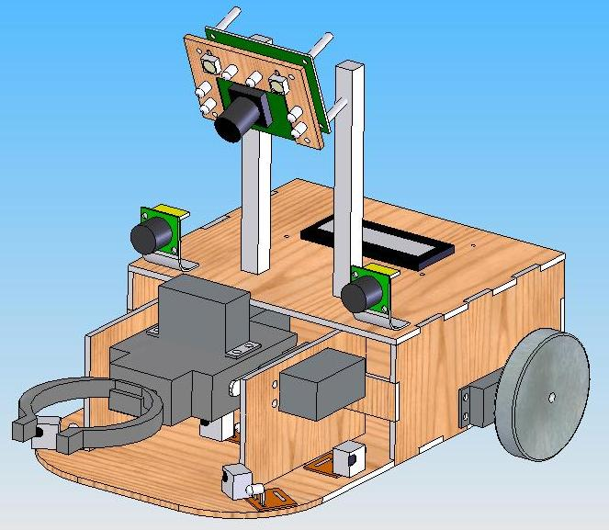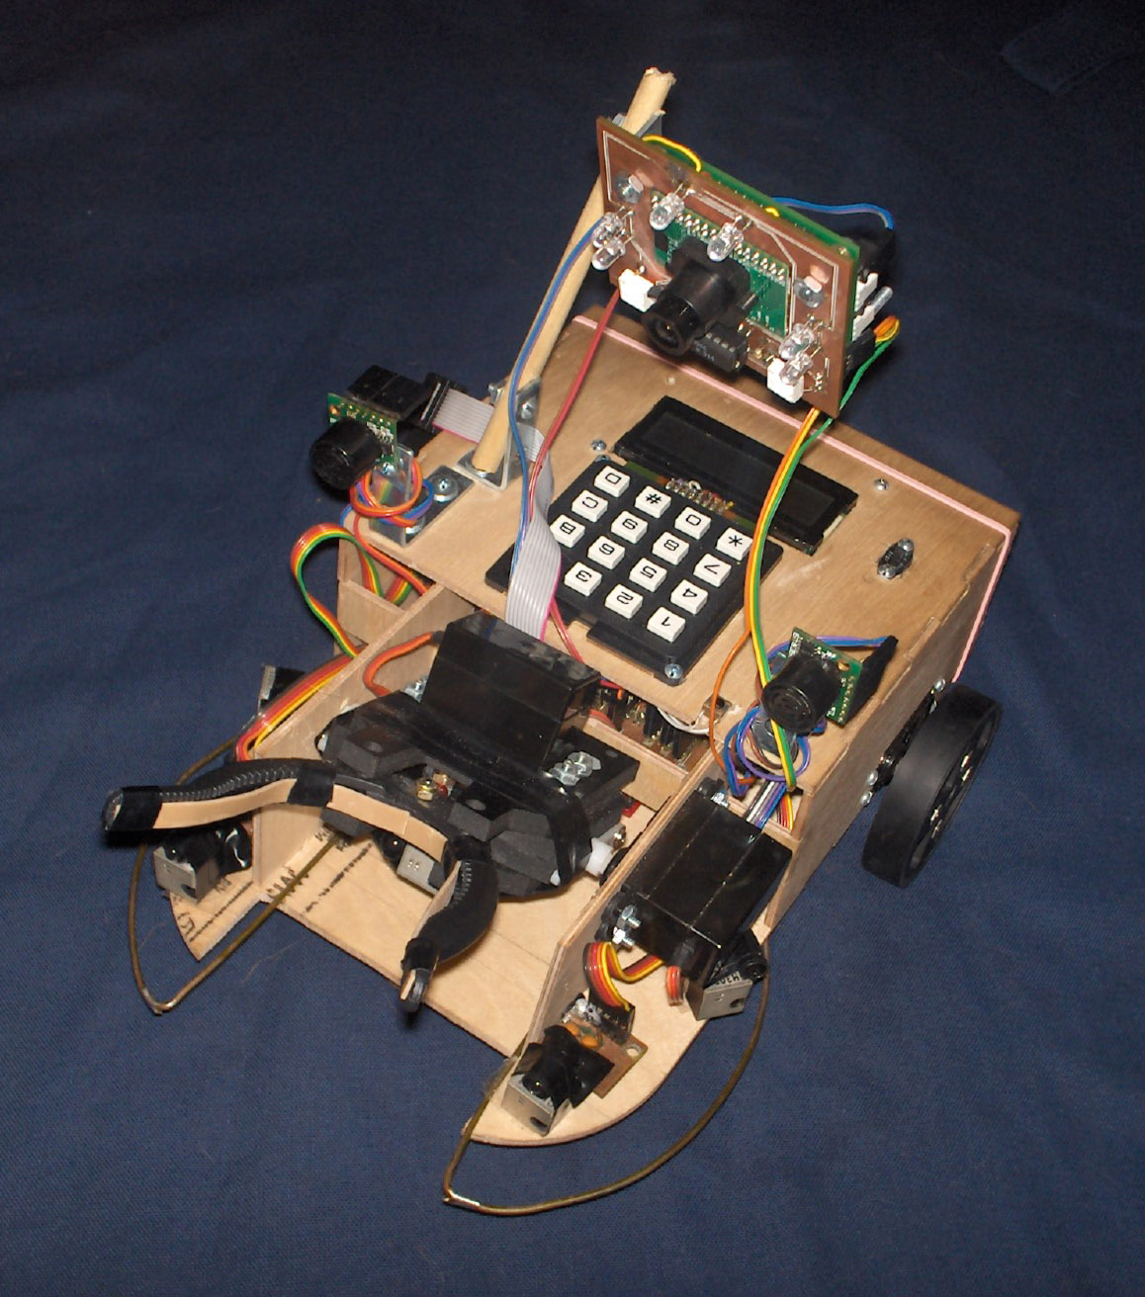

VI. Actuation
The servos supply the two forms of actuation, movement and gripping. Two of the servos were modified so that they can rotate continuously. This was done by removing the stop inside and fixing the potentiometer in the middle position. Speed and direction can be controlled by supplying a pulse of width 1-2ms at a frequency of 50-60Hz. Servos were chosen for movement to lower costs and complexity. The plastic wheels are two inches in diameter and have a thick rubber band that grips most surfaces easily.
LDOR picks up objects using a gripper powered by a servo. When the gripper is in operation all other servos are off. The current supplied to the gripper servo is measured and the position is held when the current reaches a certain limit. Rubber bands were added to prevent objects from slipping out.

VII. Sensors
There are four sensors used to analyze the surroundings. Bump sensors will indicate a collision. Infrared rangefinders detect objects that are close to the robot. Sonar will be used to detect objects that are farther away. The camera sees blobs of colors that are used to infer if an object of interest is ahead.

IR Sensors
The infrared sensors used were custom built for this project. A 555 timer was used to produce a 38 kHz signal to send through an infrared LED. The schematic can be seen in Appendix A. A Sharp QH3031 IR detector was used to sense this signal. This detector was modified so that its output signal is proportional to the intensity of the received signal. The microprocessor takes at least 10 samples of its output and averages them to get a useful result. The output varies from 1 to 2.1 volts depending on the intensity of the received signal. The range of the detector is linear over a finite range, typically only a few inches. This range is dependent on the intensity of the IR signal. By varying the intensity of the LED, the range of the sensor can be extended. The LED intensity can be adjusted with a 4-bit counter. The counter sinks the current through its 4 output ports. The current is greatest at zero and as it cycles through the count, the current is decreased. When the counter reaches 15, the current is zero. By varying the intensity of the infrared light, the sensor can get a better resolution and range. The circuitry used can be found in Appendix A.

The microprocessor samples the output of the detector for each one of the 16 intensities. The result is stored in an array that can be used to interpret the distance of the object in front of it. Objects that are far away will only show up on the highest intensities, while objects that are close will saturate the high intensities and be read better by the middle to low intensities. The intensity of the signal is affected by the size, shape, and material composition of the object.

There is some variation between the six sensors. They do not all have the same range and all differ slightly in the range of voltages. The variation were measured and compensated for in the software. The sensors must be calibrated constantly between runs. These sensors are usable, but very undependable. The cost of time debugging the design outweighed the cash savings of making my own.

Sonar
The sonar module used was the LV-MaxSonar EZ0. This module feature several output formats such as pulse width, analog voltage, and serial digital output. For this application, the analog output was used. Readings can be taken every 50ms. The RX pin is pulled high by the microprocessor for 20us to command a range reading. The module then sends out thirteen 42kHz waves, after 37.5ms the analog voltage is set. The distance can be approximated in inches dividing the A/D result by 2.

AVRCam
The AVRcam is a real-time image processing engine that utilizes an Omnivision OV6620 CMOS image sensor. An Atmel AVR mega8 microcontroller performs the entire image processing tasks. The interface is accessible through a standard serial port. The AVRcam can track up to 8 different colorful objects at 30 frames/second. It can be configured to recognize up to 8 different user-defined colors. The image resolution of tracked objects is 88x144 pixels. The AVRcam is completely open-source and can be tailored to the individual needs of the project using an in-circuit serial programmer.

The laser shows up on the image as bright center with a green fringe surrounding it. The bright center’s red, green and blue values read at the maximum 240. The AVRcam can recognize a color that occupies at least 3 adjacent pixels. Several factors may affect how the laser shows up in the image. If the laser pointer is too far away, there may not be enough pixels to correctly identify its presence. The color and reflectivity of the surface the laser is on also affect how much light is seen in the image. Since the laser dot will usually occupy only a small amount of pixels, the range it can be recognized is limited. Heavily lit areas or reflective objects produce the same results and may confuse the robot. The picture below shows a sample of a laser seen by the camera. As can be seen, the only contiguous color is the white at the center.

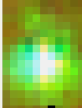

The number of distinguishable colors is limited. Red colors show up the best, white and yellow appear the same, while green can flood the image. Every environment produces its own ambient background colors that can be detected by the tracking. Problems were encountered when objects were confused with background colors. To help this an array of LEDs were mounted around the camera. These ultra-bright LEDs consume around 700mA at 5V, which drains the batteries quickly. The brightness can be adjusted using PWM. This allows the use of the least amount of light needed to see an object. While this improved the ability to distinguish colors that are close, the problem is still apparent when trying to locate objects farther than 3 feet. The only solution is to use colors that showed up consistently. An orange/red object was used for targeting and the destination was fluorescent green.

VIII. Behaviors
LDOR’s behaviors will include obstacle avoidance, target acquisition, loading objects, drop-off point attainment, unloading objects and roaming for other objects. These behaviors can be called independently with the keypad.

Obstacle Avoidance
This behavior is used whenever LDOR is moving around aimlessly.

Target Acquisition
LDOR will move around an area looking for a laser dot. Once the camera has identified the laser it will send targeting data. LDOR will start to approach it. When the laser is shut off, the last known position will be compared to the next closest object being tracked. If it is near, LDOR will start to approach. When the object is around two inches it will enter the loading behavior.

Loading Objects
LDOR slowly approaches an object, using the three front IR sensors to align the gripper. When the middle sensor reaches a peak, the gripper will begin to clamp down. It will continue until the current of the servo reaches a set maximum. The tilt servo then picks up the object. Then LDOR rotates around 180 degrees and begins to look for a destination.

Unloading Objects
Once the object has been obtained, LDOR will search for a laser dot or a color it remembers. The laser directs it to the drop-off point. It will use a procedure similar to target acquisition to find the drop-off area. It will approach until in is around 6 inches away and unload the object. Once the object is dropped off, it will roam the room looking for another object to transport or another laser pointer.

IX. Experimental Layout
The LCD was used to display relevant test information about the systems. Each component was tested and characterized before any behaviors were coded. The sonar required the least amount of testing and functioned as stated on the datasheet. The servos were tested by outputting the PWM information to the LCD. Then the keypad was used to manipulate the pulse width and the corresponding positions were noted. The IR sensors required much testing to find a method to even out the inconsistencies. Eventually an algorithm in software was developed that gave the best results over the range needed to load objects. All sensor and actuator code was developed modularly which allowed for easier troubleshooting.

X. Conclusion
The main challenge for this project was tracking objects of various colors. After experimenting it was determined that it could only find objects that are bright and stand out from the background. LDOR has difficulty tracking objects that are more than a few feet away and gets confused by background colors if too many are left on the color map. Therefore, the color map was reduced to just see the laser, bright green, red and orange. It can target an orange colored object and is able to then find the fluorescent green destination once the laser is shined on it.
Building this robot gave me the opportunity to gain experience with several CAD software programs and demonstrated some of the difficulties associated with computer vision. It gave me practical programming experience in C. This project was very time consuming and I did my best to stay on top of multiple tasks. In hindsight, I should have bought the infrared sensors so that more time could have been devoted to the problems with the camera and behavior programming.

Documentation
Oscillator Circuit
http://www.mil.ufl.edu/courses/eel5666/handouts/timer.pdf

“Sharp IR Sensor Hack for Analog Distance Measurement.”
http://www.mil.ufl.edu/courses/eel5666/handouts/sharphack.pdf

Appendix A

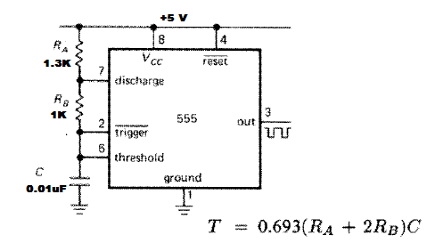
38kHz Signal Generator
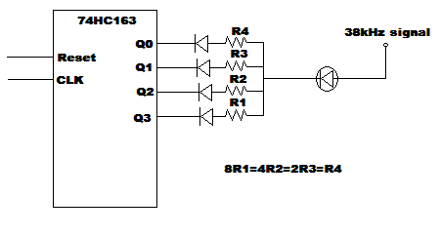
IR Intensity Controller

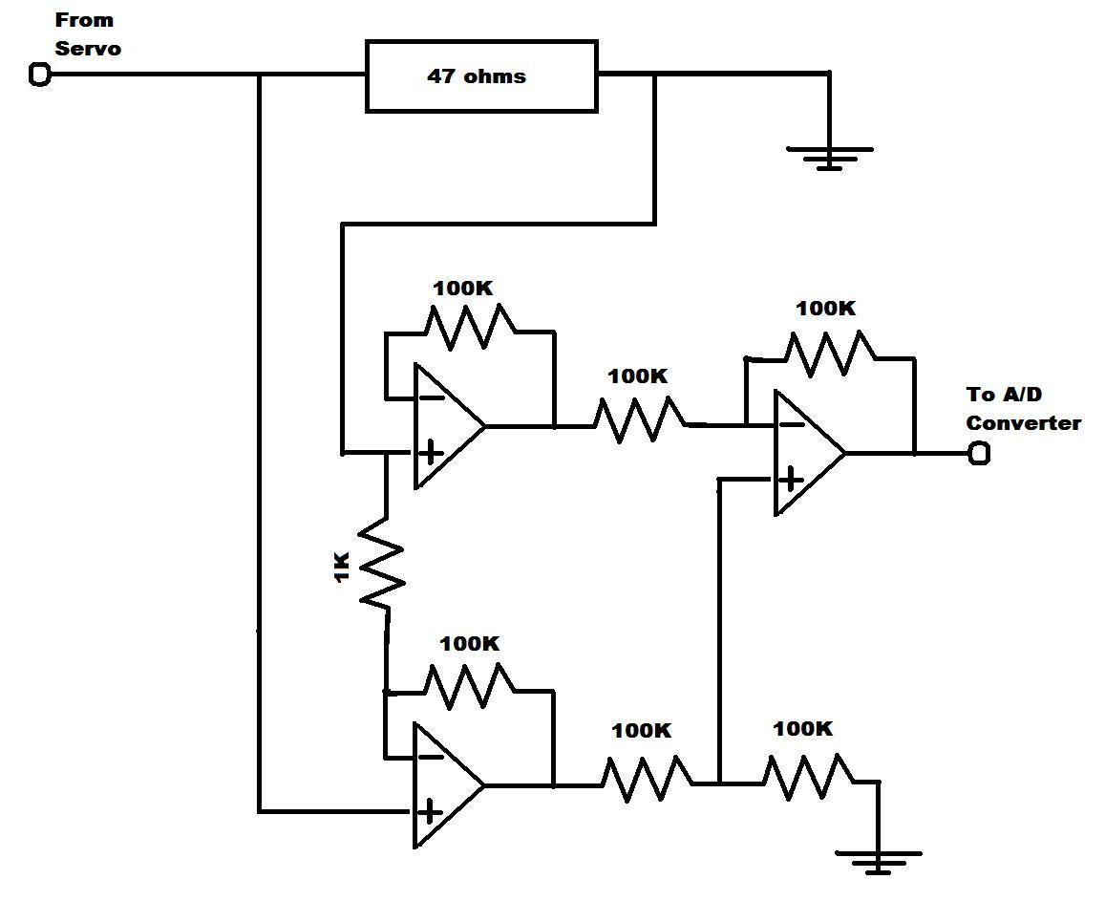
Ammeter Circuit

Appendix B

See attached file for program code.

