Date: 4/22/08
Student Name: Nikolos Burridge
TA : Kevin Claycomb
Adam Barnett
Instructors: Dr. A. Antonio Arroyo
Dr. Eric M. Schwartz

“Wimbly”
University of Florida
Department of Electrical and Computer Engineering
EEL 5666
Intelligent Machines Design Laboratory
Final Report

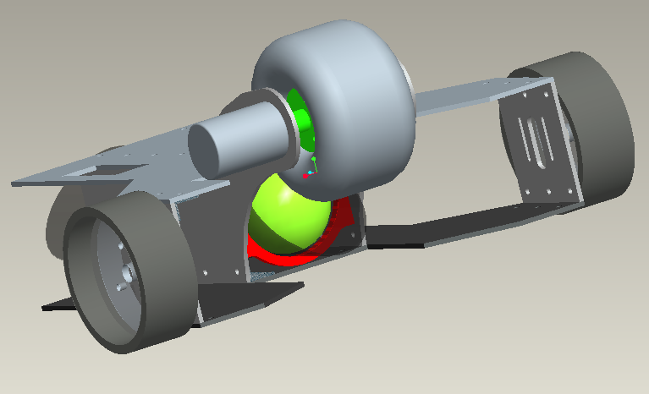

Table of Contents

I. Abstract 3
II. Executive summary 4
III. Introduction 5
IV. Integrated System 5
V. Mobile Platform 6
VI. Actuation 9
VII. Sensors 10
CMU camera data 13
IIX. Behaviors 15
IX. Conclusion 16
References 17
Thanks 17
X. Appendix 18

Abstract

To simplify the task of picking up tennis balls after playing a game of tennis in a safe and efficient manner, this robot will be built to pick up stray tennis balls and repackage the balls in their original container. If implemented at courts, this robot would keep tennis courts organized and well kept. This project will also be an attempt to manufacture and design an autonomous self contained vehicle with as little cost as possible while making the device easy to manufacture and assemble. Electrical and computer engineering aspects of this robot’s design will be learned while producing a viable and competitive product using my current mechanical engineering abilities.

Executive Summary

Salient Features:

Wimbly is an autonomous robot capable of navigating through a room without hitting still objects and collecting tennis balls. This robot is a prototype built for the Intelligent Machines Design Laboratory for academic credit through the University of Florida in the summer of 2007 semester.

This autonomous vehicle uses vision from a CMU camera to track a mass of pixels and then navigates to center the mass of pixels in the robots point of view. When the ball is close enough the robot the collecting wheel will activate and collect the tennis ball into the on board hopper. The on board hopper consists of the original tennis ball packaging. Wimbly is designed to pick up three tennis balls at a time as this is the maximum amount of balls a tennis ball container can hold.

Sonar was installed on this robot to give it the ability to avoid obstacles without coming in contact with them. Two sonar rangers are installed on the front of the robot giving it ultrasonic sight in the direction it travels most of the time. When the camera senses a target ball of the correct color the sonar will be deactivated and the robots only objective will be to collect the ball.

University of Florida 9-Aug-07 A. Antonio Arroyo, PhD
Department of ECE EEL 5666: Intelligent Machines Design Laboratory Eric M. Schwartz, PhD

Introduction

Tennis players can use a lot of balls during a game and just practicing. The proposed robot in the following paper will pick up balls in an efficient manner and store them in the onboard hopper. In reading this text you will become familiar with this project and how I will implement an autonomous machine to carry out the task of picking up tennis balls. The paper will begin by describing the project as a whole and then begin to break each system down so the relationship between all the components will become clear to the reader. The Platform will be discussed first and the rest of the robot will be explained in the same order that it was built.

Integrated System

The conceptual system of this robot will be based on its five proposed functions. This robot will be self powered, avoid obstacles, seek tennis balls, pick up tennis balls, and deposit the collected balls in to their original packaging in a quick efficient manner. First, the robots ability to move under its own power will require a stable platform that will be powered by 2 simple electric gear motors. The platform will be easy to service and contain the 3 target balls. The second function to be discussed will be the robot’s ability to avoid objects. Traveling forward, the robot will stop and change direction if an obstacle that is not a target ball appears within 1 foot in front of the robot using its 2 sonar and 3 bump sensors. Traveling along the tennis court and avoiding obstacles, the robot will seek stray tennis balls using its third function: the ability to seek tennis balls within 1 foot in front of it using a CMU camera. Once a ball is found, the robot will perform its fourth function: picking up tennis balls. The robot will roll toward the target and position itself so that the retrieval mechanism mounted in the front will grab the ball and shoot it within the robot. The robot will realize that its target is required and seek the next ball until it finds and retrieves 3 balls. Tennis balls normally come in a tubular plastic pack of three. Mounted in the rear, a compartment that will use the original tennis ball packaging as a hopper will contain the balls, satisfying its fifth function. Once the tennis ball pack is full it will be easily removed from the robot.

Mobile platform

The structure and design of this robot will be kept simple by using an easily manufactured frame and a removable ball hopper. Supporting the weight of the robot and containing the electronics will be the robot’s aluminum frame. Wood will be used to build the prototype frame so the electronics can be installed on the robot and tested for accessibility. The frame will hold all the necessary electronics: the microprocessor board, 3 motor driver boards, the CMUcamera and 2 battery packs. One pack will be six NIMH rechargeable size AA batteries and one NiCAD 7.2 stick pack. Shock created from the ball collecting mechanism will be absorbed by the frame. Composed of six main parts, shown in figures 1 through 3, the frame will be sturdy and will be able to carry the robots estimated 10 pound weight. Two of the frames components are the same to simplify manufacturing. The left and right mechanism plate pieces, shown in figure 1, will support the ball collecting wheel the robot will use to collect the target balls.

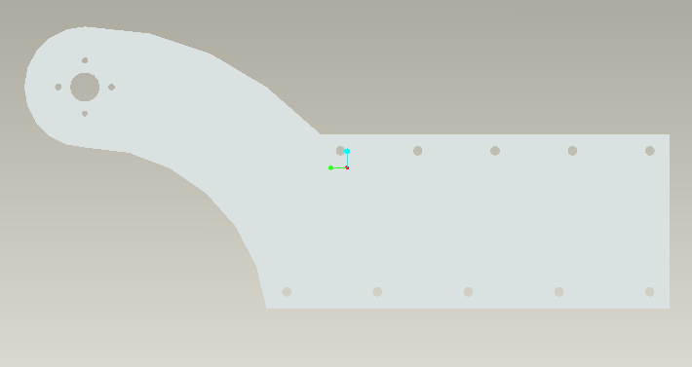
Figure 1

The left and right motor plate pieces in figure 2 will support the motor and wheel assembly.

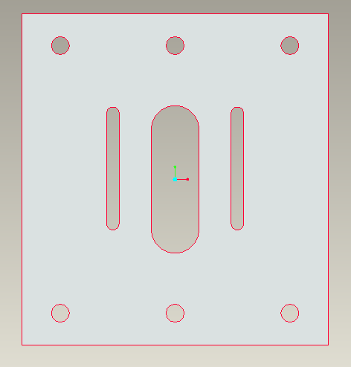
Figure 2

The upper and lower plate pieces, shown in figure 3, will connect perpendicular to the left and right mechanism and motor plates, completing the frame.

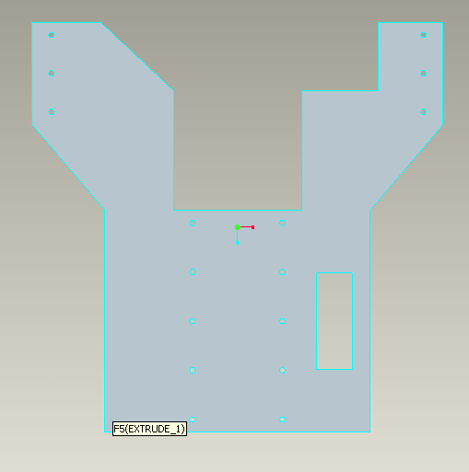
Figure 3
Figure 4 shows the basic assembled frame.

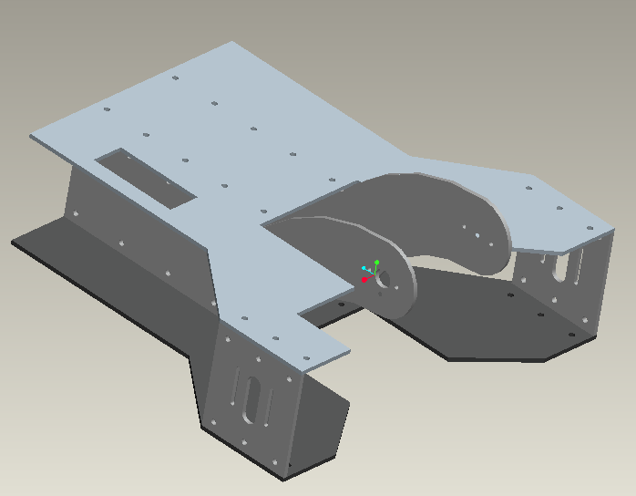
Figure 4

The hopper, shown with collecting tubes in figure 5, will be mounted between the left and right mechanism plates as shown. The top plate will be cut out to fit the collecting tubes and the tennis ball tube hopper. The collecting tubes will be cut from black PVC pipe. And will direct the ball into the hopper once the retrieval mechanism shoot s the ball in to the robot.

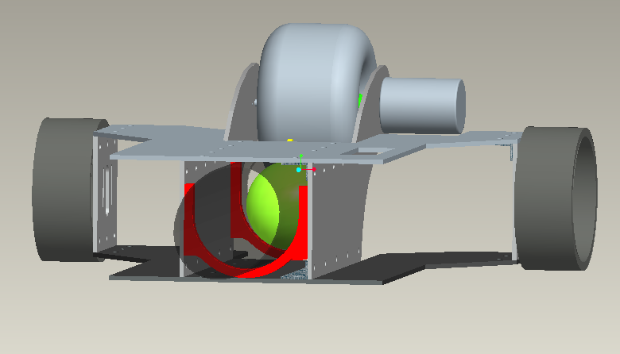
Figure 5

The electronics will fit on the outward face of the right mechanism plate and will be shielded from any external collisions by the upper and lower plates.

Actuation

Actuation for this robot will include a tank drive motor train and a spinning wheel. The two motors that drive the robot will be mounted axially identical on either side of the robot on the motor mount plates, figure 3 and figure 4, creating a tank style drive-train. The two identical 12V DC motors were attained from lynxmotion.com and one is pictured below.
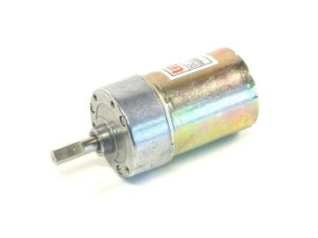
A tank drive set up will allow the robot to move 360 degrees and perform spins. A ball castor is installed on the rear of the robot to keep it stable while in motion. To greedily suck up balls into its hopper, the robot will use a high rpm motor mounted to a soft wheel from a Tamiya brand remote controlled car. The wheel will be mounted 2.25 inches above the ball. The spinning wheel will then grab the very top of the ball. The ball will then travel through the robot and into the hopper. The hopper consists of a tennis ball container that can hold three balls. The ball grabbing mechanism is shown in figure 6. To run all the motors I am implementing TPIC0108 motor drivers on my robot.

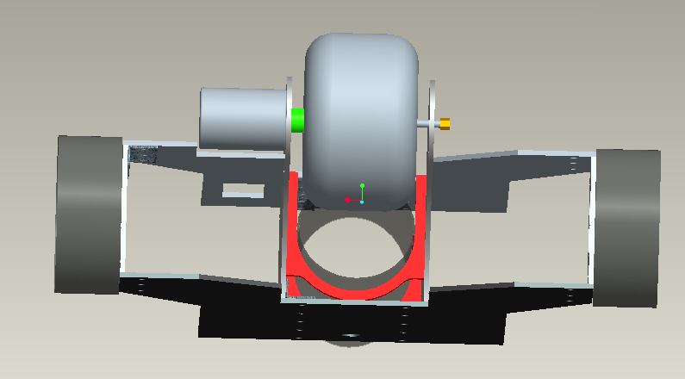
Figure 6

Sensors

Two sonar sensors, 3 bump sensors, and one CMU camera will outfit the sensor array on this robot. Fully functional, this robot will avoid obstacles using two frontally mounted sonar or IR sensors. A sonar sensor is more accurate and expensive but seems to be the better choice for outdoor use due to the IR sensor’s inability to deal with unstable environments. The sonar sensor can also be crossed with little fear of interference issues. If the robot comes in contact with an object the bump sensors mounted every 90 degrees surrounding the robot, the robot will change directions. Tennis balls will be detected using a CMU camera by tracking the fluorescent yellow-green color of the ball. A CMU camera seems like the most sensible choice due to its ease of use and the knowledge base here at UF is larger than for other cameras.

Bump

The bump switch mechanism on the robot will consist of a micro switch with an extended trigger mounted on the perimeter to aid in obstacle avoidance.
The bump sensor will cause the robot to cut power to the motors and change direction in a random fashion. The goal to implement these sensors will be to mount them and to program a stop command to the algorithm controlling the motors. The sensors can be bought from
Mouser Electronics, Inc.
1810 Gillespie Way
Suite 101
El Cajon, CA 92020
(800) 346-6873
and are manufactured by Omron Electronics Part#SS-5GL2. The sensor is not applied to the robot as of this writing. Six total sensors will be mounted to allow the robot to navigate in its environment by touch. Normally a micro-switch is wired in parallel to the power supply and some sort of tool or device that requires a safety switch. When the switch is activated, the power to the device is cut off to stop the device the switch is wired to. When a switch is activated, it enables a pin on Port A on the microprocessor to be written high. The Pin is written high and this causes the motors to stop and then move in a random direction. No data base is needed on this sensor. It does not return values, so it is simply a switch to be turned on or off.

Sonar

My sonar sensors consist of sonic devices that will allow the robot to navigate beyond the touch of the bump sensors by measuring the robots distance away from an object in its path. A sonar sensor bounces sound pulses from an emitter and waits a short amount of time to receive the same pulse. The sonar sensor has three objectives to be met upon completion. The first is to wire them to the microcontroller and mount them. The second is to activate the sonar’s ability to pulse through software. The third objective will be to integrate these sensors in to the main program for obstacle avoidance through external and internal interrupts. These sensors can be bought from:
Acroname Robotics
4822 Sterling Dr.
Boulder, CO 80301-2350
USA
Part # R271-SRF05
720.564.0373
Devantech SRF05

Two Sensors are mounted on the front of the robot on either side at a 45 degree inward angle and set to pulse at two different times. This array arrangement should provide the robot with the maximum amount of “vision” with a minimum amount of sensors. This sensor works by sending out a high pitched pulse of sound activated from the trigger input pin, which is activated by a falling edge signal from the microcontroller. The pulse bounces off an object in its path and travels back to the sensor. After waiting 10 micro seconds, the sonar receives the same pulse and sends a signal back to the microcontroller through the Echo output pin. The microcontroller then calculates the amount of time has passed between the sonar’s sending and receiving signals and outputs a distance to the LCD or a command to the motors. The sensor software algorithm uses ports D and A on the microcontroller, one of the microcontroller’s 16 bit timers, TCNT1, an interrupt that counts the number of timer overflows, and an External interrupt activated upon the sonar’s second pulse falling edge signal and uses the microcontrollers LCD on Port B to blink when ever an interrupt is fired. This algorithm still does not produce numbers that are consistently between the reasonable range of 0 to 255. Further debugging is needed before usable values can be obtained. Data values obtained as of this writing vary from 16 to 1600 nonlinearly, and seem to increase as an object gets closer. The sonar’s current values seem to contradict to normally operating sonar’s values.

CMU cam

The CMU 01 Robot Vision Cam will be my special sensor used to find tennis balls using vision processing. This device is designed to return high level vision capabilities to microprocessor boards that normally would not have enough processing power to execute such abilities. Four phases of implementation must take place to use the cameras capabilities. The first is to mount the camera to the robot and interface with the computer. Second task is to test the cameras abilities. The fourth is to program the camera through a microcontroller board to track tennis balls using preprogrammed serial commands. This camera can be bought at;
Images SI Inc.
109 Woods of Arden Road
Staten Island NY 10312
Phone: (718) 966-3694
Part # CMU 01
How sensor is applied
Theory of operation: For the camera to operate a microcontroller must send serial commands to the CMU camera, and the preprogrammed firmware on the camera will then use the Track Color command and Middle Mass mode to find the target ball, a day-glow green tennis ball, track it, while sending commands to the microcontroller. The microcontroller will then send commands to the motors to drive the robot towards its intensely colored target. There is no software algorithm written by this robots creator as of this writing, for CMU cameras firmware code contact any of its creators:
Anthony Rowe, Charles Rosenberg, or Illah Nourbakhsh, Electrical and Computer Engineering Computer Science Department Robotics Institute,
Carnegie Mellon University.

Values were taken from the CMU camera in four separate rooms within the New Engineering Building on the University of Florida’s campus to test to see what values could be obtained from different fluorescent lighting sources within the same building. The camera was mounted on the robot, 6.5 inches above the ground and angled at 45 degrees from the horizontal. The subject tennis ball was always 9 inches away from the camera lenses. The software that came with the camera did not interface correctly with the camera so I was forced to use software for a CMU 2 camera. The program could not average the color of an object so I drew a circle on the ball and took 5 values from within my marked circle and took the average. The values and cases are presented in Tables 1 through 5. The corresponding graph is Figure 7.

Figure 7

Table 1 Table 2

Rotunda Mid-Afternoon (cloudy day)
Point | Red | Green | Blue
1 | 130 | 214 | 16
2 | 133 | 175 | 29
3 | 153 | 229 | 43
4 | 124 | 176 | 35
5 | 144 | 180 | 34
average | 136.8 | 194.8 | 31.4
Rotunda At Night (dim fluorescent light)
Point | Red | Green | Blue
1 | 127 | 192 | 16
2 | 120 | 188 | 23
3 | 131 | 163 | 15
4 | 120 | 160 | 31
5 | 125 | 173 | 22
average | 124.6 | 175.2 | 21.4

Floor Near North Doors at Night (well lit)
Point | Red | Green | Blue
1 | 240 | 240 | 49
2 | 240 | 240 | 61
3 | 240 | 240 | 54
4 | 240 | 230 | 50
5 | 209 | 240 | 41
average | 233.8 | 238 | 51

Table 3 Table 4
North West Hallway At Night (well lit)
Point | Red | Green | Blue
1 | 240 | 240 | 18
2 | 240 | 240 | 16
3 | 240 | 240 | 26
4 | 240 | 240 | 19
5 | 240 | 240 | 35
average | 240 | 240 | 22.8

Table 5
Vend Machine Hallway @ Night (best lit fluorescent)
Point | Red | Green | Blue
1 | 239 | 240 | 16
2 | 233 | 240 | 19
3 | 232 | 240 | 17
4 | 237 | 240 | 20
5 | 240 | 240 | 21
average | 236.2 | 240 | 18.6

Values were also taken once during the day and once at night to witness the effect of outside ambient light had on the RGB values. Both readings were taken in the very
center of the NEB rotunda floor as shown in figure 8. The day values were taken on a cloudy day and the night values were taken to obtain a case with only fluorescent
lighting.

Figure 8

Behaviors

Seeking out three tennis balls and collecting them all while avoiding obstacles will compose of the robots main behaviors. This robot has 3 behaviors: it avoids obstacles, seeks, and picks up tennis balls. It should perform these actions quickly as players consume a lot of balls during game play and practice.

The first behavior to be discussed will be the robot’s ability to avoid objects. Traveling forward, the robot will reverse and change direction if an obstacle appears within six inches in front of the robot. This behavior is kept simple by programming the robot to proportionally change direction based on the values the sonar return

The robot will seek stray tennis balls using its second function: the ability to seek tennis balls within 1 foot in front of it. When the CMU camera returns a confidence value greater than thirty percent, meaning the camera is sure to thirty percent that it is tracking a green blob with the right values, the robot will base its motor values from the x coordinates also returned by the camera. The x coordinates used from the camera are normalized and are used as an influence on how the motors are powered.

Once a ball is found, the robot will perform its third function: picking up tennis balls. The robot will initially stop to allow the spinning wheel that picks up the ball, to get up to the necessary collecting speed. The robot will then roll toward the target and position itself so that its retrieval mechanism will suck the ball within the robot using the x coordinates returned from the camera. I have encountered an interesting problem trying to run all 3 motors using the same timer and PWM signal. When I delay the robot to get the collecting wheel up to speed to collect the tennis ball the robot will immediately shoot forward. The robot suddenly shooting forward suggests that the signal I send to the collecting wheel influences the other motors. I am not sure if this is software or hardware related. To fix this problem I put the collecting wheel on a separate timer.

CLOSING

Conclusion

Wimbly is currently not where the creator would like the robot to be in any aspect of the project. The time constraints are tough to meet while leaning the systems necessary to get a robot completed. The creator of Wimbly should have taken a class related to microprocessors or digital logic before attempting such a project. Most of the project composed of the creator trying to get the hardware to communicate with the microcontroller board. The robot is a successful learning tool for its creator and the robot can successfully pick up tennis balls. Due to my lack of hardware programming experience more complex behaviors could not be implemented due to the tight time constraints. The robots appearance really needs to be improved and the camera needs to be mounted in a safer position. The current mounting position puts the sensitive CMU sensor too far up front. If the robots sensors were to fail, the robot would damage its CMU camera. I avoided a lot of hassle by listening to what Dr. Schwartz and Arroyo had to say in class. I saw a lot of failure in other robots that relied on a toy platform or other inexpensive remanufactured component. If I could start the project over I would have designed it to be more compact and have the ability to reload the tennis ball containers when full. I still want to incorporate an IR sensor to let Wimbly know how many balls it has.

13. Documentation

References:

CMUcam Vision Board User Manual. Anthony Rowe and Carnegie Mellon University.
Version 1.20, 2004 http://www.seattlerobotics.com/cmucam.htm

Gear Head Motor Datasheet. LynxMotion, Copyright 2000
http://www.lynxmotion.com/ghm02.htm

Devantech SRF05 UltraSonic Range Finder. © 1994-2007, Acroname Inc.,
http://www.acroname.com/robotics/parts/R93-SRF05.html

MAVRIC-IIB Manual
http://www.bdmicro.com/images/mavric-iib.pdf

Atmega128 Complete Datasheet
http://www.atmel.com/dyn/resources/prod_documents/doc2467.pd

Thanks to:

Kevin Claycomb
Adam Barnett thanks for the advice and all your work on the t tech
Jacob – for all your time and spare parts I thank you. Yea, mechanicals can do it too.
Mike – thanks for the new motor driver board design
Jeff, Don, Mike, Jim , Devin from REU – my coding gurus
Dr. Arroyo and Dr Schwartz – thanks for the opportunity

Sample Code

#include <avr/io.h>
#include <avr/interrupt.h>
#include <util/delay.h>
#include <inttypes.h>
#include <stdlib.h>
#include <stdio.h>
#include <string.h>

#include "camera.h"
#include "LCD.h"
//#include "atmega128_serial.h"

////////////////////////////////Defines//////////////////////////////////////

//DEVINS DEFINE FOR UART INIT()
#define CPU_Speed 16000000L

#define UART0_Baud 19200L
#define UART0_RR ((CPU_Speed/(16L*UART0_Baud))-1)

/////////////////////////////// Prototypes //////////////////////////////////////////////////

void Collect_Wheel();
void Get_Away ();

void Right_Spin();
void Left_Spin();

void Forward_Drivers();
void Forward_Passengers();
void Reverse_Drivers();
void Reverse_Passengers();

/////////////////////////////Global Varibles/////////////////////////////////////////

char b[40]; long int j;
int n; // int v[8];
int M;
int middle_x;
int middle_y;
int x_1;
int y_1;
int x_2;
int y_2;
int pixels;
int confidence;

//motor to spool up
int f = 0;

//PWM control globals
int Move_1;
int Move_2;
int S_Factor1;
int S_Factor2;
// int C_Factor;

for initial timer value
unsigned int MyEndVal; unsigned int overflowcounter;
int stop; // when pulse returns to sonar array.
int TimeVal_1; // Declares TimeVal to hold sonar pulse's return time.
int TimeVal_2;
int overflow;
int counter;
int t;

//sonar values
int TimeVal_1 = 0;
int TimeVal_2 = 0;

int main()
{
//////////////////////////// Intialization //////////////////////////////////////////

//PWM (frequency and phase mode)
TCNT3 = 0;
TCCR3A |= 0b10101000; // commands for timer 3 register A
TCCR3B |= 0b00010010;
DDRE |= 0b00111000; ICR3 = 0x064; DDRA |= 0b11100000;
// clock initialization (sonar ? )
EICRA |= 0b00001010; TCCR1B |= 0b00000001; sei();
int counter;

DDRB |= 0b00000001; DDRD &= 0b11111100; DDRA |= 0b00000011;
PORTA &= 0b11111100; LCD_Init(20,2);

////////////////////////////////////////////////////////////////////////////////////////////////////////

////////////////////Wills CMU camera code//////////////////////////////////////////

for (j = 0; j < 20000; j++); for (j = 0; j < 20000; j++);
// ( ? )LCD_Init(20,2);
LCD_Write_Command(0x01);
camera_init();

LCD_Write_Char(b[0]);
LCD_Write_Char(b[1]);
LCD_Write_Char(b[2]);
LCD_Write_Char(b[3]);

////////////////////////////////////
// LCD_Write_Command(0x01); camera_send("TC 100 120 130 150 10 20\r");
camera_recieveM(b);

LCD_Write_Char(b[0]);
LCD_Write_Char(b[1]);
LCD_Write_Char(b[2]);
LCD_Write_Char(b[3]);

// _delay_ms(10000);

LCD_Write_Command(0x01);

while (1)
{

LCD_Write_Command(0x01); //Clear Display
camera_recieveM(b);
LCD_Goto_Pos(1,0);
sscanf(b,"M \rM %d %d %d %d %d %d %d %d",&M,&middle_x,&middle_y,&x_1,&x_2,&y_2,&pixels,&confidence); // these character arrays can now be
LCD_8bit_Out(middle_x); //used to track a ball with some behavior code
LCD_Write_Char(' ');
LCD_8bit_Out(middle_y);
LCD_Write_Char(' ');
LCD_8bit_Out(x_1);
LCD_Write_Char(' ');
LCD_8bit_Out(x_2);
LCD_Goto_Pos(2,0);
LCD_8bit_Out(y_2);
LCD_Write_Char(' ');
LCD_8bit_Out(pixels);
LCD_Write_Char(' ');
LCD_8bit_Out(confidence);

//OCR3C = 0; // stop collecting wheel, safety

if (confidence > 20) //pixels, capped at 255. confidence, capped at 255
{
//C_Factor = 30;

Collect_Wheel(); // spin collecting wheel

f = 0;

if (f = 0) {
OCR3A = 0; OCR3B = 0;
LCD_Write_Char('S');
LCD_Write_Char('T');
LCD_Write_Char('O');
LCD_Write_Char('P');
for (j = 0; j < 20000; j++); // play with value
for (j = 0; j < 20000; j++);
for (j = 0; j < 20000; j++);
for (j = 0; j < 20000; j++);

}

// camera reosolution is 80x143
if (middle_x < 30) // both motors
{
PORTA |=0b11000000; // set 1 is forward,
Move_1 = 30;
OCR3A = Move_1;
OCR3B = Move_1 -5;

}
else if (middle_x > 50) // both motors
{
//OCR3A = 0; PORTA |=0b11000000; // set 1 is forward,
Move_2 = 30; // ? /4 (?)
OCR3B = Move_2;
OCR3A = Move_2 -5;

}

else // when 35 > v[1] < 45
{
PORTA |=0b11000000; // move both motors forward,
OCR3B = 30;
OCR3A = 30 ;

}
collecting wheel

f = 1; // for (f = 0 ; f = 1; _delay_ms(10000));

}

else
{

for(t = 0; t < 3; t++)
{
//ball collecting stuff
OCR3C = 0; // stop collecting wheel
f = 0; //for (f = 0 ; f = 1;_delay_ms(10000)); to reset variable to wait for motor

//Sonar 1

EIMSK |= 0b00000001;

TIMSK |= 0b00000100; PORTA |= 0b00000001; _delay_us (10); PORTA &= 0b11111110; MyStartVal = TCNT1; overflowcounter = 0; stop = 0 ; // variable used to wait for interupt to fire

while(stop == 0)

{/* if stop = 0, do nothing and wait)*/}

EIMSK &= 0b11111110;

TimeVal_1 += (overflow*16)+((MyEndVal - MyStartVal)/

//Sonar 2

EIMSK |= 0b00000010;
TIMSK |= 0b00000100; PORTA |= 0b00000010; _delay_us (10); // wait for 10 microseconds
PORTA &= 0b11111101;
MyStartVal = TCNT1; // named TCNT1.
overflowcounter = 0; stop = 0 ; // variable used to wait for interupt to fire

while(stop == 0)
{/* if stop = 0, do nothing and wait)*/}

TimeVal_2 += (overflow*16)+((MyEndVal - MyStartVal)/4096
EIMSK &= 0b11111101 ; // clears bit to turn off external interupt INT1

} // for for(t = 0; t < 5; t++) loop

LCD_Write_Command(0x01); //Clear Display

if (t == 3)
{
TimeVal_1 /= 3;
TimeVal_2 /= 3;

// display sonar
LCD_Goto_Pos(2,12);
LCD_8bit_Out(TimeVal_1); LCD_Goto_Pos(2,16);
LCD_8bit_Out(TimeVal_2); t = 0;
}

Get_Away ();
} //End of else

}// End of while loop

}// End of main loop

///////////////////////////////////////////Sonar Interrupts/////////////////////////////////////////

//Falling edge signal interrupt for sonar 1
ISR(INT0_vect) // Put Atmel defined interupt vector in the ()'s and Note:
{

MyEndVal = TCNT1; // Variable used to read the 16 bit microprocessor timer 1 // read TCNT1 here to read value of timer after interupt has fired.
overflow = overflowcounter;
stop = 1;
sei(); //

}

//Falling edge signal interrupt for sonar 2
ISR(INT1_vect) // Put Atmel defined interupt vector in the ()'s and Note:
{

MyEndVal = TCNT1; // Variable used to read the 16 bit microprocessor timer 1 // read TCNT1 here to read value of timer after interupt has fired.
overflow = overflowcounter;
stop = 1;
sei(); //

}

//Timer Overflow Interrupt
ISR(TIMER1_OVF_vect) //INterupts are functions that run in the background and are fired when their programmed event has occoured, this interupt fires when the time overflows.
{

overflowcounter++; //increment counter here

}

//////////////////////////////// functions ////////////////////////////////////////

void Forward_Drivers(void) //drivers side is OCR3B
{
PORTA |= 0b10000000; // set 1 is forward
OCR3B = 45;
}

void Forward_Passengers(void) //drivers side is OCR3B
{
PORTA |= 0b01000000; // set 1 is forward
OCR3A = 45;
}

void Reverse_Drivers(void)
{
PORTA &= 0b01111111; // clear 0 is reverse
OCR3B = 45;

}

void Reverse_Passengers(void)
{
PORTA &= 0b10111111; // clear 0 is reverse
OCR3A = 45;
}

void Drivers_Spin (void)
{
Forward_Drivers();
Reverse_Passengers();
}

void Passengers_Spin(void)
{
Forward_Passengers();
Reverse_Drivers();
}

void Collect_Wheel(void)
{
PORTA |= 0b00100000;
OCR3C = 70;
}

void Get_Away(void)
{
if (TimeVal_2 > 60 )
{
Forward_Drivers();
}
else if (TimeVal_2 < 30)
{
PORTA &= 0b01111111; // clear 0 is reverse
OCR3B = 50;
// _delay_ms (100);
}

else // proportional control for one motor
{
PORTA |= 0b10000000; // set 1 is forward
OCR3B = 30;
//_delay_ms (100);
}

if (TimeVal_1 > 60)
{
Forward_Passengers();
}

else if (TimeVal_1 < 30)
{
PORTA &= 0b10111111; // clear 0 is reverse
OCR3A = 50;
// _delay_ms (100);
}

else // proportional control for one motor
{
PORTA |= 0b01000000; // set 1 is forward
OCR3A = 30;
// _delay_ms (100);
}

}

