Osal
Date: 5/31/07
Student Name: Nikolos Burridge
TA : Kevin Claycomb
Adam Barnett
Instructors: Dr. A. Antonio Arroyo
Dr. Eric M. Schwartz

University of Florida
Department of Electrical and Computer Engineering
EEL 5666
Intelligent Machines Design Laboratory
Project Proposal

Abstract

To simplify the task of picking up tennis balls after playing a game of tennis in a safe and efficient manner, this robot will be built to pick up stray tennis balls and repackage the balls in their original container. If implemented at courts, this robot would keep tennis courts organized and well kept. This project will also be an attempt to manufacture and design an autonomous self contained vehicle with as little cost as possible while making the device easy to manufacture and assemble. Electrical and computer engineering aspects of this robot’s design will be learned while producing a viable and competitive product using my current mechanical engineering abilities.
Introduction

Tennis players can use a lot of balls during a game and just practicing. The proposed robot in the following paper will pick up balls in an efficient manner and store them in the onboard hopper. In reading this text you will become familiar with this project and how I will implement an autonomous machine to carry out the task of picking up tennis balls.

Integrated System

The conceptual system of this robot will be based on its five proposed functions. This robot will be self powered, avoid obstacles, seek tennis balls, pick up tennis balls, and deposit the collected balls in to their original packaging in a quick efficient manner. First, the robots ability to move under its own power will require a stable platform that will be powered by 2 simple gear motors. The platform will be easy to service and contain the 3 target balls. The second function to be discussed will be the robot’s ability to avoid objects. Traveling forward, the robot will stop and change direction if an obstacle that is not a target ball appears within 3 feet in front of the robot using its 2 sonar and 3 bump sensors. Traveling along the tennis court and avoiding obstacles, the robot will seek stray tennis balls using its third function: the ability to seek tennis balls within 5 feet in front of it using a CMU camera. Once a ball is found, the robot will perform its fourth function: picking up tennis balls. The robot will roll toward the target and position itself so that the retrieval mechanism mounted in the front will grab the ball and shoot it within the robot. The robot will realize that its target is required and seek the next ball until it finds and retrieves 3 balls. Tennis balls normally come in a tubular plastic pack of three. Mounted in the rear, a compartment that will use the original tennis ball packaging as a hopper will contain the balls, satisfying its fifth function. Once the tennis ball pack is full it will be easily removed from the robot.

Mobile platform

The structure and design of this robot will be kept simple by using an easily manufactured frame and a removable ball hopper. Supporting the weight of the robot and containing the electronics will be the robot’s aluminum frame. Wood will be used to build the prototype frame so the electronics can be installed on the robot and tested for accessibility. The frame will hold all the necessary electronics: the microprocessor board, 3 motor driver boards, the fuse panel, opt isolators, and 3 battery packs. Shock created from the ball collecting mechanism will be absorbed by the frame. Composed of six main parts, shown in figures 1 through 3, the frame will be sturdy and will be able to carry the robots estimated 10 pound mass. Three of the frames components are the same to simplify manufacturing. The left and right mechanism plate pieces, shown in figure 1, will support the ball collecting wheel the robot will use to collect the target balls.

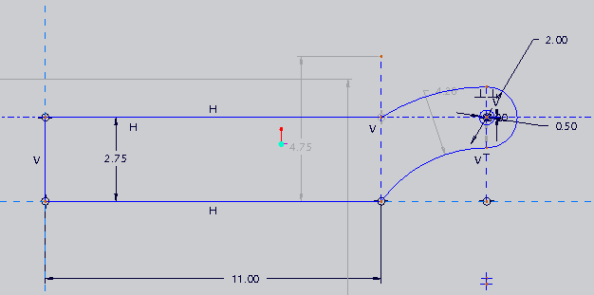
Figure 1

The left and right motor plate pieces in figure 2 will support the motor and wheel assembly.

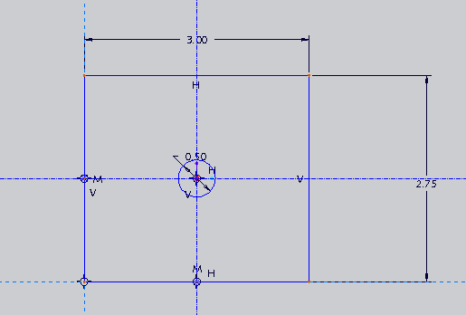
Figure 2

The upper and lower plate pieces, shown in figure 3, will connect perpendicular to the left and right mechanism and motor plates, completing the frame.

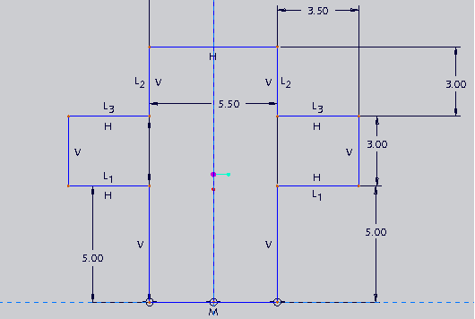
Figure 3

Figure 4 shows the basic assembled frame.

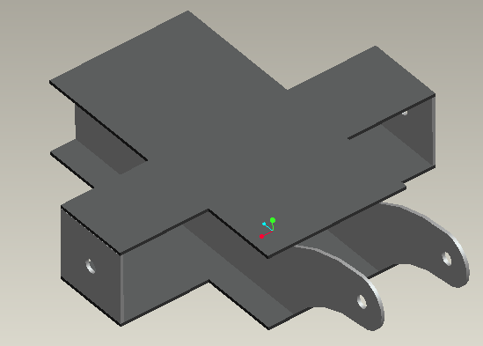
Figure 4

The hopper, shown with collecting tubes in figure 5, will be mounted between the left and right mechanism plates as shown. The top plate will be cut out to fit the collecting tubes and the tennis ball tube hopper. The collecting tubes will be cut from black PVC pipe. And will direct the ball into the hopper once the retrieval mechanism shoot s the ball in to the robot.

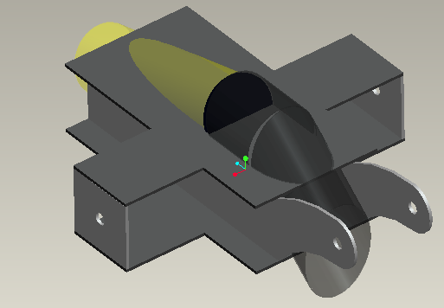
Figure 5

The electronics will fit on the outward face of the right mechanism plate and will be shielded from any external collisions by the upper and lower plates.

Actuation

Actuation for this robot will include a tank drive motor train and a spinning wheel. To move the robot, two motors will be mounted axially identical on either side of the robot on the motor mount plates, figure 3 and figure 4, creating a tank style drive-train. A tank drive set up will allow the robot to move 360 degrees and perform spins. Ball castors or omni-directional wheels will be installed on the front and rear of the robot to keep it stable while in motion. To greedily suck up balls into its hopper, the robot will use a high rpm motor mounted to a soft wheel from a Tamiya brand remote controlled car. The wheel will be mounted 2.25 inches above the ball. The spinning wheel will then grab the very top of the ball. The ball will then travel through the robot and into the hopper. The ball grabbing mechanism is shown in figure 6. I will probably implement TPIC0108 motor drivers on my robot. As the lab supplies 2 of them for student use.
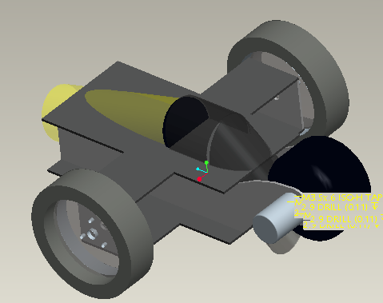
Figure 6

Sensors

Two sonar sensors, 3 bump sensors, and one CMU camera will outfit the sensor array on this robot. Fully functional, this robot will avoid obstacles using two frontally mounted sonar or IR sensors. A sonar sensor is more accurate and expensive but seems to be the better choice for outdoor use due to the IR sensor’s inability to deal with unstable environments. The sonar sensor can also be crossed with little fear of interference issues. If the robot comes in contact with an object the bump sensors mounted every 90 degrees surrounding the robot, the robot will change directions. Tennis balls will be detected using either a CMU or AVR camera by tracking the fluorescent yellow-green color of the ball. A CMU camera seems like the most sensible choice due to its ease of use and the knowledge base here at UF is larger than for an AVR camera.

Bump

The bump switch mechanism on the robot will consist of a micro switch with an extended trigger mounted on the perimeter to aid in obstacle avoidance.
The bump sensor will cause the robot to cut power to the motors and change direction in a random fashion. The goal to implement these sensors will be to mount them and to program a stop command to the algorithm controlling the motors. The sensors can be bought from
Mouser Electronics, Inc.
1810 Gillespie Way
Suite 101
El Cajon, CA 92020
(800) 346-6873
and are manufactured by Omron Electronics Part#SS-5GL2. The sensor is not applied to the robot as of this writing. Six total sensors will be mounted to allow the robot to navigate in its environment by touch. Normally a micro-switch is wired in parallel to the power supply and some sort of tool or device that requires a safety switch. When the switch is activated, the power to the device is cut off to stop the device the switch is wired to. When a switch is activated, it enables a pin on Port A on the microprocessor to be written high. The Pin is written high and this causes the motors to stop and then move in a random direction. No data base is needed on this sensor. It does not return values, so it is simply a switch to be turned on or off.

Sonar

My sonar sensors consist of sonic devices that will allow the robot to navigate beyond the touch of the bump sensors by measuring the robots distance away from an object in its path. A sonar sensor bounces sound pulses from an emitter and waits a short amount of time to receive the same pulse. The sonar sensor has three objectives to be met upon completion. The first is to wire them to the microcontroller and mount them. The second is to activate the sonar’s ability to pulse through software. The third objective will be to integrate these sensors in to the main program for obstacle avoidance through external and internal interrupts. These sensors can be bought from:
Acroname Robotics
4822 Sterling Dr.
Boulder, CO 80301-2350
USA
Part # R271-SRF05
720.564.0373
Devantech SRF05

Two Sensors are mounted on the front of the robot on either side at a 45 degree inward angle and set to pulse at two different times. This array arrangement should provide the robot with the maximum amount of “vision” with a minimum amount of sensors. This sensor works by sending out a high pitched pulse of sound activated from the trigger input pin, which is activated by a falling edge signal from the microcontroller. The pulse bounces off an object in its path and travels back to the sensor. After waiting 10 micro seconds, the sonar receives the same pulse and sends a signal back to the microcontroller through the Echo output pin. The microcontroller then calculates the amount of time has passed between the sonar’s sending and receiving signals and outputs a distance to the LCD or a command to the motors. The sensor software algorithm uses ports D and A on the microcontroller, one of the microcontroller’s 16 bit timers, TCNT1, an interrupt that counts the number of timer overflows, and an External interrupt activated upon the sonar’s second pulse falling edge signal and uses the microcontrollers LCD on Port B to blink when ever an interrupt is fired. This algorithm still does not produce numbers that are consistently between the reasonable range of 0 to 255. Further debugging is needed before usable values can be obtained. Data values obtained as of this writing vary from 16 to 1600 nonlinearly, and seem to increase as an object gets closer. The sonar’s current values seem to contradict to normally operating sonar’s values.

CMU cam

The CMU 01 Robot Vision Cam will be my special sensor used to find tennis balls using vision processing. This device is designed to return high level vision capabilities to microprocessor boards that normally would not have enough processing power to execute such abilities. Four phases of implementation must take place to use the cameras capabilities. The first is to mount the camera to the robot and interface with the computer. Second task is to test the cameras abilities. The fourth is to program the camera through a microcontroller board to track tennis balls using preprogrammed serial commands. This camera can be bought at;
Images SI Inc.
109 Woods of Arden Road
Staten Island NY 10312
Phone: (718) 966-3694
Part # CMU 01
How sensor is applied
Theory of operation: For the camera to operate a microcontroller must send serial commands to the CMU camera, and the preprogrammed firmware on the camera will then use the Track Color command and Middle Mass mode to find the target ball, a day-glow green tennis ball, track it, while sending commands to the microcontroller. The microcontroller will then send commands to the motors to drive the robot towards its intensely colored target. There is no software algorithm written by this robots creator as of this writing, for CMU cameras firmware code contact any of its creators:
Anthony Rowe, Charles Rosenberg, or Illah Nourbakhsh, Electrical and Computer Engineering Computer Science Department Robotics Institute,
Carnegie Mellon University.

Values were taken from the CMU camera in four separate rooms within the New Engineering Building on the University of Florida’s campus to test to see what values could be obtained from different fluorescent lighting sources within the same building. The camera was mounted on the robot, 6.5 inches above the ground and angled at 45 degrees from the horizontal. The subject tennis ball was always 9 inches away from the camera lenses. The software that came with the camera did not interface correctly with the camera so I was forced to use software for a CMU 2 camera. The program could not average the color of an object so I drew a circle on the ball and took 5 values from within my marked circle and took the average. The values and cases are presented in Tables 1 through 5. The corresponding graph is Figure 1. Values were also taken once during the day and once at night to witness the effect of outside ambient light had on the RGB values. Both readings were taken in the very center of the NEB rotunda floor as shown in figure 2. The day values were taken on a cloudy day and the night values were taken to obtain a case with only fluorescent lighting.

Table 1

Rotunda Mid-Afternoon (cloudy day)
Point | Red | Green | Blue
1 | 130 | 214 | 16
2 | 133 | 175 | 29
3 | 153 | 229 | 43
4 | 124 | 176 | 35
5 | 144 | 180 | 34
average | 136.8 | 194.8 | 31.4

Table 2
Rotunda At Night (dim fluorescent light)
Point | Red | Green | Blue
1 | 127 | 192 | 16
2 | 120 | 188 | 23
3 | 131 | 163 | 15
4 | 120 | 160 | 31
5 | 125 | 173 | 22
average | 124.6 | 175.2 | 21.4

Table 3
Floor Near North Doors at Night (well lit)
Point | Red | Green | Blue
1 | 240 | 240 | 49
2 | 240 | 240 | 61
3 | 240 | 240 | 54
4 | 240 | 230 | 50
5 | 209 | 240 | 41
average | 233.8 | 238 | 51

Table 4
North West Hallway At Night (well lit)
Point | Red | Green | Blue
1 | 240 | 240 | 18
2 | 240 | 240 | 16
3 | 240 | 240 | 26
4 | 240 | 240 | 19
5 | 240 | 240 | 35
average | 240 | 240 | 22.8

Table 5
Vend Machine Hallway @ Night (best lit fluorescent)
Point | Red | Green | Blue
1 | 239 | 240 | 16
2 | 233 | 240 | 19
3 | 232 | 240 | 17
4 | 237 | 240 | 20
5 | 240 | 240 | 21
average | 236.2 | 240 | 18.6

Figure 7

Figure 8

Sample Sonar Code (full of bugs)

// this program will run the SRF05 sonar device using external interupts and code to

#include "LCD.h" // Note: header files not written by bit manufacturers
// but by users are defined by "" quotation marks.
#include <avr/io.h>
#include <avr/interrupt.h>
#include <util/delay.h>

//** Wiring notes **//
// Mavric Input, Pin 0, Port D = blue wire = Sonar Echo Output
// Mavric Output, Pin 1, POrt D = purple wire = Sonar Trigger input

//global variables
unsigned int MyStartVal; // declares variable used for initial timer value
int MyEndVal; // Defines variable used for final timer value
int long mycounter;
// when pulse returns to sonar array.
int TimeVal; // Declares TimeVal to hold sonar pulse's return time.
int main(void)
{
EIMSK = 0b00000001; // the output on the sonar sends an external interupt to the input pin on the mavric so the interupt defined on pin 0 on the mavric should be enabled throughth the interupt mask. the mask tells the board which interupt will be used, interupts correspond to a certain pin, output on the sonar is input on the microprocessor, write interupts accordingly
EICRA = 0b00000010; // This just defines that the interupt EICRA will fire on a falling edge.
TCCR1B |= 0b00000001;
sei(); // Enables interupts "interupt service routine" Shut of interupt is CLI

int counter;

//Initialization; not to be within your while loop, just a waste of processing power
DDRB |= 0b00000001; // Defines port B pin 0 to output for mavric LED
DDRD = 0b00000010; // defines pin 0 of portD as input, pin 1 is an output not in while loop dut to intitalization, dont need to loop initialization
PORTD = 0b00000000; // sets pin 1 of portD to low (0Volts) to clear bit use bitwise &
LCD_Init(20,2);

while(1)
{

PORTD = 0b00000010; // sets pin 1 of portD to high (+5Volts), (Pin 1 = sonar input/ mavric output),intiate sonic pulse, | isolates the bit change to pin1

_delay_us (10); // wait for 10 microseconds

PORTD = 0b00000000; // set pin 1 of port D to low to complete squarewave
MyStartVal = TCNT1; // Variable used to read the 16 bit microprocessor timer 1
// named TCNT1.

LCD_Write_Command(0x01); //Clear Display
LCD_Goto_Pos(1,0);
LCD_16bit_Out(TimeVal); // if you are not sure lcd command is working or not write a # to it to test it.
LCD_Goto_Pos(1,8);
LCD_16bit_Out(TCNT1);
mycounter = 0;

//loop to delay main
counter = 1;
while (counter <= 1000)
{
counter++;
_delay_ms (1);
}

}
}

ISR(INT0_vect) // Put Atmel defined interupt vector in the ()'s and Note:
{

PORTB = PORTB ^ 0b00000001; // fires lcd on mavric microprocessor board.

MyEndVal = TCNT1; // Variable used to read the 16 bit microprocessor timer 1
TimeVal = (MyEndVal - MyStartVal + 65535 * mycounter)/10; // dividing it by 100 prescales the value so that it can fit
// resets mycounter so that # of overflows can be acuurately measured.
_delay_ms (1); // named TCNT1 after interupt has fired.
PORTB = 0b00000000;

}
ISR(TIMER1_OVF_vect) //INterupts are functions that run in the background and are fired when their programmed event has occoured, this interupt fires when the time overflows.
{

PORTB = PORTB ^ 0b00000001; // fires lcd on mavric microprocessor board by setting pin 0 of PortD to high
mycounter++;
_delay_ms (1); //increment counter here
PORTB = 0b00000000;
}

Behaviors

Seeking out three tennis balls and collecting them all while avoiding obstacles will compose of the robots main behaviors.

Initially the proposed robot will have four functions: it will avoid obstacles, seek tennis balls, pick up tennis balls, and deposit the collected tennis balls in to their original packaging. It should perform these actions quickly as players consume a lot of balls during game play and practice.

The first function to be discussed will be the robot’s ability to avoid objects. Traveling forward, the robot will stop and change direction if an obstacle appears within 3 feet in front of the robot. The designer will make the robot stay outside of the tennis courts play area and only collect balls at the perimeter if time allows.

Traveling along the tennis court and avoiding obstacles, the robot will seek stray tennis balls using its second function: the ability to seek tennis balls within 5 feet in front of it.

Once a ball is found, the robot will perform it’s third function: picking up tennis balls. The robot will roll toward the target and position itself so that it’s retrieval mechanism will suck the ball within the robot. The robot will realize that it’s target is required and seek the next ball until it finds and retrieves 3 balls.

Tennis balls normally come in a tubular plastic pack of three. This robot will have a compartment that will use the original tennis ball packaging as a hopper. Once the pack is full it should be easily removed from the robot.

The robot will perform all of these functions quickly and autonomously. The average speed of the robot will be about 3 miles per hour. The robot will collect balls in an instantaneous fashion once the balls are located.

Structure & Design

Robots should be built in both mechanically and electronically simple way. The structure and design of this robot will be kept simple by using an easily manufactured frame, a tank drive motor train, a rotating wheel to collect tennis balls, front mounted obstacle avoidance sensors, obstacle collision sensors in 4 directions and a front mounted camera for ball detection.

Structurally, this robot will use four main pieces of eighth inch thick material for the upper and lower horizontally mounted frame pieces, and quarter inch thick material for the left and right vertically mounted pieces. The left and right pieces will support the ball collecting wheel the robot will use to collect the target balls. The tennis ball tube described above will fit between the left and right frame components.
Proposed components

Two motors will be mounted axially identical on either side of the robot creating a tank style drive-train. When a single motor is actuated or given a proportionally greater amount of power with respect to the other motor, the robot will change direction. A tank drive set up will also allow the robot to move 360 degrees and perform spins. Ball castors or omni-directional wheels will be installed on the front and rear of the robot to keep it stable while in motion.
Proposed components
Fully functional, this robot will avoid obstacles using two frontally mounted sonar or IR sensors. A sonar sensor is more accurate and expensive but seems to be the better choice for outdoor use due to the IR sensor’s inability to deal with unstable environments. The sonar sensor can also be crossed with little fear of interference issues. If the robot comes in contact with an object the bump sensors mounted every 90 degrees surrounding the robot, the robot will change directions.
Proposed components

Now for the paragraph you have probably skipped to. Tennis balls will be detected using either a CMU or AVR camera by tracking the fluorescent yellow-green color of the ball. Upon detection, the robot will attack the ball, and greedily suck it up into its hopper using a high rpm motor mounted to a soft wheel from a Tamiya brand remote controlled car. The wheel will be mounted 2.25 inches above the ball. The spinning wheel will then grab the very top of the ball. The ball will then travel through the robot and into the hopper. The hopper will utilize the packaging the tennis balls come in and be removable for ease of use.
Proposed components

The proposal should not be more than three to five typewritten pages, excluding figures
And tables. This proposal should specify the purpose, function, structure & design of your robot
and predict your robot’s capabilities upon completion of your project. You will give a 3-5 minute
talk on your proposal.

Guidelines for Written Reports
Written reports in this class will be evaluated on the basis of the following guidelines.
Layout and Design
Title page
Single column and single line spacing
Consistent headings, no more than three levels
Aesthetically pleasing, 12 point font (Times or Times Roman if possible), left-and-right justified
Adequate margins and spacing
Numbered pages, figures, equations, and tables
Text references to all figures and tables in the body
Figures and tables near text reference
Syntax
Correct Spelling
Correct Grammar
Correct punctuation
Effective Sentence Structure (no run-on sentences)
Effective Paragraph Structure (single concept per paragraph, good lead-in sentences, continuity)
Effective Proofreading ( spelling and syntax error free, technical and logical correctness; read aloud for
flow, understandability, and idea sequencing)
Style
Rational Organization
Clear flow and description of ideas
Effective use of tables, graphs, and figures.
Clear and concrete wording (no vague references: given all of the above the robot... )
Sparing use of pronouns (often hard to determine antecedent)
Use of active voice (passive voice is boring and lends unmerited authority )
Use of descriptive adjectives and prepositional phrases ( …a blue, metal widget with three holes arranged
in an equilateral triangle… says more than …a widget… )
Avoid using very and forms of the verb to be.
STRUCTURE OF PAPER
OPENING
1. Title Page
No page number, but this is page one.
Paper title (e.g., Proposal), your name, robot name, course number and name, instructor name(s), TA names
2. Table of Contents
3. Abstract
Limit of 250 words
No equations, tables, figures, graphs or references
4. Executive Summary (Final Report only)
A one page description of the entire project that includes all salient characteristics. Must be different from
the abstract.
No equations, tables, figures, graphs or references
University of Florida 14-May-07 A. Antonio Arroyo, PhD
Department of ECE EEL 5666: Intelligent Machines Design Laboratory Eric M. Schwartz, PhD
2
5. Introduction
Background information that leads into the problem
References to the literature
Scope and objectives of project
A walk-through the paper
MAIN BODY
The following description applies to autonomous mobile agent written reports. Other types of reports will require
other module types, but the basic principles stated apply, in general, to any kind of technical report involving
circuits, computer software, sensors, and mechanical structures.
6. Integrated System
Complete organizational description of the system
Block diagrams, flow charts, theory of operation
High level functional and data descriptions
No detailed circuit or algorithm descriptions
Indicate how the given structure meets the specifications and objectives in the Introduction
7. Mobile Platform
Scope, specifications, objectives
Relate platform structure to objectives
Hard, interesting or embarrassing lessons learned
8. Actuation
Scope, specifications, objectives
Types of actuation, purpose, reasoning behind choices
Application (heads, wheels, legs, squirt gun, etc.)
Scope, theory, objectives of motor control
Characteristics of the motors you used: torque-speed
Circuit drawings and theory of operation
Actuation algorithms (code in appendix)
Hard, interesting or embarrassing lessons learned
9. Sensors
Scope, specifications, objectives
For each sensor:
Scope, theory, objectives, references (vendor address, part number, phone)
How you applied the sensor in your project
Circuit drawings and theory of operation
Sensor software algorithm (code in appendix)
Sensor data base
Graphs of performance
Sensor integration: Scope, theory, objectives (code in appendix)
Hard, interesting or embarrassing lessons learned
10. Behaviors
Scope, specifications, objectives
Behavior algorithms (code in appendix)
Hard, interesting or embarrassing lessons learned
11. Experimental Layout and Results
Scope, specifications, objectives of experiments
Data presentation (graphs, tables, figures) and interpretation
University of Florida 14-May-07 A. Antonio Arroyo, PhD
Department of ECE EEL 5666: Intelligent Machines Design Laboratory Eric M. Schwartz, PhD
3
CLOSING
12. Conclusion
Realistic summary of work accomplished
Limitations of your work
Cite areas that exceeded expectations and areas that can be improved
Technical caveats for students to follow
Future work:
What would you do if you started the project over?
What enhancements would you make?
What specifications would you change?
13. Documentation
Complete References
Correct IEEE form
14. Appendices
Program Code
Additional Circuit diagrams
Other supplementary material
WRITING ORDER
Write the Introduction, Abstract, and Executive Summary last. Write a rough draft of the main body of the paper
as the work is performed. Later modification and editing is easier than writing from scratch. Write Appendices any
time. I write mine at the beginning because its the easiest to do and provides immediate psychological satisfaction of
progress. In general, organize your report and write it in the order that is easiest for you (!) and then put the pieces
together with glue words.

Purpose
Pick up balls fast

Function
“For the initial scope”
Avoid obstacles
Change directions
Self guided
Will not enter playing area
Seek balls
Pick up balls
Repackage balls in original 3 pack container
How it will do it
Quickly
Speed of robot
Speed of ball collecting
Autonomously

Structure & design

Platform
Frame
Easily accessible electronics
Aluminum/wood
Tank drive
Two wheels and a ball castor
Motors
Functions
Obstacle avoidance
Sensors
Sonar
Mounting
Bump stop
Mounting and position
Ball detection
Initial idea
Webcam

Backup plan
CMU camera
Ball collecting
Spinning wheel mounted just below top of tennis ball
Description: soft tire, RC rim, machine hub?
Front mounted arm
Wood/aluminum

Ball containment
Ball delivery path from collecting arm to container
Ball containment possibilities

Start of Report 2

Platform

9. Sensors
Scope, specifications, objectives
For each sensor:
Scope, theory, objectives, references (vendor address, part number, phone)
How you applied the sensor in your project
Circuit drawings and theory of operation
Sensor software algorithm (code in appendix)
Sensor data base

Sensors

