Tanmay Rajpathak

Robot Name: T-Robot

IMDL Final Proposal

Instructor: Dr. Arroyo, Dr. Schwartz

Walking Robot

# Proposal: To make a two legged walking robot, which can avoid obstacles in its path

Humanoid Robot is a robot that imitates one or more human actions. The aim behind its creation is that one day it will be able to understand human intelligence and work with and like humans. Humanoid robots could have structure same as a human body or some part of it.

[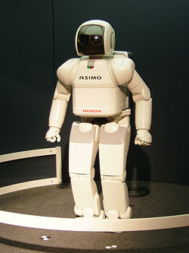](http://en.wikipedia.org/wiki/Image:HONDA_ASIMO.jpg)

Honda’s ASIMO an example of a humanoid robot

# Concept: How humans walk?

When walking with legs, location of centre of gravity of the human body is very important. In case of two legged walking, if left leg is first put forward, right hand also moves naturally with it. This serves two purposes: Move position of CG forward and maintain CG at centre.

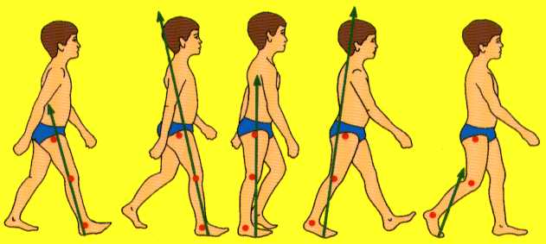

This concept will be used for this project. The robot will consist of two legs joined by a channel. A heavy mass will be placed over it and will be able to slide along the channel by motor power. Another pair of motors will be used to rotate legs and channel, so as to move forward. The robot should be able to stand on one leg. The heavy mass will be used to shift robot balance from one leg to the other leg.

# Steps:

1. Shift weight to left leg
2. Rotate channel anticlockwise by 450
3. Shift weight to right leg
4. Rotate channel by 900, clockwise and anticlockwise alternatively while shifting the weight
5. Change the angle of rotation to turn

The robot will also be able to do obstacle avoidance, which makes it an intelligent robot. A sonar sensor will be used to identify any object in proximity of the robot. A sensor of higher beam angle is chosen, so that it can scan more space around the robot. Higher beam angle gives higher sensitivity.

Parts design and accurate manufacturing is very important for this robot. It is also important to choose motors of sufficient capacity. First of all, I will create a model in Pro-E and start manufacturing the parts. After completing this robot, if time permits, I plan to add fire fighting mechanism. I also plan to give it a nice external appearance.