Formal Report

Huizhong Cheng

Instructors: Dr. A. Antonio Arroyo, Dr. Eric M. Schwartz

TAs: Andy Gray, Jake Easterling, Ralph F. Leyva

EEL 5666C Intelligence Machine Design Lab

**Table of Contents**

Abstract ..................................................................................................................2 Introduction..............................................................................................................2 Integrated System ....................................................................................................3 Actuation ................................................................................................................3 Sensors .....................................................................................................................4

Appendix A ...............................................................................................................4

**Abstract**

I will create a robot dancing to real-time music. First record music by a microphone connected to Raspberry Pi, which also carries out digital signal processing to implement beat detection. Send music information to Arduino, control the dancing robot with four motors. The robot could move around and do obstacle avoiding.

**Introduction**

This dancing robot is a toy designed for child. The Robot is not a human shape one, Fig.1 is the rough structure of the whole system. It will have a doll appearance.

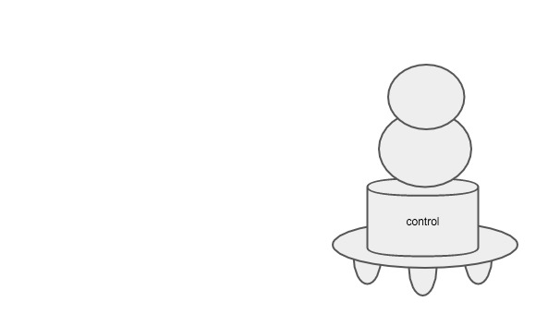

Figure 1

Here is the goal for the project:

* The Basic function: detect the base rhythm, which is usually fixed. And design several sets of movements to assign randomly. Make sure the beating and movements are synchronous.
* The Advanced function: Besides the fixed basic rhythm, make some innovation while detect some special characteristic, e.g. sudden hard beat, booming drums and etc.

**Integrated System**

Fig.2 shows the system structure. Microphone is connected to Raspberry Pi, 6 motors are drove by Arduino.

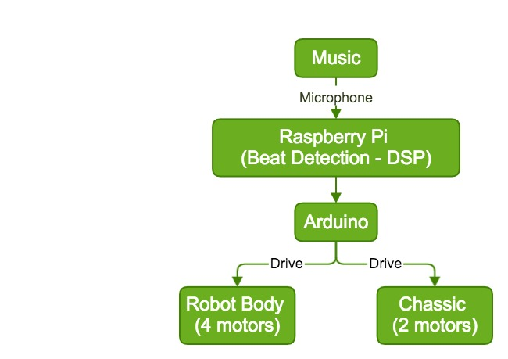

Figure 2

In general, the simplest beat-detection algorithms work by locating peaks in bass energy, which is easy to detect and will apply to music with strong rhythm. More sophisticated statistical or waveform methods are need for complex situation. Fig.3 shows the flow chart of DSP process.

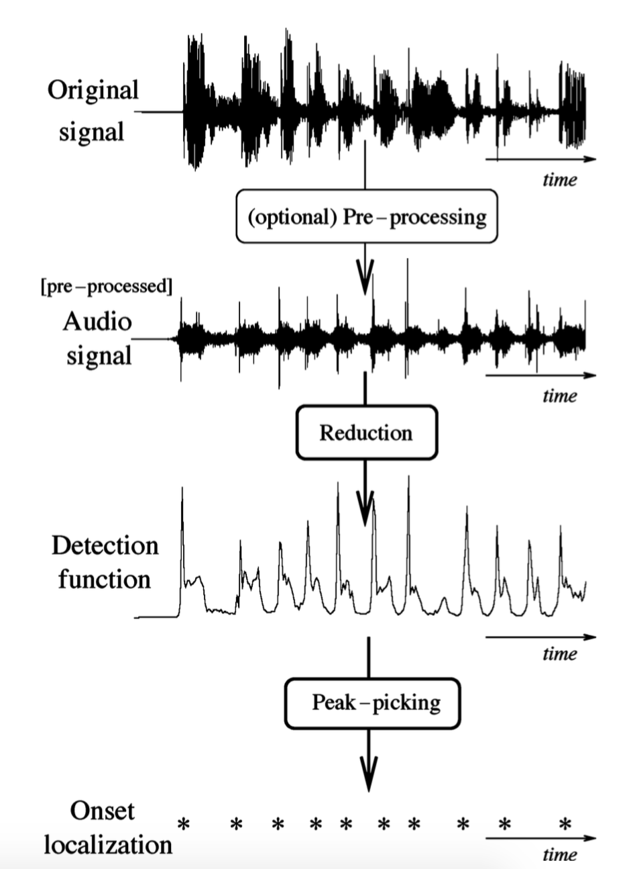

Figure 3

For Digital Signal Processing(DSP), the first step is to do a Fast Fourier Transform(FFT). We know that the bass part of a music make people feel beating. So after FFT, I will rearrange the weight of each different frequency. I will accentuate low frequency and attenuate high frequency. Then the next step, transfer amplitude to energy wave. After this step, the peak will be really obvious. Then I will carry out peak detection. I will not use fixed threshold, because music is soft sometimes and strong sometimes. Here I will use an adaptive threshold which based on the average energy during a past period of time. In this way, the accuracy will be improved.

**Actuation**

In order to make the dancing robot act more vivid. Four servos are needed to control four degree of movement. They are sideway-tilt (including front-back and right-left), vertical-shrink and horizontal-rotate. The combination of those four would generate a lot of poses and dancing modes.

**Sensors**

For audio signal, I use a microphone to deal with recording. For Obstacle avoiding, I use the regular HC-RS04 ultrasonic ranging module to detect obstacles.

**Appendix A Hardware**

* Master Board: Raspberry pi 2 model B
* Slave Board: Arduino UNO-R3
* Ultrasonic Ranging Module: HC-RS04
* Microphone: Electret Microphone Breakout Board
* Servo for robot body:

ROB-09065 Servo - Generic (Sub-Micro Size)

ROB-11887 Servo - Hitec HS-85MG (Micro Size)

ROB-10189 Servo - Generic Full Rotation (Standard Size)

ROB-11965 Servo - Generic High Torque (Standard Size)

* Motors for bottom platform
* Arduino Motor Shield