Not So Evil Bug
Six Legged Walker
Intelligent Machines Design Lab

Final Report

Spring 1998

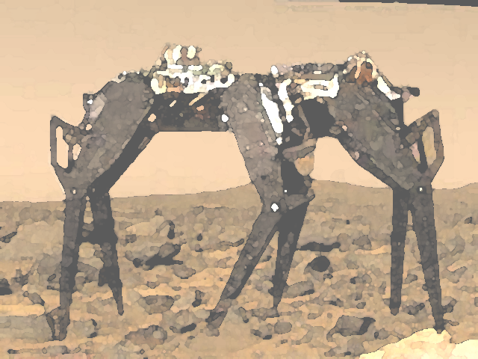

Andor Almasi
April 25, 1998
Prof. Antonio Arroyo

Table of Contents
ABSTRACT 3
EXECUTIVE SUMMARY 3
INTRODUCTION 4
HARDWARE DESIGN 5
Platform design 5
Leg design 5
Body design 7
Electronic hardware 8
SOFTWARE DESIGN 9
Overview 9
Sensor Reading 10
Control 12
Walking 12
PWM generation 13
CONCLUSION 14
Accomplishments 14
Failures 14
Future work 14
Thanks 15
APPENDIX A – Mobile Platform Plans 16
APPENDIX B – Software source code 21
Header 21
Sensor Acquisition 22
Controller 26
Movement generator 33
SCI system 36

ABSTRACT

The Not So Evil Bug is a six-legged mobile platform designed to walk and climb/descend high obstacles. The bug is controlled by two HC11s, one for servo control, another for everything else. The current behaviors consist of object-avoidance.

EXECUTIVE SUMMARY

This robot is based on a six-legged platform designed to allow the ascent/descent of tall objects. I designed the platform in AutoCAD and cut it out of plywood on the T-Tech machine. I modeled the legs after the grasshopper’s hind legs. They use two servos each, and have two degrees of freedom.
The robot is controlled by two Motorola 68HC11 microprocessors. One of them is housed in a MB2325 board. This processor runs in single-chip mode, and generates the PWM signals controlling the servos. The other HC11 is on the EVBU board, running in expanded mode. This processor runs all the other code, including sensor reading, object avoidance, movement coordination.
I successfully designed and built the platform, and wrote the software that would enable my robot to do everything advertised. Unfortunately, the platform turned out to be way to heavy, and the robot could not support itself while walking. This is a major failure, since the planned behaviors of the robot rely on the specific platform I designed.

INTRODUCTION

Most mobile platforms used for robots employ wheels as a mode of propulsion. Although wheels are a very efficient mode of propulsion, they do have their drawbacks. One of these is their inability to traverse extremely rough terrain. Legged platforms on the other hand do not rely on a constant contact point with the surface, and are thus the better platform to use over rough terrain. I chose to push this idea a bit further and attempted to design a robot that could climb up/down an obstacle about one half the robot’s standing height. In order to do this, the robot needed a way to detect an object’s height/depth and enter a crawl mode in which it would execute a specialized two-legged walk, instead of the normal three-legged walk. The planned behaviors for the robot are object avoidance and climbing.

HARDWARE DESIGN

The robot hardware includes the body, legs, servos, battery, sensors and microprocessor boards.

Platform design

The robot is based on a six-legged mobile platform. My inspiration for this platform was Robobug, designed/built/programmed by David Novick and Jennifer Laine. I first saw Robobug at a demo in 4744, and thought that it was the coolest thing since (apple pie?) The ideas for my own robot started to develop in the coming weeks, during some oh-so-dull 4712 classes. By the start of this semester, I had a good idea of what I wanted my platform to look like. I did the actual design in AutoCAD version 14. The entire platform is built from wood, cut on the T-tech machine in the Intelligent Machines Design Laboratory lab. The design sheets for the cutouts can be found in appendix A.

Leg design

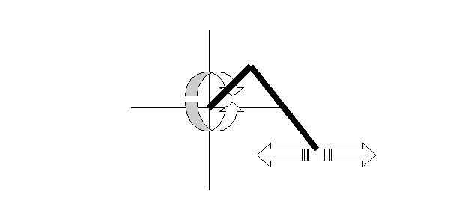
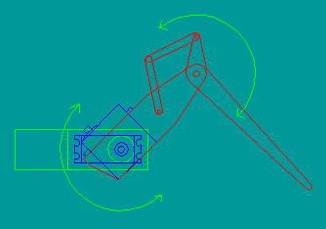
The most important consideration in designing the legs was to make them long enough to allow the robot to climb over fairly high objects. The robot has six identical legs, two facing forward and four facing toward the rear. The legs have two degrees of freedom, one rotational and one lateral (figure 1). The legs move in a plane parallel to the length of the body. The idea for the general shape and function is most closely related to the rear leg of a grasshopper (figure 2). The upper leg (thigh) holds the servo actuating the lower leg. It is attached to the body via a servo horn on the inner surface of the thigh. The lower leg is actuated by a linkage system. This linkage is designed to magnify the servo’s range of motion. The servo connects to the linkage by a length of 1/16th inch diameter piano wire. The leg pieces are designed to easily fit into each other during assembly, and to provide good structural support once built. A tubular joint made from 1/8th inch thick aluminum connects the upper and lower legs. The large diameter of the tubing ensures that the joint will be strong and smooth rolling. I originally considered using ball bearings in the joint, but after testing one of the above joints, I decided the added weight and complexity were not worth the minute gain in smoothness. I had to redesign the legs after the first cutout, because I made the notches that connect the pieces incorrectly. I also made the attachment points for the linkages at the wrong place. The first version of the legs served as a prototype for the redesign, and helped point out some of the pitfalls that I would likely encounter in latter designs. One of these was that the notches that connected the pieces together only fit if I used a new drill bit in the T-tech. Most of the time the bit wear can be neglected, but in this case the effects of bit wear are actually doubled. This is because if the bit is thinner than expected, the notch comes out thicker and the hole it fits into comes out thinner. This leads to a warm relationship with the Dremel tool, which I often used to correct the above problem. A late addition to the legs was the feet (figure 3). They prevent the legs from slipping and serve as touch sensors. Some very tacky rubber (from a lint-removing roller) is glued on the bottom of the feet to ensure a good contact with the ground. The foot surfaces are currently too small and make the feet unstable.
Figure 1 2DOF of the legs
Figure 2 Leg design

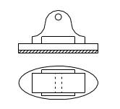
Body design
Figure 3 Foot design

The purpose of the body is to provide an attachment point for the legs and to hold all the other components (microprocessor boards, batteries). The body design is centered around the servos and the battery pack. I built a cardboard prototype of the body to avoid any clearance problems in the final design. Extraneous pieces of wood in the body were cut out to save weight. I added notch attachment points throughout the body to allow for further expansion. The EVBU board rests in the middle of the body, attached by four metal posts. The servo control board rests on the rear of the body, attached by four screws and rubber feet.
Both the legs and the body are painted with flat black spray-paint. This serves as a waterproof barrier and a cosmetic enhancement.

Electronic hardware

The robot uses two microprocessor boards. One is the EVBU board, the other is an MB2325 board. The EVBU board has the 32k memory expansion, two output ports, one input port and a 40kHz signal generator. The EVBU is powered from the MB2325, which has a 5V voltage regulator on it. The MB2325 is directly attached to a 7.2 volt battery pack (6 subC NiCad cells). Leg movement is provided by two servos per leg (one inside the body, one inside thigh). I am using Hitec SuperSport servos purchased from Mayor Hobby (www.majorhobby.com). The servo specifications are listed in table 1. The servos are powered by a 6 volt voltage regulator attached to a heat sink on the bottom of the robot. Two IR emitter-receiver pairs are attached to the front of the robot, as well as sensor switches actuated by whiskers. There are a total of three whiskers, two in a cross configuration pointing forward and one pointing down. The whiskers are made of thin piano wire that bends some on contact. This ensures that nothing breaks when the robot walks into a wall. As an added benefit, the whisker switches activate over a wide range of approach angles. The switch sensors (whiskers and foot) are broken up into groups of three, each driving a voltage-divider network. This network reduces nine digital inputs to three analog inputs.
Torque49 oz/in @ 6VSpeed60deg in .17 sec @ 6VWeight1.6 ozSize1.6 x 0.8 x 1.4”
Table 1 Servo specifications

SOFTWARE DESIGN

Overview

All of the software running on the robot is written in assembly. I chose assembly over IC or ICC because it gives me precise timing control crucial in coordinating leg movements. The software can be broken up into the hierarchical structure shown in figure 4. The software is broken into three parts. The sensor reading process includes reading all of the sensor inputs and converting them to a more usable form. The control process coordinates movements and behaviors based on sensor outputs. The walk generator process generates the appropriate leg movement sequences for the action requested by the control process. The PWM generator uses those sequences to directly control the servos. All but the PWM generator code is loaded into the SRAM on the EVBU board. The PWM code is running on the MB2325 board, in EPROM. See Appendix B for a complete software listing.
IR sensor
Whiskers
Foot sensors
Control1
Control2
Walk
Generator
PWM
Generator
Figure 4 Software Structure

Sensor Reading

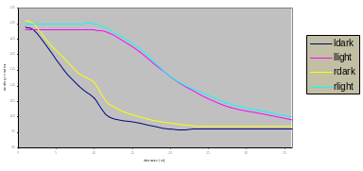
This process has the job of reading any and all sensor data and preparing it for use by the control process. For the IR sensors it uses a lookup table to distinguish among five different IR level readings. The final output is in the form of a single 8-bit variable. Four bits are dedicated to each IR sensor. The possible IR readings and their meanings are listed in table 2. This method allows calibration of the IR sensors completely transparently to processes using these readings. The only things that need to be changed in case the sensors need recalibrating are the lookup table values within this procedure. In fact, the IR sensors could be replaced with a completely different type of sensor, without any effect on other methods. T he IR readings are often unreliable, since surface color greatly affects the reflectance of IR. Figure 5 shows the difference in reaction between a white and a dark surface.
0000Bad reading0001Low reading, nothing ahead0010High reading, possible obstruction0100Saturated1000
Table 2 IR levels and their meanings
Figure 5 IR readings on different surfaces
The whisker sensors compensate for any errors the IR sensors make. The output format for all the switch sensors is binary. In theory, the analog readings coming from the switch voltage divider network should wiggle one specific bit of the digitized reading for a specific switch. Unfortunately, due to mismatch in resistances this does not work out quite well. Therefore, a lookup table is used to simulate the desired effect. The added benefit of this method is transparency. Once again, any of the foot or whisker sensors could be changed to a different type, without having to change the output.
The foot sensors give feedback about leg position for a dynamically generated walking algorithm. They work the same way as the whiskers above.
My special sensor was going to be an IR range finder. These are used in autofocus cameras to measure the distance between the camera and the subject. They work by emitting a highly localized pulsed IR spot (about six inches diameter at five feet) and measuring the offset of the spot on a specialized IR receiver. This receiver’s current output varies according to where on its surface the IR reading is the highest. Lenses focus both the outgoing and incoming IR beams. A decoder chip takes as input the IR emitter frequency and the IR receiver output and converts it to a more usable form. Unfortunately, I have little idea what that form is. I obtained three cameras that had this sensor in them, but could not get any of the manufacturers (Kodak, Canon, and Pentax) to release any useful information. I also tried contacting the decoder manufacturers (Sharp and Hamamatsu Corp) for a datasheet without success. I managed to figure out how the Pentax sensor works. I found that pin 13 on the Sharp IR3S43A decoder emitted a PWM signal whose duty cycle was relative to the distance to the object. The signal varied linearly with distance, duty cycle decreasing until object distance of about 1 foot, increasing for closer and further distances. I was going to use this sensor as an edge-of-the-world detector that would prevent my robot from walking off a table, and allow it to judge if it can walk off a platform or not. Unfortunately while trying to separate the sensor from the rest of the robot I managed to fry some mystery component and could never get the sensor to work again. I did not have any success finding an output on the other two sensors.

Control

The control method evaluates the sensor readings and makes a decision on the next action to send to the legs. The decision process is currently in two phases. In the first phase, IR sensor outputs are evaluated and a recommendation is made to the second phase. The second phase checks the more accurate sensors (whiskers, and depth sensor, if it worked) and makes sure that they do not conflict with the phase 1 recommendation. If so, the recommendation is promoted to an action and is passed on to the walk generator. In case of a conflict, phase 2 reevaluates the possible actions based on its sensor inputs and generates an action. The actions generated by the two control phases emerge into a basic object-avoidance behavior.

Walking

The walk generator takes the action and turns it into a sequence of servo movements. There are two possible walking methods. The first is to use a hardcoded sequence of movements for each action. The second is to dynamically generate movement sequences based on the action and foot switch inputs. The latter allows would allow to self-compensate for uneven terrain, but is much more difficult to implement. I chose to implement the first method.
Actions are commands like walk fwd, turn, climb, etc. An action is made up of sequences. The time delay between two sequences determines the speed of the action. A sequence is 16 servo position values that are fed into the servo controller. Each sequence is sent to the PWM generator five times. A complete action is treated much like a character string. The sequences from the start of the action are sent to the PWM generator until and ENDACT (end-of-action, $FF) character is encountered. Actions are kept as short as possible. This means that a single execution of the walk action, for example, will move the robot forward one step.
Walking is achieved by lifting up three opposing feet, moving them forward and doing the same for the other three feet. Climbing is achieved by moving opposing pairs of feet onto the object to be climbed. I have not found a good turning algorithm for the robot yet. The most likely possible turning method will move one side of the robot less than the other, much like on a tank.

PWM generation

The MB2325 board is running the servo control code. The input format is $BB$Cx$yy, where x is the servo number, yy is the servo position in the range of 00 to A4. The input is passed through the SCI port. The output is a constant PWM signal on ports B and C. The servo control code was developed and written by Jenny Laine.

CONCLUSION

Accomplishments

I have built and designed the platform, installed the basic object-avoidance sensors, written the object-avoidance code and interfaced to the servo controller.

Failures

The mobile platform turned out to be too heavy. As of now, the robot can stand on all six feet, but falls over as soon as three feet are lifted. This is a major design flaw, and has prevented me from developing all the planned movement actions into the robot. As much as I wish otherwise, I discovered that the laws of physics apply to my robot just as much as everyone else’s.
I was not able to get my special sensor working. This is a minor setback, considering that the robot does not walk.

Future work

The next step in the robot’s development will be to try a five-legged walk. This involves moving one leg at a time, until a full step is taken. Another alternative is to get some 80 oz/in servos. These would be strong enough to allow the robot to stand stable on three legs.
If neither one of these will work, I will be forced to redesign my platform completely.
I am also planning to integrate the sensor I developed for my senior project onto the robot platform. This will eliminate the need for my current special sensor.

Thanks

I wish to thank Jenny Laine for developing and letting me use the servo controller code I am running on the MB2325 board.

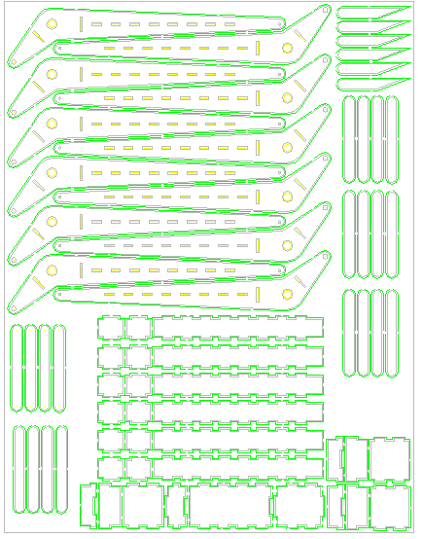
APPENDIX A – Mobile Platform Plans
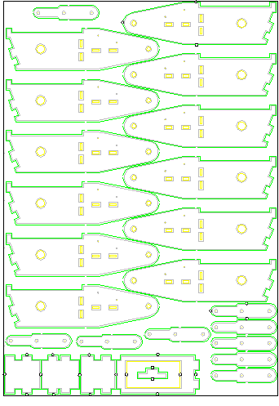
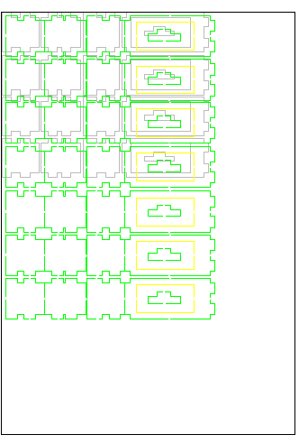
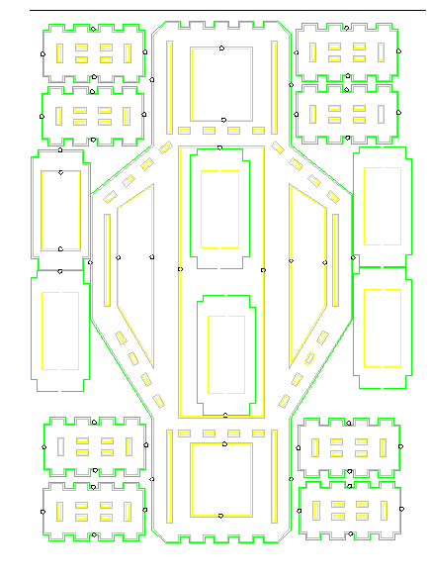
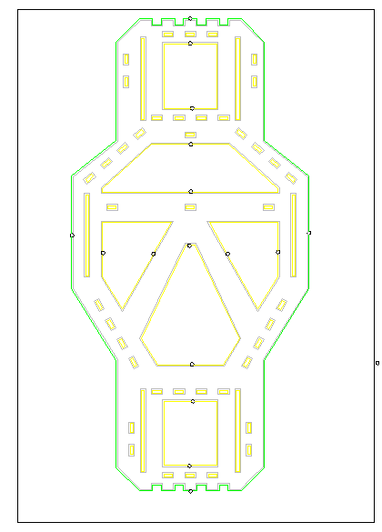

APPENDIX B – Software source code

Header

*< Assembly file header
* Includes all registers as 8 bit offsets
* Includes important addresses as 16 bit values
* Includes single bit masks
* Place at end of new assembly programs
*>

SRAM EQU $2000 ; start of external RAM on EVBU
CRAM EQU $0000 ; start of internal RAM
EPROM EQU $D000 ; start of eprom
EEPROM EQU $B600 ; start of eeprom

BIT7 EQU %10000000 ; single bit masks
BIT6 EQU %01000000
BIT5 EQU %00100000
BIT4 EQU %00010000
BIT3 EQU %00001000
BIT2 EQU %00000100
BIT1 EQU %00000010
BIT0 EQU %00000001
INV6 EQU %10111111 ; inverses
INV5 EQU %11011111
INV4 EQU %11101111
INV3 EQU %11110111
INV2 EQU %11111011
INV1 EQU %11111101
INV0 EQU %11111110

BASE EQU $1000 ; register base

ADCTL EQU $30 ; A/D Control/Status
ADR1 EQU $31 ; A/D Result
ADR2 EQU $32 ; A/D Result
ADR3 EQU $33 ; A/D Result
ADR4 EQU $34 ; A/D Result
BAUD EQU $2B ; Baud Rate Control Register
BPROT EQU $35 ; Block Protect
CFORC EQU $0B ; Timer Compare Force
CONFIG EQU $3F ; Security disable, COP, ROM Mapping, EEPROM Enables
COPRST EQU $3A ; Arm/Reset COP Timer Circuitry
DDRC EQU $07 ; Data Direction Control for Port C
DDRD EQU $09 ; Data Direction Control for Port C
EPROG EQU $36 ; EPROM Programming Control
HPRIO EQU $3C ; Highest Priority I-Bit Interrupt amd Misc
INIT EQU $3D ; RAM and Register Mapping
OC1D EQU $0D ; Output Compare 1 Data
OC1M EQU $0C ; Output Compare 1 Mask
OPTION EQU $39 ; System Configuration Options
PACNT EQU $27 ; Pulse Accumulator Control
PACTL EQU $26 ; Pulse Accumulator Control
PIOC EQU $02 ; Parallel I/O Control
PORTA EQU $00 ; Port A Data
PORTB EQU $04 ; Port B Data
PORTC EQU $03 ; Port C Data
PORTCL EQU $05 ; Port C Latched Data
PORTD EQU $08 ; Port D Data
PORTE EQU $0A ; Port E Data
PPROG EQU $3B ; EEPROM Programming Control
SCCR1 EQU $2C ; SCI Control 1
SCCR2 EQU $2D ; SCI Control 2
SCDR EQU $2F ; SCI Data Register
SCSR EQU $2E ; SCI Status Register
SPCR EQU $28 ; Serial Peripheral Control
SPDR EQU $2A ; SPI Data
SPSR EQU $29 ; SPI Status Register
TCNT EQU $0E ; Timer Count
TCTL1 EQU $20 ; Timer Control 1
TCTL2 EQU $21 ; Timer Control 2
TEST1 EQU $3E ; Factory Test
TFLG1 EQU $23 ; Timer Interrupt Flag 1
TFLG2 EQU $25 ; Timer Interrupt Flag 2
TIC1 EQU $10 ; Timer Input Capture 1
TIC2 EQU $12 ; Timer Input Capture 2
TIC3 EQU $14 ; Timer Input Capture 3
TIC4 EQU $1E ; Timer Input Capture 4
TMSK1 EQU $22 ; Timer Interrupt Mask 1
TMSK2 EQU $24 ; Timer Interrupt Mask 2
TOC1 EQU $16 ; Timer Output Compare 1
TOC2 EQU $18 ; Timer Output Compare 2
TOC3 EQU $1A ; Timer Output Compare 3
TOC4 EQU $1C ; Timer Output Compare 4
TOC5 EQU $1E ; Timer Output Compare 5

Sensor Acquisition

*< Title : Robot sensor data ack prog
* Filename : sensor.asm
* Programmer : Andor Almasi
* Date : Mar 18, 1997
* Version : 1.0
* Description : Read in foot, feelers, ir
*>

*<
************************************************************************
* Data Section
************************************************************************
*>
STACK EQU $41

ORG CRAM

*< The following are the treshold values for the IR sensors
* 0000 < BAD < 0001 < LOW <0010 < HI < 0100 <SAT < 1000
*>
BIT76 EQU %11000000
BIT65 EQU %01100000
BIT75 EQU %10100000
BIT765 EQU %11100000
BIT32 EQU %00001100
BIT21 EQU %00000110
BIT31 EQU %00001010
BIT321 EQU %00001110

LIR_BAD EQU $59 ; left reading too low
LIR_LOW EQU $65 ; left reading far
LIR_HI EQU $74 ; left reading close
LIR_SAT EQU $7E ; left reading saturated

RIR_BAD EQU $5C ; right reading too low
RIR_LOW EQU $68 ; right reading far
RIR_HI EQU $74 ; right reading close
RIR_SAT EQU $7E ; right reading saturated

IRSENS RMB 1 ; IR sensor data

*< Whisker sensor data structure
*>
L_C_R EQU $90 ; L_C_R > 90 1110xxxx
L_X_R EQU $85 ; L_X_R > 85 1010xxxx
X_C_R EQU $79 ; X_C_R > 79 1100xxxx
X_X_R EQU $65 ; X_X_R > 65 1000xxxx
L_C_X EQU $55 ; L_C_X > 55 0110xxxx
L_X_X EQU $35 ; L_X_X > 35 0010xxxx
X_C_X EQU $20 ; X_C_X > 20 0100xxxx

WHISKER RMB 1 ; whisker sensor data

*< Foot sensor data structure, same for left & right
*>
R_M_F EQU $9C ; R_M_F > 9C 1110
R_M_X EQU $95 ; R_M_X > 95 1100
R_X_F EQU $85 ; R_X_F > 85 1010
R_X_X EQU $75 ; R_X_X > 75 1000
X_M_F EQU $5A ; X_M_F > 5A 0110
X_M_X EQU $40 ; X_M_X > 40 0010
X_X_F EQU $20 ; X_X_F > 20 0100

FOOT RMB 1 ; FOOT sensor data
AD RMB 8 ; A/D register readings (for debugging)

*<
************************************************************************
* Define Strings for displaying messages
************************************************************************
*>
Mess1 FCB LF, CR
FCC ' AD: '
FCB EOS

Mess0 FCC ' Here we go '
FCB EOS
*<
************************************************************************
* MAIN PROGRAM
* Calls : InitSCI, OutStr, InChar, OutChar
************************************************************************
*>
ORG SRAM
Main SEI ; turn off interrupt system
LDS #STACK ; Define a stack
LDX #BASE
BSET OPTION,X BIT7 ; turn on A/D system
LDAA #40 ; wait 100 us (200 E)
LGF4 DECA ; for A/D to charge
BNE LGF4 ;

*< printout code
*>
JSR InitSCI ; init serial Communication
LDX #Mess0
JSR OutStr
LDX #CLS ;
JSR OutStr ; clear the screen
LDX #Mess0
JSR OutStr

Again JSR ReadSens
LDX #Mess1
JSR OutStr
LDX #FOOT
JSR OutByt
LDX #WHISKER
JSR OutByt
LDX #IRSENS
JSR OutByt

LDY #0
Loop DEY
LDAB #1
Loop2 DECB
BNE Loop2
CPY #0
BNE Loop
BRA Again

SWI ; return to buffalo

*<
***************************************************
** Subroutine to read sensors
** Raw A/D data is stored in AD
***************************************************
*>
ReadSens PSHA
PSHX
PSHY
LDX #BASE
LDY #AD ; debug

*< These are pins 44-46, IR inputs *
* Here sensor readings are converted into two 4bit
* values stored in IRSENS
*>
LDAA #%00010100
STAA ADCTL,X
*< Total delay is 2+((2+2+3)*9) = 65 E's *>
LDAA #9 ; 2 E cycles
LOOP1a NOP ; 2 E cycles
DECA ; 2 E cycles
BNE LOOP1a ; 3 E cycles
CLR IRSENS ; void old sensor reading
LDAA ADR1,X ; the left sensor
CMPA #LIR_SAT ; convert sensor read
BLO NEXT1a
BSET IRSENS BIT7
BRA ENDLa
NEXT1a CMPA #LIR_HI
BLO NEXT2a
BSET IRSENS BIT6
BRA ENDLa
NEXT2a CMPA #LIR_LOW
BLO NEXT3a
BSET IRSENS BIT5
BRA ENDLa
NEXT3a CMPA #LIR_BAD
BLO ENDLa
BSET IRSENS BIT4
ENDLa STAA 4,Y ; debug
LDAA ADR2,X ; the right sensor
CMPA #RIR_SAT ; convert sensor read
BLO NEXT4a
BSET IRSENS BIT3
BRA ENDRa
NEXT4a CMPA #RIR_HI
BLO NEXT5a
BSET IRSENS BIT2
BRA ENDRa
NEXT5a CMPA #RIR_LOW
BLO NEXT6a
BSET IRSENS BIT1
BRA ENDRa
NEXT6a CMPA #RIR_BAD
BLO ENDRa
BSET IRSENS BIT0
ENDRa STAA 5,Y ; debug
*< These are pins 45-47-49
*>
LDAA #%00010000
STAA ADCTL,X
*< Total delay is 2+((2+2+3)*18) = 128 E's *>
LDAA #18 ; 2 E cycles
LOOP1a NOP ; 2 E cycles
DECA ; 2 E cycles
BNE LOOP1a ; 3 E cycles
CLR FOOT ; void old sensor reading
LDAA ADR2,X ; pin 45, right feet
CMPA #R_M_F ; convert sensor read
BLO NEXT1c
BSET FOOT BIT321
BRA ENDRc
NEXT1c CMPA #R_M_X
BLO NEXT2c
BSET FOOT BIT32
BRA ENDRc
NEXT2c CMPA #R_X_F
BLO NEXT3c
BSET FOOT BIT31
BRA ENDRc
NEXT3c CMPA #R_X_X
BLO NEXT4c
BSET FOOT BIT3
BRA ENDRc
NEXT4c CMPA #X_M_F
BLO NEXT5c
BSET FOOT BIT21
BRA ENDRc
NEXT5c CMPA #X_M_X
BLO NEXT6c
BSET FOOT BIT2
BRA ENDRc
NEXT6c CMPA #X_X_F
BLO ENDRc
BSET FOOT BIT1
ENDRc STAA 1,Y ; debug
LDAA ADR3,X
CMPA #R_M_F ; convert sensor read
BLO NEXT1d
BSET FOOT BIT765
BRA ENDRd
NEXT1d CMPA #R_M_X
BLO NEXT2d
BSET FOOT BIT76
BRA ENDRd
NEXT2d CMPA #R_X_F
BLO NEXT3d
BSET FOOT BIT75
BRA ENDRd
NEXT3d CMPA #R_X_X
BLO NEXT4d
BSET FOOT BIT7
BRA ENDRd
NEXT4d CMPA #X_M_F
BLO NEXT5d
BSET FOOT BIT65
BRA ENDRd
NEXT5d CMPA #X_M_X
BLO NEXT6d
BSET FOOT BIT6
BRA ENDRd
NEXT6d CMPA #X_X_F
BLO ENDRd
BSET FOOT BIT5
ENDRd STAA 2,Y ; debug
LDAA ADR4,X ; pin 43, whiskers
CLR WHISKER ; void old sensor reading
CMPA #L_C_R ; convert sensor read
BLO NEXT1b
BSET WHISKER BIT765
BRA ENDWb
NEXT1b CMPA #L_X_R
BLO NEXT2b
BSET WHISKER BIT75
BRA ENDWb
NEXT2b CMPA #X_C_R
BLO NEXT3b
BSET WHISKER BIT76
BRA ENDWb
NEXT3b CMPA #X_X_R
BLO NEXT4b
BSET WHISKER BIT7
BRA ENDWb
NEXT4b CMPA #L_C_X
BLO NEXT5b
BSET WHISKER BIT65
BRA ENDWb
NEXT5b CMPA #L_X_X
BLO NEXT6b
BSET WHISKER BIT5
BRA ENDWb
NEXT6b CMPA #X_C_X
BLO ENDWb
BSET WHISKER BIT6
ENDWb STAA 3,Y ; debug
PULY
PULX
PULA
RTS

Controller

*< Title : Robot controller prog
* Filename : control.asm
* Programmer : Andor Almasi
* Date : Mar 18, 1997
* Version : 1.0
* Description : guide robot based on sensor data
*>

*<
************************************************************************
* Data Section
************************************************************************
*>
STACK EQU $1ff

ORG SRAM
JMP Main

*< The following are the treshold values for the IR sensors
* 0000 < BAD < 0001 < LOW <0010 < HI < 0100 <SAT < 1000
*>
BIT76 EQU %11000000
BIT65 EQU %01100000
BIT75 EQU %10100000
BIT765 EQU %11100000
BIT32 EQU %00001100
BIT21 EQU %00000110
BIT31 EQU %00001010
BIT321 EQU %00001110

LIR_BAD EQU $59 ; left reading too low
LIR_LOW EQU $65 ; left reading far
LIR_HI EQU $74 ; left reading close
LIR_SAT EQU $7E ; left reading saturated

RIR_BAD EQU $5C ; right reading too low
RIR_LOW EQU $68 ; right reading far
RIR_HI EQU $77 ; right reading close
RIR_SAT EQU $81 ; right reading saturated

IRSENS RMB 1 ; IR sensor data

*< Whisker sensor data structure
*>
L_C_R EQU $90 ; L_C_R > 90 1110xxxx
L_X_R EQU $85 ; L_X_R > 85 1010xxxx
X_C_R EQU $79 ; X_C_R > 79 1100xxxx
X_X_R EQU $65 ; X_X_R > 65 1000xxxx
L_C_X EQU $55 ; L_C_X > 55 0110xxxx
L_X_X EQU $35 ; L_X_X > 35 0010xxxx
X_C_X EQU $20 ; X_C_X > 20 0100xxxx

WHISKER RMB 1 ; whisker sensor data

*< Foot sensor data structure, same for left & right
*>
R_M_F EQU $9C ; R_M_F > 9C 1110
R_M_X EQU $95 ; R_M_X > 95 1100
R_X_F EQU $85 ; R_X_F > 85 1010
R_X_X EQU $75 ; R_X_X > 75 1000
X_M_F EQU $5A ; X_M_F > 5A 0110
X_M_X EQU $40 ; X_M_X > 40 0010
X_X_F EQU $20 ; X_X_F > 20 0100

FOOT RMB 1 ; FOOT sensor data
AD RMB 1 ; A/D register readings (for debugging)
AD1 RMB 1
AD2 RMB 1
AD3 RMB 1
AD4 RMB 1
AD5 RMB 1
AD6 RMB 1
AD7 RMB 1

ACTION RMB 2 ; address of action stored here
SPEED RMB 2 ; address of speed of action

FAST EQU $8000
SLOW EQU $0000

Hello FCC 'hello.... '
FCB EOS
STAND FCC '< STAND IN PLACE >'
FCB EOS
FWD FCC '< WALK FORWARD >'
FCB EOS
BWD FCC '< WALK BACKWARD >'
FCB EOS
TURNL FCC '< TURNING LEFT >'
FCB EOS
TURNR FCC '< TURNING RIGHT >'
FCB EOS
SHARPL FCC '< SHARP LEFT >'
FCB EOS
SHARPR FCC '< SHARP RIGHT >'
FCB EOS
CLIMB FCC '< CLIMB >'
FCB EOS

*<
************************************************************************
* MAIN PROGRAM
************************************************************************
*>
Main SEI ; turn off interrupt system
LDS #STACK ; Define a stack
LDX #BASE
BSET OPTION,X BIT7 ; turn on A/D system
LDAA #40 ; wait 100 us (200 E)
LGF4 DECA ; for A/D to charge
BNE LGF4 ;

*< printout code
*>
JSR InitSCI ; init serial Communication
LDX #CLS ;
JSR OutStr ; clear the screen
LDX #Hello
JSR OutStr

Again JSR ReadSens
JSR WhatToDo
BRA Again

*<
***************************************************
** Subroutine to decide action based upon sensor
** readings
***************************************************
*>

WhatToDo PSHA
PSHB
PSHX
PSHY

LDX SLOW
STX SPEED ; default speed is slow

BRCLR 0,X %00001111 STAND_R ; bad reading, stop
BRCLR 0,X %11110000 STAND_R ; bad reading, stop
BRSET 0,X %10001000 BACK_R ; back up
BRSET 0,X %10000000 SHR_R ; sharp right
BRSET 0,X %00001000 SHL_R ; sharp left
BRSET 0,X %01000000 TR_R ; turn right
BRSET 0,X %00000100 TL_R ; turn left
BRSET 0,X %00100000 SFWD_R ; forward slow
BRSET 0,X %00000100 SFWD_R ; forward slow
BRSET 0,X %00010000 FFWD_R ; forward fast
BRSET 0,X %00000001 FFWD_R ; forward fast

STAND_R LDX #STAND ; store recommendation
STX ACTION
BRA CHK_WH
BACK_R LDX #BWD ; store recommendation
STX ACTION
BRA CHK_WH
SHR_R LDX #SHARPR ; store recommendation
STX ACTION
BRA CHK_WH
SHL_R LDX #SHARPL ; store recommendation
STX ACTION
BRA CHK_WH
TR_R LDX #TURNR ; store recommendation
STX ACTION
BRA CHK_WH
TL_R LDX #TURNL ; store recommendation
STX ACTION
BRA CHK_WH
FFWD_R LDX #FWD ; store recommendation
STX ACTION
LDX FAST ; store speed
STX SPEED
BRA CHK_WH
SFWD_R LDX #FWD ; store recommendation
STX ACTION
CHK_WH LDX #WHISKER
*< these are the final word in the action that will be taken *>
BRCLR 0,X %11100000 EXEC ; execute IR recommendation
BRSET 0,X %10100000 BACK ; go back
BRSET 0,X %10000000 SHR ; sharp right
BRSET 0,X %00100000 SHL ; sharp left
BRSET 0,X %01000000 CLMB ; climb
BACK LDX BWD ; store action
STX ACTION
BRA EXEC
SHL LDX SHARPL ; store action
STX ACTION
BRA EXEC
SHR LDX SHARPR ; store action
STX ACTION
BRA EXEC
CLMB LDX CLIMB ; store action
STX ACTION

EXEC JSR Move

PULY
PULX
PULB
PULA
RTS

*<
**********************************************************************
* leg control subroutine (temporary one)
* input: ACTION - start of sequence to execute
* SPEED - delay between sequence steps
**********************************************************************
*>

Move PSHA
PSHB
PSHX
PSHY

LDX ACTION
JSR OutStr
LDY SPEED ; delay before going to next seq
Loop DEY ;
LDAB #$15 ;
Loop2 DECB ;
BNE Loop2 ;
CPY #0 ;
BNE Loop ;

PULY ; outta here
PULX
PULB
PULA
RTS

*<
***************************************************
** Subroutine to read sensors
** Raw A/D data is stored in AD
***************************************************
*>
ReadSens PSHA
PSHX
PSHY
LDX #BASE
LDY #AD ; debug

*< These are pins 44-46, IR inputs *
* Here sensor readings are converted into two 4bit
* values stored in IRSENS
*>
LDAA #%00010100
STAA ADCTL,X
*< Total delay is 2+((2+2+3)*9) = 65 E's *>
LDAA #9 ; 2 E cycles
LOOP1a NOP ; 2 E cycles
DECA ; 2 E cycles
BNE LOOP1a ; 3 E cycles
CLR IRSENS ; void old sensor reading
LDAA ADR1,X ; the left sensor
CMPA #LIR_SAT ; convert sensor read
BLO NEXT1a
BSET IRSENS BIT7
BRA ENDLa
NEXT1a CMPA #LIR_HI
BLO NEXT2a
BSET IRSENS BIT6
BRA ENDLa
NEXT2a CMPA #LIR_LOW
BLO NEXT3a
BSET IRSENS BIT5
BRA ENDLa
NEXT3a CMPA #LIR_BAD
BLO ENDLa
BSET IRSENS BIT4
ENDLa STAA 4,Y ; debug
LDAA ADR2,X ; the right sensor
CMPA #RIR_SAT ; convert sensor read
BLO NEXT4a
BSET IRSENS BIT3
BRA ENDRa
NEXT4a CMPA #RIR_HI
BLO NEXT5a
BSET IRSENS BIT2
BRA ENDRa
NEXT5a CMPA #RIR_LOW
BLO NEXT6a
BSET IRSENS BIT1
BRA ENDRa
NEXT6a CMPA #RIR_BAD
BLO ENDRa
BSET IRSENS BIT0
ENDRa STAA 5,Y ; debug
*< These are pins 45-47-49
*>
LDAA #%00010000
STAA ADCTL,X
*< Total delay is 2+((2+2+3)*18) = 128 E's *>
LDAA #18 ; 2 E cycles
LOOP1a NOP ; 2 E cycles
DECA ; 2 E cycles
BNE LOOP1a ; 3 E cycles
CLR FOOT ; void old sensor reading
LDAA ADR2,X ; pin 45, right feet
CMPA #R_M_F ; convert sensor read
BLO NEXT1c
BSET FOOT BIT321
BRA ENDRc
NEXT1c CMPA #R_M_X
BLO NEXT2c
BSET FOOT BIT32
BRA ENDRc
NEXT2c CMPA #R_X_F
BLO NEXT3c
BSET FOOT BIT31
BRA ENDRc
NEXT3c CMPA #R_X_X
BLO NEXT4c
BSET FOOT BIT3
BRA ENDRc
NEXT4c CMPA #X_M_F
BLO NEXT5c
BSET FOOT BIT21
BRA ENDRc
NEXT5c CMPA #X_M_X
BLO NEXT6c
BSET FOOT BIT2
BRA ENDRc
NEXT6c CMPA #X_X_F
BLO ENDRc
BSET FOOT BIT1
ENDRc STAA 1,Y ; debug
LDAA ADR3,X
CMPA #R_M_F ; convert sensor read
BLO NEXT1d
BSET FOOT BIT765
BRA ENDRd
NEXT1d CMPA #R_M_X
BLO NEXT2d
BSET FOOT BIT76
BRA ENDRd
NEXT2d CMPA #R_X_F
BLO NEXT3d
BSET FOOT BIT75
BRA ENDRd
NEXT3d CMPA #R_X_X
BLO NEXT4d
BSET FOOT BIT7
BRA ENDRd
NEXT4d CMPA #X_M_F
BLO NEXT5d
BSET FOOT BIT65
BRA ENDRd
NEXT5d CMPA #X_M_X
BLO NEXT6d
BSET FOOT BIT6
BRA ENDRd
NEXT6d CMPA #X_X_F
BLO ENDRd
BSET FOOT BIT5
ENDRd STAA 2,Y ; debug
LDAA ADR4,X ; pin 43, whiskers
CLR WHISKER ; void old sensor reading
CMPA #L_C_R ; convert sensor read
BLO NEXT1b
BSET WHISKER BIT765
BRA ENDWb
NEXT1b CMPA #L_X_R
BLO NEXT2b
BSET WHISKER BIT75
BRA ENDWb
NEXT2b CMPA #X_C_R
BLO NEXT3b
BSET WHISKER BIT76
BRA ENDWb
NEXT3b CMPA #X_X_R
BLO NEXT4b
BSET WHISKER BIT7
BRA ENDWb
NEXT4b CMPA #L_C_X
BLO NEXT5b
BSET WHISKER BIT65
BRA ENDWb
NEXT5b CMPA #L_X_X
BLO NEXT6b
BSET WHISKER BIT5
BRA ENDWb
NEXT6b CMPA #X_C_X
BLO ENDWb
BSET WHISKER BIT6
ENDWb STAA 3,Y ; debug
PULY
PULX
PULA
RTS

Movement generator

*< Title : Robot movement coordination
* Filename : move.asm
* Programmer : Andor Almasi
* Date : Apr 22, 1997
* Version : 1.0
* Description :
*>

*<
************************************************************************
* Data Section
************************************************************************
*>
STACK EQU $1ff

ORG SRAM
JMP Main

*<
************************************************************************
* Define Strings for displaying messages
************************************************************************
*>
TEMP1 RMB 2
Spd FCC ' Enter servo speed: '
FCB EOS

SERVO RMB 1 ; current servo count
SPEED RMB 2 ; time between movements
ACTION RMB 2 ; which action to perform
ENDACT EQU $FF ; end action delimiter
ROT_ADJ EQU $5A ; servo rotation adjustment factor

*< posi+tion tables, hold sequences of positions for 16 servos
* a set of sequences form an action
* body part notation [LEFT/RIGHT][FRONT/CENTER/BACK][UPPER/LOWER]
*
* servo number c0 c1 c2 c3 c4 c5 c6 c7 c8 c9 ca cb cc cd ce cf
*<inverse: NO NO NO NO NO NO YES YES YES YES YES YES *>
*<body part: LFL LFU RCL RCU RRL RRU N/C N/C N/C N/C RFL RFU LCL LCU LRL LRU *>
STAND FCB $30,$35,$40,$30,$30,$35,$00,$00,$00,$00,$30,$35,$40,$30,$30,$35
FCB ENDACT

*<body part: LFL LFU RCL RCU RRL RRU N/C N/C N/C N/C RFL RFU LCL LCU LRL LRU *>
FWD FCB $40,$50,$50,$20,$30,$35,$00,$00,$00,$00,$30,$35,$40,$30,$50,$20
FCB $40,$50,$50,$20,$20,$25,$00,$00,$00,$00,$40,$20,$30,$30,$50,$20
FCB $50,$40,$40,$40,$20,$25,$00,$00,$00,$00,$40,$20,$30,$30,$20,$40

FCB ENDACT

*<body part: LFL LFU RCL RCU RRL RRU N/C N/C N/C N/C RFL RFU LCL LCU LRL LRU *>
BWD FCC '< WALK BACKWARD >'
FCB ENDACT

*<body part: LFL LFU RCL RCU RRL RRU N/C N/C N/C N/C RFL RFU LCL LCU LRL LRU *>
TURNL FCC '< TURNING LEFT >'
FCB ENDACT

*<body part: LFL LFU RCL RCU RRL RRU N/C N/C N/C N/C RFL RFU LCL LCU LRL LRU *>
TURNR FCC '< TURNING RIGHT >'
FCB ENDACT

*<body part: LFL LFU RCL RCU RRL RRU N/C N/C N/C N/C RFL RFU LCL LCU LRL LRU *>
SHARPL FCC '< SHARP LEFT >'
FCB ENDACT

*<body part: LFL LFU RCL RCU RRL RRU N/C N/C N/C N/C RFL RFU LCL LCU LRL LRU *>
SHARPR FCC '< SHARP RIGHT >'
FCB ENDACT

*<body part: LFL LFU RCL RCU RRL RRU N/C N/C N/C N/C RFL RFU LCL LCU LRL LRU *>
CLIMB FCC '< CLIMB >'
FCB ENDACT

*<
************************************************************************
* MAIN PROGRAM
************************************************************************
*>
Main SEI ; turn off interrupt system
LDS #STACK ; Define a stack
LDX #BASE

LDAA #$2000
STAA $b900 ; notify user to switch

*< printout code
*>
JSR InitSCI ; init serial Communication

* LDX #Spd
* JSR OutStr
* JSR InByt
* JSR InByt
* LDD TEMP1
* STD SPEED
* LDX #TEMP1
* JSR OutByt
* JSR OutByt

LDAA #0
STAA $b900 ; notify user to switch
LDY #0 ; delay gives time to switch
Loope DEY ;
LDAB #$15 ;
Loop2e DECB ;
BNE Loop2e ;
CPY #0 ;
BNE Loope ;

LDX #$3000
STX SPEED

LDAA #5
Again LDX #STAND
STX ACTION
JSR Move
DECA
BNE Again

KeepOn LDX #FWD
STX ACTION
JSR Move
BRA KeepOn

*<
**********************************************************************
* leg control subroutine
* input: ACTION - start of sequence to execute
* SPEED - delay between sequence steps
**********************************************************************
*>

Move PSHA
PSHB
PSHX
PSHY

LDX ACTION

NEXT_SQ LDAA #$c0
STAA SERVO ; current servo

NEXT_SV LDAA SERVO ;
CMPA #$d0 ; is it beyond last servo
BEQ END_S ;

LDAB #5 ; send same thing five times
SendOvr LDAA #$BB ; header
JSR OutChar ; header sent
LDAA SERVO ; servo number
JSR OutChar ; servo num sent
LDAA 0,X ; servo position
CMPA #ENDACT ; is it end of sequence?
BEQ END_A ; outta here

LDY #SERVO
BRSET 0,Y BIT3 NoAdj ; rotation adjustment check
LDAA #ROT_ADJ ; load adjustment factor
SUBA 0,X ; adjusted position
NoAdj JSR OutChar ; position sent
DECB ;
BNE SendOvr ;

INC SERVO ; next servo
INX ; next position
BRA NEXT_SV ; do same for next servo

END_S LDY SPEED ; delay before going to next seq
Loop DEY ;
LDAB #$15 ;
Loop2 DECB ;
BNE Loop2 ;
CPY #0 ;
BNE Loop ;
BRA NEXT_SQ ; do next sequence

END_A PULY ; outta here
PULX
PULB
PULA
RTS

SCI system

*< Title : SCI system functions
* Filename : sci.asm
* Programmer : Andor Almasi
* Date : Feb 15, 1997
* Version : 1.0
* Description : InitSCI, OutChar, OutStr, InChar, OutXY, MakeBCD
*>

*<***********************************************************************
* Common definitions, assumes that header.asm is already included
************************************************************************>

*<OutChar, OutStr, OutXY*>
CLS FCB ESC,$5B,$32,$4A ; ANSI sequence to clear screen
FCB ESC,$5B,$3B,$48 ; and move cursor to home
FCB EOS ; EOS character
*<OutChar, OutStr, OutXY, InChar*>
EOS EQU $04 ; User-defined End Of String (EOS) character
CR EQU $0D ; Carriage Return Character
LF EQU $0A ; Line Feed Character
ESC EQU $1B ; Escape Character
SP EQU $20 ; Space Character

*<***********************************************************************
* SUBROUTINE - InitSCI
* Description: This subroutine initializes the BAUD rate to 9600 and
* sets up the SCI port for 1 start bit, 8 data bits and
* 1 stop bit. It also enables the transmitter and receiver.
* Effected registers are BAUD, SCCR1, and SCCR2.
* Input : None.
* Output : Initializes SCI.
* Destroys : None.
* Calls : None.
************************************************************************
*<Baud rate defs: $30 9600
* $31 4800
* $32 2400
* $33 1200
* $34 0600
* $35 0300
* $36 0150
* $37 0075 *>
RATE EQU $30
InitSCI PSHA ; Save contents of A register
LDY #BASE
LDAA #RATE ; Set BAUD rate
STAA BAUD,Y
CLR SCCR1,Y ; Set SCI Mode to 1/8/1
LDAA #$0C ; Enable SCI Transmitter
STAA SCCR2,Y ; and Receiver
PULA ;Restore A register
RTS ; Return from subtoutine
*<
************************************************************************
* SUBROUTINE - OutChar
* Description: Outputs the character in register A to the screen after
* checking if the Transmitter Data Register is Empty.
* Input : Data to be transmitted in register A.
* Output : Transmit the data.
* Destroys : None.
* Calls : None.
************************************************************************
*>
OutChar PSHB ; Save contents of B register
LDY #BASE
Loop1 LDAB SCSR,Y ; Check status reg (load it into B reg)
ANDB #$80 ; Check if transmit buffer is empty
BEQ Loop1 ; Wait until empty
STAA SCDR,Y ; Register A ==> SCI data
PULB ; Restore B register
RTS ; Return from subtoutine
*<
************************************************************************
* SUBROUTINE - OutStr
* Description: Outputs the string terminated by EOS. The starting
* location of the string is pointed by X register. Calls
* the OutChar subroutine to display a character on the screen
* and exit once EOS has been reached. In order to print the
* string properly with RTI, it automatically disables and
* enables interrupts.
* Input : Starting location of the string to be transmitted
* : (passed in X register)
* Output : Prints the string.
* Destroys : Contents of X register.
* Calls : OutChar.
************************************************************************
*>
OutStr PSHA ; Save contents of A register
LDY #BASE
SEI ; Disable interrupts
Loop2 LDAA 0,X ; Get a character (put in A register)
CMPA #EOS ; Check if it's EOS
BEQ Done ; Branch to Done if it's EOS
JSR OutChar ; Print the character by calling OutChar
INX ; Increment index
BRA Loop2 ; Branch to Loop2 for the next char.
Done CLI ; Enable interrupts
PULA ; Restore A register
RTS ; Return from subtoutine
*<
************************************************************************
* SUBROUTINE - InChar
* Description: Receives the typed character into register A.
* Input : None
* Output : Register A = input from SCI
* Destroys : Contents of Register A
* Calls : None.
************************************************************************
*>
InChar LDX #BASE
LDAA SCSR,X ; Check status reg.
ANDA #$20 ; Check if receive buffer full
BEQ InChar ; Wait until data present
LDAA SCDR,X ; SCI data ==> A register
RTS ; Return from subroutine

*<***************************************************************************
* OutByt - convert the byte at X to two
* ASCII characters and output. Return X pointing
* to next byte.
* This is from the buffalo source code
*****************************************************************************
*>

OutByt PSHA
LDAA 0,X ;get data in a
PSHA ;save copy
BSR OUTLHLF ;output left half
PULA ;retrieve copy
BSR OUTRHLF ;output right half
PULA
INX
RTS

OUTLHLF LSRA ;shift data to right
LSRA
LSRA
LSRA
OUTRHLF ANDA #$0F ;mask top half
ADDA #$30 ;convert to ascii
CMPA #$39
BLE OUTA ;jump if 0-9
ADDA #$07 ;convert to hex A-F
OUTA JSR OutChar ;output character
RTS

*<
**********************************************************************
* InByt - reads two ascii numbers and converts them to hex,
* returns them in TEMP + 1, shifting TEMP+1 to TEMP
* Uses buffalo function HEXBIN (modified)
*
**********************************************************************
*>
InByt JSR InChar
JSR HEXBIN
JSR InChar
JSR HEXBIN
RTS
*<
*****************
* HEXBIN(a) - Convert the ASCII character in a
* to binary and shift into TEMP1. Assumes correct hex input
*****************
*>

HEXBIN PSHA
PSHB
PSHX
JSR UPCASE ; convert to upper case
CMPA #'0'
BLT HEXRTS ; jump if a < $30
CMPA #'9'
BLE HEXNMB ; jump if 0-9
CMPA #'A'
BLT HEXRTS ; jump if $39> a <$41
CMPA #'F'
BGT HEXRTS ; jump if a > $46
ADDA #$9 ; convert $A-$F
HEXNMB ANDA #$0F ; convert to binary
LDX #TEMP1
LDAB #4
HEXSHFT ASL 1,X ; 2 byte shift through
ROL 0,X ; carry bit
DECB
BGT HEXSHFT ; shift 4 times
ORAA 1,X
STAA 1,X
HEXRTS PULX
PULB
PULA
RTS

*<
*****************
* UPCASE(a) - If the contents of A is alpha,
* returns a converted to uppercase.
*****************
*>
UPCASE CMPA #'a'
BLT UPCASE1 jump if < a
CMPA #'z'
BGT UPCASE1 jump if > z
SUBA #$20 convert
UPCASE1 RTS

