Table of Contents

Abstract 2
Executive Summary 3
Introduction 4
Integrated System 5
Mobile Platform 6
Actuation 7
Sensors – Overview 10
Bump Switches 11
IR Sensors: 11
Photoresistors 11
Inclinometer 12
Shaft Encoders 15
Speed 16
Sonar 17
RF Module 21
Code / Behaviors 23
Conclusion 26
Documentation 28
Appendix A: Analog Multiplexer Circuit 29
Appendix B: DOTBOT’s AutoCAD drawing 30
Appendix C: Portescap Data Sheets 32
Appendix D: ICC11 Demo-day Source Code 36
Appendix E: Visual Basic 6.0(SP4) RF Comm. Software 49

Table of Figures:

Figure 1: Bumper Illustration 6
Figure 2: Schematic Diagram of Motor Drivers 8
Figure 3: Voltage Sensor 10
Figure 4: CDS cells circuit 12
Figure 5: Inclinometer Circuit 13
Figure 6: Inclinometer Readings 15
Figure 8: Sonar Transmitter Schematic 18
Figure 9: Sonar Receiver Schematic 18
Figure 10: Sonar Arrangement 189
Figure 11: Sonar Readings 20
Figure 12: LC-Series connection schematics 22
Figure 13: Visual Basic Main Communications console 26

Abstract

DOTBOT is a mobile, autonomous agent controlled by a Motorola 68HC11E9 microcontroller. This robot fits in the category of “micromouses”. This autonomous agents have the ability to navigate “intelligently” inside a maze in order to find the exit point. In addition, this robot has RF communication capabilities to transmit sensory data to a host computer in order to map its movements and objects it encounters in its path and provide graphic representation of sensor status and position. DOTBOT’s wide sensor array is composed by IR proximity sensors, bump switches, Cds cells, a 2-axis tilt/inclinometer sensor, sonar and shaft encoders in order to perceive the surroundings in a meaningful manner in order to accomplish its predefined objectives.

Executive Summary

The robot’s name is DOTBOT coming from the initials of the designer’s name. DOTBOT is a mapping robot with the ability of navigating mazes which conveniently makes into the category of ‘micromouses’. This is a mobile, autonomous agent equipped with a wide sensor array and RF communication capabilities to reports its sensory status to a host computer in which an interpreter developed using Visual Basic 6.0 displays all the critical information of the sensors and maps the location of the robot, identifying objects and other obstacles in its path.
DOTBOT’s uses the power and versatility of Motorola’s 68HC11E9 microcontroller combined with Mekatronix MTJPro board to perform sensory interpretation and implement decision making behaviors. To sense the surrounding and be able to navigate in an environment, the robot has a number of sensors that makes interaction between the mobile agent and the surroundings possible. DOTBOT’s sensory array includes IR proximity detection, light level detection, sonar ranging, two-axis inclinometer, micro-switches for bump detection and magnetic shaft encoders for precise positioning.
DOTBOT’s main program was developed using ICC11 form Imagecraft which takes the flexibility and high-level ease of the C programming language to small 8-bit micro-controllers like the 68HC11 series with low overhead and seamlessly customization.

Introduction

In order to successfully negotiate a maze there are certain behaviors that a robot must possess. First, the robot must be able to avoid obstacles such as walls and other obstructions in its path, it has to make decisions at junctions, it has to remember some previous decisions in order to avoid redundant routes and it should be able to move precisely and relatively fast whenever possible.
DOTBOT incorporates all of the aforementioned behaviors and accomplishes such behaviors using a broad sensor array to retrieve data from the surroundings. For obstacle avoidance, he robot incorporates 5 IR proximity sensors for short range object detection, sonar for long range detection and mapping and finally bump switches as a last resource to prevent any equipment damage. In order move accurately and precisely, magnetic shaft encoder are used to provide precise turning and feedback to the microcontroller of its speed in order to make adjustments if necessary. A tilt/inclinometer sensor was implemented to work in conjunction with the RF modules to reset the path in case the robot is manually placed in a different location or in the unlikely event that the robot losses balance. If either situation occurs, the path is reset and the initial conditions Finally, a photo resistor is used to recognize the exit of the maze where a bright light will be located.

Integrated System

This robot uses the powerful and versatile 8-bit 68HC11E9 microcontroller from Motorola mounted on an MTJPro11 board from Mekatronix. This configuration provides the necessary characteristics for this project and an ample set of features which can also be upgraded if necessary via an external bus made available by an 8-pin header
The following is the feature set of the MTJPro – 68HC11 combination:
- 32 kbytes of memory (SRAM)
- Total of 8 analog input channels with 3-pin (signal, power and ground) headers.
- Mode switch header, power switch header, reset switch header, battery power header, power-on LED header, battery charge header.
- Serial Communications Interface with 6-pin header (can connect to an MB2325).

Input/Output Capabilities
- 4 digital switch inputs with 2-pin headers (uses one of the analog channels).
- 5 servo controller outputs with 3-pin (signal, power and ground) headers.
- 3 digital inputs/input capture inputs.
- 8 bits of digital output capable of driving a total of 75ma continuous current. A single output can drive as much as 35ma of continuous current.
- 8 by 2 pin header array in series with the 8 digital outputs and 8 pull-up resistors.
- 4 memory-mapped digital input and 3 memory-mapped digital output enables with 7-pin header controlled by the R/W line and E-clock of the MC68HC11 processor.
- Stable, crystal-driven, 40Khz clock to modulate IR and sonar.

Furthermore, all of those features are comprised in a 2.5 by 2.5 inches board that reduces overhead in the platform and allows for a cleaner design and more room for upgrades and additional features.

Mobile Platform

The mobile platform is a custom design. It was designed using AutoCAD 2000 and cut on the T-Tech machine in the IMDL lab. The main considerations on the design were robustness and mobility. The top platform is a round shape large enough to accommodate the essential controls, antennas, servo and the IR emitters. Its overall dimensions are 23.7x24x22.5cm, conforming with the micromouse rules established for competition. The design is simple, robust and aesthetically pleasing.
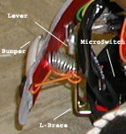
The bumpers are made from aluminum mounted on bronze L-braces and supported by 2 springs each. The curvature is produced by tension produced by 18-gauge cables attached to the brace and the sides of the bumper. On impact, the bumpers actuate microswitches mounted on the body with levers that extend to the bumper. This setup proved to be reliable during operation, although, at low speeds and hitting soft surfaces the operations becomes erratic and unpredictable. Figure 1 illustrate the mechanics and arrangement of the bumper design.
Figure 1: Bumper Illustration
The support platform was painted black along with the sides and the top platform was given a shiny gold plated look accompanied by blue decorative touches. In the inside, 2 tiers hold the motors and electronics in place. The bottom tier supports the DC motors and bumper microswitches while the top tier accommodates the motor drivers, MTJPro and other electronic components. Space is extremely limited and access to the electronics is almost impossible without taking the top platform off. Design limitations were imposed by the micromouse size regulations, but maybe making a third tier or keep expanding up would have make the electronics more accessible since the is no limitation on height on micromouse contests. An AutoCAD plotted draft is provided in Appendix B.

Actuation

Traversing time is an important consideration in micromouse robots. Speed, acceleration and movement accuracy are important factors to consider when designing and actuation method. DOTBOT employs a twin DC ironless gearhead motor system to control movement and direction The design departs from the commonly used method of hacked servos. Originally, one of the decisive factors on this design choice was the thought of linear transition in speed which can be translated into predictability and added control. However, preliminary testing revealed that this paradigm was erroneous. The behavior resembles a logarithmic curve just as the hacked servos show (more information on the sensors section)
Another consideration was that DC gearhead motors provide more flexibility in terms of winding types and gearing that eventually translates into differences in speed and torque. Therefore, at the design stage, the perception of speed gains and added control out-weighted the simplicity of using hacked servos for actuation. As the project progressed some of the original notions were erroneous but in the end, the DC Ironless motors with built-in magnetic encoder chosen turned out to be a very good design choice.
The wheel arrangement used is a standard differential drive with two ball casters creating a diamond pattern. This arrangement provides stability and excellent turning radius. The rear ball caster is spring supported to accommodate the robot’s weigh and to prevent loss of traction in cases where undulations in the terrain may break the contact between the drive wheels and the ground.
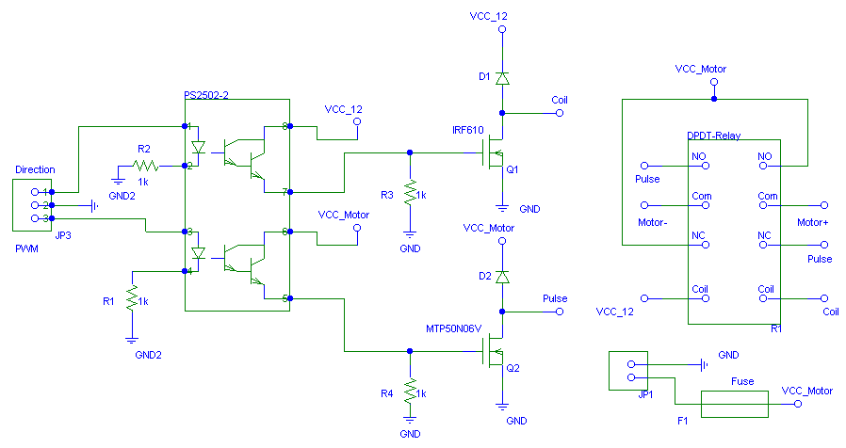
The original design of the motor drivers used in DOTBOT are from Eric Anderson, a former IMDL student. Some of the features of this motor driver design includes: optoisolatotion, diode protection from voltage spikes, slow-blow fuse protection and high current DPDT relay (5A). This implementation differs slightly from the original design. For convenience, a quad-channel photodarlington output optoisolator from ISOCOM (PS2502-4) is used to drive up to 2 DC motors, independently channeling the pulse width modulated signal and the direction bit. To provide sensory feedback, it is recommended to use a bicolor LED with a 330 Ohm, ½ watt resistor across the motor to monitor the direction of the current across the relay. It also makes a good tool for debugging purposes.
Motor driver Schematics:

Figure 2: Schematic Diagram of Motor Drivers

Parts List:
Parts Type | Designator | Part Description | Quantity
1K Resistor | R1,2,3,4 | Resistor | 4
330 Ohm Resistor |  | Resistor | 2
CON1 | J3,4 | Jumper | 1
Diode | D1,2 | 1N4004 | 2
Fuse | F1 | 5A Slow Blow | 1
Fuse Holder | F1 | Fuse Holder | 1
Header 2 | JP1,2,4 | 2 Position | 1
Header 3 | JP3 | 3 Pin header | 1
Optoisolator | U1 | PS2502-4 | 1 (for 2 motors)
MOSFET N | Q1 | IRF610 | 1
MOSFET N | Q2 | MTP50N06V | 1
Relay-DPDT | R1 | 5A DPDT | 1
Bicolor LED |  | Red/Green LED | 1

The jumper can be shorted to used a single power supply for the coil of the relay and the motors. The coil on the relay used in this motor driver (Radio Shack #275-249) is rated between 8-12Vdc, therefore, if the motors used are rated between that voltage, some real estate in the robot can be saved by sharing the battery for this operation.
Note: To conserve battery power, the motor should be wired in such a way that the forward direction corresponds to the normally closed position of the relay.
The 2 DC Ironless motors are from ApiMotion, formerly known as Portescap. These are high quality motors with built-in shaft encoders. The motor model is MDC-222-1060 and the gearhead model is S-24. The motors are rated at 12Vdc, have a no-load speed of 5900 rpm and a stall torque of 1.21 oz-in which is considerably increased to approximately 77 oz-in. of torque by using a gear head with ratio 64:1. Technical data sheets of the motor, gear-head and encoder is provided in Appendix C.
Power to these motor will be delivered by an 8-cell Ni-Cd pack rated 9.6Vdc at 900mAh.

Sensors – Overview

DOTBOT uses a variety of sensors to sense its surroundings. There are a total of 18 sensors including bumpers, IR’s, CDS cells , inclinometer, sonar, shaft encoders and a voltage level sensor. In order to accommodate the 11 sensors that make use of analog ports, an analog multiplexer board was made to expand the analog ports on the MTJPRo to a total of 15. The circuit is included in Appendix A
The bumper array consists of 4 micro-switches arranged on the front and back of the robot. Five IR’s are used as short range proximity sensors. These sensors are hacked for analog output and are manufactured by SHARP, model GPU58Y. Two are located on the front, one on each side for wall detection and one on the back. Photoresistors are also employed to observe changes in illumination level. Two CDS cells are located on the front of the robot pointing upwards 30 – 40 degrees. In addition, a voltage level indicator was added to denote the battery depletion during the robot’s operation. The following circuit illustrates the simple voltage divider used
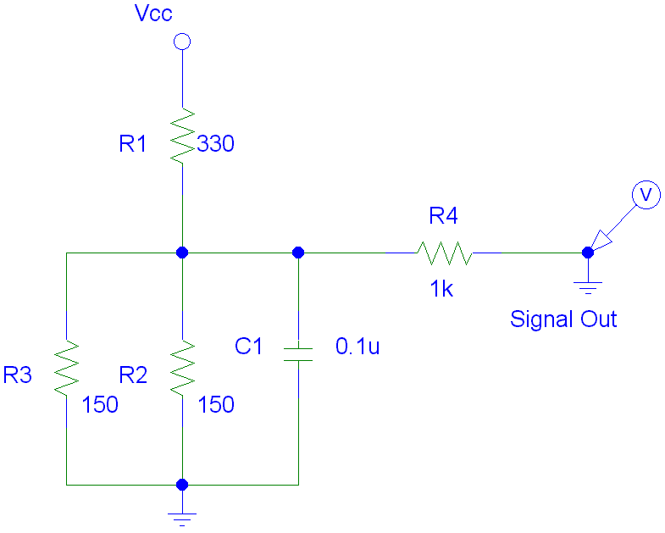
Figure 3: Voltage Sensor
This simple sensor proved to be very valuable during testing and operation. During testing, information stored in arrays was transferred safely before the batteries were drained and the information lost.

Bump Switches

Bump switches are the last resort to avoid damage to the robot. Four switches guard each side of the robot using contact switches with different resistances connected to the analog port PE0, making use of the resistors present in the MTJPro board, specifically designed for this purpose.

IR Sensors:

The IR sensors are SHARP GPU58Y IR sensors modulated at 40khz. The sensors are hacked for analog distance measurement to be used as a short range proximity detectors. Five IR sensors are mounted in the platform to provide a wide field of detection (front, side and back). Two IR’s on the front pointing outwards provide front view, one on each side provide wall following capabilities and one centered on the back provides obstacle detection when the robot is backing up.

Photoresistors

Two Cds cells mounted on the front pointing upward at 30 degrees provide illumination level detection to the robot. The main purpose of the photoresistors is to recognize success when a bright light awaits the robot at the end of the labyrinth. In addition, with the mapping capabilities of the robot and RF communications, future uses may include setting comfortable illumination levels for rooms were the robot is navigating or simply record the values for user deliberation. A voltage divider is used to measure the voltage across the photo cells.
The following diagram illustrates this simple principle:
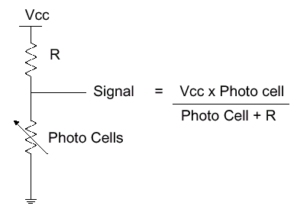
Figure 4: CDS cells circuit
After some experimentation with resistor values, it was determined that R=47k provide a wide range of values and acceptable sensibility to different levels of illumination and even more accuracy when dealing with subtle changes in normal ambient levels of light.
The remaining sensors will be explained in more detail with supporting information such as schematics, graphs and data tables.

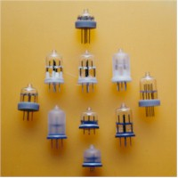
Inclinometer

The tilt sensor from Specton Sensors provides information on 2-axis with a range of +/- 60°. Its purpose is to work in conjunction with the RF module to keep a valid data feed between the host computer and the robot. If the robot is lifted from the ground or accidentally losses balance due to changes in terrain or slope, the current map will be reset until the robot recovers stability and traction. The alcohol based electrolyte in this sensor is very sensitive to the current and voltage applied. To insure proper operation the pins should be energized with an AC waveform of about +/- 5 VC and 1.5mA. To generate such waveform a signal conditioner was used. The CMOS SA40015 can generate up to four AC square waveforms at different frequencies. With different frequencies the output can be easily distinguished to measure changes in the incline angle in the x and y direction, energizing the different pins appropriately (convention used: ‘x’ is aligned with motor shaft and ‘y’ is perpendicular to the direction of forward motion). In order to use an analog port to interpret the output, another circuit is needed to offset the output signal to nominal values which the port can read (0-5v). The output from the SA40015 is +/- 1.5 VDC for each axis. That signal is then put through an op-amp configured as an input adder to generate the desired output. The range is then offset to an effective range of approximately 1.5 and 4.5 VDC. See the following circuit schematics:
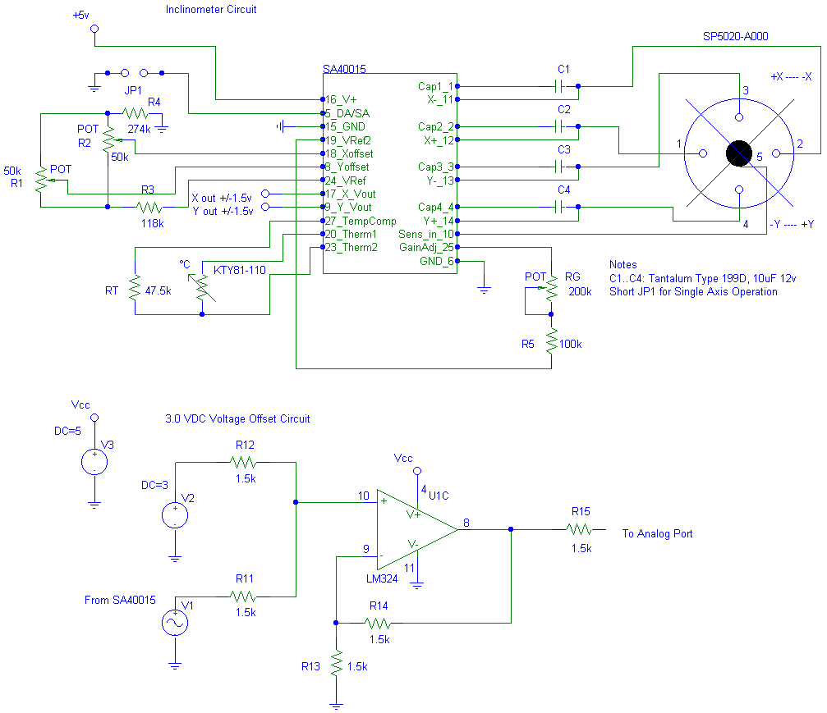
Figure 5: Inclinometer Circuit

The inclinometer is also temperature compensated using a silicon temperature sensor between pins 20 and 23 (KTY81-110). The accurate operating temperature range is between –20 °C and +70 °C.

The readings were taken independently on each axis using 10 degree increments. The spectrum for each axis is similar and behave in a linear fashion. The empirical range for the x-axis is 139 units, a resolution of 1.15 units per degree. The y-axis range is 143 units, 1.19 units per degree. The data is shown below.

Readings table at 10 degree increments:

Inclinometer | Readings
Angle | X – Axis | Y - Axis
-60 Max Range | 74 | 68
-50 | 82 | 76
-40 | 93 | 87
-30 | 101 | 95
-20 | 119 | 107
-10 | 132 | 123
0 - Level | 145 | 136
10 | 158 | 149
20 | 165 | 161
30 | 173 | 172
40 | 189 | 185
50 | 201 | 198
+60 Max Range | 213 | 211

Plotted Data:

Figure 6: Inclinometer Readings

Shaft Encoders

The purpose of the shaft encoders is to receive feedback on the rotation speed of the wheels to implement an accurate velocity control on the robot. Ultimately, the objective is to calculate the distance traveled based on the encoder readings at fix time intervals. The setup of closed loop control will prove that it is not necessary to use stepper motors to achieve accurate positioning and movement. Using conventional DC motors provides greater flexibility, easier setup and reduced power consumption compared to stepper motors.
The shaft encoders used are from ApiMotion, formerly known as Portescap. The F16 model is a simple to interface, low cost solution for measuring shaft rotation. The F16 is a magnetic encoder with a frequency resolution of 16 pulses per revolution. However, since a 64:1 gear-head is attached to the shaft, the resolution is increased by that factor to 1024 pulses per revolution. Each pulse is generated by a rising edge on a square waveform generated by the encoder. To interface the encoder to the 68HC11E9, ports PA0 and PA7 were used. PA7 can be configured as a 8-bit counter hardware pulse accumulator (PACTL) which facilitates the programming effort. PA0 is an input capture and interrupt TIC3 was configured on rising edges to count the right wheel pulses. In addition, since the high resolution on the encoder exceeds the range of the 8-bit counter several times per revolution, an overflow interrupt was configured on the pulse acc. (PAOVI). The ICC11 library developed is attached in Appendix D
The following readings illustrate the behavior of the encoder at different speeds and directions:

Shaft Encoder Readings:
Speed | Pulses Readings every 4100 msec.
Speed | Left Wheel (PA7) | Right Wheel(PA0)
-90 | 5211 | 5239
-80 | 5151 | 5170
-70 | 5079 | 5053
-60 | 4989 | 4995
-50 | 4864 | 4859
-40 | 4692 | 4706
-30 | 4444 | 4465
-20 | 4045 | 4062
-10 | 3295 | 3300
0 | 0 | 0
10 | 2549 | 2549
20 | 3786 | 3825
30 | 4268 | 4326
40 | 4552 | 4613
50 | 4747 | 4793
60 | 4884 | 4925
70 | 4981 | 5023
80 | 5058 | 5098
90 | 5120 | 5159
100 | 5170 | 5209

Plotted Data:

Figure 7: Shaft Encoder Readings

The readings demonstrate the aforementioned statement that using DC motors instead of hacked servo motors does not deliver a linear transition is speed as originally expected. Fortunately, both wheels appear to be performing evenly, the reading shows almost negligible difference among the two wheels making a bias offset almost unnecessary to produce straight motion. The magnetic shaft encoders perform with extraordinary accuracy and beyond expectations.

Sonar

The sonar is used as a ranging module to estimate distances beyond the limited range of the hacked IR’s. The schematics for the sonar receiver and transmitter were taken from the IMDL website and are shown below. The schematic for the transmitter was redrawn because the original transformer used in the circuit was replaced by a series of hex inverters (7404) in parallel. In addition, a 10k resistor was added to pull down the signal on the crystal driven 40khz frequency generated by the MTJPro board used to drive the sonar.

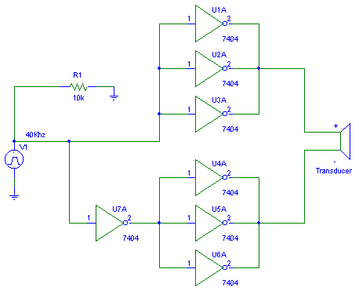

Figure 8: Sonar Transmitter Schematic

Sonar Receiver Schematic:

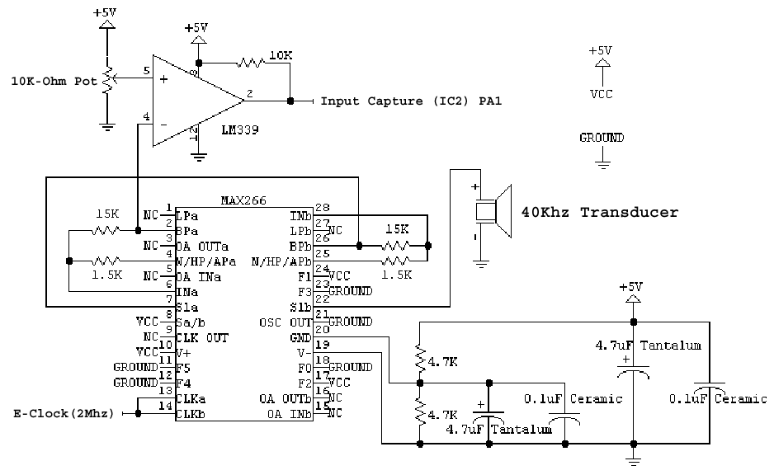

Figure 9: Sonar Receiver Schematic

The receiver is connected to the input capture (IC2), port PA1. The transmitter is connected to the IR emitters latch, address 0x7000 and it is activated for 15 msec intervals. Furthermore, the echo receive line connected to PA1 is configured as input capture on rising edges, therefore, as soon a the echo line goes high, a flag is recorded Theoretically, the number of e-clock pulses from the ping time to the echo received represents the time of flight of the sound wave. This is the digital approach used to drive the sonar in DOTBOT’s. Other methods were tried, including experimenting with analog readings but the reliability and accuracy of the data does not begin to compare with the digital method. Although the range is somewhat inferior, the effective accuracy and sensibility at distance fewer than 3 feet proved vastly superior.

Problems with the sonar:
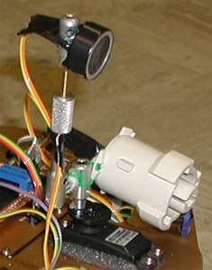
Some preliminary data recorded resulted useless since the range of transmitted wave appears to be wide enough to make the receiver flag go high as soon as the ping initiated. This resulted in under appreciated distances which corrupted the validity of the experiments. The solution was to insulate the sonar emitter in a way that the sound wave does not propagate in such a wide spectrum and positioning the receiver far enough so that no misreading can occur. This arrangement is shown in figure 9 and produced exceptional results. The only adverse side-effect was that the sonar maximum reach was reduced by as much as 40%. Fortunately, this trade-off does not affect the functionality of the sonar, the current accurate range is from 3in. to 8ft. which proved perfectly satisfactory in testing and small to relatively large areas.
Figure 10: Sonar Arrangement
Distance | SONAR
Distance | Counter Reading
3in. | 42
6in. | 69
1ft. | 109
1.5ft | 141
2ft. | 183
4ft. | 353
6ft. | 422

Sonar readings, plotted data:

Figure 11: Sonar Readings

RF Module

DOTBOT is equipped with RF modules from Linx Technologies and it is capable of full-duplex communications up to 5000bps. (2400 bauds was used). The transmitter and receiver used are from the LC series of compact, low cost single chip wireless solution. The simplicity of use, low cost and reliable performance makes them ideal for robotics projects. The Tx/Rx require no external components and are easy to interface with any microcontroller with a serial communications interface. The power consumption is low (7mA at continuous carrier and 1.5uA at stand-by) and they possess CMOS/TTL level input and output for data. The modules operate with direct interface logic level I/O and the form of modulation used is a standard OOK (on-off keying), also known as CPCA (Carrier-Present Carrier-Absent). The LC series of transmitters/receivers are unidirectional, therefore, the full duplex capability is achieved using different frequencies. The robot uses a frequency of 418Mhz to transmit and 315Mhz to receive signals from the host computer. Conversely, the host computer transmit at 315 Mhz and receives at 418Mhz. To convert the logic level I/O from the modules to UART compatible levels, the MB2325 bi-directional serial communications voltage converter from Mekatronix was used.

The following schematics show the simplicity of interfacing these self-contained modules:
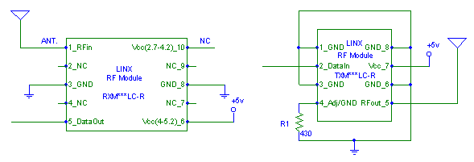
Figure 12: LC-Series connection schematics

On one end, the modules are connected to Motorola’s serial communications interface (SCI) and on the other, to Mekatronix’s MB2325 voltage converter board to the RS232 port on the host computer.
During testing some problem were identified regarding the transmission range. Without any attenuation pads as required by the FCC, the range was low and nowhere near the specified range of the modules. To improve the situation, a power supply filter using a 10 resistor in series with the supply followed by a 47F tantalum capacitor from Vcc to ground was used to clean any noise coming from the power supply. In addition, RG-174 (50) coax cable was used as transmission line for the RF signal and a better ground plane was provided for the transmitters. These modification seemed to help considerably the transmission of radio waves into free space and transmission errors were greatly reduced. Nevertheless, the 300 feet range that the modules claim is a goal which is far away from being achieved.

Code / Behaviors

The code for DOTBOT was developed using ICC11 v5.0 and Visual Basic 6.0(SP4) was used to interpret the RF information sent by the robot. The demo-day ICC11 source can be found in Appendix D and the Visual Basic code in Appendix E.
The Robot first enter a RF test subroutine in which a data stream is sent to verify the communications status. Data is then transmitted to the robot to continue with the program. After th RF test completes successfully, a self calibration routine is invoked to test its sensors in its current position. An average on 3 reading will be the valid measure of the calibration procedure for each sensor.

The following code implementation is used on obstacle avoidance when an object is detected.
turn(0, (TURNFACTOR+(IRfrontrt-IROBSTACLE)*35),'r');

The turn radius is determined by the distance to the obstacle. The closer the object the sharper the turn. ‘Turn’ is a subroutine which accepts 3 values: the first is the turning angle and 0 means to disregard the angle so that an encoder value can be passed, -1 represents a random turn, the second value is the shaft encoder value to advance and the third value represents which wheel will rotate until the encoder value is reached. ‘TURNFACTOR’ is a constant with a standard turning encoder value, it serves as a baseline for turning radius.
Most of the code is modular so subroutines can be reused later with minimal effort. The shaft encoders interrupt routine was compiled as a separate library. The library calls are ‘left_vel()’ and ‘right_vel()’ to read the current encoder values. Every time the function is called, the values are reset to zero. For future IMDL students, the library can be used and once the hardware is completed, it will only be a matter of minutes to have the shaft encoders working. The library uses PA0 for the right wheel and PA7 for the left wheel. Because the hardware pulse accumulator is only 8-bits, overflows can become a problem, however, the library handles overflows with the PAOVI interrupt so interfacing high resolution encoders is not a problem. The function returns an unsigned integer from 0 to 65535.
Wall following is implemented randomly at the beginning of the program. It uses the two sides IR and the calibrate data to stay on course where calibration began. Afterwards, it looks for openings and the correct condition to perform precise turns aided by the shaft encoders. The opening is determined by changes in IR reading with respect to the average of the last 3 reading. The subroutines leantowall() and lookdoors() work together to implement this behavior.
Some other behaviors implemented are the shutdown behavior which starts when the inclination angle changes radically in which the robot will shut itself off and waits for a bumper signal to continue normal operation. Another behavior lets the robot realize it is out of clutter environment like mazes and starts a random obstacle avoidance behavior announcing its decision by a 360 degree turn. Other feedback signals is provided by a piezzo buzzer connected to PA3 configured as output compare (OC5).

The following figures illustrates the main screen developed in Visual Basic which displays all relevant information from the robot. The top left window is where the path drafting takes places and the bottom portion is where all sensory information is displayed along with calibration reading. On the right side of the screen it is the voltage meter which displays DOTBOT’s main power supply level, powering all electronics, sonar servo and sensors. There is a separate power supply for the motors and relay coils which does not have a voltage sensor and therefore not present in the reading. The top right section displays the raw information received by the host computer and also provides feedback on Tx/Rx status.

Visual Basic captured screen:

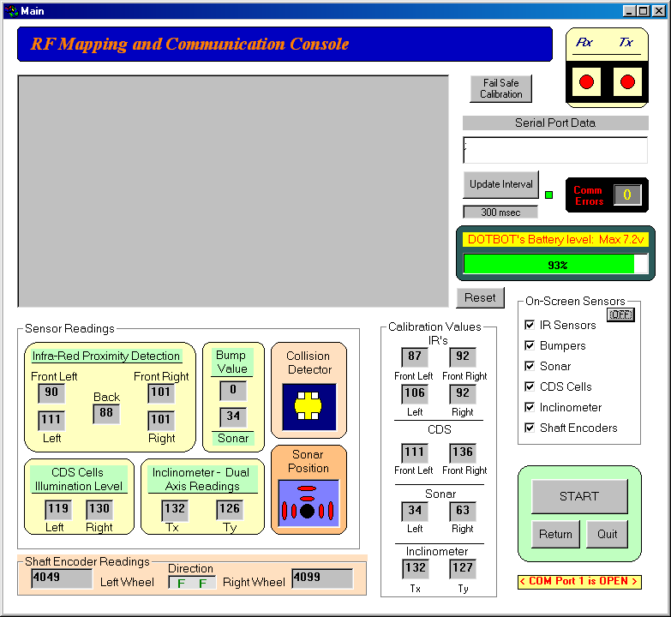
Figure 13: Visual Basic Main Communications console

Conclusion

DOTBOT’s was an outstanding learning experience and a wonderful introduction into the field of Robotics. The experiences learned with this project will without doubt be extremely valuable on any subsequent robotics endeavors.
DOTBOT’s possesses a wide range and broad quantity of sensors which create a lot of potential and flexibility in terms of capabilities but increases the complexity of integration and cohesion in its applications. If I were to redo the project I would probably opt for fewer kinds of sensors and try to get the most out of each implementation. One of the first thing you hear in this course is “try to achieve simplicity” which are wise words that we do not always take into account. Simple is better, especially when one has no background in the field; sometimes experience can teach reinforce the concept of simplicity.
Nevertheless, DOTBOT’s sensor array works flawlessly and the radio frequency modules from Linx Technologies proved to be a fabulous addition to the project. The code is not as mature as I would like it to be but any successful coding effort takes time, patience and testing, three factor which scarce during the scope of this class. Overall, DOTBOT’s accomplished its predefined objectives and the platform and sensor array work beyond expectations. Some of the sensors are underutilized but they can certainly become critical once the coding is completed. In addition, they give breathing room for expansion if more behaviors are to be incorporated.
One advise for future IMDLers’, start early and be prepared to dedicate time and effort to an exciting and intellectually rewarding project, otherwise, this course may not be suitable for you.

Documentation

Jones, Joseph L., et al. Mobile Robots - Inspiration to Implementation, Second Ed.
- K. Peters, Natick, MA. 1999 .

Martin, Fred. The 6.270 Robots Builders Guide.
MIT Media Lab, Cambridge, MA. 1992.

Van Sickle, Ted. Programming Microcontrollers in C.
Technology Publishing, Eagle Rock, VA. 1994

Useful Resources:

Intelligent Machines Design Lab Webpage: http://www.mil.ufl.edu/imdl/

Mekatronix Webpage: http://www.mekatronix.com

ApiMotion DC motors: http://www.apimotion.com

Spectron Sensors: http://www.spectronsensors.com

Suppliers and Distributors:

- Radio Shack
- Jameco
- Newark Electronics
- All Electronics Corporation

Appendix A: Analog Multiplexer Circuit

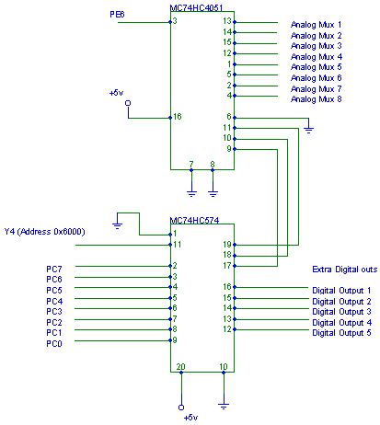

Appendix B: DOTBOT’s AutoCAD drawing

Appendix C: Portescap Data Sheets

Appendix D: ICC11 Demo-day Source Code

/**********************************************************************
* DOTBOT Main Program Code - Compiler: ICC11 v5 for Motorola 68HC11E9 *
* Programmer: Diego O Terzano Email:doter@email.com *
* Date: August 3, 2000 * * Version 1.2 *
* Features: Maze Navigation, RF Communication, Sonar Routines *
* Shaft Encoders, Self calibration, etc. * ***********************************************************************/

/*************************** Includes ********************************/
#include <dotbase.h>
/*********************************************************************/

/**************************** Defines ********************************/
#define TRUE 1
#define FALSE 0
#define RF_USE TRUE
#define SONARSERVO 0
#define RSERVO 680
#define CSERVO 2610
#define LSERVO 4420
#define RTURN 1280
#define LTURN 1280
#define BIAS 3
#define SFACTOR 70
#define FFACTOR 100
#define TURNFACTOR 750 /* Encoder Value: Reference */
#define IROBSTACLE 124
#define SNOBSTACLE 75
#define DOORBIAS 5
#define CURVES 100
#define ENCODERTH 4096
#define FRONTBUMP (BUMPER> 135)
#define BACKBUMP (BUMPER> 15)&&(BUMPER< 65)
#define IR_FRONTLF analog(7)
#define IR_FRONTRT analog(4)
#define IR_LEFT analog(5)
#define IR_RIGHT analog(3)
#define IR_BACK analog(2)
#define MUX_PORT analog(6)
#define MUX *( unsigned char *)(0x6000)
#define INFRARED *( unsigned char *)(0x7000)
/*************** RF Definitions ******************/
#define GO_ON 0x26 /* & char to continue */
#define TEST 0x30 /* 0 to Test RF */
#define BEEP 0x31 /* 1 for Beep codes */
#define RFOK 0x32 /* 2 for OK - PASS TEST */
/*********************************************************************/

/************************** Prototypes *******************************/
void initialize(void);
void calibrate(void);
void init_sonar(void);
void init_buzzer(void);
void init_RF(void);
void TestRF(void);
void SendRF(void);
void obsavoid(void);
void sensordata(void);
void bumpcollision(void);
void motordrive(void);
void leantowall(void);
void lookdoors(void);
void avoidobstacles(void);
void gofast(void);
void pare(void);
void buzz(unsigned int);
void back(unsigned int);
void gofw(unsigned int , unsigned int);
void turn(int , unsigned int , char);
int sonardist(void);
/*********************************************************************/

/*************************** Globals *********************************/

int IRfrontlf;
int IRfrontrt;
int IRleft;
int IRright;
int IRback;
int CDSleft;
int CDSright;
int Tiltx;
int Tilty;
int TH_IRfrontlf;
int TH_IRfrontrt;
int TH_IRleft;
int TH_IRright;
int TH_CDSleft;
int TH_CDSright;
int TH_Tiltx;
int TH_Tilty;
int TH_Lsonar;
int TH_Rsonar;
int IRwall;
int IRaway;
int IRwallTH;
int IRawayTH;
int ServP;
int VoltSensor;
int lspeed;
int rspeed;
int Lfactor;
int Rfactor;
int leftspeed;
int rightspeed;
int SonarDistance;
int wallf;
int obstacle;
int oncourse;
int doorp;
int arrayp;
int ireadl[3];
int ireadr[3];
unsigned int Pcycles;
unsigned int Lenc;
unsigned int Renc;
int MuxChan[8] = { 0x14,0x34,0x54,0x74,0x94,0xB4,0xD0,0xF4 };
// char clear[]= "\x1b\x5B\x32\x4A\x04"; /* clear screen */
// char place[]= "\x1b[1;1H"; /* Home cursor */

/*********************************************************************/

/***************************** Main **********************************/
void main(void)
{
unsigned rand;

initialize();

rand=TCNT;
// wallf=(rand & 0x0001) ? 1: 0; /* Select Random Wall Behavior: 1 (left) */
wallf=0;
START; /* Hit bumper to start RF Test */
buzz(100);

TestRF();

START; /* Hit bumper to start Calibration */
buzz(100);

calibrate();

buzz(100);
START; /* Hit bumper to start the program */
wait(500);
gofast();

while(1)
{
++Pcycles;
sensordata();
bumpcollision();
leantowall();
lookdoors();
avoidobstacles();
motordrive();
if (Pcycles>4800) Pcycles=0;
}
}

void sensordata(void)
{
IRfrontlf = IR_FRONTLF;
IRfrontrt = IR_FRONTRT;
IRleft = IR_LEFT;
IRright = IR_RIGHT;
IRback = IR_BACK;
MUX = MuxChan[2];
Tiltx = MUX_PORT;
MUX = MuxChan[4];
Tilty = MUX_PORT;
MUX = MuxChan[7];
CDSleft = MUX_PORT;
MUX = MuxChan[0];
CDSright = MUX_PORT;
MUX = MuxChan[1];
VoltSensor = MUX_PORT;
if(((Tiltx>(TH_Tiltx+20))||(Tiltx<(TH_Tiltx-20)))||((Tilty>(TH_Tilty+20))||(Tilty<(TH_Tilty-20))))
{ pare(); START; gofast(); }

/* Sonar Routine, mainly for mapping, Send Position and Sonar data on random interval */
if(Pcycles> 3500)
{ int rand, iloop; rand=TCNT; ServP=(rand & 0x0001) ? RSERVO: LSERVO;
SERVOS_ON;
for(iloop=CSERVO; iloop< ServP; iloop+=10)
{ servo(SONARSERVO, iloop); wait(5); }

SonarDistance = sonardist();
write("xxSS:"); put_int(SonarDistance); put_char(44);
write("SV:"); put_int(ServP); put_char(44);
servo(SONARSERVO, CSERVO); wait(80);
SERVOS_OFF; }
}

void bumpcollision(void)
{
int Bumpval;
Bumpval = BUMPER;

/* Bumper Values: Back Both=57, BR=42, BL=21, Front Both=148, FR=124, FL=75 */
if FRONTBUMP { back(320); turn(180,0, 'n'); }
else if((BUMPER> 70)&&(BUMPER< 80)) { back(360); turn(0, TURNFACTOR+450, 'l'); }
else if((BUMPER> 120)&&(BUMPER< 130)) { back(430); turn(0, TURNFACTOR+290, 'r'); }
else if(BACKBUMP) { lspeed=TOP_SPEED; rspeed=TOP_SPEED; }

if FRONTBUMP { back(350); turn(180,0, 'n'); }
if((BUMPER> 70)&&(Bumpval< 10)) { back(500); turn(-1,0,'n'); }
/* Send Bumper Value on Collision to SCI */
if(Bumpval> 10) { write("xxBP:"); put_int(Bumpval); put_char(44); put_char(59); }
}

void back(unsigned int tback)
{
unsigned int vl, vr;
pare();
Lenc+=left_vel(); Renc+=right_vel();
motordot(LMOTOR, -TOP_SPEED);
motordot(RMOTOR, -TOP_SPEED);
wait(tback);
vl=left_vel(); vr=right_vel();

/* Send Reverse info to SCI */
write("xxLD:"); put_int(-TOP_SPEED); put_char(44);
write("RD:"); put_int(-TOP_SPEED); put_char(44);
write("SL:"); put_int(vl); put_char(44);
write("SR:"); put_int(vr); put_char(44);
put_char(59); put_char(59); /* Send End Transmission Character (;) */
}

void leantowall(void)
{
int factor1, factor2, iloop, avgirl=0, avgirr=0;
doorp=FALSE;

for(iloop=0; iloop<3; ++iloop) { avgirl+=ireadl[iloop]; avgirr+=ireadr[iloop]; }
avgirl=(avgirl/3); avgirr=(avgirr/3); /* First run, data from Calibration */

if((IRright<(avgirr-DOORBIAS))&&(IRleft<(avgirl-DOORBIAS))) { doorp=2; buzz(30); }
else if(IRright<(avgirr-DOORBIAS)) { doorp=1; buzz(30); }
else if(IRleft< (avgirl-DOORBIAS)) { doorp=-1; buzz(30); }
else if((IRright<(avgirr-DOORBIAS))&&(IRleft>120)) { doorp=FALSE; gofw(400,400); pare(); turn(90, 0,'n'); gofw(660,660); }
else if((IRleft<(avgirl-DOORBIAS))&&(IRright>120)) { doorp=FALSE; gofw(400,400); pare(); turn(-90, 0,'n'); gofw(660,660); }

if((avgirr<110)&&(avgirl<110)&&(IRfrontrt<105)&&(IRfrontlf<110)&&(IRback<100)) obsavoid();

/* Put new reading in array to update average when no door is present */
if(!doorp)
{ if(arrayp>2) arrayp=0;
ireadl[arrayp]=IRleft; ireadr[arrayp]=IRright; ++arrayp;}

}

void lookdoors(void)
{
unsigned rand;
int iloop;
rand=TCNT;
SonarDistance=-1;

if((IRaway<IRawayTH-DOORBIAS)&&(oncourse)) /* If a door is found on opposite side, send sensor data */
if(wallf==1) { write("xxRR:"); put_int(IRaway); put_char(44); put_char(59); }
else { write("xxLL:"); put_int(IRaway); put_char(44); put_char(59); }

if(doorp)
{
if(wallf==1)
{ buzz(20);

if((doorp==-1)||(doorp==2)) { gofw(800,800); pare(); turn(-90, 0,'n'); gofw(800,800); }
else if((doorp==1)&&(IRfrontlf>120)) { gofw(800,800); pare(); turn(90, 0,'n'); gofw(800,800); }
}
else
{ buzz(20);
if((doorp==1)||(doorp==2)) { gofw(800,800); pare(); turn(90, 0,'n'); gofw(660,660); }
else if((doorp==-1)&&(IRfrontrt>120)) { gofw(800,800); pare(); turn(-90, 0,'n'); gofw(660,660); }
}
}

}

void turn(int angle, unsigned int encoder, char wheel)
{
/* (+) Angles clockwise dir, -1 Random Turn, 0 to accept Encoder Input: l(left),r(right),n(NULL value) */
unsigned rand;
unsigned int vl, vr, lse=0, rse=0;
rand = TCNT;

if(angle==-1) angle=(rand & 0x0001) ? 90 : -90;

switch(angle)
{
case 0:
if (wheel=='l') { lse=encoder; lspeed=TOP_SPEED; rspeed=((TOP_SPEED)*10/100); }
else { rse=encoder; lspeed=((TOP_SPEED)*10/100); rspeed=TOP_SPEED; }
break;
case 90:
lse=RTURN;
lspeed = TOP_SPEED;
rspeed = STOP;
break;
case -90:
rse=LTURN;
lspeed = STOP;
rspeed = TOP_SPEED;
break;
case 180:
pare();
lse=RTURN; rse=LTURN;
if(rand & 0x0001) { lspeed = TOP_SPEED; rspeed = -TOP_SPEED; }
else { lspeed = -TOP_SPEED; rspeed = TOP_SPEED; }
break;
}

/* Use shaft Encoders for precise turns */
Lenc+=left_vel(); Renc+=right_vel();
motordot(LMOTOR, lspeed);
motordot(RMOTOR, rspeed);
for(vl=0, vr=0; ((vl<lse)||(vr<rse)); vl+=left_vel(), vr+=right_vel()) wait(25);

motordot(LMOTOR, TOP_SPEED);
motordot(RMOTOR, TOP_SPEED);

/* Send When change heading to SCI */
write("xxLD:"); put_int(lspeed); put_char(44);
write("RD:"); put_int(rspeed); put_char(44);
write("SL:"); put_int(vl); put_char(44);
write("SR:"); put_int(vr); put_char(44);
put_char(59); put_char(59); /* Send End Transmission Character (;) */

sensordata();

/* Resume Normal Movement */
Lfactor=FFACTOR; Rfactor=FFACTOR;
lspeed=TOP_SPEED; rspeed=TOP_SPEED;

}

void avoidobstacles(void) /* Obstacle definition, clokwise: on order of importance */
{
obstacle=0x00;
if((IRright>IROBSTACLE)&&(IRright>TH_IRright+BIAS)) obstacle|=0x02;
if((IRleft>IROBSTACLE)&&(IRleft>TH_IRleft+BIAS)) obstacle|=0x04;
if(IRback>IROBSTACLE) obstacle|=0x01;
if(IRfrontlf>IROBSTACLE) obstacle|=0x10;
if(IRfrontrt>IROBSTACLE) obstacle|=0x08;
if((IRfrontlf>IROBSTACLE)&&(IRfrontrt>IROBSTACLE)&&(IRright>IROBSTACLE-2*BIAS)&&(IRleft>IROBSTACLE-2*BIAS)) obstacle=0xFF;

if(obstacle)
{

buzz(20);
Lfactor=FFACTOR;
Rfactor=FFACTOR;
if(obstacle>=0x1E) { back(200); turn(180,0,'n'); } /* Obstacle in Front and sides */
else if(obstacle==0x18) turn(-1,0,'n'); /* Object in front only, turn random */
else if((obstacle> 0x01)&&(obstacle< 0x04)) turn(0, (TURNFACTOR+(IRright-IROBSTACLE)*25),'r'); /* turn(0, (TURNFACTOR+(IRright-IROBSTACLE)*12),'r'); Obs. on Right */
else if((obstacle> 0x02)&&(obstacle< 0x08)) turn(0, (TURNFACTOR+(IRleft-IROBSTACLE)*25),'l'); /* turn(0, (TURNFACTOR+(IRleft-IROBSTACLE)*12),'l'); Obs. on Left */
else if((obstacle>= 0x08)&&(obstacle< 0x10)) turn(0, (TURNFACTOR+(IRfrontrt-IROBSTACLE)*35),'r');/* { turn(0, (TURNFACTOR+(IRfrontrt-IROBSTACLE)*5),'r'); } Obs. on Front Right */
else if((obstacle>= 0x10)&&(obstacle< 0x18)) turn(0, (TURNFACTOR+(IRfrontlf-IROBSTACLE)*35),'l');/* { turn(0, (TURNFACTOR+(IRfrontlf-IROBSTACLE)*5),'l'); } Obs. on Front Left */
else if(obstacle==0x01) { lspeed=TOP_SPEED; rspeed=TOP_SPEED; }

}

}

void gofast(void)
{
motordot(LMOTOR, TOP_SPEED);
motordot(RMOTOR, TOP_SPEED);
}

void motordrive(void)
{
int lsp,rsp;

rsp=(Rfactor*rspeed/100); lsp=(Lfactor*lspeed/100);

if(lsp!=leftspeed) motordot(LMOTOR, lsp);
if(rsp!=rightspeed) motordot(RMOTOR, rsp);

leftspeed=lsp;
rightspeed=rsp;

lspeed=TOP_SPEED; rspeed=TOP_SPEED; Lfactor=FFACTOR; Rfactor=FFACTOR;

Lenc+=left_vel(); Renc+=right_vel();
if((Lenc> ENCODERTH)||(Renc> ENCODERTH)) SendRF(); /* Send Data if encoder interval is met */
}

void gofw(unsigned int sencleft, unsigned int sencright) /* Advance specific # of Encoder Pulses */
{
unsigned int vl1, vr1;
/* Use shaft Encoders for precise Control */

Lenc+=left_vel(); Renc+=right_vel();
motordot(LMOTOR, TOP_SPEED);
motordot(RMOTOR, TOP_SPEED);
for(vl1=0, vr1=0; ((vl1<sencleft)||(vr1<sencright)); vl1+=left_vel(), vr1+=right_vel()) wait(25);
Lenc+=vl1; Renc+=vr1;
}

void pare(void) /* Stop ROBOT in order to change direction */
{
motordot(LMOTOR, STOP);
motordot(RMOTOR, STOP);
wait(150);
}

int sonardist(void)
{
int counter = 0;
int stimer = 0;

CLEAR_FLAG(TFLG1, 0x02); /* Clear Echo receive flag of IC2 (PA1) */
INFRARED = 0xFF; /* Send Ping, Sonar transducer connected to 0x80 on IRE latch*/

while(counter < 800) /* 800 pulses is equivalent to 15 msec. of ping, approx. */
{ /* Sufficient for ranges less than 6 feet. */
++counter;
if((TFLG1 & 0x02) != 0)
{
stimer = counter;
break;
}
else
stimer = -1;
}
INFRARED = 0x1F; /* Stop Ping */
return stimer; /* Return number of counted pulses, sound wave time of flight */
}

void init_buzzer(void)
{
SET_BIT(PACTL, 0x08); /* Configure PA3 for output */
}

void init_RF(void) /* Set appropriate baud rate for RF communication */
{
CLEAR_BIT(SPCR, 0x20);
BAUD = 0x32; /* 0x33 is 1200, 0x32 is 2400 (*) , 0x31 is 4800 baud */
SCCR2 = 0x0C;
}

void init_sonar(void)
{
SET_BIT(TCTL2, 0x04); /* Set input capture IC2 on rising edges */
CLEAR_BIT(TCTL2, 0x08); /* to the corresponding line PA1 (IC2) */
}

void buzz(unsigned int tmsec)
{
SET_BIT(PORTA, 0x08); /* Set PA3 for output */
wait(tmsec); /* Buzz time */
CLEAR_BIT(PORTA, 0x08); /* Stop buzzer */
}

void initialize(void)
{
init_analog();
init_clocktjp();
init_motordot();
init_shaftenc();
init_servotjp();
init_sonar();
init_buzzer();

if (RF_USE)
init_RF();
else
init_serial();

INFRARED = 0x1F; /* Turn the 5 IR emiters ON */
SERVOS_ON;
}

void calibrate(void)
{
int i, aloop;
for(i=1; i<4; i++)
{
TH_IRfrontlf = ((TH_IRfrontlf*(i-1)) + IR_FRONTLF)/i;
TH_IRfrontrt = ((TH_IRfrontrt*(i-1)) + IR_FRONTRT)/i;
TH_IRleft = ((TH_IRleft*(i-1)) + IR_LEFT)/i;
TH_IRright = ((TH_IRright*(i-1)) + IR_RIGHT)/i;

MUX = MuxChan[2];
TH_Tiltx = ((TH_Tiltx*(i-1)) + MUX_PORT)/i;
MUX = MuxChan[4];
TH_Tilty = ((TH_Tilty*(i-1)) + MUX_PORT)/i;
MUX = MuxChan[7];
TH_CDSleft = ((TH_CDSleft*(i-1)) + MUX_PORT)/i;
MUX = MuxChan[0];
TH_CDSright = ((TH_CDSright*(i-1)) + MUX_PORT)/i;
MUX = MuxChan[1];
VoltSensor = ((VoltSensor*(i-1)) + MUX_PORT)/i;

wait(100);
}

for(aloop=CSERVO; aloop< LSERVO; aloop+=10) /*Go Left direction*/
servo(SONARSERVO, aloop);
wait(1000);
TH_Lsonar = sonardist();
wait (500);

for(aloop=LSERVO; aloop> RSERVO; aloop-=10) /*Go Right direction*/
servo(SONARSERVO, aloop);
wait(1500);
TH_Rsonar = sonardist();

servo(SONARSERVO, CSERVO);

buzz(100);
wait(500);

/* Send Calibration Data to serial port */
write("xxFL:"); put_int(TH_IRfrontlf); put_char(44);
write("FR:"); put_int(TH_IRfrontrt); put_char(44);
write("LL:"); put_int(TH_IRleft); put_char(44);
write("RR:"); put_int(TH_IRright); put_char(44);
write("TX:"); put_int(TH_Tiltx); put_char(44);
write("TY:"); put_int(TH_Tilty); put_char(44);
write("CL:"); put_int(TH_CDSleft); put_char(44);
write("CR:"); put_int(TH_CDSright); put_char(44);
write("SS:"); put_int(TH_Lsonar); put_char(44);
write("SV:"); put_int(TH_Rsonar); put_char(44);
write("VS:"); put_int(VoltSensor); put_char(44);
put_char(99); put_char(64); /* Send code for calibration det. (c@) */

if(TH_IRleft<95 && wallf==1) TH_IRleft=100;
if(TH_IRright<95 && wallf!=1) TH_IRright=100;
if(TH_IRleft>126) TH_IRleft=TH_IRleft-BIAS;
if(TH_IRright>126) TH_IRright=TH_IRright-BIAS;
if(TH_Lsonar<SNOBSTACLE) TH_Lsonar=SNOBSTACLE;
if(TH_Rsonar<SNOBSTACLE) TH_Rsonar=SNOBSTACLE;

for(aloop=0; aloop<3; ++aloop)
{ ireadl[aloop]=TH_IRleft; ireadr[aloop]=TH_IRright; }

Lfactor=FFACTOR; Rfactor=FFACTOR;
lspeed=TOP_SPEED; rspeed=TOP_SPEED;
oncourse=TRUE;
SERVOS_OFF;
}

void TestRF(void)
{
int rx=0;
wait(350);
while ((rx != GO_ON)||(BUMPER<15))
{
rx = getchar();
switch ( rx)
{
case TEST:
write("xxBegin Transmission:");
write("This is DOTBOT communicating. This is a test_ of DOTBOT's communication capabilities._");
write("Receiving data at 418Mhz, 2400 baud. **");
break;
case BEEP:
write(" xxBEEP...!!");
buzz(300);
break;
case RFOK:
write("xxTest completed successfully._ RF is READY for FULL DUPLEX operation._");
write("<End Transmission>>");
break;
}
}
buzz(30);
}

void SendRF(void)
{
/* Send Sensors Data to SCI */

write("xxFL:"); put_int(IRfrontlf); put_char(44);
write("FR:"); put_int(IRfrontrt); put_char(44);
write("LL:"); put_int(IRleft); put_char(44);
write("RR:"); put_int(IRright); put_char(44);
write("BB:"); put_int(IRback); put_char(44);
write("TX:"); put_int(Tiltx); put_char(44);
write("TY:"); put_int(Tilty); put_char(44);
write("CL:"); put_int(CDSleft); put_char(44);
write("CR:"); put_int(CDSright); put_char(44);
write("VS:"); put_int(VoltSensor); put_char(44);
write("SL:"); put_int(Lenc); put_char(44);
write("SR:"); put_int(Renc); put_char(44);
write("LD:"); put_int(leftspeed); put_char(44);
write("RD:"); put_int(rightspeed); put_char(44);
put_char(59); put_char(59); /* Send End Transmission Character (;) */

Lenc=0; Renc=0; /* Initialize interval, reset encoder variables */
}

void obsavoid(void)
{
turn(180,0,'n'); buzz(150); turn(180,0,'n'); buzz(150);
gofast();
while(1)
{
sensordata();
bumpcollision();
avoidobstacles();
motordrive();
}
}

Dotbase.h Include file

/**********************************************************************
* Title dotbase.h *
* Programmer Diego O Terzano *
* Date July 26, 2000
* Version 1.1 with servo drivers *
* *
* Description: *
* Collects include files and general constants into one file. *
**********************************************************************/

/*************************** Includes ********************************/

#include <analog.h>
#include <clocktjp.h>
#include <motordot.h>
#include <sencdot.h>
#include <servotjp.h>
#include <serialtp.h>
#include <isrdot.h> /* IMPORTANT! Modify when a new isr is used */
#include <vectors.h>

/************************ End of Includes ****************************/

/**************************** Constants ******************************/
#define LMOTOR 0
#define RMOTOR 1
#define TOP_SPEED 96
#define STOP 0

#define BUMPER analog(0)
#define START while(BUMPER< 70)

/* Enable OC4 interrupt and all servo operations */
#define SERVOS_ON SET_BIT(TMSK1, 0x10)

/*Disable OC4 interrupt: Stops all servo holding torques, useful for energy savings*/
#define SERVOS_OFF CLEAR_BIT(TMSK1, 0x10)

/************************ End of Constants ****************************/

Shaft Encoders Library: sencdot.c

/**********************************************************************
* DOTBOT Shaft Encoder Code
* Programmer: Diego Terzano Email: doter@email.com
* Date: July 15, 2000
* Version 1.1 (Revised PA overflows, Remove float casts)
* Resources: PA7, PA0 (IC3)
***********************************************************************/

/**************************** Includes **********************************/
#include <hc11.h>
#include <mil.h>
/************************************************************************/

/**************************** Constants *********************************/
#define leftshaftenc_hand PAV_isr
#define rightshaftenc_hand TIC3_isr
/************************************************************************/

/*************************** Prototypes *********************************/
#pragma interrupt_handler PAV_isr /* Left wheel shaft encoder handler */
#pragma interrupt_handler TIC3_isr /* Right wheel shaft encoder handler */
void init_shaftenc(void);
void rightshaftenc_hand(void);
void leftshaftenc_hand(void);
unsigned int left_vel(void);
unsigned int right_vel(void);
/************************************************************************/

/***************************** Globals **********************************/
unsigned int right_clicks; /* Count variable for right wheel */
unsigned int left_clicks; /* Count variable for left wheel */
/************************************************************************/

void init_shaftenc(void)
{
INTR_OFF();

/*install interrupt handler on IC3 */
*((void (**)())0xffea) = rightshaftenc_hand;

PACTL = 0x50; /* Enable Pulse acc as input on rising edges (01010000) */
PACNT = 0; /* Start with 0 velocity */
SET_BIT(TMSK2, 0x20); /* Enable PAOVI Interrupt */

CLEAR_BIT(TCTL2, 0x02); /* Set IC3 interrupts on rising edges */
SET_BIT(TCTL2, 0x01); /* Set IC3 interrupts on rising edges */
SET_BIT(TMSK1, 0x01); /* Enable IC3 Interrupt */

INTR_ON(); /* Enable Interrupts in General */
}

unsigned int left_vel() /* Left velocity from PA7, pulse accumulator */
{
unsigned int velocity;
velocity = left_clicks + PACNT;
left_clicks = 0; /* Reset variable from interrupt handler */
PACNT = 0; /* Reset register for the next call */
return(velocity);
}

unsigned int right_vel() /* Right velocity form PA0 using interrupts */
{
unsigned int velocity;
velocity = right_clicks;
right_clicks = 0; /* Reset variable from interrupt handler for the next call */
return(velocity);
}

void rightshaftenc_hand(void)
{
++right_clicks; /* Increment variable when interrupt occurs */
CLEAR_FLAG(TFLG1, 0x01); /* Clear IC3I flag */
}

void leftshaftenc_hand(void)
{
left_clicks += 256; /* Increment 8-bits of the PA on every overflow interrupt */
PACNT = 0; /* Set the 8-bit counter to 0 */
CLEAR_FLAG(TFLG2, 0x20); /* Clear PAOVF flag */
}

Shaft Encoders Library: sencdot.h

#ifndef _SENCDOT_H
#define _SENCDOT_H

/**********************************************************************
* DOTBOT Shaft Encoder Code Library
* Programmer: Diego Terzano
* Date: July 15, 2000
* Version 1.1 (added PAV_isr)
* Resources: PA7, PA0 (IC3)
***********************************************************************/

/**************************** Includes **********************************/
#include <hc11.h>
#include <mil.h>
/************************************************************************/

/*************************** Prototypes *********************************/
#pragma interrupt_handler PAV_isr /* Left wheel shaft encoder handler */
#pragma interrupt_handler TIC3_isr /* Right wheel shaft encoder handler */
void init_shaftenc(void);
void rightshaftenc_hand(void);
void leftshaftenc_hand(void);
unsigned int left_vel(void);
unsigned int right_vel(void);
/************************************************************************/

#endif

Appendix E: Visual Basic 6.0(SP4) RF Comm. Software

“frmwelcome.frm” Welcome Screen

Option Explicit

Private Sub Form_Load()
Dim i As Integer

lblTitle = "DOTBOT's RF Communication Program"
lblintro = "This program lets you communicate with the robot. " & vbCr _
& vbCr & "DOTBOT is capable of full duplex communication at 315Mhz and 418.02Mhz"

lblSpeed = "RF Communication data rate: 2400 bauds/s"

For i = 1 To 2
cmbCOM.AddItem Choose(i, "COM1", "COM2")
Next

If PortNum = 1 And PortErr Then
cmbCOM.ListIndex = 1
PortErr = False
Else
cmbCOM.ListIndex = 0
PortErr = False
End If

End Sub

Private Sub cmdCont_Click()
PortNum = (cmbCOM.ListIndex + 1)
Unload Me
frmMain.Show
End Sub

Private Sub Form_Unload(Cancel As Integer)
Unload Me
End Sub

“frmtest.frm” RF Testing Form

Option Explicit
Private Declare Function PlaySound Lib "winmm.dll" Alias "PlaySoundA" (ByVal lpszName As String, ByVal hModule As Long, ByVal dwFlags As Long) As Long
Dim RecvTest As String
Dim SoundText As Boolean
Dim Once As Boolean

Private Sub cmdCont_Click()
MSComm1.Output = Chr(38) 'Send & to continue (0x26)
MSComm1.InBufferCount = 0
Unload Me
frmMain.SetFocus
End Sub

Private Sub cmdMtest_Click()
MSComm1.Output = Chr(48) ' Send (0) to start Testing
End Sub

Private Sub Form_Load()
With MSComm1
.CommPort = PortNum 'Sets Port Number
.Settings = "2400,n,8,1" 'Sets 2400 Baud, No Parity, 8bits, and 1 stop bit
.InputLen = 1 'Sets How many characters to fetch on Recieve
.DTREnable = False 'Disables DTR Protocol
.RTSEnable = False 'Disables RTS Protocol
.InBufferSize = 512
.OutBufferSize = 8
.RThreshold = 1 'Specifies How many bytes must be recieved before firing OnCOMM()
.SThreshold = 1 'Specifies How many bytes must be transmited before firing OnCoMM()
.InBufferCount = 0 ' Empty the input buffer
End With
If Not MSComm1.PortOpen Then MSComm1.PortOpen = True

SoundText = True
Once = False
MSComm1.Output = Chr(48) ' Send (0) to start Testing

End Sub

Private Sub Form_Unload(Cancel As Integer)
If (MSComm1.PortOpen) Then MSComm1.PortOpen = False
End Sub

Private Sub MSComm1_OnComm()
On Error GoTo Err1

Select Case MSComm1.CommEvent
Case comEvReceive

RecvTest = RecvTest & MSComm1.Input

If (Right$(RecvTest, 1) = Chr(42)) And Not Once Then ' Expect (*) to continue
Once = True
DoEvents
SoundTextsub
BeepRoutine
End If
If (Right$(RecvTest, 1) = Chr(33)) And Not Once Then ' Expect (!) to continue
Once = True
DoEvents
SoundTextsub
RFOK
End If
If (Right$(RecvTest, 1) = Chr(62)) And Not Once Then ' Expect (>) to continue
Once = True
DoEvents
SoundTextsub
End If
End Select

Exit Sub

Err1:
MsgBox "A Connection error has been detected. Please check your I/O and try again.", vbCritical, "DOTBOT's Error Code 13"
End Sub

Sub BeepRoutine()
Once = False

MSComm1.Output = Chr(49) ' Send (1) for Beep codes

End Sub

Sub RFOK()
Once = False
SoundText = True

lblTest.Caption = lblTest.Caption & vbCrLf
MSComm1.Output = Chr(50) ' Send (2) for OK
End Sub

Private Sub SoundTextsub() 'Generate a sound for each character displayed
Dim i As Integer, strRecv As String * 1

Call FilterRx(RecvTest) 'Filter Data

For i = 1 To Len(RecvTest)
strRecv = Mid$(RecvTest, i, 1)
lblTest.Caption = lblTest.Caption & strRecv
If ((strRecv = Chr(58)) Or (strRecv = Chr(95))) Then lblTest.Caption = lblTest.Caption & vbCrLf ' (Char : and _ used for CrLf)
If SoundText Then
If (i Mod 2) = 0 Then PlaySound "c:\dotbot\type.wav", 0&, &H1
WaitTime (60)
End If
Next

If Not SoundText Then WaitTime (1500)
MSComm1.InBufferCount = 0 ' Empty the input buffer
RecvTest = Empty ' Clear buffer for next transmission
SoundText = False
lblTest.Caption = lblTest.Caption & vbCrLf

End Sub

“frmMain.frm” Main Console Form

Option Explicit
Private Declare Function PlaySound Lib "winmm.dll" Alias "PlaySoundA" (ByVal lpszName As String, ByVal hModule As Long, ByVal dwFlags As Long) As Long
Dim BatteryLevel(1 To 3) As Integer
Dim RecvComm As String
Dim BatteryAvg As Integer
Dim cycleArr As Integer
Dim LastPx As Long, LastPy As Long
Dim Lencoder As Long, Rencoder As Long
Dim AngAdjust As Integer
Dim Once As Boolean
Dim StartX As Long, StartY As Long ' Map Starting Position
Const FullCharge As Integer = 164 ' Using a 6-Pack (7.2v), Cells: 1.2v Ni-Cd 1000mAh
Const DefaultInterval As Integer = 300 ' Defualt Update interval for On-screen updates
Const EncoderTH As Long = 4096 ' Encoder Threshold for scale purposes
Const Turn90L As Long = 1280 ' Shaft Encoder Reading for 90 degree turn Left
Const Turn90R As Long = 1280 ' Shaft Encoder Reading for 90 degree turn Right

Private Sub chkBumper_Click()
If chkBumper Then
shbFL.Visible = True
shbFR.Visible = True
shbBL.Visible = True
shbBR.Visible = True
lblBumpval.Enabled = True
lblBumpval.Font.Strikethrough = False
Else
shbFL.Visible = False
shbFR.Visible = False
shbBL.Visible = False
shbBR.Visible = False
lblBumpval.Enabled = False
lblBumpval.Font.Strikethrough = True
End If
End Sub

Private Sub chkCDS_Click()
If chkCDS Then
lblCDSLr.Enabled = True
lblCDSRr.Enabled = True
lblCDSLr.Font.Strikethrough = False
lblCDSRr.Font.Strikethrough = False
Else
lblCDSLr.Enabled = False
lblCDSRr.Enabled = False
lblCDSLr.Font.Strikethrough = True
lblCDSRr.Font.Strikethrough = True
End If
End Sub

Private Sub chkInc_Click()
If chkInc Then
lblTXr.Enabled = True
lblTYr.Enabled = True
lblTXr.Font.Strikethrough = False
lblTYr.Font.Strikethrough = False
Else
lblTXr.Enabled = False
lblTYr.Enabled = False
lblTXr.Font.Strikethrough = True
lblTYr.Font.Strikethrough = True
End If
End Sub

Private Sub chkIR_Click()
If chkIR Then
lblFL.Enabled = True
lblFR.Enabled = True
lblLL.Enabled = True
lblRR.Enabled = True
lblBck.Enabled = True
lblFL.Font.Strikethrough = False
lblFR.Font.Strikethrough = False
lblLL.Font.Strikethrough = False
lblRR.Font.Strikethrough = False
lblBck.Font.Strikethrough = False
Else
lblFL.Enabled = False
lblFR.Enabled = False
lblLL.Enabled = False
lblRR.Enabled = False
lblBck.Enabled = False
lblFL.Font.Strikethrough = True
lblFR.Font.Strikethrough = True
lblLL.Font.Strikethrough = True
lblRR.Font.Strikethrough = True
lblBck.Font.Strikethrough = True
End If
End Sub

Private Sub chkSenc_Click()
If chkSenc Then
lblLWr.Enabled = True
lblRWr.Enabled = True
lblDir.Enabled = True
lblLWr.Font.Strikethrough = False
lblRWr.Font.Strikethrough = False
lblDir.Font.Strikethrough = False
Else
lblLWr.Enabled = False
lblRWr.Enabled = False
lblDir.Enabled = False
lblLWr.Font.Strikethrough = True
lblRWr.Font.Strikethrough = True
lblDir.Font.Strikethrough = True
End If
End Sub

Private Sub chkSonar_Click()
Dim i As Integer
If chkSonar Then
lblSS.Enabled = True
lblSS.Font.Strikethrough = False
For i = 0 To 1
shSSfr(i).Visible = True
shSSLL(i).Visible = True
shSSRR(i).Visible = True
Next
Else
lblSS.Enabled = False
lblSS.Font.Strikethrough = True
For i = 0 To 1
shSSfr(i).Visible = False
shSSLL(i).Visible = False
shSSRR(i).Visible = False
Next
End If
End Sub

Private Sub cmdAll_Click()
If cmdAll.Caption = "ON" Then
chkIR.Value = 1
chkBumper.Value = 1
chkSonar.Value = 1
chkSenc.Value = 1
chkCDS.Value = 1
chkInc.Value = 1
cmdAll.Caption = "OFF"
Else
chkIR.Value = 0
chkBumper.Value = 0
chkSonar.Value = 0
chkSenc.Value = 0
chkCDS.Value = 0
chkInc.Value = 0
cmdAll.Caption = "ON"
End If
End Sub

Private Sub cmdFailSafe_Click()
MSCommRF.Output = Chr(38) 'Send & to calibrate in case test fails (0x26)
End Sub

Private Sub cmdQuit_Click()
Dim ans As Integer
ans = MsgBox("Are you sure you want to Quit?", vbQuestion + vbYesNo, "Quit?")
If ans = vbNo Then Exit Sub
If (MSCommRF.PortOpen) Then MSCommRF.PortOpen = False
Set frmMain = Nothing
Unload Me
End Sub

Private Sub cmdReset_Click()

picMap.Cls
StartX = picMap.ScaleWidth / 2
StartY = picMap.ScaleHeight - 300
picDOT.Move StartX, StartY
LastPx = StartX: LastPy = StartY

picMap.CurrentX = StartX
picMap.CurrentY = StartY

LastPx = 0: LastPy = 0
End Sub

Private Sub cmdReturn_Click()
Unload Me
frmWelcome.Show
End Sub

Private Sub cmdStart_Click()
If (MSCommRF.PortOpen) Then MSCommRF.PortOpen = False
frmTest.Show
End Sub

Private Sub cmdUpdInt_Click()
On Error GoTo ErrInt
Dim ans As String

ans = InputBox("Please enter the update interval (in msec) to refresh the on screen sensor data (Default = " & DefaultInterval & "msec.)", "Update Interval", DefaultInterval)

Select Case ans
Case Val(ans)
Timer1.Interval = Val(ans)
lblInterval = Timer1.Interval & " msec"
Case "on", "ON", "On"
Call TimerON
Case "off", "OFF", "Off"
Call TimerOFF
Case ""
Case Else
MsgBox "Not a valid entry, no change has been made", vbInformation, "Information"
End Select

Exit Sub

ErrInt:
MsgBox "Subscript out of range (<= 65535), no change has been made to the update interval", vbCritical, "ERROR"
End Sub

Private Sub Form_Activate()
On Error GoTo Comm_Err
If Not MSCommRF.PortOpen Then MSCommRF.PortOpen = True 'Opens Port

Comm_Err:
End Sub

Public Sub Form_Load()
On Error GoTo Comm_Err

With MSCommRF
.CommPort = PortNum 'Sets Port Number
.Settings = "2400,n,8,1" 'Sets 2400 Baud, No Parity, 8bits, and 1 stop bit
.InputLen = 1 'Sets How many characters to fetch on Recieve
.DTREnable = False 'Disables DTR Protocol
.RTSEnable = False 'Disables RTS Protocol
.InBufferSize = 512
.OutBufferSize = 8
.RThreshold = 1 'Specifies How many bytes must be recieved before firing OnCOMM()
.SThreshold = 1 'Specifies How many bytes must be transmited before firing OnCoMM()
.InBufferCount = 0 ' Empty the input buffer
End With
If Not MSCommRF.PortOpen Then MSCommRF.PortOpen = True

lblPortOpen.Caption = "< COM Port " & PortNum & " is OPEN >"
If MSCommRF.PortOpen Then
lblPortOpen.Visible = True
lblPortClose.Visible = False
Else
lblPortOpen.Visible = True
lblPortClose.Visible = False
End If

FillSensortlArray
Once = False
cycleArr = 0
Timer1.Interval = DefaultInterval

Call TimerOFF 'Start with Timer Off, after calibration it becomes enabled.

' Setup Map: Starting conditions
picMap.Cls
StartX = picMap.ScaleWidth / 2
StartY = picMap.ScaleHeight - 300
picDOT.Move StartX, StartY
LastPx = StartX: LastPy = StartY

picMap.CurrentX = StartX
picMap.CurrentY = StartY

SHtxON.Move (picTx.ScaleWidth / 2) - (SHtxON.Width / 2), (picTx.ScaleHeight / 2) - (SHtxON.Width / 2)
SHtxON.FillColor = vbRed

SHrxON.Move (picRx.ScaleWidth / 2) - (SHrxON.Width / 2), (picRx.ScaleHeight / 2) - (SHrxON.Width / 2)
SHrxON.FillColor = vbRed

Exit Sub

Comm_Err:
MsgBox "COM port " & PortNum & " seems to be unavailable. Please return to the welcome screen and select another port", vbCritical, "COM Port Error!"
If (MSCommRF.PortOpen) Then MSCommRF.PortOpen = False
lblPortOpen.Visible = False
lblPortClose.Caption = "< COM " & PortNum & " ERROR >"
lblPortClose.Visible = True
PortErr = True
End Sub

Private Sub Form_Deactivate()
If (MSCommRF.PortOpen) Then MSCommRF.PortOpen = False
End Sub

Private Sub Form_Unload(Cancel As Integer)
PlaySound "c:\dotbot\exit.wav", 0&, &H2000
If (MSCommRF.PortOpen) Then MSCommRF.PortOpen = False
Unload Me
End Sub

Private Sub MSCommRF_OnComm()
On Error GoTo Err1

Select Case MSCommRF.CommEvent
Case comEvReceive
SHrxON.FillColor = vbGreen
SHtxON.Refresh

RecvComm = RecvComm & MSCommRF.Input
lblDataIN.Caption = RecvComm
'DoEvents

' Filter and Decode on every (;) received
If ((Right$(RecvComm, 1) = Chr(59) And (Len(RecvComm) > 3)) And Not Once) Then
Once = True
DoEvents
RecvData = RecvComm: RecvComm = Empty
Call DecodeValues
End If
If Right$(RecvComm, 2) = "c@" Then Call Calibration
End Select

Exit Sub

Err1:
MsgBox "A Connection error has been detected. Please check your I/O and try again.", vbCritical, "DOTBOT's Error Code 13"
End Sub

Sub DecodeValues()
On Error GoTo ErrDecode

Dim i As Integer, cnt1 As Integer, StEnd As Integer, StCode As String
Dim strArray() As String, Match As Boolean
cnt1 = 0

Call FilterRx(RecvData) ' Filter data stream
'Further filtering, Remove ; from the stream
If Asc(Right$(RecvData, 1)) = 59 Then RecvData = Left$(RecvData, Len(RecvData) - 1)
Once = False

Do

StEnd = InStr(1, RecvData, Chr(44)) ' Get position of the comma to separate group (code:value)
StCode = Left$(RecvData, StEnd - 1) ' Separate groups of data from the received stream
strArray = mySplit(StCode, Chr(58)) ' Split (code:value) into an array. Array: (0)Code,(1)Value

Match = False
RecvData = Right$(RecvData, Len(RecvData) - StEnd) ' Remove string in the new array for next call
cnt1 = cnt1 + 1 ' Counter for failsafe exit loop

For i = 1 To UBound(SensorTl)

If strArray(0) = SensorTl(i) Then
Select Case i
Case 1 To UBound(SensorVal)
If (Val(strArray(1)) > 255 Or Val(strArray(1)) < -1) Then
strArray(1) = -1
ErrCnt = ErrCnt + 1
End If
SensorVal(i) = Val(strArray(1))
Case (UBound(SensorVal) + 1) To UBound(SensorTl)
If (Val(strArray(1)) > 65535 Or Val(strArray(1)) < -100) Then
strArray(1) = 0
ErrCnt = ErrCnt + 1
End If
ShaftEnc(i - UBound(SensorVal)) = Val(strArray(1))
End Select
Match = True
Exit For
End If

Next

'If there were no recognized sensor codes, the increment transmission errors
If Not Match Then ErrCnt = ErrCnt + 1
Loop Until (Len(RecvData) < 3 Or cnt1 > UBound(SensorTl))

MSCommRF.InBufferCount = 0 ' Empty the input buffer
RecvData = Empty ' Clear buffer for next transmission

Exit Sub

ErrDecode:
ErrCnt = ErrCnt + 1
RecvData = Empty ' Clear buffer for next transmission
lblDataIN.Caption = ""

End Sub

Sub Calibration()
Dim i As Integer, Heading As Integer

RecvData = RecvComm: RecvComm = Empty
RecvData = Left$(RecvData, Len(RecvData) - 2)

Call DecodeValues

lblIRFL.Caption = SensorVal(1)
lblIRFR.Caption = SensorVal(2)
lblIRLL.Caption = SensorVal(3)
lblIRRR.Caption = SensorVal(4)
lblTxc.Caption = SensorVal(6)
lblTyc.Caption = SensorVal(7)
lblCDSL.Caption = SensorVal(8)
lblCDSR.Caption = SensorVal(9)
lblsnL.Caption = SensorVal(10)
lblsnR.Caption = SensorVal(11)

For i = 1 To UBound(BatteryLevel)
BatteryLevel(i) = SensorVal(12)
Next
BatteryAvg = SensorVal(12)
Call BatteryGaugeBar

Call TimerON ' Turn Timer ON and begin displaying sensor data

End Sub

Private Sub Timer1_Timer()
Dim i As Integer, sgnchange As Integer
Dim Distx As Long, Disty As Long, Distance As Long
Dim Sin1 As Double, Cos1 As Double
Dim ChangeDir As Boolean

cycleArr = cycleArr + 1

lblErrors.Caption = ErrCnt

SHrxON.FillColor = vbRed
SHrxON.BorderColor = vbBlack
SHtxON.Refresh

'Sensor Data
lblFL.Caption = SensorVal(1)
lblFR.Caption = SensorVal(2)
lblLL.Caption = SensorVal(3)
lblRR.Caption = SensorVal(4)
lblBck.Caption = SensorVal(5)
lblTXr.Caption = SensorVal(6)
lblTYr.Caption = SensorVal(7)
lblCDSLr.Caption = SensorVal(8)
lblCDSRr.Caption = SensorVal(9)
lblSS.Caption = SensorVal(10)
lblBumpval.Caption = SensorVal(13)

Select Case SensorVal(11) ' Sonar Servo Position
Case 2 'Front
For i = 0 To 1
shSSfr(i).Visible = True
shSSLL(i).Visible = False
shSSRR(i).Visible = False
Next
Case 1 'left
For i = 0 To 1
shSSfr(i).Visible = False
shSSLL(i).Visible = True
shSSRR(i).Visible = False
Next
Case 3 'Right
For i = 0 To 1
shSSfr(i).Visible = False
shSSLL(i).Visible = False
shSSRR(i).Visible = True
Next
End Select

Select Case SensorVal(13) 'Bumper Collision Detector
Case 0 To 10 ' No Bump
shbFL.FillColor = &HFFFFFF
shbFR.FillColor = &HFFFFFF
shbBL.FillColor = &HFFFFFF
shbBR.FillColor = &HFFFFFF
Case 146 To 152 'Both Front
shbFL.FillColor = &HFF&
shbFR.FillColor = &HFF&
shbBL.FillColor = &HFFFFFF
shbBR.FillColor = &HFFFFFF
Case 122 To 128 'Front Right
shbFL.FillColor = &HFFFFFF
shbFR.FillColor = &HFF&
shbBL.FillColor = &HFFFFFF
shbBR.FillColor = &HFFFFFF
Case 73 To 79 'Front Left
shbFL.FillColor = &HFF&
shbFR.FillColor = &HFFFFFF
shbBL.FillColor = &HFFFFFF
shbBR.FillColor = &HFFFFFF
Case 55 To 60 'Both Back
shbFL.FillColor = &HFFFFFF
shbFR.FillColor = &HFFFFFF
shbBL.FillColor = &HFF&
shbBR.FillColor = &HFF&
Case 18 To 23 'Back Left
shbFL.FillColor = &HFFFFFF
shbFR.FillColor = &HFFFFFF
shbBL.FillColor = &HFF&
shbBR.FillColor = &HFFFFFF
Case 40 To 44 'Back Right
shbFL.FillColor = &HFFFFFF
shbFR.FillColor = &HFFFFFF
shbBL.FillColor = &HFFFFFF
shbBR.FillColor = &HFF&
End Select

'Shaft Encoders Data
lblLWr.Caption = ShaftEnc(1)
lblRWr.Caption = ShaftEnc(2)

If ShaftEnc(3) > 0 Then
lblDir.Caption = "F "
ElseIf ShaftEnc(3) <= 0 Then
lblDir.Caption = "R "
Else: lblDir.Caption = "O "
End If
If ShaftEnc(4) > 0 Then
lblDir.Caption = lblDir.Caption & "F"
ElseIf ShaftEnc(3) < 0 Then
lblDir.Caption = lblDir.Caption & "R"
Else: lblDir.Caption = lblDir.Caption & "O"
End If

'picMap.Line -(200, 500)

' Battery Gauge-Bar Routine
BatteryLevel(cycleArr) = SensorVal(12)
For i = 1 To UBound(BatteryLevel)
BatteryAvg = ((BatteryAvg * (i - 1)) + BatteryLevel(i)) / i
Next
Call BatteryGaugeBar
If cycleArr = UBound(BatteryLevel) Then cycleArr = 0

' Map DOTBOT's movements
If (((AlmostEqual(ShaftEnc(1), Lencoder) = False Or AlmostEqual(ShaftEnc(2), Rencoder) = False) And (ShaftEnc(1) < 800 Or ShaftEnc(2) < 800))) Or (Sgn(ShaftEnc(3)) <> Sgn(ShaftEnc(4))) Then ChangeDir = True

If Sgn(ShaftEnc(3)) <> Sgn(ShaftEnc(4)) Then
sgnchange = -1
Else
sgnchange = 1
End If

' Heading Angle: (\) Int Division, 4 times faster than (/)
If ChangeDir Then
Heading = AngAdjust + ((ShaftEnc(1) * 90 \ Turn90L) - (ShaftEnc(2) * 90 \ Turn90R) * sgnchange)
Sin1 = Sin(Heading)
Cos1 = Cos(Heading)
AngAdjust = Cuadrant(Sin1, Cos1)
End If

If ShaftEnc(1) > 800 And ShaftEnc(2) > 800 Then
Distance = ((ShaftEnc(1) + ShaftEnc(2)) \ 2) * (((picMap.ScaleHeight + picMap.ScaleWidth) / 2) * 0.01 / EncoderTH)
Else
Distance = 0
End If

If (Sgn(ShaftEnc(3)) = -1 And Sgn(ShaftEnc(4)) = -1) Then Distance = -Distance

Distx = Distance * Sin(Heading)
Disty = -Distance * Cos(Heading)

picDOT.Move (LastPx + Distx), (LastPy + Disty)

LastPx = LastPx + Distx: LastPy = LastPy + Disty
Lencoder = ShaftEnc(1): Rencoder = ShaftEnc(2)

End Sub

Sub TimerON()
Timer1.Enabled = True
lblInterval = Timer1.Interval & " msec"
shIntOFF.Visible = False
shIntON.Visible = True
End Sub

Sub TimerOFF()
Timer1.Enabled = False
lblInterval = Timer1.Interval & " msec"
shIntOFF.Visible = True
shIntON.Visible = False
End Sub

Sub BatteryGaugeBar()
GaugeBarBattery.ColorDark = vbGreen
If BatteryAvg <= (FullCharge * 0.85) Then GaugeBarBattery.ColorDark = vbYellow
If BatteryAvg <= (FullCharge * 0.7) Then GaugeBarBattery.ColorDark = vbRed
BatteryAvg = (BatteryAvg * 100 / FullCharge)
GaugeBarBattery.SetProgress (BatteryAvg)
End Sub
“mdlMain.bas” Main Module Code

Option Explicit
Declare Function GetTickCount Lib "kernel32" () As Long
Public PortNum As Byte
Public PortErr As Boolean
Public SensorVal() As Integer
Public SensorTl() As String * 2
Public RecvData As String
Public ShaftEnc(1 To 4) As Long
Public ErrCnt As Integer
Public Heading As Integer
Public Calibrate As Boolean
Const Nsensors As Byte = 17 ' Total Number of Sensors

Sub Main()

Dim oFormW As frmWelcome
Set oFormW = New frmWelcome
oFormW.Show vbModal
Set oFormW = Nothing

End Sub

Sub FillSensortlArray() ' Sensor Codes

ReDim SensorTl(1 To Nsensors)
ReDim SensorVal(1 To (Nsensors - UBound(ShaftEnc)))

SensorTl(1) = "FL" 'Front Left IR
SensorTl(2) = "FR" 'Front Right IR
SensorTl(3) = "LL" 'Left IR
SensorTl(4) = "RR" 'Right IR
SensorTl(5) = "BB" 'Back IR
SensorTl(6) = "TX" 'Tilt x
SensorTl(7) = "TY" 'Tilt y
SensorTl(8) = "CL" 'CDS Left
SensorTl(9) = "CR" 'CDS Right
SensorTl(10) = "SS" 'Sonar Reading (Left Sonar in Calibration)
SensorTl(11) = "SV" 'Servo Position (Right Sonar in Calibration)
SensorTl(12) = "VS" 'Voltage Sensor
SensorTl(13) = "BP" 'Bumper Value
SensorTl(14) = "SL" 'Shaft Encoder Left
SensorTl(15) = "SR" 'Shaft Encoder Right
SensorTl(16) = "LD" 'Left Wheel direction
SensorTl(17) = "RD" 'Right Wheel direction

End Sub

Public Sub WaitTime(ByVal pt As Long)
Dim t As Long
t = GetTickCount + pt
Do
DoEvents
Loop Until t < GetTickCount
End Sub

Public Sub FilterRx(RxData As String)
Dim i As Long, strData As String * 1

For i = 1 To Len(RxData)
strData = Mid$(RxData, i, 1)
'if the string is xx then filter, cut the first characters (garbage)
If ((strData = Mid$(RxData, i + 1, 1)) And (Asc(strData) = 120)) Then
RxData = Right$(RxData, Len(RxData) - i - 1)
Exit Sub
End If
Next

End Sub

Function mySplit(strToSplt As String, strSplitOn As String) As String()
Dim ip1 As Long, ip2 As Long
Dim strArray() As String
Dim iCount As Long

ip1 = 1: ip2 = 1
Do
ip2 = InStr(ip1, strToSplt, strSplitOn)
If ip2 = 0 Then
ip2 = Len(strToSplt) + 1
End If

If iCount Mod 100 = 0 Then
ReDim Preserve strArray(iCount + 100) As String
End If
strArray(iCount) = Mid$(strToSplt, ip1, ip2 - ip1)

ip1 = ip2 + Len(strSplitOn)
iCount = iCount + 1

Loop Until ip2 >= Len(strToSplt)

ReDim Preserve strArray(iCount - 1)
mySplit = strArray

End Function

Function myInStrRev(strStringToSearch As String, strFind As String, _
Optional iStart As Long) As Long

Dim ip1 As Long, ip2 As Long

Dim iLenStringToSearch As Long

'get the length of the string
iLenStringToSearch = Len(strStringToSearch)

'if the start is 0 then set the start to the length
'og the string
If iStart = 0 Then
iStart = iLenStringToSearch
End If

ip1 = 1
Do
ip2 = InStr(ip1, strStringToSearch, strFind)

If (ip2 > 0) And (ip2 < iStart) Then
'if ip2 is not zero and it is less than the
'place to start searching then set the function
'to return that position
myInStrRev = ip2
ElseIf ip2 = 0 Then
ip2 = iLenStringToSearch
End If

ip1 = ip2 + 1

Loop Until ip1 >= iStart

End Function

Function AlmostEqual(x, y) As Boolean
AlmostEqual = (Abs(x - y) <= 400)
End Function

Function Cuadrant(x1 As Double, x2 As Double) As Integer
If Sgn(x1) = 1 And Sgn(x2) >= 0 Then Cuadrant = Heading
If Sgn(x1) = -1 And Sgn(x2) >= 0 Then Cuadrant = -Heading

End Function

