University of Florida

Department of Electrical and Computer Engineering

Final Project Report - EEL 5666

Intelligent Machines Design Laboratory

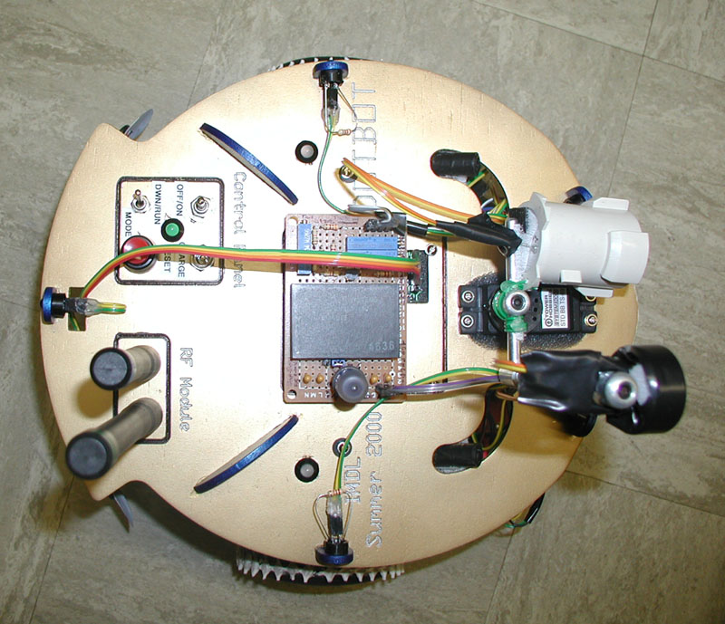

Instructors
Dr. Antonio Arroyo / Dr. Eric Schwartz

“D.O.T.BOT”

By
Diego O. Terzano

Summer 2000

