Sensor Report

EEL5666

July 14, 2000

Donald Cheung

Prof. A.A.Arroyo
Introduction

Two sensors were experimented with and data taken. Both are necessary to complete the fire fighter.

Flame detection components:
Hamamatsu R2868 flame detector
Hamamatsu C3704 driver circuit
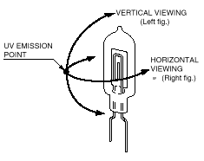

Bump detection components:
Motorola MPX5100DP
Motorola 68HC11 driver circuit/program
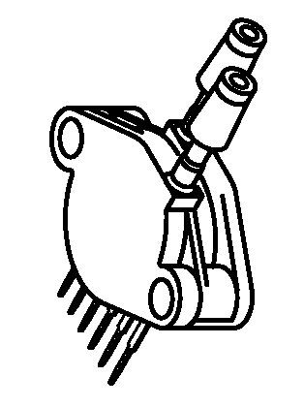

Flame Detector

The Hamamatsu Corporation has developed a near UV(ultra-violet) radiation detector. The detection range of 185-260nm wavelength of light allows it to see the presence of fire in most environments. Sunlight and modern artificial lighting emit very small amounts of UV. This allows the UV Tron R2868 to detect a flame due to its radiation of UV. Figure 1 depicts this from the Hamamatsu datasheet on the UV Tron.

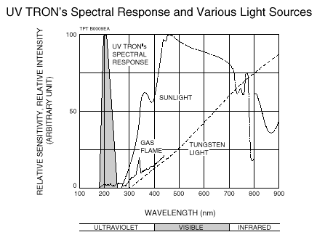
Figure 1

Experiment

The driver circuit, C3704, of the UV Tron provides the user with many options. Figure 2 was taken from the Hamamatsu datasheet on the UV Tron driver circuit.

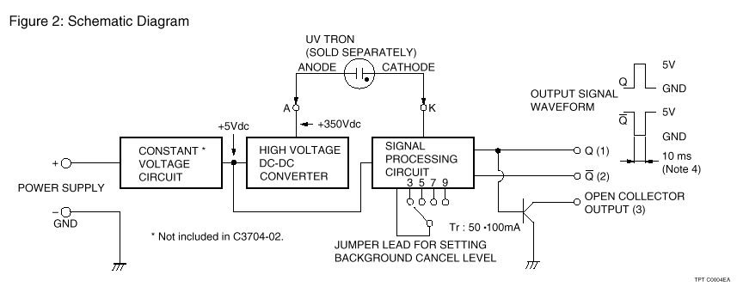
Figure 2
The circuit was powered up by a 5V-power supply and the output was fed to an oscilloscope. By introducing a .47μF capacitor to the C_{x} points on the board, the 10ms-pulse width output was modified to .5s. This allows the 5V pulse to be seen as a 0-5V representation on the limited scope rather than to try to catch the 10ms pulse. This has implications with a microprocessor input as well.

Experiments were conducted with several covers over the UV Tron tube. This proved to be the best method to use the UV Tron to find the direction of the flame. A two-inch candle generated the flame.

The following two illustrations depicts the experiment setup and results.

Experiment with a slit cover. +/- 10º space of no detection.
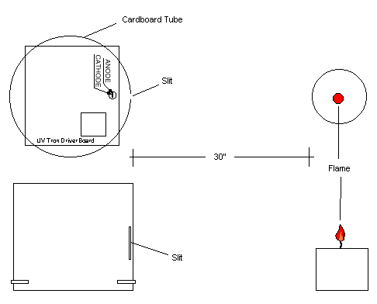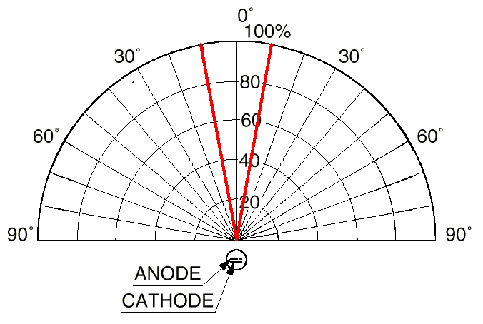
Figure 3

Experiment with a tube projected cover. Narrower +/- 8º space of no detection.
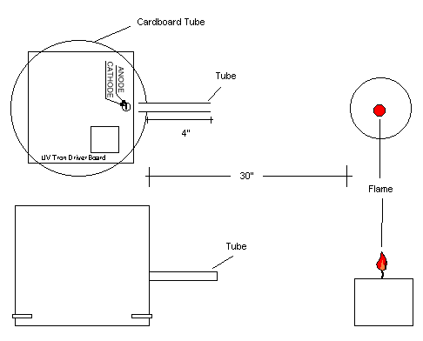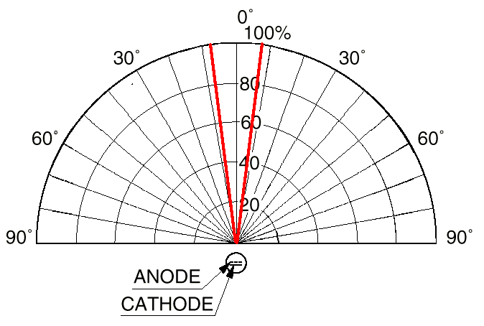
Figure 4

5V observed on the oscilloscope verify that the detector sees the flame. Simple trigonometric math was used to calculate the angles of visibility. The detector’s range of 5m from the flame source was seen to hold even when using the different covers.

Conclusion

The UV Tron R2868 and C3704 detector/driver proves to be a worthy flame detector for fire fighting robotic applications. The detector will be used for a first detection of a flame. The rotating turret will be used to search 180º left and right to seek for a flame. An ordinary CdS cell, used in conjunction with the system, may be used for pinpointing the actual flame just before extinguishing the flame.
Bump Detector

The MPX5100DP pressure sensor, made by Motorola, was used as a bump sensor in the following experiment. The sensor has a DP designation meaning differential port. The vacuum side of the part was vented to the atmosphere for reference to one atmospheric pressure. The pressure sensor provides a 0-5V output corresponding to the difference in pressure between the pressure side of the package and the vacuum side of the part. The MPX5100DP is integrated, an all in one package with temperature compensation, signal amplification, and voltage conversion.

The pressure measured is in kPa(kilo Pascal), where 1kPa = .145psi(pounds per square inch). This linearity simplifies the data acquisition process. The microprocessor was programmed to read in from the A/D port continuously and continuously output the detected values to the screen. The source code is included at the end of this document.

Experiment

The following figures depicts the experimentation process:

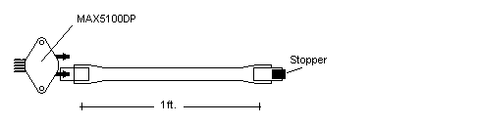
Figure 5

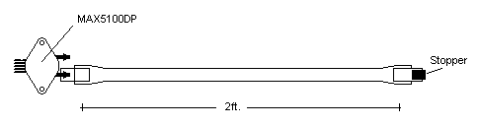
Figure 6

The Table 1 is results from the experimentation with the two different lengths of silicone surgical tubing. Depressing a finger on the tubing simulated jarring. The longer tube length lost pressure due to the flexible nature of the tubing. This effect was not too drastic so tube lengths up to two feet may be used safely and was still able to detect a bump. The 1ft. sensor, which had a greater pressure range, will be used.

Conclusion

Much better resolutions may be gained by using a sensor with smaller range. The MPX5100DP has a range from 0-100kPa or 0-14.5psi. The MPX5010DP has a range of 10kPa, or 1.45psi, which is more suited to the bump application.

1ft. Tubing |  |  | 2ft. Tubing
Hex | Decimal | PSI | Hex | Decimal | PSI
0A | 10 | 0.57 | 0B | 11 | 0.62
0A | 10 | 0.57 | 0B | 11 | 0.62
0A | 10 | 0.57 | 0C | 12 | 0.68
0A | 10 | 0.57 | 0C | 12 | 0.68
0A | 10 | 0.57 | 0C | 12 | 0.68
0A | 10 | 0.57 | 0C | 12 | 0.68
0A | 10 | 0.57 | 0C | 12 | 0.68
0A | 10 | 0.57 | 0C | 12 | 0.68
0A | 10 | 0.57 | 0C | 12 | 0.68
0A | 10 | 0.57 | 0D | 13 | 0.74
0B | 11 | 0.62 | 0D | 13 | 0.74
0A | 10 | 0.57 | 0D | 13 | 0.74
0A | 10 | 0.57 | 0E | 14 | 0.80
0B | 11 | 0.62 | 0E | 14 | 0.80
0B | 11 | 0.62 | 0E | 14 | 0.80
0A | 10 | 0.57 | 0E | 14 | 0.80
0B | 11 | 0.62 | 0F | 15 | 0.85
0B | 11 | 0.62 | 0F | 15 | 0.85
0B | 11 | 0.62 | 0F | 15 | 0.85
0C | 12 | 0.68 | 0F | 15 | 0.85
0B | 11 | 0.62 | 0F | 15 | 0.85
0C | 12 | 0.68 | 0F | 15 | 0.85
0C | 12 | 0.68 | 0F | 15 | 0.85
0D | 13 | 0.74 | 0F | 15 | 0.85
0D | 13 | 0.74 | 0F | 15 | 0.85
0D | 13 | 0.74 | 0F | 15 | 0.85
0E | 14 | 0.80 | 0F | 15 | 0.85
0E | 14 | 0.80 | 0F | 15 | 0.85
0E | 14 | 0.80 | 0F | 15 | 0.85
0F | 15 | 0.85 | 12 | 18 | 1.02
10 | 16 | 0.91 | 12 | 18 | 1.02
10 | 16 | 0.91 | 0F | 15 | 0.85
11 | 17 | 0.97 | 0F | 15 | 0.85
12 | 18 | 1.02 | 0F | 15 | 0.85
13 | 19 | 1.08 | 0F | 15 | 0.85
13 | 19 | 1.08 | 12 | 18 | 1.02
13 | 19 | 1.08 | 12 | 18 | 1.02
13 | 19 | 1.08 | 0F | 15 | 0.85
13 | 19 | 1.08 | 0F | 15 | 0.85
13 | 19 | 1.08 | 0F | 15 | 0.85
13 | 19 | 1.08 | 0F | 15 | 0.85
13 | 19 | 1.08 | 0F | 15 | 0.85
13 | 19 | 1.08 | 0F | 15 | 0.85
13 | 19 | 1.08 | 0F | 15 | 0.85
13 | 19 | 1.08 | 0F | 15 | 0.85
13 | 19 | 1.08 | 0F | 15 | 0.85
13 | 19 | 1.08 | 0F | 15 | 0.85
13 | 19 | 1.08 | 0F | 15 | 0.85
13 | 19 | 1.08 | 0F | 15 | 0.85
13 | 19 | 1.08 | 0F | 15 | 0.85
13 | 19 | 1.08 | 0F | 15 | 0.85
13 | 19 | 1.08 | 0F | 15 | 0.85
13 | 19 | 1.08 | 0F | 15 | 0.85
12 | 18 | 1.02 | 0F | 15 | 0.85
12 | 18 | 1.02 | 0F | 15 | 0.85
13 | 19 | 1.08 | 0F | 15 | 0.85
13 | 19 | 1.08 | 0F | 15 | 0.85
12 | 18 | 1.02 | 0F | 15 | 0.85
13 | 19 | 1.08 | 0F | 15 | 0.85
13 | 19 | 1.08 | 0F | 15 | 0.85
13 | 19 | 1.08 | 0F | 15 | 0.85
12 | 18 | 1.02 | 0F | 15 | 0.85
12 | 18 | 1.02 | 0F | 15 | 0.85
13 | 19 | 1.08 | 0F | 15 | 0.85
12 | 18 | 1.02 | 0F | 15 | 0.85
12 | 18 | 1.02 | 0F | 15 | 0.85
12 | 18 | 1.02 | 0F | 15 | 0.85
12 | 18 | 1.02 | 0F | 15 | 0.85
12 | 18 | 1.02 | 0F | 15 | 0.85
12 | 18 | 1.02 | 0F | 15 | 0.85
12 | 18 | 1.02 | 0F | 15 | 0.85
11 | 17 | 0.97 | 0F | 15 | 0.85
11 | 17 | 0.97 | 0F | 15 | 0.85
11 | 17 | 0.97 | 0F | 15 | 0.85
10 | 16 | 0.91 | 0F | 15 | 0.85
0F | 15 | 0.85 | 0F | 15 | 0.85
0F | 15 | 0.85 | 0E | 14 | 0.80
0E | 14 | 0.80 | 0F | 15 | 0.85
0D | 13 | 0.74 | 0F | 15 | 0.85
0C | 12 | 0.68 | 0F | 15 | 0.85
0C | 12 | 0.68 | 0F | 15 | 0.85
0B | 11 | 0.62 | 0F | 15 | 0.85
0B | 11 | 0.62 | 0E | 14 | 0.80
0A | 10 | 0.57 | 0E | 14 | 0.80
9 | 9 | 0.51 | 0E | 14 | 0.80
9 | 9 | 0.51 | 0E | 14 | 0.80
9 | 9 | 0.51 | 0D | 13 | 0.74
9 | 9 | 0.51 | 0C | 12 | 0.68
9 | 9 | 0.51 | 0C | 12 | 0.68
9 | 9 | 0.51 | 0B | 11 | 0.62
9 | 9 | 0.51 | 0B | 11 | 0.62
9 | 9 | 0.51 | 0B | 11 | 0.62
9 | 9 | 0.51 | 0B | 11 | 0.62
9 | 9 | 0.51 | 0B | 11 | 0.62
9 | 9 | 0.51 | 0B | 11 | 0.62
9 | 9 | 0.51 | 0A | 10 | 0.57
9 | 9 | 0.51 | 0A | 10 | 0.57
0A | 10 | 0.57 | 0B | 11 | 0.62
9 | 9 | 0.51 | 0B | 11 | 0.62
9 | 9 | 0.51 | 0B | 11 | 0.62
9 | 9 | 0.51 | 0B | 11 | 0.62
0A | 10 | 0.57 | 0B | 11 | 0.62
0A | 10 | 0.57 | 0B | 11 | 0.62
0A | 10 | 0.57 | 0B | 11 | 0.62
0A | 10 | 0.57 | 0B | 11 | 0.62

Pressure sensor experiment source code for the 68HC11

* Title : Pressure Sensor Experiment
* Filename : PS.ASM
* Programmer : Donald Cheung
* Date : July 16, 1998
* Version : 1.0.1.2
* Description : Uses one A/D port and outputs corresponding hex value
* to the display via the SCI port.
*
**************************************************************************
* Address locations of registers and user-defined constants
**************************************************************************
*
BAUD EQU $102B ; Baud-rate control
SCCR1 EQU $102C ; Serial Communication Control Register 1
SCCR2 EQU $102D ; Serial Communication Control Register 2
SCSR EQU $102E ; Serial Communication Status Register
SCDR EQU $102F ; Serial Communication Data Register

ADCTL EQU $1030 ;A/D Control/Status
ADR1 EQU $1031 ;A/D Results 1
ADR2 EQU $1032 ;A/D Results 2
ADR3 EQU $1033 ;A/D Results 3
ADR4 EQU $1034 ;A/D Results 4
OPTION EQU $1039 ;A/D Power-up(BIT7)

EOS EQU $04 ; User-defined End Of String (EOS) character
CR EQU $0D ; Carriage Return Character
LF EQU $0A ; Line Feed Character
FOFE EQU $0C ;Form Feed Character

OUTA EQU $FFB8
OUTCHAR EQU $FFBB ;OUTCHAR
OUTCRL EQU $FFC4 ;OUTPUT CR LF
OUTSTR EQU $FFCA ;OUTSTR W/O LEADING CR AND LF
*
************************************************************************
* Define Strings for displaying messages
************************************************************************
ORG $0100
RESULT FCC @ @ ;The main result is stored here

ORG $B600 ; Store to EEPROM
JMP MAIN

CRLF FCB CR, LF ; Carriage return and line feed
FCB EOS ; EOS character
*
************************************************************************
* MAIN PROGRAM
* Description: This program calls the InitSCI routine, and prints the
* A/D information to the screen.
************************************************************************
*
MAIN LDS #$0041 ;Define a stack
JSR INITSCI ;Initialize SCI

LDAA #%10010000 ;Initialize A/D
STAA OPTION ;continuous conversion

LDAA #%00110011 ;Start A/D conversion
STAA ADCTL

L1ADM LDAA ADCTL ;Wait for first conversion
ANDA #%10000000 ; to complete
BEQ L1ADM

L1M LDAA ADR3 ;Load A/D register 3 into A
STAA RESULT ;Store into RESULT

LDX #RESULT ;Load pointer to RESULT
JSR OUTCHAR ;Output character with hex-ascii conv.

LDAA #LF ;Output Line feed
JSR OUTA

BRA L1M ;Main loop
*
************************************************************************
* SUBROUTINE - InitSCI
* Description: This subroutine initializes the BAUD rate to 9600 and
* sets up the SCI port for 1 start bit, 8 data bits and
* 1 stop bit. It also enables the transmitter and receiver.
* Effected registers are BAUD, SCCR1, and SCCR2.
* Input : None.
* Output : Initializes SCI.
* Destroys : None.
* Calls : None.
************************************************************************
*
INITSCI PSHA ; Save contents of A register

LDAA #$30 ; Set BAUD rate to 9600
STAA BAUD
LDAA #%00000000 ; Set SCI Mode to 1 start bit,
STAA SCCR1 ; 8 data bits, and 1 stop bit.
LDAA #%00001100 ; Enable SCI Transmitter
STAA SCCR2 ; and Receiver

PULA ; Restore A register
RTS ; Return from subtoutine
*
************************************************************************
* END OF PROGRAM
************************************************************************

