EEL 5666 Final Report

Erick Garcia
Psychic

August 9, 2000

TABLE OF CONTENT

ABSTRACT ……………………….3

EXECUTIVE SUMMARY .……………………….4

INTRODUCTION ………………………..5

INTEGRATED SYSTEM ………………………..6

MOBILE PLATFORM ………………………..6

ACTUATION ………………………..6

SENSORS ………………………..7

BEHAVIOR ………………………..9

DISCUSSION ………………………..9

CONCLUSION ……………………….10

APPENDIX A – MTJPRO11 ……………………….11

APPENDIX B – BOTBASH RULES ……….13

APPENDIXV C – ICC11 CODE ……….14

ABSTRACT
Psychic is a maze navigation autonomous robot. The design for Psychic’s body is based on the Talrik Junior (TJ) which fits the dimensions set forth by the rules for the BotBash 2000 competition. The rules state that a robot must fit within an 8-½ inches by 11-inches sheet of paper, and measure no more than 15 inches in height. Psychic is design to navigate a maze using three Infrared emitters and receivers, two Bend sensors, four Bump sensors and one Optical sensor. For actuation, Psychic uses two servos that are controlled by the MC68HC11 microcontroller. The software that controls Psychic was written using Interactive C (ICC11) version 5.
EXECUTIVE SUMMARY

The main purpose of this design project was to engage in all the facets of building a low cost autonomous robot. First the robot controller, then the platform, followed by the sensors and lastly the behaviors. The robot controller is the MTJPRO11 circuit board with a MC68HC11 microcontroller, 32 kilobytes of SRAM, a five volts serial communication interface, a high-speed serial bus, a 5-volts regulator and a low voltage inhibit reset circuit. The platform is made from model airplane plywood and is based on the Talrik Junior. The sensors allow Psychic to detect, touch and navigate the walls inside a maze. The behaviors were implemented using ICC11 to bring Psychic to life.
INTRODUCTION
The purpose of this paper is to discuss the construction and development of an autonomous robot. The main task for the robot is to navigate a maze employing all the sensors implemented.

BODY
Integrated System
Psychic’s brain consist of a MTJPRO11 single chip board with 64Kbytes of SDRAM, five volts serial communication for interface, five volt regulator and a high speed synchronous serial bus. See appendix A for illustration of the MTJPRO11.

Mobile Platform
The body of this robot is based on a Talrik Junior (TJ). The reason for choosing this platform is to comply with the rules and specifications for the Botbash 2000 Autonomous robot competition. The rules state that the body of the robot must fit within a 8.5” X 11” sheet of paper, the height restriction is 15” and the weight not exceed 25 pounds (See appendix B for complete details of the rules). The circular body enables Psychic to explore his universe without the risk of getting stuck on any wall or objects.

Actuation
The motion of the robot is controlled using servo motors. A servo motor includes a built-in geartrain and is capable of delivering high torque. Psychic has two High Tech HS422 servos, each one is capable of yielding 43 oz-in of torque. The servos must be hacked before they are installed on the body of the robot. The hack is fairly easy, just follow the instructions on the TJPRO Assembly Manual provided by Mekatronix available online at www.mekatronix.com. The motors will be controlled through Interactive C (IC) software using pulse width modulation. The robot has two wheels measuring 2.75 inches in diameter.

Sensors
There are four kinds of sensors used on psychic. The first type is infrared (IR) emitters and receivers. The main task of these sensors is obstacle avoidance. Infrared sensors are the eyes of the robot, which help it interact with the immediate environment. One inconvenience of using infrared sensors is the limited range of detection of any object. When hacking the Infrared receiver, make sure that to keep the insulation on the wire. Otherwise, the hack will not work (see fig. 1).
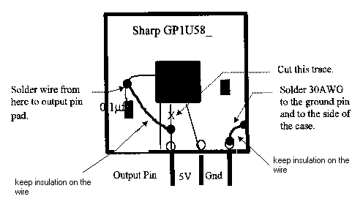
The second type are bump sensors which are used as a backup for infrared sensor failure. There are 4 bump sensors located at 10 o’clock, 12 o’clock, 2 o’clock and 6 o’clock on the circular body respectively. The third type of sensor is an optical sensor that takes visual cues from a shaft. The visual cues will be used as counting device to measure short distances. The fourth sensor is a bend sensor also known as a flex sensor. A bend sensor is a sensor that changes resistance as it is bent, thus the name. The sensor will be implemented in the wall following behavior. The physical measurements of the bend sensor are 4.5 inches in length, ½ inch in width and .02 inch in thickness (see figure 1).
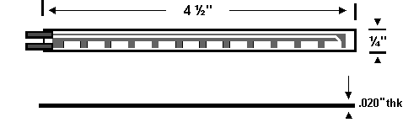
Figure 1 Jameco Bend Sensor (Part number FLX1)

Edmundo Pacheco created the circuit design. The anode is connected to 5 volts through a 22 kΩ and the cathode is connected to ground. The signal is taken from the anode. When the sensor is the straight position the signal reads 76, however when the starts to bend the signal goes up. The following table shows the data collected from the sensor.
Distance from wall | Degrees | Values(readings)
4.500 | 0.0 | 76
4.375 | 13.5 | 85
4.250 | 19.2 | 88
4.125 | 23.6 | 90
4.000 | 27.3 | 90
3.875 | 30.6 | 93
3.750 | 33.6 | 94
3.625 | 36.3 | 96
3.500 | 38.9 | 98
Table 1 Values obtained as the sensor was deflected.
The values read can be used to determine how close the robot is to the wall and its implementation will be vital for wall following behavior. Figure 2 show a plot of values vs. inches of deflections.
Figure 2 Values vs. inches of deflection

As seen from the figure 2, the sensor seems to fail when it is being deflected between 0.4 to 0.6 inches or between 23.6 and 27.3 degrees as the values obtained remain unchanged. Another way the sensor fails is if it somehow the sensor get twisted, when this happens the sensor still reads but is not as sensitive. The values go up to 82 and then remain constant regardless of deflection. It was also observed that the sensor is most effective when the bending occurs in the frontal position (see figure 3).
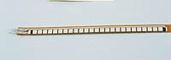
Figure 3 Sensor frontal position
If the sensor is bent in the opposite direction the values read increase slowly as in the case of twisting. Note: this sensors tend to change in shape as use is increased, therefore the values shown in Table 1 did not remained constant throughout the testing phase of Psychic. This made implementing the wall following routine very difficult, since I had to keep checking the values coming from the sensor and adjusting the code accordingly. Keep in mind that each bend sensor can have different threshold, so always test your sensors before writing code.

Behaviors
There are two types of behaviors implemented on the robot. One of the behaviors is obstacle avoidance. This is achieved through the use of infrared sensors primarily, bump sensors are employed as a fail mechanism for IR. The second behavior is wall following through the use of bend sensors. Maze navigation will be effective by combining the two behaviors.

Discussion
The most difficult task on this project was programming and debugging. A word of advice, complete the hardware on your robot as fast as possible and give yourself at least six to eight weeks to write, test and modify your code. There are many things that can go wrong in this phase. From non-working components to dead batteries to bugs on your software, the possibilities are infinite, even a cold solder can bring your work to a halt. It took me a couple of days to find out why my board would not get into download mode. It was puzzling to understand what had gone wrong, since the board had work before. I had to unmount the board and re-solder every point that looked erratic.
Motor control using software is very tricky. I found that my servos run at maximum speed or zero speed, therefore the use of the wait command become essential. There is a negative effect when using the wait command, it makes the robot shake and this subsequent behavior can be destructive to the servo motors.

CONCLUSION
Psychic worked well given the time constraint to write, test and debug the software I wrote for it. I was pleased to have finished all of the hardware and had a working robot. My wall following code needs work, especially in the area of behavior integration. Future works will include adding a CdS sensor, continue working on the software and enter the maze competition in May of 2001.
APPENDIX A
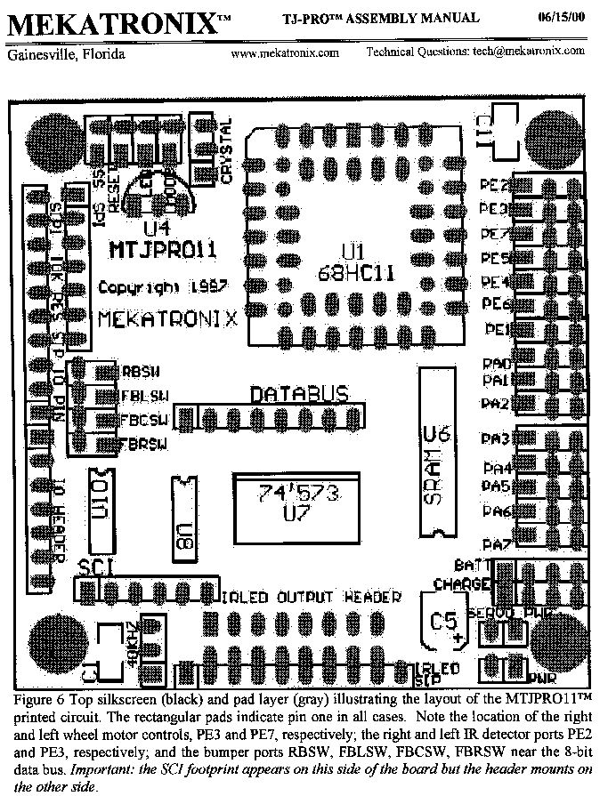
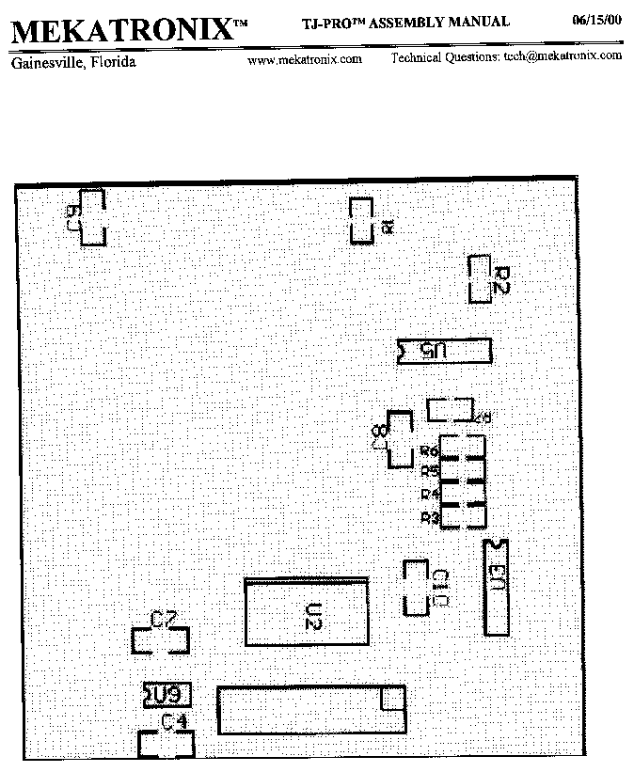
APPENDIX B

<!doctype html public “-//w3c//dtd html 4.0 transitional//en”>PAReX Autonomous Robot Competition Rules for BotBash™ 2000

- Robot Specifications

Robot must fit within the confines of a standard 8.5” X 11” sheet of paper at the start of the robot’s run in the maze, the Height restriction will be 15”. The weight shall not exceed 25 lbs.
The robot must not purposely destroy the arena, if robot attempts to destroy the arena the robot will be
disqualified.
The robot may touch the walls and floor of the arena with sensors (bump), but this is not encouraged due to this being a timed event.
Robots must be fully autonomous, this includes onboard processing. Robots will not be allowed to be tethered or have radio links to a remote computer. Robots may not be radio controlled.
Onboard processing may be performed by any means possible, but the processing must be performed onboard the robot within the size restrictions.
Explanation of robot’s processing must be presented to the judges before the entrant will be allowed to
compete. This is to just verify and understand the principle with which the robot works.
Contact with the arena floor must be maintained through the attempt, i.e. robots will not be allowed to fly across the arena.
There will be one class: Open Class

B. Arena

The arena floor will be a 4’ X 8’ sheet of pegboard that will be painted flat black. A series of like sheets may be used for larger arenas. Any gaps between sheets will be kept to an absolute minimum, and the gap will be taped with black tape if necessary. The arena walls will be 5.5” tall and painted flat white.
The Start Box and Finish Line will be defined by a 1” wide piece of white electrical tape as defined on the arena drawing. The timer is activated as soon as the robot breaks the plane of the starting beam that passes through the end of the starting box and will stop as soon as the robot breaks the plane of the finish line.
The walls will be fastened to the arena floor and will not be able to be moved by a pushing robot.
The passages and openings in the maze will not be less than 10” in width.
An arena layout will not be posted before the event. In fact, the arena will be randomly put together by the
judges 10 minutes before the competition begins.

C. Objective

Entrants will have a total of five attempts to complete three different mazes, the best attempt (farthest distance traveled towards goal or shortest time to completion) will count towards final placement. The best times (added up) to be the least total amount of total time or addition of the distances to be the farthest or a logical combination of both methods will determine the overall winner.
It’s simple, the robot that transverses the mazes with the shortest time or if no one completes the maze the robot that gets the closest to the goal wins that maze. Robots that do not complete the maze will have their time for that maze listed at 7 minutes.
The maze configuration will not be changed until all competitors have had a chance to run that maze
configuration. After all competitors have had their first run of the maze, then each competitor will be given the opportunity in sequence to re-run the maze, when the second attempt runs are completed then a chance at a third and final run of the maze will be offered. After this run the maze will be changed to the next configuration.
(Note, while it is possible to run one maze three times this will only allow you one run for the other two maze configurations.) Once the maze has been changed, a previous configuration may not be re-run.
Competitors have the right to terminate a run at any time, but they must inform the judge prior to doing so. Once a run has been terminated, it may not be re-started. Competitors who terminate a run may however try the maze again at their next normal opportunity unless the terminated run was the third attempt at a specific maze or their fifth total run.
Before the competition begins competitors will have the use of the actual maze or a practice maze (at our
discretion) to test their robot and to perform any necessary adjustments (I.E. calibrate sensors)
There is a 7-minute time limit for each entrant’s attempt.
Once the competition begins the robot may not have any new or additional software loaded. This includes all three mazes.
Decision of the judge(s) is final.
APPENDIX C
/************************************************************************
* MEKATRONIX Copyright 1998 *
* Title mazesolv.c *
* Programmer Erick Garcia *
* Date August 02, 2000 *
* Version 3.13 *
* *
* Description *
* A wall following and collision avoidance program. TJ PRO will *
* read each IR detectors, bend sensors and follow a wall and *
* turn on coners. Also, if something hits TJ PRO's bumper, *
* it will back up, turn, and go on. *
* *
************************************************************************/

/*************************** Includes ********************************/

#include <tjpbase.h>
#include <stdio.h>

/************************ End of Includes ****************************/

/*************************** Constants ********************************/

#define IR_THRESH 120
#define NILL 89
#define BSL_THRESH 148
#define BSR_THRESH 130
#define MAX_V 100
#define TQTR_V 75
#define MID_V 50
#define MIN_V 0
#define BUMPER analog(0)
#define RIGHT_IR analog(2)
#define LEFT_IR analog(3)
#define BACK_IR analog(7)
#define RIGHT_BS analog(5)
#define LEFT_BS analog(6)

/************************ End of Constants ****************************/

/*************************** Prototypes *********************************/

void turn(void);
void infr(void);
void bendl(void);
void bendr(void);

/************************ End of Prototypes *****************************/

void main(void)

/****************************** Main ***********************************/
{
int lir, rir, lbs, rbs, mode, i;

init_analog();
init_motortjp();
init_clocktjp();

*(unsigned char *) 0x7000=0x07; /* turn on all Sensors emitters */

START; /*Press the rear bumper to start the program*/

while(1)
{

/*
The following block will read the IR detectors, and the bend sensors and
decide which mode to run.
*/

rir = RIGHT_IR;
lir = LEFT_IR;
rbs = RIGHT_BS;
lbs = LEFT_BS;

if (rbs <= 95 && lbs <= 95){
mode = 1;
do {
infr();
} while (mode == 1);
}

else if (lir >= 90 && lbs > 95){
mode = 2;
do {
bendl();
} while (mode == 2);
}

else if (rir >= 90 && rbs > 95){
mode = 3;
do {
bendr();
} while (mode == 3);
}

else {
mode = 4;
do {
turn();
} while (mode == 4);
}

}
}
/*********************End of Main********************************/

void turn(void)
{
int i;
unsigned rand;

rand = TCNT;

if (rand & 0x0001)
/*turn left*/
{
motorp(RIGHT_MOTOR, MAX_SPEED);
motorp(LEFT_MOTOR, -MAX_SPEED);
}
else
/*turn right*/
{
motorp(RIGHT_MOTOR, -MAX_SPEED);
motorp(LEFT_MOTOR, MAX_SPEED);
}

i=(rand % 1024);
if(i>250) wait(i); else wait(250);

if(FRONT_BUMP)
{
motorp(LEFT_MOTOR, -MAX_V);
motorp(RIGHT_MOTOR, -MAX_V);
wait(600);
turn();
}

wait(35);

}

void bendr(void)
{
int bndr, irdl;

bndr = RIGHT_BS;
irdl = LEFT_IR;

if (bndr >= 95 && bndr < 120)
{
motorp(RIGHT_MOTOR, MAX_V);
motorp(LEFT_MOTOR, MAX_V);

if (irdl > 120)
{
motorp(LEFT_MOTOR, -MAX_V);
}
else
motorp(LEFT_MOTOR, MAX_V);
}

else if (bndr >= 120 && bndr < BSR_THRESH)
{
motorp(RIGHT_MOTOR, MID_V);
motorp(LEFT_MOTOR, TQTR_V);
wait(25);
}

else if(FRONT_BUMP)
{
motorp(LEFT_MOTOR, -MAX_V);
motorp(RIGHT_MOTOR, -MAX_V);
wait(600);
turn();
}

wait(35);

}

void bendl(void)
{
int bndl, irdr;

bndl = LEFT_BS;
irdr = RIGHT_IR;

if (bndl >= 95 && bndl < 120)
{
motorp(RIGHT_MOTOR, MAX_V);
motorp(LEFT_MOTOR, MAX_V);

if (irdr > 120)
{
motorp(RIGHT_MOTOR, -MAX_V);
}
else
motorp(RIGHT_MOTOR, MAX_V);
}

else if (bndl >= 120 && bndl < BSR_THRESH)
{
motorp(LEFT_MOTOR, MID_V);
motorp(RIGHT_MOTOR, TQTR_V);
wait(25);
}

else if(FRONT_BUMP)
{
motorp(LEFT_MOTOR, -MAX_V);
motorp(RIGHT_MOTOR, -MAX_V);
wait(600);
turn();
}

wait(35);

}

void infr()
{
int irdr, irdl, speedl, speedr;

irdr = RIGHT_IR;
irdl = LEFT_IR;

if (irdl > IR_THRESH)
speedr = -MAX_V;
else
speedr = MAX_V;
if (irdr > IR_THRESH)
speedl = -MAX_V;
else
speedl = MAX_V;

motorp(RIGHT_MOTOR, speedr);
motorp(LEFT_MOTOR, speedl);

if(FRONT_BUMP)
{
motorp(LEFT_MOTOR, -MAX_V);
motorp(RIGHT_MOTOR, -MAX_V);
wait(600);
turn();
}

wait(35);
}

