Department of Electrical and Computer Engineering
EEL 5666
Intelligent Machine Design Laboratory

B.A.R.T.

Bartending Autonomous RoboT

Mark A. McCardell
June 8, 2000
Table of Contents
Abstract……………………………………………………………….. 3
Executive Summary…………………………………………………… 4
Introduction…………………………………………………………… 5
Integrated System………..……………………………………………. 6
Mobile Platform………..……………………………………………… 7
Sensors………………………………………………………………… 9
Actuation……………………………………………………………… 14
Behaviors……………………………………………………………… 15
Conclusion…………………………………………………………….. 16
Appendix……………….……………………………………………… 17

Abstract
The following paper describes the design of an autonomous robot that refills an empty cup when needed. The robot was built using a modified TALRIK platform and a hitched trailer. The robot is designed to seek out cups, determine if the cup needs refilling and refill them as needed. The mobile platform uses a Motorola 68HC11 EVBU Board, ME11 Expansion Board and sensors for feedback from the environment. The motivation behind the design of this robot was derived from working with handicapped people with limited mobility and lack the use of their hands. The use of this robot will increase their quality of life.
EXECUTIVE SUMMARY
B.A.R.T. is a three-wheeled autonomous robot. Its sole purpose is to seek out people in a room and wait periodically to see if a person needs their cup re-filled. It performs the function of a human bartender/waiter.
B.A.R.T. consists of a modified TALRIK platform and a hitched trailer containing a water reservoir. The main challenge of this project is to prevent the robot become jammed in a corner due to the hitched trailer. The secondary challenge was to design a water sensor that was reliable. If it failed, then entire platform would be destroyed.
The fully integrated platform was achieved by using the Motorola 68HC11 EVBU board, ME-11 expansion board, Infrared sensors, bump sensors and NPN transistor switches. The infrared sensors were the primary wall avoidance. If they failed, B.A.R.T. would have to rely on bump sensors alone. Motion was controlled using two servos and motor driver chip. Water was pumped into the cup using a salvaged photo lab pump.
Introduction:
Working with handicapped people, specifically, people with limited mobility, it was apparent that a simple task of refilling their ice water was a time consuming project for them. This repetitive task could be performed by a small, inexpensive autonomous robot.
The objective of this project was to build an autonomous robot that will seek out cups and, if needed, refill the cups. This objective was met using a variety of sensors, motors and mechanical pumps.
The paper will discuss the entire integrated system (mobile platform and trailer), following with the sensor suite and motor actuation used to accomplish the objective. Finally, we will discuss behavior algorithms and the specific code used to achieve the required objective.
Integrated System:
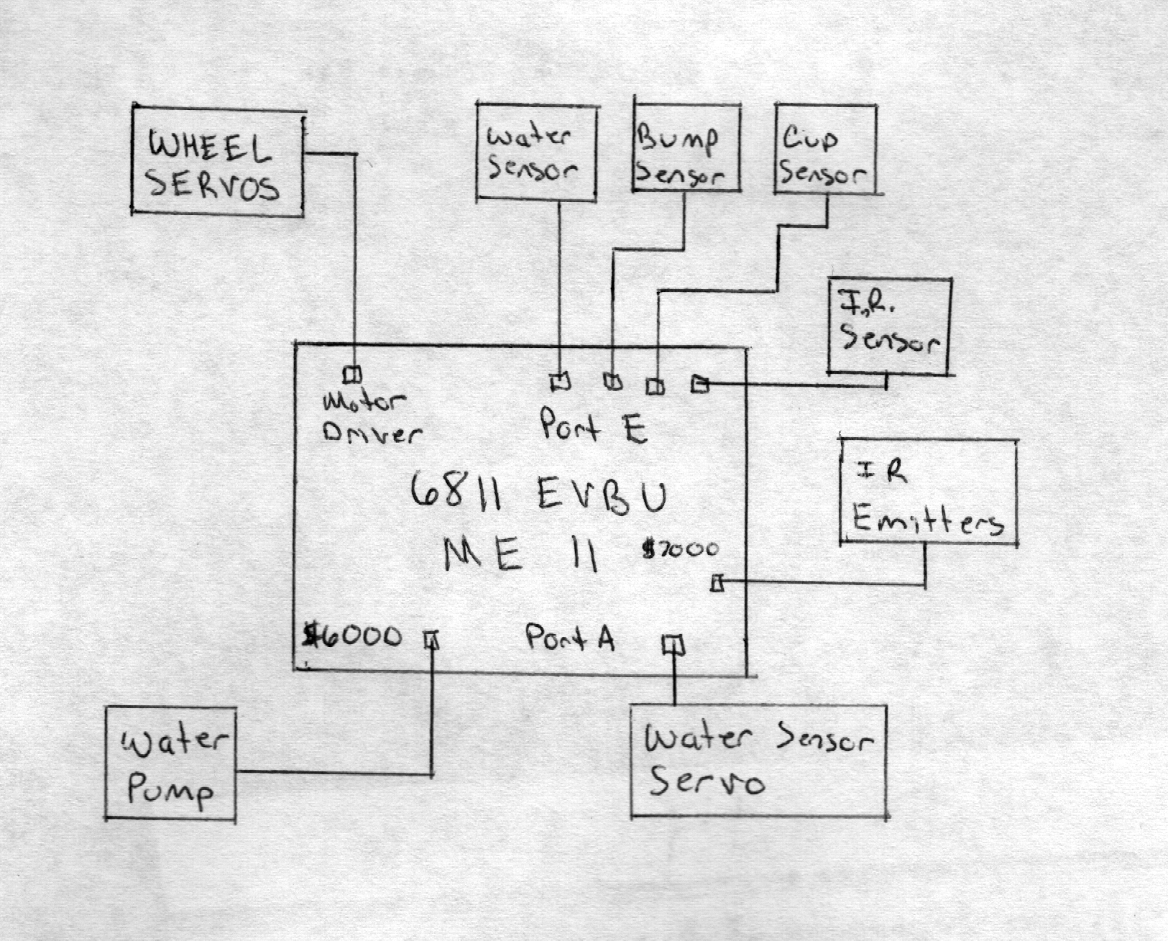
Figure 1
Figure 1 is a block diagram of the complete mobile platform. The completed system consists of 10 bumper switches, five for the front bump and 5 for the rear bumper. Infrared sensors are used for obstacle avoidance and to detect the presence of people. The Infrared emitters are powered by a 40 KHz signal generated by a memory port on the ME-11. Actuation will be accomplished by three servos. Due to the high current required, one servo for each wheel will be controlled by the motor driver on the ME11. The arm servo will be controlled with Pulse Width Modulation using Port A of the EVBU. The integrated system will be powered by eight Ni-Cad batteries providing 12volts of power.
The cup sensor will activate the water pump. The final sensor is a custom designed water detector to determine when the cup is filled.

Mobile Platform:

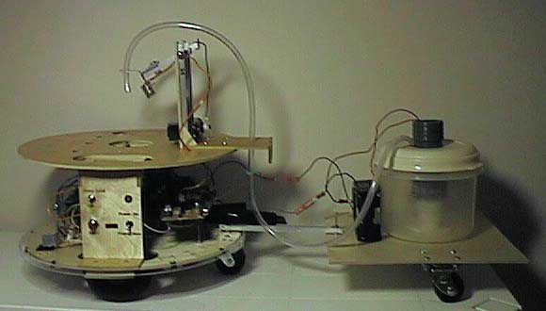
Figure 2
As can been seen in Figure #2 the mobile platform consists of a modified TALRIK platform that contains IR detectors, wheels attached to hacked servos for locomotion, one servo to raise and lower the water sensor and a micro switch to detect when a cup is placed on top of B.A.R.T. When the cup is determined to be empty, a relay switch is energized and the water pump located on the trailer is activated. The water on the trailer is then pumped into the cup until the water sensor detects the cup is full. The mobile platform as designed worked very well.
Few problems were encountered. The most significant problem occurred when BAR%T had to operate in tight confines. Because BART used a trailer, he had to be very careful when backing up. In tight confines, he would sometimes jack-knife the trailer. To combat this problem, I wrote into the avoidance code to detect when the back bumper was pressed during reverse. Since this could only occur when BART jack-knifed, he would immediately accelerate forward to eliminate the jack-knifing. However, if he was in a tight space, that proved to be impossible. In future iterations of BART I may incorporate a potentiometer into the hitch to detect the angle of the trailer before it jack-knifes. No other solution exists without significant changes to the structure to the platform. Any future robotic designs using a trailer, the designer must be aware of the limitations of the design when encountering tight spaces.

Sensors:
To simply my code, I attached all sensors to the analog port of the 6811 EVBU. Since, the code for reading the analog ports has already been written by Professor Doty, the made the job of coding much easier. The 6811 has eight analog inputs, there is plenty of room for expansion. My design called for six sensors: Two IR sensors, Bumper sensor, Water sensor, and a Cup sensor.
IR: 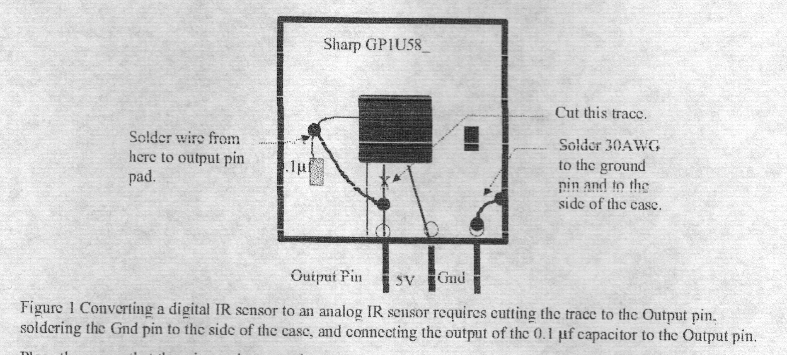
Figure 3

Figure 3. depicts the hacked version of the Sharp GP1U58 IR detector that I used for obstacle avoidance (Full details of the IR hack can be found at Mekatronix.com). This allowed me to determine approximately, how far away my robot was from an object or person. When the analog port got a reading of 128, the robot was approximately 1 foot away from the object. Many factors determine the capability of the detectors. I noticed when I used a smaller resistor in the IR emitters, it increased the distance I could detect an object/person. Conversely, if I wore dark pants the robot could not detect me until it was less than 8 inches away from my leg.
Bump:
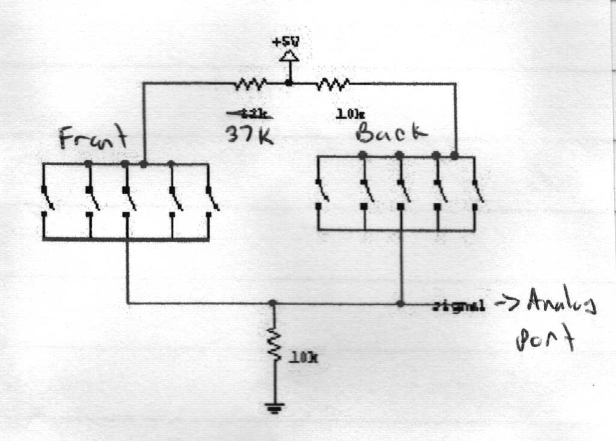
Figure 4
The bump sensors consist of 10 micro switches mounted around the perimeter of the TALRIK platform. They are the back up sensors for the IR detectors. If, for whatever reason, the IR detectors fail to detect an object, the bump sensor will determine if BART has encountered an object or person. Figure 4 is a schematic of my bumper sensor suite. Using this design, I was able to use only one analog input to detect of the front or rear bumper was pressed. If the front bumper was pressed, the analog input read 50, front bumper: 114 and if both were pressed: 130. The only drawback to this design is the robot cannot determine which side was struck by an object. A solution to this is to wire micro switches in series. An excellent design is described in “Mobile Robots” by Joseph L. Jones pg. 139. The drawback in this design is the complexity. I wanted to keep everything simple and reliable.

Water:
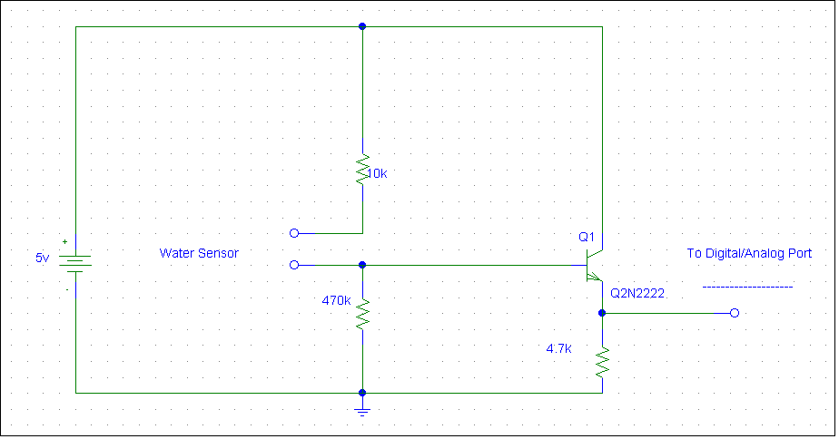
This is a customized sensor. I spent more time designing and implementing this sensor than all the other sensors combined. Its sole function is to detect water in the cup. It is similar to a continuity tester. The physics behind this sensor revolve around the NPN transistor. An NPN transistor can be used as a switch. When the base falls below .5v current will no longer flow through the emitter. By attaching the emitter to an analog port, a voltage will be detected when the voltage in the base rises above .5v. Since, water conducts electricity, it will complete the circuit at the base when water is present. WARNING: This type of detector CANNOT be used with flammable liquids. Because current is flowing through the liquid, there is a high potential for an explosion. This detector can be attached to an analog or digital port. When water is present, a voltage of 3.95v will be detected by the analog/digital port. The versatility and reliability of the sensor are its greatest strengths. It can be constructed with parts from Radio Shack for less than $5. Below is a list of the parts and a picture of the final design.
- 1.75x1.75 in. predrilled solder breadboard Catalog # 276-148
- NPN Transistor, 2N3906, Pack of 15. Catalog # 276-1617
- 470k Ohm, 10k Ohm, and 4.7k-Ohm Resistors. Catalog # 271-309
- Breadboard Wire. Catalog # unknown.
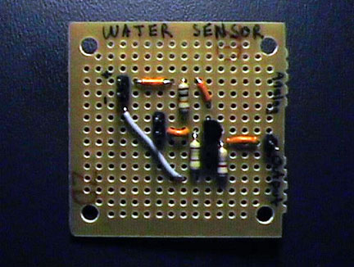
When the sensor DOES NOT water in the cup, it energizes a N.O. reed relay (Radio Shack # 275-232) by writing to a memory mapped output port at $6000. When +4v is applied to the relay, it closes a switch attached to 4.5volts. This in turn provides power to the water pump. When water is finally detected in the cup, the voltage to the relay is terminated and consequently power to the power is terminated.
My initial design used a commercially available water sensor. However, it only emitted .6mV when activated, so I attached an op-amp using a non-inverting configuration. Since, I have very little experience with op-amps, I obviously overloaded the circuit and destroyed the sensor. My final design was much easier to design and construct.

CUP:
This sensor is identical in operation to the bumper sensor. However, the bumper sensor used micro switches. For the cup sensor, I used a vertically mounted SPDT lever switch (Radio Shack # 275-017). The sensor was activated when a cup weighing more than 5 grams was placed on top the TALRIK. BART would not lower the water sensor until it detected the cup. In addition, BART would not leave until the cup was removed from its top platform.
SENSOR READINGS:
Below is a table of the analog readings obtained from sensors attached to the analog Port E. I used a program that I wrote using ICC11 (See appendix A: senstest.c) to determine the nominal and threshold (activation) values for each sensor.
 | Nominal Value | Threshold Value
Left IR Detector | 80 | 127
Right IR Detector | 85 | 127
Front Bumper | 0 | 114
Back Bumper | 0 | 45
Both Bumpers | 0 | 130
Water Sensor | 20 | 110
Cup Sensor | 0 | 200

Actuation:
Actuation for my robot was accomplished by using two hacked Hi-Tec HS-422 servos, one standard HS-422 servo and one surplus water pump. The process of hacking the servos is straightforward. The information was provided by Scott Jantz of the Intelligent Machine Design Laboratory. Full details of the servo hack can be found on Mekatronix.com The hacked servos are powered by the motor driver included with the ME-11 expansion board. Software to control these servos has already been written by Professor Keith Doty. To provide adequate power an eight pack of batteries supplied the required voltage. Note: The battery pack must be attached to the ME-11 and NOT the Motorola EVBU board. The ME-11 has a 6v voltage regulator. The EVBU does not have a voltage regulator and the electronics could be damaged if the battery pack is attached directly to the EVBU.
The standard HI-Tec HS-422 servo is used to actuate the water sensor arm. It should be noted that any brand of standard servos could be used in unhacked applications. Power for the servo is provided by a separate 6-pack battery. Control of the servo is provided by Port A, PA/OC4 pin. Sending a pulsed width modulated signal moves the sensor arm up or down. I used libraries written by professor Keith Doty to control the servo.
The water pump is a surplus part that I purchased for $3 from SkyCraft, Inc. Orlando, Fl. They can be contacted through www.skycraftsurplus.com They have extensive supply of surplus parts that can be used in the construction of a robot.
Behaviors:
The behaviors of my robot are simplistic because its only purpose is to wander a room looking for people that need their drinks refilled. I have programmed basic obstacle avoidance (See Appendix A: bart.c and bartbase.h) behavior into BART. If it comes within a foot of an object or person (At this time BART cannot determine the difference), it will pause for a couple of seconds and then back up, make a random turn and go to another location. When it pauses periodically, it waits for a person to place their cup on top of BART. If BART detects the cup is empty it will fill the cup up with water. It will not leave until the person has removed their drink from the platform. These functions imitate a waiter/bartending precisely.
Conclusion:
When I first enrolled in this class, I had grand visions of a very sophisticated robot that had moving arms, pre-recorded voice chips and mainly other fancy options. In the end, I built a robot that was simple, but still accomplished the task of refilling a person’s drink when empty. This was my first robot and I am happy with what I accomplished. The project taught me how to improvise and draw on the information that has been taught to me in the Electrical and Computer Engineering program.
The most limiting factor in my robot is that it cannot distinguish between a person and an object. Fortunately, I discovered a sensor that will detect 820nm wavelength. A human radiates this specific spectrum. It’s called a pyroelectric sensor. Unfortunately, I learned of this sensor too late in my project to order it and incorporate it into my robot. Another limiting factor in my robot is that it cannot operate in a small area. This factor cannot be changed without tossing out the entire platform and using a more nimble platform.
In the future I would like to incorporate the pyroelectric sensors to see how effect they are in detecting a person in the room. It would make BART more “intelligent”. Second, I would like to change the platform slightly and use a separate refilling station in place of the trailer. This would allow BART to operate in small rooms and provide unlimited supply of refills.
Overall, this class was extremely exciting. The TA’s, Scott Jantz and Scott Kanowitz, and professors Dr. Schwartz and Dr. Arroyo were very helpful and informative. Without them, the class would be overwhelming. I personally feel this class should be mandatory for all Electrical and Computer Engineering majors. No other class allows you to design something from the ground up.
Appendix A:
Bart.c
Bartbase.h
Senstest.c

