TRACER
Underground Cable Locator and Marker

Final Report

Michael Keefe

University of Florida

Electrical and Computer Engineering
Intelligent Machine Design Lab
Summer 2000

Instructors:

Dr. A. A. Arroyo
Dr. Eric M. Schwartz

TA’s:
Scott Jantz

Scott Kanowitz

Table of Contents

Abstract……………………………………..3
Executive Summary………………………...4
Introduction…………………………………6

Integrated System…………………………...7

Mobile Platform…………………………….8

Actuation……………………………………9

Sensors………………………………………10

Behaviors……………………………………13

Experimental Layout and Results…………..14

Conclusion…………………………………..15

Abstract

Tracer is a mobile robotic platform that will locate and trace underground cables. This is accomplished though means of radio waves. A SONAR transmitter and receiver are implemented for obstacle avoidance. Two main behaviors of locate and trace will be implemented in programming.
Executive Summary

Tracer was designed to provide an autonomous means of locating and tracing underground cables. Before any new construction can begin on a site, existing underground cable plants must be traced out. This is necessary so as to not cut or damage any cables already in the ground. This important steps prevents interruption of service to customers since most if not all underground cables and pipes are utility in one form or another. Telephone, cable, gas, water, sewage, and electricity all use underground cable and pipes. By the use of an inductive signal injector, any metallic object in the ground can be traced. With sufficiently high frequency, breaks in continuity can be jumped. This feature is useful when a rubber or other non-metallic gasket joins two pipes.

The successful completion of this robot could ease the workload of field service technicians. This concept could be taken to the point of an end-user consumer product to perform the tracing and marking without a field service technician present. A consumer could go to a local utility company, get a robot, push a button, and cables are then marked automatically. This platform can have many useful applications, one of which is tracing underground cables.

As with any new idea, a research and design phase must be completed. This paper describes the steps taken and the results produced in my research and development of this robot.

For the mobile platform, a RC car was chosen for its proven reliability and ease of adaptation. Steering and locomotion are achieved with the use of commercially available products. Marking is implemented with a solenoid and a spray paint can. Two sensors are employed, SONAR and RF. Locating and tracing will be the two main behaviors of the programming.

Introduction

Whenever any digging is to be done, an important consideration must be addressed. Any underground cables or pipes must be located and marked. This underground infrastructure contains TV, phone, and data cables as well as gas, sewage, and water pipes. Any previously installed cable or pipe must be located to prevent any damage to people and equipment or inconvenience any customers.

This job is accomplished by placing a RF signal onto a cable by direct injection or induction. A location wand is then waved across the ground until a signal is detected. By locating where the signal is strongest, the cable can be traced and marked.

My robotic platform will be able to perform this task autonomously. By incorporating radio receivers, the platform will be able to locate cable that has a location signal injected onto it. The platform will then trace and mark the cable.

This paper will cover platform design, actuation, sensors and behaviors. It will also cover collected data pertaining to the design of the mobile platform, sensors, or behaviors.
Integrated System

My platform will follow this basic mode of operation:
- Locate cable
- Follow cable
- Mark cable

These behaviors will be supplemented by obstacle avoidance as well.

Overall, the robot is of simple mind. The programming is very basic since many assumptions are made about its environment. Since the robot will be be tracing underground utility cables outside, the robot could function suitably with only the cable receiver. Since the cable will be run over open ground, obstacle avoidance during the tracing process is not very important. If an obstacle is encountered, it can be assumed to be a building or pedestal that the cable enters. When the robot encounters this obstacle, the job is done. Fig. 1 depicts a block diagram of the system function.

RF
Steering

Microcontroller

SONAR

Motor

Fig. 1

To locate, the robot will initiate a search pattern to look for a signal. When a signal is located, the operation will shift to follow mode. The robot will follow the signal by comparing two field strength readings. One will be to the right of the robot while the other will be to the left. By comparing these readings, the robot will know if it needs to go right, left, or straight.

Mobile Platform

The platform that I chose for my robot is that of a car. I chose this for its stability and mobility. An old RC car manufactured by a company called Team Associated that I had in my closet was the perfect choice for this robot. This particular car was designed for radio controlled racing and includes many benefits that I found desirable to have in a robot designed to function outside. The chassis is constructed of an aluminum tub and is very strong and light. Each wheel has its own independent suspension system utilizing oil filled shocks and a damping spring. This system is modeled after that of a car. The front and rear tires are composed of rubber. The rear tires have knobs that provide excellent traction outside.

I originally had designed a platform constructed out of 1/8” birch plywood. I found this platform to be too flimsy to handle the stresses of running outdoors. I felt that the stress of absorbing bumps would flex the platform too much and breakage would occur. This is why I opted to go for a manufactured platform.

One of the biggest problems encountered with this platform was availability of space. To overcome this, I constructed a shelf system to accommodate the extra electronics that I mounted on the platform. The chassis tub has a height of ¾”. This is deep enough to accommodate the battery, electronic speed control, and servo. I placed a sheet of 1/8” plywood on top of this tub. On this sheet, I mounted the EVBU/ME11 board, the battery pack for the EVBU board, and the sonar transmitter and receiver boards. I replaced the front bumper with a homemade bumper constructed out of 1/8” plywood. I mounted the RF receivers on this bumper. This helped to save space as well as provide distance between the RF receivers. On the front of the car, I placed a vertical plate of 1/8” plywood to which I mounted the SONAR transmitters and receivers.

I found that this platform was an excellent choice. The proven design and ruggedness of the platform is beneficial to a robot that is operating outside. The only problem that I encountered was the placement of the SONAR transducers. I will explain the reasoning in the sensor section.

Actuation

My robot uses three forms of actuation. The first, a DC motor is used for locomotion. The second, a servo, is used for steering. The third, a solenoid, is used for the marking mechanism.

For locomotion, a DC motor is used. It is controlled with an off the shelf electronic speed control (ESC). The ESC accepts a square wave signal identical to that of a servo. This signal is then run through a MOSFET driver circuit, which provides voltage to the DC motor. By varying the width of the signal pulse, different speeds can be achieved.

For steering, a standard unmodified servo is used. Again, a square wave pulse is transmitted to the servo and this in turn drives a steering circuit. By varying the width of the pulse, the servo can go forward or reverse from a neutral point. The servo is capable of rotating 45 degrees from neutral, giving a total rotation of 90 degrees. The full range of motion is not used since it is limited due to the steering design.

A solenoid is used for the spray paint marking action. By applying a voltage across the solenoid terminals, it draws in a plunger. This plunger is connected to the nozzle of a spray paint can. When pulled in, the nozzle allows paint to spray out.

The use of a commercially available ESC and servo saved a great deal of time. It also added to the simplicity of the design, since it boiled down to a black box approach. Input a signal, and get a result. Knowledge of the internal functionality is not necessary to produce the desired result. Unfortunately, I ran out of time to implement the solenoid mechanism.

Sensors

My robot employs two separate sensors, SONAR and RF. I had originally planned on using bump and IR as well for indoor testing, but decided to ditch these sensors since indoor testing was not necessary.

The first sensor is SONAR. This works by transmitting a 40kHz modulated wave of known length from a SONAR transducer. This wave is then received and filtered by a receiving transducer. By measuring the time between the outgoing and incoming pulses, the distance to an object can be determined by multiplying the time elapsed by that of the speed of sound. The transmitter is of simple design. It employs two 4049 hex inverters to drive the transducer. By connecting 5 inverters in parallel this can drive one terminal of the transducer. The other transducer is of the same design, except that is in inverted in phase by another inverter. Fig 2 shows the transmitter schematic.

Fig. 2

The receiver circuit is a filtering circuit. It uses a Maxim manufactured chip to filter the circuit so that only 40kHz signals pass through. By using an external RC network, the notch filter can be programmed. A comparator is used to establish a bias point for the filter. Fig. 3 illustrates the receiving circuit.

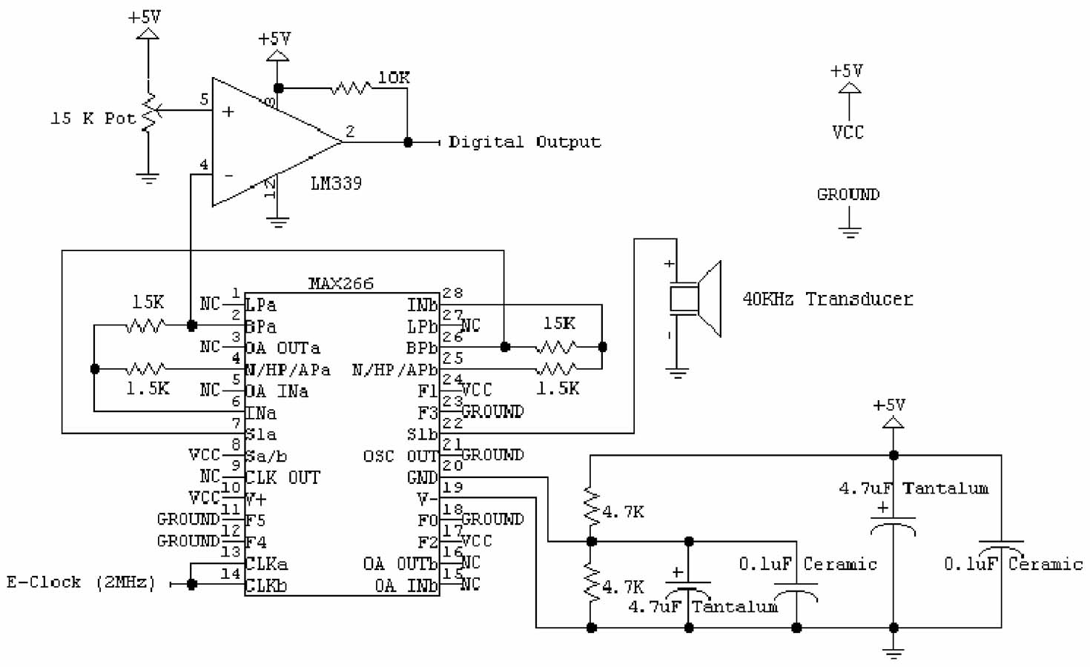
Fig. 3

A few days before demo day, my sonar receivers stopped working. I do not know why the stopped, but after power was disconnected, one board would short to ground and the other would heat up when power was applied. I was not able to get them working until the morning of demo day. By that time, they were not working correctly, so I think I might have damaged them in some way. I was unable to obtain any data from the boards regarding operation.

The primary sensor in my robot is the RF sensor. This is basically a tuned AM receiver. I picked 10kHz as my transmission frequency. A signal is placed onto the signal to be traced, wither directly or by induction. 10kHz was picked because it radiates relatively well through ground and it is too low of a frequency to jump to a nearby cable. Fig 4 illustrates my receiver.

Fig. 4

The antenna is an old solenoid casing. This was used since it provied a large number of turns in a small casing to pick up the signal better. The diode is made of germanium and is called a small signal diode. This is because of its low voltage drop across the forward bias terminals. These types of diodes are used when the signal is very weak and the diode imparts very little distortion on the signal. A RC series combination acts as a low-pass filter after the diode to smooth out the signal so that a DC voltage can be measured across the capacitor.

I encountered numerous problems with both of my sensors. My SONAR boards stopped working the day before demo day and I was unable to get them fully functional. I decided that this was not that big a problem since I would mostly rely on my RF sensor for cable location. Unfortunately, my RF sensor stopped working the day of demo day. I have found that this sensor is not a reliable design. I am not sure as to why this is. I have little knowledge in radio wave propagation and reception. I do not know if this is just a bad design, or if there are other reasons as to its failure. I have researched simple AM receivers on the web and the schematic is the same. The receiver circuit works when the signal is directly injected into the LC tank. The magnitude is frequency dependent, having a 3db roll-off bandwidth of approximately 800Hz. There are many possibilities to explore as to why this circuit is not working as intended. The antenna might be cause, if it can not successfully propagate the signal to the LC tank. The tank circuit might be detuning itself, thus negating its intended function. The signal may be too small to effectively propagate through the circuit.

Behaviors

Two basic behaviors would be implemented into the programming of the robot. The first is search and the second is trace.

During the search behavior, the robot will attempt to locate the cable. A plow, or back and forth, pattern will be implemented to locate the cable underground. By reading the RF sensor values and comparing them, a max value could be found. The location of the max value would be the starting point of the trace behavior. During the search behavior, obstacle avoidance would also be implemented. If the robot came upon an obstacle, it would steer in a random direction to avoid running into the obstacle.

When the cable is first located, the trace behavior would take control of the robot. During this behavior, a back and forth sweeping pattern would be implemented. This would allow the robot to determine the relative position to the underground cable. If the RF sensor on the right was high and then went low, the cable is on the robots right. It would then steer left to place itself back over the cable. The same operation would occur if the cable were on the left side, except the robot would steer right. This pattern is similar to that of a line following robot using CDS cells. The major difference is that with CDS, the robot can detect the edge of the line to be traced. With RF, the sensor has to pass over the cable, so a maximum value can be recorded. This behavior is necessary since there is no definite edge to the cable that the robot can “see.”

During the tracing behavior, the robot will look out for obstacles. In this mode, obstacles will be assumed to be a building or pedestal. In either case, the cable would terminate there. This assumption simplifies coding. If an obstacle is detected, stop moving. Since cables are run outside and around major obstacles, this assumption holds true. Cables are not run underneath trees or buildings, as this is a building code violation. The robot would also mark the cable every couple of seconds with the spray paint to provide a visual location of the cable.

Due to the malfunction of the sensors, I was unable to program the behaviors the robot was supposed to exhibit on demo day.

Experimental Layout and Results

I was unable to extrapolate any useful information due to the malfunction of my sensors. The only data obtained was during testing and setup of my robot. These results are discussed below.

The different pulse widths had to be determined for the steering servo as well as the ESC. Fortunately, both accepted the same kind of input signal. It was determined experimentally that the neutral pulse width for the servo was 3000 E-clock cycles. A pulse width of 2400 provided a maximum left turn. A pulse width of 3600 provided a maximum right turn. These values were similar for the ESC. A pulse width of 3300 was a neutral position. This value can be changed since there is a trim pot on the ESC that can move the neutral point around. A pulse width of 4000 provided maximum throttle. Anything below 3300 down to 2000 provided a brake, since the ESC does not have reverse capability.

For demo day, the only program that I was able to implement was for the robot to go forward and turn left and right. This was the extent of the robots' capabilities as presented on demo day.

Conclusion

Overall, I would rate my robot as a partial success. I was able to control the speed and steering of the robot via the microcontroller. Unfortunately, my sensors did not work and I could not implement them. I partly blame myself and the hardware.

I take blame for a couple reasons. My lack of knowledge concerning RF components and circuit design greatly hindered my ability to work with the RF sensor. It had been suggested that I buy an electronic dog fence or similar device, but I did not have any money to purchase these components. I believe that with better research and a faculty member experienced in this field would have helped me greatly in the design and application of my sensor. The other reason that I am to blame is that I poorly managed my time in the beginning of the semester. Had I started sooner and worked more diligently, I believe I could have had a fully functional robot. Near the end of semester I had very little time to devote to my robot due to school and work constraints. The week before demo day, I had absolutely no time to work on my robot due to work.

I think that I took on a very ambitious idea with the RF sensor. I do not know of many robots in previous classes that have employed this kind of technology. I was able to get the circuit to function correctly under certain conditions. None of the conditions, however, could be reproduced in the field. I think that with more time spent on some research and trials, I could successfully implement the RF sensor.

If I continue work on the robot in the future, I have several problems to work on. I need to get my SONAR receivers working again. I also need to get the RF sensor functional. Once these sensors were functional, I could implement the marking mechanism. This platform allows for a lot of room in coding. It can be kept very simple, or it can be quite sophisticated. Since I do not like to code, I would probably tend to take a minimalist approach to coding.

Overall, I would say the robot was a partial success.

