IMDL Final Report

By

R. David Bruns
Summer 2000

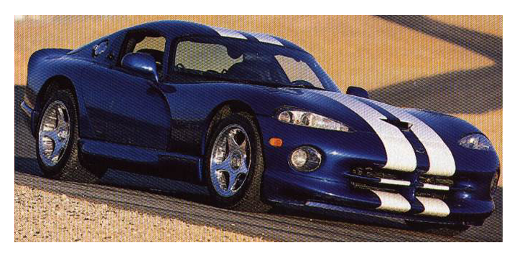
Table of Contents

Abstract………………….……………………………………………………………….2

Executive Summary…….………………………………………………………………..3

Introduction………………………………………………………………………………4
Integrated System……………………………………………………….………………..4
Mobile Platform………………………………………………………………………….4
Actuation…………………………………………………………………………………5
Sensors……………………………………………………………………………………5
Behaviors…………………………………………………………………………………8
Experimental Layout and Results………………………………………………….……10
Conclusion……………………………………………………………………………….10
Appendices
1.)Program flow Chart………………………………………………………..….11
2.)Test Programs……………………………………………………………………
3.)Final Program………………………………………………………………..….

Abstract
The purpose of Viper is to simulate an on board guidance system that would be employed on a vehicle. It is designed to be used on the interstate and to exit on off ramps automatically. Just as a passenger in such a vehicle would program in the desired direction, Viper uses a set of switches to get to a specific location. A set of LED’s on the side is used to alert the used when the vehicle if following a line, lost the line, or is taking a turn. Viper also regulates its speed based on turns and the amount of power that is contained in the batteries.

Executive Summary

The ability to detect a line is easy, to follow a line is difficult. The majority of the time spent on programming was done to try to continuously follow a line without the robot becoming confused by light being randomly reflected off of nearby objects resulting in the robot becoming confused and losing the line. The signals from the CDS cells were calibrated two different ways and their signals were continuously filtered. The amount of time that the robot waited before taking the next reading from the CDS cells was also a major factor in the performance of the robot.
Introduction
The concept for autonomous vehicles has been around for quite some time now, although due mostly in part to obvious safety implications and high cost, none of these systems have been implemented. Some solutions to the problem of how to make a car drive itself have included the use of video input for recognition of the road where others have made use of sensors which follow transmitters buried with in the surface of the road. The method that I employed to sense the road was the use of CDS cells to detect a line (electrical tape) on the road (near white surface). This method of detecting the path would be easy to implement in real life where it would only require painting a line on the surface of any road in order to support such autonomous vehicles.
Integrated Systems
Line following system:
The system employed to follow a line on the floor is an array of CDS cells located at the front of the car. The resistance of a CDS cell increases as more light is exposed the cell. Because the line is darker that its surroundings the robot tries to steer itself towards the dark line on the floor. There are several different factors which might or might not effect the integrity if the system. Some of these are ambient light reflected light and the contrast between the floor and the tape. The more that can be done to increase the contrast between the tape and the floor and to control stray light will decrease the likelihood of the robot loosing the line.
Mobile Platform
The mobile platform of the robot was a 1:12th scale radio controlled Dodge Viper manufactured by Nikko. Its total cost was $19.99 plus tax at Toys R’ Us. The platform worked out well because the mechanical system to drive and steer the robot already existed and the TJPro circuitry was able to be placed in the space where the radio receiver was located on the platform.
The servo which came with the R/C car that was designed to drive the steering wheels of the car did not use pulse width modulation and was only able to steer the car full left or full right. In order to get the robot to have a more precise steering the stock servo was removed and a Futaba S148 servo was put in its place. The two servos were slightly different in size so some small modifications had to be made in order to get the servo to fit.
Actuation
- Steering
The steering system is mechanically the same as the one that came with the R/C car with the exception of the servo. The servo was replaced in order to achieve PWM control of the steering system.
- Drive System
The drive system is a direct drive motor that used a separate motor driver circuit to handle the high current that is required for running the motor. The circuit that was used can be found at “http://www.mil.ufl.edu/imdl/handouts/Motor_Driver1.pdf”
Sensors
The CDS cells are connected directly to the TJPro board and are used in the detection of the road. These sensors will also be used in the determination of where to turn and for the regulation of the speed of the robot.
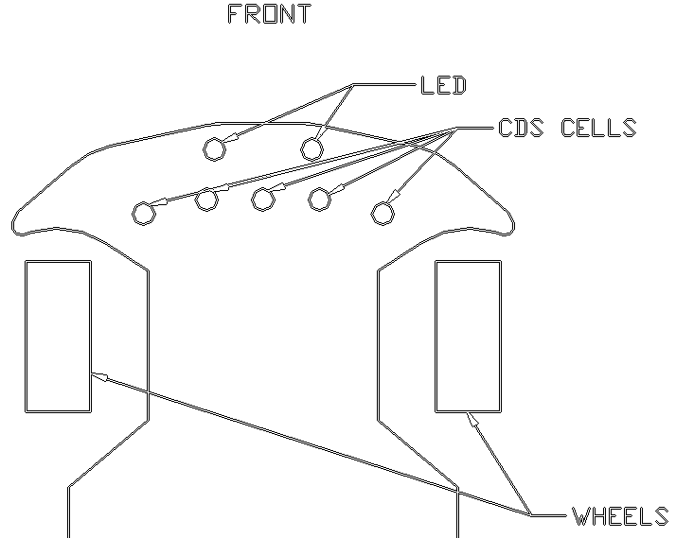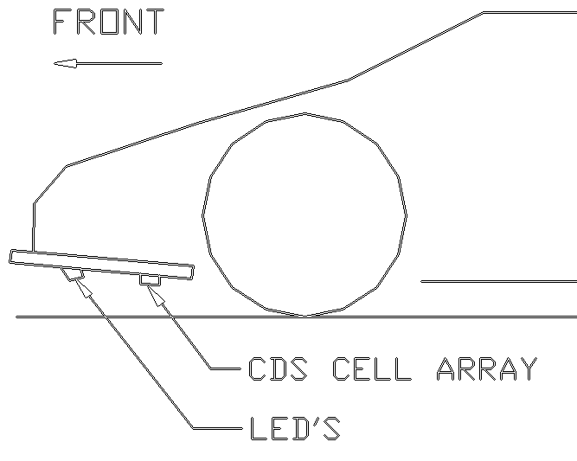
Figure 1
The CDS cell array is located on the front of the robot where it can detect the line before it gets to the steering wheels. The primary objective is to move the steering wheels to try to keep the line in the center of the array.
The problem with using the CDS cells is that each one occupies an analog input. For the steering of the robot a group of CDS cells will be required. The best type of sensor for this application would be an array of CDS cells where only a single analog input would be needed. Such an array would return an analog value based on where the lowest light value was detected along the array. With such an array, determining the steering angle could be determined by having two of the arrays parallel to each other and calculating the angle of the line on the road.
The first operation that occurs is the pre-calibration of the CDS cells. The pre-calibration is done so that the difference in the readings between light and dark between different CDS cells is the same. The level of change in resistance is different between CDS cells is different from cell to cell. This calibration is done by way of a multiplier that is used each time a CDS reading is taken and is used in conjunction with the overall calibration that is done when the robot is turned on. This pre-calibration is something that is seen as an inherent characteristic of the CDS cell and is never changed, unlike the calibration, which is first done each time the robot is turned on. Table 1 below illustrates the effect of the pre-calibration.
 | CDS 1 | CDS 2 | CDS 3
CDS in light | 243 | 245 | 244
CDS in dark | 230 Δ=13 | 235 Δ=10 | 227 Δ=17
CDS in light pre calibrated | 317 | 417 | 244
CDS in dark pre calibrated | 300 Δ=17 | 400 Δ=17 | 227 Δ=17
Table 1
Once the pre-calibration has taken place then the next step is the overall value. This is done every time the robot starts so that it can adjust to the lighting of the room where it is traveling. The code for this looks like:
/* calibration of the CDS cells*/
for( x=0 ; x < 12; ++x)
{
l2ave = l2ave + LEFT2_CDS ;
lave = lave + LEFT_CDS ;
cave = cave + CEN_CDS ;
rave = rave + RIGHT_CDS ;
r2ave = r2ave + RIGHT2_CDS ;

wait(100);
}
lave=lave/12;rave=rave/12;cave=cave/12;l2ave=l2ave/12;r2ave=r2ave/12;

l2ave=300 - l2ave;
lave=300 - lave;
cave=300 - cave;
rave=300 - rave;
r2ave=300 - r2ave;

This code first takes the average of the first twelve readings. Then the difference between this average and a set point “300” is found. This offset from the set point is taken and re-added to each reading of the CDS cells within the program. Once both calibrations have taken place then each value of the CDS cell should be the same if the cells are directly over the line that the robot is supposed to follow.
The voltage sensing of the robot was made possible by using a voltage divider between the battery supply and an analog input.
The switches that were used in determining turn directions utilized the digital inputs on the TJPro Board. All of the different possibilities were determined and included in the code for viper.
Behaviors
All of the behaviors of the robot are describes below. Each behavior took several hours of testing and refinement. It was found that the wait() function was critical to getting all of the separate to work together. A flow chart which shows the procedure that the robot follows to execute all of the different functions is shown in the Appendix as Figure 3.
- Road following
The primary behavior of the robot is to follow a line on the road. The speed of the robot in a turn would have to be increased to overcome the additional friction with the surface of the floor. The speed also had to be kept at a level to prevent the robot from over driving the line on the road.
- Taking turns
A secondary behavior of the robot would be to take left or right turns based a predetermined location the robot is supposed to drive to. The turns were “triggered” by a line perpendicular to the line that the robot is traveling on. An example of how this occurs can be seen in Figure 2. Whether a right turn or left turn was taken was determined by what settings the switches on the back of the robot were set to. There were four switches, these switches represented the first four turns that the robot encountered. Depending on the open or closed setting of theses switches, the robot would turn right or left when it encountered the respective turn.
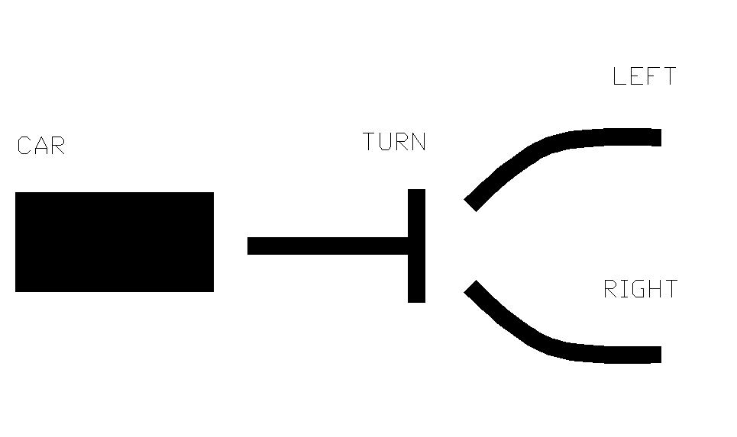
Figure 2
- Speed control
The forward velocity of the robot will be controlled by lines in the road that will lie to the left or right side of the robot and will be read by the robot similarly to a bar code. The speed was a varied due to battery voltage.
- Power Sensing
The ability of Viper to sense the amount of power in the drive batteries was employed to reduce the variation in the drive speed of the robot that occurs from the amount of power that is contained in the batteries.
- Lost mode
The final behavior of the robot will take effect when the robot loses its path on the surface of the road. If this does happen, and it will, then the robot will try to find the road again. It was found that if the usual line following of the robot was used the robot would randomly drive around and eventually could find a new line. LED’s on the side of the robot were used to alert the user that the robot was lost.
Experimental Layout
The robot utilizes two different power supplies to isolate the TJPro board from the large voltage fluctuations resulting from driving the motors. Six CDS cells were used for light and turn sensing. On analog input was used for voltage detection. The digital inputs were used for controlling the turns.
Conclusion
It was found that following a dark line on the surface of the floor was not an easy task. Quite frequently the robot was confused by light reflecting off of random sources. Once these problems were controlled the robot was able to follow a line on the floor with some success. The robot was also able to take turns that were set by the user.

