EEL 5666: IMDL

Formal Sensor Report

July 31, 2026
Michael Pusatera

Introduction:

This report will document the sensors used by Mappie: The Mapping Robot. The sensors will be described in terms of their design, implementation, and use.

Table of Contents

1. Introduction: 2
2. Table of Contents 2
3. Table of Figures 2
4. Bump Sensors 2
4.1. Sensor Design 2
4.2. Implementation 3
4.3. Use 4
5. Infrared Sensors 4
5.1. Sensor Design 4
5.2. Implementation 5
5.3. Use 5
6. Optical Mice 5
6.1. Sensor Design 6
6.2. Implementation 8

Table of Figures

Figure 1. Bump Switch Design 3
Figure 2. Infrared Sensor Design 4
Figure 3. How Optical Mouse Works 5
Figure 4. Mouse State Machine 6
Figure 5. Data Stream Format 7
Figure 6. Optical Mouse Design 7

Bump Sensors

Bump sensors are used on the exterior of the robot as a fail safe device to detect impact with objects in the robots path. This sensor is not used when infrared is working properly.

Sensor Design
The sensor is a voltage divider circuit consisting of several tactile push button switches connected in the following manner. The values of the sensor are chosen so that for any switch (s1-s4) that is pressed a different value will be placed on the analog(0) port.

Bump Switch Design
Vcc
Vcc
Vcc
Vcc
R1
R2
R3
R4
Analog(0)
R?
S1
S2
S3
S4

- Bump Switch Design

Implementation
This sensor was implemented using four push button switches and five resistors. The resistor values are:

- R1 = 10k
- R2 = 22k
- R3 = 47k
- R4 = 100k
- R5 = 10k

The bump sensors are located at the front, front-right, front-left, and back of the robot. This will ensure that any collisions from forward or reverse motion will be covered by the sensor.

Use
The sensor is connected to the analog(0) port of the 68HC11. This requires only that the port be read and appropriate action be taken in response to the data. When the bump sensor reads a value of 50 the rear bumper has been pushed and the robot will move forward. When the bump sensor reads a value of 80 the right bumper has been activated and the robot will back up and move left. When the bump sensor reads a value of 130 the left bumper has been activated and the robot will back up and move right. When the bump sensor reads a value greater than 130 the front bumper has been activated and the robot will back up, turn in a random direction for a random amount of time and move on.

Infrared Sensors

The infrared sensors are designed to be the eyes of the robot. They will be used to detect objects in the path of the robot within a two-foot range of the sensors. Infrared sensors work by sending a pulse of light out from an emitter and receiving the light back in a detector. The detector will return a voltage value proportional to the amount of light received.

Sensor Design
The sensors selected were the Sharp GP2D12 sensors. They were selected because they were inexpensive (~$15) and readily available.

Infrared Sensor Design
Analog(2)
Analog(3)
Analog(1)
IR Sensor
IR Sensor
IR Sensor
Vcc

- Infrared Sensor Design

Implementation
The sensor was remarkably simple to implement. As the above figure suggests there are only three lines in the system.

- Vcc: connected to a regulated power supply
- Gnd: connected to system ground
- Analog(x): connected to the appropriate analog port

The three sensors were placed in the front, front-right, and front-left portion of the robot. This will allow the robot to “see” any objects in its path as well as objects near its sides.

Use
The three sensors are connected to the analog(1-3) ports on the 68HC11. The program which controls the sensors will read each sensor and modify behavior based on its result. When the sensors read a value greater than 120 there is an object within one foot of the robot. When the front sensor is activated the robot will turn for a random amount of time in a random direction. When the front-right sensor is activated the robot will turn left for a random amount of time. Similarly, when the front-left sensor is activated the robot will turn right for a random amount of time.

Optical Mice

The main sensor for this design is a distance sensor composed of two optical mice. Optical mice are able to detect small distance changes, about 1/16th of a mm, with very little error.
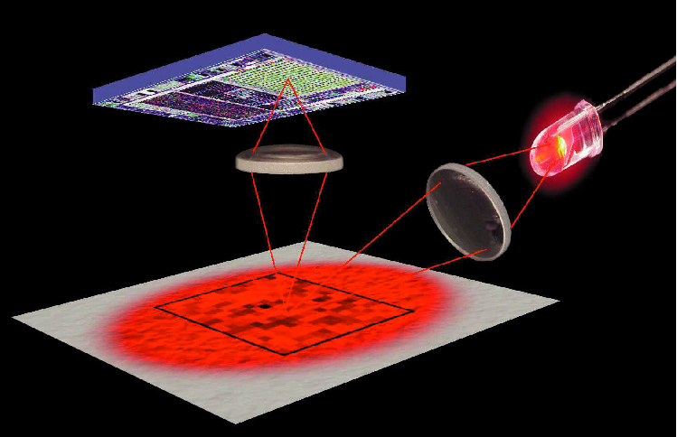

- How Optical Mouse Works

This is desirable in a mapping and navigation robot because the bot must know where it is at all times. This can be accomplished by comparing the values of the two mice, which will be placed on the left and right sides of the robot. If one value is greater than the other, the robot has turned in the direction of the shorter length. If the values are similar, the robot is moving in a straight line.

Optical mice also do not suffer from errors typically associated with relational positioning sensors. Because the sensor is independent of mechanical errors (i.e. slippage of wheels), the potential for accurate measurement is much greater.

Sensor Design
Optical mice conform to the PS/2 standard for operating any PC mouse. The system utilizes a data pin and a clock pin for use in a serial communications interface. The state machine associated with the interface is shown left.

Upon power up, the mouse enters a self-check. It is necessary to inhibit transmission during this period to ensure the mouse will work in PS/2 mode. The next two states force the mouse into a streaming mode in which the data can be read. When a command is acknowledged by the mouse, the data begins streaming.

The mouse will then send three bytes of data continuously until it is reset. The format of this data stream is shown below.
- Mouse State Machine

Byte 1
  Bit 7 | Bit 6 | Bit 5 | Bit 4 | Bit 3 | Bit 2 | Bit 1 | Bit 0
  Y overflow | X overflow | Y sign bit | X sign bit | Always 1 | Middle Btn | Right Btn | Left Btn
Byte 2
  X Movement
Byte 3
  Y Movement

- Data Stream Format
The first byte of information, the condition code register, contains information about the signs of the x and y movement, overflow bits for x and y, and the button state for each of the three buttons in the design.

The second byte of information contains the position of the movement in the x direction.

The third byte of information contains the position of the movement in the y direction.
Optical Mouse Design
Mouse
Mouse
Vcc

FPGA

Enable Reset 8 bit out
Clk Data

Mouse
Clk Data

Mouse
PortC
on HC11
8
A15
A14
A13
A12
R/W
Eclk
AS
Reset HC11

- Optical Mouse Design

Implementation
The mouse was interfaced to the UP1 board by Altera. The board contains the Flex 10k FPGA which was used to create the logic necessary to drive the two optical mice.

The state machine, created by Ty Black, interfaces the mouse and produces the 8-bit condition code register and two full 16-bit x and y registers for transfer. These outputs were connected to a memory mapped logic device that would alternate between the two mice outputs each time the address 0x7000 was read. The order of output is as follows:

- MCCR: condition code register for mouse 1
- X[15..8]: upper eight bits of x data for mouse 1
- X[7..0]: lower eight bits of x data for mouse 1
- Y[15..8]: upper eight bits of y data for mouse 1
- Y[7..0]: lower eight bits of y data for mouse 1
- MCCR2: condition code register for mouse 2
- X2[15..8]: upper eight bits of x data for mouse 2
- X2[7..0]: lower eight bits of x data for mouse 2
- Y2[15..8]: upper eight bits of y data for mouse 2
- Y2[7..0]: lower eight bits of y data for mouse 2

Upon reading the outputs into the HC11, the data from the two x and two y inputs are combined for a 16-bit x and y location register for each mouse. Once in the HC11, the data can be manipulated to determine distance and movement.

References

[1] http://www.altera.com/
[2] http://www.howstuffworks.com/mouse3.htm
[3] Ty Black, Sensor Report, IMDL
[4] Ty Black, Final Report, IMDL

