EEL 5666
Intelligent Machines Design Laboratory

Written Report for Staple-It

Cyrus Abbaschian
Summer 2004
Table of Contents
- Title Page | ………………………………………………… | 1
- Table of Contents | ………………………………………………… | 2
- Abstract | ………………………………………………… | 3
- Executive Summary | ………………………………………………… | 4
- Integrated System | ………………………………………………… | 5
- Mobile Platform | ………………………………………………… | 5
- Actuation | ………………………………………………… | 7
- Sensors | ………………………………………………… | 7
- Behaviors | ………………………………………………… | 11
- Experimental Layout and Results | ………………………………………………… | 11
- Conclusion | ………………………………………………… | 11
- Appendices | ………………………………………………… | 12

Abstract
Staple-It navigates a 2 dimensional surface and inserts staples across a heated line without human intervention. The abstract thought behind the machine is that this concept could be used in a surgical environment. Removing the surgeon from the final stapling part of procedures increases the efficiency and lowers the cost of the surgery. The intelligent machine approaches the heated wire by comparing multiple sensor outputs and moving towards the sensor that detects the highest temperature level. Through this procedure, the machine will be able to intelligently approach the heated wire without relying on a uniform sweep of the entire plane.
The machine moves the staple head through crossed axes. A stepping motor driving a timing belt moves a platform in one direction. Another stepping motor turning a timing belt moves a perpendicular platform in the other direction. This allows the staple head to cover an entire 2 dimensional surface. In the future, an expansion on this project would be to allow the staple head to rotate. This would allow staples to be inserted in any direction while currently staples can only be inserted in one direction so that they are positioned properly across a heated line.

Executive Summary
Aiming to reduce invasiveness, time, and cost of medical procedures, Staple-It takes over for the surgeon during the last steps of certain medical procedures. Staple-It scans an area and insert staples along an incision that it senses is radiating more heat than the surroundings. This simulates the elevated level of heat given off by an open surgical cut which needs to be stapled. The goal is accomplished by navigating in two axes allowing for complete scanning of a square area. Temperature sensors located near to a staple head constantly feed in data regarding the temperature in the different locations. This data is then analyzed to determine if the machine needs to move, in what direction the machine needs to move, or if a staple should be inserted. At this level of implementation the staple head does not rotate. Therefore, Staple-It only staples accurately across wires located parallel with the staple head. This way, staples are inserted perfectly perpendicular.

Integrated System
Staple-It navigates above a two axis area by positioning platforms along each axis. The platforms can be moved independently allowing for a complete sweep of the area. Each platform is controlled by a stepper motor. A minimal amount of torque is needed to move the platforms because they are mounted on linear ball bearings which travel the length of steel rods. This setup minimizes friction and at the same time allows for easy movement of the platforms. The platform will have a mounted stapling device and will have heat sensors which will locate the starting point of a heated wire located on the area surface. The heated wire simulates a surgical incision because the open cut will give off more heat than the surrounding skin. Staple-It will insert staples along the heated wire.
Mobile Platform
The platform of Staple-It is a crossed axis grid. Steel rods support the platforms enabling movement while requiring a minimal amount of force from the motors. The platform will slide along the ball bearings minimizing friction. The platform was designed similarly to products already on the market. The platform below in Figure 1 is one that is available from Arrick Robotics for $750 that covers a 9” by 9” area.
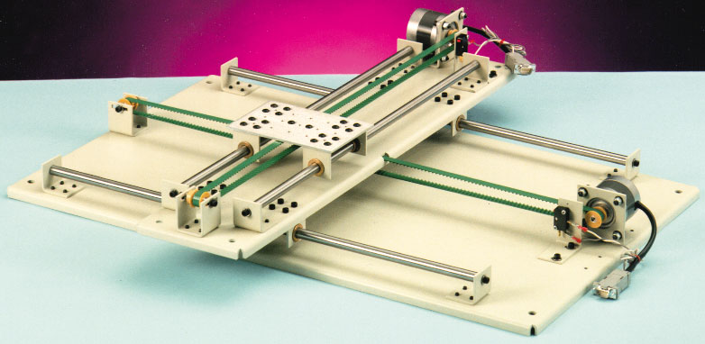
Fig 1: XY linear positioning system available from Arrick Robotics (http://www.robotics.com/xy.html).

The platform I design was much less expensive. Excluding labor, creating my 12” by 12” platform cost $200. The main objective of the platform is to allow precise movement around an area. I chose a 12” by 12” area because at this length ¾” steel rods could be used without much bend from the platform weight. This allowed for a lightweight platform that still covered a significant area.

Actuation
Staple-It has two different types of actuation. One necessary motion is moving the platform in the x and y direction. To accomplish this, stepper motors were used to rotate a belt on which the platforms were attached. Independent motors and belts were used for each direction allowing for a complete scan of the area. The second type of actuation is the propulsion of the staple into the surface once the machine has located the heated wire. For this movement, a solenoid will be used to drive staples from the head of a stapler into the surface. This is the same implementation used in the automatic office staplers.
Sensors
For the temperature sensors, National Semiconductor’s LM34 Precision Fahrenheit Temperature Sensors are used. Using Fahrenheit temperature sensors eliminates large constants and subtraction issues commonly found in temperature sensors that use Kelvins as the units. The datasheet of the sensor is located at http://www.rentron.com/Files/LM34.pdf. An issue that must be addressed in order to use this sensor is the heat level generated by the stepper motors. The sensor must have a way to filter out what is the target temperature and what is excess noise temperature. This can be accomplished by a calibration period where the sensor biases against any motor heat generated after the motors have been heated in a quick scan of the area.
The LM34 circuit is one of the more simple implementations which only required two power sources and a resistor. The output is a scaled voltage value and is taken from the middle pin on the TO-92 plastic package shown in Figure 1. The circuit implementation is diagramed below in Figure 2.

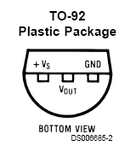 | 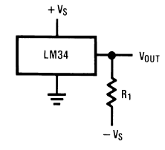
Fig. 2: Pinout of the TO-92 package | Fig. 3: Circuit implementation for Staple-It

The sensors have the quickest response to changes in temperature by conduction. When sensing temperature of a body by convection, it takes minutes to reach a final value within 95% of the actual value. Fortunately, for my implementation, I do not need an accurate final value but rather need to compare different sensor values to get an idea of the direction of the heated body. Also, the faster response time from conduction allows for improved accuracy because if a spike in a single sensor value is noted, the machine knows that this sensor is in contact with the heated body and can move a set distance to staple perfectly across the wire.
Experimental testing using the circuit wired into a breadboard have yielded results expressing the difference of response time when heat transfer is done by conduction versus convection. This is an aspect about the sensors that I did not realize until I began to characterize the sensors. At first I was concerned with the very slow response time in still air. But, I realize that it’s not necessary for me to analyze the final value of the heated body. Instead, what is important is comparing the outputs of the sensors and deciding in which direction to move. For this, assuming that all sensors react in relatively the same fashion, response time is not a crucial point. The ability for the sensor to respond much faster under conduction turns out to be a very big positive point when it comes to dealing with accuracy issues. If my machine is traveling along, following the path to the heated body and a sensor suddenly spikes in output voltage, it is reasonable to assume that the sensor lead touched the heated body. This will greatly improve my accuracy, because if I do sense a spike in voltage, I will know how far I need to move the machine so that the staple head is positioned right above the wire. Experimental data was tabulated and graphed in Figure 3 marking the response of the sensor under convection and conduction over a 45 second period. Note the quick response under conduction compared to the much slower response under convection.

Fig. 4: Comparison between response time for convection and conduction.

Behaviors
The behavior of Staple-It is to locate a heated wire and inserts staples across the wire. In order to do this, the machine must be able to navigate in the x and y direction with precision. Also, there must be a mechanism to propel the staples into the target platform. These behaviors encompass the entirety of this application.
Experimental Layout and Results
Experimentation was needed primarily with gaining a better understanding of how the sensors functioned. This understanding was achieved by using the sensors in a simple breadboarded circuit. Data collected enabled decisions to be made in order to effectively insert staples across the wire. Specifically, the voltage spike from conduction upon contact allows for a great deal of precision during the staple insertion. Above, Figure 4 has data collected from this testing.
Conclusion
As of now, the project is being held back dramatically by the sensors. They do not seem precise enough to be able to give accurate direction from any significant distance away. This creates a great difficulty in moving in a intelligent fashion towards the wire. The LM34 temperature sensor would best be used for applications when the sensors are static. Ideally, having the sensors mounted onto the temperature body intended to be monitored would be the most effective setup.
Appendices
Assembly source code can be found in the file that accompanies this report or on the internet at plaza.ufl.edu/cyrusa/StapleCode.html.

