Summer 2004 EEL 5666

FUPA
The Garbage Can Kicking-Over Robot

Jeff Cohen
7/30/04

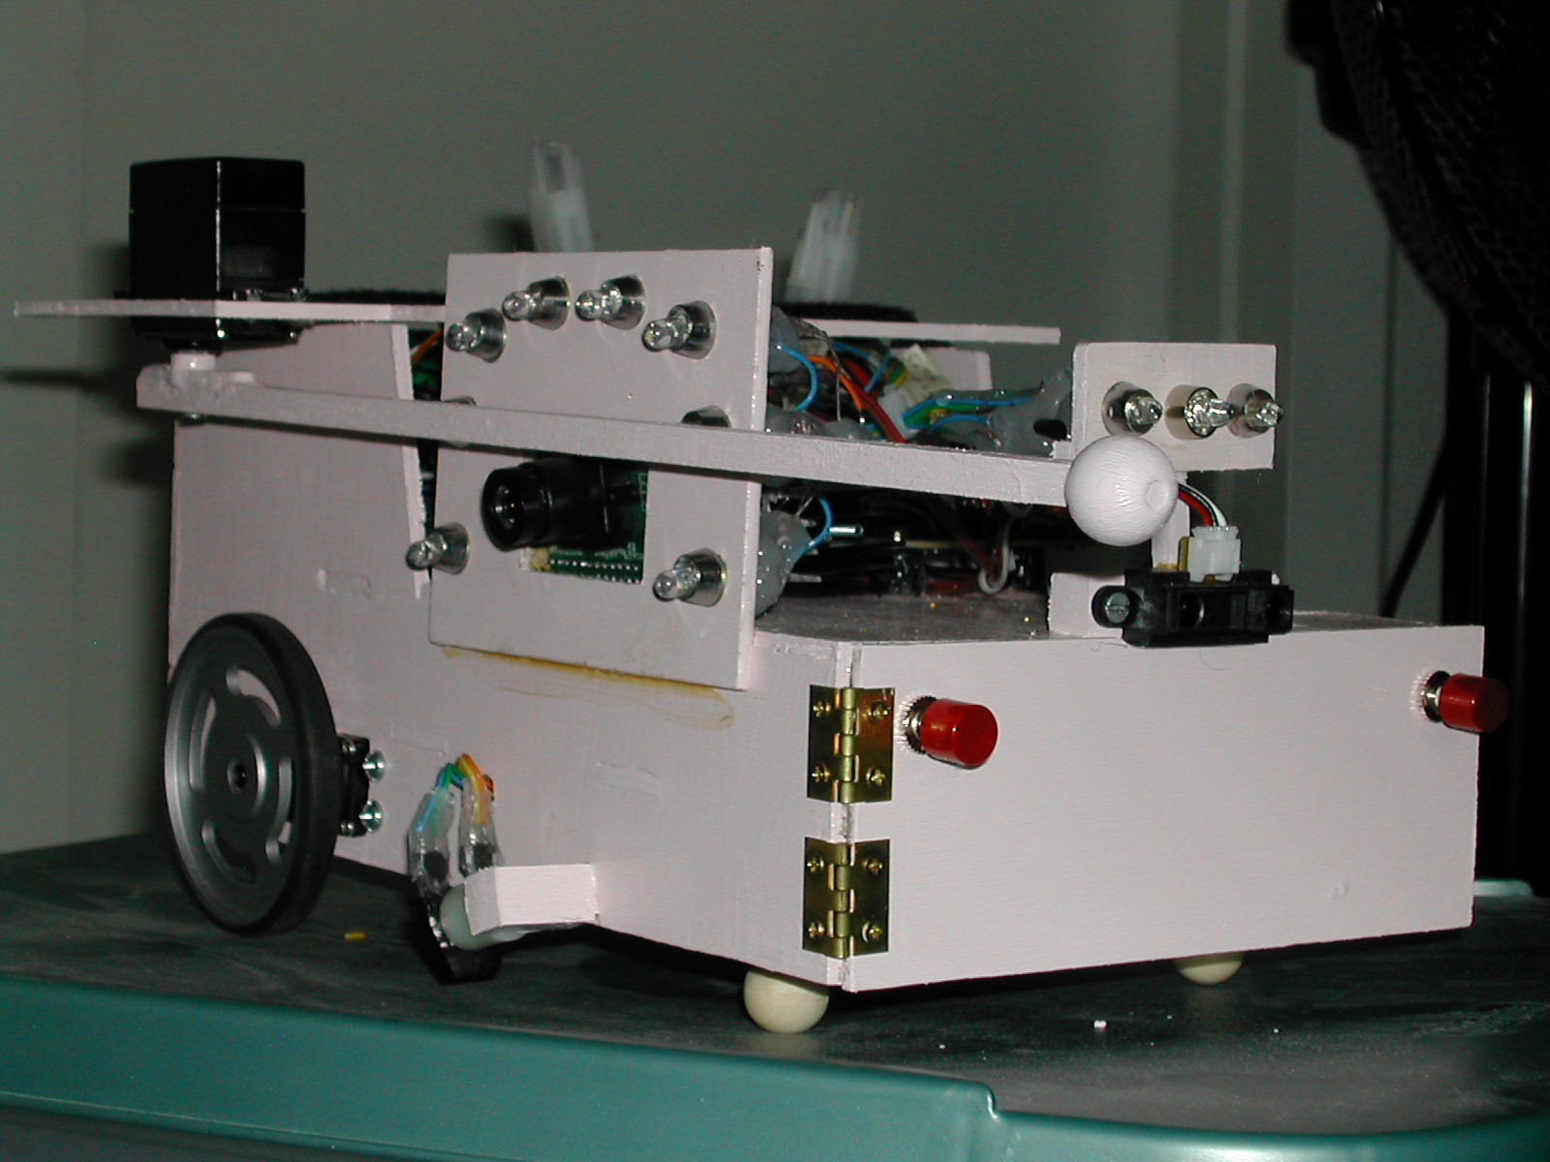

Table of Contents

Abstract…………………………………………………………………………………....3
Executive Summary…………………………………………………………………….…4
Introduction………………………………………………………………………….…….5
Integrated System…………………………………………………………………….……5
Power……………………………………………………................……………………...8
Actuation…………………………………………………………………………………..8
Sensors…………………………………………………………………………………….9
Behaviors………………………………………………………………………………...12
Components…………………………………………………………...............................13
Conclusion………………………………………………………………………..……...14
Documentation……………………………………………………………………….......14
Appendices……………………………………………………………………………….14

Abstract
FUPA is an autonomous robot. FUPA simulates a fifth grader biking home from school on Fridays which is both trash and recycling day. FUPA will follow the sidewalk and be on the lookout for empty cans along the way. When a can is found, the color will be analyzed. If there is a red recycling bin, FUPA will knock over the can with an arm that swings out from the side. FUPA will then move on to the next house, and this cycle will continue for ever. When a can is found, the correct colored LED will also illuminate on an LED bar. FUPA will also have an obstacle destruction feature from an IR sensor, and obstacle detection from two bump switches.

Executive Summary
FUPA is a 2-WD autonomous robot. It is based on an STK500 board with an ATMega32 for its processor. FUPA follows a high contrast line using two Hamamatsu P5587 IR detectors. When a third Hamamatsu P5587 IR detector detects a line to the right of the track, a CMU cam takes a picture. If there is a red can there, FUPA will swing its arm out, and knock it over. Also, a red LED will illuminate. However, if the can was blue or green, the arm will not swing out, but the corresponding colored LED will light up.

If along the way, FUPA should detect an obstacle ahead (seen by a Sharp GP2D12 IR sensor), then FUPA enters ‘destroy mode’. In destroy mode, FUPA speeds off of the track, and knocks the obstacle out of the way before returning to the track at the point FUPA left off at.

If for some reason the obstacle detection does not work, FUPA is also equipped with two bump switches which when activated will cause FUPA to cease all operations. And of course, all of the different operations include LCD feedback so you can see what FUPA is currently doing.

Introduction
Fridays used to be the best day of the week in fifth grade. This was both garbage day and recycling day. When school would let out, a fun game was to knock over all the recycling bins as one biked home from school. This is exactly what FUPA will do. This paper describes a robot that will follow a high contrast “sidewalk” made of electrical tape. When the robot arrives at a house with garbage cans, using a CMU-CAM for color detection, it will knock over all red cans with a side-swinging arm. If any obstacle is detected in FUPA’s path, FUPA will swing around and knock it out of the way.

This report will detail all of FUPA’s electrical and mechanical features and characteristics. First, the platform will be presented, followed by a detailed description about each of FUPA’s subsystems.

Integrated System
FUPA will have an STK500 as a platform, powered by an Atmega32 chip. Figure 1 (below) is a block diagram of FUPA’s components. Figure 2 (below) is a flow chart of FUPA’s software operations.
LCD
STK500

ATMega32
2 High Torque Servos
Two 7.8V NiMH Batteries
Power Board Consisting of Three Voltage Regulators
1

2

3
Servo for Swinging Arm
CMU Cam
Bump Switches for Obstacle Detection
One Sharp GP2D12 for Obstacle Destruction
Two P5587 for Line Tracking
One P5587 for Tab Detection
Fig. 1: Block diagram of FUPA

FUPA’s entire chassis is made from 1/8” birch plywood, and is painted pink with PPG paint. The top is removable to allow access to the wires and I/O pins. In addition, the front is on hinges so the STK500 can be easily removed. See Fig. 3. The LCD screen is the only device attached to the power pins on the STK500 board.

Initialize Servos, Camera, UART, A/D, and Put Arm at home position.
Poll Line Track Sensors, Tab Sensor, and A/D Value
Configure Bump Switches for Interrupt 0
Obstacle
Position to Knock Over Can and Return to Line
Tab
Get Color
Light Up Correct LED
If Red, Swing Out Arm
Fig. 2: Flow chart for FUPA’s software

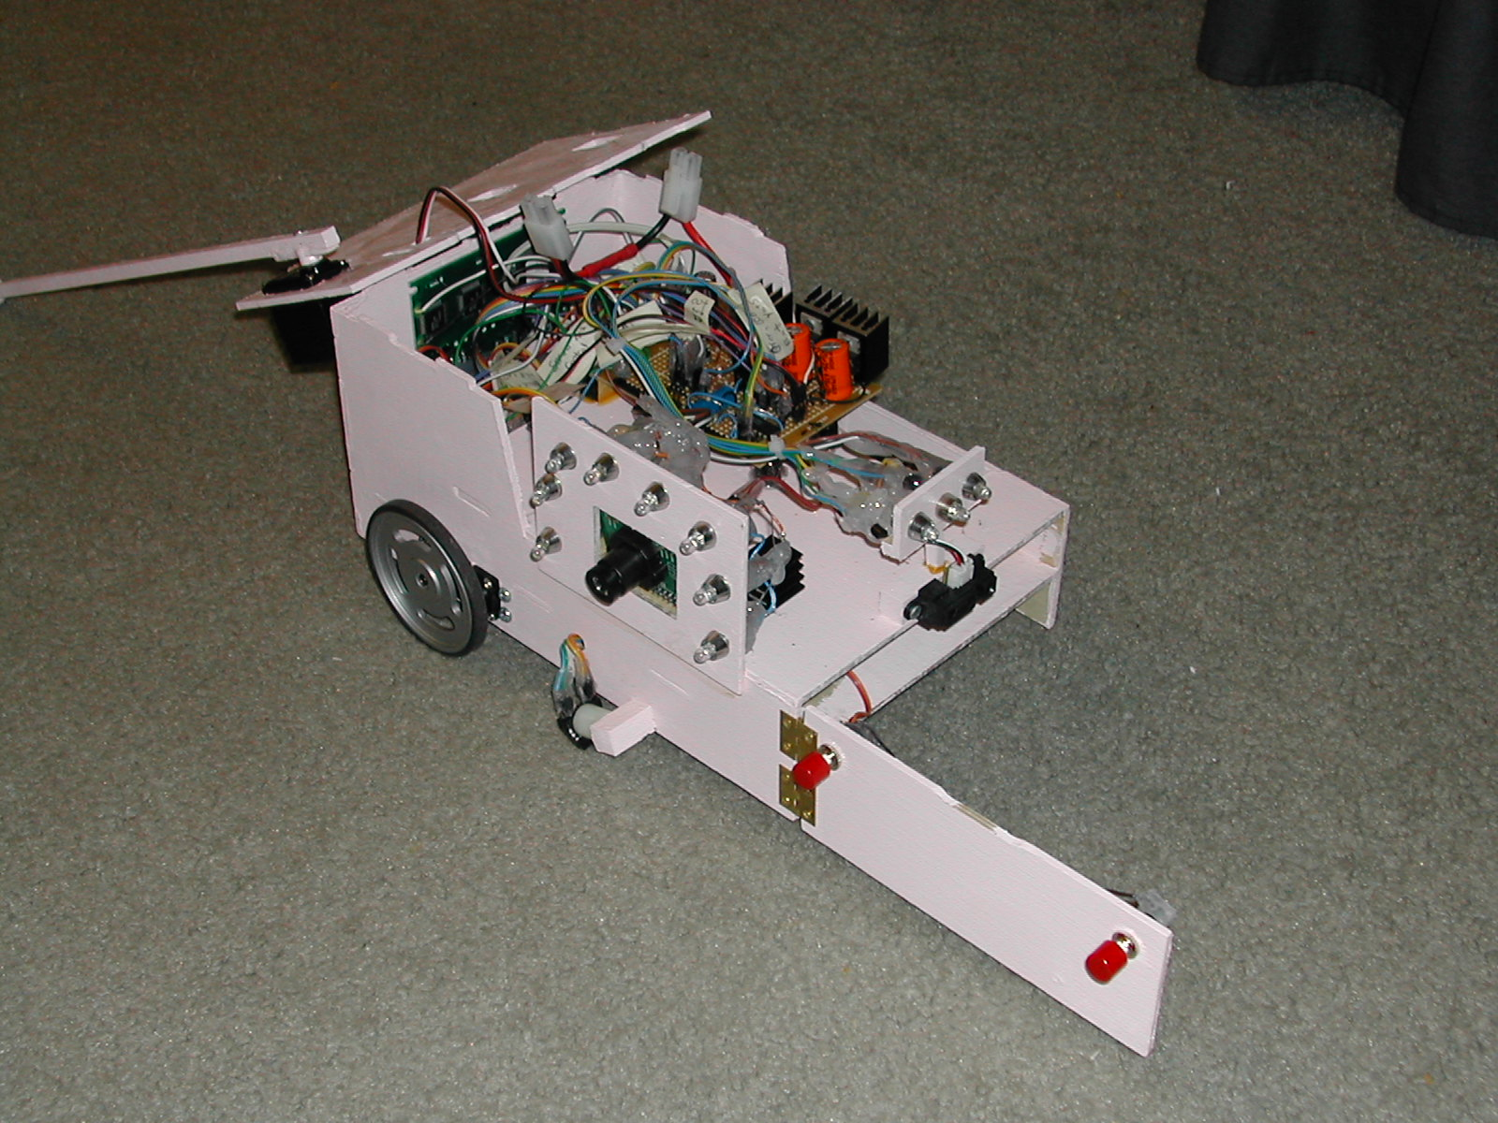
Fig. 3: Picture of FUPA’s easy access panels
Power
FUPA is powered by two rechargeable 7.2V, 3300mAh, NiMH batteries. The board is powered directly from these batteries. The camera gets its power from a 7V regulator, the servos controlling the wheels get there power from a 5V regulator, and the arm servo and sensors get there power from a second 5Vregulator. See Fig. 4. All regulators were fitted with heat fins to help dissipate heat.
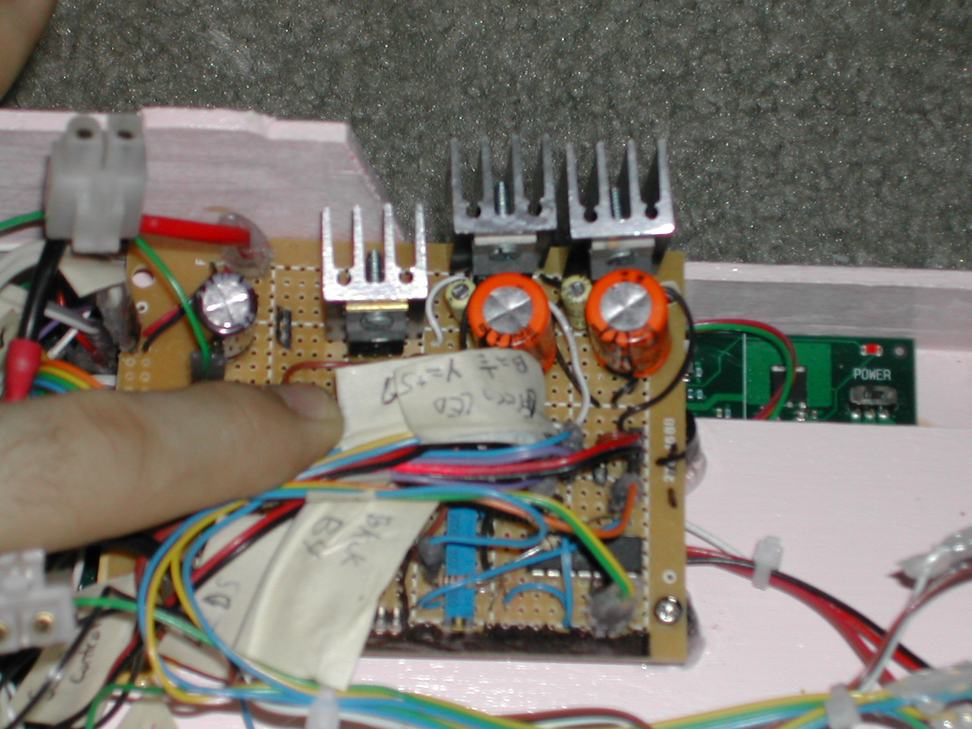
Fig. 4: Picture of FUPA’s voltage regulators and heat fins

Actuation
FUPA will have two wheels which will each be powered by a hacked high-torque Futaba servo (S03 TXF 2BB). Two ¼” wood spheres are attached to a dowel rod to act as the front two stabilizers (See Fig. 5). The swinging arm will also be powered with a servo. It will use an un-hacked Futaba S03N 2BB.
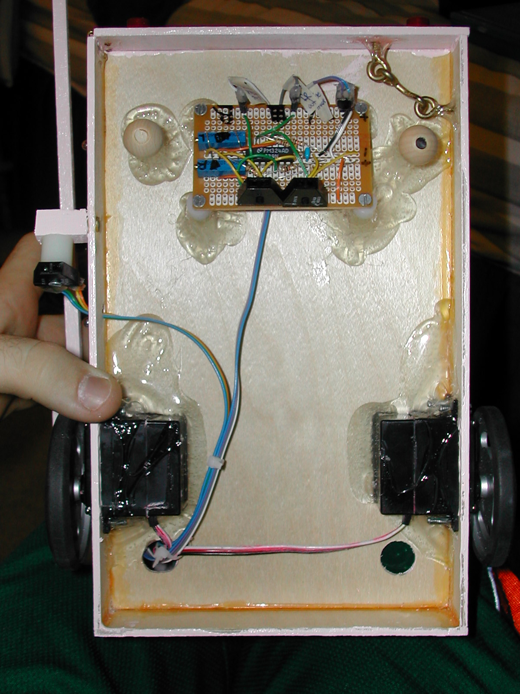
Fig. 5: Picture of FUPA’s servos and pseudo-wheels

Sensors
Since FUPA needs to follow a sidewalk, electrical tape will be used to represent a sidewalk. FUPA will follow this line using Hamamatsu P5587 IR detectors. Tabs, noting where FUPA should analyze a can’s color, will also be detected using Hamamatsu P5587 IR detectors. Bump switches will be used for collision detection, and a Sharp GP2D12 IR sensor will be used for obstacle avoidance. A CMU-CAM is what will differentiate the color of different cans.

Hamamatsu P5587 IR Detectors
Two of these sensors are used for line tracking, and one is used for tab detection. Using Will Dubel’s circuit (Fig. 6), these sensors emit a ‘high’ value if it reads black or nothing at all. They emit a ‘low’ value when they are on a white surface. Through
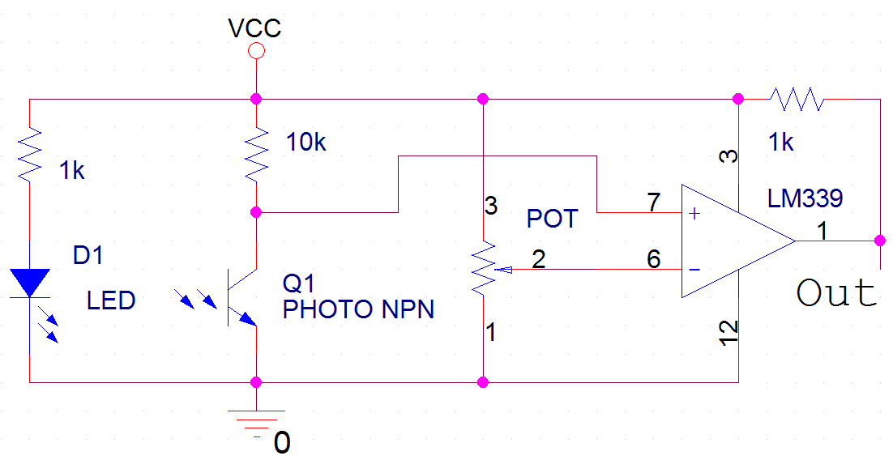
Fig. 6: Line tracking schematic
experimentation, it was determined that they work best for me 1/8” off of the ground and pointed downwards at a 40° from the horizon. FUPA’s actual line tracking circuit board and tab sensor can be seen in Fig. 5.

Bump Switches
The bump switches are just two standard SPST switches. One of each switch’s pins is attached to ground, and the other pin is attached to an interrupt pin. When either of these pins go ‘low’, the robot shuts down immediately. The bump switches can be seen in Fig. 3.

Sharp GP2D12 IR Sensor
The Sharp GP2D12 IR sensor is used for obstacle destruction, and can detect ranges from 10cm to 80cm. It is constantly returning a value to the STK500. If nothing is in FUPA’s path, then the sensor will return a zero. However, when an object enters FUPA’s path, the sensor returns a value which increases as the objects distance from FUPA decreases. When the sensor returns a value of $B0 or higher, FUPA will enter ‘destroy mode’. This sensor can be seen above the front door in Fig. 3.

CMUcam
The CMUcam uses the UART to communicate with my ATmega32 chip at a speed of 38,400 baud. This is the fastest rate that can be used while still maintaining a 0.2% error rate. The settings of the camera changed from default mode are enabling Polling Mode and Raw Data Mode. Polling Mode makes the processor run faster. It makes the camera only send 1 packet of information when requested vs. a constant 17 f.p.s. Raw Data Mode makes the camera transfer data bytes instead of ASCII characters. This saves the user from having to convert ASCII to useable data.

To use the CMUcam successfully, the camera requires a lot of white light. Pictures taken in my bedroom come out red. To fix this problem, ten, 16,000 m.c.d., 5 mm, white LEDs were ordered. After adding the lights, pictures were of very good quality. A sample picture can be seen in Fig. 7.
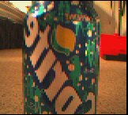
Fig. 7: A sample picture taken by the CMUcam with the white LEDs as background light
A second problem with the camera is that the picture is not centered. It is off by around 10 degrees. I had to tilt the camera when installed to account for this error. The tilted camera and the white LEDs can be seen in Fig. 3.

The voltage regulator on the camera gets very hot. To combat this problem, I installed a heat fin purchased from Radio shack.

Behaviors
Line Tracking
FUPA follows a high contrast line using two IR sensors

Destroy Mode
FUPA enters destroy mode when an obstacle is detected in its path. When FUPA enters this mode, the following steps are taken:
1) Turn off tab sensor
2) Move ahead for 1.5 seconds
3) Turn 45 degrees left and go straight for 0.5 seconds
4) Swing out arm
5) Reverse for 1.5 seconds
6) Turn right until the line is reacquired
7) Turn on tab sensor and continue to line track
In destroy mode, the obstacle is knocked out of the way, so FUPA can continue on its original path.
Camera Mode
Camera mode is entered when a tab is detected with the IR sensor. In this mode, FUPA is line tracking while snapping a picture to determine which future action to take.
Components
Quantity | Part | Price | Source
2 | Wheels | 6.00 | Mark III
2 | High Torque Futaba Servos | 21.00 | Mark III
1 | Futaba Servo | 10.50 | Mark III
1 | Sharp GP2D120 IR Sensor | 8.50 | Mark III
1 | Sharp GP2D120 IR Sensor Cable | 1.10 | Mark III
2 | Bump Switches | 2.39 | Radio Shack
8 | White LEDs and Holders | 15.00 | E-Bay
3 | DB9 Connectors | 4.80 | Radio Shack
2 | Breadboards | 4.00 | Radio Shack
4 | Heat Sinks | 6.00 | Radio Shack
2 | Female Battery Terminals | 8.00 | Radio Shack
1 | Variable Voltage Regulator | 2.50 | Radio Shack
1 | Paint and Clear Coat | 11.00 | Lowe's
2 | Hinges | 2.00 | Lowe's
1 | Latch | 3.50 | Lowe's
1 | Velcro | 2.50 | Lowe's
1 | STK500 | 80.00 | Digikey
1 | ATMega32 | 9.00 | Digikey
1 | CMUcam | 70.00 | Used
3 | Hamamatsu P5587 IRs | 12.00 | Digikey
1 | Potentiometer | 3.00 | Radio Shack
1 | Power Jack | 5.00 | Radio Shack
3 | Red, Green, Blue LEDs | 6.50 | Radio Shack
3 | Various Sized Screws | 4.50 | Lowe's
2 | Goop | 8.00 | Lowe's
1 | Solder | 4.00 | Radio Shack
2 | LED Holders | 2.00 | Radio Shack
1 | LCD Screen | 8.00 | Used
1 | Shipping Charges | 7.00
Total |  | 327.79
Wire, wood, and wood glue were provided by the lab.

Conclusion
FUPA was very successful. It works as expected, and I even added the destroy mode feature and the LED bar. The only thing that I wish I had done different was using sonar instead of tabs/IR to determine where a can is. Overall this robot was very time consuming, eating well over 300 hours of time to get everything working 100%. But, after completion, I have never had FUPA give me a false color reading or veer off of the track

Documentations
1) Will Dubel’s line tracking paper
2) Bryan Arkin’s ‘letter’ macros

Appendices
Final Code
;**************************
;* Set VTarget = 5.1V *
;* Set ARef = 4.9V *
;**************************

;Jeffrey S. Cohen
;v10 with obstacle knockdown
;7/30/2004
;EEL5666C

.INCLUDE "m32def.inc"

.CSEG
;********************
;* Reset Vector *
;********************
.ORG $000
RJMP Reset

;**************************
;* Interrupt 0 Vector *
;**************************
;Bump switch interrupt
.ORG $002
RJMP ShutDown

;*****************
;* Constants *
;*****************
;Servo Register Renames
.EQU RSERVO_H =OCR1BH
.EQU RSERVO_L =OCR1BL
.EQU LSERVO_H =OCR1AH
.EQU LSERVO_L =OCR1AL
.EQU ARM_SERVO =OCR0

;Registers
.DEF Temp =r16 ; Temporary Reg 1
.DEF Temp2 =r17 ; Temporary Reg 2
.DEF Temp3 =r18 ; Temporary Reg3
.DEF PrevIR =r19 ; Previous IR reading
.DEF ADCCounter =r20 ; Counter for # of times ADC reports back a close value
.DEF LCDReg =r21

.DEF Delay1 =r29 ; Delay Reg 1
.DEF Delay2 =r30 ; Delay Reg 2
.DEF Delay3 =r31 ; Delay Reg 3

;Ports
.EQU LCD_PORT =PORTC
.EQU LCD_DDR =DDRC

;Constant Values
.EQU ADC_Distance =$B0 ; Distance where ADC reads as object too close
.EQU Space =$20
.EQU CR =$0D

;**************
;* Macros *
;**************
;Prints Letters to LCD display
.macro letter
LDI LCDReg,@0
OUT LCD_PORT,LCDReg
SBI LCD_PORT,5
RCALL Latch
RCALL Delay5ms
LDI LCDReg,@1
OUT LCD_PORT,LCDReg
SBI LCD_PORT,5
RCALL Latch
RCALL Delay5ms
.endmacro

;************
;* Main *
;************
.ORG $60
Reset:

RGB_VALUE: .DB 0
S1: .DB 0
S2: .DB 0
R_VALUE: .DB 0
G_VALUE: .DB 0
B_VALUE: .DB 0
Rdev: .DB 0
Gdev: .DB 0
Bdev: .DB 0
S9: .DB 0

LDI Temp,low(RAMEND) ; Set low stackptr
OUT SPL,Temp

LDI Temp,high(RAMEND) ; Set high stackptr
OUT SPH,Temp

RCALL PortInit ; Initializes port directions

SBI PortD,2 ; Pull up bump switch pin

RCALL LCDInit ; Initializes LCD Screen
RCALL UART_Init ; Initialize UART
RCALL Camera_Init ; Initialize Camera
RCALL BufferFlush ; Empty out all junk data in buffer sent from camera during initialization
RCALL PWMInit_Wheels ; Initializes PWM for Wheels
RCALL ADC_Init ; Initializes ADC for IR obstacle detection

SEI ; Enable Interrupts

StartAgain:
CBI PortB,0 ; Turn off colored LEDs
CBI PortB,1
CBI PortB,4
RCALL PWMInit_Arm ; Initializes PWM for the arm servo

RCALL LineTrack

;*****************
;* Port Init *
;*****************
PortInit:
CLR Temp
OUT DDRA,Temp
; INPUT REGISTER
; Pin0 = Sharp IR obstacle avoidance
; Pin1 =
; Pin2 =
; Pin3 =
; Pin4 =
; Pin5 = IR input (Tab Detector)
; Pin6 = IR input (Left)
; Pin7 = IR input (Right)

SER Temp
OUT DDRB,Temp
; OUTPUT REGISTER
; Pin0 = Red LED control pin
; Pin1 = Green LED control pin
; Pin2 =
; Pin3 = Servo PWM (Arm)
; Pin4 = Blue LED control pin
; Pin5 =
; Pin6 = White LED control pin
; Pin7 =

SER Temp
OUT LCD_DDR,Temp
; OUTPUT REGISTER
; Pin0 = LCD DB4
; Pin1 = LCD DB5
; Pin2 = LCD DB6
; Pin3 = LCD DB7
; Pin4 = LCD enable
; Pin5 = LCD register select
; Pin6 =
; Pin7 =

LDI Temp, 0b11111010
OUT DDRD,Temp
; Pin0 = UART input (Receive)
; Pin1 = UART output (Transmit)
; Pin2 = Bump switches (INT0)
; Pin3 =
; Pin4 = Servo PWM (Right)
; Pin5 = Servo PWM (Left)
; Pin6 =
; Pin7 =

LDI Temp, 0b00000000 ;Configure interrupt
OUT MCUCR,Temp

LDI Temp, 0b01000000 ; Enable bump switch interrupt
OUT GICR, Temp
RET

;**************************
;* LCD Initialization *
;**************************
;** PC0 = DB4 (LCD pin7)
;** PC1 = DB5 (LCD pin8)
;** PC2 = DB6 (LCD pin9)
;** PC3 = DB7 (LCD pin10)
;** PC4 = E (LCD pin6)
;** PC5 = RS (LCD pin4)
;** GND = VSS (LCD pin1)
;** GND = R/W (LCD pin5)
;** VTG = VDD (LCD pin2)

LCDInit:
;Power-On 15ms Delay
RCALL Delay5ms
RCALL Delay5ms
RCALL Delay5ms

;Begin 4-Bit Enable
LDI Temp, 3
OUT LCD_PORT,Temp
RCALL Latch
RCALL Delay5ms

RCALL Latch
RCALL Delay1p5ms

RCALL Latch
RCALL Delay5ms

LDI Temp, 2
OUT LCD_PORT,Temp
RCALL Latch
RCALL Delay1p5ms

;Begin 2-Line Enable
RCALL Latch
RCALL Delay1p5ms

LDI Temp, 8
OUT LCD_PORT,Temp
RCALL Latch
RCALL Delay1p5ms

;Display on, Cursor on, Blink on
LDI Temp, 0
OUT LCD_PORT,Temp
RCALL Latch
RCALL Delay1p5ms

LDI Temp, 15
OUT LCD_PORT,Temp
RCALL Latch
RCALL Delay1p5ms

;Clear screen, cursor home
LDI Temp, 0
OUT LCD_PORT,Temp
RCALL Latch
RCALL Delay1p5ms

LDI Temp, 1
OUT LCD_PORT,Temp
RCALL Latch
RCALL Delay5ms
;Initialization Complete
RET

;*************************
;* PWM Setup (Wheels) *
;*************************
;1/8MHz = .125us per cycle
;using 64 prescaler, 1 increment of TCNT = 8us
;
;Set potentiometer so the wheel does not turn
; if the pulse is high for 1.5ms
;
;1.5ms = 187.50
;
;187.50/2=93.75
;===================================
;T=20ms, then .5T=10ms 10ms/8us=1250 ($04E2)
;
; ^ <-- Top = 1250
; / \
; / \ <-- Bottom = 0
;
;1250-93.75=1156.25 ~1156 rise
;ICR1A <-- Top
;OCR1A <-- 1156 ($0484)
;===============================================
;Full Clockwise (Right Side) : 1172 0x491
;
;Neutral : 1156 0x484
;
;Full C. Clockwise (Left Side) : 1141 0x477
;===============================================
PWMInit_Wheels:
LDI Temp,0b11110000
; bits7,6 =1,1 Set up and clear down (OC1A)
; 5,4 =1,1 Set up and clear down (OC1B)
; bits3,2 =0,0 Force output compare OFF A and B
; bits1,0 =0,0 PWM phase and Freq correct
OUT TCCR1A,Temp

LDI Temp,0b00010011 ; bit7 =0 IC noise canceler OFF
; bit6 =0 Not used in our mode
; bit5 =0 Reserved
; bits4,3 =1,0 PWM phase and Freq correct
; bits2,1,0 =Clock Select Prescaler
; 0,1,1 : (1/8Mhz)*64=8us
OUT TCCR1B, Temp

; Sets Top
LDI Temp,0x04
LDI Temp2,0xE2
OUT ICR1H,Temp
OUT ICR1L,Temp2

; Sets Pulse On Period
LDI Temp,0x04
LDI Temp2, 0x84
OUT RSERVO_H,Temp
OUT LSERVO_H,Temp
OUT RSERVO_L,Temp2
OUT LSERVO_L,Temp2

; Start TCNT's at $00
LDI Temp, 0
OUT TCNT1H, Temp
OUT TCNT1L, Temp

RET

;**********************
;* PWM Setup (Arm) *
;**********************
;1/8MHz = .125us per cycle
;using 256 prescaler, 1 increment of TCNT = 32us
;
;1.0ms = 31.25
;2.0ms = 62.50
;
;One period = (255+256)*32us = 16.352ms
;
;T=16.35ms, then .5T=8.175ms
;================================================
;8.175ms-0.5ms = 7.675ms
;
;7.675ms / 32us = 239.84 ~ 240 (1ms pulse = 240)
;================================================
;8.175ms-1.0ms = 7.175ms
;
;7.175ms / 32us = 224.22 ~ 224 (2ms pulse = 224)
;================================================
PWMInit_Arm:

; Sets OCR0
;219=swing out
;245=home position

LDI Temp,245 ; Set arm to home position on startup
OUT ARM_SERVO,Temp

; Start TCNT's at $00
LDI Temp, 0
OUT TCNT0, Temp

LDI Temp,0b01110100
; bit7 =0 Force output compare off
; bits6,3 =1,0 CTC
; bits5,4 =1,1 Set OC0 on upcount, clear on downcount
; =0,0 DISCONNECTED
; bits2,1,0 =1,0,0 Set 256 prescalar
OUT TCCR0,Temp

RET

;*******************
;* ADC IR Setup *
;*******************
ADC_Init:
LDI Temp,0b00100000 ; bits7,6 =0,0 Use AREF as reference
; bit5 =1 Left adjust
; bits4,3,2,1,0 =0,0,0,0,0 Select ADC0

OUT ADMUX,Temp

LDI Temp,0b11100110 ; bit7 =1 Enable ADC
; bit6 =1 Start conversions
; bit5 =1 Auto trigger enabled
; bit4 =0 Interrupt flag (not important)
; bit3 =0 ADC interrupt disable
; bits2,1,0 =1,1,0 prescaler=64

OUT ADCSR,Temp

LDI TEMP,(SFIOR&0b00011111) ; Set ADC to free running mode
OUT SFIOR,Temp

CLR ADCCounter ; Clear ADC counter

RET

;******************
;* UART Setup *
;******************
UART_Init:
LDI Temp,12 ; Selects baud rate (8 LSBs) 38.4k bps
OUT UBRRL,Temp ; Clock=8MHz

LDI Temp,0b00000000 ; Bit7 = 0 Must be 0 when writing to UBRRH
; Bits6,5,4 = 0,0,0 Reserved
; Bits3,2,1,0 = 0,0,0,0 Selects baud rate (4 MSBs)
OUT UBRRH,Temp

LDI Temp,0b10000110 ; Bit7 = 1 Selects proper register
; Bit6 = 0 Asynchronous mode
; Bits5,4 = 0,0 Parity disabled
; Bit3 = 0 Select 1 stop-bit
; Bits2,1 = 1,1 Select 8-bit frame
; Bit0 = 0 Clock polarity....set to 0 if asynchronous
OUT UCSRC,Temp

LDI Temp,0b00011000 ; Bit7 = 0 Rx complete interrupt disable
; Bit6 = 0 Tx complete interrupt disable
; Bit5 = 0 Data register empty interrupt disable
; Bit4 = 1 Rx enable
; Bit3 = 1 Tx enable
; Bit2 = 0 Select 8-bit frame
; Bit1 = 0 Rx 9th bit disabled
; Bit0 = 0 Tx 9th bit disabled
OUT UCSRB,Temp

RET

;********************
;* Camera Setup *
;********************
Camera_Init:
SBI PortB,6 ; Turn on white LEDs for picture

RCALL DelayS

LDI Temp,'R' ; Reset camera
RCALL Send

LDI Temp,'S'
RCALL Send

LDI Temp,CR
RCALL Send

RCALL DelayL

LDI Temp,'P' ; Enable polling mode
RCALL Send

LDI Temp,'M'
RCALL Send

LDI Temp,' '
RCALL Send

LDI Temp,'1'
RCALL Send

LDI Temp,CR
RCALL Send

RCALL DelayS

LDI Temp,'R' ; Enable raw data output
RCALL Send ; Disable 'ACK'/'NAK' responses

LDI Temp,'M'
RCALL Send

LDI Temp,' '
RCALL Send

LDI Temp,'3'
RCALL Send

LDI Temp,CR
RCALL Send

RCALL DelayS

RET

;*****************************************
;* Flush out old received characters *
;*****************************************
BufferFlush:
SBIS UCSRA,RXC
RET
IN Temp,UDR
RJMP BufferFlush

;**************************
;* Get Mean RGB values *
;**************************
GetMean:
LDI Temp,'G' ; Get mean values
RCALL Send

LDI Temp,'M'
RCALL Send

LDI Temp,CR
RCALL Send

RCALL Receive1 ; 255 (decimal)
RCALL Receive2 ; 'S'
RCALL Receive3 ; Red
RCALL Receive4 ; Green
RCALL Receive5 ; Blue
RCALL Receive6 ; Rdev
RCALL Receive7 ; Gdev
RCALL Receive8 ; Bdev
RCALL Receive9 ; ':'

LDS Temp,Rdev
LDS Temp2,Gdev
LDS Temp3,Bdev

CP Temp,Temp2
BRGE NotGreen
RJMP NotRed

NotGreen:
CP Temp,Temp3
BRGE FoundRed
RJMP FoundBlue

NotRed:
CP Temp2,Temp3
BRGE FoundGreen
RJMP FoundBlue

FoundRed:
SBI PortB,0 ; Turn on Red LED
RCALL ClearLCD
letter 5,2 ; load 'R'
letter 6,5 ; load 'e'
letter 6,4 ; load 'd'

RCALL SwingArm ; Knock over can

RJMP MoveOffTab

FoundGreen:
SBI PortB,1 ; Turn on Green LED

RCALL ClearLCD
letter 4,7 ; load 'G'
letter 7,2 ; load 'r'
letter 6,5 ; load 'e'
letter 6,5 ; load 'e'
letter 6,14 ; load 'n'

RJMP MoveOffTab

FoundBlue:
SBI PortB,4 ; Turn on Blue LED

RCALL ClearLCD
letter 4,2 ; load 'B'
letter 6,12 ; load 'l'
letter 7,5 ; load 'u'
letter 6,5 ; load 'e'

RJMP MoveOffTab

MoveOffTab:
LDI Temp, 0x04 ; Moves robot forward for 1sec to get off tab
LDI Temp2,0x89
LDI Temp3, 0x7F
OUT RSERVO_H,Temp
OUT LSERVO_H,Temp
OUT RSERVO_L,Temp2
OUT LSERVO_L,Temp3

LDI Temp,0b11110000
; bits7,6 =1,1 Set up and clear down (OC1A)
; 5,4 =1,1 Set up and clear down (OC1B)
; bits3,2 =0,0 Force output compare OFF A and B
; bits1,0 =0,0 PWM phase and Freq correct
OUT TCCR1A,Temp

RCALL DelayL
JMP StartAgain

;**********************
;* Knock over can *
;**********************
SwingArm:
; Sets OCR0
;219=swing out
;245=home position

LDI Temp,219
OUT ARM_SERVO,Temp

RET

;*******************************************
;* Line Track With Obstacle Avoidance *
;*******************************************
;===============================================
; Full Clockwise (Right Side) : 1172 0x491
; Neutral : 1156 0x484
; Full C. Clockwise (Left Side) : 1141 0x477
;
; High if black or nothing
; Low if White
;===============================================
LineTrack:
CLR ADCCounter ; Clear the ADC "object is too close" register
ADC_Obstacle_Check:
IN Temp,ADCH ; Check A/D value
CPI Temp,ADC_Distance
BRGE LineTrack2
INC ADCCounter ; If object is too close, increment the counter
CPI ADCCounter, 3
BRNE ADC_Obstacle_Check

RCALL StopForObstacle
JMP LineTrack

LineTrack2:
;Check Right Sensor
RCALL Delay5ms
RCALL Delay5ms
RCALL Delay5ms

RCALL CheckForTabs
SBIC PINA,7
RJMP RightSeesBlack
;Right Sensor sees White
;Check Left Sensor
SBIC PINA,6
RJMP TurnLeft
;Left sees White
RJMP OffTrack

RightSeesBlack:
;Check Left Sensor
SBIC PINA,6
RJMP Straight
;Left sees White
RJMP TurnRight

TurnLeft:
; Sets Pulse On Period
LDI Temp, 0x04
LDI Temp2,0x91
LDI Temp3, 0x7F
OUT RSERVO_H,Temp
OUT LSERVO_H,Temp
OUT RSERVO_L,Temp2
OUT LSERVO_L,Temp3
CLR prevIR
RJMP LineTrack

TurnRight:
; Sets Pulse On Period
LDI Temp, 0x04
LDI Temp2,0x89
LDI Temp3, 0x7D
OUT RSERVO_H,Temp
OUT LSERVO_H,Temp
OUT RSERVO_L,Temp2
OUT LSERVO_L,Temp3
CLR prevIR
RJMP LineTrack
Straight:
; Sets Pulse On Period
LDI Temp, 0x04
LDI Temp2,0x89
LDI Temp3, 0x7F
OUT RSERVO_H,Temp
OUT LSERVO_H,Temp
OUT RSERVO_L,Temp2
OUT LSERVO_L,Temp3
CLR prevIR
RJMP LineTrack

Offtrack:
INC prevIR
CPI prevIR,210
BRNE LineTrack

RCALL ShutDown

;**********************
;* Check for Tabs *
;**********************
CheckForTabs:
SBIC PINA,5
RJMP TabDetected
RET
TabDetected:
; RCALL ClearLCD
; letter 5,4 ; load 'T'
; letter 6,1 ; load 'a'
; letter 6,2 ; load 'b'

RCALL GetMean

FoundTab:
RJMP FoundTab

;*****************
;* Shut Down *
;*****************
;Determines Which message to print on LCD screen

ShutDown:
LDI Temp,0b00000000 ; Disconnect PWM
OUT TCCR1A,Temp

RCALL ClearLCD
CheckIfOffTrack:
CPI prevIR,150
BRNE CheckIfBump
RCALL PrintOffTrack
RJMP RobotSleep

CheckIfBump:
RCALL PrintBump

RobotSleep:
RJMP RobotSleep

;**********************************
;* Waits for obstacle to move *
;**********************************
StopForObstacle:
RCALL ClearLCD
RCALL PrintObstacle

RCALL ClearTCNT
;Reverse 1.75sec
LDI Temp, 0x04
LDI Temp2,0x7F
LDI Temp3, 0x89
OUT RSERVO_H,Temp
OUT LSERVO_H,Temp
OUT RSERVO_L,Temp2
OUT LSERVO_L,Temp3

RCALL DelayL
RCALL DelayS
RCALL DelayS
RCALL DelayS

RCALL ClearTCNT
;Left 1 sec
LDI Temp, 0x04
LDI Temp2,0x91
LDI Temp3, 0x84
OUT RSERVO_H,Temp
OUT LSERVO_H,Temp
OUT RSERVO_L,Temp2
OUT LSERVO_L,Temp3

RCALL DelayL

RCALL ClearTCNT
;Straight 1 sec
LDI Temp, 0x04
LDI Temp2,0x89
LDI Temp3, 0x7F
OUT RSERVO_H,Temp
OUT LSERVO_H,Temp
OUT RSERVO_L,Temp2
OUT LSERVO_L,Temp3

RCALL DelayL

LDI Temp,0b00000000 ; Disconnect PWM
OUT TCCR1A,Temp

RCALL KnockOverObstacle

RCALL PWMInit_Wheels

;Reverse 1sec
LDI Temp, 0x04
LDI Temp2,0x7F
LDI Temp3, 0x89
OUT RSERVO_H,Temp
OUT LSERVO_H,Temp
OUT RSERVO_L,Temp2
OUT LSERVO_L,Temp3

RCALL DelayL

RCALL ClearTCNT

;Backwards Right 1.25sec
LDI Temp, 0x04
LDI Temp2,0x77
LDI Temp3, 0x84
OUT RSERVO_H,Temp
OUT LSERVO_H,Temp
OUT RSERVO_L,Temp2
OUT LSERVO_L,Temp3

RCALL DelayL
; RCALL DelayS

;Return to going straight
LDI Temp, 0x04
LDI Temp2,0x89
LDI Temp3, 0x7F
OUT RSERVO_H,Temp
OUT LSERVO_H,Temp
OUT RSERVO_L,Temp2
OUT LSERVO_L,Temp3

RCALL ClearLCD
RET

;************************************************
;* Swings Out Arm To Knock Over An Obstacle *
;************************************************
KnockOverObstacle:

LDI Temp, 0
OUT TCNT0, Temp

; Sets OCR0
;219=swing out
;245=home position

LDI Temp,219
OUT ARM_SERVO,Temp

RCALL DelayL

; Start TCNT's at $00
LDI Temp, 0
OUT TCNT0, Temp

; Sets OCR0
;219=swing out
;245=home position

LDI Temp,245
OUT ARM_SERVO,Temp

RET

;***********************
;* Print Off Track *
;***********************
PrintOffTrack:
letter 4,15 ; load 'O'
letter 6,6 ; load 'f'
letter 6,6 ; load 'f'
letter 10,0 ; load ' '
letter 5,4 ; load 'T'
letter 7,2 ; load 'r'
letter 6,1 ; load 'a'
letter 6,3 ; load 'c'
letter 6,11 ; load 'k'
RET

;******************
;* Print Bump *
;******************
PrintBump:
letter 4,2 ; load "B"
letter 7,5 ; load "u"
letter 6,13 ; load "m"
letter 7,0 ; load "p"
RET

;**********************
;* Print Obstacle *
;**********************
PrintObstacle:
letter 4,15 ; Load 'O'
letter 6,2 ; Load 'b'
letter 7,3 ; Load 's'
letter 7,4 ; Load 't'
letter 6,1 ; Load 'a'
letter 6,3 ; Load 'c'
letter 6,12 ; Load 'l'
letter 6,5 ; Load 'e'
RET

;*****************
;* Clear LCD *
;*****************
ClearLCD:
LDI LCDReg,0
OUT LCD_PORT,LCDReg
CBI LCD_PORT,5
RCALL Latch
RCALL Delay5ms
LDI LCDReg,1
OUT LCD_PORT,LCDReg
CBI LCD_PORT,5
RCALL Latch
RCALL Delay5ms
RET

;*************
;* Latch *
;*************
;Used to Make A Falling Edge
Latch:
SBI LCD_PORT,4 ; set E=1
CBI LCD_PORT,4 ; set E=0
RET

;************
;* Send *
;************
Send:

SBIS UCSRA,UDRE
RJMP Send
OUT UDR,Temp

RET

;****************
;* Receive1 *
;****************
Receive1:

SBIS UCSRA,RXC
RJMP Receive1
IN Temp,UDR
STS S1,Temp
RET

;****************
;* Receive2 *
;****************
Receive2:

SBIS UCSRA,RXC
RJMP Receive2
IN Temp,UDR
STS S2,Temp
RET

;***************
;* Receive3 *
;***************
Receive3:

SBIS UCSRA,RXC
RJMP Receive3
IN Temp,UDR
STS R_VALUE,Temp
RET

;****************
;* Receive4 *
;****************
Receive4:

SBIS UCSRA,RXC
RJMP Receive4
IN Temp,UDR
STS G_VALUE,Temp
RET

;****************
;* Receive5 *
;****************
Receive5:

SBIS UCSRA,RXC
RJMP Receive5
IN Temp,UDR
STS B_VALUE,Temp
RET

;****************
;* Receive6 *
;****************
Receive6:

SBIS UCSRA,RXC
RJMP Receive6
IN Temp,UDR
STS Rdev,Temp
RET
;****************
;* Receive7 *
;****************
Receive7:

SBIS UCSRA,RXC
RJMP Receive7
IN Temp,UDR
STS Gdev,Temp
RET

;****************
;* Receive8 *
;****************
Receive8:

SBIS UCSRA,RXC
RJMP Receive8
IN Temp,UDR
STS Bdev,Temp
RET

;****************
;* Receive9 *
;****************
Receive9:

SBIS UCSRA,RXC
RJMP Receive9
IN Temp,UDR
STS S9,Temp
RET

;*************************
;* Clears Wheel TCNT *
;*************************
ClearTCNT:
LDI Temp, 0
OUT TCNT1H, Temp
OUT TCNT1L, Temp
RET

;****************
;* Delay 1s *
;****************
DelayL:
; =============================
; 8000000 cycles:
; -----------------------------
; delaying 7999992 cycles:
LDI Delay1, $48
WGLOOP0:
LDI Delay2, $BC
WGLOOP1:
LDI Delay3, $C4
WGLOOP2:
DEC Delay3
BRNE WGLOOP2
DEC Delay2
BRNE WGLOOP1
DEC Delay1
BRNE WGLOOP0
; -----------------------------
; delaying 6 cycles:
LDI Delay1, $02
WGLOOP3:
DEC Delay1
BRNE WGLOOP3
; -----------------------------
; delaying 2 cycles:
NOP
NOP
; =============================
RET

;*******************
;* Delay 0.25s *
;*******************
DelayS:
; =============================
; 1000000 cycles:
; -----------------------------
; delaying 999999 cycles:
LDI Delay1,$09
WGLOOP00:
LDI Delay2,$BC
WGLOOP11:
LDI Delay3,$C4
WGLOOP22:
DEC Delay3
BRNE WGLOOP22
DEC Delay2
BRNE WGLOOP11
DEC Delay1
BRNE WGLOOP00
; -----------------------------
; delaying 1 cycle:
NOP
; =============================
RET

;****************
;* Delay 5ms *
;****************
Delay5ms:
; =============================
; delay loop generator
; 40000 cycles:
; -----------------------------
; delaying 39999 cycles:
LDI Delay1,$43
LoopD:
LDI Delay2,$C6
LoopE:
DEC Delay2
BRNE LoopE
DEC Delay1
BRNE LoopD
; -----------------------------
; delaying 1 cycle:
NOP
; =============================
RET

;******************
;* Delay 1.5ms *
;******************
Delay1p5ms:
; =============================
; delay loop generator
; 12000 cycles:
; -----------------------------
; delaying 11997 cycles:
LDI Delay1, $1F
Delay1p5msLOOP0:
LDI Delay2, $80
Delay1p5msLOOP1:
DEC Delay2
BRNE Delay1p5msLOOP1
DEC Delay1
BRNE Delay1p5msLOOP0
; -----------------------------
; delaying 3 cycles:
LDI Delay1, $01
Delay1p5msLOOP2:
DEC Delay1
BRNE Delay1p5msLOOP2
; =============================
RET

