ProCoBot
Aaron Matthews
IMDL
Summer 2004

Table Of Contents:

Abstract ……………………………………………………………………………..page 3
Executive Summery ………………………………………………………………...page 4
Introduction ..………………………………………………………………….…….page 5
Integrated System ….…………………………..……………………………….…...page 5
Mobile Platform …...…………………………..……………………………………page 7
Actuation ..…………..…………………………..…………………………………page 11
Sensors………….………………………..……………………………………. …..page 12 Behaviors..………………………………………………………………………….page 14
Experimental Layout and Results .…………..……………………………………..page 15
Conclusion …………………………………………………………………………page 16
Documentation …………………………………………………………………...page 19
Appendices ………………………………………………………………………...page 20

Abstract:

ProCoBot is an autonomous robot that is designed to aid coffee shops or bars. ProCoBot is able to detect the location of a cup, using sonar and infrared detectors. When approaching a cup ProCoBot will be able to determine the type of liquid that will be poured into the cup. For example, if the cup is dark it will pour regular coffee. If the cup is light ProCoBot will pour decaffeinated coffee. The robot will have another sensor so that it will be able to determine if the cup is of any level, such as full, half full, etc.

Effective summery:

When starting out building ProCoBot it seemed as if I had “bitten off more then I can chew.” However I worked at an easy yet steady pace and accomplished everything that I originally suggested. I used the Mavric II board because it had everything that I needed. This board runs off the Atmega128, which there is a plethora of information at both the lab and on the Internet. The board was preferable because it had plenty of A/D ports for the infrared sensors, PWM’s for the servo’s, internal USART for the LCD and output/input compare for the sonar. One of the more interesting sensor usages on ProCoBot was the infrared red GP2D120 distance-measuring device. It was able to detect liquid levels inside cups. It worked best on the less translucent the liquid was, however water could also be measured but at a fairly limited basis. As far as cup detection, an array of sonar and infrared detectors were used. All in all ProCoBot is just made of simple sensors and programmed in a way such that it attacks a seemingly complex task.

Introduction:

The main goal of ProCoBot is to safely approach any cup and fill it with a liquid. This has to be done carefully because fluids and circuitry do not mix well. You can break down the problem into four simple stages that I individually approached.
- Find a cup.
- Approach the cup so that ProCoBot can “mount.”
- Check weather the cup needs to be filled.
- Fill it with the appropriate liquid.
Something that sets this robot apart from others would likely be the unique way I addressed the color of the cup problem. Instead of spending the money on the CMUcam, I instead used a line tracking circuit. This will, of course, be addressed in more detail in the Sensors section.

Integrated System:
One of the first issues that had to be addressed after finding out what I wanted the autonomous robot to do was what microprocessor would I use. I started out with Rabbit Microprocessor’s RabitCore RCM3200. This was way more powerful and the functionality of it was more extensive than that was needed. I originally thought of it because of possible later projects that could be run with it. However, due to a mishap I was forced to switch to either buy another one or to switch to another brand. Thinking about both money and time I chose to use the Atmega128, Mavric II board. This High performance, low powered, 8-bit micro controller had just what I needed. It runs off of a 16 MHz clock, with 128K Bytes of in system reprogramable flash. Some peripheral features all making the Mavric II desirable are listed below.
- Two 8-bit Timer/Counters with Separate Prescalers and Compare Modes
- Two Expanded 16-bit Timer/Counters with Separate Prescaler, Compare Mode and Capture Mode
- Real Time Counter with Separate Oscillator
- Two 8-bit PWM Channels
- 6 PWM Channels with Programmable Resolution from 2 to 16 Bits
- Output Compare Modulator
8-channel, 10-bit ADC
8 Single-ended Channels
7 Differential Channels
2 Differential Channels with Programmable Gain at 1x, 10x, or 200x
- Byte-oriented Two-wire Serial Interface
- Dual Programmable Serial USARTs
- Master/Slave SPI Serial Interface
- Programmable Watchdog Timer with On-chip Oscillator
- On-chip Analog Comparator

I used three of the PWM channels to control the two front hacked servos, which were used for the wheels of the robot, and the Arm which had the liquid measuring IR on it. Three of the A/D ports were used for each one of the infrared (IR) sensors. The output compare modulator was used for the sonar to find the cup that was far away. Finally the USART was used to communicate with a special LCD. All the code that was written for the behavior of ProCoBot was done in WinAVR, which is a free program that can be downloaded. The actual programming cable was the WINISP.

Mobile Platform:

The mobile platform was designed in Autocad2000. This design was milled out on the T-Tech machine in the IMDL laboratory. Figure 1 below depicts the dimensions of the top lid of the robot and the base of the robot.
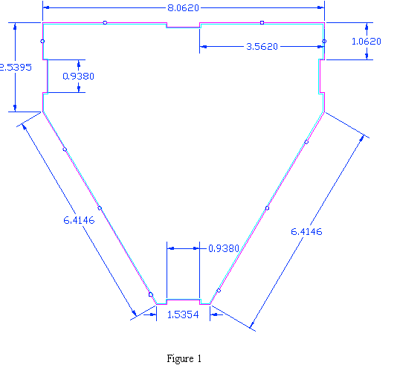
Figure 2 below shows the sides of the robot so that the top and the sides will connect.
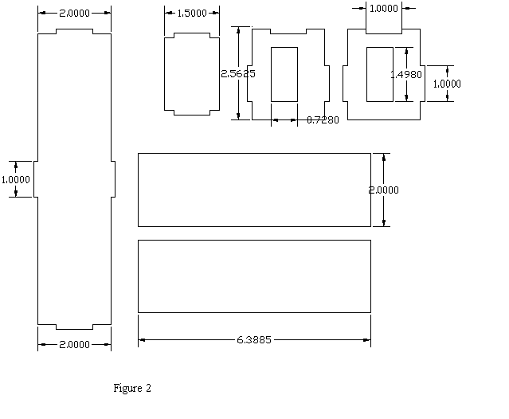
Finally figures 3 and 4 below shows the actually outcome when the robot was milled out and glued together.
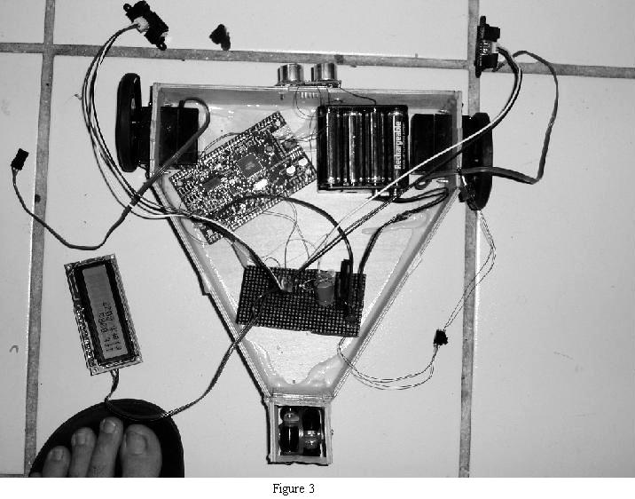
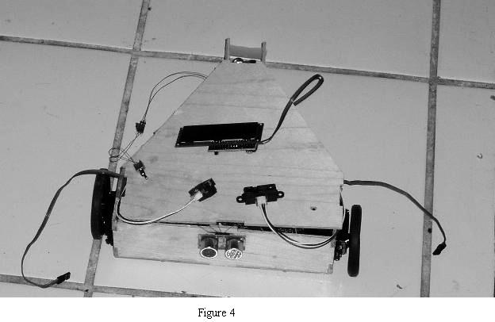
A simple wood glue was the adhesive used to keep the robot together. As you can see the back casters with an omni-directional wheel. This is so that I can directly attach it to the robot and not have to worry about it swiveling. The “caster” that was made for it was done at home by a dremel and glue. The front wheels were Injected Molded Wheels bought at MARKIII, and were made to fit the servos. It was a little tricky learning to use Autocad2000 for the first time, but with the help of the class and the TA’s I went through and made the platform with no hitches whatsoever.
Actuation:

Balsa Products BP148X 2BB High-torque Ball-Bearing servomotors drive the wheels. Each servo uses 2 ball bearings and put out 69oz.in. Of torque at 4.8V and 86oz.in. at 6.0V with a max transit time of 0.17 sec./60°. The servo’s themselves run off the PWM channels OC1A and OC1B which was PinB5 and PinB6 on my processor. Since the servos would suck too many Amps and would reset the Atmega128 whenever they were run, I had to create an outside power supply. This power supply is what powers everything besides the pumps, which will be addressed later. You can see the power supply in figure 3, it is what is closest to the back wheel. It was based off of the circuit shown in figure 5 below.
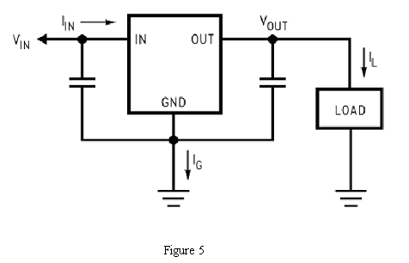
Sensors:
Since all sensors are pretty much sonar and infrared distance measuring devices. This is covered in my special sensor report. Some other sensors that were not addressed in the special sensor report were the cup color detector. This is basically a line tracking circuit. I used the OPB745 from Digikey for my combined IR LED and phototransistors. The general circuit that was made I got from William Dubel’s Reliable Line Tracking paper. Figure 6 below is cut directly from that paper, and is the exact circuit that I used.
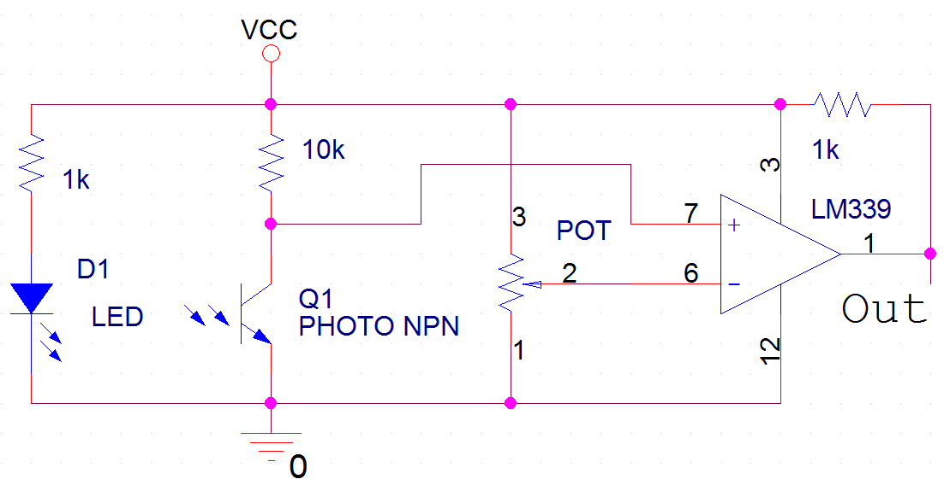
Figure 6

As suggested in the paper I use LM339 for the comparator. Since this has to get real close to the cup yet not too close or the readings will be inaccurate I created another arm that will “scoop” the cup to the specific distance. It was pretty home fashioned but it works well enough and detection is almost 100%. You can see how this turned out at the end of the document. Something not entirely a sensor but more of an output device is the LCD that I used. Instead of the standard Hitachi LCD’s I used a 2 Line Serial Enabled LCD with Backlight. This reduced on the number of wires that I had to use (5 V, GND, and signal). All transitions occur at 9600 bps with 8 bits of data, 1 start bit, one stop bit, and no parity. It is important to use PORTD3 and not the MAVRIC/MAVRIC-II UART1 TX pin because the UART1 TX pin is a level shifted RS232 voltage, while the SpeakJet utilizes just the TTL level. Which was one of the major problems that I was facing until I realized that I wasn’t connecting it to PORTD3.

Behaviors:
The behaviors of ProCoBot are fairly simple and haven’t been changed much since the initial coding of the robot. Since from the beginning ProCoBot seemed to behave in a manner suitable the only major changes were to add on more functions. ProCoBot starts off initializing all the systems, i.e.) LCD, SONAR, IR’s, and SERVO’s. All the initializations and methods that run these systems are stored in the library of the WINAVR such that they are automatically downloaded to the memory each time. All I did after saving them in the libraries was include them into my main method.
ProCoBot will start out spinning to the right while searching for an object within 3 feet of it with the sonar. Once it finds an object it immediately stops and starts to go forward towards it. It does this until a certain distance then it slows down and approaches forwards. After a certain distance the IR and the sonar will work together to align the cup so that it goes directly into the Arm/scooper. When the cup hits the end of the arm where the color detector, ProCoBot stops. The arm on top of the robot attached to the servo will swing right so that the IR and pump heads are directly overhead. The line-tracking device will measure the color of the cup. Telling which circuit to turn on (set one port high or the other). This goes into its final while loop. It immediately checks the level in the cup. If it is under a certain amount it will pour the correct liquid from the pump. The line-tracking circuit determined the correct pump. It will do this until its full. The robot will then retract its arm, reverse and start again. If the cup is already full then it will see that immediately and reverse without pumping. As you can see in my code I’ve narrowed this code in the main method into just four functions. This makes it a lot easier to see what is going on.

Experimental Layouts and Results:
Most experiments that were done were with the special sensor included in the Special Sensor Report. However there were a few tests that were done to check if the IR would measure the cup and the liquid in the cup. When putting the IR over the top of the cup I was worried that it would read the sides and give off a false static reading. However the radius in which the IR is emitted wasn’t significant to affect the readings. Also, whether the IR would even read a liquid was an issue. When trying it with a plain liquid it seemed to read it but it didn’t look like the IR values obtained from the output compare were increasing linearly. This probably had to do with refraction of a translucent liquid. That and IR could probably travel straight through. I believed that the readings that were generated had something to do with the ripples of the liquid when they were being poured in. I didn’t have any real time to experiment with this since my main concern would it read a darker non-transparent liquid. This it read increasingly better. The IR readings were much more linear. This worked to my advantage because now finding the level of liquid in the cup seemed not to be a problem. Using an IR sensor seemed like such an easy solution that I wonder why when in projects previously done similar to this it wasn’t approached.

Conclusion:

To sum up how everything worked out, I was completely amazed how fluidly things got done with ProCoBot. I had anticipated a lot of snags and spending a lot of time working out programming bugs, which none of this was the case. I believe that it was the way I approached the problem. I had initially set a goal that I believed would be too high, but a goal non-the less. I had tackled each problem one at a time and did not start another one until I had finished the first. This also made coding much easier, because it was essentially starting out with the “hello world” approach. Figure 7 below shows the final stage of ProCoBot.
One of the main dilemmas that I did face, however, was in the very beginning with the Rabbit Microprocessor, RabitCore RCM3200. I had initially tried to create my own power supply with reset switch for the processor. I didn’t take enough time and wasn’t careful enough and I believe this was why I fried the chip. I am not exactly sure what I did, but I do believe that it was me who did it. This is why I was so careful when starting over with the MAVRIC II, that and I couldn’t afford to break another one.
As far as evolution of ProCoBot went, the only really significant thing that I changed was the name. I started out thinking that I would use two sonar but found out that one was good enough. As far as detecting the difference between two cups I had a choice between using CDSL’s and the OPB745. I settled on the OPB745 mostly because it seemed easier. I accomplished everything that I set out to do.
How would I change it, or improve it? One of the first things I would do would be to put end of the world detectors on it. I think that this robot would perform much better on a counter top or table. This would also make more sense, instead of having to bend down and put a coffee cup on the ground. Also the wire wrapping in the robot seems disorganized and I don’t like it much. I would use better wire and headers that fit on each pin that is used. Probably the final thing that I would like to change would be the platform. When I initially made it I didn’t know how big the pumps were going to be, or how big that I would make the coffee reservoir. Even though all this fits onto the robot perfectly I would rather have made it wider so that it doesn’t give it such a crowded look to it.
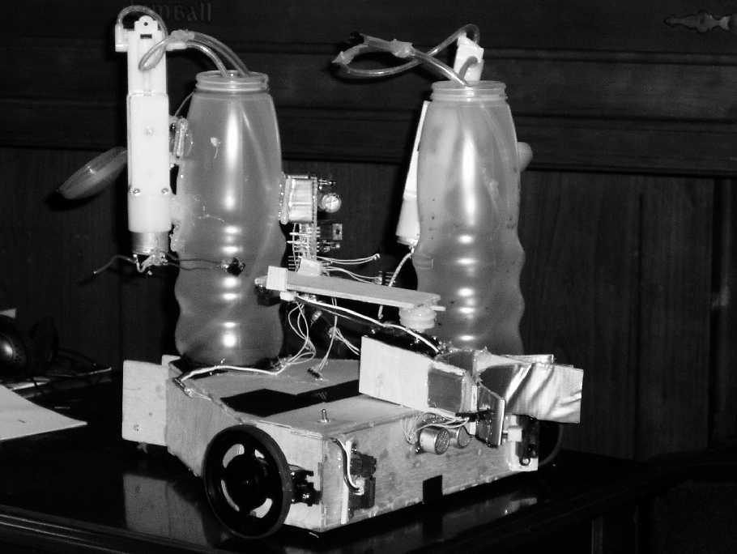
Figure 7

Documentation:

MAVRIC II
http://www.bdmicro.com/
WINAVR
http://sourceforge.net/projects/winavr
Atmega128 documentations
http://www.avrfreaks.net/Devices/devices.php?action=1&devid=54
SRF04 - Ultra-Sonic Ranger
http://www.robot-electronics.co.uk/htm/srf04tech.htm

Sharp GP2D120 Distance Measuring Sensor/Servos/Molded wheels

http://www.junun.org/MarkIII/Store.jsp

2 Line Serial Enabled LCD with Backlight
http://www.sparkfun.com/shop/index.php?shop=1&cart=83085&cat=72&

Appendices:
//Main Program.
#include <inttypes.h>
#include <avr/io.h>
#include <avr/interrupt.h>
#include <avr/signal.h>
#include <lcd.c>
#include <delayms.c>
#include <robotmove.c> //init with servo_init()
#include <sonar.c> //init with sonar_init()
#include <ir.c> //init with ir_init()

#define cupDist 0x300
/*old value 0x670*/

/*turn robot right until it see's something*/

void findCup(void)
{
while(sonar_dist() >= cupDist)
{
robotMove("fastright");
}

// check();
}

void check(void)
{

while(sonar_dist() >= 0x0670)
{
robotMove("left");
}

}

//if object there approach. when it gets a certain
//distance it will adjust with IR's
void approach(void)
{

while((sonar_dist() < cupDist) && (sonar_dist() >= 0x0100))
{
robotMove("fastforward");
}
while((sonar_dist() < 0x0100) && (sonar_dist() > 0x0019))
{

while(ir_dist("right") > (ir_dist("left") + 0x20) )
{
robotMove("left");
}
while(ir_dist("left") > (ir_dist("right") + 0x10))
{
robotMove("right");
}

robotMove("forward");

}

}

// at a certain distance it stops extends the arm
// then it takes the reading to see the color
// of the cup. It then goes into a loop
//and will turn the correct pump on untill hte
//cup is full
void fill(void)
{

if( (sonar_dist() < 0x002a) && (ir_dist("left") > 0x43) && (ir_dist("right") > 0x3c) )
{
robotMove("stop");

robotMove("armout");
delayms(10000);

while(ir_dist("arm") < 0x50)
{

int check;
check = PINA & 0xf0;

if(check == 0x80)
{
PORTA = 0x01;
}
if(check == 0x00)
{
PORTA = 0x02;
}

lcd_cmd("clear");
lcd(" ");
lcd_num(ir_dist("arm"));
delayms(600);
}
//this turns the pumps off and retracts the arm
//and reverses the robot

PORTA = 0X00;
PORTA = 0X00;

robotMove("armzero");
robotMove("fastreverse");
delayms(10000);
}

while(ir_dist("right") > (ir_dist("left") + 0x20) )
{
robotMove("left");
}
while(ir_dist("left") > (ir_dist("right") + 0x20))
{
robotMove("right");
}

}

main()
{

//initialize all the systems.
//all of these are located in the
//libraries.
sonar_init();
lcd_init();
servo_init();
ir_init();
// retract arm
robotMove("armzero");
DDRA = 0x03;

while(1)
{

/*moves around until cup is detected*/
/* DO NOT ERASE ME */

//finds a cup. stops. aproaches it. then fills it if needed.
//in function fill it reverses the cup if not needed, or when
//done
findCup();
robotMove("stop");
approach();
fill();
}

}

/*controls LCD*/

* Author : Brian Dean, bsd@bdmicro.com
* Date : 2 March, 2004
*/

/*
* Magnevation SpeakJet Speech and Sound Sythesizer Module
*
* This directory contains a complete test program for demonstrating the
* use of the Magnevation SpeakJet speach chip with the BDMICRO MAVRIC
* and MAVRIC-II microcontroller boards. Feel free to copy the relevent
* function definitions into your own applications and to customize them
* for your needs.
*
* The code is written in C using the GNU GCC C Compiler. A Makefile is
* provided which is known to work correctly on the FreeBSD Unix
* operating system.
*
* Configuration:
*
* Hook up the SpeakJet according to its data sheet. Attach the
* SpeakJet output to an amplifier. Attach your MAVRIC or MAVRIC-II
* PORTD3 to SpeakJet pin 11 (Serial TTL Data). It is important to use
* PORTD3 and not the MAVRIC/MAVRIC-II UART1 TX pin because the UART1
* TX pin is a level shifted RS232 voltage, while the SpeakJet utilizes
* just the TTL level. PORTD3 on the MAVRIC/MAVRIC-II is the TTL level
* RS232 output pin which is the one to use with the SpeakJet.
*
* When the MAVRIC/MAVRIC-II comes out of reset, it will speak the
* phrase: "Welcome to the BDMICRO MAVRIC SpeakJet Test Program".
*
* For more information about the MAVRIC and MAVRIC-II microcontroller
* boards, see:
*
* http://www.bdmicro.com/
*
* For more information about the Magnevation SpeakJet Speech chip, see:
*
* http://www.speakjet.com/
*
*
*/

#include <avr/io.h>
#include <avr/interrupt.h>
#include <avr/signal.h>
#include <avr/pgmspace.h>

#include <inttypes.h>

#define MCU_FREQ 16000000L
#define BAUD 9600L

volatile uint16_t ms_count;

#define WP 5

#define N_ANNC sizeof(announce)

void uart1_init(uint16_t baud)
{
uint16_t brr;

brr = MCU_FREQ / (16L*(long)baud) - 1;

UBRR1H = brr >> 8;;
UBRR1L = brr & 0x00ff;
UCSR1B = BV(TXEN);
}

//void uart_putc(uint8_t uart, char c[])
//{
// while ((UCSR1A & BV(UDRE)) == 0)
// ;
// UDR1 = c;
// while ((UCSR1A & BV(UDRE)) == 0)
// ;
// UDR1 = 1;
//}

int lcd_cmd(char str[])
{
if(str == "clear")
{

while ((UCSR1A & BV(UDRE)) == 0)
;
UDR1 = 254;
while ((UCSR1A & BV(UDRE)) == 0)
;
UDR1 = 1;

}

if(str == "line")
{

while ((UCSR1A & BV(UDRE)) == 0)
;
UDR1 = 254;
while ((UCSR1A & BV(UDRE)) == 0)
;
UDR1 = 192;

}

}
void lcd_init(void)
{
uart1_init(BAUD);
}

int lcd(char str[])
{

int j = 0;

uint8_t i;

while(str[j] != '\0')
{

while ((UCSR1A & BV(UDRE)) == 0)
;
UDR1 = str[j];
j++;
}

}
void lcd_num(int c)
{
int temp4,temp1,temp2,temp3;
char b[4];
char d[5];

temp1 = (c >> 12);
temp2 = ((c & 0x0fff) >> 8);
temp3 = ((c & 0x00ff) >> 4);
temp4 = (c & 0x000f);

itoa(temp1,b,16);
d[0] = b[0];
itoa(temp2,b,16);
d[1] = (b[0]);
itoa(temp3,b,16);
d[2] = b[0];
itoa(temp4,b,16);
d[3] = b[0];
d[4] = '\0';

lcd(d);

}

/*
* Author : Brian Dean, bsd@bdmicro.com
* Date : 2 March, 2004
*/

/*
* Magnevation SpeakJet Speech and Sound Sythesizer Module
*
* This directory contains a complete test program for demonstrating the
* use of the Magnevation SpeakJet speach chip with the BDMICRO MAVRIC
* and MAVRIC-II microcontroller boards. Feel free to copy the relevent
* function definitions into your own applications and to customize them
* for your needs.
*
* The code is written in C using the GNU GCC C Compiler. A Makefile is
* provided which is known to work correctly on the FreeBSD Unix
* operating system.
*
* Configuration:
*
* Hook up the SpeakJet according to its data sheet. Attach the
* SpeakJet output to an amplifier. Attach your MAVRIC or MAVRIC-II
* PORTD3 to SpeakJet pin 11 (Serial TTL Data). It is important to use
* PORTD3 and not the MAVRIC/MAVRIC-II UART1 TX pin because the UART1
* TX pin is a level shifted RS232 voltage, while the SpeakJet utilizes
* just the TTL level. PORTD3 on the MAVRIC/MAVRIC-II is the TTL level
* RS232 output pin which is the one to use with the SpeakJet.
*
* When the MAVRIC/MAVRIC-II comes out of reset, it will speak the
* phrase: "Welcome to the BDMICRO MAVRIC SpeakJet Test Program".
*
* For more information about the MAVRIC and MAVRIC-II microcontroller
* boards, see:
*
* http://www.bdmicro.com/
*
* For more information about the Magnevation SpeakJet Speech chip, see:
*
* http://www.speakjet.com/
*
*
*/

#include <avr/io.h>
#include <avr/interrupt.h>
#include <avr/signal.h>
#include <avr/pgmspace.h>
#include <inttypes.h>
#define MCU_FREQ 16000000L
#define BAUD 9600L
volatile uint16_t ms_count;
#define WP 5
#define N_ANNC sizeof(announce)

void uart1_init(uint16_t baud)
{
uint16_t brr;

brr = MCU_FREQ / (16L*(long)baud) - 1;

UBRR1H = brr >> 8;;
UBRR1L = brr & 0x00ff;
UCSR1B = BV(TXEN);
}

int lcd_cmd(char str[])
{
if(str == "clear")
{

while ((UCSR1A & BV(UDRE)) == 0)
;
UDR1 = 254;
while ((UCSR1A & BV(UDRE)) == 0)
;
UDR1 = 1;

}

if(str == "line")
{

while ((UCSR1A & BV(UDRE)) == 0)
;
UDR1 = 254;
while ((UCSR1A & BV(UDRE)) == 0)
;
UDR1 = 192;

}
}

void lcd_init(void)
{
uart1_init(BAUD);
}

//displays a string to the lcd
int lcd(char str[])
{

int j = 0;

uint8_t i;

while(str[j] != '\0')
{

while ((UCSR1A & BV(UDRE)) == 0)
;
UDR1 = str[j];
j++;
}

}
//takes a 16 bit number and
//displays it onto the lcd
//this and below is my code.
void lcd_num(int c)
{
int temp4,temp1,temp2,temp3;
char b[4];
char d[5];

temp1 = (c >> 12);
temp2 = ((c & 0x0fff) >> 8);
temp3 = ((c & 0x00ff) >> 4);
temp4 = (c & 0x000f);

itoa(temp1,b,16);
d[0] = b[0];
itoa(temp2,b,16);
d[1] = (b[0]);
itoa(temp3,b,16);
d[2] = b[0];
itoa(temp4,b,16);
d[3] = b[0];
d[4] = '\0';

lcd(d);

}

//delayms

#include <inttypes.h>
#include <avr/io.h>
#include <avr/interrupt.h>
#include <avr/signal.h>

//a delay. for every n = 20000 you
//get about 5.85 second delay
void delayms(int n)
{
//delay n ms
int x;
while(n--)
{
x= 2000;
while(x--);
}

}

//Robotmove (PWM for Sevos)
#include <inttypes.h>
#include <avr/io.h>
#include <avr/interrupt.h>
#include <avr/signal.h>

#define mask 0x07
#define PRESCALE 0x05
#define SERVO_MAK 0x23
#define SERVO_MIN 0x0D
#define SERVO_NEUTRAL 0x12

//the essentials of this code was given to me
//by Kaveh Nawroozi. I did break it down
//so that it only used what i needed to

void servo_init(void)
{
DDRB = 0xFF;
timer1Init();
timer1PWMInit();
timer1PWMAOn();
timer1PWMBOn();
timer1PWMCon();
}

void timer1Init(void)
{
timer1setprescaler(PRESCALE);
outp(0,TCNT1H);
outp(0,TCNT1L);
sbi(TIMSK, TOIE1);
}

void timer1setprescaler(int prescale)
{
outp( (inp(TCCR1B) & ~mask) | prescale, TCCR1B);
}

void timer1PWMInit(void)
{
cbi(TCCR1A,WGMA1);
sbi(TCCR1A,WGMA0);
outb(OCR1AH,0);
outb(OCR1AL,0);
outb(OCR1BH,0);
outb(OCR1BL,0);
outb(OCR1CH,0);
outb(OCR1CL,0);
}

void timer1PWMAOn(void)
{
sbi(TCCR1A,COMA1);
cbi(TCCR1A,COMA0);
}

void timer1PWMBOn(void)
{
sbi(TCCR1A,COMB1);
cbi(TCCR1A,COMB0);
}

void timer1PWMCon(void)
{
sbi(TCCR1A,COMC1);
cbi(TCCR1A,COMC0);
}
void timer1PWMBSet(signed short duty)
{
outp( (duty>>8), OCR1BH);

outp( (duty & 0x00FF), OCR1BL);
}

void timer1PWMASet(signed short duty)
{
outp( (duty>>8), OCR1AH);

outp( (duty & 0x00FF), OCR1AL);
}

void timer1PWMCSet(signed short duty)
{
outp( (duty>>8), OCR1CH);

outp( (duty & 0x00FF), OCR1CL);
}

//by sending this a string it determins
//what direction and speed to turn the
//wheels
void robotMove(char direction[])
{

if(direction == "stop")
{
timer1PWMBSet(0x00);
timer1PWMASet(0x00);
}
else if(direction == "fastforward")
{
timer1PWMBSet(SERVO_MAK);
timer1PWMASet(SERVO_MIN);
}
else if(direction == "forward")
{
timer1PWMBSet(SERVO_NEUTRAL + 1);
timer1PWMASet(SERVO_NEUTRAL - 1);
}
else if(direction == "fastreverse")
{
timer1PWMBSet(SERVO_MIN);
timer1PWMASet(SERVO_MAK);
}
else if(direction == "fastright")
{
timer1PWMBSet(SERVO_MAK);
timer1PWMASet(SERVO_MAK);
}
else if(direction == "right")
{
timer1PWMBSet(SERVO_NEUTRAL + 1);
timer1PWMASet(SERVO_NEUTRAL + 1);
}
else if(direction == "fastleft")
{
timer1PWMBSet(SERVO_MIN);
timer1PWMASet(SERVO_MIN);
}
else if(direction == "left")
{
timer1PWMBSet(SERVO_NEUTRAL - 1);
timer1PWMASet(SERVO_NEUTRAL - 1);
}
else if(direction == "armzero")
{
timer1PWMCSet(0x04);
}
else if(direction == "armout")
{
timer1PWMCSet(0x10);
}
else
{
timer1PWMBSet(SERVO_NEUTRAL);
timer1PWMASet(SERVO_NEUTRAL);
}
}
//Sonar

#include <inttypes.h>
#include <avr/io.h>
#include <avr/interrupt.h>
#include <avr/signal.h>

//initalizes the output compare.
void sonar_init(void)
{
outp(0x10,DDRE);
outp(0x22,OCR3AH);
outp(0x2E,OCR3AL);
outp(0x00,OCR3BH);
outp(0x10,OCR3BL);
outp(0x00,TCNT3H);
outp(0x00,TCNT3L);
outp(0x23,TCCR3A);
outp(0x9B,TCCR3B);
outp(0x20,ETIMSK);
}

//takes 4 readings and averages them.
//idea and code basics came from
//Anthony Huereca's sbob code.
int sonar_dist()
{
int high, temp, low, temp1, temp2,temp3,temp4;
low = ICR3L;
high = ICR3H;
high = high << 8;
temp1 = high + low;
delayms(70); // about 40 ms
low = ICR3L;
high = ICR3H;
high = high << 8;
temp2 = high + low;
delayms(70);
low = ICR3L;
high = ICR3H;
high = high << 8;
temp3 = high + low;
delayms(70); // about 40 ms
low = ICR3L;
high = ICR3H;
high = high << 8;
temp4 = high + low;
temp = (temp1 + temp2 +temp2 + temp4) >> 2;
return (temp-0x0069);
}

//IR
#include <inttypes.h>
#include <avr/io.h>
#include <avr/interrupt.h>
#include <avr/signal.h>

//idea and code basics came from
//Anthony Huereca's sbob code
//uses the A/D to get readings from
//the IR. I take 2 readings
//and average them to readuce
//spikes
void ir_init(void)
{
outp((1<<ADEN) | (1<<ADPS2) | (ADPS1), ADCSRA);
}

int ir_dist(char channel[])
{

int first, second, avg;

if(channel== "left")
outp(0x60,ADMUX);
else if(channel=="right")
outp(0x61,ADMUX);
else
outp(0x62,ADMUX);

sbi(ADCSRA, ADSC);
loop_until_bit_is_clear(ADCSRA, ADSC);
first = inp(ADCH);

if(channel=="left")
outp(0x60,ADMUX);
else if(channel=="right")
outp(0x61,ADMUX);
else
outp(0x62,ADMUX);

sbi(ADCSRA, ADSC);
loop_until_bit_is_clear(ADCSRA, ADSC);
second = inp(ADCH);
avg=(first+second)>>1;
return avg;

}

