University of Florida
Department of Electrical and Computer Engineering
EEL 5666
Intelligent Machines Design Laboratory

Final Report

T.o.P.S.o.R

Kaveh Nowroozi
August 3, 2004
TAs: Max Koessick, William Dubel
Professors: A. Antonio Arroyo
Eric M. Schwartz
Table of Contents:

Abstract ………………………………………………………………………………….. 3

Executive Summary ……………………………………………………………………... 4

Introduction ……………………………………………………………………………… 5

Integrated System ………………………………………………………………………... 5

Mobile Platform …………………………………………………………………………. 7

Actuation ………………………………………………………………………………… 7

Sensors …………………………………………………………………………………... 8

Behaviors ………………………………………………………………………………. 14

Conclusion ……………………………………………………………………………....15

Documentation…………………………………………………………………………...15

Appendices …....................................................................................................................16
Abstract:
The main goal of this project is to create an autonomous agent using an Atmel Mega 128 Microcontroller to perform the necessary operations to collect cans within a defined boundary resembling a child’s play area and return them to their home color-coded areas. The robot drives around inside the play area searching for objects and when one is found, it is picked up. After successfully grabbing a toy, the robot then searches for the line that bounds the play area. The robot then determines the color of the area that it is in and if the area color matches the can color, it will leave the can there. If the can is not the same color as the area, the robot will search for another boundary and try again, repeating until it finds the right place for the can.

The robot system was designed using servos for the drive system and grabbing arm, photo resistors to find the boundary of the playing area, and a camera for color differentiation. With all of these systems combined, a successful design was implemented. LCD feedback was used in all operations performed by the robot to allow for easier debugging of problems.
Executive Summary:

T.o.P.S.o.R was first envisioned as a robot to pick up and sort children’s’ toys. This basis for design is very relevant and practical for many people. Parents don’t always want to follow their children around and pick up after them, so it seems beneficial to create a robot to do this. In order to adapt this in to a reasonable design, many environmental adjustments had to be made to suit a project of this size. Because a small robot was created for this task, a restriction had to be placed on the size of the toys, and a universal object was used. In this case, 8oz soda cans painted different colors represent the children’s toys. The child’s ‘play-area’ was also adjusted from the size of an entire room to a 60” X 40” X 8” open-topped cube created with foam board. By creating this encapsulated area, the objective is able to be quickly and easily tested. The main objective for the robot is to drive around this small area using two servos as drive motors and two omni-directional castors for turning and balance. Using distance measuring sensors for object detection, a camera to see, and a servo controlled gripping arm to grab, the robot will be able to find, pick up, and identify the color of any can that is in the field. Due to the restrictions of the camera, the colors chosen for this task were red, green, and blue. Upon picking up a can, the robot will drive until it senses the boundary of the playing area, marked off by black tape using photo resistors. Once the boundary is found, the wall in front of the robot is checked to see if its color matches the color of the can. If it does, the robot will release the can and do a dance. If the colors do not match, however, the robot will search for the appropriate wall and deposit the can in front of it.

Introduction:

Children are messy. Watching my younger brother grow up was fun at times and tedious at others. Many times, I would find myself picking up his toys and putting them away. In choosing a design for this course, I remembered my troubles of years past, “If I only had something to pick these toys up for me.” This project gave me a wonderful opportunity to create something that solves the problem that I had and that many other older siblings are having right now. My robot, the Toy Picking up and Sorting Robot (T.o.P.S.o.R) is designed with the older sibling in mind. Not only does it pick up the toys left around by young children, it also puts them away where they are supposed to go. In this case, all of the toys of a certain color belong in that same colored area.

Integrated System:

T.o.P.S.o.R was created using a Mega128-Dev PC-Board (Figure 1) from Progressive Resources using the Atmel ATMega128 Microcontroller with a 16 MHz Clock and an external 14.7456 MHz Crystal Oscillator. The controller board was used to control two hacked Parallax servos (Figure 2) for a drive system. A CMUCam (Figure 3) was used to identify toy and wall colors. Two more servos were used to control a grabbing arm used to pick up objects. Two photo resistors (Figure 4) were mounted on the underside of T.o.P.S.o.R to allow for the finding of the taped off boundary of the playing area. Three distance measuring sensors (Figure 5) were mounted on top of T.o.P.S.o.R so he would be able to determine the position of a can placed anywhere in front of him. These components, along with LEDs and an LCD display complete the robot.

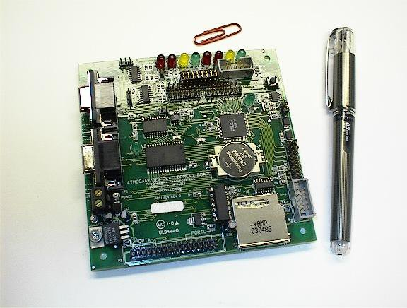
Figure 1
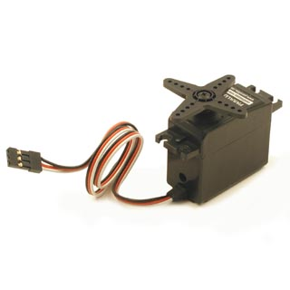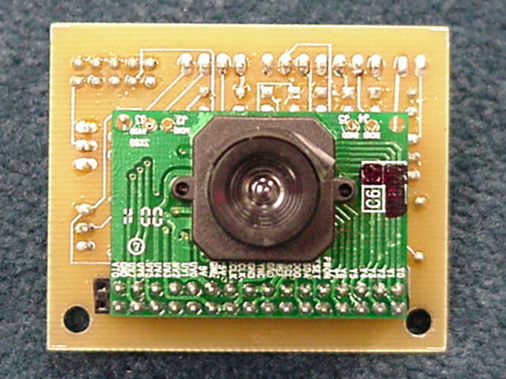

Figure 2 Figure 3

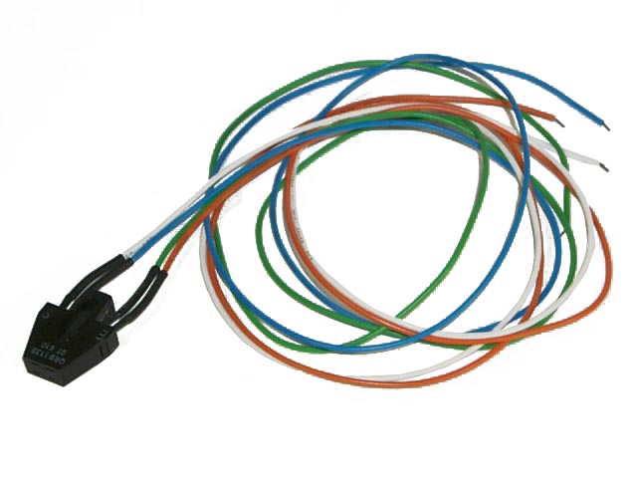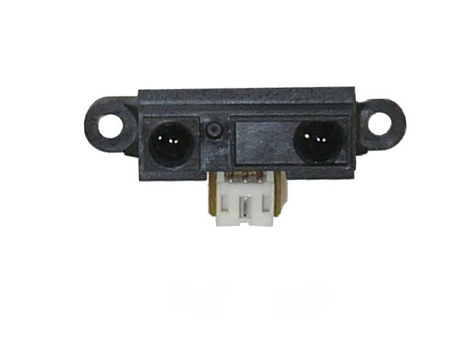
Figure 4 Figure 5

The drive servos and the arm controlling servos were all mounted to 4 of the 8 PWM channels available on this chip. Both the distance measuring sensors and the photo resistors were integrated using the ADC port on the ATMega and the CMUCam was connected serially through the USART. I chose this board because it came preprogrammed with a boot loader that was very easy to use and understand. This cut time down for me in figuring out how to load my software to the chip.

Mobile Platform:

The mobile platform of T.o.P.S.o.R was cut with acrylic material. The dimensions of the platform were 6” X 7” square for the main platform where all components wee mounted on two separate layers. The platform shape and design for T.o.P.S.o.R was not critical nor did it have to be specific in any way. I wanted to use acrylic so the robot had a ‘see-through’ look as everyone would be able to see the wiring and circuitry. As the project progressed, however, the messier my wiring and gluing became so I wish that I had not used this material at all. However, it was sturdy enough to hold all of the components in tact, and that is all that really mattered in the end.

Actuation:

As mentioned before, T.o.P.S.o.R moves using two hacked Parallax servos ordered from http://www.acroname.com as a drive system. After calculating the divisor needed to create the pulse width required to drive the servos, I set the timers I needed accordingly using timer libraries I found on AVRFreaks to send out the PWM signals. All code for servo use can be found in Appendix A (Servo Code) at the end of this document. The PWM output to each of the servos is adjusted from 1ms to 2ms to allow for turning and movement in different directions. The other two servos control the opening and closing of the gripping arm located on the front of the robot.

Sensors:

All sensors used in this design have been mentioned above. I will now give a more detailed explanation of each individual sensor and its uses in this project. The table below lists relevant information about the sensors I used in this project.

Sensor | Ordered From: | Part Number | Price
CMUCam | Acroname | R140CMUCAMKIT | 1 X $109
Sharp Distance Measuring Sensor | Mark III | GP2D12 | 3 X $8.25
Fairchild IR Photo reflector | Mark III | QRB1134 | 3 X $1.50

CMUCam:
The CMUCam is used in this project to provide for visual color detection of both cans and walls of the playing area. This was accomplished without the use for a tilting mechanism for the camera because of the small size of the cans. The camera is mounted high enough on the robot where it is able to see both the can and the wall in different user-defined windows. This camera was ordered from http://www.acroname.com as a kit that I had to assemble. The part number for this product was R140-CMUCAM-KIT. After assembling the kit, I tested the camera connected to a PC to verify that it worked correctly. Figures 6 and 7 show two screens grabbed from the camera from testing. The hardest part about interfacing the camera to the CPU was figuring out that my PCB was incorrectly wired. The Rx and Tx pins on the main board were switched (Figure 8), so I had to make a cable to get around this problem. This took a few hours of testing before I realized the problem. After that, the camera worked fine and gave readings to my LCD using modified code from an old IMDL student (Kyle Tripician). The code that I got from him was only used to track the color red. I rewrote most of it in order to get the mean value of Red, Green, and Blue of each object using the ‘gm’ (get mean) command of the camera. After receiving the mean values, the CPU performs appropriate actions with them. The Code is listed in Appendix A (Camera Code).

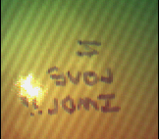
Figures 6 and 7 (Camera Shots)
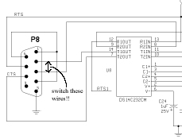
Figure 8
The algorithms I used for can and wall detection differed slightly as the 2 inch difference in objects significantly affected the values seen by the camera. For can detection I detected a color by checking to see if (on a scale of 0x00-0xFF) 0x60 of a certain color was present and if the value of that color was greater than the presence of the other colors. For the wall, however, the test value was lowered to 0x45 for green and red and remained the same for blue because the lights I was using were bright white lights that created a blue tint. Because of this, blue was found very easily and the value did not have to be changed.

Sharp Distance Measuring Sensor:
I used three of these sensors to use in can distance detection and to aid in positioning for the arm to grab cans. Two sensors were mounted on the top-front left and right corners of the robot and the other was mounted behind and underneath the grabbing arm, creating a viewing angle of approximately 120°. These sensors were very easy to test and interface with the ADC of the CPU. Graphs of data from the datasheet and my own tests are shown in Figures 9 and 10. The values obtained from testing the sensor were very close to those given in the data sheet so I decided that this was an acceptable method for measuring distance from the robot. By using this data, I could determine very approximately how far a can was positioned in front of the robot. The code to interface and use these sensors is shown in Appendix A (Sharp Code). The algorithm I used for these sensors determines the value of the analog voltage sent by the sensor, and if it is greater than 0xC0 (on scale of 0x00 – 0xFF) then the can is within a reachable distance of the can. Depending on which sensor sent this signal, the robot will turn towards the can and keep turning and moving forward until it is close enough to where the value received from the sensor in the center reads above a value of 0xC0, after this is realized, the robot moves forward and closes its arms and the camera begins to identify the color.

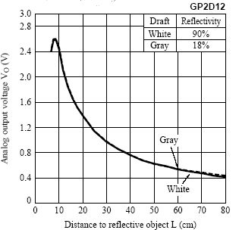
Figure 9 – From Sharp Data Sheet

Figure 10 – Sharp Test Data

Fairchild IR Photo reflector:
The original design of T.o.P.S.o.R. called for 3 of these photo resistors to use line tracking to find different bins around the playing area, but as time progressed and I had to get done with everything, the line tracking was scrapped in favor of using colored walls as placement points for the cans. Although the idea was not used, these photo resistors were very handy in finding the boundary of the playing area so the robot knew when to snap a picture of the wall and identify its color. The data sheet for this sensor had no data on distance verses output voltage, so there is no basis for comparison of the values that I received. I tested the resistors reflectivity of black and white objects to see what distance would be the most beneficial in this project. Figure 11 shows the data I received from the photo resistor when connected to the circuit (Figure 12) I found at http://www.superdroidrobots.com/product_info/qrb1134.htm . According to the website I found this at, the resistor will give a voltage of ~4.8V over a black surface and ~0.5V over a white surface.
Figure 11

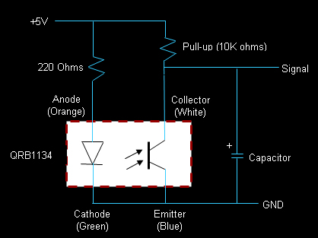

Figure 12 – Drive Circuit for QRB1134

Based on this information and the test that I did on the sensor, I found that the smaller the distance between the sensor and the ground, the easier it would be to differentiate analog values and determine if the floor is black or white. I mounted two of these sensors 1cm off of the ground. I chose to mount two incase one sent erroneous data causing a malfunction with the robot. By having two sensors, the robot is programmed to stop whenever both sensors are on the boundary line. For my equation, I used a value of 0xB0 as a threshold. (Code is identical to that used for Sharp sensors. See Sharp Test Code in Appendix A for ADC initialization) If the analog value received from the sensor while the robot is looking for a wall is less than this threshold, the floor is determined to be white, otherwise, the floor is black and the robot has reached a boundary of the playing area.

Behaviors:

T.o.P.S.o.R has the following behaviors to perform its tasks. It searches for a can, identifies a can, searches for a wall, identifies a wall and deposits a can. The first behavior that T.o.P.S.o.R uses is the search behavior. While searching for a can, the robot uses the Sharp distance sensors to search for cans and stop when one comes in the appropriate range. If a can is in front of it, it moves forward until it is inside the hand of the robot and the arm closes. If the can is on either side of the robot in front of it, it turns toward the can until it is found by the middle sensor and then drives forward until it is in the claw and the claw closes. The next behavior it performs is identifying the can. Once the can is inside the claw, the CMUCam takes a picture of the can to determine its mean color. If the color is one of the three colors the robot is looking for, the claw closes again to ensure the can is secure and is ready to go. If the can is not seen or is the wrong color, the claw opens and T.o.P.S.o.R backs up and then searches for another can. After a can is captured, the next behavior is started; searching for a wall. T.o.P.S.o.R will drive forward until the photo resistors mounted on the underside find the black boundary of the play area. Once the boundary is seen by the photo resistors, the last behavior is implemented. T.o.P.S.o.R then takes a picture of the wall to identify its color. If the color is the same, the arms open and T.o.P.S.o.R backs up to do a little dance inside the play area. If the colors are not the same, it will back up and turn to find another wall. The previous behavior then repeats to find a wall and will keep repeating until the wall is the same color of the can.

Conclusion:

Overall, the project was a success. T.o.P.S.o.R did what I had hoped it would do, but there were some problems that I ran into I found myself modifying the goal a couple of times. There were some things that I had originally wanted to get done, but did not have enough time to complete. Other things that held me back were monetary constraints. If given the opportunity to do this project with an unlimited source of funding, I would have bought much better parts. Despite being a success, there were some very important lessons that I learned from my experience. The most important thing I learned was to always be aware in changes in environment when testing a robot. If the lighting is even slightly different and you are using light sensitive sensors or camera, the whole robot may not function correctly and you will inevitably spend hours upon hours debugging for nothing. To all those reading this, make sure you always have a good source of light and always make sure you fully understand how all your parts work before you throw them all together and have too many problems to pinpoint a single one. Another important thing to appreciate is time. As advisement to others who desire taking this class, do NOT have a full course load and try to add this class in on top of that. It is VERY important that you have a lot of time to spend working on this project. And last but certainly not least, you need to appreciate all the sleep you have gotten before enrolling for this class. I encountered many sleepless nights, especially near the end of the semester and I am almost certain that some, if not all of future students reading this will be lucky if they only miss a few nights of sleep.

Documentation:

The following is a list of all sources used in this project:

- Mega128-Dev PCB Manual - http://www.prllc.com/Mega128_Dev.pdf
- AtMega128 Data Sheet –
http://www.atmel.com/dyn/resources/prod_documents/doc2467.pdf
- Sharp GP2D12 - http://www.junun.org/MarkIII/datasheets/GP2D12_15.pdf
- Fairchild QRB1134 - http://www.junun.org/MarkIII/datasheets/QRB113x.pdf
- CMUCam –
http://www-2.cs.cmu.edu/~cmucam/Downloads/CMUcamManual.pdf

Appendix A:
(All included libraries can be found in avrlibc library files…use Google)
(If any coded is used/borrowed, proper reference MUST be given)

Servo Test Code:

#include <stdlib.h>
#include <avr/io.h>
#include <avr/delay.h>
#include "timer128.h"
#include "test_servo.h"

#define SERVO_MAX 0x0F
#define SERVO_MIN 0x01
#define SERVO_NEUTRAL 0x08

void motor_init(void)
{
timer1Init();
timer1PWMInit(8);
timer1PWMAOn();
timer1PWMBOn();
}

int main(void)
{
motor_init(); //INITIALIZE DRIVE SYSTEM
int temp = 0;
DDRB = 0xFF; //ENABLE PORT B FOR OUTPUT
//pwm generated on port b pins 5 and 6 => OC1A and OC1B
while(temp == 0)
{
timer1PWMBSet(SERVO_MAX); //Drive forward
timer1PWMASet(SERVO_MIN);

}
}

Camera Test Code:

#include <stdlib.h>
#include <avr/io.h>
#include <avr/delay.h>
#include <avr/interrupt.h>
#include <avr/signal.h>
#include <string.h>
#include <avr/pgmspace.h>

#include "lcd.h"
#include "timer128.h"
#include "test.h"
#include "uart2.h"
#include "motors.h"
#include "myuart.h"

#define BAUD_RATE1_REG (unsigned int)(CPU_CLK_SPEED / (16 * BAUD_RATE1) ) - 1
#define ACTUAL_BAUD1 (unsigned int)(CPU_CLK_SPEED / (16 * BAUD_RATE1_REG + 1)
#define CPU_CLK_SPEED 14745600
#define BAUD_RATE1 115200
#define NUM_OF_BAUDREGS 2
#define BAUD1H_REG UBRR1H
#define BAUD1L_REG UBRR1L
#define NUM_OF_UARTS 2
#define RXTXEN1_REG UCSR1B
#define STAT1RXTX_REG UCSR1A

#define RX1EN RXEN1
#define TX1EN TXEN1
#define RX1C RXC1
#define UDR1E UDRE1

#define red 1
#define green 2
#define blue 3

#define can 1
#define wall 2
#define r 0
#define l 1

volatile u08 i =0;
volatile u08 j =0;
int canfound = 0;
int left_sensor,right_sensor,right_on, mid_on, color, sight,cancolor,wallcolor,middle_on,count =0;

//This is the interrupt that fires when there is data waiting on USART
SIGNAL(SIG_UART1_RECV)
{
temp=UDR1; //read data on USART and send to temp var
if (temp == 0x3A) //if data is ‘:’ then start reading data
i=0;
if (temp != 0x3A && temp > 0x19) //if camera hasn’t sent CR/LF
{
cmudat[i]=temp; //set array value to temp
i++;
}

if(i == 5) //after first 5 chars are read from cam, test them
//index 2 is mean Red value, 3 is mean Blue value,
//4 is mean Blue value. If using stdev,
//change if to i==8 and 5 is stdv of R, 6 -> B, 7->G
{
if ((cmudat[2] > 120) && (cmudat[2] > cmudat[3]) &&
(cmudat[2] > cmudat[4]))
{
lcd_clrscr();
lcd_puts(“can is red");
ret();
}
else if ((cmudat[3] > 120) && (cmudat[3]
> cmudat[2]) && (cmudat[3] > cmudat[4]))
{
lcd_clrscr();
lcd_puts("can is green");
ret();
}
else if ((cmudat[4] > 120) && (cmudat[4] > cmudat[2])
&& (cmudat[4] > cmudat[3]))
{
lcd_clrscr();
lcd_puts("can is blue");
}
else
{
lcd_clrscr();
lcd_puts("i dont see a can");
DDRB = 0x00;
}
i=0;
}
}

void init_uart1 (void)
{
//turn on TX and RX
RXTXEN1_REG = 0x98;

//set up baud rate
#if (BAUDREGS == 2)
BAUD1H_REG = (unsigned char)(BAUD_RATE1_REG >> 8);
BAUD1L_REG = (unsigned char)BAUD_RATE1_REG;
#else
BAUD1L_REG = (unsigned char)BAUD_RATE1_REG;
#endif
return;
}

void uint(void)
{
UCSR1B = 0x98;
UCSR1C = 0x06;
UBRR1H = 0x00; //set baud
UBRR1L = 23; //see atmega128 datasheet for correct value for
//your oscillator
}
//this function sends string through usart
void uartstring(char* myStringIn)
{
unsigned char *myString = myStringIn;
unsigned char ch1;
unsigned char gotNULL = 0;
ch1 = *myString++;
while(!gotNULL)
{
uarttransmit(ch1);
_delay_loop_2(60000);
ch1 = *myString++;
if(ch1 == '\r')
{
gotNULL = 1;
uarttransmit(ch1);
}
}
}
//this function sends single character to usart
void uarttransmit(unsigned char data)
{
while(!(UCSR1A & (1<<UDRE1)));
UDR1 = data;
}

void caminit()
{
//set camera to raw mode 3 (see manual)
uartstring("RM 3\r");
_delay_loop_2(60000);
//set camera to poll mode 1 (see manual)
uartstring("PM 1\r");
_delay_loop_2(60000);
}

int main(void)
{
init_uart1();
caminit();
sei();

//this returns the mean of default window
uartstring("gm \r");
_delay_loop_2(60000);

}

Sharp Test Code (Collision Avoidance):

//Kaveh Nowroozi
//WORKING_ COLLISION AVOIDANCE
//6/24/2004

//3 SHARP DISTANCE MEASURING SENSORS ABOUT 3-4 inch buffer before hitting wall

#include <stdlib.h>
#include <avr/io.h>
#include "lcd.h"
#include <avr/delay.h>
#include "timer128.h"
#include "motors.h"
#include "test_lcd.h"

#define rightm 1
#define leftm 2

#define forward 1
#define reverse 2

int front_bump, right_bump, left_bump, lastdir, temp,bad, right, left ;

//initialize ADC
void ADC_init(void)
{
DDRF = 0x00;
ADMUX |= (0<<REFS0) | (1<<REFS1);
ADCSR |= ((1<<ADEN) |(0<<ADPS2)|(0<<ADPS1));
}
//Start Conversion
int convert(char adc)
{
int value;
ADMUX &= 0x00;
ADMUX |= adc;
ADCSR |= (1<<ADSC);
while((ADCSR&(1<<ADSC)));
value = ADCL;
value |= (ADCH<<4);
return value;
}

int main(void)
{
lcd_init(LCD_DISP_ON);
lcd_clrscr();
ADC_init();
_delay_loop_2(30000);
motor_init();
int temp = 0;
DDRB = 0xFF;
while(temp == 0)
{
checkbump();
}
}
void check()
{
front_bump = convert(PINF1);
_delay_loop_2(60000);

left_bump = convert(PINF0);
_delay_loop_2(60000);

right_bump = convert(PINF2);
_delay_loop_2(60000);
}
void checkbump()
{
check();

if (front_bump > 0xC0)
{
while (front_bump > 0xC0)
{
lcd_clrscr();
if (left == 1)
{
turn_left();
}
else if (right == 1)
{
turn_right();
}
else
{
turn_left();
}
check();
}
}
if (left_bump > 0xC0)
{
while (left_bump > 0xC0)
{
if (left == 1)
{
bad +=1;
if (bad == 2)
{
lcd_clrscr();
lcd_puts("back up");
motors(leftm,0);
motors(rightm,0);
for(int i=0;i<10000;i++);
delay(10000);

turn_left();
lastdir = reverse;
bad = 0;
}
}
else
{
turn_right();
}
check();
}
}
if (right_bump > 0xC0 )
{
while (right_bump > 0xC0 )
{
if (right == 1)
{
bad += 1;
if(bad==2)
{
lcd_clrscr();
lcd_puts("back up");
motors(leftm,0);
motors(rightm,0);
for(int i=0;i<10000;i++);
delay(10000);
turn_right();
bad = 0;
}
}
else
{
turn_left();
}
check();
}
}
drive_forward();
}

void drive_forward(void)
{
lcd_clrscr();
lcd_puts("Driving Forward");
motors(leftm,100);
motors(rightm,100);
right = 0;
left = 0;
}

void turn_right(void)
{
lcd_clrscr();
lcd_puts("tURNING right");
motors(leftm,100);
motors(rightm,0);
right = 1;
left = 0;
}

void turn_left(void)
{
lcd_clrscr();
lcd_puts("tURNING Left");
motors(leftm,0);
motors(rightm,100);
right = 0;
left = 1;
}

LCD CODE (BONUS)
I had trouble finding LCD code, but eventually found very powerful code.
Go here http://jump.to/fleury for info on HD44780U LCD library.

Final Code:

//Kaveh Nowroozi
//Final Code
//8/02/2004

#include <stdlib.h>
#include <avr/io.h>
#include <avr/delay.h>
#include <avr/interrupt.h>
#include <avr/signal.h>
#include <string.h>
#include <avr/pgmspace.h>

#include "lcd.h"
#include "timer128.h"
#include "test.h"
#include "uart2.h"
#include "motors.h"

#define BAUD_RATE1_REG (unsigned int)(CPU_CLK_SPEED / (16 * BAUD_RATE1) ) - 1
#define ACTUAL_BAUD1 (unsigned int)(CPU_CLK_SPEED / (16 * BAUD_RATE1_REG + 1)
#define CPU_CLK_SPEED 14745600
#define BAUD_RATE1 115200
#define NUM_OF_BAUDREGS 2
#define BAUD1H_REG UBRR1H
#define BAUD1L_REG UBRR1L
#define NUM_OF_UARTS 2
#define RXTXEN1_REG UCSR1B
#define STAT1RXTX_REG UCSR1A

#define RX1EN RXEN1
#define TX1EN TXEN1
#define RX1C RXC1
#define UDR1E UDRE1

#define rightm 1
#define leftm 2

#define forward 1
#define reverse 2

#define red 1
#define green 2
#define blue 3

#define can 1
#define wall 2
#define r 0
#define l 1

volatile u08 i =0;
volatile u08 j =0;
int canfound = 0;
int left_sensor,right_sensor,right_on, mid_on, color, sight,cancolor,wallcolor,middle_on,count =0;

SIGNAL(SIG_UART1_RECV)
{
temp=UDR1;
if (temp == 0x3A)
i=0;
if (temp != 0x3A && temp > 0x19)
{
cmudat[i]=temp;
i++;
}

if (sight == 0)
{
i=0;
lcd_clrscr();
lcd_puts("Camera Ready...");
}

else if (sight == can)
{

if(i == 5)
{
if ((cmudat[2] > 120) && (cmudat[2] > cmudat[3]) && (cmudat[2] > cmudat[4]))
{
setretry(0);
setcancolor(red);
ret();
}
else if ((cmudat[3] > 120) && (cmudat[3] > cmudat[2]) && (cmudat[3] > cmudat[4]))
{
setretry(0);
setcancolor(green);
ret();
}
else if ((cmudat[4] > 120) && (cmudat[4] > cmudat[2]) && (cmudat[4] > cmudat[3]))
{
setretry(0);
setcancolor(blue);
ret();
}
else
{
lcd_clrscr();
lcd_puts("i dont see a can");
DDRB = 0x00;
setcan(0);
open_arms();
_delay_loop_2(60000);
backup();
_delay_loop_2(60000);
_delay_loop_2(60000);
_delay_loop_2(60000);
_delay_loop_2(60000);

}
i=0;
}
}
else if (sight == wall)
{
if(i == 5)
{
if ((cmudat[2] > 60) && (cmudat[2] > cmudat[3]) && (cmudat[2] > cmudat[4]))
{
setretry(0);
setwallcolor(red);
// ret2();
}
else if ((cmudat[3] > 60) && (cmudat[3] > cmudat[2]) && (cmudat[3] > cmudat[4]))
{
setretry(0);
setwallcolor(green);
// ret2();
}
else if ((cmudat[4] > 100) && (cmudat[4] > cmudat[2]) && (cmudat[4] > cmudat[3]))
{
setretry(0);
setwallcolor(blue);
// ret2();
}
else
{
lcd_clrscr();
lcd_puts("i dont see a wall");

}
i=0;
}
}
}
void init_uart1 (void)
{
//turn on TX and RX
RXTXEN1_REG = 0x98;

//set up baud rate
#if (BAUDREGS == 2)
BAUD1H_REG = (unsigned char)(BAUD_RATE1_REG >> 8);
BAUD1L_REG = (unsigned char)BAUD_RATE1_REG;
#else
BAUD1L_REG = (unsigned char)BAUD_RATE1_REG;
#endif
return;
}

void uint(void)
{
UCSR1B = 0x98;
UCSR1C = 0x06;
UBRR1H = 0x00;
UBRR1L = 23;
}

void uartstring(char* myStringIn)
{
unsigned char *myString = myStringIn;
unsigned char ch1;
unsigned char gotNULL = 0;
ch1 = *myString++;
while(!gotNULL)
{
uarttransmit(ch1);
_delay_loop_2(60000);
ch1 = *myString++;
if(ch1 == '\r')
{
gotNULL = 1;
uarttransmit(ch1);
}
}
}
void uarttransmit(unsigned char data)
{
while(!(UCSR1A & (1<<UDRE1)));
UDR1 = data;
}

void setcan(int n)
{
canfound = n;
}

void ADC_init(void)
{
DDRF = 0x00;
ADMUX |= (0<<REFS0) | (0<<REFS1);
ADCSR |= ((1<<ADEN) |(0<<ADPS2)|(0<<ADPS1));
}

int convert(char adc)
{
int value;
ADMUX &= 0x00;
ADMUX |= adc;
ADCSR |= (1<<ADSC);
while((ADCSR&(1<<ADSC)));
value = ADCL;
value |= (ADCH<<4);
return value;
}

void setbump(int a, int b, int c)
{
front_bump = a;
left_bump = b;
right_bump = c;
}

int getbump1(void)
{
return front_bump;
}

int getbump2(void)
{
return left_bump;
}
int getbump3(void)
{
return right_bump;
}

void checkbumps(void)
{
//sharp sensors
setbump(convert(PINF1),convert(PINF0),convert(PINF2));
}

void checkfloor(void)
{
//floor sensors
int lb = convert(PF6);
_delay_loop_2(60000);
_delay_loop_2(60000);

int rb = convert(PF5);
_delay_loop_2(60000);
_delay_loop_2(60000);

if (lb > 0x90)
mid_on = 1;
else mid_on = 0;

if (rb > 0x90)
right_on = 1;
else right_on = 0;
}

void checkbump()
{
int n;
while (canfound < 3)
{
checkbumps();
if (getbump1() > 0xC0)
{

int n;
canfound = 3;
left_sensor = 0;
right_sensor = 0;
drive_forward();
for(n=0;n<75;n++)
_delay_loop_2(60000);
DDRB = 0x0F;
canfound = 3;
}

else if (getbump2() > 0xD0)//left_bump > 0xD0)
{
lcd_clrscr();
turn_left();
for(n=0;n<10;n++)
_delay_loop_2(60000);
do
{
if (count > 3)
{
count = 0;
break;
}
turn_left();
for(n=0;n<10;n++)
_delay_loop_2(60000);
drive_forward();
for(n=0;n<15;n++)
_delay_loop_2(60000);
DDRB = 0x00;
for(n=0;n<50;n++)
_delay_loop_2(60000);
checkbumps();
count++;
}while (getbump1() < 0xC0);
drive_forward();
for(n=0;n<15;n++)
_delay_loop_2(60000);
DDRB = 0x00;
checkbumps();
if(getbump1() < 0xE0)
{
while (getbump1() < 0xE0)
{
if (count > 3)
{
count = 0;
break;
}
DDRB = 0x06;
drive_forward();
checkbumps();
count ++;
}
}
DDRB = 0x00;
canfound = 3;
}

else if (getbump3()> 0xD0)
{
right_sensor = 1;
lcd_clrscr();
turn_right();
for(n=0;n<10;n++)
_delay_loop_2(60000);
do
{
if (count > 3)
{
count = 0;
break;
}
turn_right();
for(n=0;n<10;n++)
_delay_loop_2(60000);
drive_forward();
for(n=0;n<15;n++)
_delay_loop_2(60000);
DDRB = 0x00;
for(n=0;n<50;n++)
_delay_loop_2(60000);
checkbumps();
count++;
}while (getbump1() < 0xC0);
drive_forward();
for(n=0;n<15;n++)
_delay_loop_2(60000);
DDRB = 0x00;
checkbumps();

if(getbump1() < 0xE0)
{
while (getbump1() < 0xE0)
{
if (count > 3)
{
count = 0;
break;
}
DDRB = 0x06;
drive_forward();
checkbumps();
count++;
}
}
DDRB = 0x00;
canfound = 3;
}

else
{
drive_forward();
DDRB = 0xF0;
canfound = 0;
}

}
close_arms();
lcd_clrscr();
lcd_puts("Identifying can");
DDRB = 0x0F;
PORTB |= 0x0F;
for(n=0;n<50;n++)
_delay_loop_2(60000);
sight = 1;
caminit();
}

void caminit()
{
uartstring("RM 3\r");
_delay_loop_2(60000);
uartstring("PM 1\r");
_delay_loop_2(60000);
uartstring("SW 10 20 80 40\r"); // FOR CAN
_delay_loop_2(60000);
uartstring("gm \r");
_delay_loop_2(60000);

}

void caminit2()
{
int n;
_delay_loop_2(60000);
for(n=0;n<25;n++)
_delay_loop_2(60000);

uartstring("RM 3\r");
_delay_loop_2(60000);
_delay_loop_2(60000);
uartstring("PM 1\r");
_delay_loop_2(60000);
_delay_loop_2(60000);
uartstring("SW 1 120 80 143\r"); // FORWALL
_delay_loop_2(60000);
_delay_loop_2(60000);
_delay_loop_2(60000);
uartstring("gm \r");
_delay_loop_2(60000);
_delay_loop_2(60000);

}

void drive_forward(void)
{
lcd_clrscr();
lcd_puts("Driving Forward");
DDRB |= 0x60;
motors(leftm,100);
motors(rightm,100);
right = 0;
left = 0;
}

void turn_right(void)
{

lcd_clrscr();
lcd_puts("Turning right");
DDRB |= 0x60;
motors(leftm,100);
motors(rightm,200);
right = 1;
left = 0;

}

void turn_left(void)
{
lcd_clrscr();
lcd_puts("Turning Left");
DDRB |= 0x60;
motors(leftm,200);
motors(rightm,100);
right = 0;
left = 1;
}

void backup(void)
{
lcd_clrscr();
lcd_puts("Backing Up");
DDRB |= 0x60;
motors(leftm,200);
motors(rightm,200);
left = 1;
right = 1;
}

void close_arms()
{
timer3Init();
timer3PWMInit(8);
timer3PWMAOn();
timer3PWMBOn();
timer3PWMBSet(0x0F);
timer3PWMASet(0x01);

DDRE = 0x1F;

int j;

for (j=0;j<35;j++)
_delay_loop_2(60000);

DDRE = 0x02;
for (j=0;j<12;j++)
_delay_loop_2(60000);
DDRE = 0x01;
for (j=0;j<12;j++)
_delay_loop_2(60000);

timer3PWMOff();
DDRE = 0x00;

}

void open_arms()
{
timer3Init();
timer3PWMInit(8);
timer3PWMAOn();
timer3PWMBOn();
timer3PWMBSet(0x06);
timer3PWMASet(0x0A);

DDRE = 0x1F;
int j;
for (j=0;j<20;j++)
_delay_loop_2(60000);

DDRE = 0x00;
for (j=0;j<20;j++)
_delay_loop_2(60000);
timer3PWMBSet(0x0A);
timer3PWMASet(0x06);
DDRE = 0x1F;

_delay_loop_2(60000);
_delay_loop_2(60000);_delay_loop_2(30000);
DDRE = 0x00;
timer3PWMOff();
// for (j=0;j<12;j++)
// _delay_loop_2(60000);
}

void setretry(int ret)
{
retry = ret;
}

void setcolor(int col)
{
color = col;
}

void ret(void)
{
switch (getcancolor())
{
case red:
lcd_clrscr();
lcd_puts("I found a red can!");
break;
case green:
lcd_clrscr();
lcd_puts("I found a green can!");
break;
case blue:
lcd_clrscr();
lcd_puts("I found a blue can!");
break;
}
int h;
close_arms();
for(h=0;h<100;h++)
_delay_loop_2(60000);
timer3PWMOff();
}

void ret2(void)
{
switch (getwallcolor())
{
case red:
lcd_clrscr();
lcd_puts("I found a red wall!");
break;
case green:
lcd_clrscr();
lcd_puts("I found a green wall!");
break;
case blue:
lcd_clrscr();
lcd_puts("I found a blue wall!");
break;

}
int h;
for(h=0;h<100;h++)
_delay_loop_2(60000);
}

void setcancolor(int n)
{
cancolor = n;
}

void setwallcolor(int n)
{
wallcolor = n;
}

int getcancolor()
{
return cancolor;
}

int getwallcolor()
{
return wallcolor;
}

int main(void)
{
int i;
lcd_init(LCD_DISP_ON);
lcd_clrscr();
init_uart1();
//caminit();

ADC_init();
motor_init();
_delay_loop_2(30000);
sei();

while(1)
{
open_arms();
canfound = 0;
color = 0;
cancolor = 0;
wallcolor = 0;
sight =0;
uartstring("RS\r"); // FORWALL
_delay_loop_2(60000);
_delay_loop_2(60000);
_delay_loop_2(60000);
for(i=0;i<100;i++)
_delay_loop_2(60000);

checkbump();

for(i=0;i<100;i++)
_delay_loop_2(60000);

while(canfound == 3)
{
// DDRC = 0x0F;
// PORTC |= 0x0F;

checkfloor();
if (!(mid_on == 1 && right_on == 1))
{
while (!(mid_on == 1 && right_on == 1))
{
checkfloor();
drive_forward();
}
}
else
{
DDRB = 0x00;
DDRE = 0x00;
DDRC = 0x00;

for(i=0;i<100;i++)
_delay_loop_2(60000);
backup();
for(i=0;i<20;i++)
_delay_loop_2(60000);
if(getcancolor() == green || getcancolor() == blue)
DDRB = 0x0F;
else DDRB = 0x00;
PORTB |= 0x0F;
DDRE |= 0xF0;
PORTE |= 0xF0;
for(i=0;i<100;i++)
_delay_loop_2(60000);
sight = 0;
uartstring("RS\r"); // FORWALL
_delay_loop_2(60000);
_delay_loop_2(60000);
_delay_loop_2(60000);
sight = 2;
caminit2();

for(i=0;i<100;i++)
_delay_loop_2(60000);

if(getcancolor() == getwallcolor())
{
lcd_clrscr();
lcd_puts("can and wall are same");
DDRB = 0x00;
DDRE = 0x00;
DDRC = 0x00;
for(i=0;i<100;i++)
_delay_loop_2(60000);
drive_forward();
for(i=0;i<30;i++)
_delay_loop_2(60000);
DDRB = 0x00;
for(i=0;i<80;i++)
_delay_loop_2(60000);
backup();
for(i=0;i<10;i++)
_delay_loop_2(60000);
DDRB = 0x00;
for(i=0;i<80;i++)
_delay_loop_2(60000);
open_arms();
DDRE = 0x00;
for(i=0;i<50;i++)
_delay_loop_2(60000);
lcd_clrscr();
backup();
for(i=0;i<150;i++)
_delay_loop_2(60000);
turn_right();
while(1);
}
else if( ( (getcancolor() == green) && (getwallcolor() == red)) || ( (getcancolor() == red) && (getwallcolor() == green)))
{
lcd_clrscr();
lcd_puts("can and wall are differnt");
DDRB = 0x00;
DDRE = 0x00;
DDRC = 0x00;
for(i=0;i<100;i++)
_delay_loop_2(60000);
backup();
for(i=0;i<75;i++)
_delay_loop_2(60000);
DDRB = 0x00;
turn_right();
for(i=0;i<120;i++)
_delay_loop_2(60000);
DDRB = 0x00;
canfound = 3;
}

else
{
lcd_clrscr();
lcd_puts("can and wall are differnt");
DDRB = 0x00;
DDRE = 0x00;
DDRC = 0x00;
for(i=0;i<100;i++)
_delay_loop_2(60000);
backup();
for(i=0;i<75;i++)
_delay_loop_2(60000);
DDRB = 0x00;
turn_right();
for(i=0;i<58;i++)
_delay_loop_2(60000);
DDRB = 0x00;
canfound = 3;
}
}
}
}
}

