MILee
An Autonomous Line Following Robot

University of Florida
Department of Electrical and Computer Engineering
EEL 5666
Intelligent Machines Design Laboratory

Name: Paul Dutka
Date: 07/31/05
TAs: William Dubel
Steven Pickles
Instructor: Dr. Schwartz

Table of Contents
Abstract 3
Introduction 3
Integrated System 3
Actuation 4
Sensors 5
Behaviors 9
Conclusion 9
Appendix 10
Abstract

The goal of this project is to design a small autonomous robot which can track a black line on a white background, while avoiding obstacles. It can avoid obstacles at both a distance and upon contact. The robot is equipped with an LCD and wireless BlueTooth module with debugging (and interaction from BlueTooth). The main purpose behind this robot is to be a simple teaching tool for students interested in getting started in robotics. The line-tracking and BlueTooth modules are examples of how to expand upon the base robot design.

Introduction

Robots are a fantastic tool for expanding a student’s imagination and electrical / computer knowledge / expertise. For those that are just beginning, don’t want the pressure of working for a grade, or just don’t have the time or money, many turn to the “New MILers” class at the Machine Intelligence Lab (MIL) to get started in the world of robotics. As such, in order to give a basic, yet complete introduction to robotics, an appropriate robot is required. “MILee” serves this very purpose. Then, taking that base function and design, it is then added upon to show the diversity and power of the system. The line-tracking and wireless modules are just some examples of how the robot can be expanded to teach even more past the basics.

Integrated System

“MILee” is an extended project for Intelligent Machine Design Lab (IMDL) that has its inspirational roots from the New MILers’ class. With this in mind, the overall system complexity can grow beyond the scope of this summer, all while being based on the idea of a relatively simple, yet complete, robotic system.
The core system has all the requirements of a complete robotic system, with (hacked) servos for actuation, switches for obstacle bump detection, and infrared range finding for detecting obstacles at a distance. This system is driven by a microprocessor, the Atmel Mega8. The robot also has LCD output for system analysis and debugging. Added upon this core system is a line-tracking module to detect the position of a dark line relative to the robot. Also added, is a BlueTooth module that works through the processor’s UART hardware to send and receive serial data wirelessly to either another robot or a PC. On a PC, a GUI or HyperTerminal program can be used to read the data or send information to the robots.
Actuation

“MILee” moves using 2 hacked servos. Un-hacked servos provide movement to a position between 0º to a little over 180º. In hacking a servo, you simply remove the tab that drives the pot, and then adjust it so that it does not turn at the “zero” position (1.5 ms). This allows the servo to rotate a full 360º and control speed instead of position. The servo circuitry uses a PWM signal to control the servo motor. The signal has a 20ms period with a pulse width from 1ms to 2ms to control the servos’ position / speed.

Pulse Width Modulation (PWM):

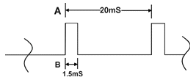

 | 1.0 ms | 1.5 ms | 2.0 ms
Un-hacked | Left – 90 | Center – 0 | Right – 90
Hacked | Backwards – Full Speed | Still | Forwards – Full Speed

This signal is used to provide the desired speed / position, while a potentiometer provides the actual “speed” / position.
Potentiometers (pot):
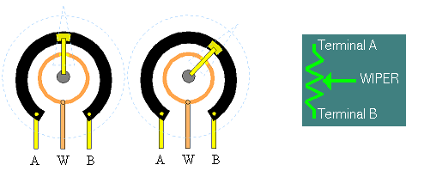

Potentiometer Resistance = R_{AB} R_{AB} = R_{AW} + R_{WB}

From this, you can see that: $V_{\text{WB}}=\frac{R_{\text{AW}}}{R_{\text{AW}}+R_{\text{WB}}}V_{\text{AB}}=\frac{R_{\text{AW}}}{R_{\text{AB}}}V_{\text{AB}}$

The farther the position, the faster the servo turns to achieve it. Hacking allows for position to become speed and direction.
Sensors

“MILee” combines several sensors to accomplish it’s goals. The sensors used on the robot include bump, IR ranging, line-tracking and wireless serial communication.
The bump sensor uses a micro-push type switch with a lever mechanism to detect if the robot touches something. This allows the robot to tell if it bumps into an object while backing up or going forward, if it may have been missed by the IR sensors. The switches use an active-low arrangement, with a logical 0 signifying “pressed”.
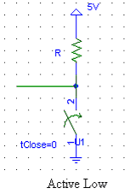
The infrared range finding uses an IR detector and an IR emitter. The emitter outputs a 40 kHz signal that the detector picks up from reflected surfaces. The detector is hacked to read in the analog voltage level. The higher the voltage is on the signal pin, the closer the object. This voltage is then converted using the processor’s analog-to-digital (A/D) converter. The result can then be analyzed in software to tell how far an object is from the robot. The process for hacking the IR detector can be seen in the figure below.
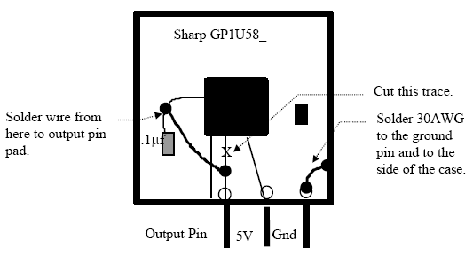
The line-tracking uses an infrared LED emitter and phototransistor for detection. The following circuit design is used to create a single detection unit.
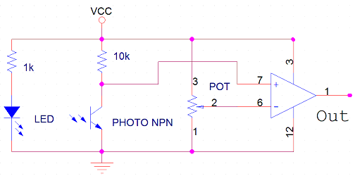
It consists of an emitter, a detector, a potentiometer and an op-amp. The op-amp circuit is designed to create a comparator between the phototransistor and the threshold determined by the potentiometer. This can be adjusted to match the required threshold for detecting a black line. The op-amp then out puts a low voltage for no line, and a high voltage (VCC) for a black line detected. “MILee” uses four of these units arranged in a ‘+’ shape to achieve detection of 16 different line position variations.
The final major sensor on “MILee” is the Bluetooth module. This module acts as a sort of “black box” that the microprocessor can write to through its UART hardware. The module works at the board’s TTL voltage without the need for any level shifting. The serial data is then transmitted wirelessly to other “base” modules, or to a PC module. The PC module is a USB serial device that creates a virtual serial port that can then be used with some HyperTerminal type program to send and receive data from the robot. The data can range from 9600 to 115200 baud rates, and reach over 50 feet indoors. This allows up to eight BlueTooth modules to communicate together at a time. Something like this can be used to support swarming behaviors between various robots, with the PC side possibly acting as a “master mind”, influencing the overall group behavior. In this project, the PC module is used to monitor various statistics about the robot through a MATLAB GUI interface (as seen below). The robot sends a string of sensor and actuator data to the GUI, which then interprets the data and displays it in an organized and easy to read manner. All the aforementioned sensors and actuators can be monitored and used to debug or simply observed or record for senor calibration or behavior analysis.
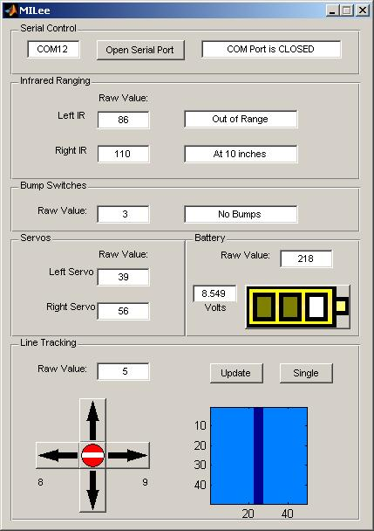
An additional sort of sensor is the batter level monitor. This simply divides the 9V battery voltage in half, and then converts it to a digital value to allow for the robot or user to know the current status of the battery life (through either internal software behavior, the onboard LED, or through the GUI) and when it will need to be changed.

Behaviors

In its most basic form, “MILee” drives around using its servos and can interact with its surroundings using its bump and IR sensors. With the addition of the line-tracking module, the robot can follow some defined path by keeping track of the line relative to itself, attempting to keep it as center as possible as it is traveling. The wireless port allows it to then inform some system of its behavior and stats which can be monitored or controlled. “MILee” is completely ready to begin interacting with other “MILee”s to accomplish some task, or receive some kind of information about its environment from other sensors, such as a vision processing PC system analyzing the environment and sending the information to the robot.
Conclusion

This robot is a great tool for expanding a student’s imagination and engineering expertise as it gives a basic, yet complete introduction to robotics. Whether it’s for those just getting or don’t have the time or money, this robot, in conjunction with the “New MILers” class at the Machine Intelligence Lab (MIL) can get them started in the fun and fulfilling world of robotics. This project then shows how this small yet diverse and powerful platform can then be added upon, in this case, with line-tracking and wireless modules. This allows the robot to be used to teach someone beyond even the basics.

