University of Florida
Department of Electrical and Computer Engineering
EEL 5666
Intelligent Machines Design Laboratory
Sensor Report

Date: 7/7/05
Name: Jonathan Mau
TAs: William Dubel
Steven Pickles
Instructors: A.A. Arroyo
E.M. Schwartz
Table of Contents

Introduction…………………………………………………………………………………3

Bump Sensors...……………………………………………………………………………..4

Photosensors.……………………………………………………………………………......4

Infrared Sensors…………………………………………………………………………......5

Ultrasonic Sensors………………………………………………………………………......7

Conclusion…………………………………………………………………………………10
Introduction
This report focuses on the sensors used to implement a Guide/Follow System that will allow the robot to follow a remote control car to simulate autopilot during a traffic jam. The robot’s platform is based on a hacked remote control Hummer. It uses the existing rear-wheel drive and single-axle steering setup. Sensors will be mounted in the front and in the back of the robot. Ultrasonic sensors will be placed in the front and on the left and right side. An infrared sensor will be mounted in the front center, and bump sensors will be placed in the front and back of the robot.

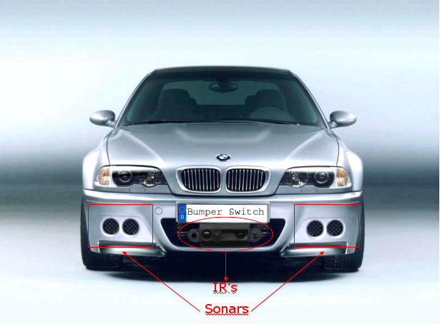
Figure 1. Placement of sensors

Bump Sensors
Bump sensors will simply be switches that register high when closed, that is, upon contact, at which point the robot will stop its motion and GPS will shutdown. Since in the real world, when a car hits something in the front or is hit from behind, the first action is to stop. I am using the Zippy Subminiature Microswitches SM-05, which can be seen in Figure 2. They can handle up to a current of 5 A and a voltage of 250 VAC. Two switches are used: one in the front and one in the back.
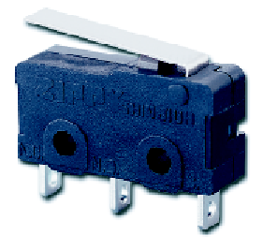
Figure 2. Zippy Microswitch

Photosensors
As mentioned above, sonar, infrared, and bump sensors are used, but additionally, shaft encoders are also vital to the robot’s design. To implement a shaft encoder, an Omron Photomicrosensor EE-SB5VC, shown in Figure 3, is placed facing the inside of the wheel. The photomicrosensor uses a phototransistor and uses a reflective method to sense. The optimal sensing distance is 5mm and it operates on voltages between 5 VDC to 15 VDC. The sensing accuracy is as high as 0.6 mm.

Figure 3. Omron Photomicrosensor

Furthermore, a disk wheel of alternating black and white sections is attached to the inside of the wheel for the photomicrosensor to switch high and low. The disk wheel pattern is shown in Figure 4. By counting the number of white sections that were deflected, the robot is able to determine the number of revolutions it has traveled.

Figure 4. Disk Wheel

The implementation of shaft encoders will allow the robot to measure the distance traveled, but more importantly, the speed it is traveling. The robot will only follow the guide car up to a certain speed, since in the real world, you are no longer in a traffic jam when you are able to drive faster.

Sensors: Infrared
Two Sharp GP2D12 infrared sensors will be used at the front of the robot to detect obstacles that are directly ahead. An image of the sensor is shown in Figure 5. In the real world, should an animal suddenly jump in front of the car, the sensor will relay the information back to the controller and the automation will halt after stopping the car. Likewise, in the robot, if the sensor detects that an object in front of the car is too close, the robot will stop its motion and GPS will shut down.
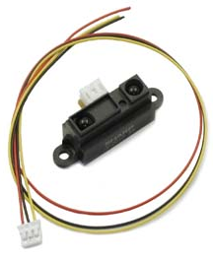
Figure 5. Infrared Sensor

The sensor emits infrared light and detects the reflection; thereby, making it an ideal low-cost sensor. Another advantage is that the color of the reflective object does not play a major factor in the performance. The sensor takes a continuous distance reading and reports the distance as an analog voltage with a distance range of 10cm (~4") to 80cm (~30"). The interface is 3-wire with power, ground and the output voltage. It operates on 4.5 to 5.5 V and draws a maximum current of 50 mA. The detecting distance is between 10 cm to 80 cm.

One disadvantage of the GP2D12 is that its output is not linear with the distance of the reflective object. This fact can be seen from Sharp’s datasheet, which is shown in Figure 6. If I were using the sensors for a more variable and further distance detection, I would create a lookup table of output voltages to the actual distances instead of relying on a linear math equation. However, for my purposes, I only need to act upon a reading that is below a certain threshold (an obstacle is detected to be too close), so I do not need to create one.
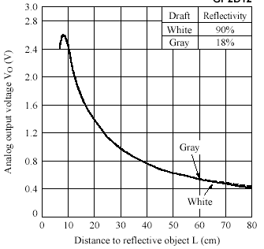
Figure 6. Analog Output Voltage vs. Distance to Reflective Object

Ultrasonic Sensors
The robot will use two Devantech SRF04 ultrasonic sensors. They will act as the special sensors required by the department, as they are the most important. As mentioned above, the sensors will be placed on the front sides of the robot. This arrangement will allow it to measure its alignment with respect to the guide car. If the guide car turns left slightly, the right sonar will measure a distance greater than the distance measured by the left sonar. This information will activate the robot to turn left slightly until the distance measured by both sensors is similar. At the same time, the ultrasonic sensors will help maintain a certain distance between the robot and the guide car. To help reduce erroneous measurements, an average value will be calculated, upon which the robot will then act.

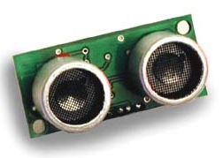
Figure 7. Ultrasonic Sensor

The ultrasonic sensors are able to measure distances between 3 cm to 3 m. It requires an operating voltage of 5 V and draws an average current of 30 mA. The operating frequency is 40 kHz. The pin connections are shown below in Figure 8. As you can see, the sensor has four connections: 5 V supply, echo output, trigger input, and ground.

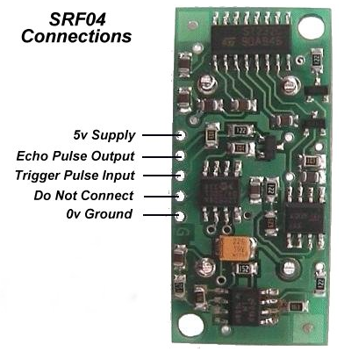
Figure 8. Ultrasonic Sensor Connections

The ultrasonic sensor was designed to require a trigger pulse input and provides an output echo pulse. The length of the echo is timed to find the distance between the sensor and an object. The timing diagram is shown in Figure 9.
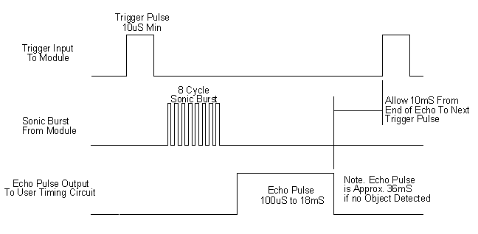
Figure 9. Ultrasonic Sensor Timing Diagram

The sensor requires a 10 μS pulse to the trigger input to start the ranging. The SRF04 will in turn send an 8 cycle sonic burst at 40 kHz and raise its echo line high. It then waits for a responding echo, and as soon as it detects one, it lowers the echo line. If nothing is detected after 36 mS, the echo line is lowered automatically by the sensor. The echo line becomes a pulse with a width that is proportional to the distance to the object and the robot is programmed to time the pulse and translate the range into inches.

The sensor uses a transducer to emit the ultrasonic sound and listens for its reflection. The beam pattern of the transducer is shown in Figure 10, taken from the manufacturer’s datasheet. As you can see, the beam spreads in all directions rather than traveling a straight line. It is because of this fact that two ultrasonic sensors cannot be fired at the same time since they can pick up each other’s echo and report a false reading. Since I am using two SRF04’s and they are relatively close to each other, I am firing them sequentially at 65 mS apart.
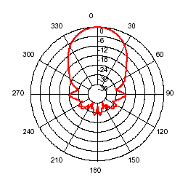
Figure 10. Ultrasonic Sensor Beam Pattern

Conclusion
My robot is using the aforementioned sensors as inputs to its surrounding environment. The combination of the four will provide sufficient knowledge and will allow the robot to complete its task. If time willing, I will implement a fifth sensor, a digital compass, as a bonus.

