Antoin Baker

University of Florida

Department of Mechanical and Aerospace Engineering

EEL 5666: Intelligent Machines Design Laboratory

Final Report

TABLE OF CONTENTS

Section Page

Abstract 3

Executive Summary 3

Introduction 4

Integrated System 5

Mobile Platform 5

Actuation 6

Sensors 6

Behaviors 7

Experimental Layout 7

Conclusion 7

Documentation 8

Appendix 9

ABSTRACT

This paper outlines the development and implementation of an autonomous air vehicle that is capable of taking off, hovering, and landing. It shows the thought process of how the vehicle was conceived and is currently being developed. This paper shows the how the sensors will be integrated will the mobile platform to exhibit the desired behaviors.

EXECUTIVE SUMMARY

The goal of this class was to design an autonomous four propeller helicopter. The project goal was to use a three axis accelerometer and two axis gyro to control the pitch of the four propellers. Changing the pitch of the propellers would affect the thrust of the motors. This change is thrust would theoretically allow us to control the stability of the platform. This project was completed in five major steps: 1. Manufacturing of Mechanical Components. 2. Connecting of electrical components. 3. Software testing.
The manufacturing of the mechanical components was the simplest of the issues. Being a mechanical engineer, I had the all of the mechanical systems in place after one week of manufacturing. Rushing the completion of the mechanical systems proved to be a safety net as I anticipated problems with the testing phase of the process.
The implementation of the electrical systems was not very difficult, but extremely tedious. Since this was my first time wiring any electrical components, I received some help from previous IMDL students. I would like to give special thanks to the Machine Intelligence Laboratory for tolerating my ignorance in this area. The wiring of the electrical systems took approximately two weeks to complete.
Software testing (also known as systems integration) proved to be extraordinary difficult. This phase of the project took the remaining of the semester. To make a long story short, Murphy’s Law applied to every phase of the testing.
The first problem encountered was the noisy data coming from the accelerometers. But accelerometers are susceptible to noise, placing these on a helicopter was extremely noisy. After passing the data through several filters, acceptable data was able to be processed.
The second problem encountered was the varying pitch propellers. After two weeks of testing, a propeller broke. Two weeks later, a second propeller broke. Keeping in mind that these propellers cost $50 each, this was starting to become very expensive. After the third propeller broke, I realized that there was a manufacturing defect that could not be corrected no matter how hard I tried. To remedy this problem, the propeller had to remain in a fixed position. Therefore, the only to control the thrust was to change the speeds of the motors.
The third and truly most frustrating part of the project was the stability. This was a two part problem. With the original design the center of mass was above the propellers, effectively creating an aerial inverted pendulum problem. This problem was resolved by hanging the battery below the propellers. The second part of this problem was that the propellers couldn’t change speed fast enough to give accurate control of the system. This problem was solved by balancing the system as best as possible, therefore making the control system have to do much less work.

INTRODUCTION

An autonomous system is one that can perform its specified duties without any human intervention. Autonomous systems are all around us. From voice recognition software to your everyday home dishwasher, autonomous systems impact our lives in ways most people take for granted (until the power goes out).
A branch of autonomous systems are autonomous vehicles. Autonomous vehicles include ground vehicles such as those that participated in the DARPA Grand Challenge. Autonomous vehicles also apply to marine type applications, such as the Machine Intelligence Laboratory’s Subjugator.
However, my research is concerned with autonomous air vehicles (AAV), in particular micro air vehicles. Much research has gone into developing planes that are capable of autonomous control; be it vision-based or other sensor types. The major downfall of these types of AAV is the amount of space that is required for testing. In order to ensure that the controller is working properly, areas as big as football fields are needed for safety. Another downfall of these planes is that they are usually traveling at relatively high speeds. This means if they crash, they usually break; and since most people can’t design a controller correctly the first time, there is a lot of down time spent rebuilding the aircraft. The final downfall of these vehicles is their maneuverability. Because they travel at such high speeds, having these vehicles creep through tiny crevices or through open windows in nearly impossible.
The goal of this project is to design a vehicle that is capable of vertical takeoff, hovering, landing, and having the capability to move at relatively high speeds (Figure 1). Because this vehicle is capable of traveling at most speeds, the problems associated other AAV’s is eliminated. The amount of space required for testing will be minimal. Indoor flight will be more than feasible. Because the vehicle can travel at low speeds, if the controller does fail the damage will be minimal. Finally, because of the low speeds and the ability to hover, this vehicle will have maximal maneuverability.

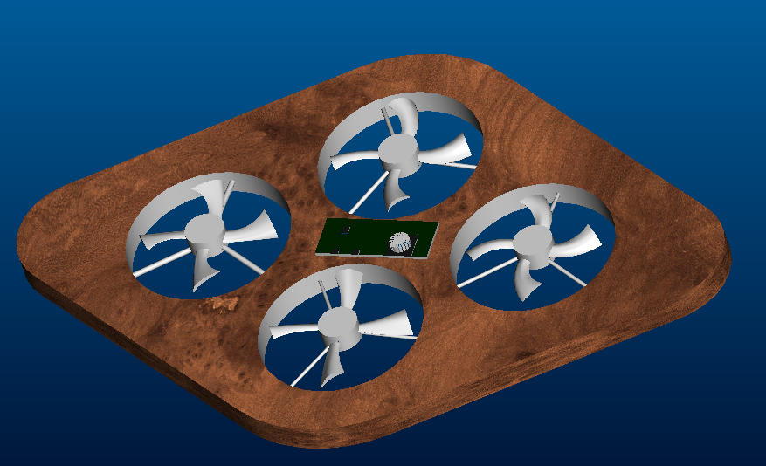
Figure 1: Autonomous Air Vehicle Design

INTEGRATED SYSTEM

This AAV, code named “CYPHER” will be capable of autonomous take off, hovering and landing. This platform will combine sensors and actuators that allow complete control over the position and orientation of the platform. These sensors include a three axis accelerometer, and a dual axis gyroscope. The actuators include brushless outrunner motors whose speed will control the thrust. The integration of these sensors and actuators will be performed by an Atmel microcontroller (www.bdmicro.com, see figure 2).

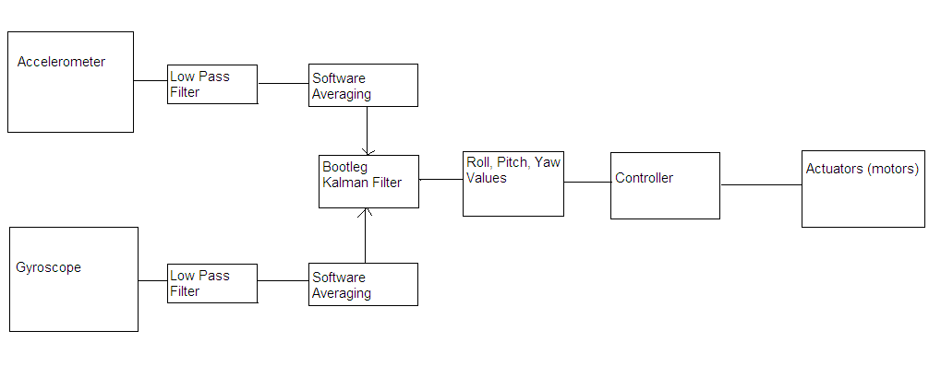
Figure 2: Integrated System

MOBILE PLATFORM
Because this vehicle must have the capability to take off vertically, weight must be minimal. Therefore, I chose to construct the entire platform of three materials (foamboard, Styrofoam, and Balsa wood). I was surprised at the strength of these materials, considering how lightweight they are. Although I thought the Styrofoam would be the easiest piece to manufacture, it turned out to be the most difficult. Every tool I used to cut the Styrofoam either melted or broke. I ended up using an extremely sharp kitchen knife, this seemed to work best.

ACTUATION
To control the platform, a novel idea was proposed by Donald Macauthur. I originally planned to control the platform by varying the speed of the propellers. This introduces substantial lag time in the control. Donald suggested that instead of varying the speed of the motors, we could vary the pitch of the propellers. This method of control greatly reduces the lag time. Although this system is much more expensive, the payoff will be worth it. However, after two weeks of testing the variable pitch propellers would break, rendering them unreliable. The components of the actuator system are shown below:

- 4- Castle Creations Phoenix-25 Speed Controller
- 4 - Axi Hollow Shaft Brushless Outrunner Motors
- 4- EVP PRO Variable Pitch Propellers (currently fixed)
- 4- Hitec 65MG Servos (currently not in implementation)
- 1- 11.1 Volt, 4000 mah Lithium Polymer Batteries (Thunder Power)

Theoretical calculations showed that this system would be capable of producing 8 pounds of thrust. However, the reality was that they only produced 4 pounds. The calculations did not take into account the shape of variable pitch propellers greatly reduces their efficiency. Luckily I originally planned to have a power to weight ratio of two, so I was still safe.

SENSORS
To control the position and orientation of the platform, we need a combination of sensors. To control the pitch and roll of the platform, a three axis accelerometer will be implemented. By making the z-axis vertical, the acceleration from gravity on the x and y axes should be nearly zero. Using these measurements as feedback, the platform will be kept nearly flat. To control the elevation of the platform relative to the ground, sonar will be implemented.
Three sensors can be implemented to control the yaw of the platform. I have the choice of using a magnetometer, accelerometer or a gyroscope. Using the magnetometer, I have the ability to control the absolute position of the platform. However, this system is sensitive to electromagnetic fields. The accelerometer is not susceptible to electric fields, but it is very noisy. Using the gyroscope, I cannot control the absolute position, but I can control the rate at which the platform is yawing. The gyroscope is also not very sensitive to electromagnetic fields. For this project, I interfaced the accelerometers and the gyroscope to give me absolute and rate information about the platform.
Although outside the scope of this class, I additionally want to add a Global Positioning System for movement of the platform.

BEHAVIORS
The scope of this platform is to autonomously take off, hover and land. Using the sensors and actuators present, this behavior is achievable. However this project will take more than one semester to be anywhere near satisfactory.

EXPERIMENTAL LAYOUT AND RESULTS
The experimental layout is shown in Figure 3. This is the final design that is used for testing purposes. For the majority of the testing, the platform was tethered to the ground by the rubber bands shown in the picture. Stable hovering was achieved only two days before the demonstration day. This was not what I planned, but everything worked out in the end. Once the class is over, I will relieve my frustrations with this project by turning it on untethered and walking away.

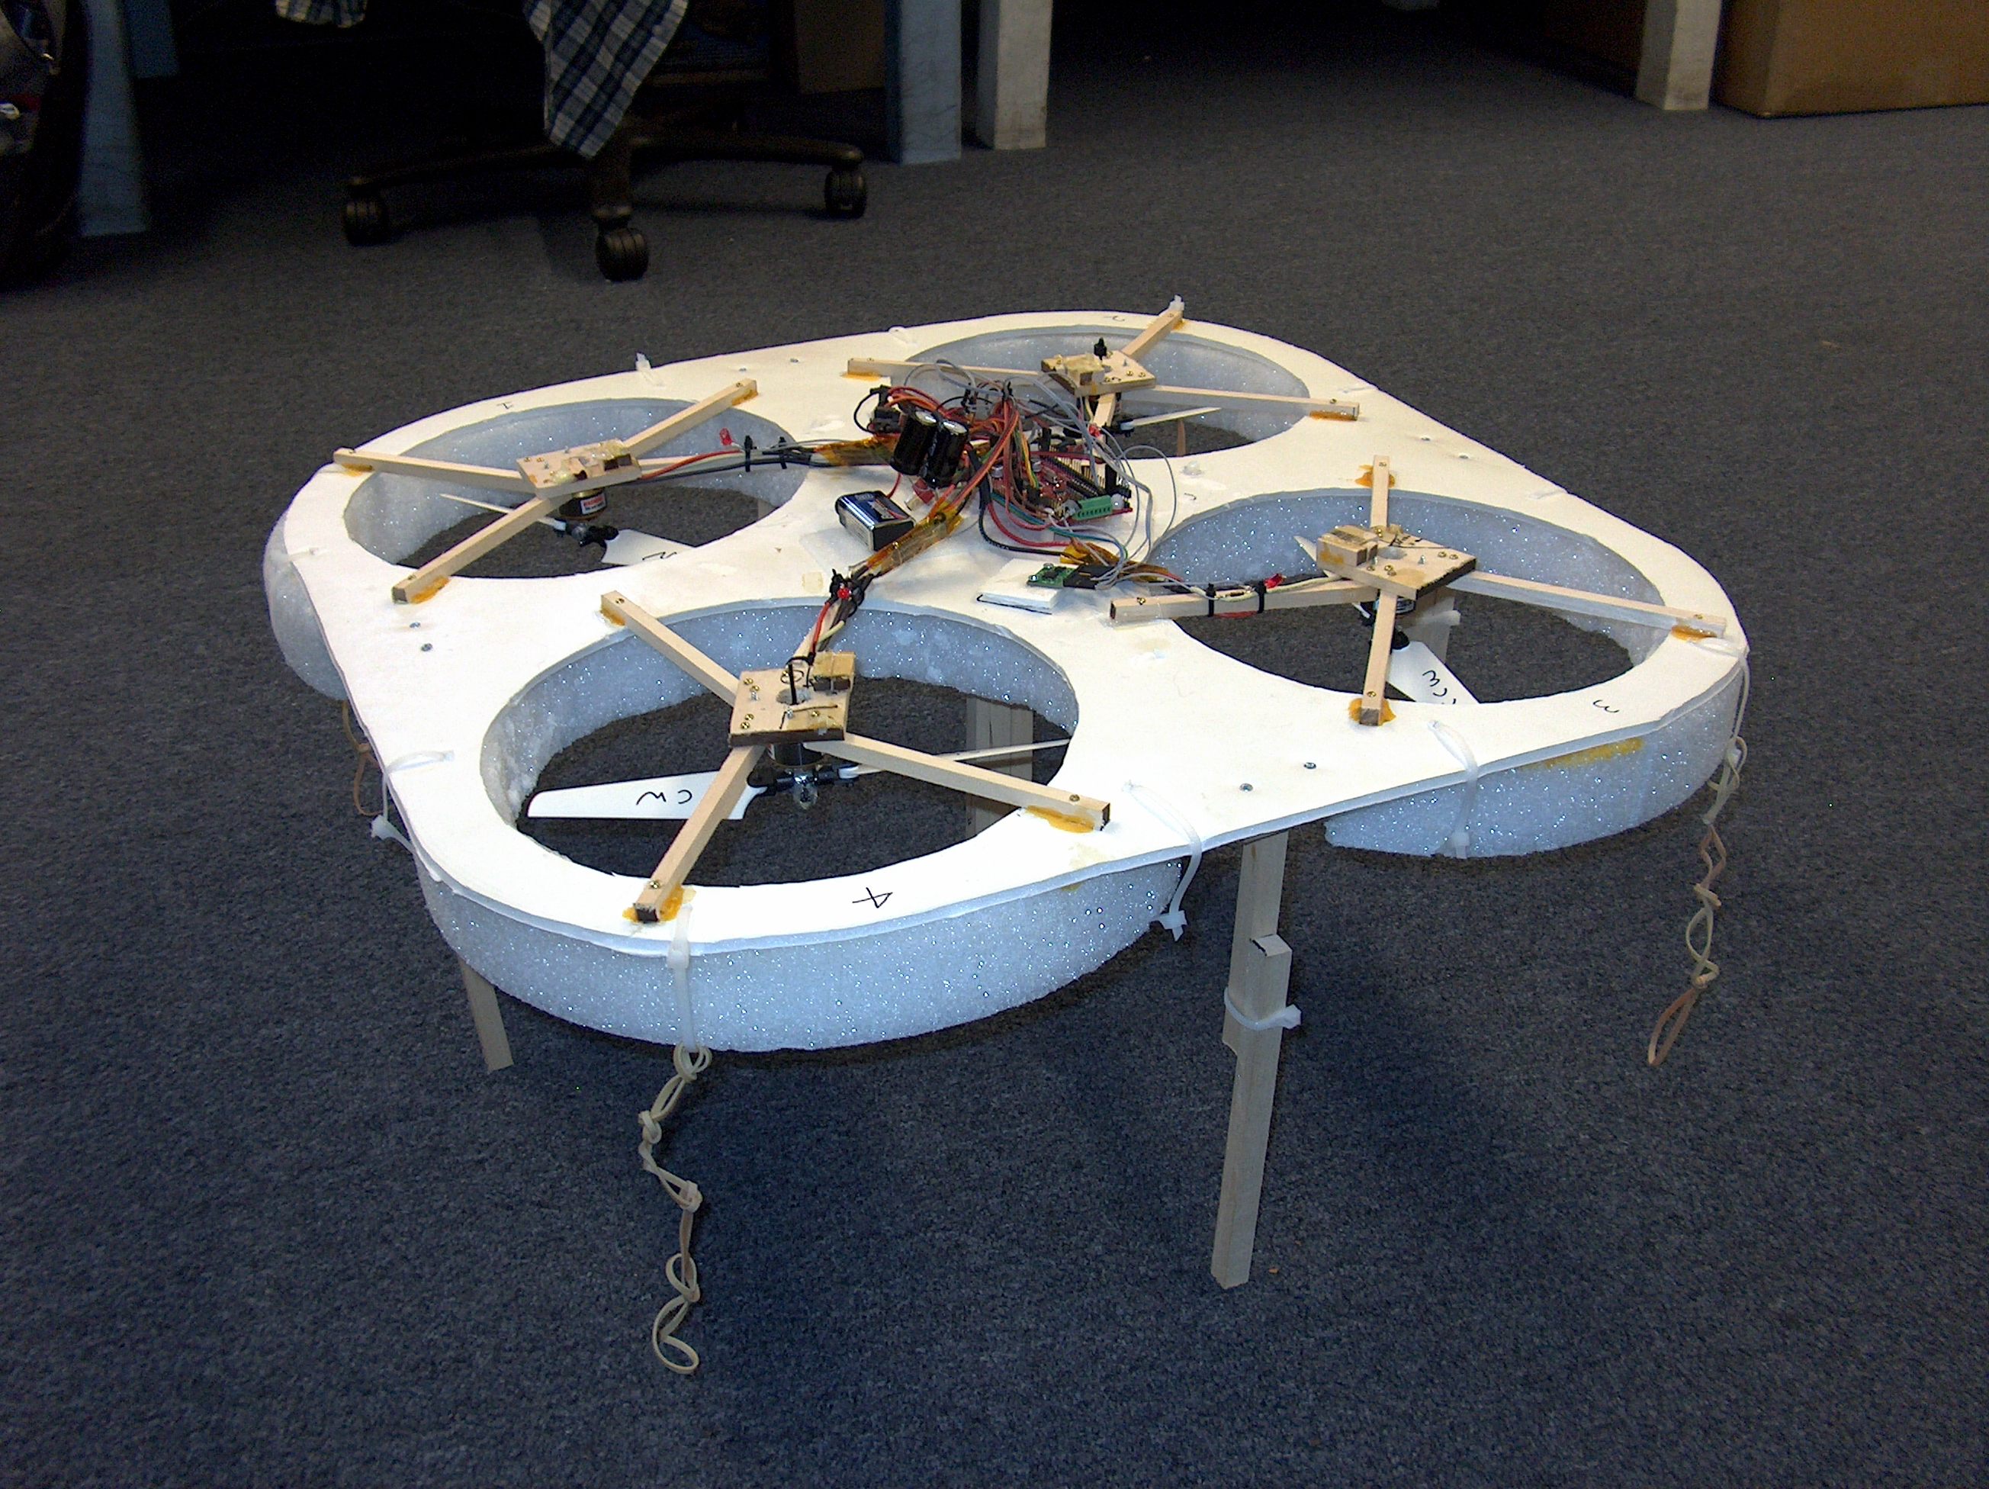

Figure 3: Final Experimental Layout

CONCLUSIONS AND RECOMMENDATIONS

- This is NOT a semester project. A good job will take years.
- Get funding, for this project will cost you upward of $5000
- Do not attempt this if you have never worked with microcontrollers before.
- Keep your center of gravity below the propellers.
- Varying the speed of the motors will not give you adequate control.
- Wear gloves while testing
- Very noisy, this project will disturb everyone in the hallway.

This project has been a vast learning experience for me. I violated almost all of the recommendations during this process. I will continue this project to find a way to design an adequate controller.

DOCUMENTATION

Daniel Kent, Daedalus. IMDL Spring 2003.
http://www.mil.ufl.edu/imdl/papers/IMDL_Report_Spring_03/kent_daniel/daedalus.pdf

APPENDICES

Code:

#include <mega128.h>
#include <delay.h>
#include <stdio.h>

/*#asm
.equ __lcd_port=0x15
#endasm
#include <lcd.h>*/

#define ADC_VREF_TYPE 0x40

unsigned int read_adc(unsigned char adc_input)
{
ADMUX=adc_input|ADC_VREF_TYPE;
ADCSRA|=0x40;
while ((ADCSRA & 0x10)==0);
ADCSRA|=0x10;
return ADCW;
}

// Declare your global variables here
int hover = 105;
//int motor_change = 5;

int x_desired ;
int y_desired ;

int x[70];
int y[70] ;
int x_accel_data ;

int y_accel_data;

int x_error_minus_one;
int y_error_minus_one;
int x_error;
int y_error;

int gyro_x[70];
int gyro_y[70];
int gyrox;
int gyroy;
int g_offset_x;
int g_offset_y;

//char lcd_buffer[33];
int i;

void main(void)
{
// Declare your local variables here

// Input/Output Ports initialization
// Port A initialization
// Func0=In Func1=In Func2=In Func3=In Func4=In Func5=In Func6=In Func7=In
// State0=T State1=T State2=T State3=T State4=T State5=T State6=T State7=T
PORTA=0x00;
DDRA=0x00;

// Port B initialization
// Func0=In Func1=In Func2=In Func3=In Func4=In Func5=In Func6=In Func7=In
// State0=T State1=T State2=T State3=T State4=T State5=T State6=T State7=T
PORTB=0x00;
DDRB=0xFF;

// Port C initialization
// Func0=In Func1=In Func2=In Func3=In Func4=In Func5=In Func6=In Func7=In
// State0=T State1=T State2=T State3=T State4=T State5=T State6=T State7=T
PORTC=0x00;
DDRC=0x00;

// Port D initialization
// Func0=In Func1=In Func2=In Func3=In Func4=In Func5=In Func6=In Func7=In
// State0=T State1=T State2=T State3=T State4=T State5=T State6=T State7=T
PORTD=0x00;
DDRD=0x00;

// Port E initialization
// Func0=In Func1=In Func2=In Func3=In Func4=In Func5=In Func6=In Func7=In
// State0=T State1=T State2=T State3=T State4=T State5=T State6=T State7=T
PORTE=0x00;
DDRE=0x38;

// Port F initialization
// Func0=In Func1=In Func2=In Func3=In Func4=In Func5=In Func6=In Func7=In
// State0=T State1=T State2=T State3=T State4=T State5=T State6=T State7=T
PORTF=0x00;
DDRF=0x00;

// Port G initialization
// Func0=In Func1=In Func2=In Func3=In Func4=In
// State0=T State1=T State2=T State3=T State4=T
PORTG=0x00;
DDRG=0x00;

// Timer/Counter 0 initialization
// Clock source: System Clock
// Clock value: Timer 0 Stopped
// Mode: Normal top=FFh
// OC0 output: Disconnected
TCCR0=0x00;
ASSR=0x00;
TCNT0=0x00;
OCR0=0x00;

// Timer/Counter 1 initialization
// Clock source: System Clock
// Clock value: Timer 1 Stopped
// Mode: Normal top=FFFFh
// OC1A output: Discon.
// OC1B output: Discon.
// OC1C output: Discon.
// Noise Canceler: Off
// Input Capture on Falling Edge
TCCR1A=0xAB;
TCCR1B=0x2C;
TCNT1H=0x00;
TCNT1L=0x00;
OCR1AH=0x00;
OCR1AL=0x00;
OCR1BH=0x00;
OCR1BL=0x00;
OCR1CH=0x00;
OCR1CL=0x00;

// Timer/Counter 2 initialization
// Clock source: System Clock
// Clock value: Timer 2 Stopped
// Mode: Normal top=FFh
// OC2 output: Disconnected
TCCR2=0x00;
ASSR=0x00;
TCNT2=0x00;
OCR2=0x00;

// Timer/Counter 3 initialization
// Clock source: System Clock
// Clock value: Timer 3 Stopped
// Mode: Normal top=FFFFh
// OC3A output: Discon.
// OC3B output: Discon.
// OC3C output: Discon.
TCCR3A=0xAB;
TCCR3B=0x2C;
TCNT3H=0x00;
TCNT3L=0x00;
OCR3AH=0x00;
OCR3AL=0x00;
OCR3BH=0x00;
OCR3BL=0x00;
OCR3CH=0x00;
OCR3CL=0x00;

// External Interrupt(s) initialization
// INT0: Off
// INT1: Off
// INT2: Off
// INT3: Off
// INT4: Off
// INT5: Off
// INT6: Off
// INT7: Off
EICRA=0x00;
EICRB=0x00;
EIMSK=0x00;

// Timer(s)/Counter(s) Interrupt(s) initialization
TIMSK=0x00;
ETIMSK=0x00;

// Analog Comparator initialization
// Analog Comparator: Off
// Analog Comparator Input Capture by Timer/Counter 1: Off
ACSR=0x80;
SFIOR=0x00;

// ADC initialization
// ADC Clock frequency: 1000.000 kHz
// ADC Voltage Reference: AVCC pin
ADMUX=ADC_VREF_TYPE;
ADCSRA=0x84;

// LCD module initialization
//lcd_init(16);

//Initiate Startup Sequence

/*sprintf(lcd_buffer,"Initializing");
lcd_clear();
lcd_puts(lcd_buffer);*/

//OCR1AL=90; //port b 5 Servos 1 and 3
//OCR1BL=90; //port b6 Servos 2 and 4
OCR1CL=90; // port b7 Motor 1
OCR3AL=90; //port e3 Motor 2
OCR3BL=90; // port e4 Motor 3
OCR3CL=90; // port e5 Motor 4

delay_ms(2000);

OCR1CL=45; //motor 1
OCR3AL=45; //motor 2
OCR3BL=45; //motor 3
OCR3CL=45; //motor 4
delay_ms(4000);

for(i=0;i<70;i++)
{
x[i]=read_adc(0);
y[i]=read_adc(1);
gyro_x[i]=read_adc(4);
gyro_y[i]=read_adc(5);
delay_ms(1);
}

gyrox=0;
gyroy=0;
x_desired=0;
y_desired=0;

for(i=0;i<70;i++)
{

x_desired=x_desired + x[i] ;
y_desired=y_desired + y[i];
gyrox=gyrox+gyro_x[i];
gyroy=gyroy+gyro_y[i];

}

x_desired = x_desired/70;
y_desired = y_desired/70 ;
g_offset_x = gyrox/70;
g_offset_y = gyroy/70;

for (i=45;i<90;i++)
{
OCR1CL=i;
OCR3AL=i; //port e3 Motor 2
OCR3BL=i; // port e4 Motor 3
OCR3CL=i; //port e5 Motor 4
delay_ms(200);

}

OCR1CL=hover;
OCR3AL=hover; //port e3 Motor 2
OCR3BL=hover; // port e4 Motor 3
OCR3CL=hover; //port e5 Motor 4

/*sprintf(lcd_buffer,"Starting Motors");
lcd_clear();
lcd_puts(lcd_buffer);
delay_ms(100); */

//}

delay_ms(1000);

while (1)
{

// getting error one time step ago
for(i=0;i<70;i++)
{
x[i]=read_adc(0);
y[i]=read_adc(1);
gyro_x[i]=read_adc(4);
gyro_y[i]=read_adc(5);
delay_ms(1);
}

gyrox=0;
gyroy=0;
x_accel_data=0;
y_accel_data=0;

for(i=0;i<70;i++)
{

x_accel_data=x_accel_data + x[i] ;
y_accel_data=y_accel_data + y[i];
gyrox=gyrox+gyro_x[i];
gyroy=gyroy+gyro_y[i];

}

x_accel_data = x_accel_data/70 ;
y_accel_data = y_accel_data/70 ;
gyrox=gyrox/70 - g_offset_x;
gyroy=gyroy/70 - g_offset_y;

x_error_minus_one= (x_desired - x_accel_data)/5 + gyrox;
y_error_minus_one= (y_desired - y_accel_data)/5 + gyroy;

// getting current error

for(i=0;i<70;i++)
{
x[i]=read_adc(0);
y[i]=read_adc(1);
gyro_x[i]=read_adc(4);
gyro_y[i]=read_adc(5);
delay_ms(1);
}

gyrox=0;
gyroy=0;
x_accel_data=0;
y_accel_data=0;

for(i=0;i<70;i++)
{

x_accel_data=x_accel_data + x[i] ;
y_accel_data=y_accel_data + y[i];
gyrox=gyrox+gyro_x[i];
gyroy=gyroy+gyro_y[i];

}

x_accel_data = x_accel_data/70 ;
y_accel_data = y_accel_data/70 ;
gyrox=gyrox/70 - g_offset_x;
gyroy=gyroy/70- g_offset_y;

x_error= (x_desired - x_accel_data)/5; //+ gyrox;
y_error= (y_desired - y_accel_data)/5;// + gyroy;

//implementation of a fuzzy controller

// Fuzzy logic controller for the x axis

if (x_error > 1)
{

PORTB.0=1;
PORTB.2=0;
//OCR3BL = hover;
// OCR1CL = hover-motor_change;
}

else if (x_error < -1)
{
PORTB.2 =1;
PORTB.0=0;
//OCR1CL = hover ;
//OCR3BL = hover-motor_change;
}

else
{
PORTB.0=0 ;
PORTB.2=0;
//OCR1CL = hover;
//OCR3BL = hover;
}

// Fuzzy Logic Controler for the y axis

if (y_error > 1)
{

PORTB.3=1;
PORTB.1 = 0;
//OCR3AL = hover;
//OCR3CL = hover-motor_change;
}

else if (y_error < -1)

{
PORTB.1=1;
PORTB.3=0;
//OCR3CL = hover;
//OCR3AL = hover-motor_change;
}

else
{
PORTB.1=0;
PORTB.3=0;
//OCR3AL = hover;
//OCR3CL = hover;
}

/*sprintf(lcd_buffer,"%d, %d",x_error, y_error);
lcd_clear();
lcd_puts(lcd_buffer); */

}
}

