Antoin Baker

University of Florida

EEL 5666: Intelligent Machine Design Lab

Final Sensor Report

For this class, I am designing an autonomous flying vehicle codenamed “Cipher” (see Figure 1). This vehicle will be capable of autonomously taking off, hovering, and landing. The cipher represents a monumental controls problem. I must be able to control the roll, pitch, and yaw of the aircraft for it to hover properly. Therefore a combination of special sensors must be needed.

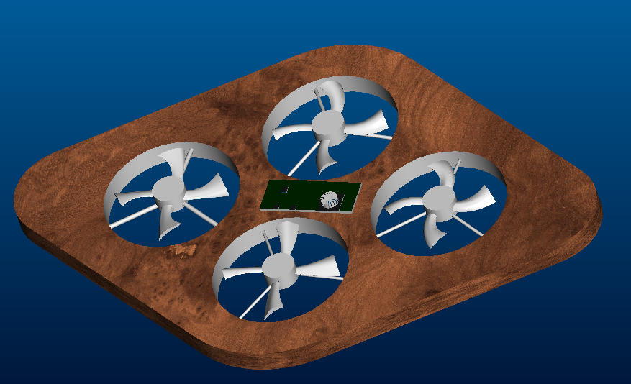
Figure 1: Autonomous Flying Vehicle “Cipher”

The special sensors that I will use for my robot consist of a triple axis accelerometer and a dual axis gyroscope (see Figure 2). As shown in the Figure the accelerometer give me the acceleration on the x,y, and z axes. From the acceleration due to gravity, I will be able to determine my roll and pitch. In theory, with the z-axis facing downward, if the vehicle is flat, the acceleration on the x and y axes should be zero. The gyroscopes give me the rotational rate about the x, and y axes. All 5 of these detectors are placed on a board no bigger than the size of a quarter. The weight of the sensor without any attached headers is approximately two grams. The small size and weight of this sensor makes it ideal for a vertical takeoff aircraft.

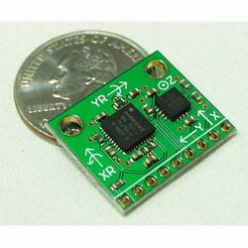
Figure 2: Three Axis Accelerometer and Dual Axis Gyroscope

Implementation of the accelerometers was a mind-numbing issue. One of the major downfalls of accelerometers is their susceptibility to noise. Because of the extremely low weight of the accelerometers, noise was a major issue. No matter how the accelerometers were mounted on the platform, the turning of the motors caused more noise than the actual signal. To eliminate this noise, three methods were used: 1. Low pass hardware filtering 2. Software averaging 3. Weighted Average from gyro data.
The first step in reducing the noise was to implement a basic low pass hardware filter (Figure 3). For vertical flight, the propellers will be spinning around 8000 revolutions per minute (130 times per second). To successfully eliminate noise, I needed a filter with a break frequency much less than the oscillation frequency. I arbitrarily chose 20 hertz as my break frequency. Using this criterion, I sized the resistors and capacitors using Equation 1. The implementation of this filter greatly reduced the amount of noise in the signal. However, I still had noise that caused an error of five degrees in my controller. To compensate for this error, I had to rely on software filtering.

$ω=\frac{1}{\text{RC}}$ Equation 1

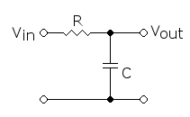

Figure 3: Simple Low Pass Filter

For the software filter, I used a simple averaging method. I collected data for 100 milliseconds with each sample being 1 millisecond apart. This averaging was the equivalent of adding another low pass filter on top of the preexisting hardware filter. By adding this filter, I was able to reduce noise to 3 degrees.
For the last filter, I incorporated the gyroscopes. The accelerometers provide the absolute roll and pitch values. The gyroscopes provide me with rotational rates. By knowing my sample rate and taking a weighted average of the accelerometer and gyroscope data, I was further able to reduce the noise (see Figures 4 and 5).

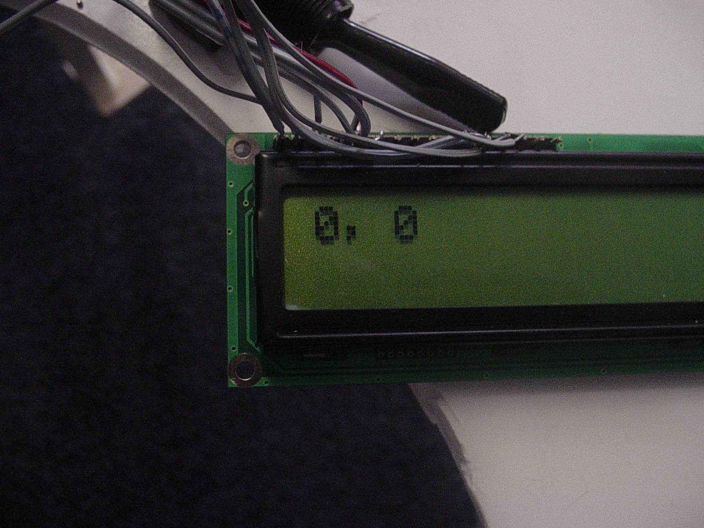
Figure 4: Signal With Zero Pitch and Roll

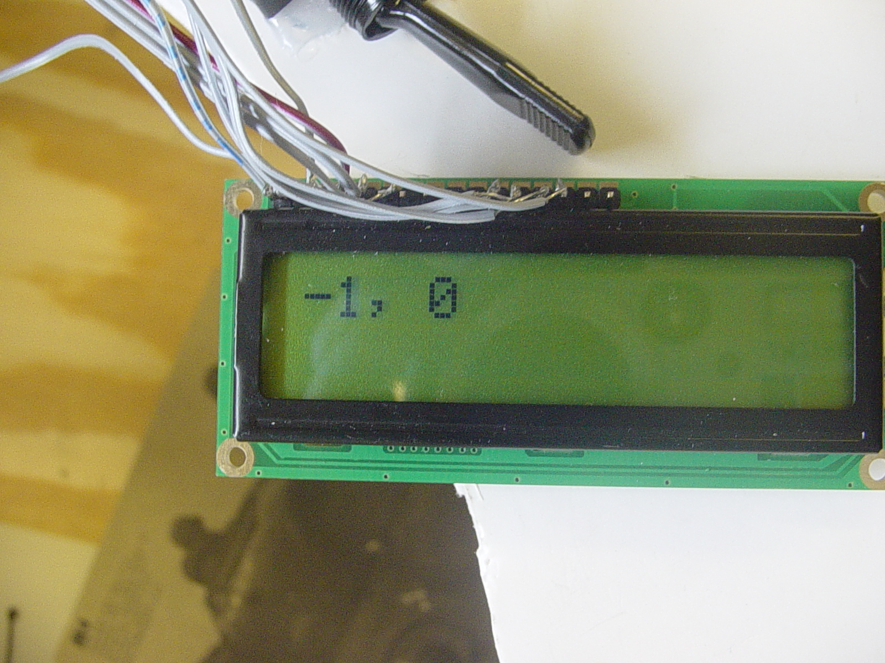
Figure 5: Signal With a Slight Tilt in the X direction

The combination of all these filters finally allowed reliable data to be read from the accelerometers and gyroscopes. This reliable data was then fed to an Atmel microcontroller for further processing.

