SPECIAL SENSOR REPORT

UBLOX SAM_LS GPS UNIT

EEL5666 – IMDL

William S Bowman

July 11, 2006

Instructors: Dr. Antonio Arroyo and Dr. Eric Schwartz

TA’s: William Otto and Adam Barnett

OVERVIEW

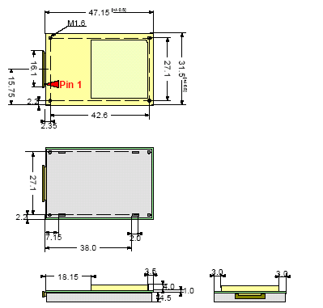
The M.A.L.V. (Micro Air/Land Vehicle) Robot is being developed to be a land navigating vehicle capable of obstacle avoiding and point-to-point GPS navigation. The sensor/actuator suite consists of sonars, digital compass, DC motors, a servo and GPS (Global Positioning Satellites) receiver. The GPS receiver is a critical sensor for the robot to understand its whereabouts and will aid the compass unit to maintain a proper trek. The MALV stays very close to the ground where it is sometimes difficult to have good satellite coverage, so a high gain receiver and excellent satellite tracking algorithms are needed to compensate. Therefore, the uBlox SAM_LS All-in-one GPS unit was chosen because of its excellent poor condition reception. Also, the SAM unit is fairly small and light weight , which are necessities for the MALV. The all-in-one unit means that the receiver, tuned patch antenna, and ground plane/electrical shielding is included all in one package. The receiver is setup for a 1 Hz position update.

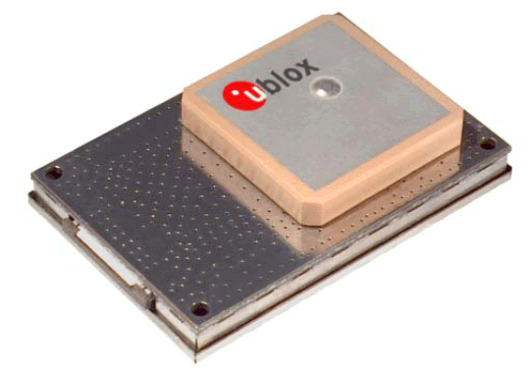

Figure 1. Picture of SAM_LS Unit and Physical Dimensions (in mm)
Operating Conditions

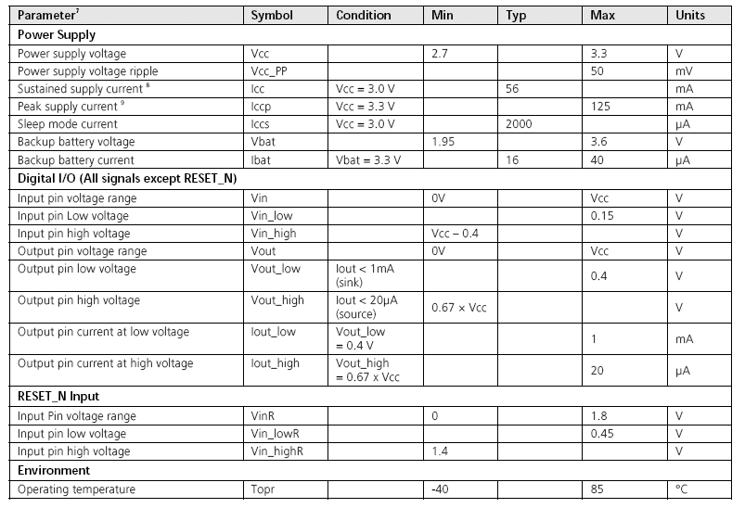

Figure 2. Table of Manufactures Operating Conditions

INTEGRATION

The SAM_LS GPS unit has a required voltage level between 2.7V – 3.3 V. The Atmega128 and other integrated circuit chips in the MALV use the 5V from the regulator on the MavericII board. Therefore, a GPS integration board was made to accommodate a 3.3V regulator, header pins, and a 20 position flat flex Molex header to connect to the GPS. There are two serial outputs and two serial inputs from the SAM_LS unit. Only one of the serial outputs will be used because there is no need to send anything to the GPS during tracking, however, on the breakout board a receiver line was included to allow firmware upgrades to the SAM. The one output line outputs a 8 bit, no parity, 1 stop bit, asynchronous 38400 baud, serial signal. This one wire will be brought in directly to the Atmega128’s RX0 port. For debugging and initial protocol filtering help, the MavericII’s MAX232 driver is used to up the voltage to communicate with a computer’s serial port. Ublox has software called “uCenter” that was used to evaluate the GPS’s status and to setup the GPS’s output protocol scheme.
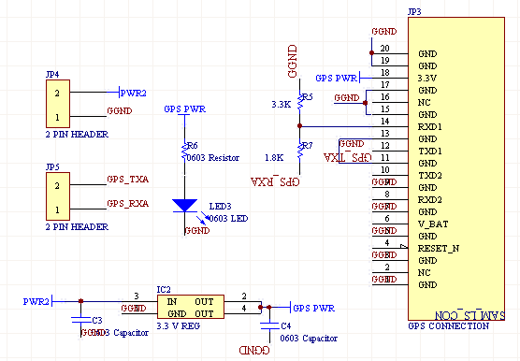

Figure 3. Circuit of GPS integration board

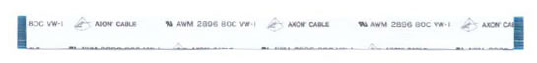

Figure 4. 20 position Flat Flex Cable used to connect GPS to integration board

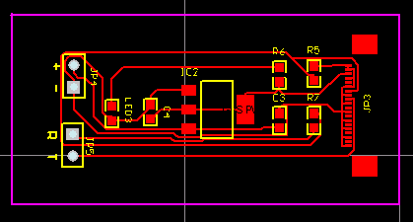

Figure 5. Picture of GPS integration board PCB

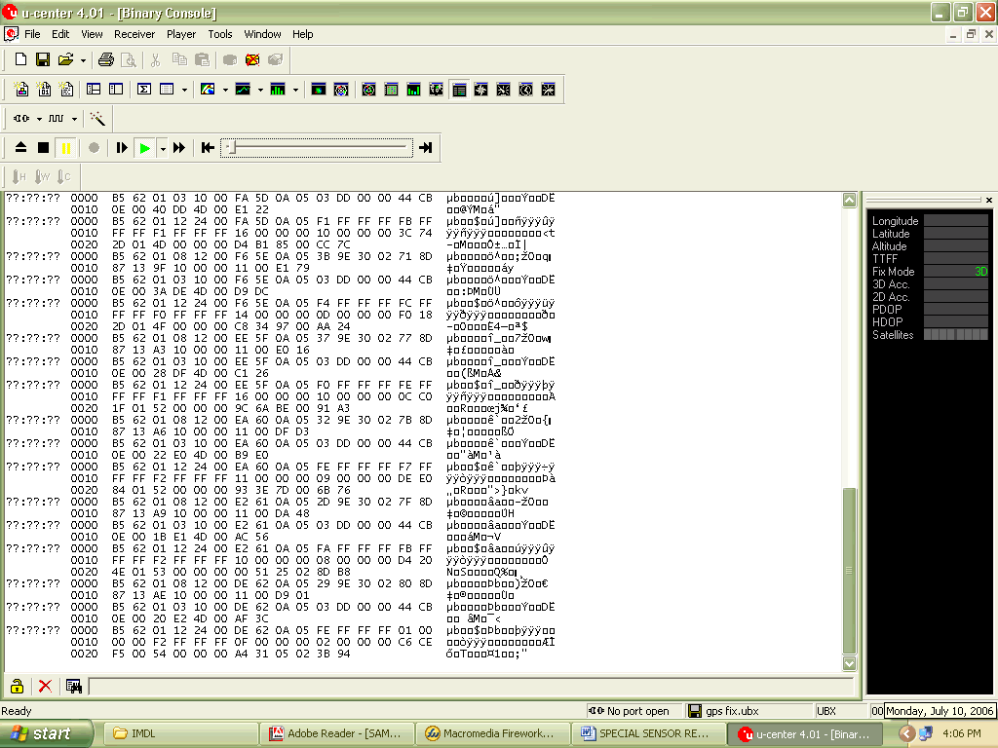

Figure 6. Screen Shot of uCenter Software

GPS SERIAL PROTOCOL

The SAM_LS GPS units can be configured to output many different types of data in several different formats. The SAM unit can either output a NMEA or UBX protocol. The NMEA is ASCII based protocol that contains 13 selectable sub-packets depending on the kind of information the user wants extract from the GPS. For instance, the GPGLL sub-packet gives information about longitude/latitude and UTC time, while the GPGSV sub-packet gives information about GPS satellite locations. The NMEA protocol is an industry standard protocol that is compatible with many devices.
The UBX protocol is a uBlox proprietary binary protocol that outputs in hexadecimal format. The UBX protocol has the ability to output much more information about the GPS unit itself and more detailed position information. There is more then twice as many sub-packets in this protocol then in the NMEA protocol. This protocol has the ability to output UTM (Universal Transverse Mercator) coordinates. These Northing/Easting coordinates are in centimeters which makes it easier to pinpoint the location of a small robot such as the MALV. Also, this makes it easier on the processor instead of having to convert longitude/latitude to a more precise format. This is the main reason I choose the UBX protocol for the MALV. The three sub-packets I choose were: POSUTM, STATUS, and VELNED. The POSUTM is the UTM positioning sub-packet that was explained earlier. The STATUS sub-packet gives the status of the position fix. The position fix is a function of how many satellites the GPS is locked on to. If it is locked on 0 or 1 satellite it will report “no fix”. If the GPS is locked on 2 satellites it will report a “2D fix”, which means it is accurate up to a X,Y ground fix. If the GPS is locked onto 3 or more satellites, then it will report a “3D fix” it is accurate in the X, Y, Z direction. The Z direction is altitude in this case. The last sub-packet, the VELNED, gives various velocities data. I might extract the 2D ground speed from this sub-packet to display on the LCD if time permits.
Below are tables to show how the sub-packets are broken down to extract different data from them. This should give the reader an idea of how a software data filter could be written to grab desired information.

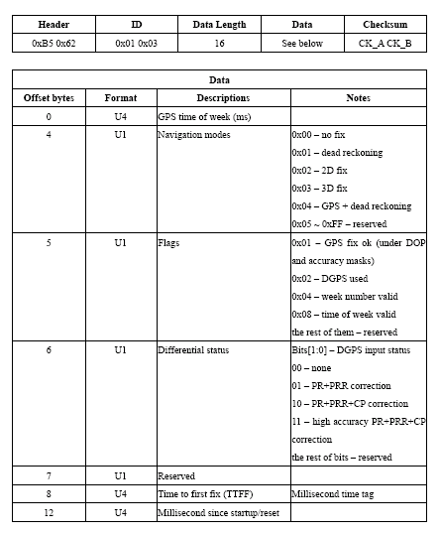

Figure 7. STATUS sub-packet definition

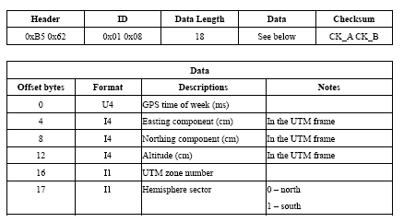
Figure 8. POSUTM sub-packet definition

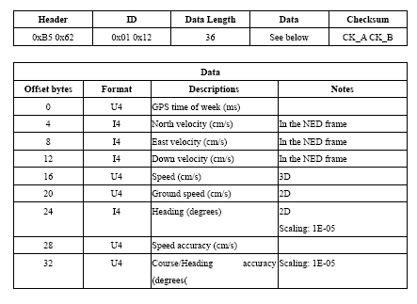
Figure 9. VELNED sub-packet definition

RECEPTION FINDINGS

The uBlox SAM_LS GPS was chosen because of its high gain receiver and excellent low signal reception capabilities. Therefore, I chose to test how well the GPS received information in certain settings by measuring the amount of satellites the GPS locked onto in different locations so I know the restrictions of the MALV’s overhead cover. The following graph shows different locations and their corresponding GPS fixes throughout the day of July 2, 2006. The day was partly cloudy all day with a high temperature of about 90 degrees. The GPS was temporarily attached to the top of the robot where it will later be fixed; this will best simulate the MALV’s final configuration. The uBlox uCenter software as well as the MavericII’s MAX232 driver was used to view the satellite numbers as the robot was moved from place to place. The MALV was tethered through a serial cable. The maximum of 8 minutes was given at each location and the maximum satellite count during that time was recorded.

CONCLUSION

GPS reception changes day to day depending on atmospheric conditions and other external factors. The day the readings were taken was a fairly clear day where reception shouldn’t have been too badly affected. According to the above results, I should be able to demo my robot outside somewhere close on campus. Maybe on the Basketball court or outside the entry way of the NEB, it all depends on the day. Hopefully, the robot will be done in time to take video of it performing on a good day in case of inclement weather come demonstration day or media day.
The SAM_LS unit seems to perform relatively well and was not terribly difficult to interface. I believe that Ublox should release a 5 V version of the sensor due to the fact that many people are working with 5 V systems, especially for prototyping purposes like with the MALV.

