- Abstract

The M.A.L.V. (Micro Air Land Vehicle) robot will take a flying version of surveillance Micro Air Vehicle (MAV) and allow it to walk, once landed. The platform chosen for this task is a sixteen inch wingspan MAV. Sensors and additional hardware will allow the robot to navigate a course between desired GPS waypoints while avoiding obstacles. The Micro Air Vehicle Research laboratory wants to develop this robot for ground surveillance purposes. To save weight, this system will be merged with existing autonomous airborne hardware.

II. Executive Summary

The Micro Air Land Vehicle is a concept robot being developed for the Micro Air Vehicle Research Lab at the University of Florida for air/ground surveillance. The purpose of the final platform is to be able to fly, land, and then walk to desired locations. Therefore, the platform of the robot is a sixteen inch Micro Air Vehicle modified to accommodate two motors in the front for ground maneuvering. Also, the rudder has a tail wheel fixed to it to help in tighter turning situations and will be controlled by the plane’s rudder servo. The robot is constructed of carbon fiber and ikerex covering material to keep the plane light yet strong.
For IMDL, the ground segment of the M.A.L.V. robot is being developed. The ground segment I developed assumes that the airplane has landed successfully. From there, the robot can begin to seek out pre-programmed waypoints. Final versions of this robot will merge already developed autonomous airborne hardware with parts of the ground segment hardware and the host processor will store embedded code to run both segments. The compass and GPS sensors that are on the airborne hardware will also be used for ground navigation.
The M.A.L.V. robot features a suite of sensors needed to navigate itself to desired waypoints while avoiding most ground obstacles. The sensors include two ultrasonic sonar sensors, a GPS receiver, and a compass. For mobility, the robot uses two variable speed, DC brushed geared-down motors and a servo to control the tail wheel. All sensors and actuators were chosen primarily because of their size and weight. Several smaller compasses were tired, but integrated with limited success. For proof on concept a larger compass was used on the current working robot, however, as further development persists, the smaller compasses will have to be revisited.
The M.A.L.V. can exhibit several behaviors that are combined to allow the robot to complete its main mission. The robot can avoid objects using the sonar sensors for object ranging. The motors are controlled in such a way to drive the robot away or around an object. The M.A.L.V. can determine its position on the earth’s surface using the GPS receiver. This allows the robot to calculate headings to desired waypoints and to allow the plane to know when it has arrived at a destination. The M.A.L.V is programmed to store the first location of adequate satellite lock and recognize this as it’s home location. After all waypoints have been reached, the M.A.L.V. can navigate it’s way back to it’s home position. Finally, the robot can follow a heading using the compass sensor. The GPS and trigonometric algorithms are used to first calculate a heading, then the compass tells the robot whether or not it is on that heading. Feedback from the compass controls the motors to stay along a desired heading. All these sub-behaviors allow the robot to navigate unobstructed to multiple GPS waypoints and back home again.

III. Introduction

The MAV research lab wishes to develop a small airplane that can both fly and walk. The lab wants an airplane that can be hand launched from a remote location and flown to a desired waypoint where it can land and crawl to another nearby waypoint(s). The plane’s abilities can be broken into two autonomous categories: The flight segment and ground segment. Both segments are developed to take advantage of an on board camera and video transmitter that will relay real-time mission status.
The flight segment consists of an autonomous airborne controller that is capable of navigating GPS waypoints. The system uses a GPS and magnetometer for navigation purposes. Currently a landing sequence is being developed to allow the autonomous controller to safely land the airplane at a given waypoint. Once landed, the ground segment will allow the plane to navigate to points of interest while avoiding obstacles in the way.
The ground segment is part of the project that I am developing. Since the plane is rather small, weight is a critical element to the plane’s flight performance. Therefore, the GPS and compass will be shared amongst the airborne and ground segments. However, for the purpose of this class and for easy transition later in the project, I will be using completely separate hardware from the ground segment. After my system is proven, we can merge the two systems later. The ground segment will be responsible for taking the preprogrammed GPS destinations and the GPS location after landing, to calculate a heading for the airplane to follow. Along that path, the airplane will have to avoid obstacles and be able to know when it has reached its destinations. This capability will allow the on board camera to view objects on the ground from a far without detection. Also, military sources have shown interests in this technology for looking under vehicles for explosives.
Although the ground segment sounds relatively straight forward and simple, there are many different subsystems that are working together to complicate the project. Each subsystem presents its own predicaments. To start, the integrated electrical system as whole will be discussed. From there, the placement of the electronics in relation to the platform will be addressed in the mobile platform section. Each individual sensor and actuator will be covered to allow the reader to understand all subsystems of the M.A.L.V. The combined behaviors of the robot will be covered in more depth in its own section. Finally, a conclusion will summarize the project and include advice to readers attempting similar robots.

- Integrated System

The integrated electrical system will consist of four sensors and three actuators and a host microcontroller. The processor will interpret sensor signals and control actuators through embedded software written in C code using the Codevision C compiler. The Maveric-II board w/ Atmega128 microcontroller will be used initially to interface with the sensors and motor drivers for proof of concept purposes. Eventually, the code will be merged with the airborne source code and reworked slightly to be completely compatible with the airborne segment’s Atmega128. This will eliminate the Maveric-II board all together.
The Ublox GPS sensor will communicate serially with the Atmega128. The chip’s UART0 port was used at a 38400 baud rate. The Daventech compass uses an I2C interface in order to talk to the Atmega128. I am using the dedicated I2C port on the chip and am using the compass as a slave device on the I2C line. The compasses read address is 0xC0. Two Maxbotix EZ1 sonar transceiver units are used in the front of the plane to detect objects. Each sonar is pinged independently to avoid the situation where the non-pinging sonar picks up any reflections from the pinging sonar. Both sonar values are read in on the Atmega’s Analog to Digital conversion port. An integer read in from these sonars refer to a particular distance (see graph in Sonar section). Two DC brush motors with gear reduction was used to move the robot along it’s heading. These motors are controlled with a single H bridge chip. The TI SN754410NE integrated circuit has two full H bridges for forward or reverse directioning and can handle up to 1 amp of current. The motors are controlled by a PWM signal from the Atmega128. The servo used to control the rudder tail wheel is a Futaba submicro servo controlled with a PWM signal from the Atmega. A LCD display will be used to monitor certain activities within the software or display certain messages during M.AL.V.’s mission. Generally the LCD is used for software debugging and I will probably remove it for the Media day demo.
The robot uses an 11.1 Volt 930 mAH three cell lithium polymer battery to power all the subsystems. A 5 volt regulator on the Maveric-II board is used to step down the voltage for the Atmega, GPS, Sonars, Compass, and H-bridge integrated circuit. The H-bridge also accepts the 11.1 Volts to operate the motors, however, in software I have the duty cycle set so the motors never see more then their max specified voltage of 7.0 Volts. The GPS has a separate integration board that steps the 5 Volts down to 3.3 Volts. Under full operating conditions with an LCD, the M.A.L.V. draws approximately 500 milli-amps.

SERVO
MOTORS
GPS
SONARSSS
COMPASS
ATMEGA
128
H- BRIDGE

Interface Block Diagram for Sensor and Actuators to Microcontroller

V. Mobile Platform

The MALV robot will be a micro air vehicle developed by the MAV research lab at the University of Florida that will be altered to accommodate the needed sensors and additional hardware. The robot is a sixteen inch long by sixteen inch wing span airplane. The robot is made of primarily carbon fiber except for the wings and stabilizer skin, which is ikerex, a lightweight fabric.
The front of the fuselage is mainly rectangular with room on the sides for holes to accommodate small diameter motors. To retrofit the fuselage with motors, an aluminum tube of equivalent diameter to the motors is fit into the male fuselage mold. Then the carbon fiber is wrapped over the mold making the motor holder merged with the fuselage. A sonar pod was made to accommodate both sonars units. Large holes were reamed out for the sonar detectors to fit thorough. The holes were oversized to allow for adjustment of the sonars. Once a desired angle was acquired, the sonars were glued into place. The compass and GPS units were double side taped to the top of the hatch to keep them out of the clutter of the fuselage. Also, the GPS needs a place for good reception of satellite signals and it keeps it away from the metallic properties of carbon fiber. If the GPS is place inside the fuselage, the carbon fiber would act as a shield, greatly reducing the ability of the GPS to lock on to satellites. The H-bridge board is placed in the front of the airplane just behind the main flight motor. It is double side taped to the fuselage so it wont move. The Maveric-II board is just squeezed into fuselage where it can fit. The battery is slid under the Maveric-II board. A switch was mounted on the vertical stabilizer of the airplane to turn off the robot when needed. The LCD will be mounted on the wing with tape away from the compass unit. Throughout the project I noticed that the LCD too close to the compass caused erroneous readings.
The current platform with only two sonar sensors provides reasonable ability for the plane to avoid obstacles. In the case the plane gets too close to an object, it is set to back up in the opposite direction hoping to clear itself of the object. The only problem with this is that the rear of the plane is vulnerable. More sensors could be used, however, not many proximity sensors are very reliable outside except for sonar, which is relatively heavy, so more of them is not plausible. Also, with the motors far in front of the center of the robot, very tight turning is not as obtainable. With the wings wider then most of the robot, it is difficult in some situations for the robot to avoid oddly shaped obstacles. Below is a diagram showing how the sensors and actuators were mounted.

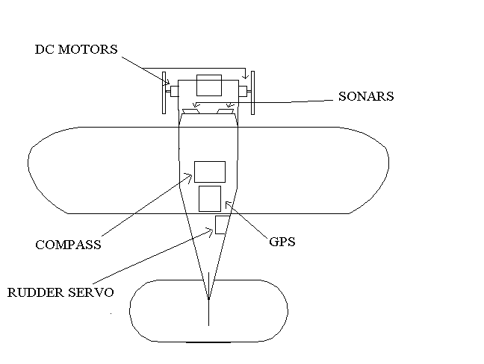

Layout of Sensors and Actuators

- Actuation

Two small, 10 mm diameter DC brushed motors will be used to make MALV mobile on the ground. The selected are the Maxon RE-10’s. More torque will be required to move the robot, so a planetary gear box was used on the heads of the motors to make an equivalent gear reduction of 64:1. Two 3.5 inch GWS wheels are attached to the shaft of the motors for mobility. In the future, a leg type structure will be used to help the robot move across various terrains instead of just parking lots.
Two full H-bridges were used to drive the motors (both on one chip). The motors have a stall current of about .8 amps, so a 1 amp H-bridge is sufficient. A heat sink was used on top of the H-bridge to avoid chip overheating. The H-bridges are controlled by the PWM output of the Atmega128. The period of the PWM is 8 milli-seconds. The max duty cycle used in software is 60 percent so the motors will not receive more then 7.0 volts. A control algorithm in software was developed using the 16 bit timer1 on the chip to pulse a certain percentage of the 60 percent allotted PWM to control the robots speed. Also, a direction bit is sent to this algorithm to tell the motors to either rotate forward or backward. From these two combinations, the robot can move in all directions in proportion.
The servo is used to help the plane in tight situations by swinging around the back end. Before the tail wheel was used the robot had a very hard time rotating because the tail was just dragging on the ground and acting like a stopper. The servo is controlled like any standard servo. The period of the PWM is 20 milli-seconds. A servo is controlled slightly different then a H-bridge. A full right deflection of the servo is controlled by a 1 ms on, 19 ms off pulse. A full left deflection of the servo is controlled by a 2 ms on, 18 ms off pulse. Proportional deflection between the two extremes is controlled by a change in the on pulse between 1 ms and 2 ms. In software, the servo is deflected by a percentage on, 0 percent being 1 ms and 100 percent being 2 ms. The PWM is generated using the timer0 on the chip.

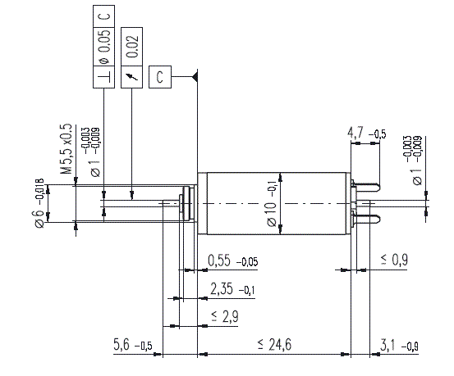
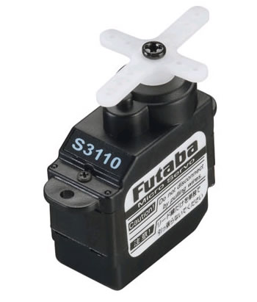

Technical Drawing of Maxon RE-10 drive motor Futaba S3110 Servo

VII. Sensors

- GPS

The MALV used GPS for 2 axis positioning. The UTM (Universal Transverse Mercator) position was used. UTM’s output a Northing and Easting position from a reference rectangle found on the earth’s surface. Two GPS points will be required to calculate a heading between where the robot is and its final destination. Also, the GPS will tell the robot when it has reached the target. The MALV is small airplane that is very weight sensitive, so a small GPS was used. Currently, I am using the Ublox SAM_LS. Later, the GPS coordinates will be taken from the Ublox LEA-4P receiver used on the airborne segment, which uses the same protocol as the SAM _LS, so transitioning to the other GPS receiver will be easy. I am considering the GPS as my “special sensor”. A separate report was written earlier in the semester on this sensor and will be included below to fully explain the GPS.

OVERVIEW

The M.A.L.V. (Micro Air/Land Vehicle) Robot is being developed to be a land navigating vehicle capable of obstacle avoiding and point-to-point GPS navigation. The sensor/actuator suite consists of sonars, digital compass, DC motors, a servo and GPS (Global Positioning Satellites) receiver. The GPS receiver is a critical sensor for the robot to understand its whereabouts and will aid the compass unit to maintain a proper trek. The MALV stays very close to the ground where it is sometimes difficult to have good satellite coverage, so a high gain receiver and excellent satellite tracking algorithms are needed to compensate. Therefore, the uBlox SAM_LS All-in-one GPS unit was chosen because of its excellent poor condition reception. Also, the SAM unit is fairly small and light weight , which are necessities for the MALV. The all-in-one unit means that the receiver, tuned patch antenna, and ground plane/electrical shielding is included all in one package. The receiver is setup for a 1 Hz position update.

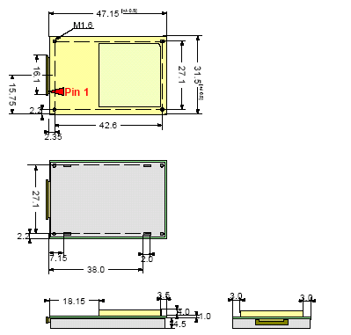
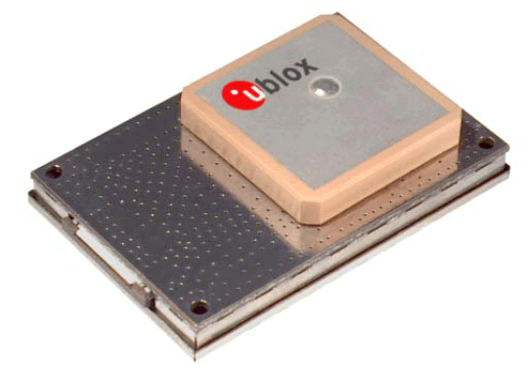

Figure 1. Picture of SAM_LS Unit and Physical Dimensions (in mm)

Operating Conditions
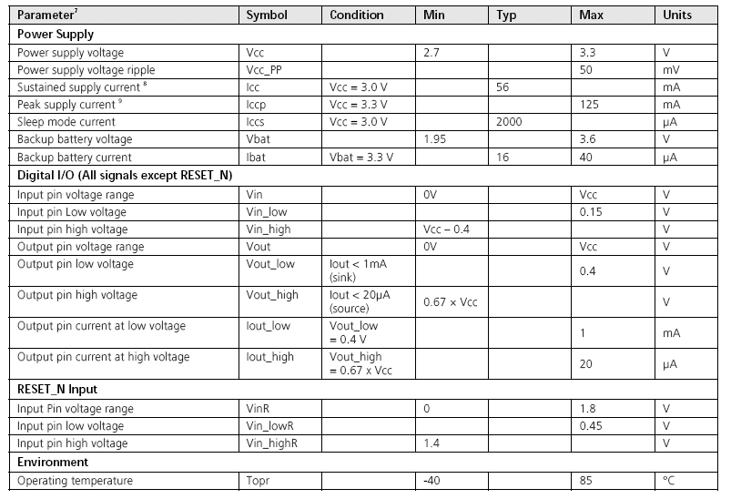

Figure 2. Table of Manufactures Operating Conditions

INTEGRATION

The SAM_LS GPS unit has a required voltage level between 2.7V – 3.3 V. The Atmega128 and other integrated circuit chips in the MALV use the 5V from the regulator on the MavericII board. Therefore, a GPS integration board was made to accommodate a 3.3V regulator, header pins, and a 20 position flat flex Molex header to connect to the GPS. There are two serial outputs and two serial inputs from the SAM_LS unit. Only one of the serial outputs will be used because there is no need to send anything to the GPS during tracking, however, on the breakout board a receiver line was included to allow firmware upgrades to the SAM. The one output line outputs a 8 bit, no parity, 1 stop bit, asynchronous 38400 baud, serial signal. This one wire will be brought in directly to the Atmega128’s RX0 port. For debugging and initial protocol filtering help, the MavericII’s MAX232 driver is used to up the voltage to communicate with a computer’s serial port. Ublox has software called “uCenter” that was used to evaluate the GPS’s status and to setup the GPS’s output protocol scheme.
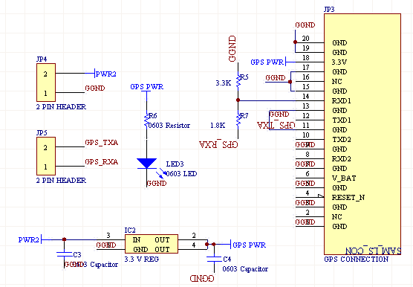

Figure 3. Circuit of GPS integration board

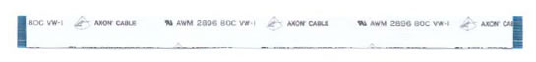

Figure 4. 20 position Flat Flex Cable used to connect GPS to integration board

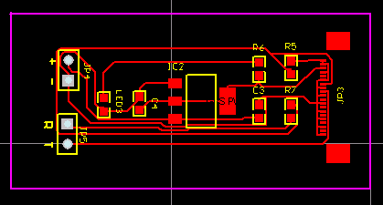

Figure 5. Picture of GPS integration board PCB

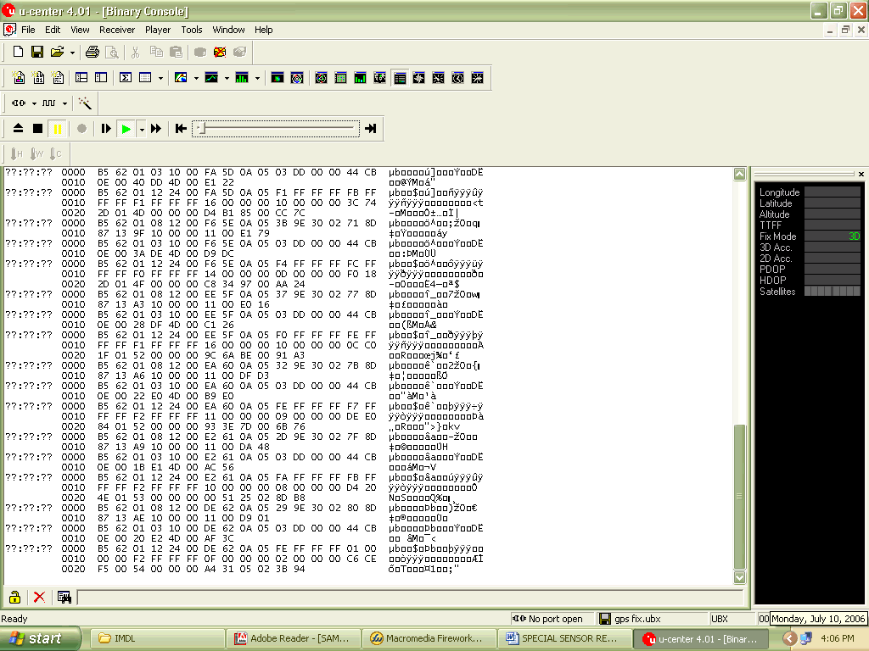

Figure 6. Screen Shot of uCenter Software

GPS SERIAL PROTOCOL

The SAM_LS GPS units can be configured to output many different types of data in several different formats. The SAM unit can either output a NMEA or UBX protocol. The NMEA is ASCII based protocol that contains 13 selectable sub-packets depending on the kind of information the user wants extract from the GPS. For instance, the GPGLL sub-packet gives information about longitude/latitude and UTC time, while the GPGSV sub-packet gives information about GPS satellite locations. The NMEA protocol is an industry standard protocol that is compatible with many devices.
The UBX protocol is a uBlox proprietary binary protocol that outputs in hexadecimal format. The UBX protocol has the ability to output much more information about the GPS unit itself and more detailed position information. There is more then twice as many sub-packets in this protocol then in the NMEA protocol. This protocol has the ability to output UTM (Universal Transverse Mercator) coordinates. These Northing/Easting coordinates are in centimeters which makes it easier to pinpoint the location of a small robot such as the MALV. Also, this makes it easier on the processor instead of having to convert longitude/latitude to a more precise format. This is the main reason I choose the UBX protocol for the MALV. The three sub-packets I choose were: POSUTM, STATUS, and VELNED. The POSUTM is the UTM positioning sub-packet that was explained earlier. The STATUS sub-packet gives the status of the position fix. The position fix is a function of how many satellites the GPS is locked on to. If it is locked on 0 or 1 satellite it will report “no fix”. If the GPS is locked on 2 satellites it will report a “2D fix”, which means it is accurate up to a X,Y ground fix. If the GPS is locked onto 3 or more satellites, then it will report a “3D fix” it is accurate in the X, Y, Z direction. The Z direction is altitude in this case. The last sub-packet, the VELNED, gives various velocities data. I might extract the 2D ground speed from this sub-packet to display on the LCD if time permits.
Below are tables to show how the sub-packets are broken down to extract different data from them. This should give the reader an idea of how a software data filter could be written to grab desired information.
The appendices section of the report includes source code on how the parsing of the serial data is buffered and processed.

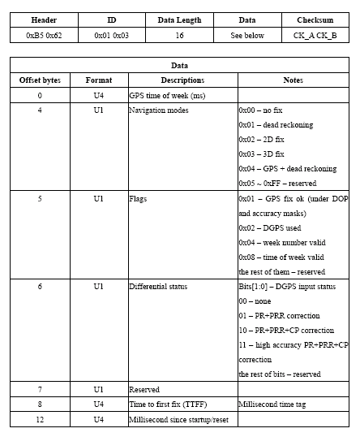

Figure 7. STATUS sub-packet definition

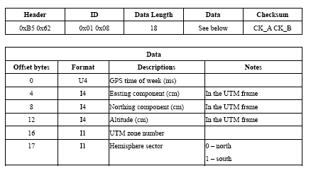
Figure 8. POSUTM sub-packet definition

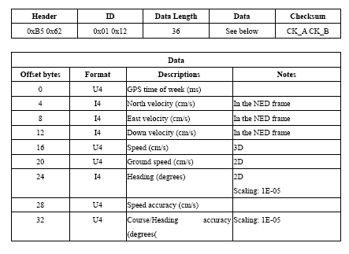
Figure 9. VELNED sub-packet definition

CONCLUSION

GPS reception changes day to day depending on atmospheric conditions and other external factors. The day the readings were taken was a fairly clear day where reception shouldn’t have been too badly affected. According to the above results, I should be able to demo my robot outside somewhere close on campus. Maybe on the Basketball court or outside the entry way of the NEB, it all depends on the day. Hopefully, the robot will be done in time to take video of it performing on a good day in case of inclement weather come demonstration day or media day.
The SAM_LS unit seems to perform relatively well and was not terribly difficult to interface. I believe that Ublox should release a 5 V version of the sensor due to the fact that many people are working with 5 V systems, especially for prototyping purposes like with the MALV.

- SONAR

A proximity sensor had to be selected in order for the M.A.L.V. to avoid obstacles. The robot is meant to be used outside, so IR and other light detecting sensors were out of the question. Therefore, an ultrasonic sensor was used. This allows for operation even at night. The sonar sensor sends out an ultrasonic pulse and awaits its return. The sensor measures the time it takes to return a transmitted pulse from an object and that time refers to particular distance based on the speed of sound. Again, this sensor has to be small and light, especially since I am using two of them. For that reason, the selected sonar sensor was the Maxbotix-EZ1. It uses a 42khz ultrasonic wave and can detect objects up to about 5 meters away. The sensors are turned at about 30 degrees from the center line of the M.A.L.V. to give a broader viewing area. At about a meter, the paths overlap leaving no dead area past that range. However, if the robot does not detect an object before that, it can have problems avoiding it. In software, if the robot sees a very close object (<12”) for more then 3 seconds, it reverses its direction until it sees an open area and then continues it’s obstacle avoidance algorithm.
The sonar sensor has three available outputs to the user. It can either use a serial output, an analog output, or a PWM output. I selected to use the analog output to save ports on the Atmega. The sonar is capable of outputting a new ranged measurement every 20 Hertz. I estimate that I range for the robot at 10 Hz by the time both sonars are done ranging. I have ran an experiment with the sonar that can be viewed in the Experimental Layout and Results section of the report.

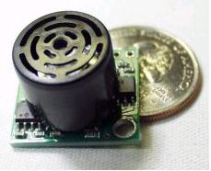

Maxbotix EZ1 Sonar Transceiver Sensor

- COMPASS

The compass works by measuring the intensity of earth’s magnetic field in the x and y direction and resolving that measurement to give a heading. The compass is used to determine MALV’s heading when it is trekking from waypoint to waypoint. GPS could be used to generate heading, however, the robot is too slow for the GPS to determine this. I originally started working with the HMC6352 by Honeywell. It is a very small (1cm x 1cm) fully integrated compass that uses an I2C interface. I had to make a breakout board for this compass and mount its PLCC package by means of a convection oven. It seems that somewhere in that process the sensor got damaged. The sensor was outputting completely random data and was abandoned until a later date where it can be retried for the final version of the M.A.L.V.
Instead, I used a well known compass that has been proven by past students of the MIL and IMDL class. The Daventech I2C compass was the compass used in the working model of the M.A.L.V. This compass is being used just for prototyping and conceptual purposes. As mentioned earlier, it will need to be replaced by a smaller packaged compass. The important thing to note is that no matter which compass is used later, with a little software work, the new compass can be easily modified to run on my navigation algorithm. This compass uses the I2C protocol which involves a host (Atmega128) controller and a slave device (Daventech compass). Basically, the host sends out a command to a certain slave address and the slave interprets the command and sends back an acknowledgement bit letting the host know that it is “listening”. Then another command is sent by the host and the corresponding slave does this action and sends a bit to let the host know that it is done doing the action. In this case, I request a heading measurement from the compass every time through the master software loop and take a running average at the end of the fourth reading. This heading is sent to the heading tracker algorithm for motor control. By doing it this way, it gives me a nice constant heading and does not stress the motors by changing so frequently.
The particular mode of the compass that I am using is only capable of reading headings in 2.83 degrees increments, which can greatly through off the robot from it destination over a long distance. To try to overcome this as much as possible, I basically take the calculated heading from the two GPS waypoints and put that into a filter that chooses the heading from a large array of headings. Sometimes the filter chooses a heading larger then the calculated one and sometimes it chooses one smaller depending on the actual calculated value. This value pulled from the array is then sent to the 4 heading moving average which then goes to the tracking algorithm mentioned above. This seems to help the robot to track more along its heading calculated by the GPS.
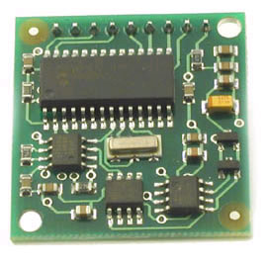

Daventech I2C Compass

- Behaviors

The MALV robot is a ground navigation robot that is capable of GPS navigation by means of heading tracking between waypoints. Along this path, it is capable of avoiding obstacles. The sensors and actuators have been explained above and describe how each help the robot complete its mission. The behavior section will explain from the start to finish of how the M.A.L.V. completes its goal. A diagram will be provided below to better understand the process.
First we will assume a scenario that the M.A.L.V. might be used for in later applications. A suitable mission for the finalized M.A.L.V. could be to fly to an open area near a meeting facility of enemy government officials. The airplane could land in an open area and walk to a GPS position to get a better look at the situation, unnoticed. If there were any objects in its path on the way to that point, it could avoid them, but still make it to its destination. After a given amount of time it could return to its landing or home position to remain out of site of enemies for pickup at a later date. A similar demonstration of just the ground segment will be shown for Media Day on August 9, 2006.
An explanation of the entire process that the plane goes through from beginning to end will now be discussed. The diagram below should help in this explanation.
The M.A.L.V. starts by waiting from its resting position, either from where it is placed first or from where it settles after a landing until it has at least a three satellite position fix. Just before this instant all sensors are initialized. Once a three satellite fix occurs, the robot waits an additional 20 seconds for more satellites to lock. During this time the drive motors are braked. After the 20 seconds is up, the robot starts the main navigation routine. If at anytime there is less then a three satellite fix during navigation, the robot stops until it again has at least a three satellite fix. This is very important because a bad position fix will result in erroneous heading calculations that will send the M.A.L.V. off the desired course. Once within the main navigation loop, the first thing that happens is that the UART reads in 94 characters and stores them in a buffer. Then, that buffer is parsed for the needed data and manipulated as needed. The final data from this process is stored as global variable to be used by the rest of the loop. After that is complete, the robot pings its right sonar waits 50 ms reads that value, then pings its left sonar and waits 50 ms and reads that value. If either of the values indicate that the robot is with 3 feet of an object, then the robot goes into a obstacle avoidance behavior and ignores the heading reading from the compass, if not then it continues through the loop. If the robot enters the obstacle avoidance behavior, it will look to see which sonar is reading a quicker return pulse. A quicker return pulse indicates a closer object; therefore, the robot will turn away from that direction indicated by a directional sonar, until either sonar reads a clearing of more then 3 feet. At this point, the robot will continue straight. If it encounters another object it will repeat the obstacle avoidance behavior, if it continues straight for more then 3 seconds, it will re-enter the navigation loop. The next step would calculate a new heading from the position at which the robot is clear of the object to the target destination. The robot will rotate to that heading using its drive motors and rudder tail wheel. Once it has reached its desired heading, the robot will start moving somewhat straight along that heading. If the robot starts moving away from the desired heading, the arbitrator will send a signal to the motors to move either left or right. For instance, if a left turn is desired, then a greater duty cycle is sent to the right motor, making it turn faster, and in-turn making the robot rotate left. Also, the servo is told to turn to the appropriate direction to aid in quicker turning. The motors are only sent one period of the signal every time through the navigation loop. After the one period is sent, the robot moves to the next state of the loop. The next part of the navigation sequence has the robot to check to see if it has reached its desired destination. At the beginning of the source code, I left a variable called, Waypoint Radius, which allows the user to define the size of an imaginary radius around the waypoint. This radius allows the robot to think it has reached it destination within a certain distance. This is a very important feature in waypoint navigation because there is error in the accuracy of the GPS waypoint versus the amount of satellites generating a position fix as well as a significant accuracy error of the compass. This radius allows the airplane to get relatively close to the waypoint without spending too much time (if ever) getting to the exact point. Once the robot arrives with that radius, the destination is considered reached, and after 10 seconds, a new waypoint is considered as a new destination waypoint and the process starts all over. If the robot gets to its last waypoint, it will insert the Home Position as its new destination waypoint and attempt to get back home. The Home Position also adheres to this Waypoint Radius variable. Once the robot is home, the motor are braked indefinitely. At this point a reboot of the robot is required to start the process over.
On the next page, a behavioral flowchart is provided for the reader to better understand the above text.

Initialize
Sensors
Wait for 3 SAT. Position Lock, Motor Brake

Wait 20 more seconds for more Satellite Lock
F
T
F
T
Store this position as “Home Position” if this is first time through loop
F
T
T
F
Calculate Heading to Destination from Current Position
F
Arrived at Destination or Home?
Motor Brake for 10 sec. then Load new Waypoint for Navigation. If Last Waypoint has been reached, load Home Position (if home, motor brake forever)
T
Filters GPS Data
Is there still at least 3 satellite position fix?
Ping R. Sonar, then Ping L. Sonar
Is there an object < 3ft away?
Obstacle Avoidance Routine
T
F
Clear of object?
Track Heading using Motor Control and Rudder Servo

M.A.L.V. Behavioral Flowchart

- Experimental Layout and Results

  - GPS

The uBlox SAM_LS GPS was chosen because of its high gain receiver and excellent low signal reception capabilities. Therefore, I chose to test how well the GPS received information in certain settings by measuring the amount of satellites the GPS locked onto in different locations so I know the restrictions of the MALV’s overhead cover. The following graph shows different locations and their corresponding GPS fixes throughout the day of July 2, 2006. The day was partly cloudy all day with a high temperature of about 90 degrees. The GPS was temporarily attached to the top of the robot where it will later be fixed; this will best simulate the MALV’s final configuration. The uBlox uCenter software as well as the MavericII’s MAX232 driver was used to view the satellite numbers as the robot was moved from place to place. The MALV was tethered through a serial cable. The maximum of 8 minutes was given at each location and the maximum satellite count during that time was recorded.

  - SONAR

I decided to use the analog output of the sonar sensor as explained above. The analog voltages range from 0.6 Volts for 0-6” away up to 2.5 Volts distances greater then 6 meters. The Atmega series of microcontrollers have a 10 bit ADC. That means that at 0.6 Volts, the integer values given from the ADC port is 124 and for 2.5 volts is 512. I tested the sensor by ranging from 0 inches to 30 inches in inch increments and getting a positive 4 increase in ADC integer per inch. Then to save time, I brought the sensor away from the wall about 71” and read that value. It remained linear through this range. This distance is plenty far for my robot, so I didn’t bother testing any more points. The results of the test below show that the sensor is very linear through this range. However, every so often it has some erroneous data that is recorded for unknown reasons.

Results of Maxbotix EZ1 Sonar at varying distances

C. MOTOR CONTROL

I initially had one motor unmounted from the M.A.L.V. platform and bread boarded with the TI H-Bridge listed in the Actuators section of the lab report. I was looking for a good switching speed for the brushes so I wouldn’t hurt the DC motor. To do this, I started with a 1 ms period PWM generated using the 16 bit, timer1 with a 40 percent duty cycle that I confirmed on an oscilloscope. I then hooked it up to the enable pin of one motor channel of the H-bridge which was reverting power from the 11.1 V battery. I held the motor to feel for any mechanical hesitations. The motor started spinning, but very choppy and violently. This switching frequency (1/1ms= 1 kHz) was not good for this particular motor. I increased the switching frequency by 500 Hz until I felt the vibration lessen, then eventually cease. I kept increasing the frequency to see what would happen, and again there was undesired mechanical hesitation. I rated each frequency tested on a 1 to 10 scale for the best switching frequency and reviewed the results when I was done. It turns out that an 8 ms PWM is optimal for these motors. Therefore, in the motor control portion of the code, I used a 16 bit timer that output a very resolute 8 ms period with varying duty cycles.

- COMPASS

The compass was fairly easy to interface. Codevision provided built in I2C port commands that I used to interface with the Daventech compass. To test the compass I wrote code to read from an 8 bit address on the compass that provided unsigned integer values (128-255) that represented different degrees of rotation. I divided this difference by 360 degrees and realized that every integer increment mean 2.83 degrees. I rotated the compass 360 degrees and had the LCD display what the compass was outputting after running through a couple functions to put it into degrees. The compass indeed went from 0 to 359.41 degrees in 2.83 degree increments. This makes precise heading difficult, but because of averaging and other techniques I used, the robot looks to track a fairly precise heading.

X. Conclusion

The M.A.L.V.’s unique robot platform and functionality would make a great reconnaissance/surveillance robot. The robot’s ground segment has proved to maneuver pretty well in reasonably-populated environments and able to recognize when it has reached it’s destination waypoints. The end result turned out to be a pretty impressive robot that the Micro Air Vehicle lab will be happy to work with.
The IMDL class is by far the most exciting and useful class that the department offers. The process of designing a robot covers so many different areas of electrical engineering and other disciplines that I feel like I have learned more in this one class then a year’s worth of classes combined. Since I had to sit down and see the project completely through, I feel very confident in all aspects of the project, from software design to soldering, and from integration to power distribution; this project covers it all. The hands on, get dirty, approach to the robot, fortifies what I have learned and what I will remember forever. Also, having great TA’s and enthusiastic professors made this class truly a treat to take. I really like the way the class is structured; where the students help one another and encourage each other to finish.
If I had to do it all over, I would probably not have chosen this small of a platform for my first robot. Trying to find small light sensors that are reliable and have a lot of supporting documentation was tough. The physical size of the robot and room to fit sensors made it frustrating to work on. This project was also a little more difficult because I had to always have the “big picture” in the back of my mind; that being a flying version of this robot. I tried to choose sensors around this idea as well as write code for a smaller processor; ie. Using only two timers and few ADC’s. I think for this robot to ever see practical use as a flying/walking robot, the drive motors have to be lightened. The motors are much too heavy for the airplane and will make the plane fly too fast, which means it will land too fast and probably end up breaking parts on landing. I am interested to see how the originally proposed “wheel” will work on this platform. In the proposal of this robot I mention “wegs”; which are wheel like legs to help the robot move around in grassy/bumpy environments. I think that they will work just fine regardless of their tendency to shake the plane from side to side.
I wanted to take the time to thank Dr. Schwartz and Dr. Arroyo for their good spirit and enthusiasm for the subject. They really inspired me and were a very big part in helping me finish this project. The TA’s were very knowledgeable in the subject of robotics and were always willing to spend a little more time in the lab helping even though they didn’t have to. Without them, I would have never finished the project. A big thank you goes out to UF’s Micro Air Vehicle lab for allowing me to use their tools and funding most of the project. I hope that this robot can become a usable technology in the future.

XI. Documentation

Maveric-IIB Board: http://www.bdmicro.com/mavric-iib/
ISP Parallel Programmer: http://www.olimex.com/dev/pdf/avr-pg2b.pdf
Maxbotix EZ1 Sonar: http://www.sparkfun.com/datasheets/Sensors/MaxSonar-EZ1-Datasheet.pdf
TI SN754410NE H-Bridge: http://www.acroname.com/robotics/parts/R6-754410.html
Maxon RE-10 DC motor: http://www.maxonmotorusa.com/files/catalog/2005/pdf/05_055_e.pdf
Daventech Compass: http://www.acroname.com/robotics/parts/R117-COMPASS.html
20 x 2 LCD: http://www.mil.ufl.edu/4744/ - Look at LCD specs
Ublox SAM_LS GPS: http://www.u-blox.com/products/sam_ls.html
Futaba S3110 Servo: http://www.futabarc.com/servos/servos.html

XII. Appendices

The following C code written in the Codevision C compiler shows how the GPS serial data was parsed and extracted for needed data. This code was made referenced with a .h file and included in the main for organizational purposes.

void GPS_FILTERING(void);
float EAST_POS(void);
float NORTH_POS(void);
float GROUND_SPEED(void);
int GPS_LOCK(void);

char GPS_data[94];
char NAV_data[20];
char SAT_data[18]; // Array size include 2 bytes of "Check_Sum" plus acutal data length refer to
char VEL_data[38]; // UBX protocal definitions

float EAST_data[4];
float NORTH_data[4];
float SPEED_data[4];

int GPS_LOCKED=0;

float EAST;
float NORTH;
float SPEED;

int lock=0;
int nav;
int sat;
int vel;
int east_count;
int north_count;
int ground_count;
int filter_loop=0;

//**************************** GPS FILTERING ****************************************

void GPS_FILTERING(void){

for(filter_loop=0;filter_loop<94;filter_loop++){
GPS_data[filter_loop]=getchar();
putchar(GPS_data[filter_loop]);
}

filter_loop=0;
do{

if (GPS_data[filter_loop]==0xB5){
filter_loop++;

if(GPS_data[filter_loop]==0x62){

filter_loop++;

if(GPS_data[filter_loop]==0x01){

filter_loop++;

if(GPS_data[filter_loop]==0x03){ //Satellite protocol filter
sat=0;
filter_loop++;
filter_loop++;
do{
SAT_data[sat]=GPS_data[filter_loop];
lock=SAT_data[5];

if(lock>2 & lock<5){
//PORTB.0=1;
GPS_LOCKED = 1;
}

else{

PORTB.0=0;
GPS_LOCKED = 0;

}

sat++;
filter_loop++;
}while(sat<18);

}

else if (GPS_data[filter_loop]==0x12){ //Velocity protocol filter
vel=0;
filter_loop++;
filter_loop++;
do{
VEL_data[vel]=GPS_data[filter_loop];
vel++;
filter_loop++;
}while(vel<38);

}

else if (GPS_data[filter_loop]==0x08){ //Navigation protocol filter (will give UTM's in cm)
nav=0;
filter_loop++;
filter_loop++;
do{
NAV_data[nav]=GPS_data[filter_loop]; // NAV_data[7] to NAV_data[10] contains Easting info
// NAV_data[11] to NAV_data[14] contains Easting info
nav++;
filter_loop++;
}while(nav<20);

}

}
}
}
filter_loop++;
}while(filter_loop<94);

}
//******************************* END GPS FILTERING ****************************************************

//************************************ EAST POSITION CALCULATION *****************************
float EAST_POS(void){

//THIS IS I4 DATA

for(east_count=0;east_count<4;east_count++)
{
EAST_data[east_count]=NAV_data[8-east_count]; //8 thorough 5
}
/*
EAST_data[0]= 0x02;
EAST_data[1]= 0x30;
EAST_data[2]= 0x9D;
EAST_data[3]= 0x7E;
*/

EAST_data[0]=EAST_data[0]*pow(16,6)+48;
EAST_data[1]=EAST_data[1]*pow(16,4)+4;
EAST_data[2]=EAST_data[2]*pow(16,2)+4;

EAST=EAST_data[0]+EAST_data[1]+EAST_data[2]+EAST_data[3]+2;

if(EAST==58){
EAST=0;
}

return EAST;
}
//******************************* END EAST POSITION CALCULATION *******************************

//********************************* NORTH POSITION CALCULATION ********************************
float NORTH_POS(void){

// THIS IS I4 DATA

for(north_count=0;north_count<4;north_count++)
{
NORTH_data[north_count]=NAV_data[12-north_count]; //12 thorough 9
}
/*
NORTH_data[0]= 0x13;
NORTH_data[1]= 0x87;
NORTH_data[2]= 0x8C;
NORTH_data[3]= 0x76;
*/

NORTH_data[0]=NORTH_data[0]*pow(16,6)+480;
NORTH_data[1]=NORTH_data[1]*pow(16,4)+36;
NORTH_data[2]=NORTH_data[2]*pow(16,2)+4;

NORTH=NORTH_data[0]+NORTH_data[1]+NORTH_data[2]+NORTH_data[3];

if(NORTH==520){
NORTH=0;
}

return NORTH;

}
//********************************* END NORTH POSITION CALCULATION ***************************

//********************************* GROUND SPEED FUNCTION ************************************
float GROUND_SPEED(void){

//THIS IS U4 DATA

for(ground_count=0;ground_count<4;ground_count++)
{
SPEED_data[ground_count]=VEL_data[23-ground_count]; //23 thorough 20
}

SPEED=SPEED_data[0]+SPEED_data[1]+SPEED_data[2]+SPEED_data[3];

return SPEED;

}
//******************************** END GROUND SPEED FUNCTION ********************************

//****************************** GPS LOCK FUNCTION*******************************************
int GPS_LOCK(void){

return GPS_LOCKED;
}
//********************************* END GPS LOCK FUNCTION************************************

