Table of Contents:

Abstract 3

Introduction 3

Integrated System 3

Mobile Platform 4

Actuation 5

Sensors 5

Behaviors 6

Experimental Results 6

Conclusion 7
Abstract:

The robot I am designing is a Poker-dealer robot. It will be able to shuffle cards and move around the table to deal cards. When playing a game of poker, the user would use a flashlight to indicate that he wants to be dealt cards. The robot would then move toward each player and deal two cards. As of now, the robot may only deal to a set number of players, but it can be easily improved to deal to a variable number of players. After dealing to the players, the robot would move to the center of the players and deal the first three cards, then the next one, and then the last one. After each round, the user would collect the cards and put them into the robot, which would shuffle the cards and ready for the next round.

Executive Summary:

The base of the robot is built on a ¼’’ x ½’ x 1 ½’ wooden board. The board is cut so that two halves of an automatic shuffler may rest on either side of the board and still leave a 2 inch gap between each shuffler and the dealer. The rest of the robot is made of wood and plastic. Due to difficulties in testing the mechanical aspects of the robot, a pre-designed platform, support, and chasis is out of the question. Instead, 2’’ x 2’’ wooden blocks are used to provide support for the various components of the robot.

The shufflers and dealer are made from automatic shufflers purchased from Walgreens. The below picture is one that looks almost exactly like the original shuffler:
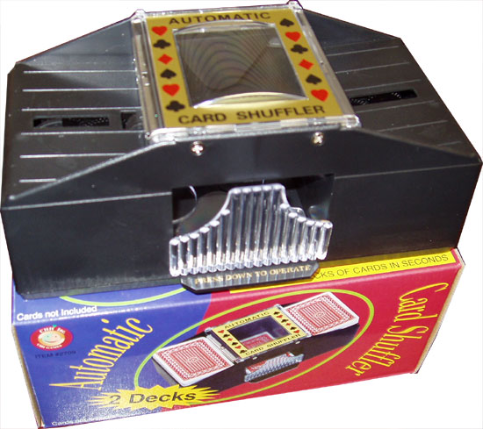
Two shufflers are cut exactly in half. Two of the halves are placed at the ends of the robot so that they shuffle into a middle chamber, which is made up of another half of a shuffler. The middle shuffler would then deal the cards.

Simples motors are used for locomotion, IR sensors are used for end of the world detection, Sonars are used for obstacle detection, and photoresistors are used for direction detection.

Introduction:

My friends and I often play poker to pass time, and dealing and shuffling cards is always a big hassle. The robot that I intend to design should be able to do both, thus making our lives much easier. To deal, cards must be dealt close to the person asking for them. Since the sizes of tables/surfaces we play on vary as well as the distance we sit away from the surface, the robot must be able to move toward the players to deal cards. Also, since there are often stacks of playing chips on the table, the robot needs to be able to avoid them and not deal cards onto them. To shuffle cards, the robot needs to do it in within reasonable time and the shuffling needs to be thorough.

Integrated System:

All functions of the robot will be controlled by an ATMega128 microprocessor. Outputs from all sensors are sent to the Mavric-IIB board and all motor functions will be controlled by it as well. Since all motors used are fairly small, no special motor control board is used. Instead, a few H-bridge chips is sufficient to run this robot. Below is a diagram of the entire system:

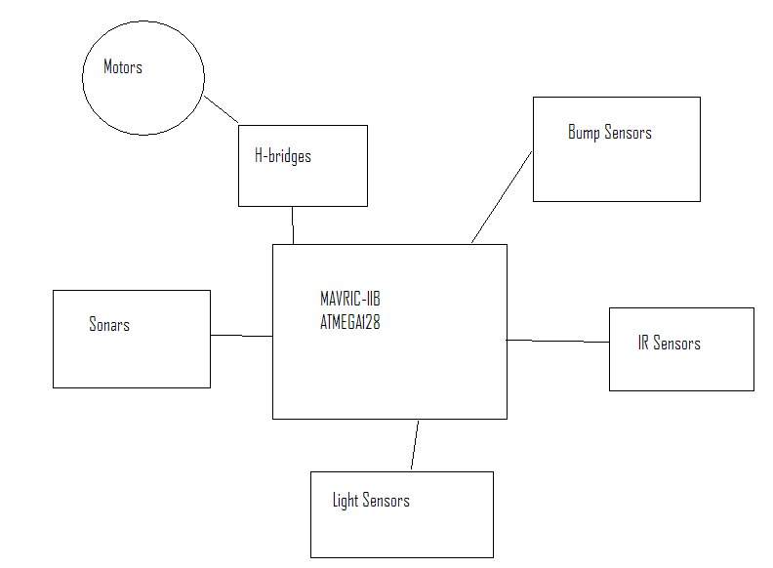

Mobile Platform:

The mobile platform will be almost entirely be made of cardshufflers purchased from Walgreens, although some wood will be used as support structure. A picture of the card shuffler I am using is below:

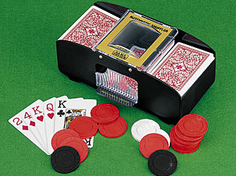

The shuffler portion is made entirely of the purchased shuffler on top a few wooden blocks. A large wooden board provides the basic platform below everything. More wooden blocks and boards are used to attach the sensors.

Actuation:

A total of five motors are used. Three of the motors are taken from the shuffler, two of which are used to shuffle and one is used to deal. The two shuffling motors occupy one H-bridge chip(SN754410) and are supplied with 8V of voltage. The dealing motor uses one H-bridge chip and is supplied with also 8V of voltage. The two motors used for locomotion will each use one H-bridge chip due to their larger stall currents. The controls are very simple, as no sudden reversal of direction is required. They may all be controlled by simple stop, reverse, or go instructions.

Sensors:

- IR Sensor: I use a basic Sharp GP2D12 sensor for end of the world detection. The output voltage decreases quasi-exponentially as distance increases. Since the robot is tall and the IR sensors are attached to the top of the robot, the minimum detection distance of 10 centimeters is of little concern. They are angled downward and used to detect sudden changes in distance(that is, a sudden lowering in output voltage) as the edge of a table. The exact distance is unimportant for this application.
- Sonar: I use a SRF05 sonar to detect approaching obstacle. The obstacle they are aimed to detect are stacks of chips on the table. Two SRF05’s were used to cover the area in front of the robot. When either sonar detects an obstacle in front, it prompts the robot to deal cards.
- Photoresistors: I use photoresistors as my special sensor. Their resistances are very sensitive to light. In the direct path of a light source, the resistance is usually in the 1-5 kOhms range, while it is usually in the hundreds of kOhms range when facing toward ambient light. The resistors are wrapped in electrical tape for optimal noise reduction. They are connected in series with 22 kOhm resistors to set up a voltage divider circuit. When in the presence of light, the voltage across the resistor will be around 2.5V – 5V, while the voltage will be near 0V in the absence of direct light source.

Behaviors:

- Direction determination: It can detect the direction of the poker players based on the flashlight the player shines on it. The robot will have eight photosensors on top of it so that when a player flashes a light at the robot, it may determine the direction by the resistor that reacts most strongly to it.
- End of the world detection: The IR sensors angled downward will detect sudden change of depth and thus signaling that an edge is ahead by lowering the voltage output.
- Obstacle avoidance: The two sonars together detect when an object is close and stop the robot to deal cards.

Experimental Layout and Results:

IR sensor: I have the IR sensors output results in terms of voltage onto a LCD screen and compare them to the manufacturer’s specifications. The matching is very good, within 5% usually, although such accuracy is not needed for its application. Below is a voltage vs. distance graph:
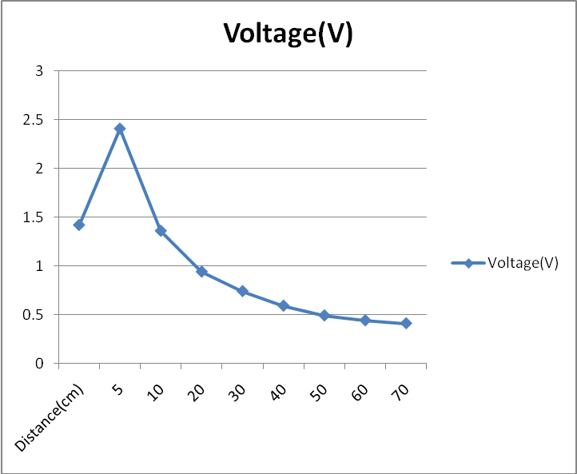
The sensor works as expected. The robot stops immediately upon nearing an edge.

Sonars: .Somewhat non-linear response just like the IR. Also works well, although it does sometimes pick up small objects that should not stop the robot.

Photoresistors: When faced directly at a light source from a distance of about 6 feet away, the resistance is around 5 kOhms. When tilted away 45 degrees or more in a fairly well-sunlit room, the resistance increases to around 50-60 kOhms. The drop is much sharper in a dimly lit room, as the resistance increase to over 150 kOhms when turned 90 degrees away from the light source. The actual values vary slightly due to differing ambient lighting. All photoresistors work fine except one. I am not completely sure of the cause of this yet.

Conclusion:

All except the shuffler works now, as the robot fell from the table due to an accident. The robot still needs major work in advancing its capabilities, namely the shuffling and obstacle avoidance. The IR sensors are attached a bit too high right now and detect edges too far away from the robot. I could also add a couple additional sensors to make the number of playable players variable. Other than those things, the baseline robot performs as expected.
Appendix

Robot_ctrl.c
#include <avr/io.h>
#include <avr/interrupt.h>
#include <avr/pgmspace.h>
#include <avr/signal.h>

#include <stdio.h>

#include "adc.h"
#include "lcd.h"
#include "MOTOR_CTRL.h"

#define CPU_FREQ 16000000L /* set to clock frequency in Hz */

#if CPU_FREQ == 16000000L
#define OCR_1MS 125
#elif CPU_FREQ == 14745600L
#define OCR_1MS 115
#endif

volatile uint16_t ms_count;

int ir_stop = 0;
int sr_stop = 0;
int stop = 0;
int stopped = 1;
int turn = 0;
int exec_SR;
int players = 3;

/*
* ms_sleep() - delay for specified number of milliseconds
*/
void ms_sleep(uint16_t ms)
{
TCNT0 = 0;
ms_count = 0;
while (ms_count != ms)
;
}

void deal(int num_cards)
{
int i;
for (i = 0; i < num_cards; i++)
{
motor_D(-100);
ms_sleep(300);
motor_D(0);
ms_sleep(300);

motor_D(100);
ms_sleep(300);
motor_D(0);
ms_sleep(300);
}
}
/*
* millisecond counter interrupt vector
*/
SIGNAL(SIG_OUTPUT_COMPARE0)
{
ms_count++;
}

ISR(INT0_vect)
{
uint16_t sr;
double distance;
// int range;
int carry;

sr = TCNT2;

carry = (0x40 & TIFR);

if (carry != 0)
{
sr |= 0x0100;
TIFR |= 0x40;
}

distance = ((double)sr) * 1.089; //convert to distance in cm
// lcd_clear();
// lcd_int((int)(distance));

if (distance < 30 ) //If an object is within 20 cm.
{

exec_SR = 1;
/* motor_MR(0); //then stop both motors, signal stop to the rest of the program,
ms_sleep(1); //and indicate that the stop signal comes from the SR
motor_ML(0);

motor_MR(-100);
motor_ML(-100);
ms_sleep(1500);
motor_MR(0);
motor_ML(0);

// deal(1);
stopped = 1;
stop = 1;
sr_stop = 1;
turn = 0;

lcd_int(4);*/
}
else
{
sr_stop = 0;
exec_SR = 0;
}
}

/*
ISR(INT1_vect)
{
uint16_t sr;
double distance;
int range;
int carry;

sr = TCNT2;

carry = (0x40 & TIFR);

if (carry != 0)
{
sr |= 0x0100;
TIFR |= 0x40;
}

distance = ((double)sr) * 1.089; //convert to distance in cm
lcd_clear();
lcd_int((int)(distance));
if (distance < 30) //If an object is within 20 cm.
{
if (stopped == 0) //if the robot hasn't already stopped,
{
motor_MR(0); //then stop both motors, signal stop to the rest of the program,
ms_sleep(1); //and indicate that the stop signal comes from the SR
motor_ML(0);
stopped = 1;
stop = 1;
sr_stop = 1;
}
}
else
{
sr_stop = 0;
}
}*/

/*
* Initialize timer0 to use the main crystal clock and the output
* compare interrupt feature to generate an interrupt approximately
* once per millisecond to use as a general purpose time base.
*/
void init_timer0(void)
{
TCCR0 = 0;
TCCR2 = 0;
TIFR |= _BV(OCIE0)|_BV(TOIE0);
TIMSK |= _BV(TOIE0)|_BV(OCIE0); /* enable output compare interrupt */
TCCR0 = _BV(WGM01)|_BV(CS02)|_BV(CS00); /* CTC, prescale = 128 */
TCCR2 = _BV(CS22) | _BV(CS20); /* CTC, prescale = 256 */
TCNT0 = 0;
TCNT2 = 0;
OCR0 = OCR_1MS; /* match in aprox 1 ms */

EICRA = 0x0A; //Set falling edge trigger for INT0 and INT1
EIMSK = 0;
EIMSK |= (_BV(INT0))|(_BV(INT1)); //Enable INT0 and INT1
}

void ping_SR(void)
{
PORTE |= _BV(PE0); //Give rising edge for echo

ms_sleep(1); //Wait for 1 ms

PORTE &= ~(_BV(PE0)); //Give falling edge for start of polling for echo
TCNT2 = 0; //Clear counter and clear TOV2.
TIFR |= 0x40;
}

int main(void)
{
motor_init();
DDRC = 0xFF;
DDRA = 0xFF;
DDRE = 0x01;
PORTA = 0x00;
// PORTE = 0x00;

// motor_init();
lcd_init();
adc_init();
init_timer0();
sei();

// ping_SR();

// lcd_string("Ready for IR test.");

// lcd_row(1);

lcd_string("Good luck!");

uint16_t ir;
uint16_t luminosity;
uint16_t luminosity2;
double volts;
double volts2;
int range;
int range1;
int range2;
int chan_sel = 0;

// init_timer0();
int i;

// lcd_string("Hi");
/* enable interrupts */
// sei();

/* initialize A/D Converter */
// adc_init();

i = 0;

/* motor_SR(100);
ms_sleep(240);
motor_SR(0);
ms_sleep(420);

motor_SL(100);
ms_sleep(240);
motor_SL(0);
ms_sleep(420);*/
/* while(i < 16)
{
motor_SR(100);
ms_sleep(120);
motor_SR(0);
ms_sleep(360);

lcd_clear();
lcd_int(i);
motor_SL(100);
ms_sleep(120);
motor_SL(0);
ms_sleep(360);

i++;
}*/

// motor_MR(100);
// motor_ML(100);

/* i = 0;
while(i < 10)
{
motor_D(-100);
ms_sleep(300);
motor_D(0);
ms_sleep(300);

motor_D(100);
ms_sleep(300);
motor_D(0);
ms_sleep(300);

i++;
}*/

// motor_MR(100);
// motor_ML(100);

deal(5);
ms_sleep(500);
while (1)
{

// PORTA = 0x0C;

// ms_sleep(500);

/* luminosity = adc_readn(3,3);
volts = ((double)luminosity) * 5.0 / 1024.0;
lcd_clear();
lcd_int((int)(volts));*/

/* luminosity = PORTE;
lcd_clear();
lcd_int((int)(luminosity));*/

PORTA = chan_sel;

ms_sleep(50); // sleep for 15 milliseconds
if ((chan_sel == 0) || (chan_sel == 4) || (chan_sel == 6) )
{
luminosity = adc_readn(3,10); // sample channel 3 3 times, take average
}
else
{
luminosity = adc_readn(0,10);
}

PORTA = 0x02;
ms_sleep(15);
luminosity2 = adc_readn(3,10);
volts2 = ((double)luminosity2) * 5.0 / 1024.0;

volts = ((double)luminosity) * 5.0 / 1024.0; // convert to Volts
// lcd_clear();
// lcd_int((int)(volts));

if ((ir_stop == 0) && (sr_stop == 0))
{
stop = 0; // Stop resets to 0 only when both the SR and the IR give the go ahead
}

if ((volts < 4) && (chan_sel != 2) && (stop == 0) && (turn == 0))
{
motor_MR(100);
ms_sleep(1);
motor_ML(-100);
turn = 1;
stopped = 0;
lcd_int(3);
}
else if ((volts2 < 4) && (stop == 0) && (turn == 1))
{
motor_MR(100);
ms_sleep(1);
motor_ML(100);
turn = 0;
stopped = 0;
lcd_int(1);
}

ir = adc_readn(2, 10);
volts = ((double)ir) * 5.0 / 1024.0;
range1 = ((int)(volts * 100));
ir = adc_readn(1, 10);
volts = ((double)ir) * 5.0 / 1024.0;
range2 = ((int)(volts * 100));

/* lcd_clear();
lcd_int(range1);
ms_sleep(100);
lcd_row(1);
lcd_int(range2);
ms_sleep(100);*/

if ((range1 < 50) || (range2 < 50)) //If edge of world detected and
{
// if (stopped == 0) //if the robot hasn't already stopped,
// {
motor_MR(0); //then stop both motors, signal stop to the rest of the program,
ms_sleep(1); //and indicate that the stop signal comes from the IR.
motor_ML(0);

/* motor_MR(-100);
motor_ML(-100);
ms_sleep(500);
motor_MR(0);
motor_ML(0);*/
stopped = 1;
stop = 1;
ir_stop = 1;
turn = 0;
deal(2);

lcd_int(2);
players--;
// }
}
else
{
ir_stop = 0;
}

if (exec_SR == 1)
{
motor_MR(0); //then stop both motors, signal stop to the rest of the program,
ms_sleep(1); //and indicate that the stop signal comes from the SR
motor_ML(0);

/* motor_MR(-100);
motor_ML(-100);
ms_sleep(500);
motor_MR(0);
motor_ML(0);*/

deal(2);
stopped = 1;
stop = 1;
sr_stop = 1;
turn = 0;
exec_SR = 0;
ms_sleep(2000);
players--;
}

if (players == 0)
{
deal(1);
motor_MR(100);
motor_ML(-100);
ms_sleep(200);
motor_MR(0);
motor_ML(0);
deal(1);
motor_MR(100);
motor_ML(-100);
ms_sleep(200);
motor_MR(0);
motor_ML(0);
deal(1);
while(1)
{}

}
ping_SR();

if (chan_sel == 7)
{
chan_sel = 0;
}
else if (chan_sel == 1)
{
chan_sel = chan_sel + 2;
}
else
{
chan_sel++;
}
}
}

Motor_ctrl.c

#include <avr/io.h>
#include <avr/interrupt.h>
#include <avr/pgmspace.h>
#include <avr/signal.h>

#include <stdio.h>

#include "lcd.h"

#define CPU_FREQ 16000000L /* set to clock frequency in Hz */

#if CPU_FREQ == 16000000L
#define OCR_1MS 125
#elif CPU_FREQ == 14745600L
#define OCR_1MS 115
#endif

volatile uint16_t ms_count;

int initialized = 0;

void motor_init(void)
{
DDRB = 0xFF;
PORTB = 0x00;
}

void motor_SL(int direction)
{
// motor_init();
if (direction == 0)
{
PORTB &= ~(_BV(PB1));
}

else if (direction == 100)
{
PORTB |= _BV(PB1);
}

}

void motor_SR(int direction)
{
// motor_init();

// ms_sleep(1);

if (direction == 0)
{
PORTB &= ~(_BV(PB2));
}

else if (direction == 100)
{
PORTB |= _BV(PB2);
}

}

void motor_D(int direction)
{
// motor_init();
if (direction == 0)
{
PORTB &= ~(_BV(PB3));
PORTB &= ~(_BV(PB0));
}

else if (direction == 100)
{
PORTB |= _BV(PB3);
PORTB &= ~(_BV(PB0));
}

else if (direction == -100)
{
PORTB |= _BV(PB0);
PORTB &= ~(_BV(PB3));
}

}

void motor_ML(int direction)
{

// motor_init();
if (direction == 0)
{
PORTB &= ~(_BV(PB4));
PORTB &= ~(_BV(PB5));
}

else if (direction == 100)
{
PORTB |= _BV(PB5);
// ms_sleep(1);
PORTB &= ~(_BV(PB4));
}

else if (direction == -100)
{
PORTB &= ~(_BV(PB5));
// ms_sleep(1);
PORTB |= _BV(PB4);
}

// ms_sleep(duration);
}

void motor_MR(int direction)
{
// motor_init();
// lcd_int(direction);
if (direction == 0)
{
PORTB &= ~(_BV(PB6));
PORTB &= ~(_BV(PB7));
}

else if (direction == 100)
{
PORTB |= _BV(PB6);
// ms_sleep(1);
PORTB &= ~(_BV(PB7));
}

else if (direction == -100)
{
PORTB &= ~(_BV(PB6));
// ms_sleep(1);
PORTB |= _BV(PB7);
}

// ms_sleep(duration);
}

/*int main(void)
{

DDRC = 0xFF;
DDRB |= 0x02;
PORTB &= ~(_BV(PB1));

lcd_init();

lcd_string("Ready for motor test.");

lcd_row(1);

lcd_string("Good luck! ");

init_timer0();

sei();

motor_MR(100);
ms_sleep(1000);
motor_MR(0);
// motor_ML(100);

return 0;

}*/

LCD_C.c

/*

University of Florida

EEL 5666C Intelligent Machine Design Lab (IMDL)

LCD setup code by Adam Barnett (and one method written by Josh Hartman, noted below)

*/

#include <avr/io.h>

void lcd_delay(); // short delay (50000 clocks)
void lcd_init(); // sets lcd in 4 bit mode, 2-line mode, with cursor on and set to blink
void lcd_cmd(); // use to send commands to lcd
void lcd_disp(); // use to display text on lcd
void lcd_clear(); // use to clear LCD and return cursor to home position
void lcd_row(int row); // use to put the LCD at the desired row

/* IMPORTANT!

Before using this code make sure your LCD is wired up the same way mine is, or change the code to
match the wiring of your own LCD. My LCD is connected to PortC of the At-Mega128 in the following manner:

PortC bit 7 : LCD data bit 7 (MSB)
PortC bit 6 : LCD data bit 6
PortC bit 5 : LCD data bit 5
PortC bit 4 : LCD data bit 4 (LSB)

PortC bit 3 : (not connected)
PortC bit 2 : LCD enable pin (clock)
PortC bit 1 : LCD R/W (read / write) signal
PortC bit 0 : LCD RS (register select) pin

Also remember you must connect a potentiometer (variable resistor) to the vcc, gnd, and contrast pins on the LCD.
The output of the pot (middle pin) should be connected to the contrast pin. The other two can be on either pin.

*/

void lcd_delay() // delay for 10000 clock cycles
{
long int ms_count = 0;
while (ms_count < 10000)
{
ms_count = ms_count + 1;
}
}

void lcd_cmd( unsigned int myData )
{

/* READ THIS!!!

The & and | functions are the BITWISE AND and BITWISE OR functions respectively. DO NOT
confuse these with the && and || functions (which are the LOGICAL AND and LOGICAL OR functions).

The logical functions will only return a single 1 or 0 value, thus they do not work in this scenario
since we need the 8-bit value passed to this function to be preserved as 8-bits
*/

unsigned int temp_data = 0;

temp_data = ( myData | 0b00001000 ); // these two lines leave the upper nibble as-is, and set
temp_data = ( temp_data & 0b11111000 ); // the appropriate control bits in the lower nibble
PORTC = temp_data;
lcd_delay();
PORTC = (temp_data & 0b11110000); // we have written upper nibble to the LCD

temp_data = ( myData << 4 ); // here, we reload myData into our temp. variable and shift the bits
// to the left 4 times. This puts the lower nibble into the upper 4 bits

temp_data = (temp_data & 0b11111000); // temp_data now contains the original
temp_data = (temp_data | 0b00001000); // lower nibble plus high clock signal

PORTC = temp_data; // write the data to PortC
lcd_delay();
PORTC = (temp_data & 0b11110000); // re-write the data to PortC with the clock signal low (thus creating the falling edge)
lcd_delay();

}

void lcd_disp(unsigned int disp)
{

/*

This function is identical to the lcd_cmd function with only one exception. This least significant bit of
PortC is forced high so the LCD interprets the values written to is as data instead of a command.

*/

unsigned int temp_data = 0;
lcd_delay();

temp_data = ( disp & 0b11110000 );
temp_data = ( temp_data | 0b00001001 );
PORTC = temp_data;
lcd_delay();
PORTC = (temp_data & 0b11110001);
lcd_delay(); // upper nibble

temp_data = (disp << 4 );
temp_data = ( temp_data & 0b11110000 );
temp_data = ( temp_data | 0b00001001 );
PORTC = temp_data;
lcd_delay();
PORTC = (temp_data & 0b11110001);
lcd_delay(); // lower nibble

}

void lcd_init()
{
lcd_cmd(0x33); // writing 0x33 followed by
lcd_cmd(0x32); // 0x32 puts the LCD in 4-bit mode

lcd_cmd(0x28); // writing 0x28 puts the LCD in 2-line mode

lcd_cmd(0x0F); // writing 0x0F turns the display on, curson on, and puts the cursor in blink mode

lcd_cmd(0x01); // writing 0x01 clears the LCD and sets the cursor to the home (top left) position

//LCD is on... ready to write

}

void lcd_string(char *a)
{

/*

This function writes a string to the LCD. LCDs can only print one character at a time so we need to
print each letter or number in the string one at a time. This is accomplished by creating a pointer to
the beginning of the string (which logically points to the first character). It is important to understand
that all strings in C end with the "null" character which is interpreted by the language as a 0. So to print
an entire string to the LCD we point to the beginning of the string, print the first letter, then we increment
the pointer (thus making it point to the second letter), print that letter, and keep incrementing until we reach
the "null" character". This can all be easily done by using a while loop that continuously prints a letter and
increments the pointer as long as a 0 is not what the pointer points to.

*/

while (*a != 0)
{
lcd_disp((unsigned int) *a); // display the character that our pointer (a) is pointing to
a++; // increment a
}
return;

}

void lcd_int(int value)
{

/*
This routine will take an integer and display it in the proper order on
your LCD. Thanks to Josh Hartman (IMDL Spring 2007) for writing this in lab
*/

int temp_val;
int x = 10000; // since integers only go up to 32768, we only need to worry about
// numbers containing at most a ten-thousands place

if (value == 0)
{
lcd_disp(0x30);
return;
}

while (value / x == 0) // the purpose of this loop is to find out the largest position (in decimal)
{ // that our integer contains. As soon as we get a non-zero value, we know
x/=10; // how many positions there are int the int and x will be properly initialized to the largest
} // power of 10 that will return a non-zero value when our integer is divided by x.

while (value > 0) // this loop is where the printing to the LCD takes place. First, we divide
{ // our integer by x (properly initialized by the last loop) and store it in
temp_val = value / x; // a temporary variable so our original value is preserved. Next we subtract the
value -= temp_val * x; // temp. variable times x from our original value. This will "pull" off the most
lcd_disp(temp_val+ 0x30); // significant digit from our original integer but leave all the remaining digits alone.
// After this, we add a hex 30 to our temp. variable because ASCII values for integers
x /= 10; // 0 through 9 correspond to hex numbers 30 through 39. We then send this value to the
} // LCD (which understands ASCII). Finally, we divide x by 10 and repeat the process
// until we get a zero value (note: since our value is an integer, any decimal value
return; // less than 1 will be truncated to a 0)

}

void lcd_clear() // this function clears the LCD and sets the cursor to the home (upper left) position
{
lcd_cmd(0x01);

return;
}

void lcd_row(int row) // this function moves the cursor to the beginning of the specified row without changing
{ // any of the current text on the LCD.

switch(row)
{

case 0: lcd_cmd(0x02);
case 1: lcd_cmd(0xC0);

}

return;
}

Adc.c
/*
* $Id: adc.c,v 1.3 2005/03/22 19:12:10 bsd Exp $
*/

/*
* ATmega128 A/D Converter utility routines
*/

#include <avr/io.h>
#include <stdio.h>

/*
* adc_init() - initialize A/D converter
*
* Initialize A/D converter to free running, start conversion, use
* internal 5.0V reference, pre-scale ADC clock to 125 kHz (assuming
* 16 MHz MCU clock)
*/
void adc_init(void)
{
/* configure ADC port (PORTF) as input */
DDRF = 0x00;
PORTF = 0x00;

ADMUX = _BV(REFS0);
ADCSR = _BV(ADEN)|_BV(ADSC)|_BV(ADFR) | _BV(ADPS2)|_BV(ADPS1)|_BV(ADPS0);
}

/*
* adc_chsel() - A/D Channel Select
*
* Select the specified A/D channel for the next conversion
*/
void adc_chsel(uint8_t channel)
{
/* select channel */
ADMUX = (ADMUX & 0xe0) | (channel & 0x07);
}

/*
* adc_wait() - A/D Wait for conversion
*
* Wait for conversion complete.
*/
void adc_wait(void)
{
/* wait for last conversion to complete */
while ((ADCSR & _BV(ADIF)) == 0)
;
}

/*
* adc_start() - A/D start conversion
*
* Start an A/D conversion on the selected channel
*/
void adc_start(void)
{
/* clear conversion, start another conversion */
ADCSR |= _BV(ADIF);
}

/*
* adc_read() - A/D Converter - read channel
*
* Read the currently selected A/D Converter channel.
*/
uint16_t adc_read(void)
{
return ADC;
}

/*
* adc_readn() - A/D Converter, read multiple times and average
*
* Read the specified A/D channel 'n' times and return the average of
* the samples
*/
uint16_t adc_readn(uint8_t channel, uint8_t n)
{
uint16_t t;
uint8_t i;

adc_chsel(channel);
adc_start();
adc_wait();

adc_start();

/* sample selected channel n times, take the average */
t = 0;
for (i=0; i<n; i++) {
adc_wait();
t += adc_read();
adc_start();
}

/* return the average of n samples */
return t / n;
}

Adc.h
/*
* $Id: adc.h,v 1.1 2003/12/11 01:35:00 bsd Exp $
*/

#ifndef __adc_h__
#define __adc_h__

void adc_init(void);

void adc_chsel(uint8_t channel);

void adc_wait(void);

void adc_start(void);

uint16_t adc_read(void);

uint16_t adc_readn(uint8_t channel, uint8_t n);

#endif

LCD.h

#ifndef __lcd_h__
#define __lcd_h__

void lcd_init(void);

void lcd_delay(void);

void lcd_cmd(unsigned int myData);

void lcd_disp(unsigned int disp);

void lcd_string(char *a);

void lcd_int(int value);

void lcd_clear(void);

void lcd_row(int row);

#endif

Motor_ctrl.h

#ifndef __MOTOR_CTRL_h__
#define __MOTOR_CTRL_h__

void motor_init(void);

void motor_SL(int direction);

void motor_SR(int direction);

void motor_D(int direction);

void motor_ML(int direction);

void motor_MR(int direction);

//void deal(int num_cards);

#endif

